**Verde-visionaries**

**Documentation**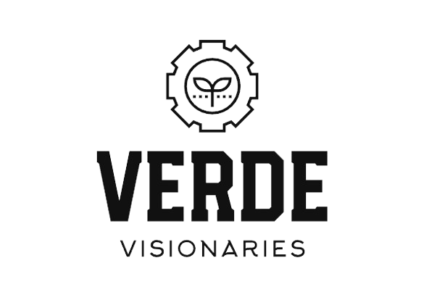

**Contents**

1. Participants and their roles.
2. The mission of our website.
3. Used apps and technology.
4. Resume.
5. **Participants and their roles.**

|  |  |  |
| --- | --- | --- |
| Name | Class | Role |
| Ivan-Mihail Ivanov | 9b | Scrum Trainer |
| Ivaylo Gyurov | 9b | Designer |
| Kaloyan Ivanov | 9b | Front-end developers |
| Kristian Dimitrov | 9b | Front-end developers |

1. **The mission of our website.**

Our website gives a wonderful opportunity to those who want to organize events, spread awareness and exchange opinions on topics concerning ecology.

1. **Used apps and technology**

1. **Resume**

Verde Visionaries is a small team of people with similar ideas and an aspiration for ecology. Our initiative is to encourage people to be more responsible and provide a website for those who share our interests. Are you ready to go green?

