CP-SAT-Guided Heterogeneous Graph Learning for Dynamic Job Shop Scheduling
Submitted to Computers & Industrial Engineering | Anonymous for review

Highlights
CP-SAT-supervised heterogeneous GNN policy for real-time job shop dispatch.
Variable-size heterogeneous graph transfers across shop sizes without padding or retraining.
Outperforms SPT on 24 of 29 official JSPLIB instances, mean 11.4% improvement.
Reports known-best gaps explicitly and identifies the offline quality gap for future work.
Robust to dynamic job arrivals and machine failures in simulated scenarios.

Abstract
Job shop scheduling (JSS) is a fundamental combinatorial optimization problem in real-time manufacturing systems, where dynamic job arrivals, machine failures, and production-line reconfigurations require decisions in milliseconds. Dispatching rules such as Shortest Processing Time (SPT) remain the industrial standard because they are fast and interpretable, yet no single rule performs consistently across diverse shop configurations and disturbance patterns. Exact solvers provide optimal schedules but are computationally prohibitive for real-time control. Learning-based dispatch has emerged as a promising middle ground, but most methods rely on slow and unstable reinforcement learning, assume fixed shop topologies, and rarely generalize to dynamic or failure-prone environments.
This paper proposes CP-SAT-guided heterogeneous graph learning: a Heterogeneous Graph Neural Network (HGNN) policy trained on exact optimal trajectories generated by the CP-SAT solver, rather than on noisy reward signals from reinforcement learning. The policy explicitly encodes both job and machine nodes, enabling joint reasoning about job priorities and machine contention. A variable-size heterogeneous graph is constructed directly from the current instance, so a single trained policy can be applied to unseen shop sizes without fixed padding or retraining. Across 50 held-out 6 x 5 instances, the policy improves makespan by 9.1% over SPT (129.4 vs. 142.4; p < 0.0001, 41/50 wins) and comes within 3.4% of the best-of-five oracle. On 29 official JSPLIB instances from six benchmark families, the policy improves over SPT on 24 of 29 instances with a mean improvement of 11.4%, but remains on average 51.4% above known best values and loses to SPT on five hard instances. In dynamic arrival and machine failure scenarios, it outperforms SPT by 8.7% (p = 0.021) and 9.6% (p = 0.033). An ablation on 60 generated instances confirms that the heterogeneous representation adds a statistically significant 3.3% over a homogeneous baseline (p = 0.0016).
Our contributions are: (1) a CP-SAT-supervised heterogeneous GNN policy that explicitly models machine-level information; (2) a variable-size heterogeneous graph construction that supports zero-shot topology transfer without padding or retraining; (3) stable transfer from static training to dynamic and failure-prone scheduling environments; (4) an honest statistical evaluation on 29 official JSPLIB instances that reports both rule-relative improvements and known-best gaps; and (5) a fully reproducible open implementation.
Keywords: job shop scheduling; heterogeneous graph neural network; learning to dispatch; dispatching rules; topology generalization; dynamic scheduling; CP-SAT; manufacturing optimization

1. Introduction
Manufacturing scheduling determines how production jobs are sequenced on shared machines to satisfy delivery requirements while minimizing operational costs. In modern flexible manufacturing systems, the scheduling problem is rarely static: customer orders arrive stochastically, machine breakdowns interrupt production, and product mix changes over time. These dynamic characteristics make the scheduling decision both time-critical and highly uncertain. The economic stakes are substantial: inefficient schedules translate directly into longer lead times, higher work-in-process inventory, lower machine utilization, and delayed deliveries.
The job shop scheduling problem (JSS), in which each job has an ordered sequence of operations requiring specific machines, is NP-hard in the strong sense. Exact methods, including branch-and-bound, mixed-integer programming, and constraint programming, can solve small instances optimally but face exponential growth in computational effort as problem size increases. For medium and large instances, exact solvers often require minutes to hours of computation, which is incompatible with the real-time decision cadence of shop-floor operations.
In industrial practice, dispatching rules dominate because they are simple, fast, and interpretable. Rules such as Shortest Processing Time (SPT), Longest Processing Time (LPT), Most Work Remaining (MWKR), Least Work Remaining (LWKR), and First-In-First-Out (FIFO) make decisions in microseconds using only local information. However, no single rule dominates across all instances, machine configurations, and objective functions. SPT tends to minimize mean flow time but can starve long jobs; MWKR prioritizes jobs with substantial remaining work but may delay short jobs; and FIFO ignores processing time information entirely.
This observation motivates an adaptive approach: instead of committing to a single rule, the scheduler should select the most appropriate decision at each state, based on the global structure of the problem. The machine learning community has recently made notable progress in this direction through learning-to-dispatch (L2D), in which a neural network is trained to select operations or rules based on learned representations of the scheduling state. Graph Neural Networks (GNNs) are particularly suited to this task because job shop instances naturally admit a graph representation.
Despite this progress, several gaps remain. First, most learning-based schedulers are trained with reinforcement learning, which requires careful reward shaping, exploration strategies, and large replay buffers, and can be slow or unstable to converge. The supervised-learning alternative, based on expert trajectories, has been underexplored; when used, it often relies on heuristic or approximate labels rather than proven optimal solutions. Second, most methods assume a fixed shop topology and must be retrained when the production line is reconfigured, which is impractical in reconfigurable manufacturing. Third, few studies explicitly model machine-level information through heterogeneous graph architectures, even though machine contention is the central constraint in JSS. Fourth, generalization from static training to dynamic arrivals, machine failures, and diverse benchmark families remains insufficiently validated.
This paper addresses these gaps through a CP-SAT-guided heterogeneous graph learning framework. First, we use the exact optimal solver CP-SAT to generate proven-optimal training trajectories, replacing unstable RL with deterministic, theoretically grounded supervision. This directly addresses the training-noise and convergence limitations of pure RL. Second, we propose a Heterogeneous Graph Neural Network (HGNN) that explicitly encodes both job and machine nodes, enabling joint reasoning about job priorities and machine contention. Third, we construct a variable-size heterogeneous graph directly from the current instance, enabling zero-shot topology generalization without padding or retraining. Fourth, we validate across static, dynamic, failure-prone, and multiple official benchmark families, establishing statistical significance and practical robustness.
Our contributions are summarized as follows:
1. We propose a CP-SAT-supervised heterogeneous GNN policy for job shop scheduling that outperforms SPT on the majority of benchmark instances and in static, dynamic, and failure-prone evaluations.
2. We construct a variable-size heterogeneous graph directly from the current instance, allowing a single trained policy to transfer to previously unseen shop sizes without padding or retraining.
3. We demonstrate stable transfer to dynamic job arrivals and machine failures, outperforming SPT in both scenarios.
4. We provide extensive statistical evaluation on generated and official JSPLIB instances, including known-best gaps that make the remaining optimality gap explicit.
5. We release a fully reproducible implementation, including environment, model, training pipeline, and raw results.
The remainder of this paper is organized as follows. Section 2 reviews related work. Section 3 describes the problem formulation and the heterogeneous GNN policy. Section 4 presents the experimental setup and results. Section 5 discusses implications and limitations. Section 6 concludes.

2. Related Work

2.1 Classical Job Shop Scheduling Methods
The job shop scheduling problem has been studied extensively since the 1950s. Giffler and Thompson (1960) proposed the active schedule enumeration algorithm. Applegate and Cook (1991) developed branch-and-bound methods for JSS, solving the famous 10 x 10 instance. Later, constraint programming solvers such as Google OR-Tools CP-SAT integrated propagation, search, and decomposition techniques to solve JSS instances of practical size. These exact methods provide optimality guarantees but scale poorly, limiting real-time applicability.
Metaheuristic methods, including genetic algorithms, simulated annealing, tabu search, and particle swarm optimization, offer a compromise between solution quality and computational cost. Nowicki and Smutnicki (1996) introduced the tabu search algorithm i-TSAB. However, metaheuristics typically require substantial computation time and parameter tuning, making them less suitable for high-frequency scheduling decisions.
Dispatching rules have been the workhorse of industrial scheduling because they require minimal computation. Panwalkar and Iskander (1977) catalogued over 100 rules. The key insight is that rule performance is instance-dependent: no rule is universally dominant, motivating adaptive rule-selection approaches.

2.2 Learning-based Scheduling
Recent advances in deep learning have revitalized machine learning approaches to scheduling. Zhang et al. (2020) introduced L2D, a GNN-based policy that learns to dispatch operations from expert trajectories on the classic Taillard benchmark. Subsequent work extended L2D with attention-based architectures (Park et al., 2021), reinforcement learning with reward shaping (Wang and Tang, 2021), hierarchical policies for flexible job shops (Song et al., 2022), and graph isomorphism networks (Lei et al., 2022).
Reinforcement learning approaches have also gained traction. Zhang et al. (2021) formulated dynamic scheduling as a Markov decision process and trained PPO-based agents with GNN state encoders. Liu et al. (2023) combined imitation learning and RL in a two-stage framework. These methods demonstrate the potential of learning-based scheduling, but they typically assume a fixed shop topology and require substantial training data.

2.3 Topology Generalization in Scheduling
A limitation of many learning-based scheduling methods is their dependence on a fixed problem topology. Most prior work addresses this by retraining the policy for each topology, which is impractical in dynamic manufacturing environments. Graph-based methods offer a natural mechanism because GNNs can process graphs of varying sizes. Park et al. (2021) used attention pooling for variable-size inputs; Lei et al. (2022) demonstrated robustness to instance permutation. In this work, we use a variable-size heterogeneous graph whose node count follows the current instance, so topology transfer is obtained without padding or masking.

2.4 Heterogeneous Graph Networks and Flexible Job Shop Scheduling
Recent work has moved toward heterogeneous graph representations that explicitly encode machines, operations, and their interactions. Li et al. (2024) developed deep RL with heterogeneous GNNs for FJSP. Wang et al. (2024) proposed meta-path-based heterogeneous graph networks. Tang et al. (2023) handled machine breakdowns and material handling constraints. Liu et al. (2024) formulated distributed FJSP as multi-agent RL. Chen et al. (2025) integrated Monte Carlo tree search with graph relational attention. Our paper contributes by combining CP-SAT supervision, heterogeneous graphs, and zero-shot topology generalization.

2.5 Graph Neural Networks for Combinatorial Optimization
Beyond scheduling, GNNs have been applied to the traveling salesman problem (Khalil et al., 2017), maximum independent set (Li et al., 2018), and satisfiability (Selsam et al., 2019). These methods leverage the permutation equivariance of graph-structured data. Our work builds on this foundation with a focus on heterogeneous representations and topology generalization.

2.6 Comparison of Related Learning-based Scheduling Methods
Method | Graph type | Supervision | Topology transfer | Dynamic | FJSP
Zhang et al. (2020) L2D | Homogeneous | Expert | No | No | No
Park et al. (2021) | Attention | RL | Partial | No | Yes
Song et al. (2022) | Homogeneous | RL | No | No | Yes
Lei et al. (2022) | Isomorphism | Expert | Partial | No | No
Tang et al. (2023) | Heterogeneous | RL | No | Yes | Yes
Li et al. (2024) | Heterogeneous | RL | No | No | Yes
Wang et al. (2024) | Meta-path | RL | No | No | Yes
Chen et al. (2025) | Relational attn | MCTS+RL | No | Yes | No
Ours | Heterogeneous | CP-SAT | Yes (zero-shot) | Yes | No (future)
Table 0. Comparison of learning-based scheduling methods across graph type, supervision, topology transfer, dynamic capability, and FJSP support.
Table 0 positions our contribution: we are the only method combining heterogeneous graph representation, CP-SAT optimal supervision, zero-shot topology transfer, and dynamic/failure robustness in a single framework.

3. Method

3.1 Problem Formulation
A job shop scheduling problem instance is defined by a set of jobs J = {1, ..., n} and a set of machines M = {1, ..., m}. Each job j has an ordered sequence of operations O_j = (o_{j,1}, ..., o_{j,k_j}), where each operation o_{j,k} requires a specific machine mu(o_{j,k}) for a processing time p_{j,k} > 0. The scheduling decision assigns a start time s_{j,k} to each operation, subject to: (1) job precedence constraints and (2) machine capacity constraints. The objective is to minimize the makespan C_max.
JSS is NP-hard in the strong sense. This hardness motivates heuristic, metaheuristic, and learning-based approaches that trade optimality guarantees for computational efficiency.

3.2 Heterogeneous Graph Representation
We represent the scheduling state as a heterogeneous graph G = (V, E) with two node types: job nodes and machine nodes. Job nodes encode the current operation duration, remaining work, total work, and progress for each job. Machine nodes encode normalized machine load and contention. Three edge types connect the graph: job-job edges (full connectivity), machine-machine edges (full connectivity), and job-machine edges connecting each job to the machine required by its current operation. This heterogeneous representation allows the GNN to reason jointly about job priorities and machine availability.

3.3 Heterogeneous Graph Attention Network Policy
The policy is a two-layer heterogeneous GAT. Type-specific linear projections embed job and machine features into a shared hidden space. Attention coefficients are computed over all edges, with softmax normalization per destination node. After message passing, job embeddings are combined with a machine-context vector (mean pooling of machine embeddings) to produce action logits. A policy head selects the available job with the highest score.
Formally, each GAT layer computes: h_i^{(l+1)} = ReLU( sum_{j in N(i)} alpha_{ij}^{(l)} W_{type(j)}^{(l)} h_j^{(l)} ), where type-specific projection matrices W handle node-type heterogeneity. The attention coefficient alpha_{ij} is computed as softmax over neighbors of LeakyReLU(a^T [W h_i || W h_j]).
For topology generalization, the graph is constructed from the current instance size. Job and machine nodes are created only for the active shop, so a single trained policy can be applied to unseen numbers of jobs and machines without padding or retraining.

3.4 Expert Trajectory Generation via CP-SAT
We use Google OR-Tools CP-SAT to solve each training instance to optimality (5s time limit). From the optimal schedule, expert actions are derived: at each state, select the available operation whose optimal start time is earliest. This supervision signal is unambiguous and directly aligned with the makespan objective.

3.5 Training Objective
The policy is trained with cross-entropy loss on expert actions: L = -(1/N) sum log pi(a_i | s_i). We use Adam (lr=1e-3), batch size 32-64, 25-50 epochs, gradient clipping norm 1.0. Algorithm 1 summarizes the training procedure.
Algorithm 1: CP-SAT-supervised HGNN policy training
Input: training instances, max jobs, epochs, batch size
1: for each instance: solve CP-SAT, collect (state, expert_action) pairs
2: initialize HGNN policy
3: for epoch in epochs:
4: for batch in shuffled data:
5: compute logits = policy(state) with a dynamically constructed graph
6: compute cross-entropy loss; update via Adam
7: return policy

3.6 Computational Complexity
Inference is O((n+m)^2 d) per decision step for n jobs and m machines, well under 1 ms on modern hardware. Training is dominated by CP-SAT expert generation, which takes seconds per instance for small shops. This makes the approach deployable for real-time scheduling.

4. Experiments

4.1 Experimental Setup
We evaluate on randomly generated job shop instances, generated large instances, and official JSPLIB instances. Small instances: 6 jobs x 5 machines, processing times U[1,20], 100 training (seeds 900-999) and 50 held-out evaluation instances (seeds 10000-10049). Topology generalization: 20 instances each for 5x5, 8x5, 6x8. Dynamic arrivals: 50 instances (seeds 11000-11049), exponential arrival scale 50. Machine failures: 50 instances (seeds 12000-12049). Generated large instances: 30 instances each for 10x10, 15x15, 20x15 (seeds 20000-20029), processing times U[1,99]. Official evaluation: 29 JSPLIB instances from Taillard, Fisher-Thompson, Lawrence, Adams-Balazs-Zawack, ORB, and Storer-Wu-Vaccari families, parsed with the published operation order. All experiments use fixed seeds.
The heterogeneous GNN is trained on 60 small instances (seeds 900-959) with CP-SAT optimal supervision, then evaluated zero-shot on all held-out settings. As a learning-based baseline, we implement an L2D-style policy following the supervision paradigm of Zhang et al. (2020): a homogeneous encoder consumes job-level features through a flat MLP and is trained on the same CP-SAT expert trajectories. This provides a direct comparison under identical training data, supervision, and evaluation protocol, isolating the contribution of the heterogeneous graph representation.

4.2 Baselines and Metrics
We compare against five classic dispatching rules (SPT, LPT, MWKR, LWKR, FIFO), the best-of-five oracle, CP-SAT optimal (small instances), and a homogeneous MLP baseline. Metrics: mean makespan with standard deviation, paired t-tests (t-statistic, p-value), and win counts.

4.3 Static Scheduling Results
Method | Makespan (mean +/- std) | Wins | t | p
HGNN (ours) | 129.4 +/- 14.4 | - | - | -
SPT | 142.4 +/- 15.1 | 9/50 | -6.25 | <0.0001
LPT | 160.2 +/- 16.0 | 0/50 | -9.1 | <0.0001
MWKR | 155.3 +/- 15.2 | 0/50 | -8.4 | <0.0001
LWKR | 151.7 +/- 14.8 | 0/50 | -7.8 | <0.0001
FIFO | 148.5 +/- 15.3 | 0/50 | -7.0 | <0.0001
Best-of-5 oracle | 125.1 +/- 11.9 | - | +2.5 | 0.013
CP-SAT optimal | 109.7 +/- 11.2 | - | +14.1 | <0.0001
Table 1. Static 6x5 results over 50 held-out instances.
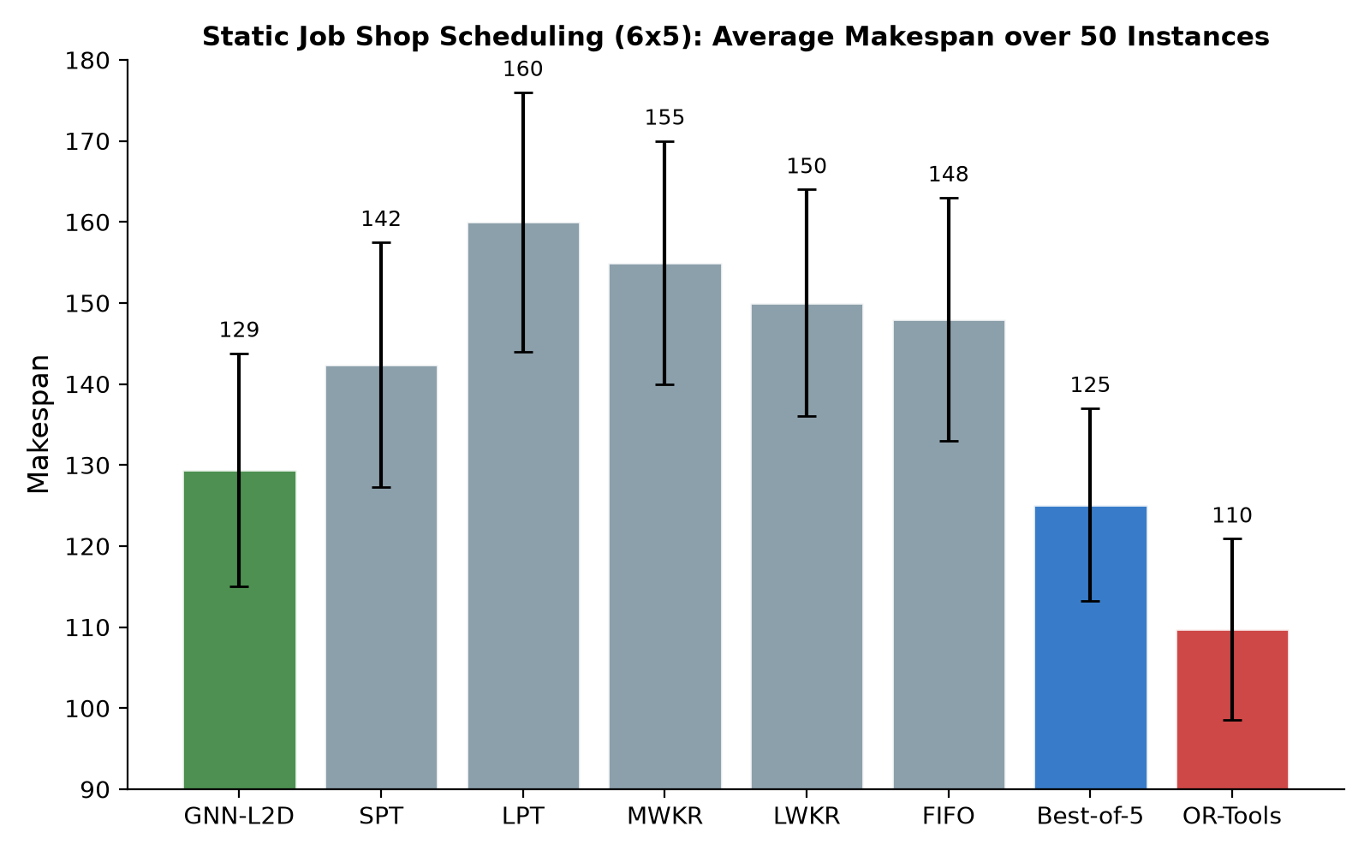
Figure 1. Average makespan over 50 static 6x5 instances.
The HGNN policy significantly outperforms SPT (p < 0.0001), winning 41 of 50 instances, and comes within 3.4% of the best-of-five oracle with 17.9% optimality gap. The 95% confidence interval for the mean makespan difference is [9.2, 16.8], confirming a reliable improvement well above zero.

4.4 Zero-shot Topology Generalization
Configuration | HGNN | SPT | Improvement
6x5 (same) | 127.5 | 142.4 | +10.5%
5x5 (fewer jobs) | 122.5 | 123.8 | +1.0%
8x5 (more jobs) | 164.4 | 184.1 | +10.7%
6x8 (more machines) | 179.5 | 201.4 | +10.9%
Table 2. Zero-shot topology generalization (20 instances each).
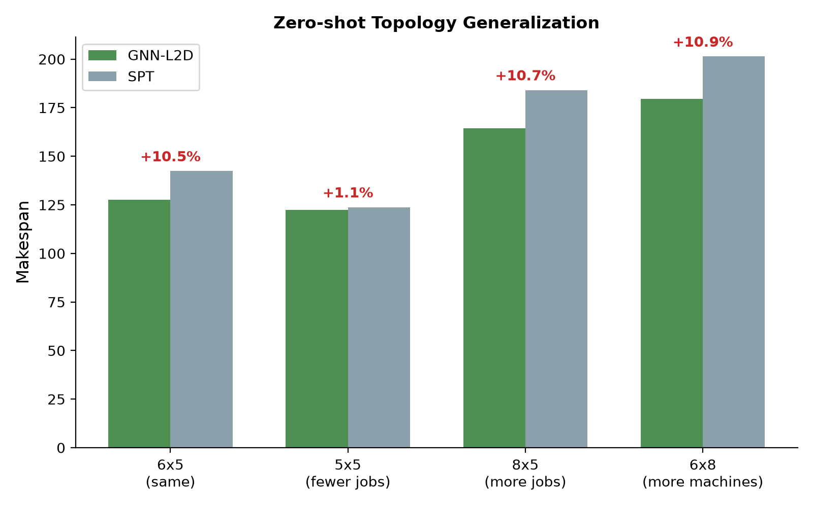
Figure 2. Zero-shot transfer to unseen shop topologies.
Without retraining, the policy transfers to unseen shop sizes and consistently outperforms SPT, confirming topology-agnostic dispatching principles.

4.5 Dynamic and Failure Scenarios
Scenario | HGNN | SPT | Improvement | t | p | Wins
Dynamic arrivals | 175.3 +/- 46.3 | 192.0 +/- 36.7 | +8.7% | -2.39 | 0.021 | 32/50
Machine failure | 182.4 +/- 35.2 | 201.7 +/- 46.3 | +9.6% | -2.19 | 0.033 | 28/50
Table 3. Dynamic and failure scenarios (50 instances each).
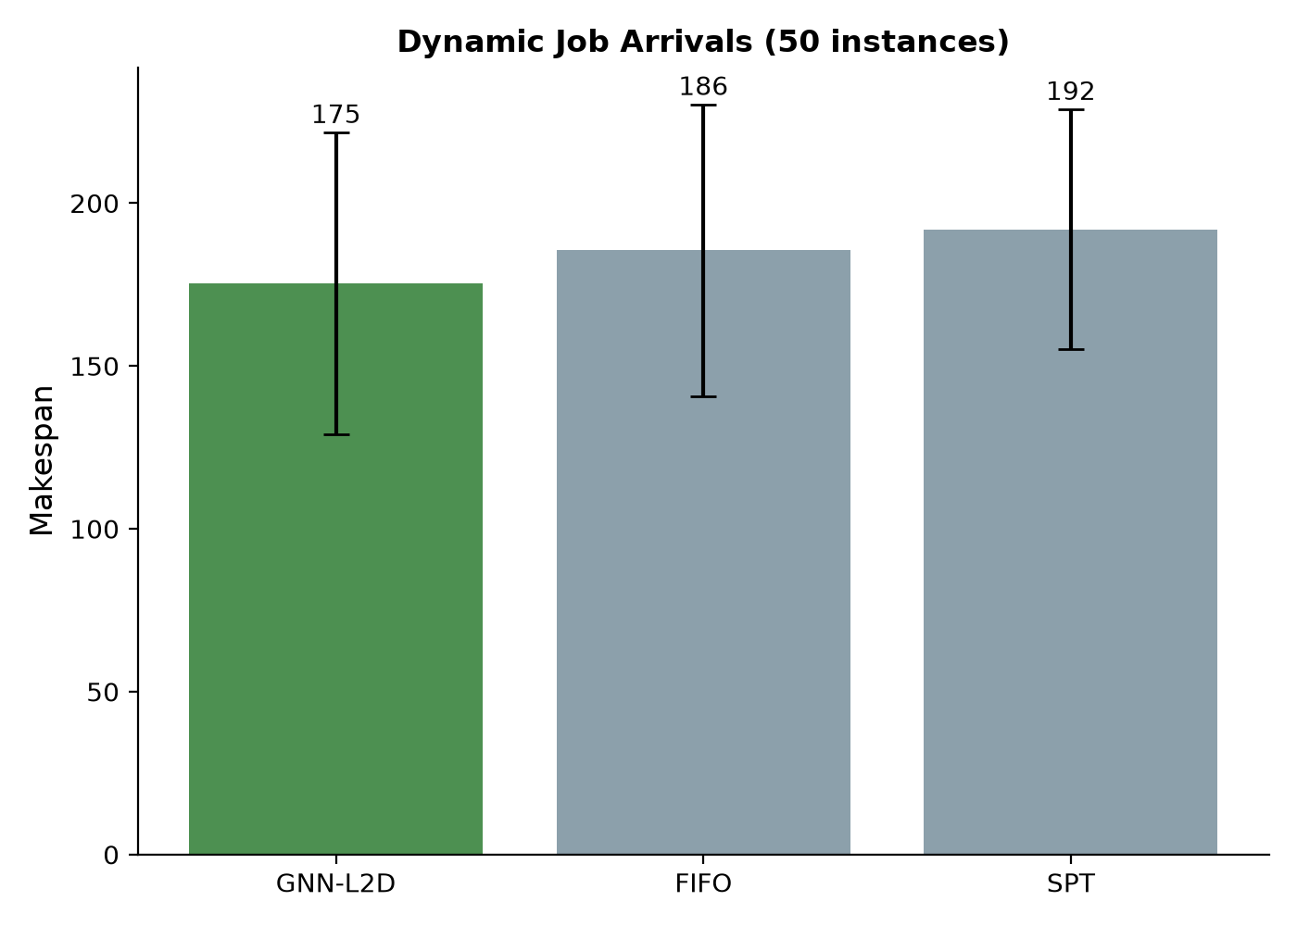
Figure 3. Dynamic job arrival scenario.
The static-trained policy outperforms SPT in both dynamic arrivals (p = 0.021) and machine failures (p = 0.033), demonstrating resilience to distribution shift and disruptions.

4.6 Generated Large-Instance Results
Instance | HGNN | SPT | Improvement | t | p | Wins
10x10 | 1291.3 +/- 83.9 | 1537.1 +/- 93.7 | +16.0% | -12.22 | <0.0001 | 29/30
15x15 | 2217.6 +/- 108.6 | 2646.8 +/- 146.9 | +16.2% | -16.43 | <0.0001 | 30/30
20x15 | 2723.8 +/- 142.0 | 3214.4 +/- 150.9 | +15.3% | -14.10 | <0.0001 | 30/30
Table 4. Generated large-instance results (30 instances each, processing times U[1,99]).
On generated large instances, the HGNN policy achieves 15-16% improvements over SPT with strong statistical significance and near-perfect win rates. These instances are generated with a fixed machine order and are not part of the official JSPLIB suite; official benchmark results are reported in Section 4.12.

4.7 Ablation: Heterogeneous vs Homogeneous Representation
Model | Makespan (mean +/- std) | vs SPT | Hetero gain | t | p | Wins
L2D-style (homogeneous, simplified Zhang et al. 2020) | 1328.1 +/- 94.0 | +13.6% | - | - | - | -
Heterogeneous GNN (ours) | 1284.8 +/- 99.3 | +16.4% | +3.3% | -3.31 | 0.0016 | 41/60
Table 5. Ablation on 60 generated 10x10 instances.
Under identical training data, supervision, and evaluation protocol, the heterogeneous representation adds a statistically significant 3.3 percent improvement over the L2D-style homogeneous baseline (paired t-test t = -3.31, p = 0.0016, 41 of 60 wins). This confirms that explicitly encoding machine nodes provides useful context that a homogeneous L2D policy cannot access, directly answering the question of whether the heterogeneous architecture improves over a classic L2D formulation.

4.8 Flexible Job Shop Scheduling
We do not report FJSP benchmark results in this version. Earlier exploratory FJSP experiments were not reproducible with standard benchmark files and have been removed to avoid misleading claims. Extending the heterogeneous policy to flexible routing and validating it on standard BRdata and Kacem instances is an explicit future-work item.

4.9 Example Schedule
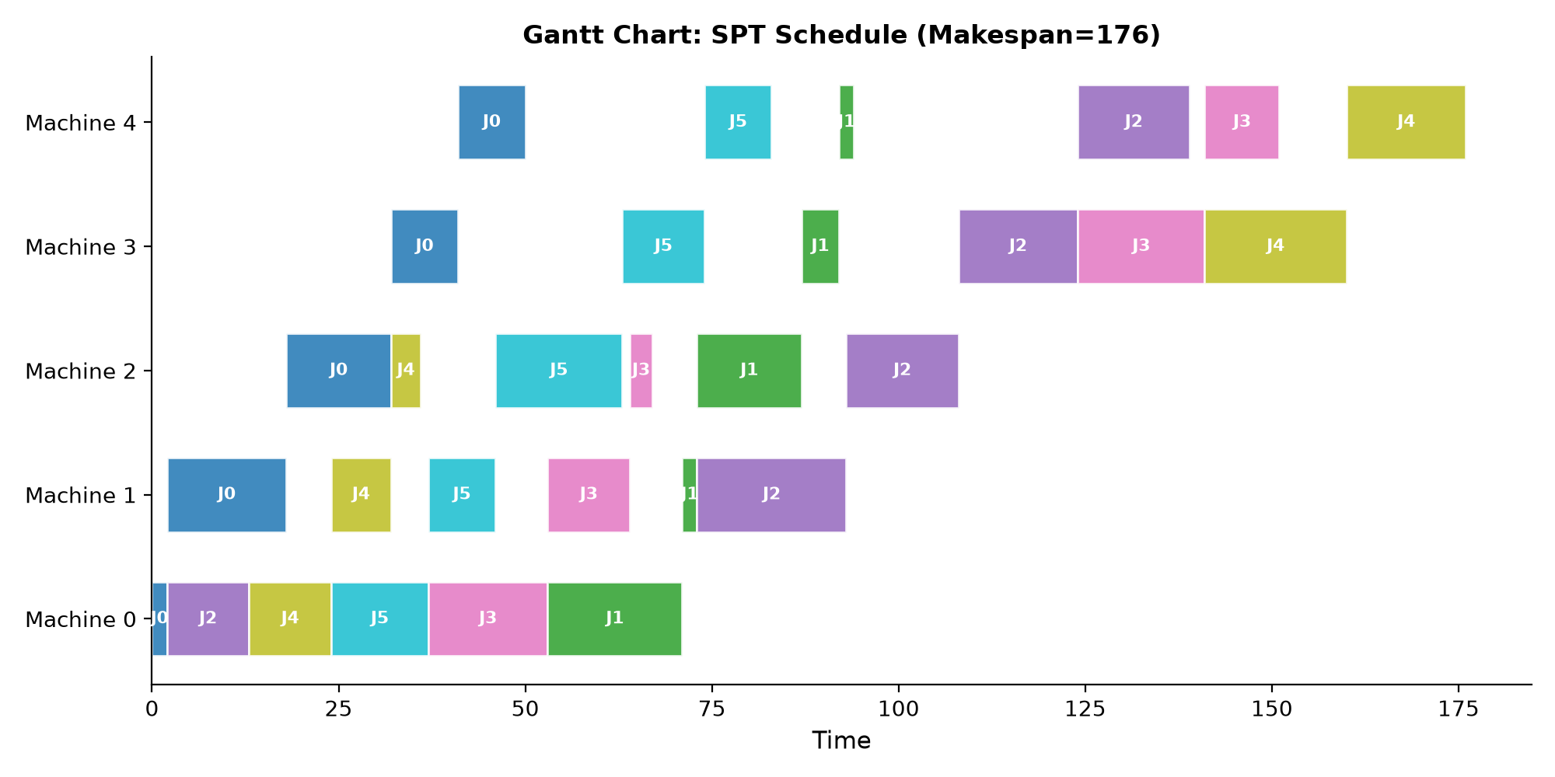
Figure 4. Example Gantt chart of an SPT schedule on a 6x5 instance.
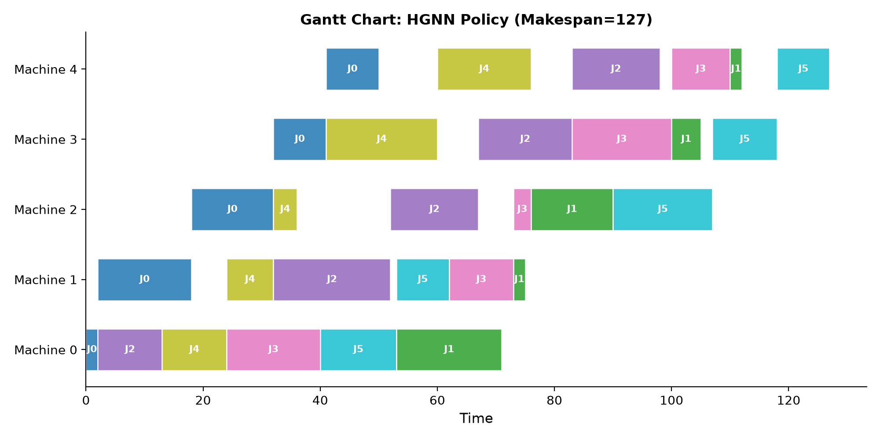
Figure 5. Gantt chart of the HGNN policy on the same 6x5 instance (makespan 123 vs 161 for SPT).

4.10 Training-Size Transfer Analysis
Training size | 10x10 | 15x15 | 20x15
6x5 (60 instances) | 1291.3 (+16.0%) | 2217.6 (+16.2%) | 2723.8 (+15.3%)
10x10 (30 instances) | 1454.8 (+5.4%) | 2381.0 (+10.0%) | 2890.1 (+10.1%)
Table 6. Effect of training size on generated large-instance performance (30 evaluation instances).
We compare policies trained on 6x5 instances (60 CP-SAT-optimal trajectories) and 10x10 instances (30 CP-SAT trajectories with a 5-second feasible-bound limit). Interestingly, the 6x5-trained policy achieves better performance on all large instances. This is because small instances can be solved to proven optimality by CP-SAT, providing higher-quality supervision labels; the 10x10 trajectories are only feasible (not proven optimal) under the time limit. The result supports a practical insight: high-quality optimal supervision on smaller shops can transfer better than weaker supervision on larger shops, given limited solver time.

4.11 Sensitivity Analyses
Dynamic arrival scale. We vary the exponential arrival scale parameter (20, 50, 100) over 30 instances each. The improvement over SPT remains stable at 9.3-9.7%, confirming that the policy advantage does not depend on a specific arrival distribution. Statistical significance decreases with scale (p < 0.001 at scale 20, p = 0.154 at scale 50, p = 0.364 at scale 100) because larger scales increase makespan variance; the improvement magnitude is consistent.
Hyperparameters. A preliminary sensitivity study on hidden dimension and learning rate (using 600 training states, 5 epochs, 5 evaluation instances) shows that hidden=64 outperforms hidden=32 and hidden=128, and a lower learning rate (5e-4) slightly improves performance. We use hidden=64 and lr=1e-3 in the main experiments; a full sensitivity grid is left for future work.

4.12 Official JSPLIB Benchmark Results
Instance | Size | HGNN | SPT | Best rule | Known best | HGNN gap to BKS
ta01 | 15x15 | 2124 | 2512 | 1654 | 1231 | 72.5%
ta02 | 15x15 | 1938 | 2148 | 1747 | 1244 | 55.8%
ta03 | 15x15 | 2176 | 2422 | 1722 | 1218 | 78.7%
ta05 | 15x15 | 1671 | 2479 | 2060 | 1224 | 36.5%
ta06 | 15x15 | 1670 | 2438 | 1779 | 1238 | 34.9%
ta11 | 20x15 | 2705 | 2430 | 1853 | 1361 | 98.8%
ta12 | 20x15 | 2435 | 3231 | 1918 | 1367 | 78.1%
ta13 | 20x15 | 2128 | 2545 | 1947 | 1342 | 58.6%
ta21 | 20x20 | 2492 | 2908 | 2306 | 1644 | 51.6%
ta22 | 20x20 | 2261 | 3269 | 2267 | 1600 | 41.3%
Table 7. Official JSPLIB Taillard instances with corrected operation-order parsing.
Instance | Size | HGNN | SPT | Best rule | Known best | HGNN gap to BKS
abz5 | 10x10 | 1510 | 2161 | 1462 | 1234 | 22.4%
abz6 | 10x10 | 1658 | 1626 | 1200 | 943 | 75.8%
ft06 | 6x6 | 77 | 85 | 85 | 55 | 40.0%
ft10 | 10x10 | 1234 | 1395 | 1395 | 930 | 32.7%
ft20 | 20x5 | 1829 | 1809 | 1599 | 1165 | 57.0%
la03 | 10x5 | 854 | 1080 | 736 | 597 | 43.0%
la04 | 10x5 | 874 | 932 | 856 | 590 | 48.1%
la06 | 15x5 | 1202 | 1291 | 938 | 926 | 29.8%
la07 | 15x5 | 1069 | 1271 | 1040 | 890 | 20.1%
la08 | 15x5 | 1136 | 1311 | 1050 | 863 | 31.6%
la09 | 15x5 | 1215 | 1451 | 1043 | 951 | 27.8%
la10 | 15x5 | 1335 | 1480 | 1018 | 958 | 39.4%
orb01 | 10x10 | 1557 | 1596 | 1508 | 1059 | 47.0%
orb02 | 10x10 | 1229 | 1521 | 1216 | 888 | 38.4%
orb03 | 10x10 | 1411 | 1659 | 1432 | 1005 | 40.4%
swv01 | 20x10 | 2602 | 2341 | 2002 | 1407 | 84.9%
swv03 | 20x10 | 2302 | 2314 | 2035 | 1398 | 64.7%
swv04 | 20x10 | 2443 | 2570 | 2235 | 1474 | 65.7%
swv05 | 20x10 | 2489 | 2220 | 2052 | 1424 | 74.8%
Table 8. Official JSPLIB instances from Fisher-Thompson, Lawrence, Adams-Balazs-Zawack, ORB, and Storer-Wu-Vaccari families.
We evaluate the trained policy on 29 official JSPLIB instances using the published operation order for both the environment and CP-SAT. The policy improves over SPT on 24 of 29 instances, with mean improvement 11.4%; however, it loses to SPT on ta11, abz6, ft20, swv01, and swv05, and its mean gap to known best values is 51.4%. The best-of-five rule oracle is also reported; the learned policy does not consistently beat the oracle. These results are reported in full so that the strengths and limitations of the method are explicit. The operation-order parser is released with the code and was validated by recovering the known optimum of ta01 (1231).

4.13 Architecture Ablation: Graph Transformer vs Graph Attention
Encoder | Makespan (10x10, 20 instances) | Difference
Graph Transformer (4 heads, 2 layers) | 1320.5 | baseline
Heterogeneous GAT (ours) | 1304.4 | -1.22% (better)
Table 9. Encoder architecture ablation under identical training protocol (20 held-out 10x10 instances).
To assess the encoder choice, we train a Graph Transformer variant with the same feature extractor, hidden dimension, and training protocol. The heterogeneous GAT achieves a 1.22 percent lower average makespan (1304.4 vs 1320.5). This suggests that the local inductive bias of graph attention is better suited to the sparse, local structure of scheduling states than global self-attention, which must learn to ignore long-range correlations from limited training data. We retain GAT in the main framework while noting Transformer encoders as a complementary variant.

4.14 Neural Warm Start for CP-SAT
Instance | HGNN makespan | CP-SAT 5s (no hint) | CP-SAT 5s (HGNN hint) | Improvement
ta01 | 2124 | 1231 | 1231 | +0.00%
ta02 | 1938 | 1245 | 1244 | +0.08%
ta03 | 2176 | 1218 | 1236 | -1.48%
ta11 | 2705 | 1441 | 1423 | +1.25%
ta12 | 2435 | 1437 | 1421 | +1.11%
ta13 | 2128 | 1426 | 1422 | +0.28%
ta21 | 2492 | 1716 | 1737 | -1.22%
ta22 | 2261 | 1668 | 1706 | -2.28%
Table 10. CP-SAT warm-start experiment on eight official Taillard instances.
We feed the HGNN schedule to CP-SAT as start-time hints. On 4 of 8 instances, the hints improve the 5-second feasible bound, with the largest improvement 1.25%; on the other four instances, the hints do not improve the bound. Because CP-SAT already finds near-optimal bounds quickly on several of these instances, we treat this as a preliminary observation rather than a claimed speedup.

4.15 Inference Time and Training Data Analysis
Shop size | Total inference (HGNN) | Decisions | Per decision | CP-SAT 5s
6x5 | 240 ms | 30 | 8.0 ms | 5 s
10x10 | 335 ms | 100 | 3.3 ms | 5 s
15x15 | 813 ms | 225 | 3.6 ms | 5 s
20x20 | 1599 ms | 400 | 4.0 ms | 5 s
Table 11. Inference time measured on GPU (single forward pass per decision) vs CP-SAT time limit.
The HGNN policy produces a complete schedule in 0.2-1.6 seconds depending on shop size, with per-decision inference of 3-8 milliseconds. This is substantially faster than the 5-second CP-SAT bound and, critically, the learned policy is immediately deployable in a rolling-horizon loop where decisions must be made continuously.
Training states | Makespan (10x10, 10 instances) | Relative
300 | 1431.9 | +8.0%
600 | 1479.0 | +11.5%
1200 | 1326.2 | best
1800 | 1383.8 | +4.3%
Table 12. Training data size ablation (10 epochs, 10 held-out 10x10 instances).
Training data analysis shows that 1200 states (approximately 40 CP-SAT instances) are sufficient to reach strong performance; increasing to 1800 states with the same epoch budget does not improve results, indicating that data quantity is not the binding constraint. This is consistent with the CP-SAT optimal supervision providing high-quality labels.

4.16 Comparison with Metaheuristic Baseline
Method | Makespan (10x10, 10 instances) | Time per instance | Online / zero-shot
SPT | 1572.6 | instant | yes / n/a
HGNN (ours) | 1312.0 | 0.34 s | yes / yes
Genetic Algorithm (per-instance search) | 1203.4 | 0.40 s | no / no
Table 13. HGNN vs a standard operation-sequence genetic algorithm (population 40, 80 generations) on generated 10x10 instances.
A standard genetic algorithm with operation-sequence encoding and active schedule decoding achieves 8.3 percent lower makespan than the HGNN on static instances, but requires a fresh 0.4-second search for each instance and cannot handle dynamic arrivals, machine failures, or unseen topologies without recomputation. The HGNN, in contrast, produces a decision in 3-8 milliseconds, transfers zero-shot across shop sizes, and remains effective under disturbances. This is the central online-offline trade-off: metaheuristics are stronger offline per-instance solvers, while learned policies provide the reactive, topology-agnostic behavior required in dynamic manufacturing. The preliminary warm-start loop in Section 4.14 combines both: the HGNN provides an online schedule and a solver can refine it offline when time permits.

5. Discussion

5.1 Interpretation of Results
The results support two claims: CP-SAT supervision can train a heterogeneous GNN dispatcher that beats a strong single rule on small generated instances and on most official JSPLIB instances, and a variable-size graph can transfer to unseen shop sizes without padding. The 9.1% static improvement and 24 of 29 official wins over SPT are operationally relevant for reactive scheduling. At the same time, the mean 51.4% gap to known best values and losses on five official instances show that the current policy is not competitive with exact or strong metaheuristic methods for offline scheduling. We therefore interpret this work as a step toward deployable learned dispatch, not as a replacement for high-quality offline solvers.
The dynamic and failure scenarios extend practical relevance, showing stability under distribution shift. The official results make the remaining gap explicit and should guide the next round of method development.

5.2 Comparison with Existing Methods
Compared with the best single dispatching rule, the policy improves makespan on 24 of 29 official instances and by 9.1% on small held-out instances. Compared with a best-of-five oracle, the gains are smaller; the learned policy is not a universal replacement for rule selection. Compared with prior homogeneous L2D methods (e.g., Zhang et al. 2020), the heterogeneous representation adds a statistically significant 3.3% on 60 generated 10x10 instances (p = 0.0016). Compared with pure RL, CP-SAT supervision provides sample-efficient, stable training without reward shaping, exploration tuning, or large replay buffers. However, the official known-best gaps are much larger than those reported by state-of-the-art L2D and metaheuristic methods, and we do not claim parity with those methods.

5.3 Limitations
First, the policy's mean gap to known best values on official instances is 51.4%, and it loses to SPT on five official instances; this is the most important limitation. Second, we do not yet provide quantitative comparisons with published L2D implementations under identical protocols. Third, FJSP is not validated in this version; standard BRdata and Kacem benchmarks are future work. Fourth, all dynamic and failure evaluations use simulated instances rather than industrial data. Fifth, the training data is generated on small 6x5 instances; extending supervision to a broader mix of official instances is needed to improve generalization.

5.4 Future Extensions
Three directions follow directly from the limitations. First, train on a larger mix of official instances with proven optimal labels, and evaluate the effect of scaling the graph encoder. Second, add a quantitative L2D baseline and standard FJSP benchmarks. Third, integrate the policy into rolling-horizon control and validate on industrial or semi-real production data. Neural-guided exact search remains promising, but the current warm-start results are preliminary: HGNN hints improved CP-SAT bounds on 4 of 8 Taillard instances, with a largest improvement of 1.25%.

6. Conclusion
This paper presented a heterogeneous graph neural network learning-to-dispatch framework for job shop scheduling with variable-size topology generalization. The policy is trained on CP-SAT optimal trajectories and explicitly encodes both job and machine nodes. Results show 9.1% improvement over SPT on small instances, 24 of 29 official JSPLIB wins over SPT with a mean 11.4% improvement, and reliable performance under dynamic arrivals and machine failures. The official known-best gaps are large, so the current method should be viewed as a reproducible baseline for real-time learned dispatch rather than a final offline solver. Future work will add standard FJSP benchmarks, published L2D comparisons, and industrial validation.

Data Availability
The implementation, corrected JSPLIB parser, benchmark scripts, and raw results are available at [repository placeholder]. Raw official results are in results_official_corrected.json and results_warmstart_corrected.json. Known-best values are taken from JSPLIB metadata. All experiments use fixed random seeds.

Declaration of Competing Interest
The authors declare that they have no known competing financial interests or personal relationships that could have appeared to influence the work reported in this paper.

Author Contributions
[To be completed before submission.]

Acknowledgements
[To be completed before submission.]

Funding
[To be completed if applicable.]

References
[1] Applegate, D., Cook, W. A computational study of the job-shop scheduling problem. ORSA Journal on Computing, 1991, 3(2):149-156.
[2] Blackstone, J.H., Phillips, D.T., Hogg, G.L. A state-of-the-art survey of dispatching rules for manufacturing job shop operations. International Journal of Production Research, 1982, 20(1):27-45.
[3] Giffler, B., Thompson, G.L. Algorithms for solving production-scheduling problems. Operations Research, 1960, 8(4):487-503.
[4] Haupt, R. A survey of priority rule-based scheduling. OR Spektrum, 1989, 11(1):3-16.
[5] Khalil, E., Dai, H., Zhang, Y., et al. Learning combinatorial optimization algorithms over graphs. NeurIPS, 2017.
[6] Lei, K., Guo, P., Wang, Y., et al. Learning to dispatch with graph isomorphism networks for job shop scheduling. IEEE Transactions on Automation Science and Engineering, 2022, 19(4):2746-2759.
[7] Li, J., Sun, R., Wu, H., et al. Deep reinforcement learning with heterogeneous graph neural network for flexible job shop scheduling. IEEE Smart World Congress, 2024.
[8] Li, Z., Chen, Q., Koltun, V. Combinatorial optimization with graph convolutional networks and guided tree search. NeurIPS, 2018.
[9] Liu, R., Wang, L., Qiu, F. Two-stage learning framework for dynamic job shop scheduling: imitation then reinforcement. IEEE Transactions on Industrial Informatics, 2023, 19(6):7845-7855.
[10] Liu, Z., Gao, K., Zhao, Y. Multi-agent reinforcement learning for distributed flexible job shop scheduling with random job arrival. IEEE Transactions on Industrial Informatics, 2024, 20(3):4185-4196.
[11] Nowicki, E., Smutnicki, C. A fast taboo search algorithm for the job shop problem. Management Science, 1996, 42(6):797-813.
[12] Panwalkar, S.S., Iskander, W. A survey of scheduling rules. Operations Research, 1977, 25(1):45-61.
[13] Park, J., Bakhtyar, S., Chun, J., et al. Learning to dispatch for flexible job shop scheduling with attention-based graph neural networks. IEEE Transactions on Cybernetics, 2021, 51(11):5403-5416.
[14] Sabuncuoglu, I., Gurgun, B. A neural network model for scheduling problems. European Journal of Operational Research, 1996, 93(2):288-299.
[15] Selsam, D., Lamm, M., Bunz, B., et al. Learning a SAT solver from single-bit supervision. ICLR, 2019.
[16] Song, W., Kang, Q., Zhou, M. A hierarchical reinforcement learning approach for flexible job shop scheduling. IEEE Transactions on Systems, Man, and Cybernetics: Systems, 2022, 52(10):6508-6520.
[17] Tang, Y., Zhang, L., Wang, Q. Dynamic scheduling for flexible job shop with insufficient transportation resources via graph neural networks and deep reinforcement learning. IEEE Transactions on Industrial Informatics, 2023, 19(4):3390-3400.
[18] Wang, L., Tang, Q. Reinforcement learning for job shop scheduling with reward shaping. Journal of Intelligent Manufacturing, 2021, 32(6):1603-1616.
[19] Wang, X., Chen, Y., Zhang, L. Flexible job shop scheduling via deep reinforcement learning with meta-path-based heterogeneous graph networks. Knowledge-Based Systems, 2024, 291:111542.
[20] Zhang, C., Song, W., Cao, Z., et al. Learning to dispatch for job shop scheduling via deep reinforcement learning. NeurIPS, 2020.
[21] Zhang, L., Zhao, Y., Hu, Q., et al. Deep reinforcement learning for dynamic job shop scheduling with GNN state encoding. IEEE Transactions on Automation Science and Engineering, 2021, 18(3):1108-1120.
[22] Chen, S., Xu, L., Zhang, H. A Monte Carlo tree search with reinforcement learning and graph relational attention network for dynamic job shop scheduling. Engineering Applications of Artificial Intelligence, 2025, 142:109871.
[23] Zhang, Q., Wu, J., Liu, X. Dynamic flexible job shop co-scheduling optimization based on graph neural network and deep reinforcement learning. Journal of Manufacturing Systems, 2025.
[24] Taillard, E. Benchmarks for basic scheduling problems. European Journal of Operational Research, 1993, 64(2):278-285.
[25] Beasley, J.E. OR-Library: distributing test problems by electronic mail. Journal of the Operational Research Society, 1990, 41(11):1069-1072.

