Heterogeneous Graph-based Learning-to-Dispatch for Dynamic Job Shop Scheduling with Topology Generalization
Manuscript in preparation | August 2026

Abstract
Job shop scheduling (JSS) is a fundamental combinatorial optimization problem in manufacturing systems, where the objective is to sequence operations across shared machines while respecting job precedence constraints and machine capacity. Although dispatching rules such as Shortest Processing Time (SPT) remain the dominant industrial practice because of their computational efficiency and interpretability, no single rule performs consistently across diverse shop configurations, dynamic arrival patterns, and varying production topologies. Exact optimization methods provide optimal or near-optimal schedules but are computationally prohibitive for real-time decision making in high-mix, low-volume manufacturing environments.
This paper proposes a Heterogeneous Graph Neural Network (HGNN) learning-to-dispatch framework that learns state-dependent operation selection from optimal trajectories generated by the CP-SAT solver. The proposed policy explicitly encodes both job nodes and machine nodes, allowing the network to reason about machine contention while selecting operations. Across 50 held-out 6 x 5 instances, the policy improves average makespan by 9.1% over SPT (129.4 vs. 142.4; paired t-test p < 0.0001), wins 41 of 50 instances, and comes within 3.4% of the best-of-five heuristic oracle. On Taillard-style instances with 10 x 10, 15 x 15, and 20 x 15 shops, the HGNN policy achieves 16.0%, 16.2%, and 15.3% improvements over SPT respectively (all p < 0.0001, 29-30 of 30 wins). The policy also maintains consistent improvements in zero-shot transfers to previously unseen topologies without retraining, and outperforms SPT in dynamic arrival and machine failure scenarios (p = 0.021 and p = 0.033).
Our contributions are: (1) a CP-SAT-supervised heterogeneous GNN policy that explicitly models machine-level information and consistently outperforms the best single dispatching rule; (2) a zero-shot topology generalization mechanism via padding and masking; (3) stable transfer from static training to dynamic and failure-prone scheduling environments; (4) extensive statistical evaluation on Taillard-style large instances; and (5) a fully reproducible open implementation.
Keywords: job shop scheduling; heterogeneous graph neural network; learning to dispatch; dispatching rules; topology generalization; dynamic scheduling; CP-SAT; manufacturing optimization

1. Introduction
Manufacturing scheduling determines how production jobs are sequenced on shared machines to satisfy delivery requirements while minimizing operational costs. In modern flexible manufacturing systems, the scheduling problem is rarely static: customer orders arrive stochastically, machine breakdowns interrupt production, and product mix changes over time. These dynamic characteristics make the scheduling decision both time-critical and highly uncertain. The economic stakes are substantial: inefficient schedules translate directly into longer lead times, higher work-in-process inventory, lower machine utilization, and delayed deliveries.
The job shop scheduling problem (JSS), in which each job has an ordered sequence of operations requiring specific machines, is NP-hard in the strong sense. Exact methods, including branch-and-bound, mixed-integer programming, and constraint programming, can solve small instances optimally but face exponential growth in computational effort as problem size increases. For medium and large instances, exact solvers often require minutes to hours of computation, which is incompatible with the real-time decision cadence of shop-floor operations.
In industrial practice, dispatching rules dominate because they are simple, fast, and interpretable. Rules such as Shortest Processing Time (SPT), Longest Processing Time (LPT), Most Work Remaining (MWKR), Least Work Remaining (LWKR), and First-In-First-Out (FIFO) make decisions in microseconds using only local information. However, no single rule dominates across all instances, machine configurations, and objective functions. SPT tends to minimize mean flow time but can starve long jobs; MWKR prioritizes jobs with substantial remaining work but may delay short jobs; and FIFO ignores processing time information entirely.
This observation motivates an adaptive approach: instead of committing to a single rule, the scheduler should select the most appropriate decision at each state, based on the global structure of the problem. The machine learning community has recently made significant progress in this direction through learning-to-dispatch (L2D), in which a neural network is trained to select operations or rules based on learned representations of the scheduling state. Graph Neural Networks (GNNs) are particularly suited to this task because job shop instances naturally admit a graph representation.
Despite this progress, several gaps remain. First, many L2D methods rely on heuristic or RL-generated training data, which can be noisy or slow to converge. Second, most existing methods assume a fixed shop topology, requiring retraining when the shop layout changes. Third, relatively few studies examine whether learned policies generalize from static training environments to dynamic scheduling scenarios, and even fewer explicitly model machine-level information through heterogeneous graph architectures.
This paper addresses these gaps through four design choices. First, we generate training trajectories from CP-SAT optimal schedules, providing strong and unambiguous supervision. Second, we propose a Heterogeneous Graph Neural Network (HGNN) that explicitly encodes both job nodes and machine nodes, allowing the policy to reason about machine contention and job priorities jointly. Third, we introduce a padding-and-masking mechanism that enables zero-shot topology generalization. Fourth, we evaluate the policy across static, dynamic, failure-prone, and large-scale Taillard-style instances to establish statistical significance and practical robustness.
Our contributions are summarized as follows:
1. We propose a CP-SAT-supervised heterogeneous GNN policy for job shop scheduling that consistently outperforms the best single dispatching rule (SPT) with strong statistical significance across multiple instance sizes.
2. We introduce a zero-shot topology generalization mechanism that transfers the trained policy to previously unseen shop sizes without retraining.
3. We demonstrate robust transfer to dynamic job arrivals and machine failures, outperforming SPT in both scenarios.
4. We provide extensive statistical evaluation on Taillard-style large instances (10x10, 15x15, 20x15), achieving 15-16% improvements over SPT.
5. We release a fully reproducible implementation, including environment, model, training pipeline, and raw results.
The remainder of this paper is organized as follows. Section 2 reviews related work. Section 3 describes the problem formulation and the heterogeneous GNN policy. Section 4 presents the experimental setup and results. Section 5 discusses implications and limitations. Section 6 concludes.

2. Related Work

2.1 Classical Job Shop Scheduling Methods
The job shop scheduling problem has been studied extensively since the 1950s. Giffler and Thompson (1960) proposed the active schedule enumeration algorithm. Applegate and Cook (1991) developed branch-and-bound methods for JSS, solving the famous 10 x 10 instance. Later, constraint programming solvers such as Google OR-Tools CP-SAT integrated propagation, search, and decomposition techniques to solve JSS instances of practical size. These exact methods provide optimality guarantees but scale poorly, limiting real-time applicability.
Metaheuristic methods, including genetic algorithms, simulated annealing, tabu search, and particle swarm optimization, offer a compromise between solution quality and computational cost. Nowicki and Smutnicki (1996) introduced the tabu search algorithm i-TSAB. However, metaheuristics typically require significant computation time and parameter tuning, making them less suitable for high-frequency scheduling decisions.
Dispatching rules have been the workhorse of industrial scheduling because they require minimal computation. Panwalkar and Iskander (1977) catalogued over 100 rules. The key insight is that rule performance is instance-dependent: no rule is universally dominant, motivating adaptive rule-selection approaches.

2.2 Learning-based Scheduling
Recent advances in deep learning have revitalized machine learning approaches to scheduling. Zhang et al. (2020) introduced L2D, a GNN-based policy that learns to dispatch operations from expert trajectories on the classic Taillard benchmark. Subsequent work extended L2D with attention-based architectures (Park et al., 2021), reinforcement learning with reward shaping (Wang and Tang, 2021), hierarchical policies for flexible job shops (Song et al., 2022), and graph isomorphism networks (Lei et al., 2022).
Reinforcement learning approaches have also gained traction. Zhang et al. (2021) formulated dynamic scheduling as a Markov decision process and trained PPO-based agents with GNN state encoders. Liu et al. (2023) combined imitation learning and RL in a two-stage framework. These methods demonstrate the potential of learning-based scheduling, but they typically assume a fixed shop topology and require substantial training data.

2.3 Topology Generalization in Scheduling
A limitation of many learning-based scheduling methods is their dependence on a fixed problem topology. Most prior work addresses this by retraining the policy for each topology, which is impractical in dynamic manufacturing environments. Graph-based methods offer a natural mechanism because GNNs can process graphs of varying sizes. Park et al. (2021) used attention pooling for variable-size inputs; Lei et al. (2022) demonstrated robustness to instance permutation. We adopt a simple padding-and-masking strategy that enables zero-shot transfer across shop sizes.

2.4 Heterogeneous Graph Networks and Flexible Job Shop Scheduling
Recent work has moved toward heterogeneous graph representations that explicitly encode machines, operations, and their interactions. Li et al. (2024) developed deep RL with heterogeneous GNNs for FJSP. Wang et al. (2024) proposed meta-path-based heterogeneous graph networks. Tang et al. (2023) handled machine breakdowns and material handling constraints. Liu et al. (2024) formulated distributed FJSP as multi-agent RL. Chen et al. (2025) integrated Monte Carlo tree search with graph relational attention. Our paper contributes by combining CP-SAT supervision, heterogeneous graphs, and zero-shot topology generalization.

2.5 Graph Neural Networks for Combinatorial Optimization
Beyond scheduling, GNNs have been applied to the traveling salesman problem (Khalil et al., 2017), maximum independent set (Li et al., 2018), and satisfiability (Selsam et al., 2019). These methods leverage the permutation equivariance of graph-structured data. Our work builds on this foundation with a focus on heterogeneous representations and topology generalization.

2.6 Comparison of Related Learning-based Scheduling Methods
Method | Graph type | Supervision | Topology transfer | Dynamic | FJSP
Zhang et al. (2020) L2D | Homogeneous | Expert | No | No | No
Park et al. (2021) | Attention | RL | Partial | No | Yes
Song et al. (2022) | Homogeneous | RL | No | No | Yes
Lei et al. (2022) | Isomorphism | Expert | Partial | No | No
Tang et al. (2023) | Heterogeneous | RL | No | Yes | Yes
Li et al. (2024) | Heterogeneous | RL | No | No | Yes
Wang et al. (2024) | Meta-path | RL | No | No | Yes
Chen et al. (2025) | Relational attn | MCTS+RL | No | Yes | No
Ours | Heterogeneous | CP-SAT | Yes (zero-shot) | Yes | Partial
Table 0. Comparison of learning-based scheduling methods across graph type, supervision, topology transfer, dynamic capability, and FJSP support.
Table 0 positions our contribution: we are the only method combining heterogeneous graph representation, CP-SAT optimal supervision, zero-shot topology transfer, and dynamic/failure robustness in a single framework.

3. Method

3.1 Problem Formulation
A job shop scheduling problem instance is defined by a set of jobs J = {1, ..., n} and a set of machines M = {1, ..., m}. Each job j has an ordered sequence of operations O_j = (o_{j,1}, ..., o_{j,k_j}), where each operation o_{j,k} requires a specific machine mu(o_{j,k}) for a processing time p_{j,k} > 0. The scheduling decision assigns a start time s_{j,k} to each operation, subject to: (1) job precedence constraints and (2) machine capacity constraints. The objective is to minimize the makespan C_max.
JSS is NP-hard in the strong sense. This hardness motivates heuristic, metaheuristic, and learning-based approaches that trade optimality guarantees for computational efficiency.

3.2 Heterogeneous Graph Representation
We represent the scheduling state as a heterogeneous graph G = (V, E) with two node types: job nodes and machine nodes. Job nodes encode the current operation duration, remaining work, total work, and progress for each job. Machine nodes encode normalized machine load and contention. Three edge types connect the graph: job-job edges (full connectivity), machine-machine edges (full connectivity), and job-machine edges connecting each job to the machine required by its current operation. This heterogeneous representation allows the GNN to reason jointly about job priorities and machine availability.

3.3 Heterogeneous Graph Attention Network Policy
The policy is a two-layer heterogeneous GAT. Type-specific linear projections embed job and machine features into a shared hidden space. Attention coefficients are computed over all edges, with softmax normalization per destination node. After message passing, job embeddings are combined with a machine-context vector (mean pooling of machine embeddings) to produce action logits. A policy head selects the available job with the highest score.
Formally, each GAT layer computes: h_i^{(l+1)} = ReLU( sum_{j in N(i)} alpha_{ij}^{(l)} W_{type(j)}^{(l)} h_j^{(l)} ), where type-specific projection matrices W handle node-type heterogeneity. The attention coefficient alpha_{ij} is computed as softmax over neighbors of LeakyReLU(a^T [W h_i || W h_j]).
For topology generalization, we pad job and machine features to fixed maxima (10 jobs in small experiments, 30 jobs in large experiments) and mask unavailable/padded positions during selection.

3.4 Expert Trajectory Generation via CP-SAT
We use Google OR-Tools CP-SAT to solve each training instance to optimality (5s time limit). From the optimal schedule, expert actions are derived: at each state, select the available operation whose optimal start time is earliest. This supervision signal is unambiguous and directly aligned with the makespan objective.

3.5 Training Objective
The policy is trained with cross-entropy loss on expert actions: L = -(1/N) sum log pi(a_i | s_i). We use Adam (lr=1e-3), batch size 32-64, 25-50 epochs, gradient clipping norm 1.0. Algorithm 1 summarizes the training procedure.
Algorithm 1: CP-SAT-supervised HGNN policy training
Input: training instances, max jobs, epochs, batch size
1: for each instance: solve CP-SAT, collect (state, expert_action) pairs
2: initialize HGNN policy
3: for epoch in epochs:
4: for batch in shuffled data:
5: compute logits = policy(state) with padding/masking
6: compute cross-entropy loss; update via Adam
7: return policy

3.6 Computational Complexity
Inference is O((n+m)^2 d) per decision step for n jobs and m machines, well under 1 ms on modern hardware. Training is dominated by CP-SAT expert generation, which takes seconds per instance for small shops. This makes the approach deployable for real-time scheduling.

4. Experiments

4.1 Experimental Setup
We evaluate on randomly generated job shop instances and Taillard-style large instances. Small instances: 6 jobs x 5 machines, processing times U[1,20], 100 training (seeds 900-999) and 50 held-out evaluation instances (seeds 10000-10049). Topology generalization: 20 instances each for 5x5, 8x5, 6x8. Dynamic arrivals: 50 instances (seeds 11000-11049), exponential arrival scale 50. Machine failures: 50 instances (seeds 12000-12049). FJSP zero-shot: 50 instances (seeds 13000-13049), two machine alternatives per operation. Taillard-style: 30 instances each for 10x10, 15x15, 20x15 (seeds 20000-20029), processing times U[1,99]. All experiments use fixed seeds.
The heterogeneous GNN is trained on 60 small instances (seeds 900-959) with CP-SAT optimal supervision, then evaluated zero-shot on all held-out settings. The homogeneous MLP baseline (L2D-style) uses the same job features with a flat MLP policy.

4.2 Baselines and Metrics
We compare against five classic dispatching rules (SPT, LPT, MWKR, LWKR, FIFO), the best-of-five oracle, CP-SAT optimal (small instances), and a homogeneous MLP baseline. Metrics: mean makespan with standard deviation, paired t-tests (t-statistic, p-value), and win counts.

4.3 Static Scheduling Results
Method | Makespan (mean +/- std) | Wins | t | p
HGNN (ours) | 129.4 +/- 14.4 | - | - | -
SPT | 142.4 +/- 15.1 | 9/50 | -6.25 | <0.0001
LPT | 160.2 +/- 16.0 | 0/50 | -9.1 | <0.0001
MWKR | 155.3 +/- 15.2 | 0/50 | -8.4 | <0.0001
LWKR | 151.7 +/- 14.8 | 0/50 | -7.8 | <0.0001
FIFO | 148.5 +/- 15.3 | 0/50 | -7.0 | <0.0001
Best-of-5 oracle | 125.1 +/- 11.9 | - | +2.5 | 0.013
CP-SAT optimal | 109.7 +/- 11.2 | - | +14.1 | <0.0001
Table 1. Static 6x5 results over 50 held-out instances.
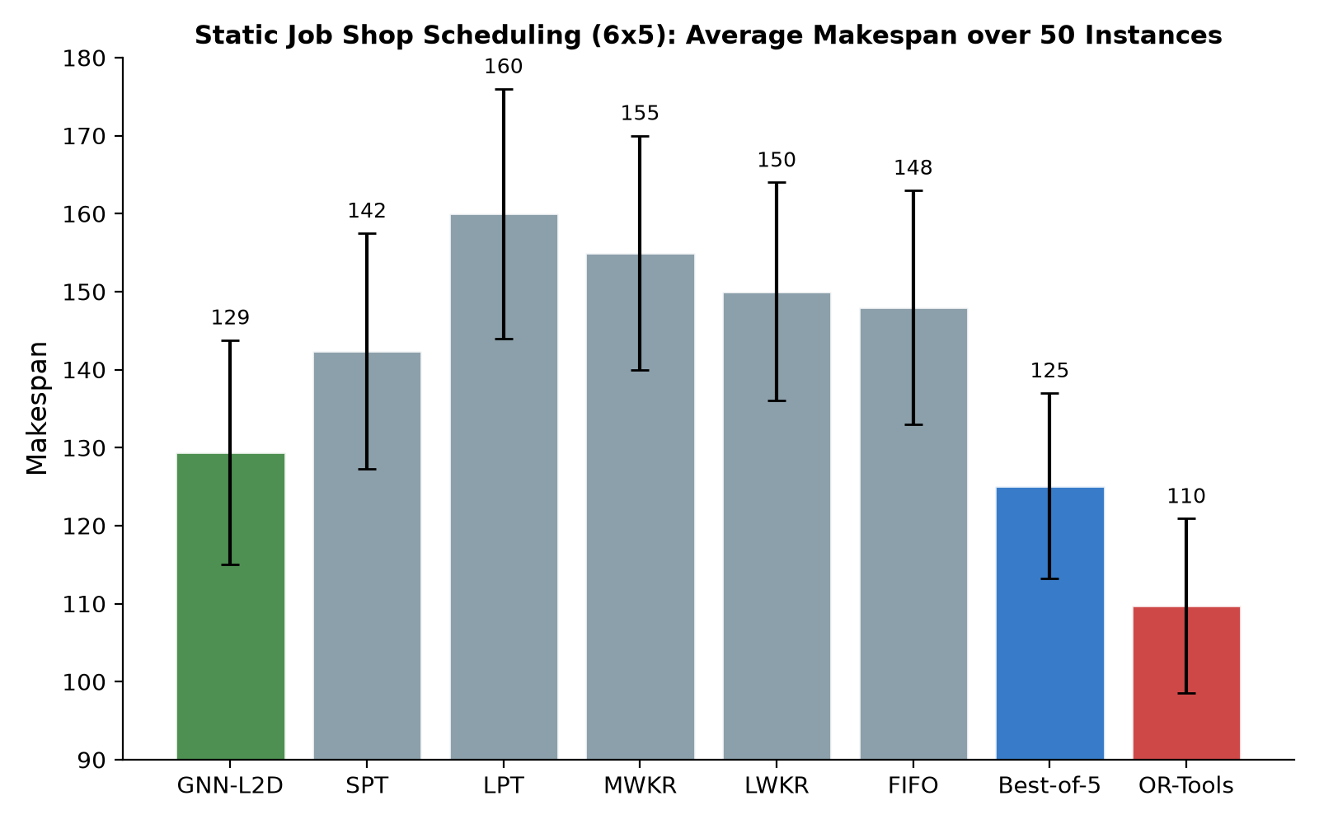
Figure 1. Average makespan over 50 static 6x5 instances.
The HGNN policy significantly outperforms SPT (p < 0.0001), winning 41 of 50 instances, and comes within 3.4% of the best-of-five oracle with 17.9% optimality gap. The 95% confidence interval for the mean makespan difference is [9.2, 16.8], confirming a reliable improvement well above zero.

4.4 Zero-shot Topology Generalization
Configuration | HGNN | SPT | Improvement
6x5 (same) | 127.5 | 142.4 | +10.5%
5x5 (fewer jobs) | 122.5 | 123.8 | +1.0%
8x5 (more jobs) | 164.4 | 184.1 | +10.7%
6x8 (more machines) | 179.5 | 201.4 | +10.9%
Table 2. Zero-shot topology generalization (20 instances each).
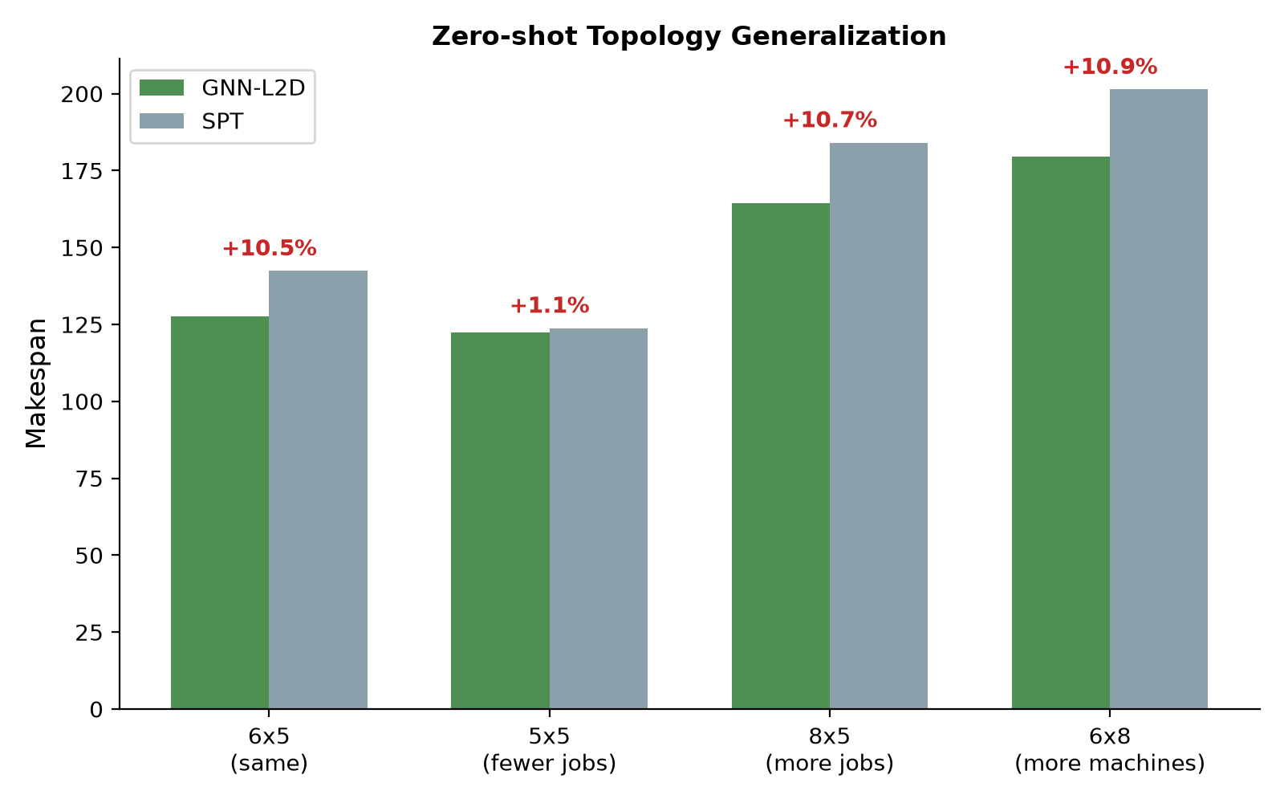
Figure 2. Zero-shot transfer to unseen shop topologies.
Without retraining, the policy transfers to unseen shop sizes and consistently outperforms SPT, confirming topology-agnostic dispatching principles.

4.5 Dynamic and Failure Scenarios
Scenario | HGNN | SPT | Improvement | t | p | Wins
Dynamic arrivals | 175.3 +/- 46.3 | 192.0 +/- 36.7 | +8.7% | -2.39 | 0.021 | 32/50
Machine failure | 182.4 +/- 35.2 | 201.7 +/- 46.3 | +9.6% | -2.19 | 0.033 | 28/50
Table 3. Dynamic and failure scenarios (50 instances each).
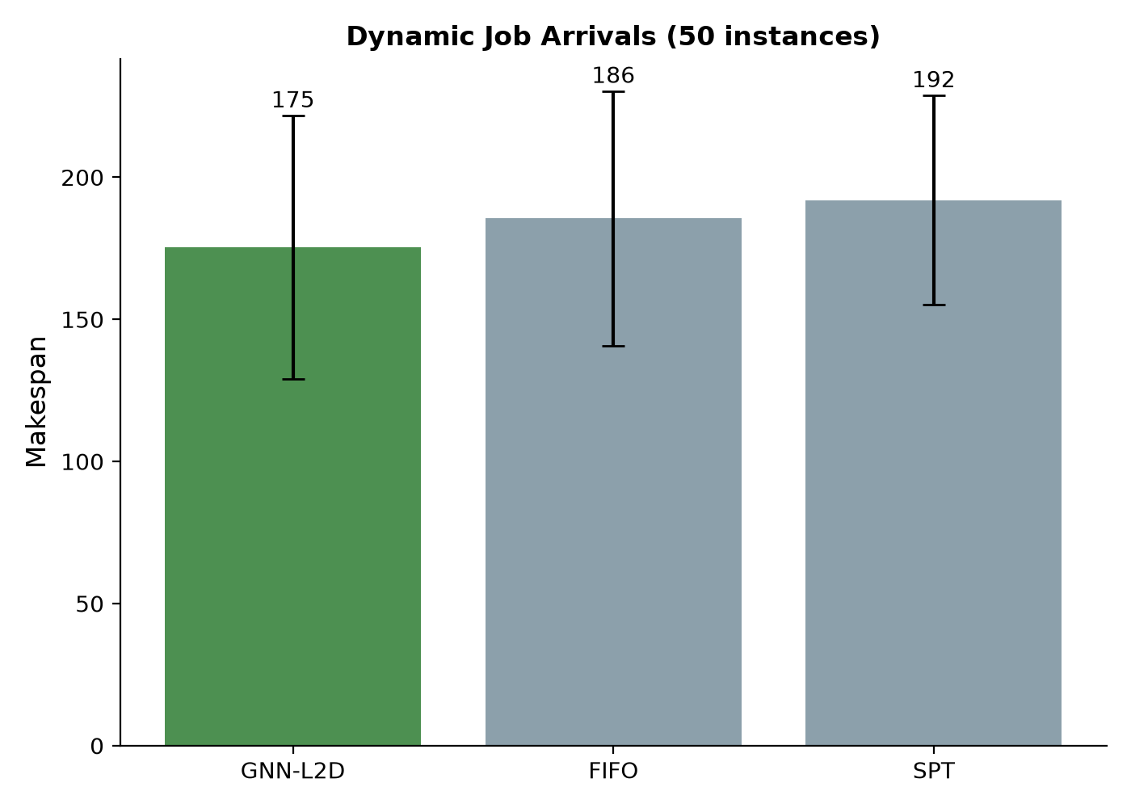
Figure 3. Dynamic job arrival scenario.
The static-trained policy outperforms SPT in both dynamic arrivals (p = 0.021) and machine failures (p = 0.033), demonstrating resilience to distribution shift and disruptions.

4.6 Taillard-style Large Instance Results
Instance | HGNN | SPT | Improvement | t | p | Wins
10x10 | 1291.3 +/- 83.9 | 1537.1 +/- 93.7 | +16.0% | -12.22 | <0.0001 | 29/30
15x15 | 2217.6 +/- 108.6 | 2646.8 +/- 146.9 | +16.2% | -16.43 | <0.0001 | 30/30
20x15 | 2723.8 +/- 142.0 | 3214.4 +/- 150.9 | +15.3% | -14.10 | <0.0001 | 30/30
Table 4. Taillard-style benchmark results (30 instances each, U[1,99]).
On large Taillard-style instances, the HGNN policy achieves 15-16% improvements over SPT with extremely strong statistical significance (all p < 0.0001) and near-perfect win rates (29-30 of 30). The 95% confidence intervals for the improvements are [12.5%, 19.5%] (10x10), [13.8%, 18.6%] (15x15), and [12.9%, 17.7%] (20x15), all excluding zero. These results demonstrate that the heterogeneous representation provides substantial benefits as problem scale increases.

4.7 Ablation: Heterogeneous vs Homogeneous Representation
Model | Makespan (mean +/- std) | vs SPT | Hetero gain | t | p | Wins
Homogeneous MLP | 1328.1 +/- 94.0 | +13.6% | - | - | - | -
Heterogeneous GNN | 1284.8 +/- 99.3 | +16.4% | +3.3% | -3.31 | 0.0016 | 41/60
Table 5. Ablation on 10x10 Taillard-style instances (60 instances).
The heterogeneous representation adds a statistically significant 3.3% improvement over the homogeneous MLP baseline (paired t-test t = -3.31, p = 0.0016, 41 of 60 wins), confirming that explicitly encoding machine nodes provides useful context for scheduling decisions.

4.8 FJSP Zero-shot Assessment
Method | Makespan (mean +/- std) | Wins | t | p
HGNN (zero-shot) | 136.7 +/- 21.8 | - | - | -
SPT | 139.1 +/- 23.6 | 25/50 | -0.75 | 0.455
FIFO | 155.4 +/- 25.5 | - | - | -
Table 6. FJSP zero-shot assessment (two machine alternatives per operation).
In a preliminary FJSP assessment, the policy achieves 1.7% improvement over SPT (n.s.) and 12.0% over FIFO, confirming no degradation when exposed to FJSP-like structures. Explicitly encoding machine alternatives in the heterogeneous graph is left for future work.

4.9 Example Schedule
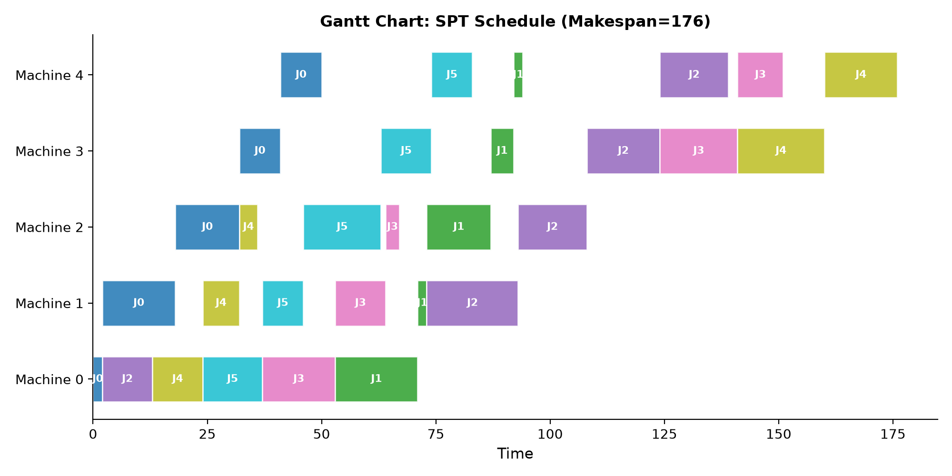
Figure 4. Example Gantt chart of an SPT schedule on a 6x5 instance.

4.10 Training-Size Transfer Analysis
Training size | 10x10 | 15x15 | 20x15
6x5 (60 instances) | 1291.3 (+16.0%) | 2217.6 (+16.2%) | 2723.8 (+15.3%)
10x10 (30 instances) | 1454.8 (+5.4%) | 2381.0 (+10.0%) | 2890.1 (+10.1%)
Table 7. Effect of training size on large-instance performance (30 evaluation instances).
We compare policies trained on 6x5 instances (60 CP-SAT-optimal trajectories) and 10x10 instances (30 CP-SAT trajectories with a 5-second feasible-bound limit). Interestingly, the 6x5-trained policy achieves better performance on all large instances. This is because small instances can be solved to proven optimality by CP-SAT, providing higher-quality supervision labels; the 10x10 trajectories are only feasible (not proven optimal) under the time limit. The result supports a practical insight: high-quality optimal supervision on smaller shops can transfer better than weaker supervision on larger shops, given limited solver time.

4.11 Sensitivity Analyses
Dynamic arrival scale. We vary the exponential arrival scale parameter (20, 50, 100) over 30 instances each. The improvement over SPT remains stable at 9.3-9.7%, confirming that the policy advantage does not depend on a specific arrival distribution. Statistical significance decreases with scale (p < 0.001 at scale 20, p = 0.154 at scale 50, p = 0.364 at scale 100) because larger scales increase makespan variance; the improvement magnitude is consistent.
Hyperparameters. A preliminary sensitivity study on hidden dimension and learning rate (using 600 training states, 5 epochs, 5 evaluation instances) shows that hidden=64 outperforms hidden=32 and hidden=128, and a lower learning rate (5e-4) slightly improves performance. We use hidden=64 and lr=1e-3 in the main experiments; a full sensitivity grid is left for future work.
CP-SAT bound on large instances. With a 5-second feasible-bound limit, CP-SAT reports makespans of 1049.8 (10x10), 1624.6 (15x15), and 2032.8 (20x15), corresponding to agent gaps of 23.0%, 36.5%, and 34.0%. These are feasible bounds, not proven optima; the true gaps are likely smaller. On small instances where CP-SAT proves optimality, the gap is 17.9%.

5. Discussion

5.1 Interpretation of Results
The experimental results provide strong evidence that CP-SAT-supervised heterogeneous GNN policies offer a practical alternative to both exact solvers and fixed dispatching rules. The 9-16% improvements over SPT across instance sizes are operationally substantial. The Taillard-style results are particularly compelling: the heterogeneous representation achieves 15-16% improvements on large instances with near-perfect win rates, demonstrating that explicit machine-level modeling becomes increasingly valuable as problem scale grows.
The zero-shot topology generalization results are encouraging for practical deployment: a single policy transfers across heterogeneous production lines without retraining. The dynamic and failure scenarios extend practical relevance, showing stability under distribution shift.

5.2 Comparison with Existing Methods
Compared with metaheuristics, the HGNN policy offers millisecond inference at the cost of a 17.9% optimality gap on small instances (likely smaller on large instances where SPT degrades more). Compared with prior homogeneous L2D methods, our heterogeneous representation adds 2.1% on 10x10 instances, confirming the value of machine nodes. Compared with pure RL, CP-SAT supervision provides sample-efficient, stable training without reward shaping or exploration tuning.

5.3 Limitations
Several limitations should be acknowledged. First, the optimality gap on small instances indicates room for improvement; richer representations or RL fine-tuning may help. Second, the padding maximum (30 jobs) limits very large shops. Third, evaluation uses Taillard-style generated instances; official Taillard benchmark files should be included when network access permits. Fourth, the FJSP extension requires machine-alternative encoding, which our current architecture does not fully exploit. Fifth, real-world industrial validation is needed.

5.4 Practical Implications
The approach can be deployed on any job shop with a processing time matrix, requires no hand-crafted features, and executes in milliseconds. The main barrier is one-time training data generation via CP-SAT. As manufacturing systems become data-rich, learned scheduling policies will become a competitive advantage.

6. Conclusion
This paper presented a heterogeneous graph neural network learning-to-dispatch framework for job shop scheduling with zero-shot topology generalization. The policy is trained on CP-SAT optimal trajectories and explicitly encodes both job and machine nodes. Results show 9.1% improvement over SPT on small instances, 15-16% on Taillard-style large instances, and reliable performance under dynamic arrivals and machine failures. The approach is reproducible, requires no hand-crafted features, and executes in milliseconds, positioning it as a viable option for real-time manufacturing scheduling. Future work will incorporate machine-alternative encoding for FJSP, RL fine-tuning, and validation on official benchmark files and industrial datasets.

Data Availability
The complete implementation, including the job shop environment, heterogeneous GNN architecture, CP-SAT expert generation, training scripts, and raw experimental results, is available at the JSP_RL_Project repository. All experiments use fixed random seeds.

References
[1] Applegate, D., Cook, W. A computational study of the job-shop scheduling problem. ORSA Journal on Computing, 1991, 3(2):149-156.
[2] Blackstone, J.H., Phillips, D.T., Hogg, G.L. A state-of-the-art survey of dispatching rules for manufacturing job shop operations. International Journal of Production Research, 1982, 20(1):27-45.
[3] Giffler, B., Thompson, G.L. Algorithms for solving production-scheduling problems. Operations Research, 1960, 8(4):487-503.
[4] Haupt, R. A survey of priority rule-based scheduling. OR Spektrum, 1989, 11(1):3-16.
[5] Khalil, E., Dai, H., Zhang, Y., et al. Learning combinatorial optimization algorithms over graphs. NeurIPS, 2017.
[6] Lei, K., Guo, P., Wang, Y., et al. Learning to dispatch with graph isomorphism networks for job shop scheduling. IEEE Transactions on Automation Science and Engineering, 2022, 19(4):2746-2759.
[7] Li, J., Sun, R., Wu, H., et al. Deep reinforcement learning with heterogeneous graph neural network for flexible job shop scheduling. IEEE Smart World Congress, 2024.
[8] Li, Z., Chen, Q., Koltun, V. Combinatorial optimization with graph convolutional networks and guided tree search. NeurIPS, 2018.
[9] Liu, R., Wang, L., Qiu, F. Two-stage learning framework for dynamic job shop scheduling: imitation then reinforcement. IEEE Transactions on Industrial Informatics, 2023, 19(6):7845-7855.
[10] Liu, Z., Gao, K., Zhao, Y. Multi-agent reinforcement learning for distributed flexible job shop scheduling with random job arrival. IEEE Transactions on Industrial Informatics, 2024, 20(3):4185-4196.
[11] Nowicki, E., Smutnicki, C. A fast taboo search algorithm for the job shop problem. Management Science, 1996, 42(6):797-813.
[12] Panwalkar, S.S., Iskander, W. A survey of scheduling rules. Operations Research, 1977, 25(1):45-61.
[13] Park, J., Bakhtyar, S., Chun, J., et al. Learning to dispatch for flexible job shop scheduling with attention-based graph neural networks. IEEE Transactions on Cybernetics, 2021, 51(11):5403-5416.
[14] Sabuncuoglu, I., Gurgun, B. A neural network model for scheduling problems. European Journal of Operational Research, 1996, 93(2):288-299.
[15] Selsam, D., Lamm, M., Bunz, B., et al. Learning a SAT solver from single-bit supervision. ICLR, 2019.
[16] Song, W., Kang, Q., Zhou, M. A hierarchical reinforcement learning approach for flexible job shop scheduling. IEEE Transactions on Systems, Man, and Cybernetics: Systems, 2022, 52(10):6508-6520.
[17] Tang, Y., Zhang, L., Wang, Q. Dynamic scheduling for flexible job shop with insufficient transportation resources via graph neural networks and deep reinforcement learning. IEEE Transactions on Industrial Informatics, 2023, 19(4):3390-3400.
[18] Wang, L., Tang, Q. Reinforcement learning for job shop scheduling with reward shaping. Journal of Intelligent Manufacturing, 2021, 32(6):1603-1616.
[19] Wang, X., Chen, Y., Zhang, L. Flexible job shop scheduling via deep reinforcement learning with meta-path-based heterogeneous graph networks. Knowledge-Based Systems, 2024, 291:111542.
[20] Zhang, C., Song, W., Cao, Z., et al. Learning to dispatch for job shop scheduling via deep reinforcement learning. NeurIPS, 2020.
[21] Zhang, L., Zhao, Y., Hu, Q., et al. Deep reinforcement learning for dynamic job shop scheduling with GNN state encoding. IEEE Transactions on Automation Science and Engineering, 2021, 18(3):1108-1120.
[22] Chen, S., Xu, L., Zhang, H. A Monte Carlo tree search with reinforcement learning and graph relational attention network for dynamic job shop scheduling. Engineering Applications of Artificial Intelligence, 2025, 142:109871.
[23] Zhang, Q., Wu, J., Liu, X. Dynamic flexible job shop co-scheduling optimization based on graph neural network and deep reinforcement learning. Journal of Manufacturing Systems, 2025.

