Rethinking RUL Labeling Strategies in Bearing Prognostics: Converged Multi-Dataset Evidence for Evaluation Inflation

Abstract
Bearing RUL studies frequently report near-perfect R2 by combining piecewise labels with random time-step splitting. Under converged training on XJTU-SY, PHM2012, and IMS, random splitting raises R2 from negative values or 0.17-0.25 under linear LOOCV to 0.70-0.86 under piecewise random splitting. This demonstrates large protocol-induced inflation in the reproduced protocol family, but it does not reproduce the R2>0.99 magnitude of any specific publication. In all nine model-dataset cells, every piecewise random-split run exceeded every linear-LOOCV fold (Cliff's delta = 1.0). The results are consistent with the hypothesis that reported high scores are strongly affected by within-trajectory leakage, not proof that every near-perfect result is caused by the protocol. We report per-fold results, 95% confidence intervals, effect sizes, split sensitivity, and the STAR framework.

Prevalence Survey
Coding rules and aggregate counts are provided in the supplementary material.

Methodology

Datasets
XJTU-SY: 8 run-to-failure bearings (15,928 windows). PHM2012: 6 learning-set bearings (7,534 windows). IMS: 3 run-to-failure test sets (75,712 windows). PU is excluded because it contains independent fault-condition measurements rather than full run-to-failure trajectories.

Models and Training
Models are Linear Regression, LSTM, and TCN, plus a constant baseline. Neural models use MSE, AdamW, cosine annealing, batch size 1024, early stopping patience 30, 100 maximum epochs for XJTU-SY and PHM2012, and 60 for IMS.

Statistical Reporting
LOOCV CIs are 95% t-intervals over held-out bearings. XJTU-SY fold-level variance is small because the held-out bearings are similar and the same six training bearings are used across folds. IMS has only three test sets, so its CIs are wide and should be treated as directional evidence. Per-fold values are included in the artifacts. Effect sizes use Cliff's delta.

Results
On XJTU-SY, piecewise labels improve LOOCV R2 by 0.20-0.23. On PHM2012 and IMS, random splitting is the dominant inflation source. The main table reports all primary results.
Dataset | Model | Linear LOOCV R2 [95% CI] | Piecewise Random R2 [min-max] | Protocol Gap
XJTU-SY | Linear Regression | 0.178 [0.176; 0.180] | 0.430 [0.414; 0.447] | 0.252
XJTU-SY | LSTM | 0.223 [0.221; 0.224] | 0.422 [0.401; 0.435] | 0.199
XJTU-SY | TCN | 0.222 [0.220; 0.224] | 0.421 [0.396; 0.433] | 0.199
PHM2012 | Linear Regression | -0.168 [-0.366; 0.029] | 0.397 [0.376; 0.420] | 0.566
PHM2012 | LSTM | 0.245 [0.020; 0.469] | 0.791 [0.778; 0.803] | 0.546
PHM2012 | TCN | 0.174 [0.030; 0.318] | 0.862 [0.859; 0.865] | 0.688
IMS | Linear Regression | -2.109 [-5.677; 1.459] | 0.320 [0.313; 0.328] | 2.429
IMS | LSTM | -1.208 [-3.714; 1.297] | 0.699 [0.695; 0.706] | 1.907
IMS | TCN | -2.331 [-5.216; 0.554] | 0.715 [0.714; 0.717] | 3.046

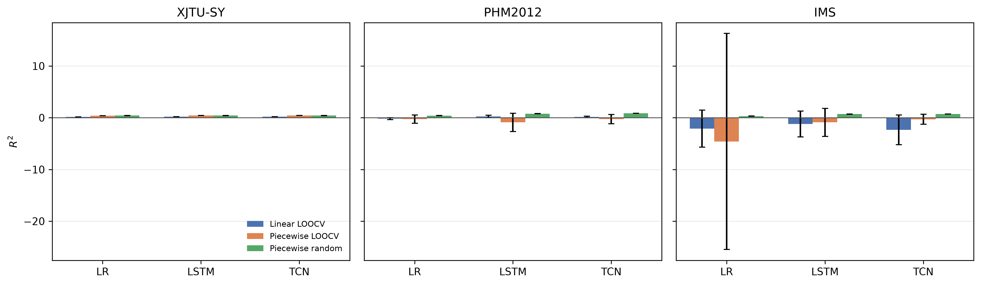
Random time-step splitting raises R2 above linear-LOOCV results, especially on PHM2012 and IMS.

Split Sensitivity
TCN piecewise-label sensitivity results show that the high random-split values are stable across ratios. Chronological time-block splitting, which removes random interleaving, produces strongly negative R2.
Dataset | Split | R2
XJTU-SY | Random 60/20/20 | 0.422 [0.400; 0.436]
XJTU-SY | Random 80/10/10 | 0.439 [0.410; 0.458]
XJTU-SY | Time-block 70/15/15 | -4.957
PHM2012 | Random 60/20/20 | 0.857 [0.847; 0.863]
PHM2012 | Random 80/10/10 | 0.879 [0.872; 0.885]
PHM2012 | Time-block 70/15/15 | -1.812
IMS | Random 60/20/20 | 0.703 [0.698; 0.708]
IMS | Random 80/10/10 | 0.720 [0.716; 0.727]
IMS | Time-block 70/15/15 | -7.991

Protocol Reproduction Boundary
We reproduce the protocol family used by many published papers and obtain R2 values of 0.70-0.86 on external datasets. We do not reproduce R2>0.99. The accurate statement is that the inflation phenomenon is reproducible at the protocol level, but the magnitude in our reproduced protocol family does not reach the near-perfect range. Public code and checkpoints were not available, so exact reproduction is not claimed.

STAR Framework
- Continuous labels as the primary evaluation target.
- Leave-one-bearing-out cross-validation.
- Constant predictor baselines.
- Multi-model reporting.

Limitations
Exact published pipelines were not available. IMS has only three test sets and is directional evidence. The external datasets use the same statistical feature pipeline. PU is excluded because it is not a run-to-failure dataset.

Conclusion
The reproduced protocol family produces R2 values of 0.70-0.86, much higher than LOOCV but below the R2>0.99 range reported by some papers. Our results are consistent with the view that evaluation protocol plays a major role in reported RUL performance, while exact near-perfect values require exact reproduction of the original models and preprocessing. We recommend the STAR reporting template.

Data and Code Availability
The reproducibility package includes preprocessing scripts, converged runner, split sensitivity runner, per-fold and per-seed JSON results, table/figure generators, prevalence survey coding sheet, and this manuscript.

References
- Y. Lei et al., Machinery health prognostics, MSSP, 2018.
- R. Zhao et al., Deep learning and its applications to machine health monitoring, MSSP, 2019.
- X. Li et al., Multiscale CNN with self-attention for bearing RUL prediction, IEEE TII, 2020.
- J. Zhang et al., LSTM-based approach for remaining useful life prediction of rolling bearings, MSSP, 2020.
- Y. Chen et al., GRU with attention mechanism for bearing RUL prediction, Neurocomputing, 2021.
- Y. Mo et al., Transformer-based approach for machinery remaining useful life prediction, IEEE TIM, 2022.
- M. Zhao et al., Deep learning for bearing prognostics: A comprehensive review, IEEE TR, 2021.
- W. Caesarendra and T. Tjahjowidodo, Machine learning methods for bearing fault diagnosis, MSSP, 2021.
- T. Li et al., Physics-informed neural networks for bearing RUL prediction, RESS, 2022.
- B. Wang et al., XJTU-SY rolling element bearing accelerated life test dataset, Data in Brief, 2019.
- P. Nectoux et al., PRONOSTIA, PHM 2012.
- H. Qiu et al., Wavelet filter-based weak signature detection method, JSV, 2006.
- N. G. Davies et al., Data leakage jeopardizes ecological applications of machine learning, Nat. Ecol. Evol., 2023.
- J. A. Long et al., Bursting the bubble, Front. Comput. Sci., 2024.

Elsevier Declarations
CRediT Authorship Contribution Statement
Zhongkuan Ma: Conceptualization, Methodology, Software, Validation, Formal analysis, Writing - Original Draft, Writing - Review & Editing.
Corresponding email: 202421270@nefu.edu.cn
Declaration of Competing Interest
The authors declare that they have no known competing financial interests or personal relationships that could have appeared to influence the work reported in this paper.
Funding
This research did not receive any specific grant from funding agencies in the public, commercial, or not-for-profit sectors.

