Keysight Technologies

Using VISA COM I/O API in .NET

Application Note

Introduction

## .NET and Test & Measurement I/O

The Microsoft .NET architecture, with its C# and Visual Basic

programming languages and the Microsoft Visual Studio development environment, has many features that make it an excellent environment for Test & Measurement programmers. There is only one problem: doing actual instrument communication. Keysight Technologies, Inc. has released the T&M Toolkit, which provides services, applications, and API’s to make instrument programming natural and simple in Visual Studio environments ([www.keysight.com/ind/toolkit](http://www.keysight.com/find/toolkit)). While the T&M Toolkit provides a simple, easy-to-use programming environment from Visual Studio, savvy Visual Studio users today can fall back on more basic I/O tools such as VISA COM I/O to get their T&M programming tasks done in .NET environments.

## VISA COM I/O and .NET

The VISA COM I/O API is a programming interface standardized by the IVI Foundation for communicating with instruments over GPIB, LAN, USB, RS-232, or other hard- ware interfaces. Keysight Technologies has an implementation of the VISA COM I/O standard that works with Keysight I/O hardware as well as the computer-standard I/O interfaces. VISA COM I/O is an update of the older VISA C API to work in and with Microsoft’s COM technology.

Microsoft has integrated robust support for COM components in the .NET environ- ment. The COM interfaces tend to translate well into .NET equivalents via automated wrapper-generator tools that Microsoft provides. Due to this COM support in .NET, many programmers will ind VISA COM to be an excellent choice for instrument com- munication in .NET. This article describes how to use Keysight’s VISA COM I/O imple- mentation with C# and Visual Basic (VB) examples.

# Getting started

The examples in this application note were developed using C# 2003 and Visual Basic 2003 as part of Visual Studio 2003 Professional Edition. We will commonly call them C# and VB throughout this application note. In addition, Keysight IO Libraries Suite 14.2 was used.

First you must install Keysight VISA COM I/O, which is installed as part of the Keysight IO Libraries Suite. You can download the latest version of the IO

Libraries Suite at [www.keysight.com/ind/](http://www.keysight.com/ind/) iolib. After installing the IO Libraries Suite, you are ready to add VISA COM I/O to your C# Microsoft Visual Studio project. To use VISA COM I/O, you need to create a reference to it in your project. To add a COM reference to your project, click the “Solution Explorer” window in your C# project and right-click the “References” menu item.

### The Visual Studio Add Reference dialog

You will see the “Add Reference” dialog. Click on the “COM” tab to look for the VISA COM reference you will need. Select the “VISA COM 3.0 Type Library” reference so that you can instantiate the Keysight VISA COM I/O implementation. The VISA COM 3.0 Type Library also includes the type information for VISA COM I/O.

The Visual Studio environment with the Solution Explorer window

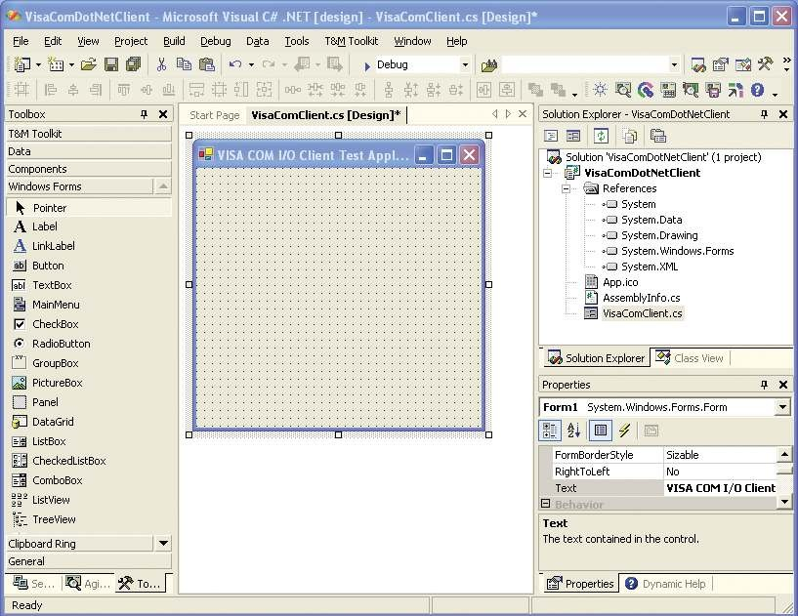

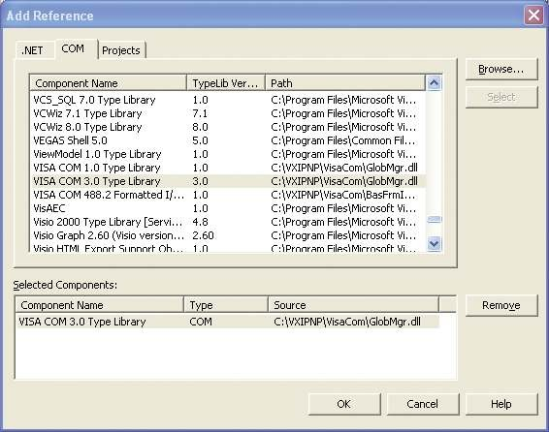The Visual Studio Add Reference dialog

### Get familiar with the Object Browser

Now that you have added the appropriate references into your application, it is

a good time to look at the interfaces and classes available to use. Press CTRL+ALT+J or go to the View menu and select Object Browser to open the Object Browser. This window allows

you to examine the class hierarchies of all the currently referenced COM and .NET projects and libraries. Take a look at Ivi. Visa.Interop to see the classes and interfaces you will be using.

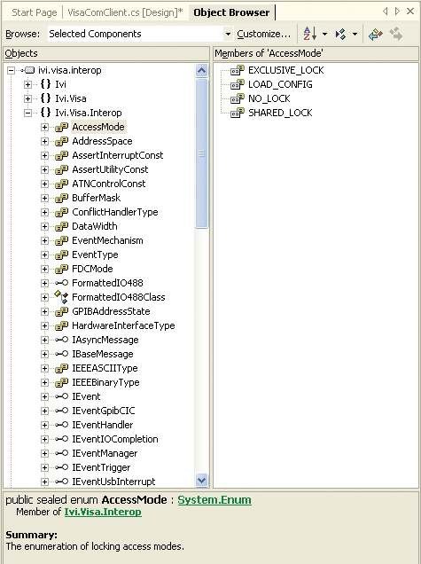The Visual Studio Oject Browser dialog

### Instantiating and using Keysight’s VISA COM I/O in .NET

Once you have your references to VISA COM in your project, you are ready to create and use VISA COM I/O objects. Included is an example of a simple method that creates a resource and uses the VISA COM 488.2 Formatted I/O component

to communicate with a keysight 54501A Oscilloscope. It is shown using both C# and VB.

C#

private void DoInstrumentIO()

{

Ivi.Visa.Interop.ResourceManagerClass rm = new Ivi.Visa.Interop.ResourceManagerClass(); Ivi.Visa.Interop.FormattedIO488Class ioobj = new Ivi.Visa.Interop.FormattedIO488Class();

try

{

object[] idnItems;

ioobj.IO = (Ivi.Visa.Interop.IMessage) rm.Open(“GPIB2::10::INSTR”, Ivi.Visa.Interop.AccessMode.NO_LOCK, 0, “”);

ioobj.WriteString(“*IDN?”, true);

idnItems = (object[]) ioobj.ReadList(Ivi.Visa.Interop.IEEEASCIIType.ASCIIType_Any, “,”); foreach(object idnItem in idnItems)

{

System.Console.Out.WriteLine(“IDN Item of type “ + idnItem.GetType().ToString()); System.Console.Out.WriteLine(“\tValue of item is “ + idnItem.ToString());

}

}

catch(Exception e)

{

System.Console.Out.WriteLine(“An error occurred: “ + e.Message);

}

finally

{

try{ ioobj.IO.Close(); } catch {}

try{ System.Runtime.InteropServices.Marshal.ReleaseComObject(ioobj);

}

catch {}

try{ System.Runtime.InteropServices.Marshal.ReleaseComObject(rm);

}

catch {}

}

}

VB

Private Sub DoInstrumentIO()

Dim rm As Ivi.Visa.Interop.ResourceManagerClass Dim ioobj As Ivi.Visa.Interop.FormattedIO488Class

Dim idnItem As Object Dim idnItems As Object()

Try

rm = New Ivi.Visa.Interop.ResourceManagerClass ioobj = New Ivi.Visa.Interop.FormattedIO488Class

ioobj.IO = rm.Open(“GPIB2::10::INSTR”)

ioobj.WriteString(“*IDN?”, True)

idnItems = ioobj.ReadList(Ivi.Visa.Interop.IEEEASCIIType.ASCIIType_Any, “,”) For Each idnItem In idnItems

MsgBox(“IDN Item of type “ + idnItem.GetType().ToString()) MsgBox(“Value of item is “ + idnItem.ToString())

Next idnItem Catch e As Exception

MsgBox(“An error occurred: “ + e.Message) Finally

Try

ioobj.IO.Close() Catch ex As Exception End Try

Try

System.Runtime.InteropServices.Marshal.ReleaseComObject(ioobj) Catch ex As Exception

End Try

Try

System.Runtime.InteropServices.Marshal.ReleaseComObject(rm) Catch ex As Exception

End Try End Try

End Sub

### Using Keysight VISA COM I/O in Microsoft Visual Studio

The line Ivi.Visa.Interop. ResourceManagerClass rm

= newIvi.Visa.Interop ResourceManagerClass() creates the Global Resource Manager (GRM), which can instantiate (create) any VISA COM resource installed on the system. Here you see it used to open a GPIB resource at “GPIB2::10::INSTR”. The line Ivi.Visa. Interop.FormattedIO488Class ioobj = new Ivi.Visa. Interop.

FormattedIO488Class() creates an instance of the 488.2 Formatted I/O Class, which can help with parsing and writing out the data types most instruments use. Setting the IO property of the formatted I/O object prepares the object for reading and writing.

You may notice a few differences between C# and VB. These differences in large part mirror the differences between Microsoft Visual C++ 6 and Microsoft Visual Basic

6. Aside from the obvious syntactic differences there is a capability difference in how you can use VISA COM I/O. The optional parameters on the Open() method in VB are not optional in C#, and optional parameters in general are lost

in C#.

After creating the VISA COM I/O objects to be used, you see a call to WriteString(). This call sends the

“*IDN?” string to the instrument. The next line uses the ReadList() method to parse the *IDN?” return value. The method returns an object, which you can cast to an array based on the type parameter

of the ReadList() Method. With type ASCIIType_Any, the return value is an array of objects.

The code in the Finally block is designed to clean up the I/O to be sure that the I/O session is closed immediately, all

hardware I/O resources are released, and any valid COM objects are released. In COM environments like Visual C++, it was possible to destroy objects by removing the last reference to them, but in the .NET environment, you must explicitly close

the session. Call the Close() method on the Keysight VISA COM Formatted I/O

session to cause the session to release any hardware I/O resources.

# Advanced VISA COM I/O operations in .NET

One of the design goals of Microsoft’s COM technology was to try to simplify threading for typical COM programmers. They used the concept of Apartments, where certain threading behaviors were guaranteed so as to limit the possible multithreading interaction the programmer would have to defend against. Perversely, this made thread programming signiicantly more dificult in some cases. Microsoft’s

.NET architecture has placed themulti- threading burden back on the program- mer, and there are some interactions that must be guarded against when dealing with possible multithreaded situations during VISA COM I/O programming.

The programmer must worry about VISA COM I/O and threading when VISA events are used to communicate with a device. This can take the form of asynchronous I/O, handling service requests, and

other VISA events. The following code demonstrates handing an SRQ event on a keysight 34401A multimeter. Only the VB version is included for brevity.

VB

Public Class Form1

Inherits System.Windows.Forms.Form Implements Ivi.Visa.Interop.IEventHandler

‘. . . (extra VB stuff omitted)

Dim rm As Ivi.Visa.Interop.ResourceManagerClass Dim msg As Ivi.Visa.Interop.IMessage

Delegate Sub t_srqEvent(ByVal man As Ivi.Visa.Interop.IEventManager, _ ByVal evnt As Ivi.Visa.Interop.IEvent)

Public Sub SrqEvent(ByVal man As Ivi.Visa.Interop.IEventManager, _ ByVal evnt As Ivi.Visa.Interop.IEvent)

Try

man.Close() evnt.Close()

System.Runtime.InteropServices.Marshal.ReleaseComObject(rm) Catch

End Try

MsgBox(“SRQ Occurred!”, MsgBoxStyle.OKOnly, “SRQ Event”) End Sub

Private Sub DoAdvancedIO()

rm = New Ivi.Visa.Interop.ResourceManagerClass msg = rm.Open(“GPIB1::22::INSTR”)

DoGenerateSRQ(msg) End Sub

Public Sub DoGenerateSRQ(ByVal msg As Ivi.Visa.Interop.IMessage)

Dim eventman As Ivi.Visa.Interop.IEventManager eventman = msg

‘ Reset dmm and clear DMM status registers msg.WriteString(“*RST;*CLS” & vbLf)

System.Threading.Thread.Sleep(500)

eventman.InstallHandler(Ivi.Visa.Interop.EventType.EVENT_SERVICE_REQ, Me, 1000) eventman.EnableEvent(Ivi.Visa.Interop.EventType.EVENT_SERVICE_REQ, _

Ivi.Visa.Interop.EventMechanism.EVENT_HNDLR)

‘ Enable ‘operation complete bit’ to set ‘standard event’ bit in status byte msg.WriteString(“*ESE 1” & vbLf)

System.Threading.Thread.Sleep(500)

‘ Enable ‘standard event’ bit in status byte to pull the IEEE-488 SRQ line msg.WriteString(“*SRE 32” & vbLf)

System.Threading.Thread.Sleep(500)

‘ Assure synchronization msg.WriteString(“*OPC?” & vbLf)

System.Threading.Thread.Sleep(500)

‘ recieve *OPC? result msg.ReadString(1000)

‘ set dmm to 10 volt dc range msg.WriteString(“Configure:Voltage:dc 10” & vbLf)

‘ set integration time to 10 Power line cycles (PLC)” msg.WriteString(“Voltage:DC:NPLC 10” & vbLf)

System.Threading.Thread.Sleep(500) ‘ set dmm to accept 1 trigger

msg.WriteString(“Trigger:count 1” & vbLf)

System.Threading.Thread.Sleep(500)

‘ Place dmm in ‘wait-for-trigger’ state msg.WriteString(“Init” & vbLf)

System.Threading.Thread.Sleep(500)

‘ Set ‘operation complete’ bit in standard event registers when measurement is complete msg.WriteString(“*OPC” & vbLf)

End Sub

Public Sub HandleEvent(ByVal man As Ivi.Visa.Interop.IEventManager, _

ByVal evnt As Ivi.Visa.Interop.IEvent, ByVal unused As Integer) Implements _ Ivi.Visa.Interop.IEventHandler.HandleEvent

Dim args() As Object

‘ the threadsafe Invoke methods are the only safe thing to do in a COM callback args = New Object(1) {man, evnt}

Me.BeginInvoke(New t_srqEvent(AddressOf Me.SrqEvent), args) End Sub

End Class

### Advanced I/O in Microsoft Visual Studio

The DoAdvancedIO() method creates the I/O session and passes it to the DoGenerateSRQ() method, which generates a service request and enables event handling. The VB class Form1 implements the VISA COM I/O interface IEventHandler. This class has one method, HandleEvent(), which is called by VISA COM I/O whenever an event the client is interested in occurs. The InstallHandler() method call informs VISA COM to call the form’s

HandleEvent() method implementation whenever an SRQ event occurs. The EnableEvent() call turns on asynchro- nous handler invocation for SRQ events.

The HandleEvent() method does not have much code in it. This is because when you receive an event from VISA COM I/O, we don’t know what thread it came in on. In VB 6, you could be certain that it was the application’s main thread because VB 6 used apartment threading, guaranteeing a single-threaded environment for COM and VB methods. In an attempt to reduce overhead and complex implementation errors, Microsoft has abandoned this strategy and it is up to the user to recognize that this method call occurs

in an unknown thread context. As a consequence, you must know which .NET methods are thread-speciic and which ones are not, and be aware of your current threading context. Most form methods are thread-speciic, so you must be careful what methods you use.

This diagram shows the thread interaction going on in the sample code above (assuming the application is multi- threaded.)

### VISA COM I/O and VB threading

One of the few safe method calls in such a context is the BeginInvoke() method of the .NET System.Windows.Forms. Control class. This method accepts a

.NET Delegate class, which is a wrapper for a method. We wrap up a method on the form object called SrqEvent() that we want to do useful things on the VB.NET Form class when an event occurs. The BeginInvoke() method then queues up a request on the application’s main thread to call the delegate’s underlying method on the form’s main thread when it is free. As a consequence, you have to make sure that the application’s main thread is active and not occupied in a blocking task. Also, to receive the VISA COM event at all your application cannot be blocking if it is single-threaded. In a console application, this usually means calling Application. DoEvents() occasionally to give queued asynchronous COM events an opportunity to execute on the application’s only thread.

VISA COM I/O and VB threading

**VISA COM I/O**



VISA COM

I/O worker

thread

VB Form1

object main thread

VISA COM

asynchronous event thread

VISA COM

Methods, Write(), Read(), etc.

SrqEvent() via

BeginInvoke()

HandleEvent() VISA

COM I/O callback

**IEventManager:: HandleEvent()**

# Conclusion

VISA COM I/O is a viable method

of programming instruments in Microsoft’s VB and C# languages, which live in the

.NET execution environment. Both tools can quickly import the VISA COM I/O types for use in a relatively straightforward fashion. While the Keysight T&M Toolkit provides the best solution for simple .NET T&M programming tasks, basic and even advanced I/O operations are possible with VISA COM I/O and the Microsoft .NET programming languages.

**VB application**

myKeysight

[www.keysight.com/find/mykeysight](http://www.keysight.com/find/mykeysight)

A personalized view into the information most relevant to you.

[www.lxistandard.org](http://www.lxistandard.org/)

LAN eXtensions for Instruments puts the power of Ethernet and the Web inside your test systems. Keysight is a founding member of the LXI consortium.



Three-Year Warranty [www.keysight.com/find/ThreeYearWarranty](http://www.keysight.com/find/ThreeYearWarranty)



Keysight’s commitment to superior product quality and lower total cost

of ownership. The only test and measurement company with three-year warranty standard on all instruments, worldwide.

Keysight Assurance Plans [www.keysight.com/find/AssurancePlans](http://www.keysight.com/find/AssurancePlans)



Up to five years of protection and no budgetary surprises to ensure your

instruments are operating to specification so you can rely on accurate measurements.

[www.keysight.com/go/quality](http://www.keysight.com/go/quality)

Keysight Technologies, Inc. DEKRA Certified ISO 9001:2008 Quality Management System

Keysight Channel Partners [www.keysight.com/find/channelpartners](http://www.keysight.com/find/channelpartners)

Get the best of both worlds: Keysight’s measurement expertise and

product breadth, combined with channel partner convenience.

For more information on Keysight Technologies’ products, applications or services, please contact your local Keysight office. The complete list is available at: [www.keysight.com/find/contactus](http://www.keysight.com/find/contactus)

Americas

Canada (877) 894 4414

Brazil 55 11 3351 7010

Mexico 001 800 254 2440

United States (800) 829 4444

Asia Paciic

Australia 1 800 629 485

China 800 810 0189

Hong Kong 800 938 693

India 1 800 112 929

Japan 0120 (421) 345

Korea 080 769 0800

Malaysia 1 800 888 848

Singapore 1 800 375 8100

Taiwan 0800 047 866

Other AP Countries (65) 6375 8100

Europe & Middle East

Austria 0800 001122

Belgium 0800 58580

|  |  |
| --- | --- |
| Finland | 0800 523252 |
| France | 0805 980333 |
| Germany | 0800 6270999 |
| Ireland | 1800 832700 |
| Israel | 1 809 343051 |
| Italy | 800 599100 |
| Luxembourg | +32 800 58580 |
| Netherlands | 0800 0233200 |
| Russia | 8800 5009286 |
| Spain | 0800 000154 |
| Sweden | 0200 882255 |
| Switzerland | 0800 805353  Opt. 1 (DE)  Opt. 2 (FR)  Opt. 3 (IT) |
| United Kingdom | 0800 0260637 |

For other unlisted countries: [www.keysight.com/find/contactus](http://www.keysight.com/find/contactus)

(BP-09-04-14)

This information is subject to change without notice.

© Keysight Technologies, 2007 - 2014

Published in USA, July 31, 2014 5989-6338EN

[www.keysight.com](http://www.keysight.com/)