**Week 1 – PrepInsta Top 100 Codes (Python)**

**Day 1 (Monday)**

**1.Print Hello World.**

**Souce code:**

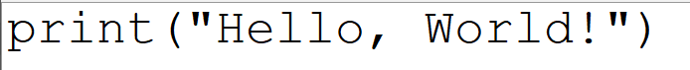 **Output:**

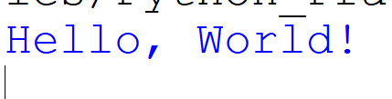

**2. Swap two numbers.**

**Souce code:**

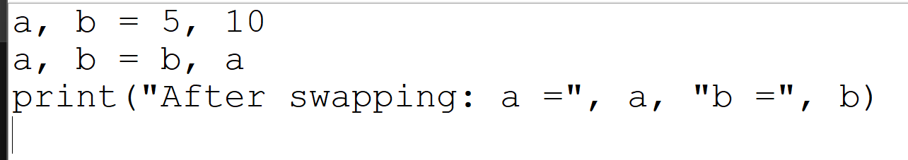

**Output:**



**3.Check whether a number is even or odd.**

**Souce code:**

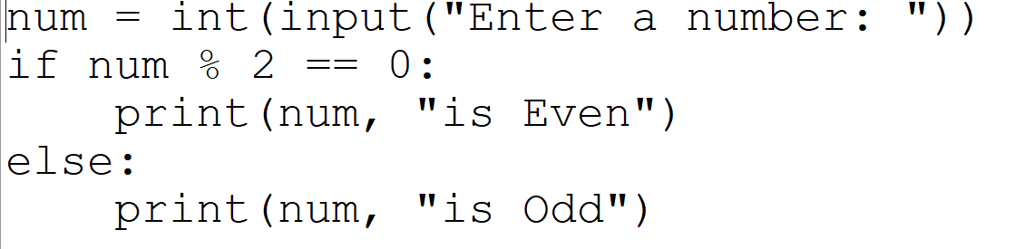

**Output:**

