**Week 1 – PrepInsta Top 100 Codes (Python)**

**Day 2 (Tuesday)**

**4.** **Find the largest of two numbers.**

**Souce code:**

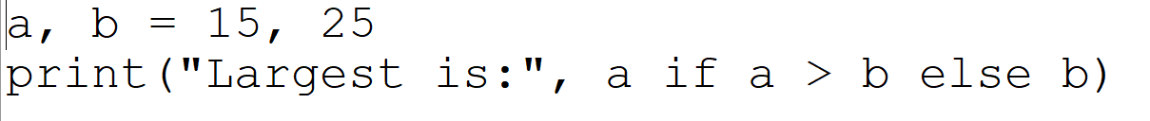

**Output:**



**5.Find the largest of three numbers.**

**Souce code:**

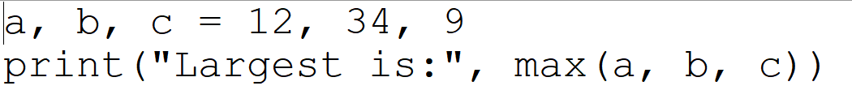

**Output:**

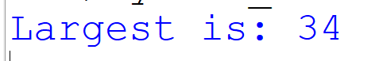

**6.** **Check leap year.**

**Souce code:**

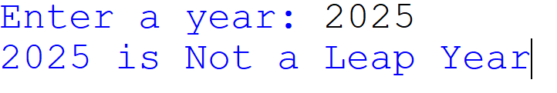

**Output:**

