**Week 1 – PrepInsta Top 100 Codes (Python)**

**Day 2 (Wednesday)**

**7.** **Check prime number.**

**Souce code:**

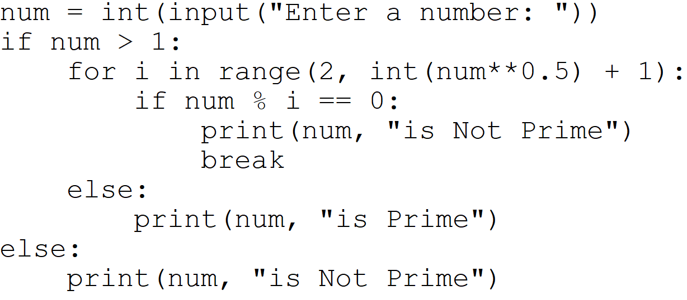

**Output:**

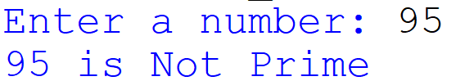

**8.** **Find factorial of a number.**

**Souce code:**

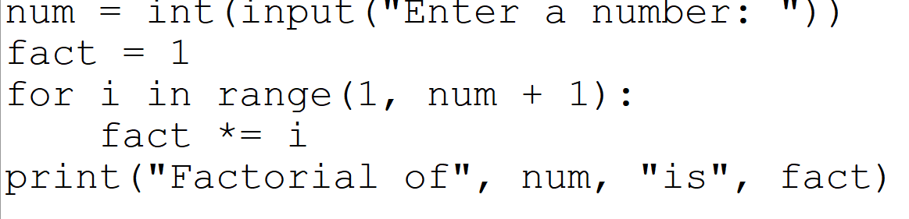

**Output:**

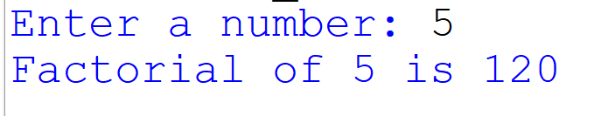

**9.** **Generate Fibonacci series**

**Souce code:**

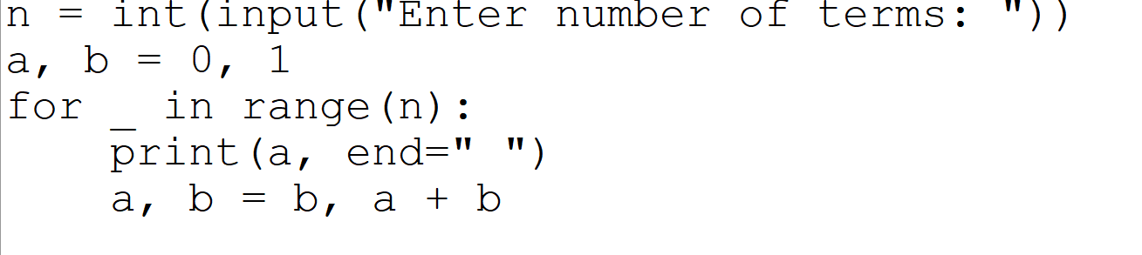

**Output:**

