**Week 1 – PrepInsta Top 100 Codes (Python)**

**Day 5 (Friday)**

**13.** **Armstrong number.**

**Souce code:**

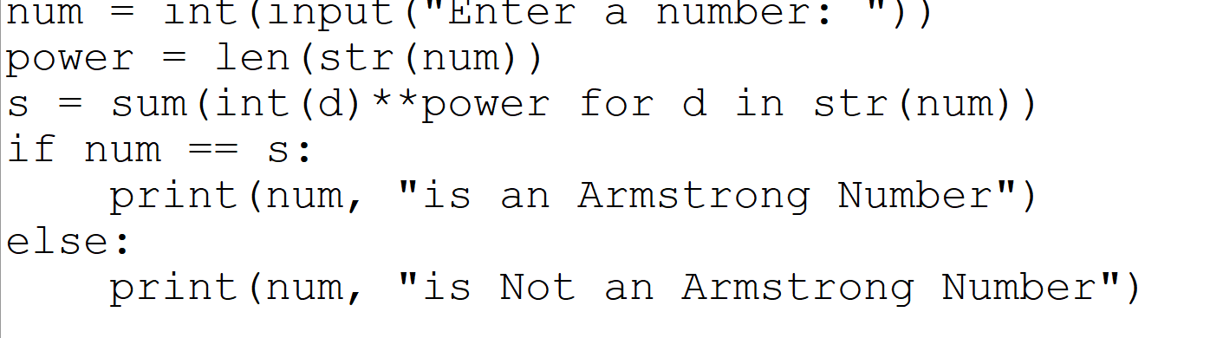

**Output:**

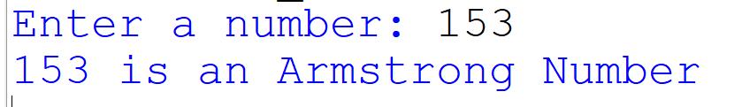

**14.** **Strong number (Sum of factorial of digits = number).**

**Souce code:**

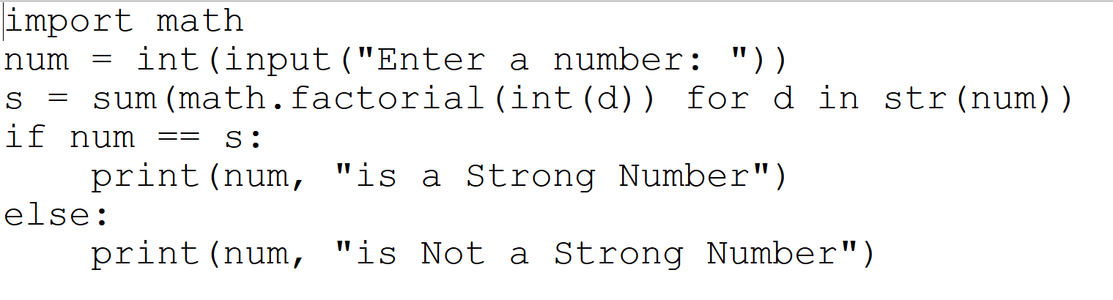

**Output:**

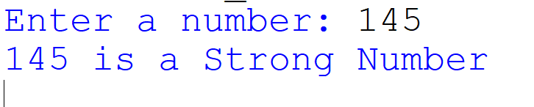

**15.** **Perfect number.**

**Souce code:**

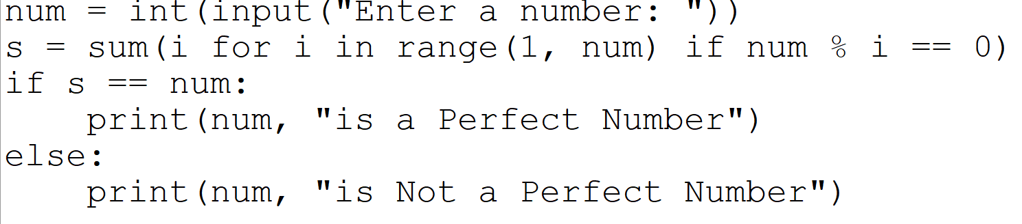

**Output:**

