**Date:** 6thJune2024

**Submitted by:** KorukondaManohar **&** 22KQ1A0751

**Details of Project:** I’m implementing this project by using Python Programming Language.

**Code**

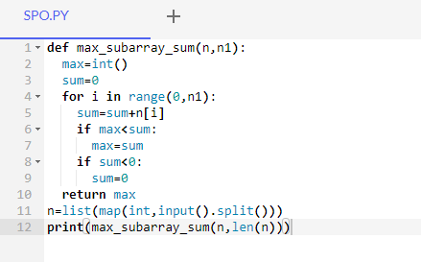

**Input and Output**

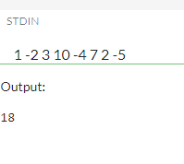

**Explanation:**

The function ‘**max**_**subarray**_**sum**(n,n1)’ is designed to find the maximum sum with a given array n of n1 length.This problem uses the “**Kadane’s** **Algorithm**”.

The function takes the two arguments ‘**n**’ and ‘**n1’**,n represent the number elements in the list and n1 represent length of list.Then initializing variables ‘**max’** and ‘**sum’**.

The ‘**for’** loop iterate over ecah statements and return the max value according to initialization,takes input from user in list format and calls the max_subarray_sum then print result.

**Conclusion:**

The function “max_subarray_sum” uses **kadane’s Algorithm** to find the maximum sum subarray by given list of integers.It over list with help of if loop and return the resultant value then print the result.