**String & Pattern Problems in python**

**1.Reverse a given string without using built-in reverse functions.**

**Source code:**

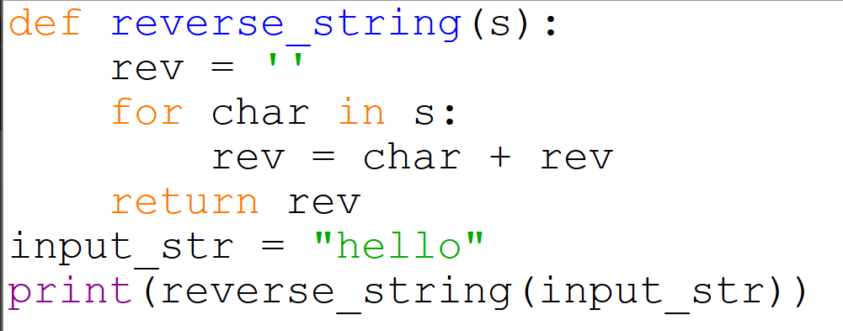

**Output:**

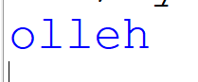

**2.Check if a string is a palindrome.**

**Source code:**

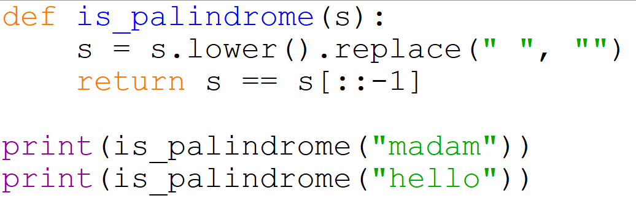

**Output:**

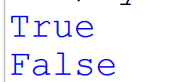

**3. Count the number of vowels and consonants in a string.**

**Source code:**

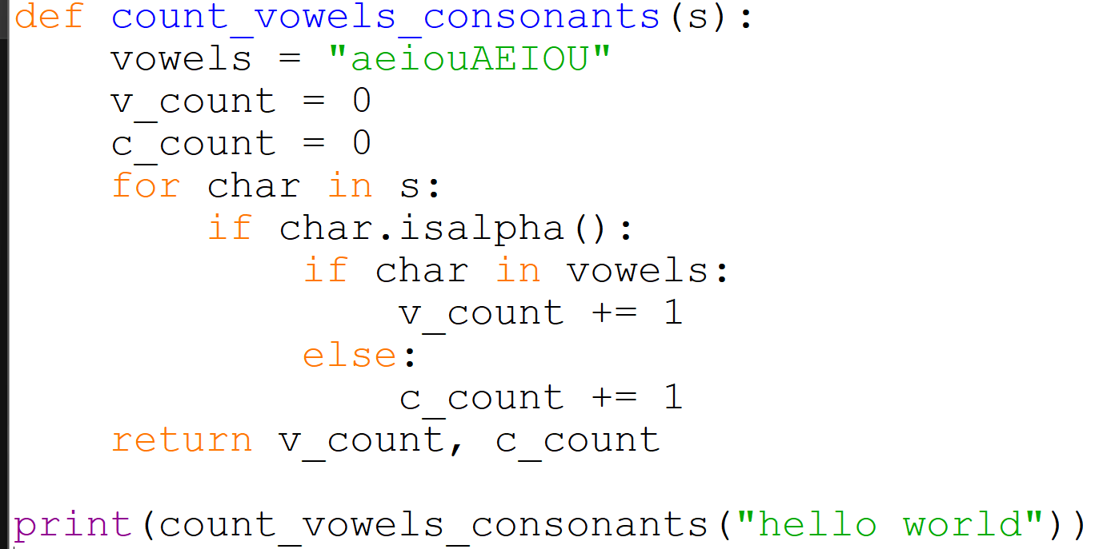

**Output:**



**4. Remove all spaces from a given string.**

**Source code:** 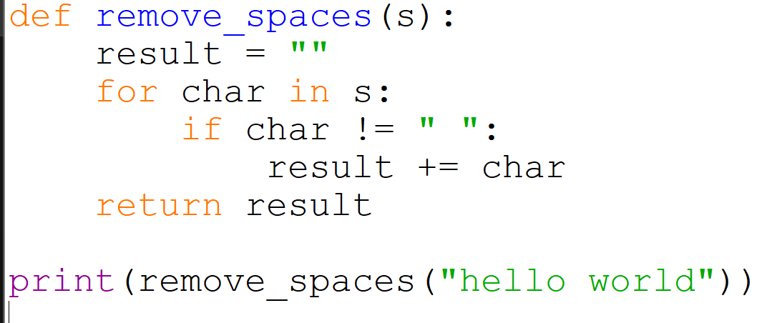

**Output:**

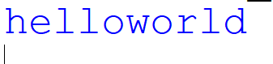

**5. Count the frequency of each character in a string python.**

**Source code:**

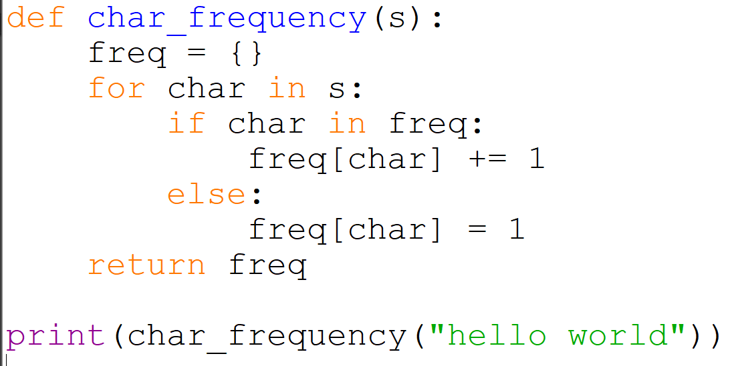

**Output:**

