git keys doc

c:\users\kkusiaku\.ssh\id-rsa in get_keyfiles.txt

working with git bash

* create a ssh key

ssh-keygen -t rsa -b 4096 -C "*your_email@example.com*" (replace email with your email)

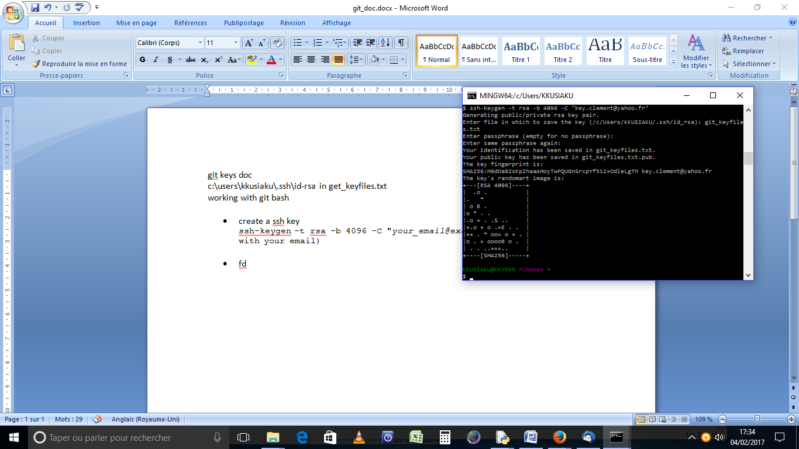

* fd