Secure File Storage System with Encryption & Role-Based Access
In this project we have added combination of AES along with RSA algorithm to perform hybrid encryption where RSA algorithm is used for KEY generation and then AES employed to encrypt given file using RSA generated keys.
To secure application access we have added MFA (multi factor authentication) by allowing application to send OTP to user email and once OTP authenticated then only user will be allowed to upload and download file.
To perform file verification we have used SHA256 hash code which can be used to verify file content. If uploaded and verifying file hash code then only file will be consider as tamper proof.
User can upload and share file with other users as ROLE based access and if the user who has permission to access file can view and download file.
To prevent unauthorized access we are logic each activity of all users in a log file.
To implement this project we have designed following modules
- New User Signup Here: user can sign up with the application
- User Login: user can login to system, after login user get OTP in mail which has to utilize to complete login process
- Upload & Share File: user can upload and share file with other desired users and file will be saved at static/files folder in encrypted format
- Decrypt & Download File: using this module user can view all his uploaded and other user shared files permission list and then can download desired files
To run project install Python 3.7.2 and then install all packages given in requirements.txt file and then create database in MYSQL by copying and pasting ‘database.txt’ content in MYSQL console
Now double click on ‘run.bat’ file to start python server and get below page
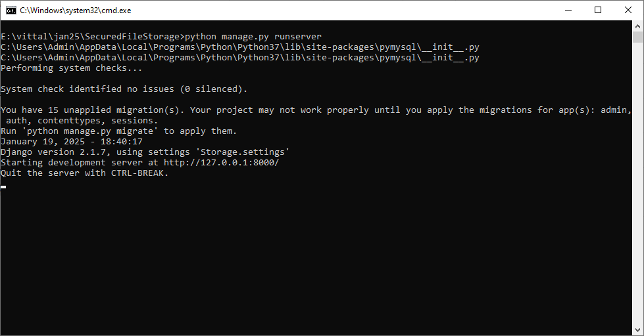
In above screen python server started and now open browser and enter URL as http://127.0.0.1:8000/index.html and then press enter key to get below page
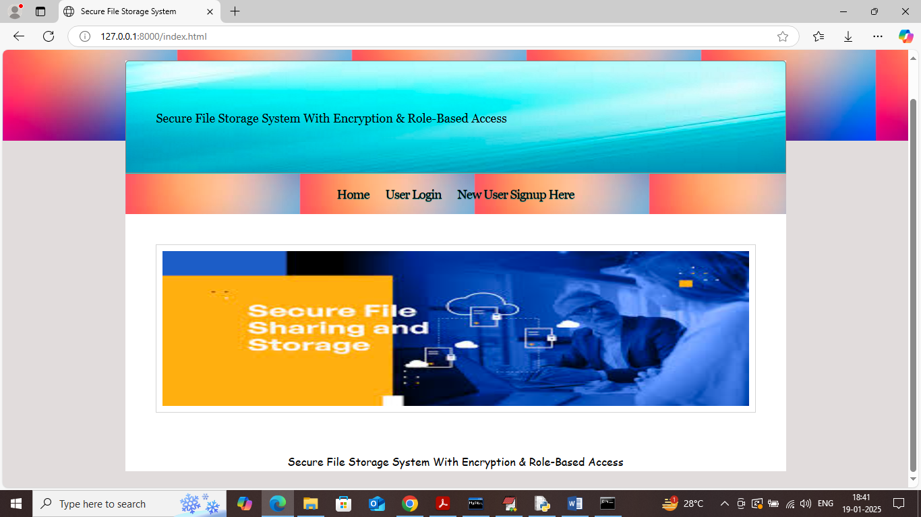
In above screen click on ‘New User Sign up’ link to get below page
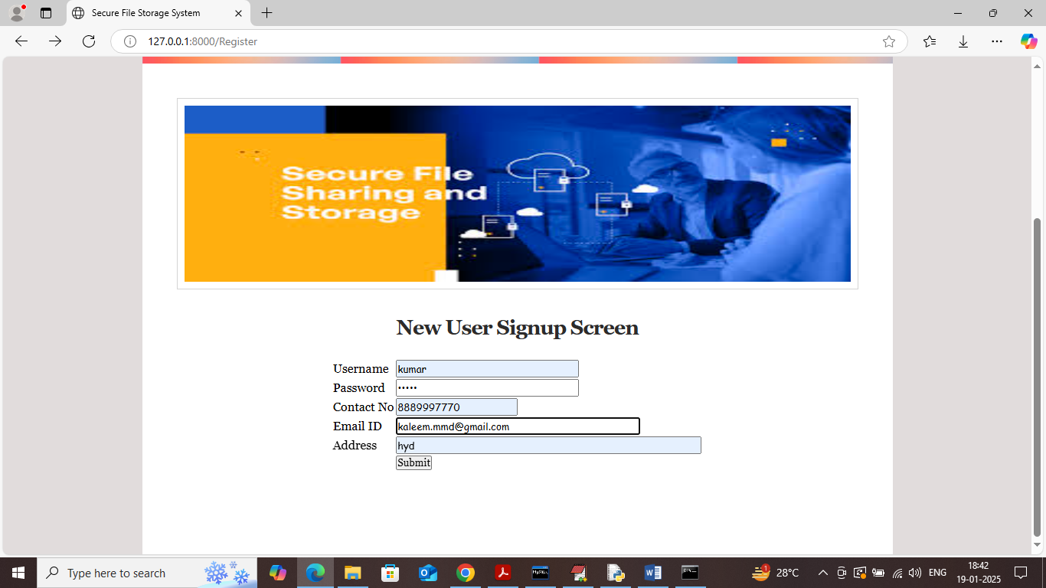
In above screen user is entering sign up details and give valid mail id to receive OTP emails and then press button to get below page
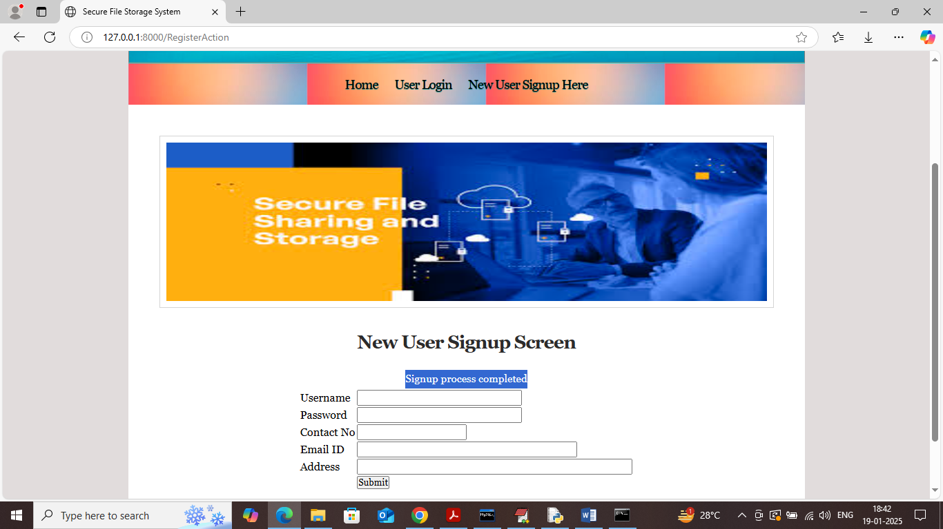
In above screen user signup completed and similarly you can add many users and now click on ‘User Login’ link to get below page
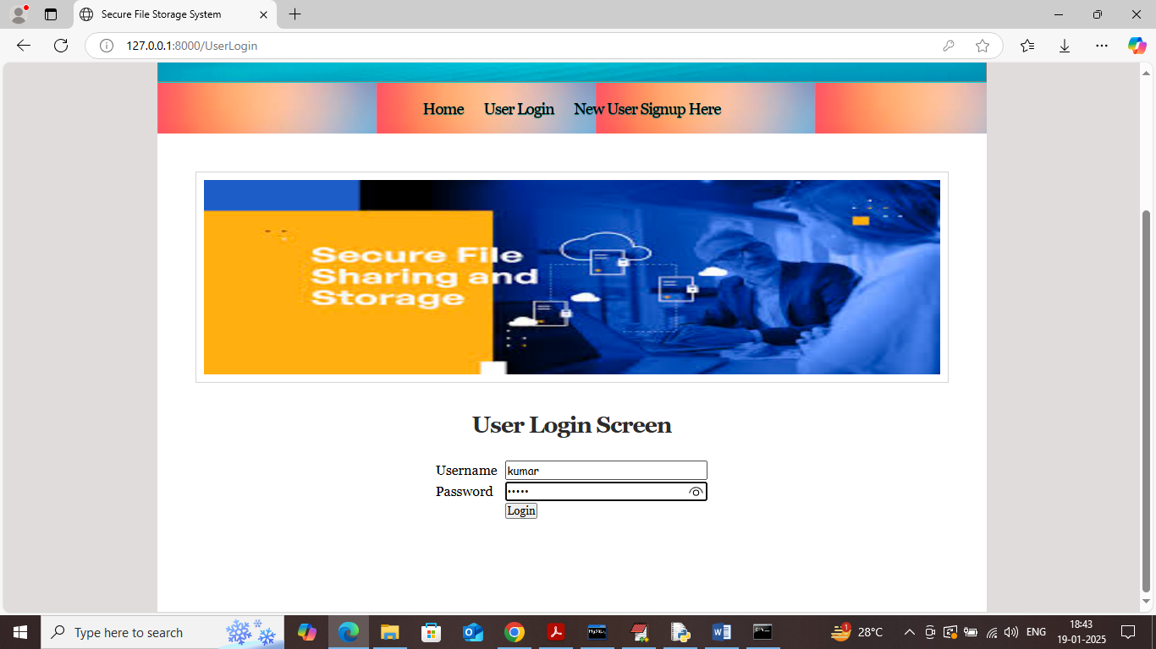
In above screen user is login and after login will get OTP in mail like below page
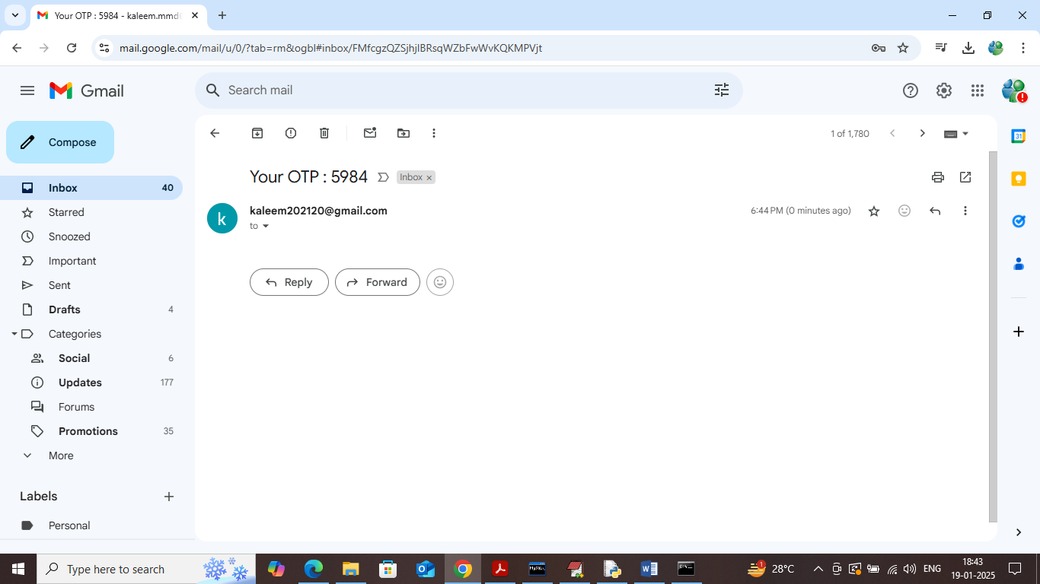
In above screen OTP received in email and now validate in application like below page
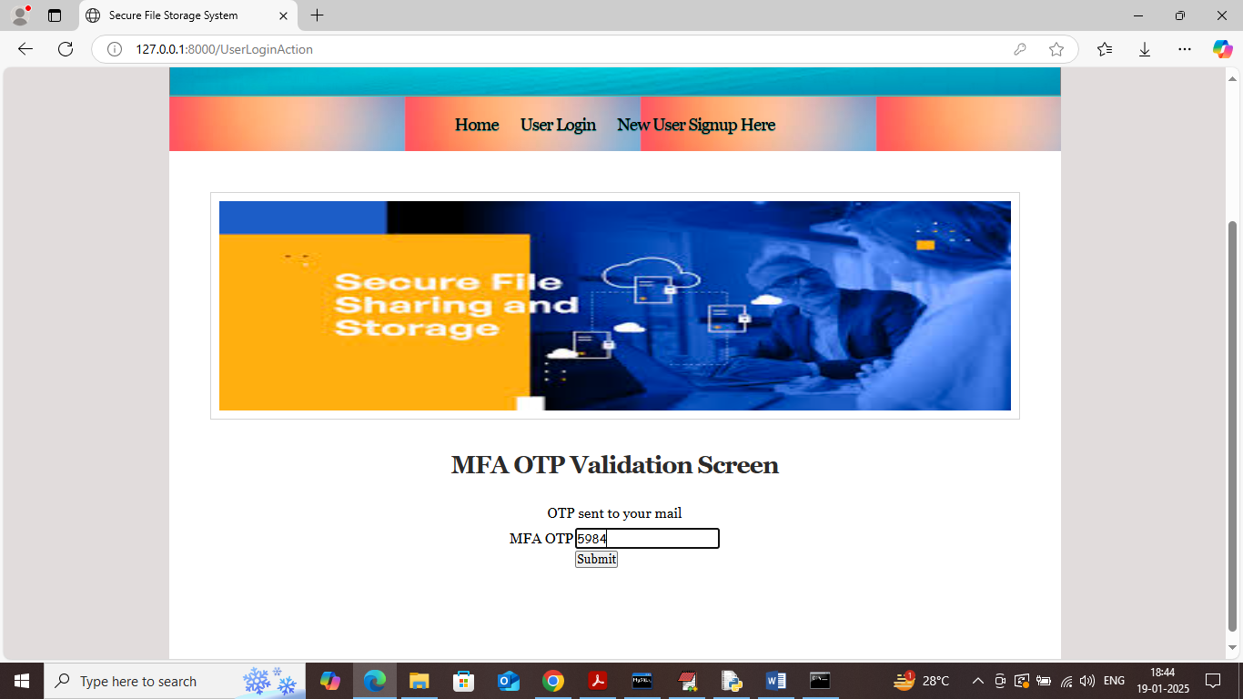
In above screen validating OTP and then press button to get below page
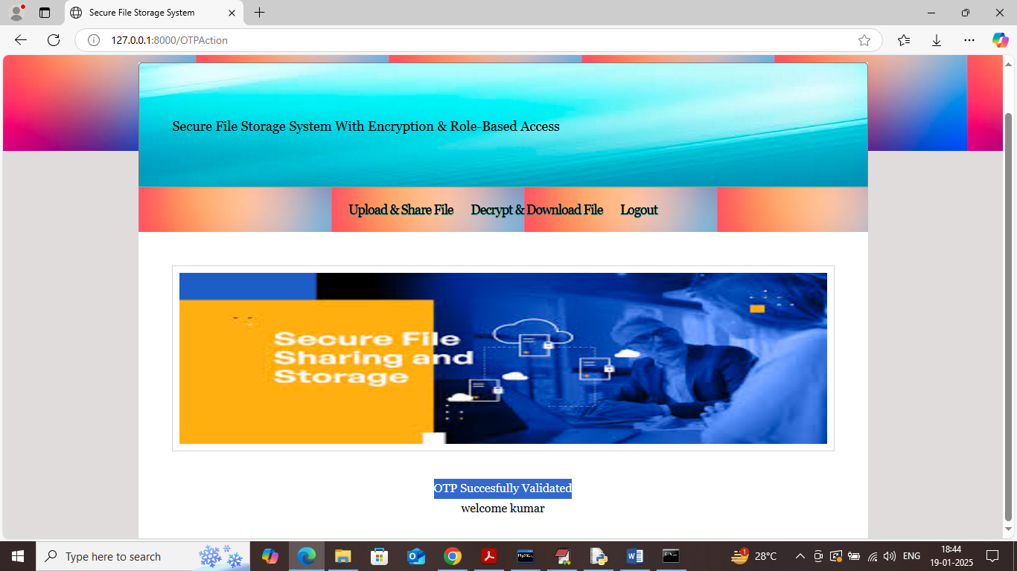
In above screen click on ‘Upload & Share File’ link to upload file and get below page
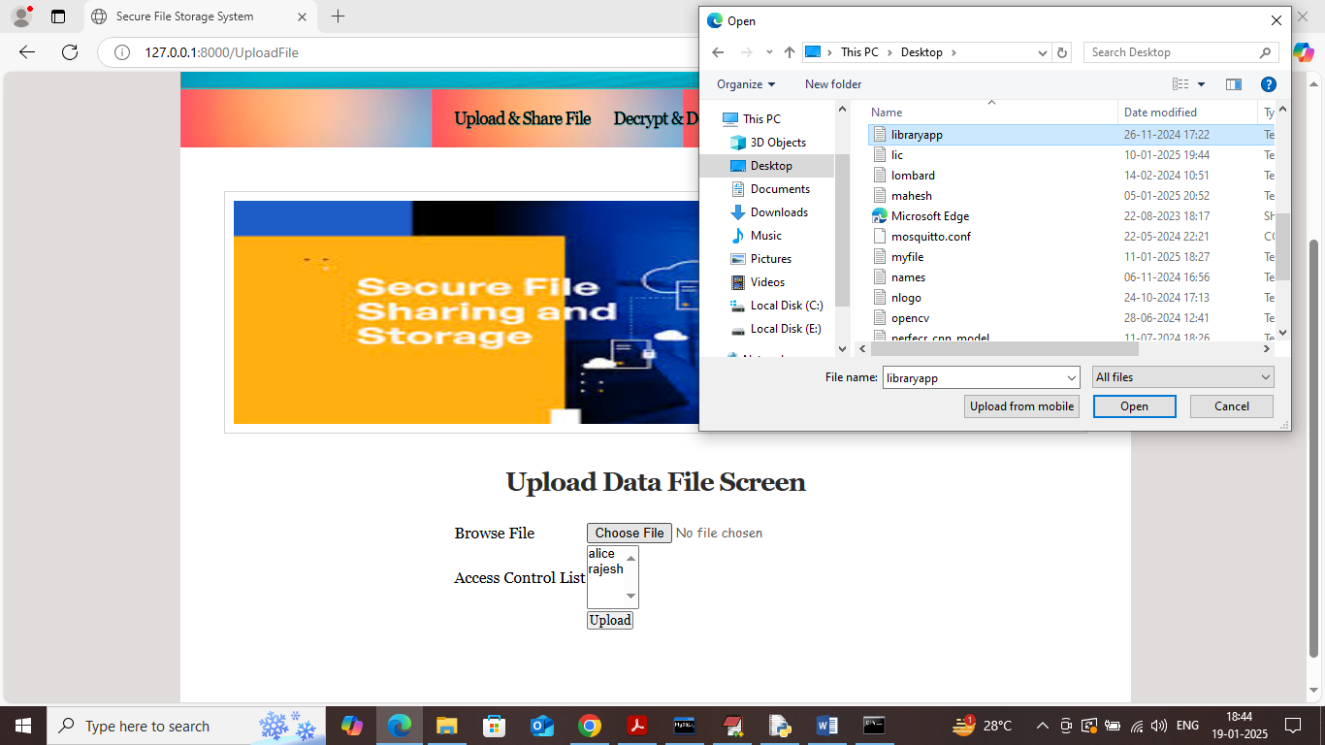
In above screen select and upload file and then choose sharing user by holding CTRL key of you want to share with multiple users and then press button to save file and get below page
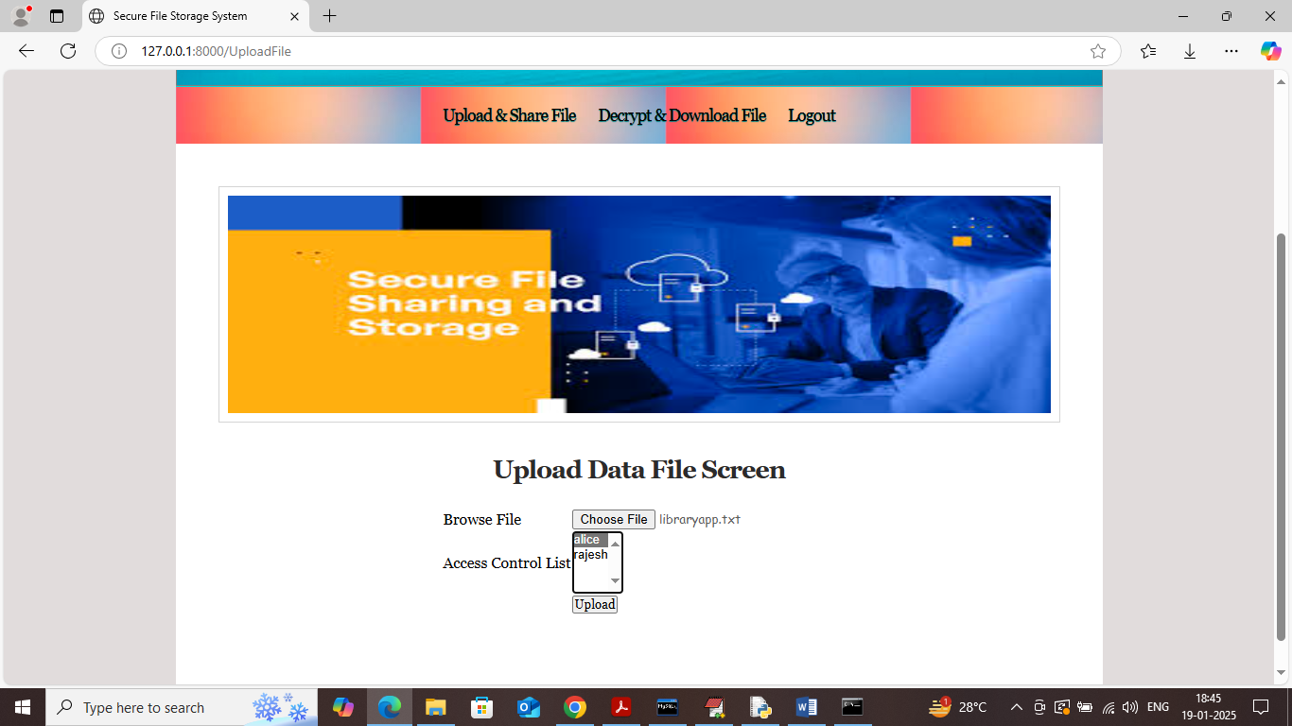
In above screen select the users and then press button to get below page and in above screen by giving share permission role to Alice
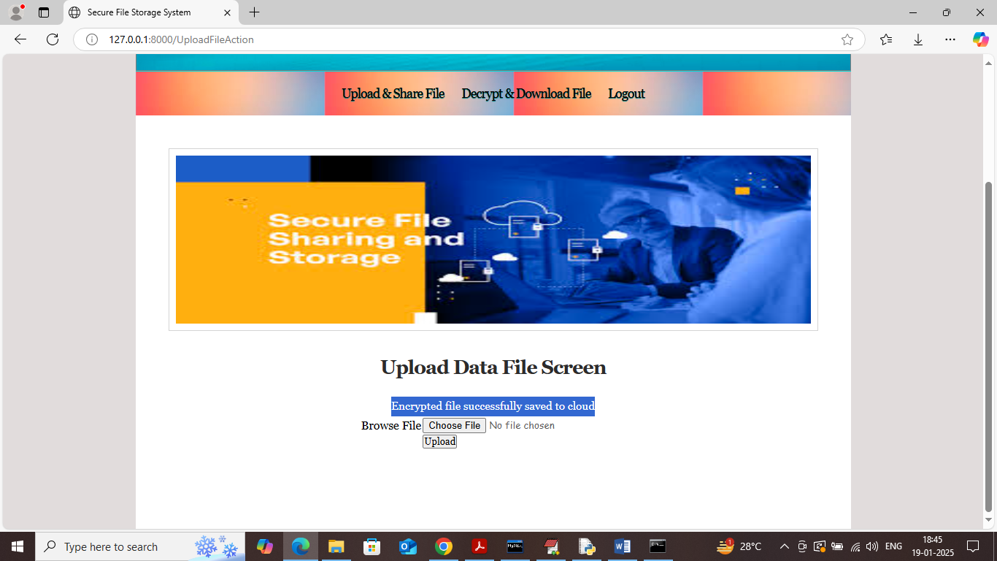
In above screen encrypted file saved at cloud which can see in below screen
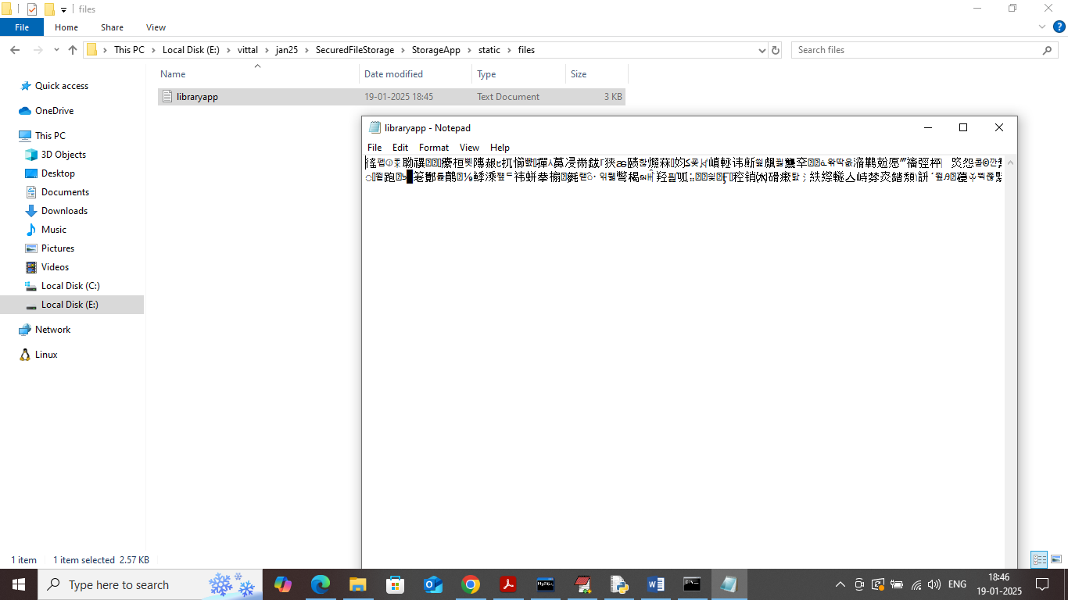
In above screen uploaded file can see in encrypted format and all encrypted wil get saved inside ‘StorageApp/static/files’ folder. Similarly you can upload as many files as you want and now click on ‘Decrypt & Download File’ to get list of files
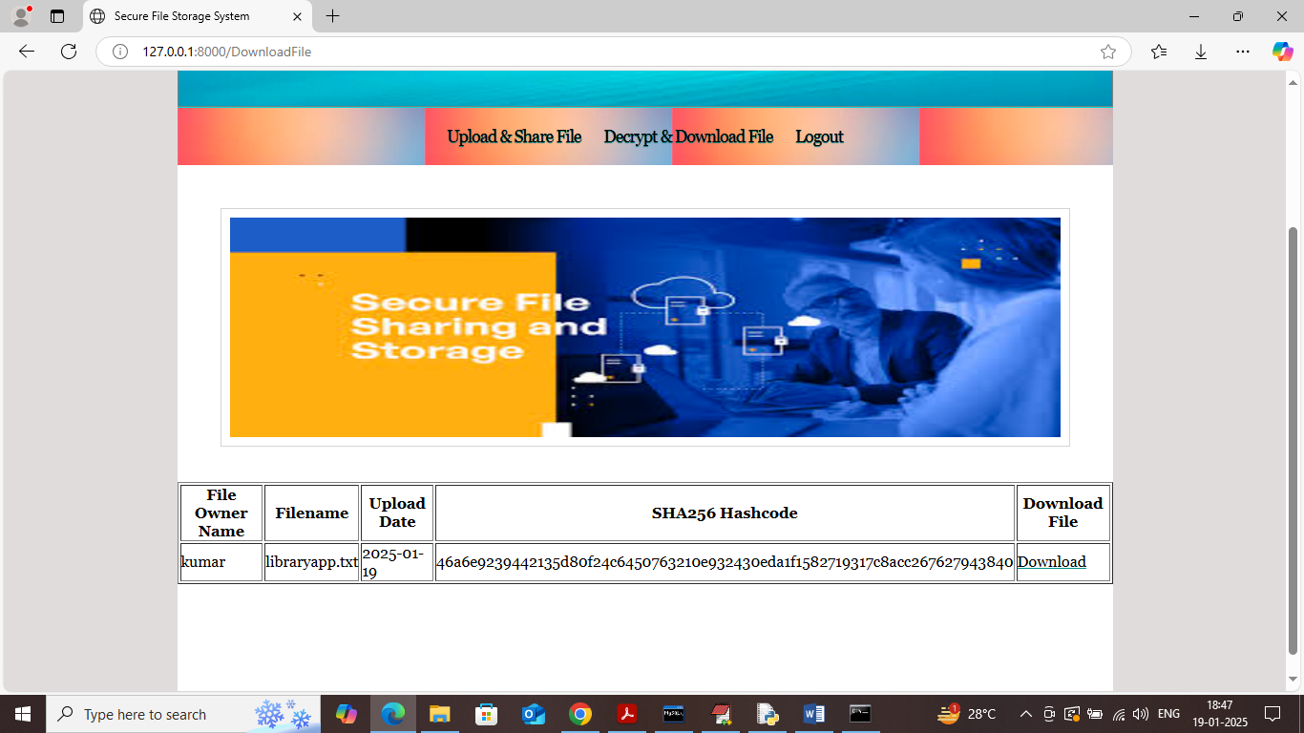
In above screen user can see list of uploaded and share files along with SHA256 hash code and now click on ‘Download’ link to download file and get below page
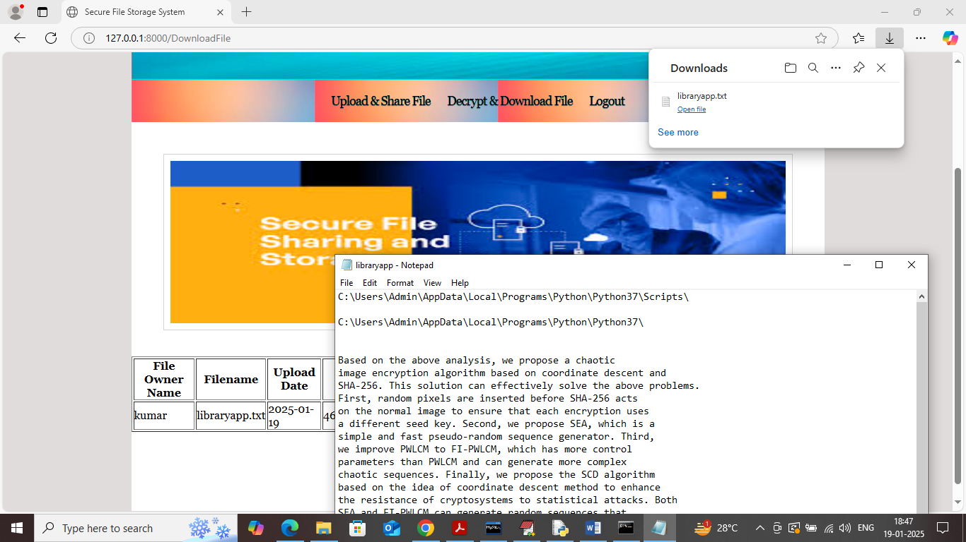
In above screen file is downloaded in decrypted format.
Similarly by following above screens you can upload and download as many files as you want.
In below screen you can see all log details saved inside log.csv file which contains all user activities details
