**PROJECT REPORT**

**FULL STACK PROJECT**





# COVID-19 WEB APP

**DEPARTMENT NAME: ​**COMPUTER SCIENCE

**SUBMITTED BY: ​**RUNTIME ERROR!

**SUBMISSION DATE: ​**30 JUNE 2020

**TECHNOLOGY USED: ​**FULL STACK DEVELOPMENT

**INTERNSHIP BY : ​**MR. SANJAY RATHORE AND

MR.ANKUSH SHARMA

## GROUP PROFILE

**RUNTIME ERROR! :**



|  |  |  |
| --- | --- | --- |
| **SNO.** | **NAMES OF CANDIDATES**​ | **RTU ROLL NUMBER** |
| **1.** | **MANASVIN SHARMA** | **18EARCS066** |
| **2.** | **KAVITA YADAV**​ | **18**​ **EARCS729** |
| **3.**​ | **CHIRAG GOYAL**​ | **18**​ **EARCS039** |
| **4.**​ | **CHAVI MAHAJAN**​ | **18**​ **EARCS037** |
| **5.**​ | **ANANYA JOSHI** | **18**​ **EARCS018** |

### ​ ABSTRACT

The project report has been prepared based on available data ,forecasts provided by experts and other project management tools.This project is considered as a non profit project. Risks have been estimated based on these types of projects.Full efforts have been made to complete this project with proper analysis of its pros and cons. The various technologies used in this project are HTML ,CSS, node js ,javascript,angularjs ,express, ajax, mongo DB . The whole project is designed using a visual code studio. However, this report is not full proof. There is always a room for improvement.

### INTRODUCTION

As technology advances the internet is becoming ever popular . Website has become an essential part .In this project we will develop a website for people to know and analyse about covid-19 .In this report every detail that is necessary has been discussed.Detailed graphs has been added to our project to give the clear picture of the circumstances.to know more about this scenario you can also visit our pages included within it which shows how to boost up your immunity and detailed information to be safe while going out of home. We are also providing you a corona tracker which will make sure the number of cases around you . In this website you will be able to know about the infected ratio , fatality ratio and recovered ratio of the world,continent,country etc. This data has been provided within attractive globes with possible accurate data .A formal training phase is included in the project to train people who have worked on this project on how to handle and work on this website.This website can be very helpful to know about the facts and figures.

### PURPOSE

There are several options in hand in terms of functionality.Depending on the requirements a website can be made in different ways.But we choose this keeping in mind the situation we all are going through ,in this scenario we need proper information to be updated using different components of a newly designed website. This is handy and can be helpful to get overall information.

### SCOPE

The project team has covered the following deliverables and other web design elements.

**WEBSITE CONTENTS**

1.Informative page on how to use this website.

2.It has a secure online account facility when you sign up.

3.It provides a platform where the user has to fill his/her details honestly for proper authentication.

4.It also has a tracker with it which tracks your location and adds it to our database .

5.It gives a description about the stats of infected ratio,recovered ratio and death ratio of people within the world,continent,country etc.

6.It also has other components such as health and safety measures to explore more.

### INSIDE WEB PAGE

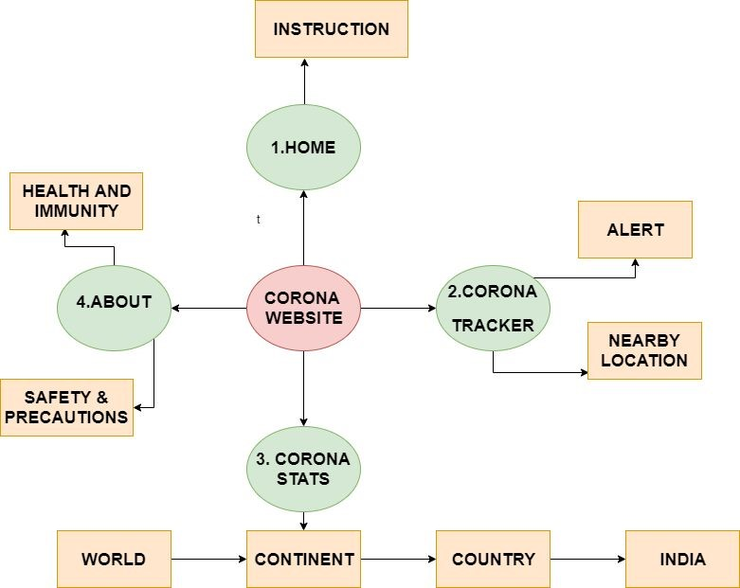

### MORE ABOUT WEB PAGE

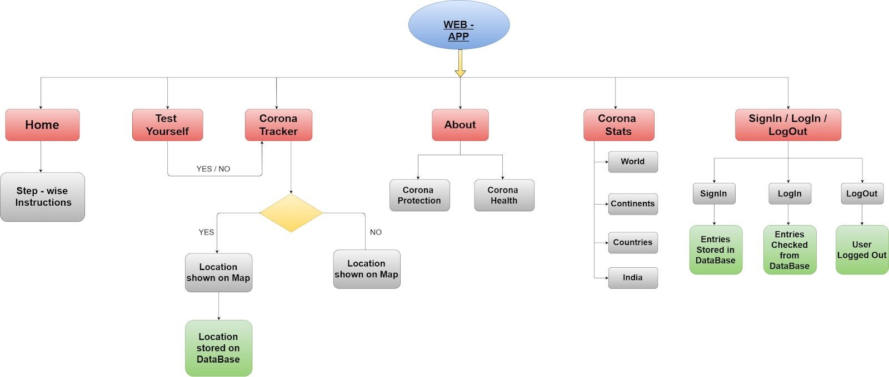

### TECHNOLOGIES USED

This project is a full stack project and consists of the following technologies:

|  |  |  |  |
| --- | --- | --- | --- |
| **FRONTEND ->** | **BACKEND ->** | **DATABASE->** | **SHARING->** |
| HTML5 | JAVASCRIPT | MONGO db ATLAS | GIT |
| CSS3 | JQUERY |  | GITHUB |
| JAVASCRIPT | AJAX |  |  |
| ANGULAR 9 | EXPRESS.JS |  |  |
| CHART.JS | NODE.JS |  |  |
| BOOTSTRAP 4 | TYPESCRIPT |  |  |
| TAILWIND CSS | GOOGLE MAP INTEGRATION |  |  |
| AWESOME FONT | ZING CHARTS LIBRARY |  |  |
| GOOGLE MAPS | EXTERNAL API |  |  |
| ZING CHARTS | CHART.JS |  |  |

### PROJECT PROFILE OF CANDIDATES

|  |  |
| --- | --- |
| **CANDIDATES** | **WORK** |
| MANASVIN SHARMA (Leader) | FULL STACK DEVELOPMENT & MANAGEMENT |
| KAVITA YADAV | BACKEND & FRONTEND DEVELOPMENT |
| CHIRAG GOYAL | BACKEND & DATABASE DEVELOPMENT |
| CHAVI MAHAJAN | FRONTEND DEVELOPMENT |
| ANANYA JOSHI | FRONTEND DEVELOPMENT |

### DATA FLOW OF API’S

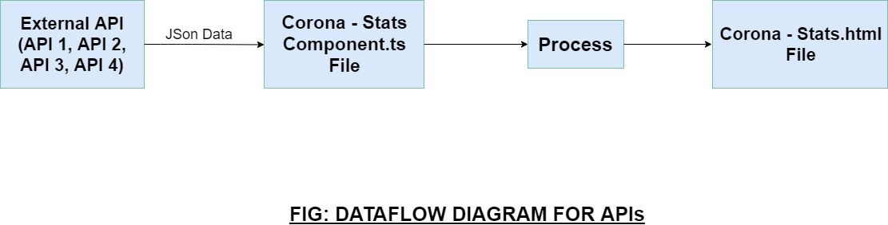

An ​***a***​*pplication* ​***p***​*rogram* ​***i***​*nterface* ​(​**API**​) is a set of ​[routines](https://www.webopedia.com/TERM/R/routine.html)​, [protocols](https://www.webopedia.com/TERM/P/protocol.html)​, and tools for building ​[software applications](https://www.webopedia.com/TERM/A/application.html)​[.](https://www.webopedia.com/TERM/A/application.html) Basically, an API specifies how software components should interact. Additionally, APIs are used when programming graphical user interface (​[GUI](https://www.webopedia.com/TERM/G/Graphical_User_Interface_GUI.html)​[)](https://www.webopedia.com/TERM/G/Graphical_User_Interface_GUI.html) components.

A good API makes it easier to develop a ​[program](https://www.webopedia.com/TERM/P/program.html)​by providing all the building blocks. A ​[programmer](https://www.webopedia.com/TERM/P/programmer.html)​then puts the blocks together.

### DATA FLOW FOR INDIAN MAP

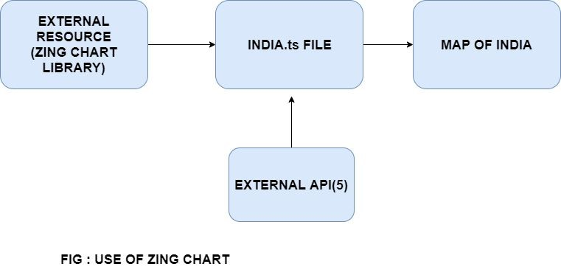

ZingChart's modular design was implemented to allow users to include only what is needed for charts, keeping file size to a minimum.

### DATA FLOW OF CORONA TRACKER

The flow chart for this is shown below.when you visit our website a home page is opened for you for instructions.Then to use our website you need to sign in to our page. After sign in, the user has to login to our web page to test himself. A simple test is being organised for the user to check whether the user is positive or not. Deciding on what user has answered it will take track of his location and also shows an alert for his safety measured within a radius of 2 kilometer.



