A1(a) Puzzle Test Cases
In this project, three puzzle instances of increasing difficulty were selected in order to evaluate the performance of different search algorithms and heuristics:
Simple Corridor 1
This is a small puzzle with a mostly linear structure and limited branching.
However, compared with Simple Corridor 2, it contains more movement dependencies and requires a longer sequence of rearrangements before the red block can reach the goal.
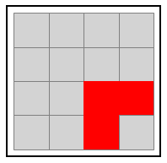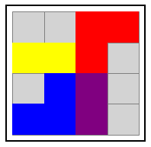
This is a genuinely simple puzzle with a mostly linear structure and very limited branching.
We make it serve as the easiest case in the test set and is useful for checking whether algorithms can find optimal solutions efficiently under very low complexity.
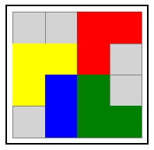
Medium Polyomino 1
This is a medium-sized puzzle with a larger board and more complex polyomino-shaped blocks.
Compared with the simple corridor puzzles, it introduces substantially more spatial interaction and dependency between pieces, so the search must explore a much larger state space before reaching the goal.
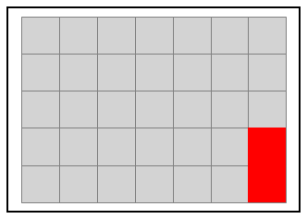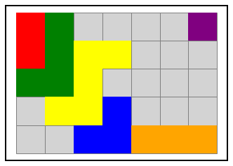
Medium Polyomino 2
This is a more difficult medium-sized puzzle with a less direct route to the goal and stronger dependencies between blocks. The target block must be repositioned across the board, while several surrounding pieces constrain its movement and make the search much harder than in Medium Polyomino 1.
It was designed as a harder medium-level case to bridge the gap between the solvable medium puzzle and the hardest puzzle.
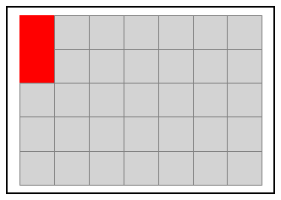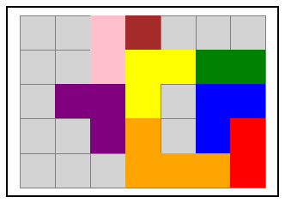
Hard Dependency
This is the most complex puzzle in the test set, with strong dependencies between multiple blocks and a more constrained goal structure.
Unlike the previous cases, solving this puzzle requires not only moving the target block but also arranging other blocks into specific positions, significantly increasing the difficulty of the search.
It was designed to test the scalability limits of the search algorithms and heuristics, and to demonstrate how performance degrades when structural dependencies become dominant.
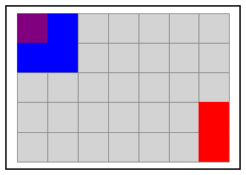

These three test cases allow comparison across different levels of problem difficulty and help reveal how algorithm performance changes as complexity increases.

A1(b) Heuristic Functions
Several heuristic functions were implemented to guide informed search algorithms:
“RedDistance” Heuristic
This heuristic estimates the distance of the target (red) block to the exit by measuring how far it is from the goal column. It is simple and computationally efficient but ignores obstacles, making it relatively weak.
In a word, it simply measures how far the red target block is from the exit column.

Blocking Heuristic
This heuristic extends the red distance by also counting the number of blocks directly obstructing the target block’s path. By incorporating obstacle information, it provides a more informed estimate of the remaining cost.

Dependency Heuristic
This heuristic further improves upon the blocking heuristic by considering the difficulty of moving blocking pieces. It introduces an additional penalty based on the positions of obstructing blocks, attempting to capture deeper structural dependencies in the puzzle.
1  2  3  4  5 | for block in blocking_blocks:  cells = state.blockcells(block)  penalty += min(c for r, c in cells)  return distance + len(blocking_blocks) + penalty
To summarize, this heuristic further considers how difficult it is to move blocking blocks.

Multi-Block Heuristic
This heuristic considers not only the target block but also additional key blocks that influence the solution. It aims to provide a broader estimate of progress toward the goal, though it may sacrifice admissibility.
1  2  3 | score += distance_of_red_block  score += position_score_of_block_6  return score
Generally, This heuristic considers not only the red block but also another key block that influences the solution.

A1(c) Search Test Sequence
After preliminary experimentation, we selected two compact test sets that together provide a clear and informative comparison of search behaviour while still fitting within the report length limits.
Test Set 1：Algorithm Comparison
This test set is designed to evaluate the effect of heuristic design on informed search.
We test five algorithms: BFS, DFS, UCS, Best-first, and A*.
The experiments are run on three representative puzzles: one simple puzzle, one challenging medium puzzle, and one hard puzzle.
For the informed algorithms, RedDistance is used as the common heuristic so that the comparison remains consistent.
The maximum number of nodes is fixed at 1,000,000, with loop checking enabled and randomisation disabled.
This test set is intended to support the comparisons in A2 Table/Figure 1, where the aim is to show how different algorithms behave as puzzle difficulty increases.
In particular, it allows direct comparison of solution quality, search cost, and success rate across the five algorithms.
Test Set 2：Heuristic Comparison
This test set is designed to evaluate the effect of heuristic design on informed search.
We test two heuristic-based algorithms: Best-first and A*.
For each algorithm, we compare four heuristics: RedDistance, Blocking, Dependency, and MultiBlock.
To keep the test set compact but still informative, we use two representative puzzles: medium_polyomino and hard_dependency.
The same node limit (1,000,000) and search settings are used as in Test Set 1.
This test set is intended to support the figures in A2 Figure 2a and Figure 2b, where the goal is to compare how heuristic choice affects solution quality and search efficiency.
It is also the basis for the observations in A3 about the impact of heuristic design and the different sensitivity of Best-first and A*.

A2 Results
Test | Puzzle | Algorithm | Heuristic | Total Nodes | Expanded Nodes | Path Length | Time(s) | Success?
1 | Simple1 | BFS | No | 386 | 382 | 41 | 0.024 | Yes
2 | Simple1 | DFS | No | 354 | 281 | 77 | 0.018 | Yes
3 | Simple1 | UCS | No | 388 | 386 | 41 | 0.024 | Yes
4 | Simple1 | BEST FIRST | RedDistance | 415 | 372 | 43 | 0.025 | Yes
5 | Simple1 | A* | RedDistance | 389 | 388 | 41 | 0.025 | Yes
6 | Medium2 | BFS | No | 1000001 | 647034 | None | 158.1068 | No
7 | Medium2 | DFS | No | 36849 | 5028 | 5027 | 3.1762 | Yes
8 | Medium2 | UCS | No | 1000001 | 647034 | None | 176.7606 | No
9 | Medium2 | BEST FIRST | RedDistance | 1000001 | 576556 | None | 153.0148 | No
10 | Medium2 | A* | RedDistance | 1000001 | 619076 | None | 152.1985 | No
11 | Hard | BFS | No | 475443 | 436741 | 36 | 78.7146 | Yes
12 | Hard | DFS | No | 14302 | 3201 | 3157 | 0.8015 | Yes
13 | Hard | UCS | No | 514117 | 475443 | 36 | 87.664 | Yes
14 | Hard | BEST FIRST | RedDistance | 65096 | 44557 | 52 | 8.5629 | Yes
15 | Hard | A* | RedDistance | 413893 | 372871 | 36 | 71.7025 | Yes
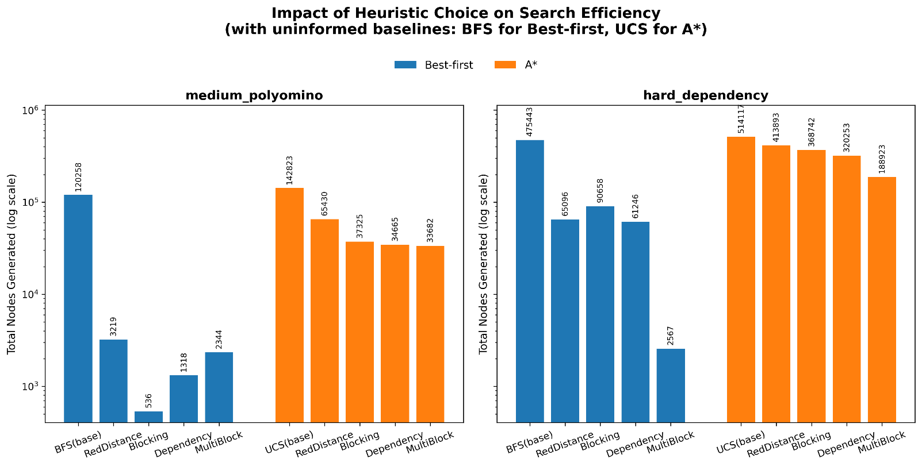
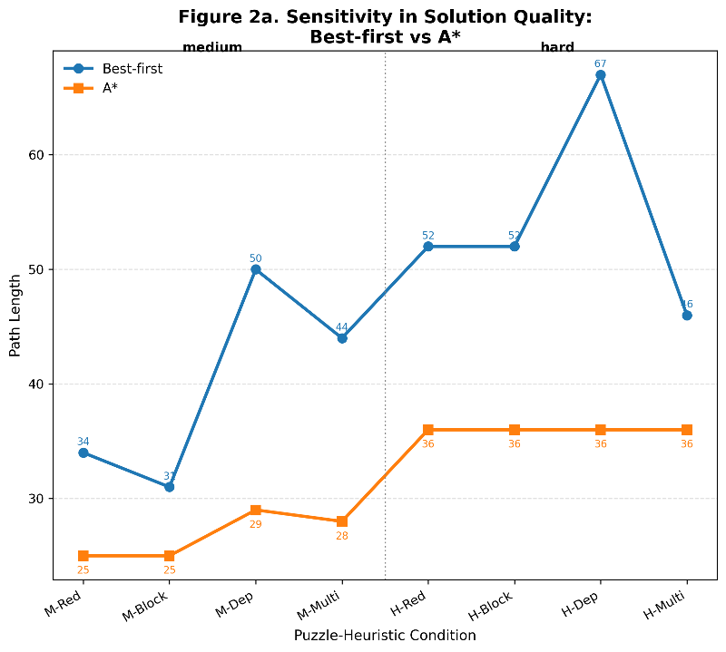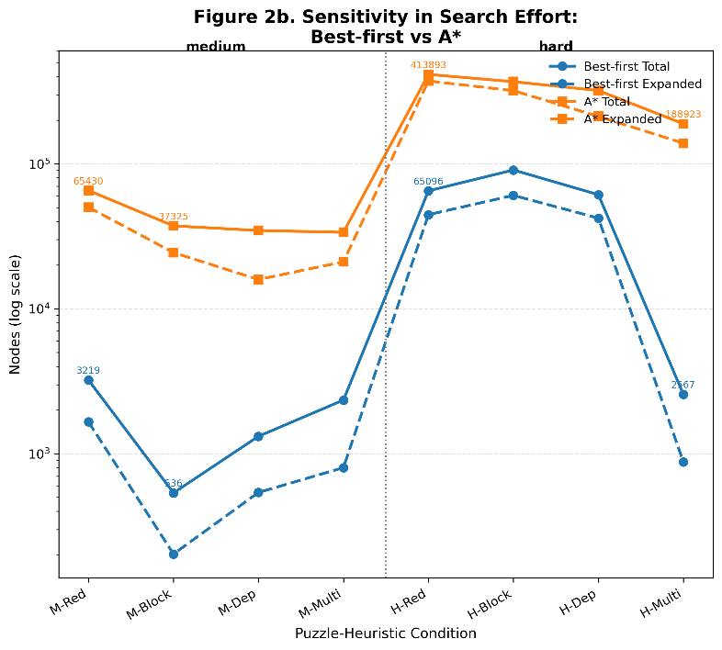
A3 Key Observations
From test set 1:
Compare Test 2 from Test 1、3-5, and Test 12 from Test 11、13-15, we find that DFS has the longest path length, much more longer than any other algorithms. However, considering test 6-10, only DFS finds out a path(with length: 5027, very large), so we can see that DFS trades solution quality for low memory usage and early feasibility, which comes about the conclusion:
1、DFS can find solutions under constraints but produces poor-quality paths.
Compare Test 4 and Test 14 from the others, we observe that BFS, UCS, and A* all find the shortest path lengths (41 in Simple1 and 36 in Hard), while Best-first consistently returns a slightly longer path (43 in Simple1 and 52 in Hard). Gowever, Best-first achieves this with fewer generated and expanded nodes, as well as significantly lower running time. This indicates a clear trade-off: Best-first improves search efficiency by using heuristic guidance aggressively, but this comes at the cost of path optimality. So we know that:
2、Best-first search improves efficiency but does not guarantee the shortest path.
Compare Test 1, 3, and 5 in Simple1, Test 11, 13, and 15 in Hard, and Test 6, 8, and 10 in Medium2, we observe that BFS, UCS, and A* all produce the same shortest path when they succeed (41 in Simple1 and 36 in Hard). However, when the problem becomes more difficult, UCS generates the most nodes, BFS slightly fewer, and A* consistently expands fewer nodes and runs faster than both. This suggests that the heuristic in A* starts to guide the search more effectively as the problem becomes harder, which comes about:
3、A* reduces the search space compared to BFS and UCS on harder problems, but its advantage is limited under the current heuristic.
From test set 2:
As shown in Figure 2b, changing the heuristic leads to large differences in search effort for both Best-first and A*, especially in hard_dependency. In A*, the path length remains the same under all four heuristics, but the number of generated nodes decreases substantially from RedDistance to MultiBlock. This shows that heuristic choice strongly affects search efficiency, and that more informative heuristics can significantly reduce the search space.
1、Heuristic choice has a major impact on search efficiency, and more informative heuristics can greatly reduce the search space.
As shown in Figure 2a and Figure 2b, both Best-first and A* are influenced by heuristic choice, but Best-first changes more dramatically. In medium_polyomino and hard_dependency, Best-first shows larger variation in both path length and search effort across heuristics. By contrast, A* also changes in generated and expanded nodes, but its path length remains much more stable. Therefore, we obtain the conclusion:
2、Best-first is more sensitive to heuristic design than A*, while A* is more stable in solution quality.

B. Robot Worker Scenario
B.1. My Robot Scenario: ISS Maintenance Task
Scenario Overview
This scenario models a robotic maintenance task on the ISS. The robot must retrieve a toolbox and a new filter, perform a replacement in the lab, and return all items to storage before ending at the Observatory.
Environment Layout
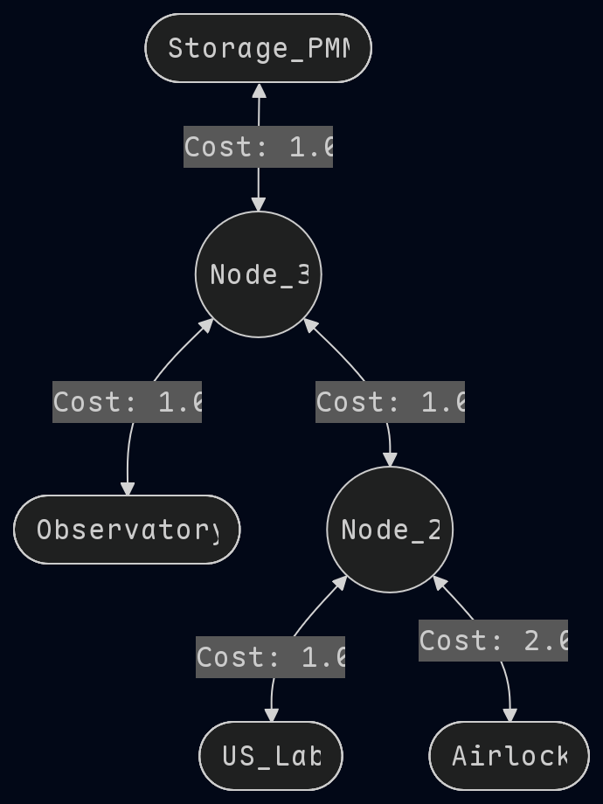
Storage_PMM: stores toolbox and new filter
US_Lab: maintenance location
Node_2 & Node_3: transit hubs
Observatory: final goal location
Airlock: leaf node

All connections are bidirectional. All edge costs are 1.0 except `Node_2 ↔ Airlock`, which is 2.0.

Objects and Constraints

Items: Toolbox, New Filter, Old Filter
Capacity: only one item can be carried at a time
Preconditions:
Old filter can only be removed in `US_Lab` with toolbox
New filter can only be installed if toolbox is in `US_Lab`
Robot Actions
Move, Pick, Drop, Remove_Old_Filter, Install_New_Filter
Goal State
New filter installed, both toolbox and old filter returned to storage, and robot ends at Observatory.

B.2. Heuristic(s)
To guide search under strong task dependencies, we design a Waypoints heuristic that encodes the required execution order.
Let the remaining task be represented as an ordered waypoint sequence:

heuristic is defined as:
W(n) = [w₁, w₂, …, $w_{k}$]
where distances are precomputed using shortest paths.
$$h(n) = dist(pos(n), w₁) + Σᵢ₌₁ᵏ⁻¹ dist(wᵢ, wᵢ₊₁)$$
The heuristic is admissible because it ignores action costs (pick/drop, etc.) and assumes unobstructed movement. Since all omitted costs are non-negative, it remains a lower bound on the true cost.

B.3. Results
We evaluated A*, BFS, DFS, and Greedy Best-First .
Algorithm | Heuristic | Nodes Expanded | Path Cost
A* | Waypoints | 103 | 18
A* | Goal | 123 | 18
BFS | N/A | 141 | 18
Best-First | Waypoints | 81 | 24
Best-First | N/A | 117 | 18
DFS | N/A | 50 | 24
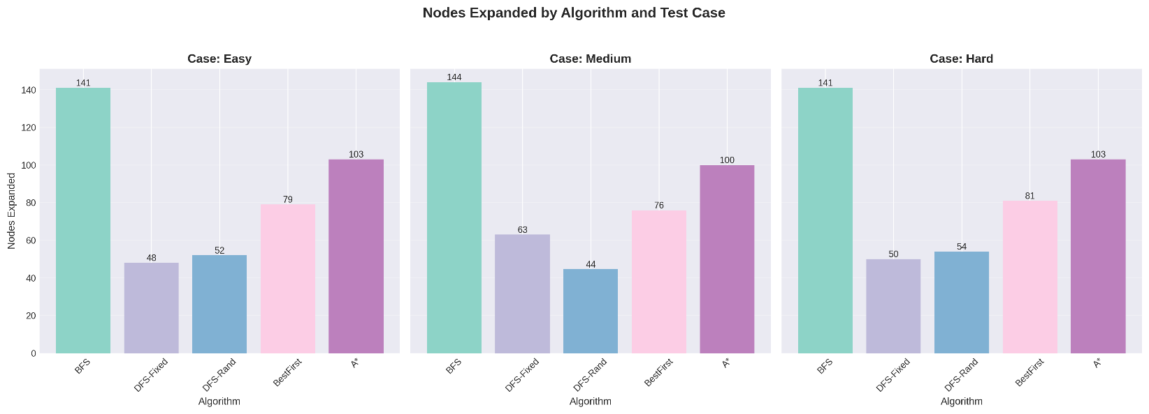
The results show that A* combined with the Waypoints heuristic achieves the best balance between efficiency and optimality. In the Hard case, it reduces node expansions by approximately 27% compared to BFS (103 vs 141) while maintaining the same optimal path cost (18), demonstrating that encoding task structure significantly improves pruning effectiveness.
Across all settings, A* consistently finds optimal solutions regardless of the heuristic used. In contrast, Greedy Best-First Search exhibits different behavior depending on the heuristic: when using simple heuristics such as Goal or Zero, it still finds optimal solutions, but when combined with the Waypoints heuristic, it produces suboptimal paths (e.g., cost 24 vs optimal 18) despite expanding fewer nodes. This indicates that the performance degradation is not due to the Greedy algorithm itself, but rather the interaction between the algorithm and the heuristic.
Specifically, in Greedy Best-First Search, the heuristic does not merely estimate remaining cost but effectively determines the search policy. The Waypoints heuristic enforces a fixed task sequence, which reduces exploration but can deviate from the true cost-optimal ordering, leading to lower efficiency in solution quality despite improved search speed.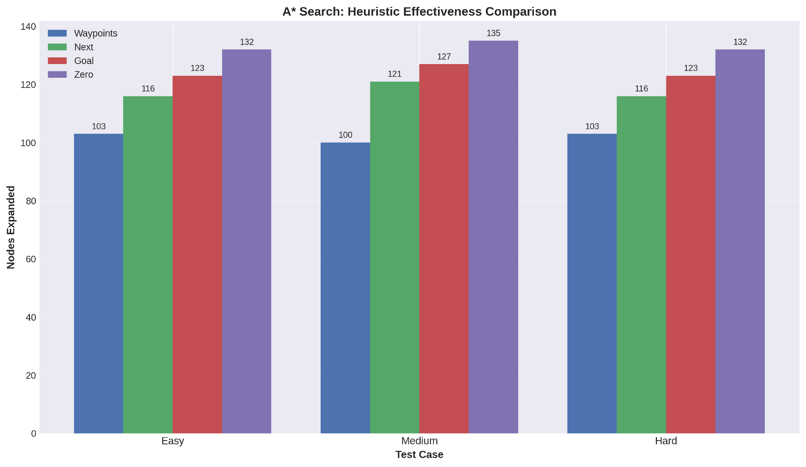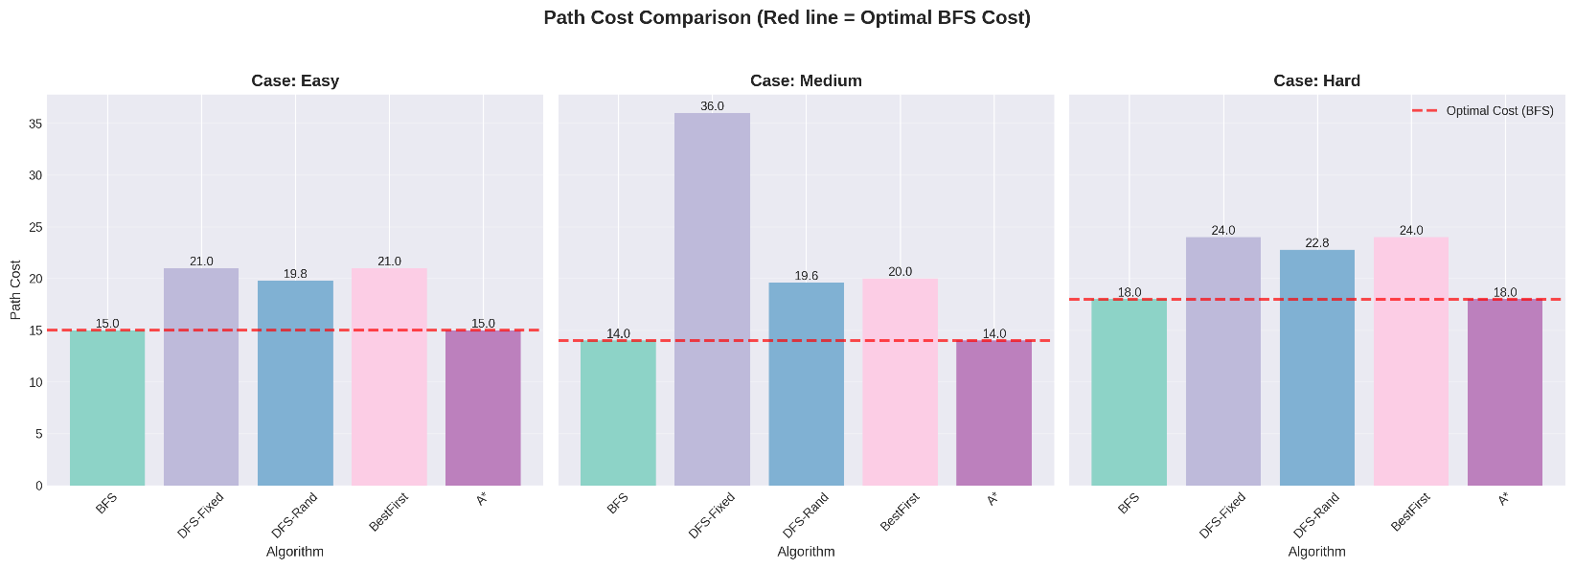

B.4. Key Findings
The experiments reveal several structural insights about the problem and algorithms. BFS consistently finds solutions with the same cost as A*, which is explained by the forms as a tree, so there is exactly one simple path between any two states, and all relevant edges have uniform cost; under these conditions, minimizing steps (BFS) is equivalent to minimizing path cost (A*). Second, the results show that effective heuristics in this domain must encode task structure rather than relying solely on spatial proximity. The Waypoints heuristic achieves this by incorporating subgoal ordering, allowing A* to avoid exploring invalid or premature action sequences. Same heuristic can have fundamentally different effects depending on the search algorithm: in A*, Waypoints improves efficiency while preserving optimality, whereas in Greedy Best-First it acts as a policy constraint rather than a pure estimator, making the algorithm highly sensitive to heuristic design. Finally, this difference can be explained by the presence or absence of bias correction: A* remains robust due to the corrective role of path cost g(n), while Greedy Best-First fully commits to the heuristic. As a result, the issue is not misleading local minima, but the over-constraining of the search trajectory when the heuristic implicitly enforces a fixed strategy.

