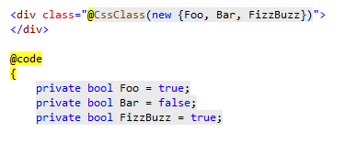

Write a code in .razor file like this…

Then you will be got this rendering!

