## 本地缓存

1. 添加 Microsoft.Extensions.Caching.Memory包，startup引用命名空间using Microsoft.Extensions.Internal;，多个实例(分布式)的情况下，该缓存的值不能全是一样，每个都是单独计算
2. 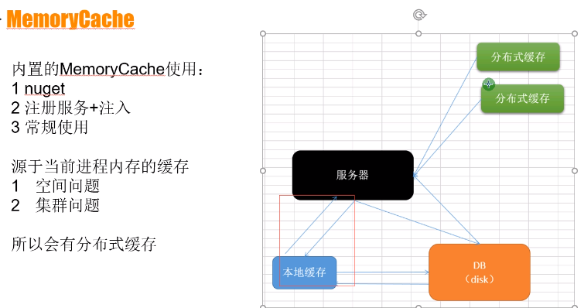

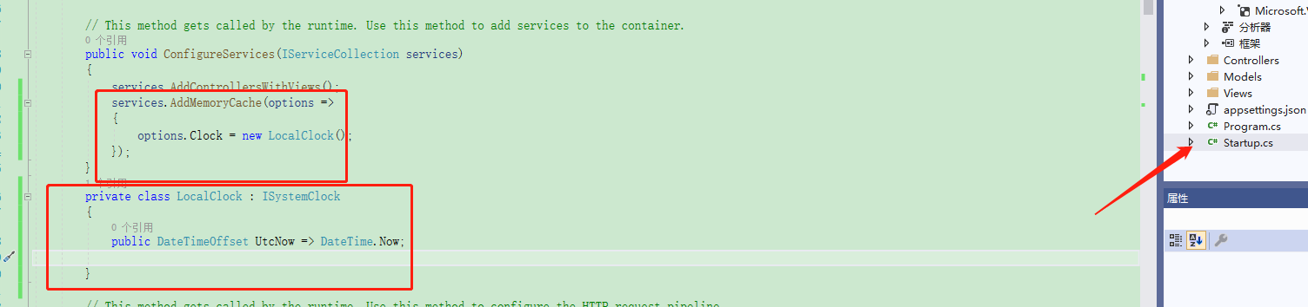

使用方法： string key = $"Test-controller-info";

if (this._memoryCache.TryGetValue(key, out string time))

{

base.ViewBag.MemryCacheNow = time;

}

else

{

time = DateTime.Now.ToString("yyyy-MM-dd HH:mm:ss:fff");

this._memoryCache.Set(key, time, TimeSpan.FromSeconds(120));//120秒后过期

base.ViewBag.MemryCacheNow = time;

}

## 分布式缓存Reids:

1. 添加Microsoft.Extensions.Caching.Redis包
2. 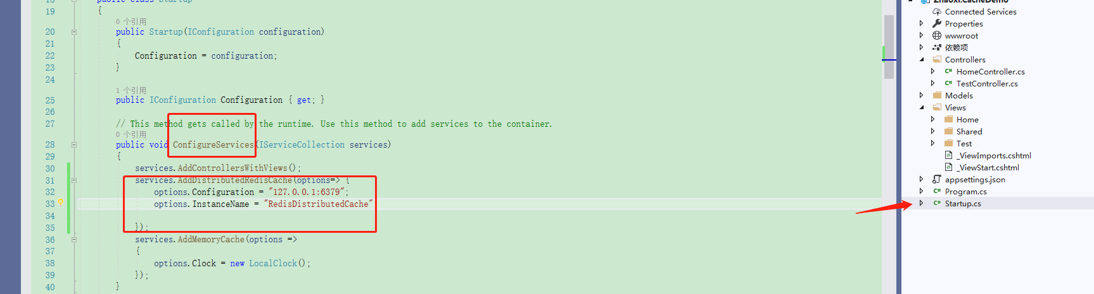

#region使用方法，解决缓存在不同实例共享的问题

string times = this._distributedCache.GetString(key);

if (string.IsNullOrWhiteSpace(times))

{

times = DateTime.Now.ToString("yyyy-MM-dd HH:mm:ss:fff");

this._distributedCache.SetString(key, times, new DistributedCacheEntryOptions()

{

AbsoluteExpirationRelativeToNow = TimeSpan.FromSeconds(120)

}) ;

}

base.ViewBag.DistributedNow = times;

1. #endregion

