场景：秒杀

## 定义

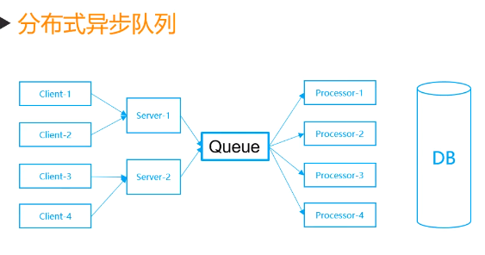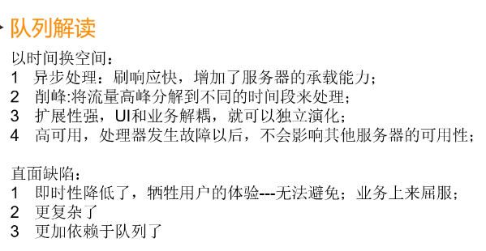

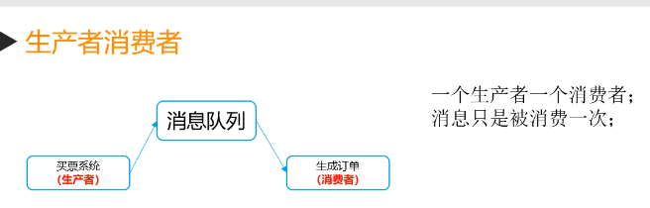 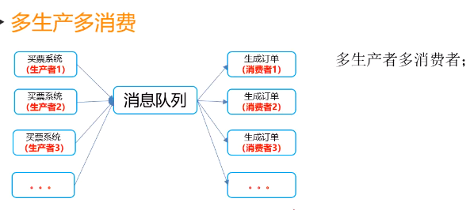

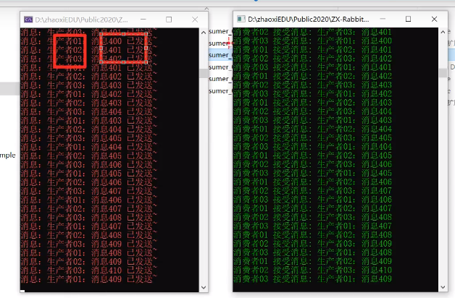 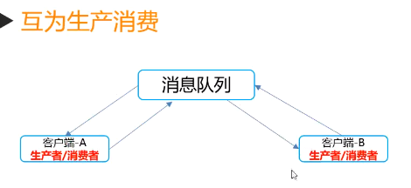

## 代码

//调用

ProductionConsumer.Show();

//生产者

public class ProductionConsumer

{

public static void Show()

{

var factory = new ConnectionFactory();

factory.HostName = "http://localhost";

factory.UserName = "guest";

factory.Password= "guest";

using (var connection=factory.CreateConnection())

{

using (IModel channel= connection.CreateModel())

{

//创建队列

channel.QueueDeclare(queue:"OnlyProducerMessage",durable:true,exclusive:false,autoDelete:false,arguments:null);

channel.ExchangeDeclare(exchange: "OnlyProducerMessageExchange",type:ExchangeType.Direct,durable:true, autoDelete: false, arguments: null);

channel.QueueBind(queue: "OnlyProducerMessage", exchange: "OnlyProducerMessageExchange",routingKey:string.Empty,arguments:null);

Console.ForegroundColor = ConsoleColor.Red;

Console.WriteLine("生产者ProductionDemo准备就绪");

int i = 1;

while(i<10)

{

string message = $"消息{i}";

byte[] body = Encoding.UTF8.GetBytes(message);

channel.BasicPublish(exchange: "OnlyProducerMessage",routingKey: string.Empty, arguments: null,body:body);

Console.WriteLine($"消息{message}已发送");

i++;

Thread.Sleep(200);

}

}

}

}

}