OUTPUTS:27nov

1)Addition of complex numbers:

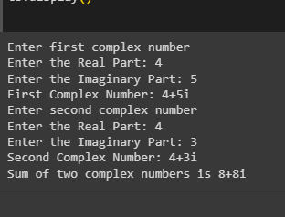

2)@classmethod:

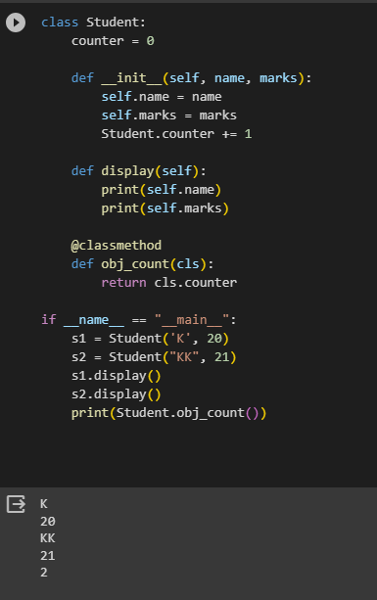

3)area of circle using lambda function:

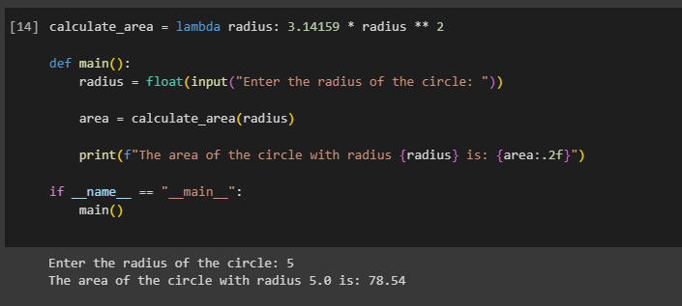

4)calculator version:

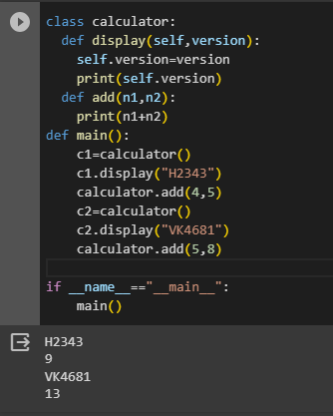

5)Class Number analysis:

