Max_element in the list:

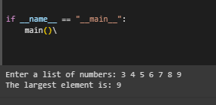

Area_of_hexagon:

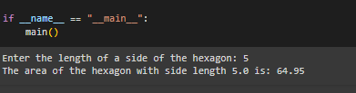

Email validation:

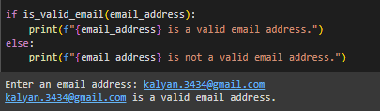

Encrypting and decrypting the text:

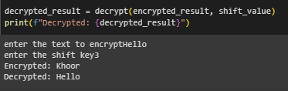

Get palindromes:

