Outputs:

1.Class instance and sub class:

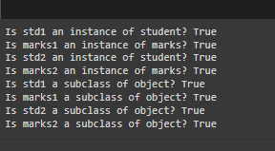

2.Birthdayboy_age:



3.Printing Lyrics:

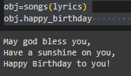

4.Dog_class:

