Database Business Documentation
Museum Management System

Contents

1 BUSINESS DESCRIPTION ………………………………………………………………………………………………………………………….………………3

1.1 Project overview …………………………………………………………………………………………………………………..…………….3

1.2 Project vision ……………………………………………………………………………………………………………………………………….3

2 Model description ……………………………………………………………………………………………………………………………………………4

2.1 Definitions & Acronyms ……………………………………………………………………………………………………………………….4

2.2 Conceptual Scheme …………………………………………………………………………………………………………………………….5

2.3 Logical Scheme …………………………………………………………………………………………………………………………………….5

2.4 Objects ………………………………………………………………………………………………………………………………………………..6

1. Business Description

1.1 Project Overview
The Museum Management System is a relational database designed to digitize and centralize the core operational data of a museum. It manages information about visitors, guides, exhibitions, museum items, and inventory– providing a unified data layer for administration and reporting.

1.2 Project Vision
During the development of this database, I started from the business idea of digitizing information about registered visitors, their visits to exhibitions, as well as the museum’s collection items and their storage locations. Based on this idea, I was able to identify the main entities at the conceptual modeling stage, as well as additional associative entities required to implement many-to-many relationships.
The attributes of most entities are straightforward and self-explanatory. However, it’s important to say, that in the current implementation, the pricing model is simplified. There are only two ticket prices: 10 and 15 dollars, representing discounted (e.g., student) and standard (adult) tickets, while admission for children is assumed to be free. This information is implicitly reflected only in the Visits table through the total price attribute. In future development, it would be more appropriate to introduce a separate Ticket type entity to explicitly represent different categories of tickets, their prices, and conditions.
Also of particular note is the Visit entity, which contains a date and time attribute. The use of the Timestamp data type reflects the fact that the time of the visit is recorded automatically from the terminal.
In contrast, the Exhibition entity contains only date attributes (no time). This design decision is based on the assumption that the museum operates on the same schedule every day, so for planning purposes it is sufficient to store only the start and end dates. Since exhibitions are planned in advance, null values ​​are not allowed for these attributes.
Regarding museum items, the current model includes only basic descriptive information. In the future, it is planned to extend the database by adding a separate entity for authors or creators of exhibits and their related details, which would improve data normalization and expand functionality.
Museum staff in this database are represented as guides or specialists who can assist visitors during specific exhibitions or conduct full guided tours. As a potential extension, the system could be enhanced by introducing an entity for planned tours, allowing visitors to select guides and schedule personalized exhibitions.

2. Model Description

2.1 Definitions & Acronyms
Term / Acronym | Definition
PK | Primary Key– a column or set of columns that uniquely identifies each row in a table.
FK | Foreign Key– a column that references the PK of another table, enforcing referential integrity.
1NF / 2NF / 3NF | First, Second, and Third Normal Forms– levels of database normalization to eliminate redundancy.
Visitor | Any adult person who attends a museum exhibition, either registered in the system or not. Let's assume that admission for children is free and no registration is kept.
Guide | A museum employee that can be hired to conduct one or more exhibitions.
Exhibition | A curated collection of items displayed over a defined date range, either on-site or online.
Item | A museum artefact, artwork, document, or object belonging to the museum collection.
Inventory | A record of the physical location of a museum item within the building.
Visit | A transactional record of one visitor attending one exhibition on a specific date and time.
Is_online | Boolean flag indicating whether an exhibition is available for online/virtual attendance.

2.2 conceptual Scheme

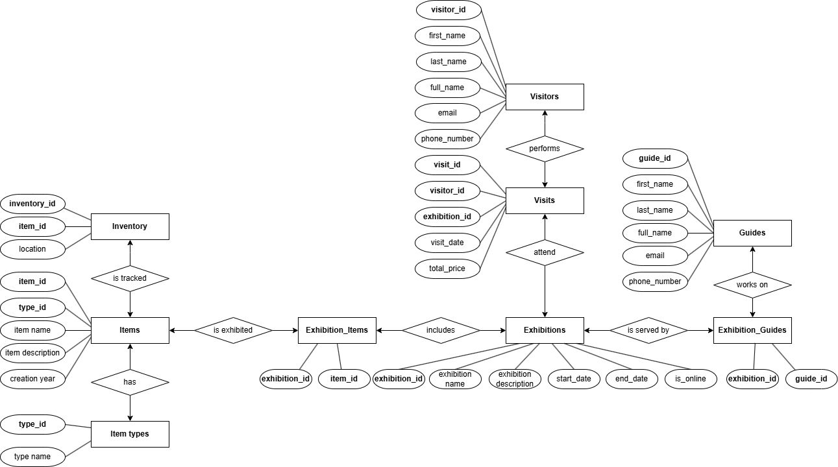

2.3 Logical Scheme
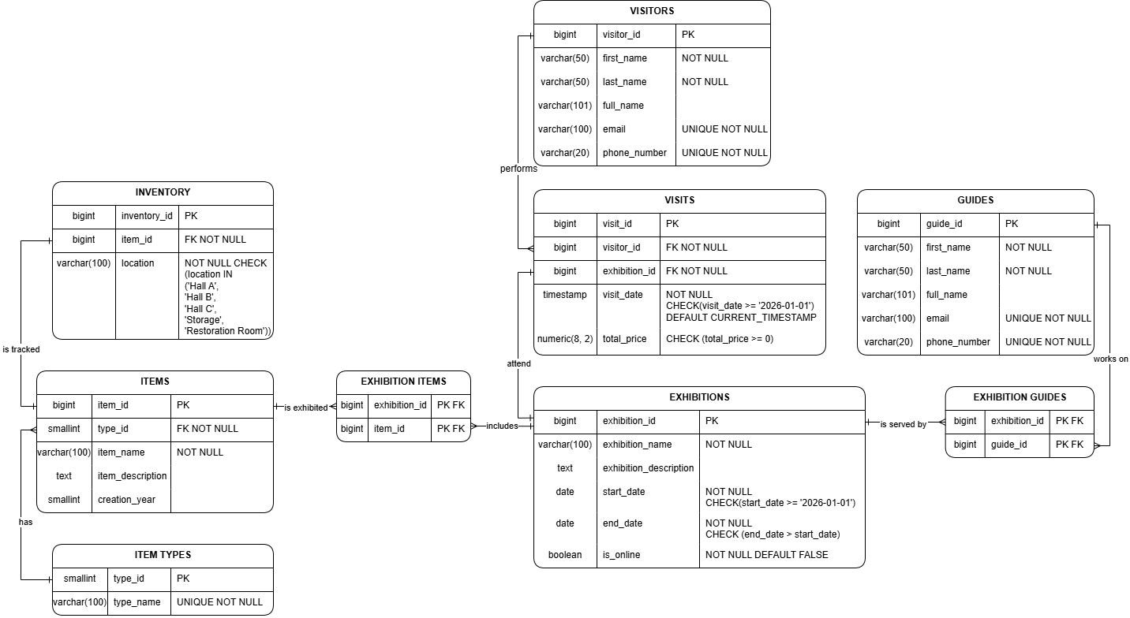

3. Objects
Each table in the Museum Management System represents a distinct real-world concept or event. The following sections describe each table, its purpose, normalization level, key constraints, and sample data.

3.1 VISITORS
The VISITORS table represents any individual who can attend museum exhibitions. It stores personal identification data (name, email, phone) and serves as the person entity in the system. A special GUEST record (guest@museum.com) acts as the anonymous identity for unregistered walk-in visitors, allowing visit tracking without requiring personal data collection.
Why must this information be stored separately?
Visitor data is stored separately from visits to avoid repetition of personal data across every visit record, to enforce uniqueness of contact details (email, phone), and to allow a visitor to be updated (e.g., change of email) in one place. Merging it into visits would violate 1NF and 2NF.
Normalization level:
3NF. The primary key is visitor_id (surrogate). first_name, last_name, email, and phone_number all depend solely on the key. The derived column full_name is a computed/generated column and introduces no transitive dependency.
Primary Key / Foreign Keys:
PK: visitor_id (BIGINT, auto-generated). No FK references in this table. visitor_id is referenced as FK in the visits table.
Table Structure:
Table Name | Field Name | Field Description | Data Type
visitors | visitor_id | Unique identifier for each visitor | BIGINT PK
 | first_name | Visitor's first name | VARCHAR(50) NOT NULL
 | last_name | Visitor's last name | VARCHAR(50) NOT NULL
 | full_name | Computed full name (generated column) | VARCHAR(101)
 | email | Visitor's email address | VARCHAR(100) UNIQUE NOT NULL
 | phone_number | Visitor's phone number | VARCHAR(20) UNIQUE NOT NULL

Example Data:
visitor_id | first_name | last_name | email | phone_number
1 | GUEST | GUEST | guest@museum.com | 0000000000
2 | Robert | Smith | r.smith@email.com | +1555010222
3 | Emily | Davis | emily.d@email.com | +1555010333
4 | Sophia | Brown | sophia.b@email.com | +1555010555

3.2 GUIDES
The GUIDES table stores information about museum employees who lead and manage exhibitions. Each guide has a unique identity (name, email, phone) and can be assigned to one or more exhibitions.
Why must this information be stored separately?
Guides are stored separately from exhibitions to avoid duplicating guide personal data for every exhibition they manage. Separation follows the same normalization logic as VISITORS and enables guides to be updated or retired independently of the exhibitions they have worked on.
Normalization level:
3NF. The primary key is guide_id. All non-key attributes (first_name, last_name, email, phone_number, full_name) depend only on guide_id with no transitive dependencies.
Primary Key / Foreign Keys:
PK: guide_id (BIGINT, auto-generated). guide_id is referenced as FK in the exhibition_guides junction table.
Table Structure:
Table Name | Field Name | Field Description | Data Type
guides | guide_id | Unique identifier for each guide | BIGINT PK
 | first_name | Guide's first name | VARCHAR(50) NOT NULL
 | last_name | Guide's last name | VARCHAR(50) NOT NULL
 | full_name | Computed full name (generated column) | VARCHAR(101)
 | email | Guide's work email address | VARCHAR(100) UNIQUE NOT NULL
 | phone_number | Guide's work phone number | VARCHAR(20) UNIQUE NOT NULL

Example Data:
guide_id | first_name | last_name | email | phone_number
1 | James | Anderson | j.anderson@museum.org | +1555090111
2 | Linda | Taylor | l.taylor@museum.org | +1555090222
3 | Barbara | Moore | b.moore@museum.org | +1555090444

3.3 EXHIBITIONS
The EXHIBITIONS table represents curated displays of museum items offered to the public over a defined time period. Each exhibition has a unique name, descriptive text, date range, and a flag indicating whether it is available online. Exhibitions are the central organizational unit linking visitors (via visits), items (via exhibition_items), and guides (via exhibition_guides).
Why must this information be stored separately?
Exhibition data is stored separately because it is a distinct entity with its own lifecycle (start and end dates), its own staff, and its own item collection. Embedding exhibition data in visits or items would cause massive duplication and make date-range queries and scheduling impossible.
Normalization level:
3NF. The primary key is exhibition_id. All attributes (exhibition_name, description, start_date, end_date, is_online) depend fully and only on exhibition_id.
Primary Key / Foreign Keys:
PK: exhibition_id (BIGINT, auto-generated). exhibition_id is referenced as FK in visits, exhibition_items, and exhibition_guides.
Table Structure:
Table Name | Field Name | Field Description | Data Type
exhibitions | exhibition_id | Unique identifier for each exhibition | BIGINT PK
 | exhibition_name | Name of the exhibition | VARCHAR(100) NOT NULL
 | exhibition_description | Detailed description of the exhibition | TEXT
 | start_date | Start date; must be >= 2026-01-01 | DATE NOT NULL
 | end_date | End date; must be > start_date | DATE NOT NULL
 | is_online | Whether the exhibition is available online | BOOLEAN NOT NULL DEFAULT FALSE

Example Data:

exhibition_id | exhibition_name | start_date | end_date | is_online
1 | Masterpieces of World Art | 2026-02-15 | 2026-04-20 | false
2 | History and Science Through Time | 2026-02-01 | 2026-12-31 | true
3 | Ancient Civilizations | 2026-03-10 | 2026-06-15 | false

3.4 VISITS
The VISITS table is a transactional entity recording each instance of a visitor attending an exhibition. It captures the precise timestamp of the visit and the price paid. It acts as a fact table, connecting the visitor and exhibition dimensions and supporting revenue and attendance analytics.
Why must this information be stored separately?
Visits must be stored separately because they are events– distinct occurrences that happen at a point in time. Embedding visit data inside the visitor or exhibition tables would create repeating groups, violate 1NF, and make it impossible to track multiple visits by the same person to different exhibitions.
Normalization level:
3NF. The composite relationship (visitor_id, exhibition_id, visit_date) naturally identifies each row. total_price depends on the visit event itself and not on either FK independently.
Primary Key / Foreign Keys:
PK: visit_id (BIGINT, auto-generated). FK: visitor_id references visitors(visitor_id); FK: exhibition_id references exhibitions(exhibition_id).
Table Structure:
Table Name | Field Name | Field Description | Data Type
visits | visit_id | Unique identifier for each visit | BIGINT PK
 | visitor_id | Reference to the visiting person | BIGINT FK NOT NULL
 | exhibition_id | Reference to the attended exhibition | BIGINT FK NOT NULL
 | visit_date | Timestamp of the visit; must be >= 2026-01-01; defaults to now | TIMESTAMP NOT NULL
 | total_price | Price paid for the visit; must be >= 0 | NUMERIC(8,2)

Example Data:
visit_id | visitor_id | exhibition_id | visit_date | total_price
1 | 1 (GUEST) | 1 (Masterpieces of World Art) | 2026-02-07 12:38:59 | 10.00
2 | 3 (Emily Davis) | 1 (Masterpieces of World Art) | 2026-03-12 14:21:16 | 15.00
3 | 4 (Sophia Brown) | 2 (History and Science) | 2026-04-23 18:09:41 | 15.00

3.5 ITEM_TYPES
The ITEM_TYPES table is a reference (lookup) table that classifies museum items into categories such as Artwork, Sculpture, Artifact, Manuscript, Scientific Instrument, and so on. It standardizes item classification and prevents free-text inconsistencies.
Why must this information be stored separately?
Storing types in a dedicated table rather than as a plain text column in items allows: consistent spelling and validation via FK, easy extension with new types, and efficient filtering/grouping of items by type without string comparison.
Normalization level:
1NF / 2NF / 3NF. The table has a simple PK (type_id) and a single non-key attribute (type_name), which depends entirely on type_id. There are no partial or transitive dependencies.
Primary Key / Foreign Keys:
PK: type_id (SMALLINT, manually assigned). type_id is referenced as FK in the items table.
Table Structure:
Table Name | Field Name | Field Description | Data Type
item_types | type_id | Unique identifier for the item type | SMALLINT PK
 | type_name | Descriptive name of the item category | VARCHAR(100) UNIQUE NOT NULL

Example Data:
type_id | type_name
1 | Artwork
2 | Sculpture
4 | Artifact
15 | Scientific Instrument

3.6 ITEMS

The ITEMS table stores the museum's permanent collection. Each item is a unique physical or digital object (artwork, sculpture, manuscript, fossil, instrument, etc.) that can be displayed in exhibitions. Attributes include the item's name, description, type classification, and year of creation.
Why must this information be stored separately?
Items must be stored separately from exhibitions because an item has an existence independent of any particular exhibition– it was created in a specific year, belongs to a type, and can be featured in multiple exhibitions across time. Embedding items in exhibitions would make it impossible to track an item's full exhibition history.
Normalization level:
3NF. The primary key is item_id. item_name, item_description, creation_year, and type_id all depend only on item_id. type_id is a FK to item_types– not a transitive dependency, since it classifies the item without creating a chain of non-key dependencies.
Primary Key / Foreign Keys:
PK: item_id (BIGINT, auto-generated). FK: type_id references item_types(type_id). item_id is referenced as FK in inventory and exhibition_items.
Table Structure:
Table Name | Field Name | Field Description | Data Type
items | item_id | Unique identifier for each museum item | BIGINT PK
 | type_id | Classification reference to item_types | SMALLINT FK NOT NULL
 | item_name | Name of the museum item | VARCHAR(100) NOT NULL
 | item_description | Descriptive text about the item | TEXT
 | creation_year | Year the item was created (negative = BCE) | SMALLINT

Example Data:
item_id | type_id | item_name | creation_year
1 | 1 (Artwork) | Mona Lisa | 1503
2 | 2 (Sculpture) | David | 1504
4 | 4 (Artifact) | Rosetta Stone | -196
6 | 15 (Scientific Instrument) | Antikythera Mechanism | -100

3.7 INVENTORY
The INVENTORY table tracks the current physical location of each museum item within the building. Locations are constrained to known halls and rooms: Hall A, Hall B, Hall C, Storage, and Restoration Room. This enables staff to quickly locate any item in the collection.
Why must this information be stored separately?
Inventory is stored separately from items because location is an operational attribute that changes independently of the item's identity or type. An item may move between halls or enter storage without any change to its descriptive data. The separation enables accurate location tracking at any point in time.
Normalization level:
3NF. PK is inventory_id. item_id (FK) and location depend only on inventory_id. There are no transitive dependencies.
Primary Key / Foreign Keys:
PK: inventory_id (BIGINT, auto-generated). FK: item_id references items(item_id). Location is constrained by a CHECK to valid values: Hall A, Hall B, Hall C, Storage, Restoration Room.
Table Structure:
Table Name | Field Name | Field Description | Data Type
inventory | inventory_id | Unique identifier for each inventory record | BIGINT PK
 | item_id | Reference to the museum item | BIGINT FK NOT NULL
 | location | Physical location of the item in the museum | VARCHAR(100) NOT NULL CHECK(location IN ('Hall A','Hall B','Hall C','Storage','Restoration Room'))

Example Data:

inventory_id | item_id | item_name (ref) | location
1 | 1 | Mona Lisa | Hall A
2 | 2 | David | Hall A
3 | 3 | The Last Supper Sketches | Hall B
4 | 4 | Rosetta Stone | Hall C

3.8 EXHIBITION_ITEMS
The EXHIBITION_ITEMS junction table resolves the many-to-many relationship between exhibitions and items. Each row records that a specific item is (or was) displayed in a specific exhibition.
Why must this information be stored separately?
This junction table is necessary because a single exhibition can feature many items, and a single item can be featured in multiple exhibitions over time. Without this table, either side would require multi-valued attributes, violating 1NF.
Normalization level:
Composite PK (exhibition_id, item_id)– fully in 3NF with no non-key attributes at all.
Primary Key / Foreign Keys:
PK: composite (exhibition_id, item_id). FK: exhibition_id references exhibitions(exhibition_id); FK: item_id references items(item_id).
Table Structure:
Table Name | Field Name | Field Description | Data Type
exhibition_items | exhibition_id | Reference to the exhibition | BIGINT PK FK
 | item_id | Reference to the displayed item | BIGINT PK FK

Example Data:
exhibition_id | exhibition_name (ref) | item_id | item_name (ref)
1 | Masterpieces of World Art | 1 | Mona Lisa
1 | Masterpieces of World Art | 2 | David
2 | History and Science Through Time | 4 | Rosetta Stone
2 | History and Science Through Time | 6 | Antikythera Mechanism

3.9 EXHIBITION_GUIDES
The EXHIBITION_GUIDES junction table records the assignment of guides to exhibitions. Each row establishes that a specific guide is responsible for servicing a specific exhibition.
Why must this information be stored separately?
A guide can work on multiple exhibitions, and an exhibition can have multiple guides– a classic many-to-many relationship. The junction table is the normalized solution, avoiding duplication of guide details in the exhibitions table or repetition of exhibition data in the guides table.
Normalization level:
Composite PK (exhibition_id, guide_id)– fully in 3NF with no non-key attributes.
Primary Key / Foreign Keys:
PK: composite (exhibition_id, guide_id). FK: exhibition_id references exhibitions(exhibition_id); FK: guide_id references guides(guide_id).
Table Structure:
Table Name | Field Name | Field Description | Data Type
exhibition_guides | exhibition_id | Reference to the exhibition | BIGINT PK FK
 | guide_id | Reference to the assigned guide | BIGINT PK FK

Example Data:
exhibition_id | exhibition_name (ref) | guide_id | guide name (ref)
1 | Masterpieces of World Art | 1 | James Anderson
1 | Masterpieces of World Art | 2 | Linda Taylor
2 | History and Science Through Time | 4 | Barbara Moore
2 | History and Science Through Time | 5 | Richard Jackson

