Figure out what security precautions are already used in your 'dvd_rental' database. Prepare description. Include SQL queries you used and their outputs for evidence. Explain whether it is sufficient or risky. Identify at least one potential security vulnerability and suggest an improvement. Focus on:
- Existing users/roles and their permissions
SQL Query:
SELECT rolname, rolsuper, rolinherit, rolcreaterole, rolcanlogin
FROM pg_roles;
Query Output:
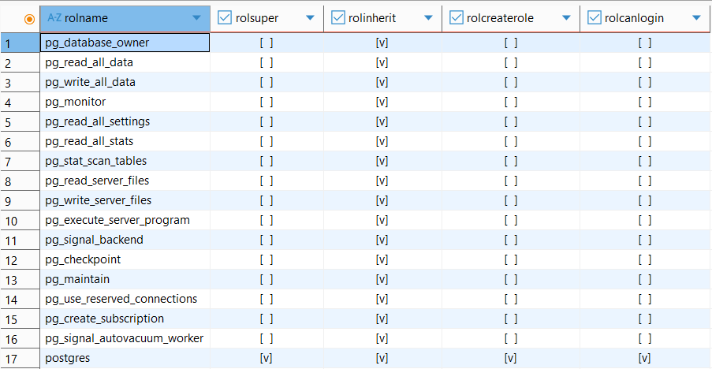
The database primarily relies on default system roles, with postgres being the only account possessing superuser status (rolsuper), role creation capabilities (rolcreaterole), and login permissions (rolcanlogin). This configuration is considered highly risky for a production environment because it lacks a granular access control model, forcing all administrative and potentially operational tasks to be performed by a single, all-powerful entity.
- Table-level privileges
SQL Query:
SELECT grantee, table_name, privilege_type
FROM information_schema.table_privileges
WHERE table_schema = 'public';
Query Output:
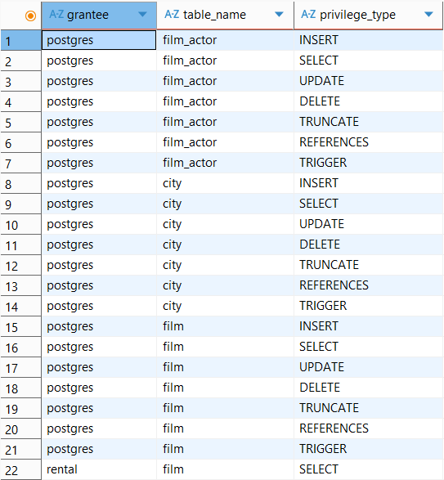
…
It confirms that this single account holds full control (INSERT, SELECT, UPDATE, DELETE, TRUNCATE, REFERENCES and TRIGGER) over all tables.
- Any existing row-level security policies
SQL Query:
SELECT c.relname AS table_name,
c.relrowsecurity AS rls_enabled,
c.relforcerowsecurity AS rls_forced
FROM pg_class c
JOIN pg_namespace n ON n.oid = c.relnamespace
WHERE n.nspname = 'public'
AND c.relkind IN ('r', ‘p’)
ORDER BY c.relname;
Query Output:
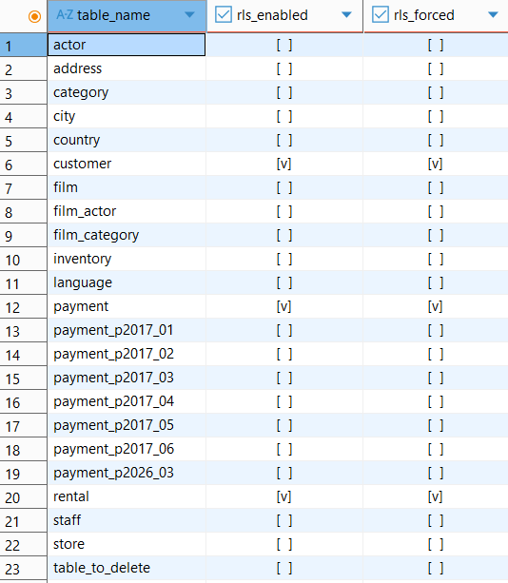
By default, Row-Level Security (RLS) was disabled for all tables in the database. However, after implementing specific security policies for each customer, the RLS status for the customer, rental, and payment tables has changed to enabled (true). The database now actively filters data access at the row level based on the current user's identity.
SQL Query:
SELECT schemaname,
tablename,
policyname,
permissive,
roles,
cmd
FROM pg_policies
WHERE schemaname = 'public'
ORDER BY tablename, policyname;
Query Output:
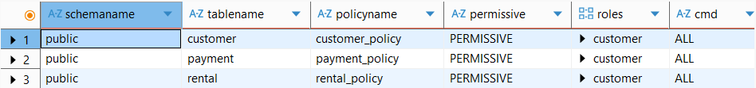
The query results confirm that Row-Level Security policies have been successfully created and applied. The customer_policy, payment_policy, and rental_policy are assigned to the customer role and cover all database operations (ALL), ensuring that access control is strictly enforced.
- Database-level settings like connection limits or authentication methods
SQL Query:
SELECT datname, datconnlimit
FROM pg_database
WHERE datname = 'dvdrental';
Query Output:
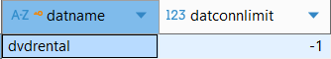
The connection limit for the dvdrental database is set to -1, which means unlimited connections are allowed. While this simplifies development and testing, it creates a risk in production scenarios: a malfunctioning application, a connection pool misconfiguration, or a deliberate denial-of-service attempt could exhaust PostgreSQL's max_connections setting (default: 100), making the database inaccessible to all clients.
5. Vulnerability
The customer table contains personal data including names, email addresses, and address references. Because RLS is disabled, any session authenticated as dvdrental_app can read or modify records for every customer in the database. In a multi-tenant or staff-facing application, this means a support agent with access to the dvdrental_app role could query or update another agent's customers without any database-enforced restriction. The same situation with rental and payment tables.
As a secondary measure, the postgres superuser should be restricted to local connections only, preventing remote login attempts. Administrative tasks should be handled via a separate, named account rather than the default superuser. This approach protects the database from external attacks.

