**Assignment -07**

**Creating a Virtual Machine, SQL Server Database, and VPN Configuration in Azure Portal**

1. Creating VPN Configuration in Azure Portal:

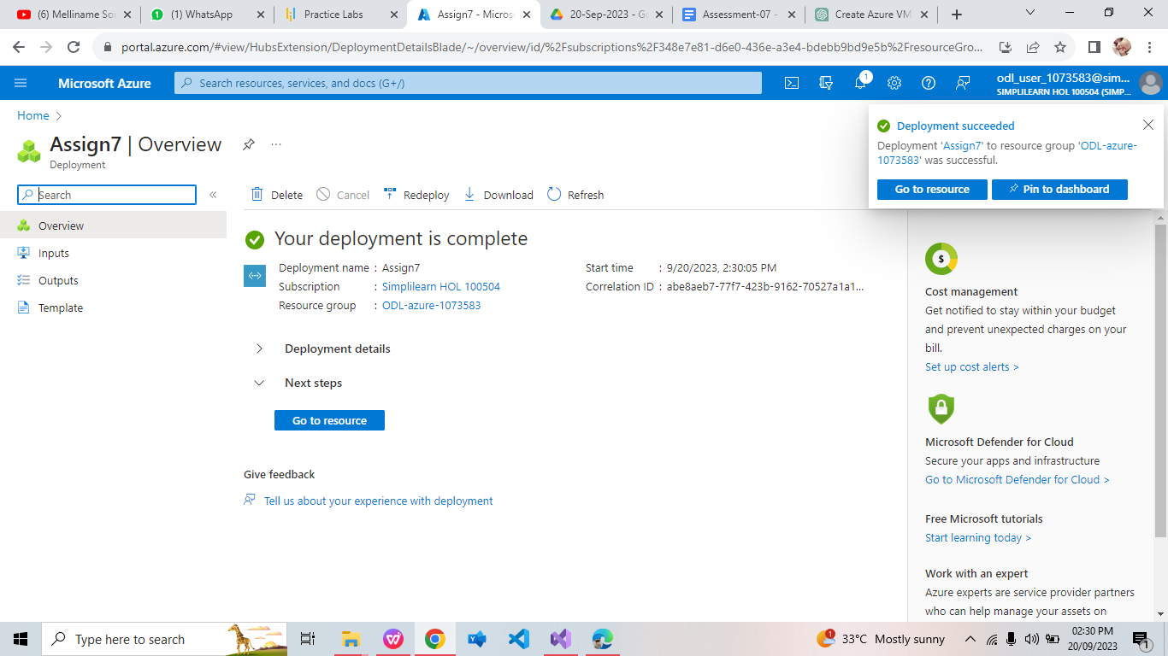

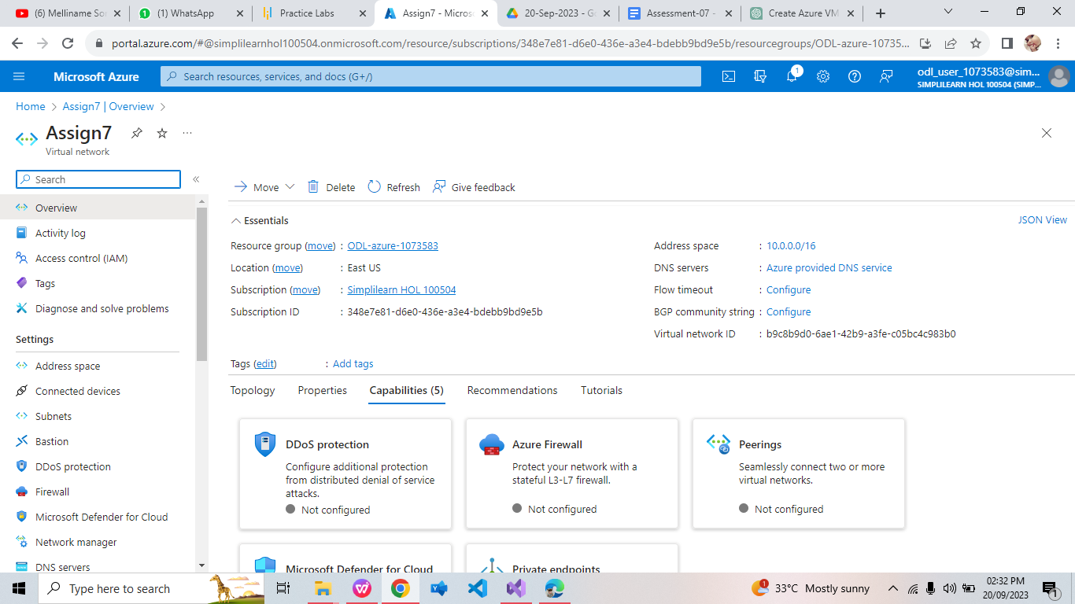

1. Creating SQL Database in Azure Portal:

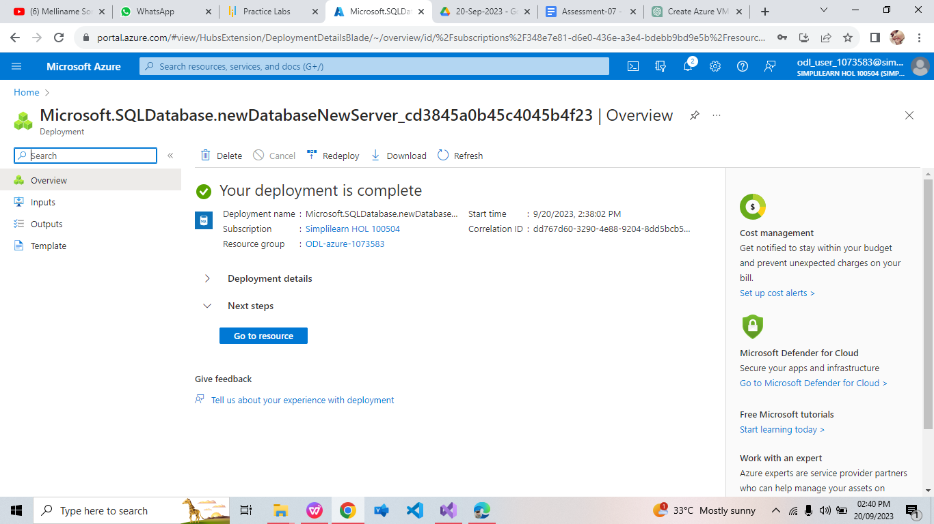

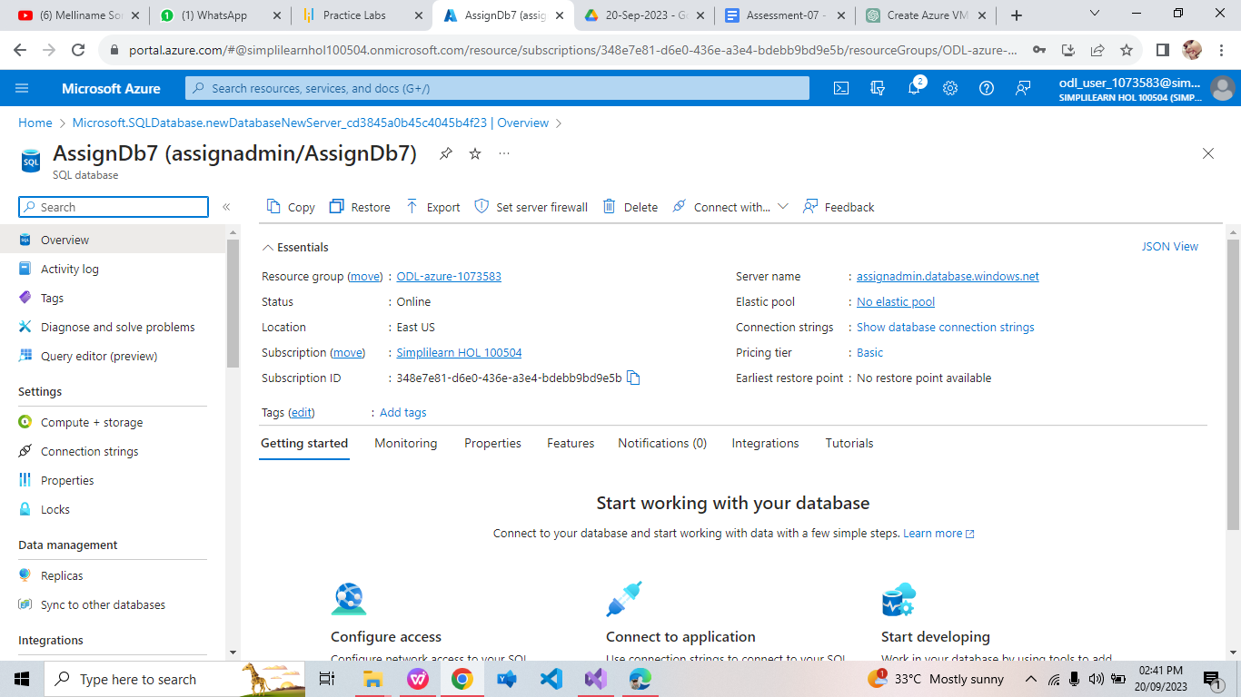

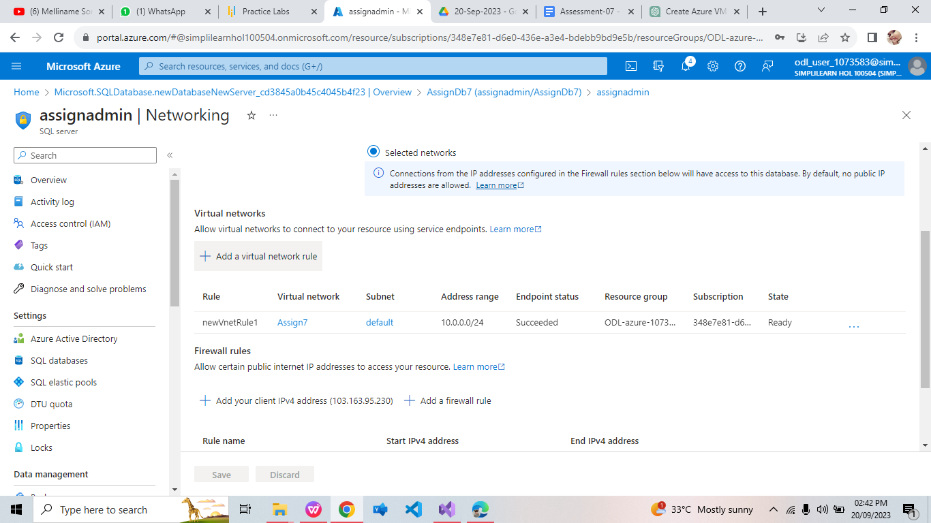

1. Creating Virtual Machine in Azure Portal:

