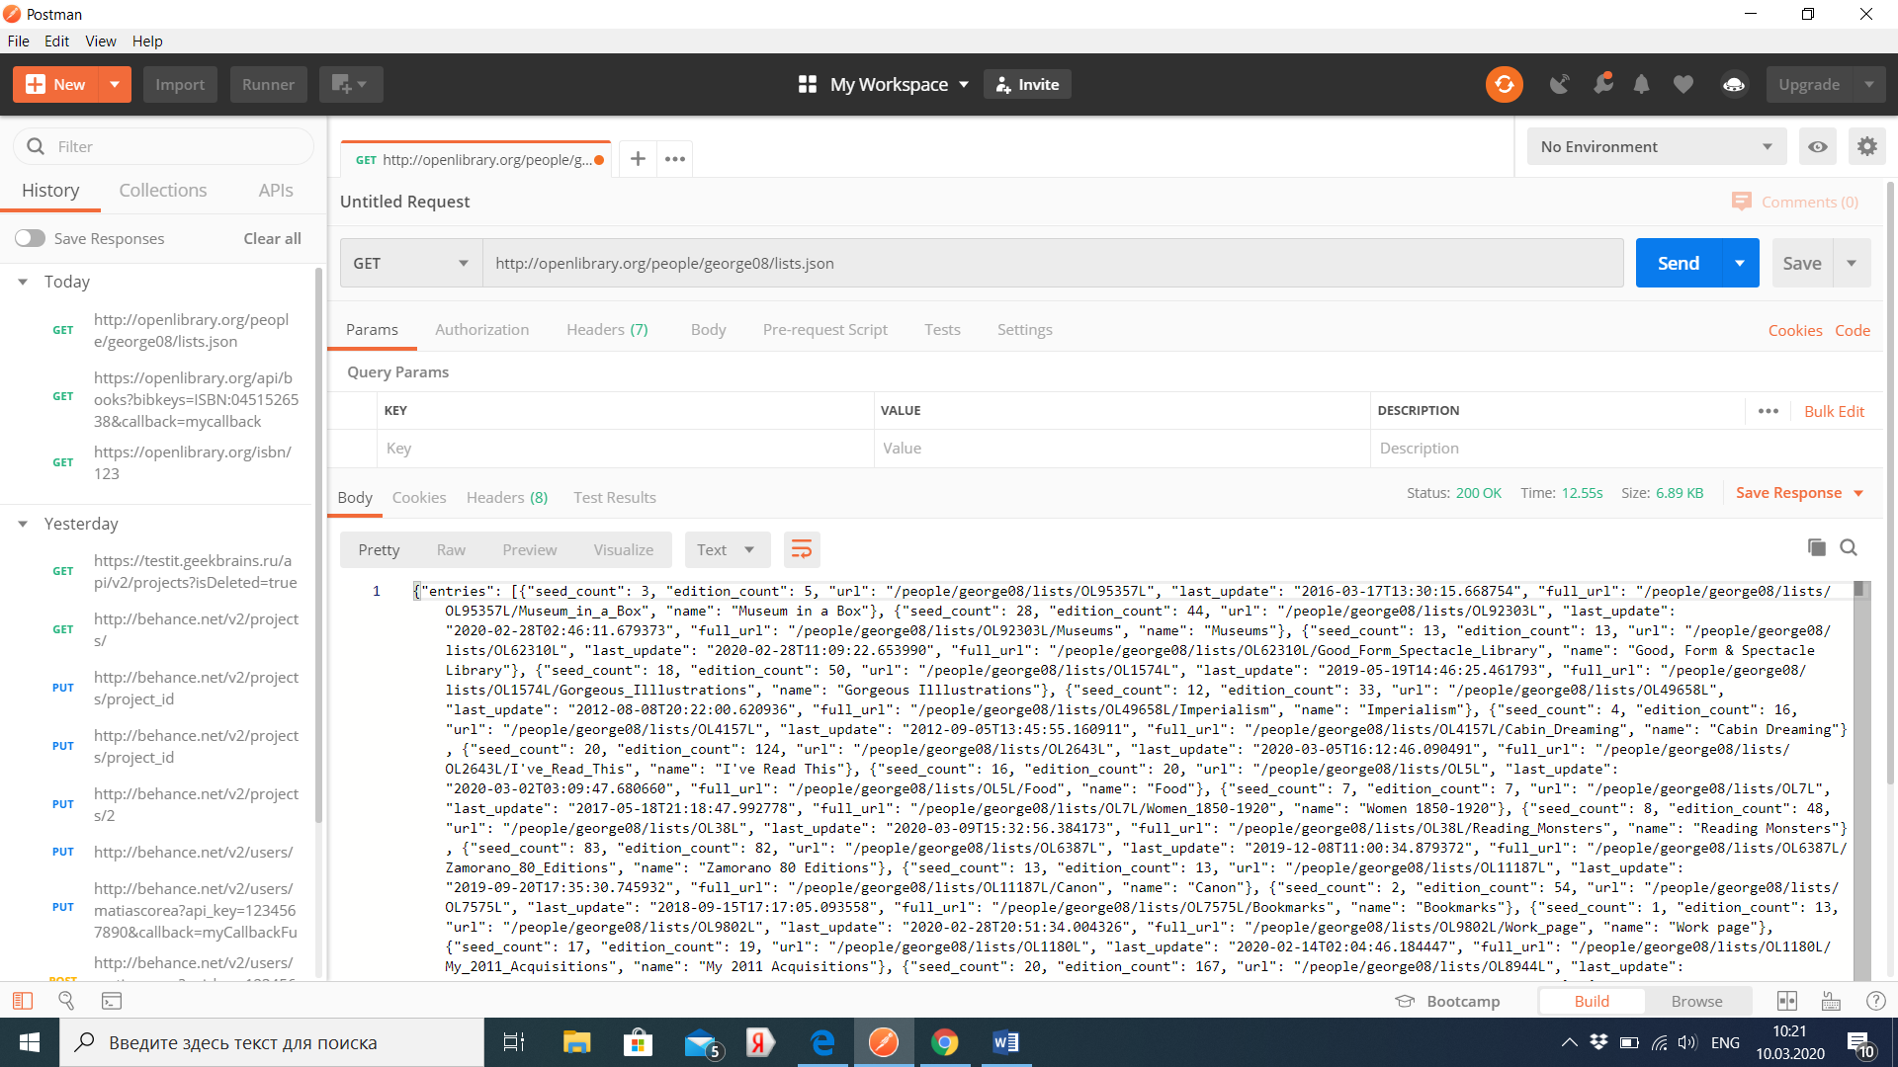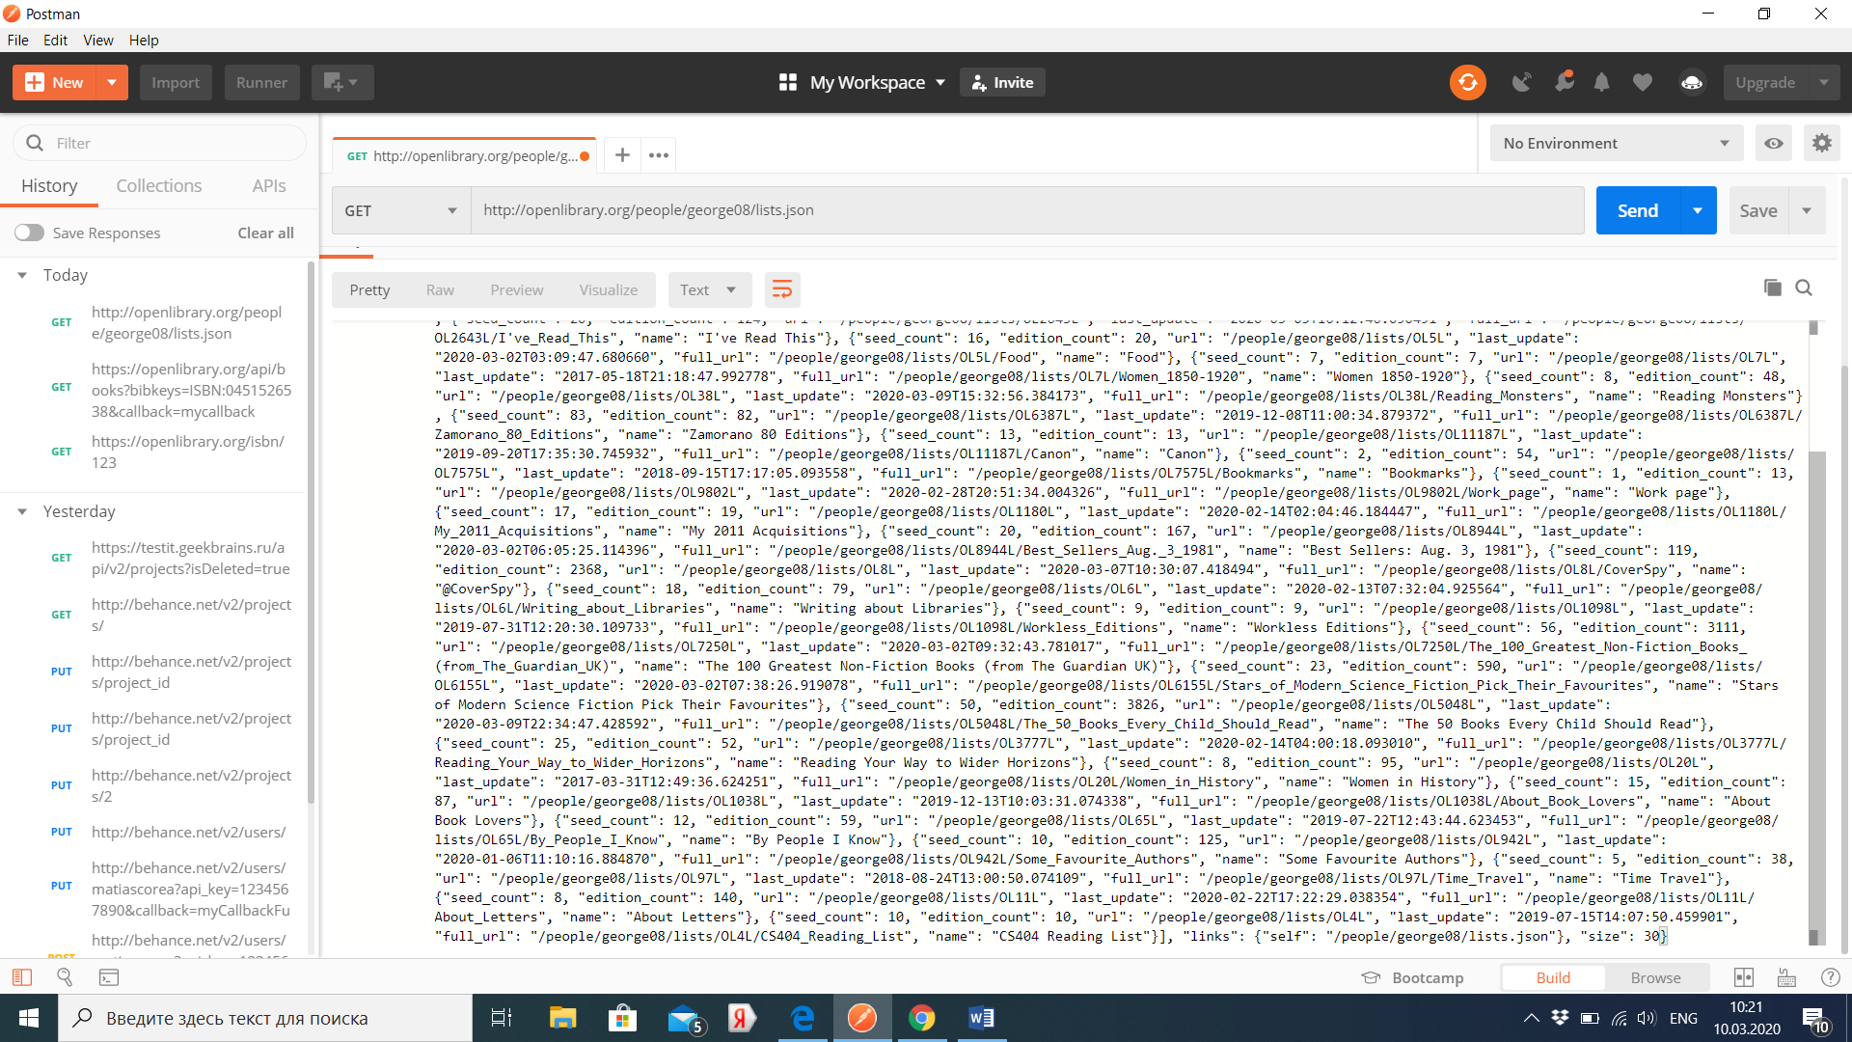

**Запрос методом get**

GET <http://openlibrary.org/people/george08/lists.json>

**Выходные данные**

{

"links": {

"self": "/people/george08/lists.json",

"next": "/people/george08/lists.json?limit=5&offset=5"

},

"size": 12,

"entries": [

{

"url": "/people/george08/lists/OL13L",

"full_url": "/people/george08/lists/OL13L/Various_Seeds_for_Testing",

"name": "Various Seeds for Testing",

"last_update": "2010-12-21T00:46:17.712513",

"seed_count": 13,

"edition_count": 13181

},

{

"url": "/people/george08/lists/OL97L",

"full_url": "/people/george08/lists/OL97L/Time_Travel",

"name": "Time Travel",

"last_update": "2010-12-17T18:27:14.781336",

"seed_count": 5,

"edition_count": 838

},

...

]

}