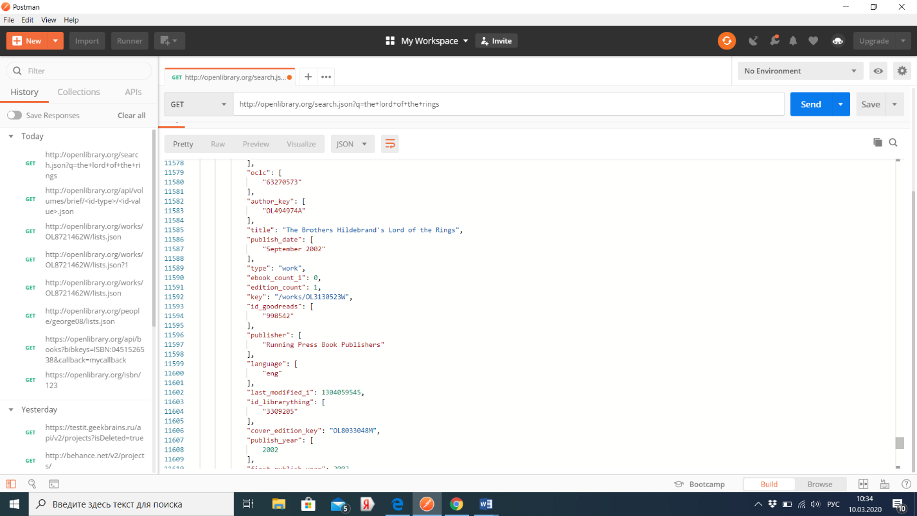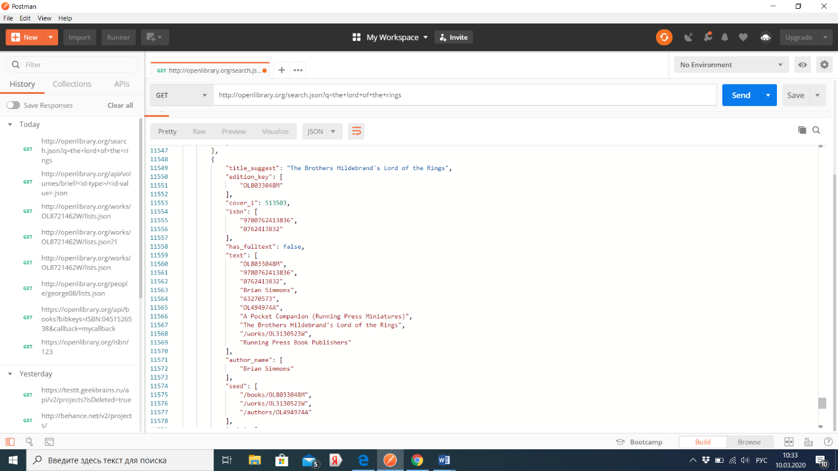

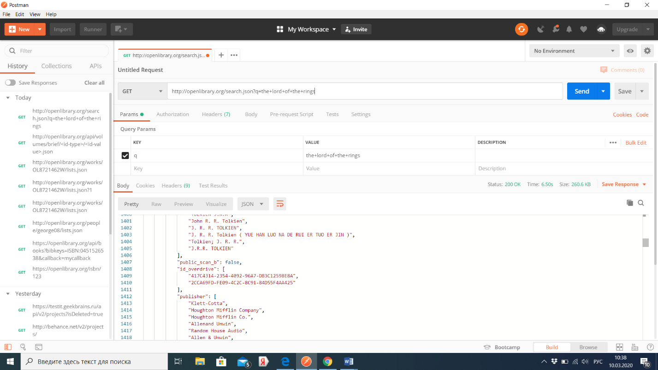**Выходные данные**

{

"start": 0,

"num_found": 629,

"docs": [

{...},

{...},

{...},

...

{...}]

}

Каждый документ в "docs"имеет следующий вид:

{

"cover_i": 258027,

"has_fulltext": true,

"edition_count": 120,

"title": "The Lord of the Rings",

"author_name": [

"J. R. R. Tolkien"

],

"first_publish_year": 1954,

"key": "OL27448W",

"ia": [

"returnofking00tolk_1",

"lordofrings00tolk_1",

"lordofrings00tolk_0",

"lordofrings00tolk_3",

"lordofrings00tolk_2",

"lordofrings00tolk",

"twotowersbeingse1970tolk",

"lordofring00tolk",

"lordofrings56tolk",

"lordofringstolk00tolk",

"fellowshipofring00tolk_0"

],

"author_key": [

"OL26320A"

],

"public_scan_b": true

}