E03-01. Implement algorithms of Breath-First Search(BFS) and give some examples to test it.

Input: a node s, an undirected graph G of n nodes

Output: the layers of nodes, BFS Tree

#include <iostream>  
#include <vector>  
#include <queue>  
using namespace std;  
class Graph {  
private:  
 int V;  
 vector<vector<int>> adj;  
public:  
 Graph(int V) : V(V) {  
 adj.resize(V);  
 }  
 void addEdge(int u, int v) {  
 adj[u].push_back(v);  
 adj[v].push_back(u);  
 }  
 vector<int> bfs(int s) {  
 vector<bool> visited(V, false);  
 vector<int> layers(V, -1);  
 queue<int> q;  
 visited[s] = true;  
 layers[s] = 0;  
 q.push(s);  
 while (!q.empty()) {  
 int u = q.front();  
 q.pop();  
 for (int v : adj[u]) {  
 if (!visited[v]) {  
 visited[v] = true;  
 layers[v] = layers[u] + 1;  
 q.push(v);  
 }  
 }  
 }  
 return layers;  
 }  
};  
  
int main() {  
 int n, m;  
 cout << "请输入图的节点个数和边个数：";  
 cin >> n >> m;  
 Graph g(n);  
 cout << "请输入图的边：" << endl;  
 for (int i = 0; i < m; ++i) {  
 int u, v;  
 cin >> u >> v;  
 g.addEdge(u, v);  
 }  
 int startNode;  
 cout << "请输入BFS的起始节点：";  
 cin >> startNode;  
 vector<int> layers = g.bfs(startNode);  
 cout << "BFS树结构如下：" ;  
 for (int i = 0; i < n; ++i) {  
 cout << "Node " << i << ": " << layers[i] << endl;  
 }  
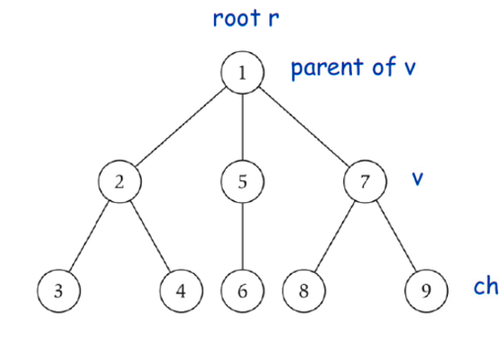 return 0;  
}

如图，对于该示例input，运行结果如下：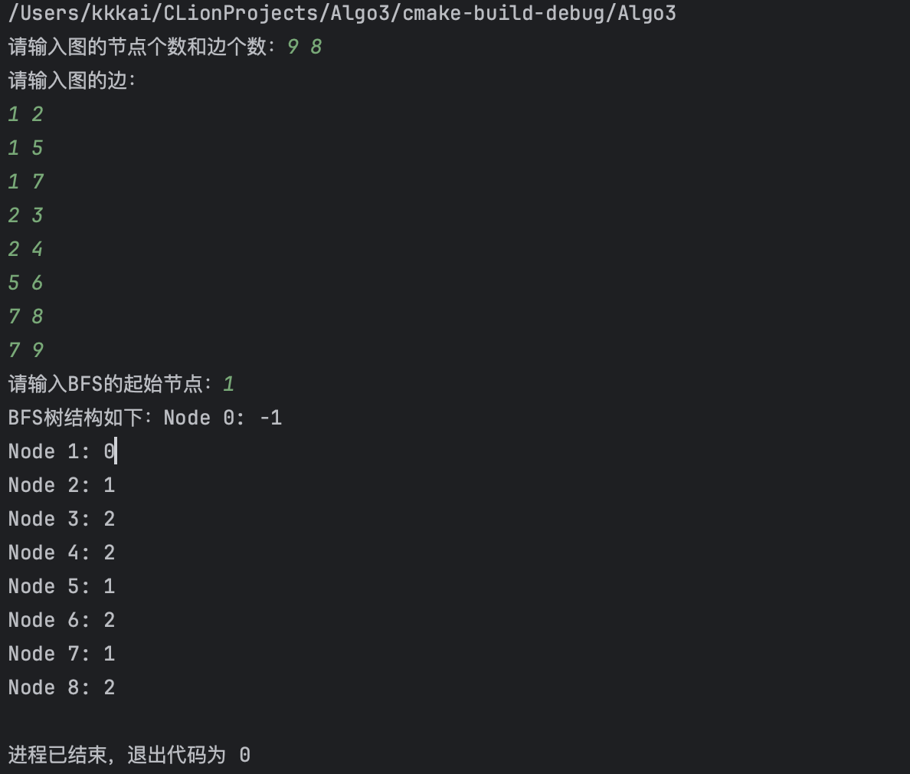

E03-02. Implement algorithms of connected component with BFS and DFS respectively and give some examples to test it.

Input: a node s, an undirected graph G of n nodes

Output: the connected component containing 𝑠.

#include <iostream>  
#include <vector>  
#include <queue>  
#include <stack>  
using namespace std;  
class Graph {  
public:  
 int V;  
 vector<vector<int>> adj;  
public:  
 Graph(int V) : V(V) {  
 adj.resize(V);  
 }  
 void addEdge(int u, int v) {  
 adj[u].push_back(v);  
 adj[v].push_back(u);  
 }  
 vector<int> bfs(int s) {  
 vector<bool> visited(V, false);  
 vector<int> layers(V, -1);  
 queue<int> q;  
 visited[s] = true;  
 layers[s] = 0;  
 q.push(s);  
 while (!q.empty()) {  
 int u = q.front();  
 q.pop();  
 for (int v : adj[u]) {  
 if (!visited[v]) {  
 visited[v] = true;  
 layers[v] = layers[u] + 1;  
 q.push(v);  
 }  
 }  
 }  
 return layers;  
 }  
 vector<int> dfs(int s) {  
 vector<bool> visited(V, false);  
 vector<int> result;  
 stack<int> stk;  
 stk.push(s);  
 while (!stk.empty()) {  
 int u = stk.top();  
 stk.pop();  
 if (!visited[u]) {  
 visited[u] = true;  
 result.push_back(u);  
 for (int v : adj[u]) {  
 if (!visited[v]) {  
 stk.push(v);  
 }  
 }  
 }  
 }  
 return result;  
 }  
};  
  
int main() {  
 int n, m;  
 cout << "请输入图的节点个数和边个数：";  
 cin >> n >> m;  
 Graph g(n);  
 cout << "请输入图的边：" << endl;  
 for (int i = 0; i < m; ++i) {  
 int u, v;  
 cin >> u >> v;  
 g.addEdge(u, v);  
 }  
 int startNode;  
 cout << "请输入起始节点：";  
 cin >> startNode;  
 vector<int> layers = g.bfs(startNode);  
 vector<int> result = g.dfs(startNode);  
 cout << "BFS求出的连通分量：" ;  
 Graph temp=g;  
 for (int i=0;i<n+1;i++){  
 if(layers[i]!=-1&&i!=startNode) {  
 cout << i << ":";  
 cout<<endl;  
 while(!g.adj[i].empty()) {  
 cout <<"("<< i<< ","<<g.adj[i].front()<<")";  
 g.adj[i].erase(g.adj[i].begin());  
 cout<<endl;  
 }  
  
 }  
 }  
 cout<<endl;  
 cout << "DFS求出的连通分量：" ;  
 for(int u:result)  
 if(u!=startNode) {  
 cout<<endl;  
 cout << u << ":";  
 while(!temp.adj[u].empty()) {  
 cout <<"("<< u<< ","<<temp.adj[u].front()<<")";  
 temp.adj[u].erase(temp.adj[u].begin());  
 cout<<endl;  
 }  
 }  
 return 0;  
}

如图，对于如下示例input，输出如下：

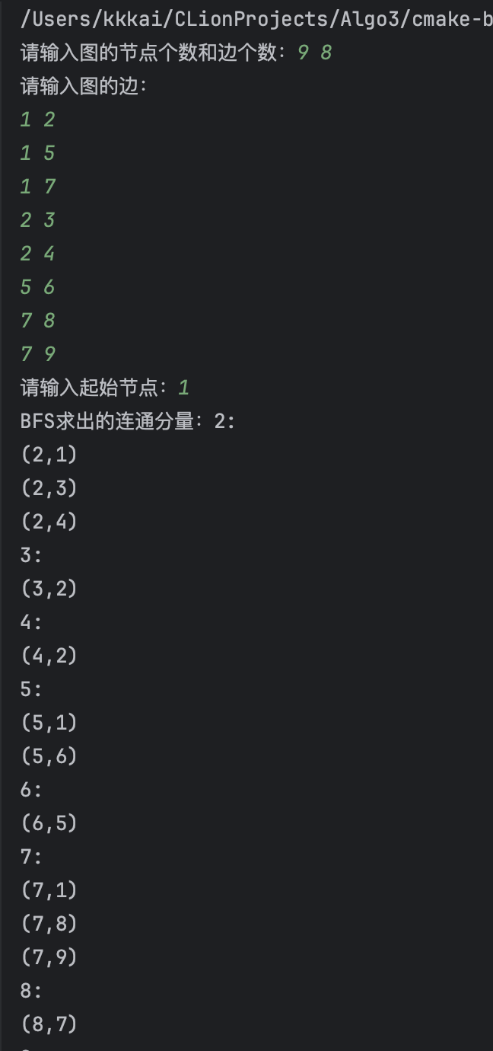 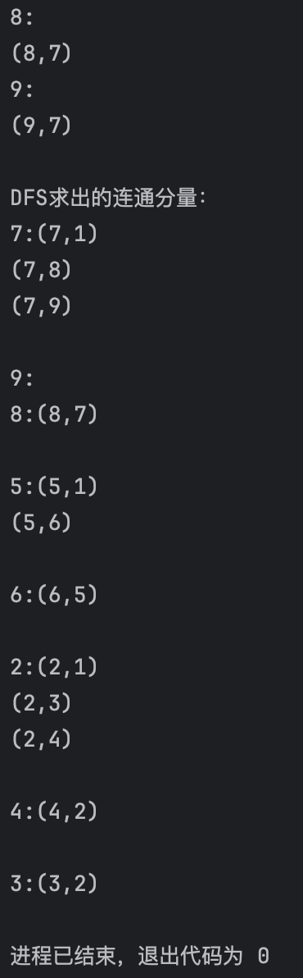

E03-03. Implement the algorithms of testing bipartiteness and give some examples to test it.

Input: an undirected graph G of n nodes  
Output: “Yes” if G is bipartite graph, or “No” if G is not.

#include <iostream>  
#include <vector>  
#include <queue>  
using namespace std;  
enum Color { *UNCOLORED*, *RED*, *BLUE* };  
class Graph {  
public:  
 int V;  
 vector<vector<int>> adj;  
public:  
 Graph(int V) : V(V) {  
 adj.resize(V);  
 }  
 void addEdge(int u, int v) {  
 adj[u].push_back(v);  
 adj[v].push_back(u);  
 }  
 bool isBipartite() {  
 vector<Color> colors(V, *UNCOLORED*);  
 queue<int> q;  
 for (int i = 0; i < V; ++i) {  
 if (colors[i] == *UNCOLORED*) {  
 colors[i] = *RED*;  
 q.push(i);  
 while (!q.empty()) {  
 int u = q.front();  
 q.pop();  
 for (int v : adj[u]) {  
 if (colors[v] == *UNCOLORED*) {  
 colors[v] = (colors[u] == *RED*) ? *BLUE* : *RED*;  
 q.push(v);  
 } else if (colors[v] == colors[u]) {  
 return false;   
 }  
 }  
 }  
 }  
 }  
 return true;   
 }  
};  
int main() {  
 int n, m;  
 cout << "输入图的顶点数、边数：";  
 cin >> n >> m;  
 Graph g(n);  
 cout << "输入图的边:" << endl;  
 for (int i = 0; i < m; ++i) {  
 int u, v;  
 cin >> u >> v;  
 g.addEdge(u, v);  
 }  
 if (g.isBipartite())  
 cout << "Yes" << endl;  
 else   
 cout << "No" << endl;  
 return 0;  
}

则对于如下示例：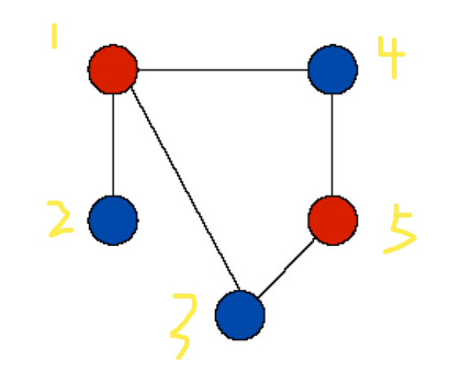，输出如下：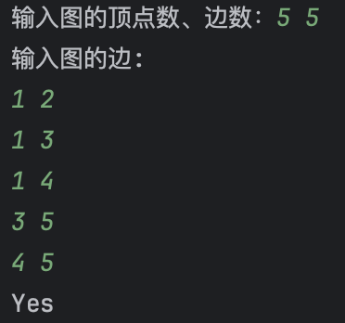

对于如下示例：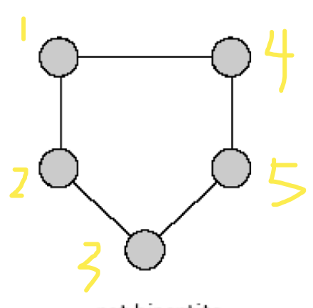，输出如下：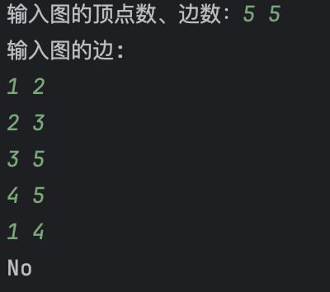

E03-04. Implement the algorithms of the topological order and give some examples to test it.

Input: a directed graph G of n nodes Output: the topological ordering of G

#include <iostream>  
#include <vector>  
#include <queue>  
using namespace std;  
class Graph {  
public:  
 int V;  
 vector<vector<int>> adj;  
public:  
 Graph(int V) : V(V) {  
 adj.resize(V);  
 }  
 void addEdge(int u, int v) {  
 adj[u].push_back(v);  
 }  
 vector<int> topologicalSort() {  
 vector<int> indegree(V, 0);  
 for (int u = 0; u < V; ++u) {  
 for (int v : adj[u]) {  
 indegree[v]++;  
 }  
 }  
 queue<int> q;  
 for (int u = 0; u < V; ++u) {  
 if (indegree[u] == 0) {  
 q.push(u); }  
 }  
 vector<int> result;  
 while (!q.empty()) {  
 int u = q.front();  
 q.pop();  
 result.push_back(u);  
 for (int v : adj[u]) {  
 indegree[v]--;  
 if (indegree[v] == 0) {  
 q.push(v);  
 } } }  
 if (result.size() != V) {  
 return vector<int>(); }  
 return result;  
 }  
};  
int main() {  
 int n, m;  
 cout << "输入有向图的顶点数和边数：";  
 cin >> n >> m;  
 Graph g(n);  
 cout << "输入有向图的边：" << endl;  
 for (int i = 0; i < m; ++i) {  
 int u, v;  
 cin >> u >> v;  
 g.addEdge(u, v);  
 }  
 vector<int> topologicalOrder = g.topologicalSort();  
 if (topologicalOrder.empty()) {  
 cout << "有向图含环，无法构成拓扑序列" << endl;  
 } else {  
 cout << "该有向图的一种可能拓扑序列如下：";  
 for (int node : topologicalOrder) {  
 cout << node << " ";  
 }  
 cout << endl;  
 }  
 return 0;  
}

则对于如下输入：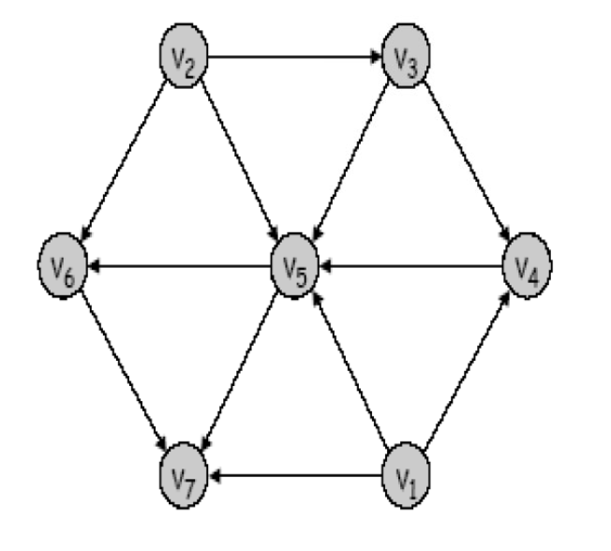输出如下：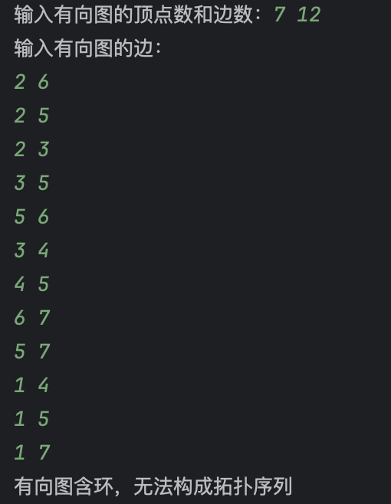

对于如下输入：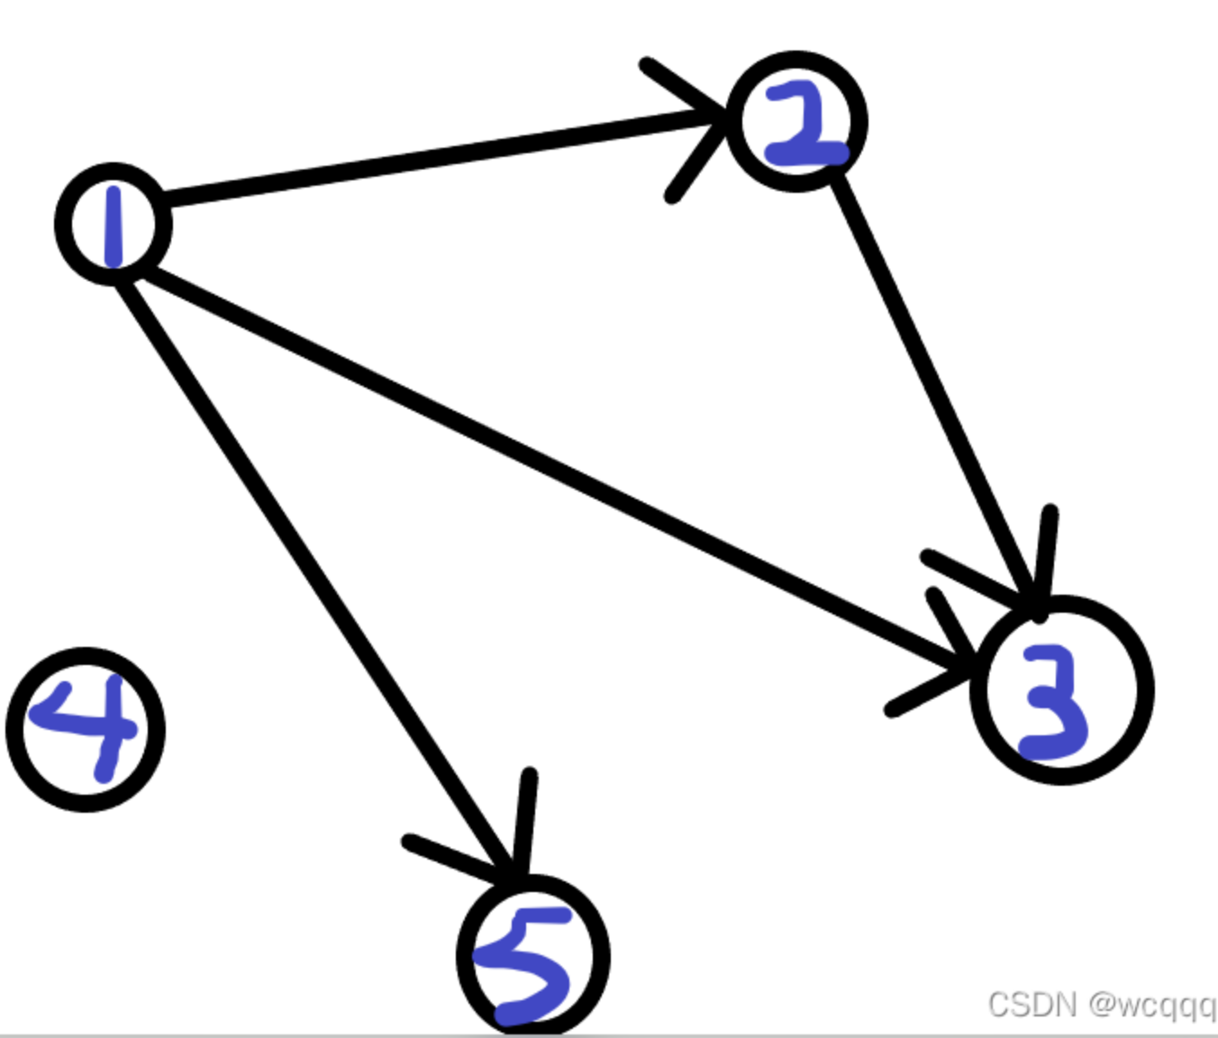输出如下