Global Distribution of Unintended Pregnancies and Contraceptive Usage

Taylor Glass and Aryln Santiago

2024-03-15

This uses MS Word as output format. [See here](https://quarto.org/docs/output-formats/ms-word.html) for more information.

# 1. Summary/Abstract

*Write a summary of your project.*

# 2. Introduction

## 2.1 General Background Information

*Provide enough background on your topic that others can understand the why and how of your analysis*

We will be looking for patterns in contraceptive methods and higher unintended pregnancies across all age groups (15-19, 20-24, 25-35, and 35-49) to investigate the effectiveness of three contraceptive methods: long acting reversible and sterilization, short acting reversible, and traditional. Financial, social, religious, and cultural factors are current challenges against efforts towards reducing unintended pregnancies. According to a cross-sectional survey done in 2017, contraceptive use was prevalent among women who had attained higher education, were in stable partnerships, and identified with the dominant ethnic group. Additionally, factors like previous pregnancies and immigration status did not appear to influence contraceptive use in this study. African and Latin American/Caribbean countries have the highest percentages of unintended pregnancies. This could be due to the current legal status of contraception within Latin American countries. Free emergency contraception access exists, but regulations differ. Chile, Colombia, and Ecuador legally recognize access, while Nicaragua and Bolivia rely on Ministerial protocols. Argentina and Brazil lack legal recognition, but offer protocols and guides. Mexico requires provision to victims of sexual and domestic violence (Hevia, 2012).

## 2.2 Description of data and data source

*Describe what the data is, what it contains, where it is from, etc. Eventually this might be part of a methods section.* The data source for this project is the Guttmacher Institute, which is a well-known research organization focusing on improving sexual and reproductive health around the world. The data used here is from their Adding It Up project. The goals of this project include estimating the need for, impact of, and costs associated with providing sexual and reproductive health services. Low and middle income countries are the target audience for this research, specifically women of reproductive age (15-49). Some of the variables included in this dataset are modern contraceptive use, unintended pregnancies, unplanned births, and abortions averted. Observations are drawn from nationally representative surveys, including Demographic and Health Surveys, UNICCEF Multiple Indicator Cluster Surveys, US Centers for Disease Control Reproductive Health Surveys, Performance Monitoring for Action Surveys, and others. The UN Population Division is the source of population projections for women in this age group, and estimates of unintended pregnancies are from the Guttmacher Institute, WHO, and other authors, which have been adjusted to 2019.

For the purpose of this project, we chose several numeric variables from the data source: percentages of pregnancy outcomes, rates of safe and unsafe abortions, percentage of various contraceptive usages, percentages of care received for various pregnancy complications, and costs for many variables including abortions and STIs. There are only three character variables that can be used to group the numeric variables: country name, region, and sub region.

## 2.3 Questions/Hypotheses to be addressed

*State the research questions you plan to answer with this analysis.*

1. Is there a significant difference in the percentage of unintended pregnancies among short acting reversible contraception users among countries?

The main outcome variables will be total percentage of unintended pregnancies among women using short acting reversible contraception methods (pct_upreg_sarc).

The predictor variables will include the total number of people women using each type of birth control standardized by population size, region, percentage of women currently married, percentage of women never married, total rate of maternal deaths, rate of maternal deaths due to unintended pregnancy and rate of maternal deaths due to abortion.

A full list of variables can be found in the processing-file in the code > processing-code folder.

# 3. Methods

*Describe your methods. That should describe the data, the cleaning processes, and the analysis approaches. You might want to provide a shorter description here and all the details in the supplement.* Reproducing this project requires R, RStudio, and Microsoft word. The README files in each folder contain descriptions of the documents located in that folder to help guide users through the reproducible processes. Begin with the processing-file.qmd in the code > processing-code folder. This file loads the original dataset from the Guttmacher Institute’s Adding It Up project, loads the codebook for the dataset, and glimpses at the data. We chose 30 variables to clean to find the percentage of unintended pregnancies based on each type of contraceptive methods: long acting reversible and sterilization methods, short acting reversible methods, traditional methods, and no contraceptive usage. After the missing data was explored, we chose to use the percentage of unintended pregnancies variables related to each method of birth control because the total variable had unexplained missingness. The processed data is saved in the data > processed-data folder as processeddata.rds.

The next step is exploratory data analysis. The eda.qmd file in the code > eda-code folder contains all the code for this process. We produced a couple summary tables before we began a simple exploration of trends in percentage of unintended pregnancies by country in our first set of histograms. The second set of histograms explore contraceptive usage methods by country. These graphs revealed outliers, so we standardized by population size for each country. The next sets of plots are line graphs showing total usage of contraceptive methods to percentage of unintended pregnancies associated with that method. The last two sets of plots contain line graphs of the relationship between the two variables stratified by region and violin plots displaying the relationship between percentage of unintended pregnancies and the categorical usage variable created during processing. All of these figures are saved in the Supplementary-Material.qmd file in the products > manuscript > supplement folder. This process led us to focus on the percentage of unintended pregnancies among short acting reversible methods as our single outcome because this method is becoming increasingly popular, so we feel that results from this contraception method will be the most relevant. Additionally, the exploratory data analysis process showed that the distribution of this outcome variable is less skewed than the other options, and the stratification by region is clearer, which allows for better understanding.

Step three is the statistical analysis and model fitting portion found in the statistical-analysis.qmd file in the code > analysis-code folder. We explore the single outcome pct_upreg_sarc based on 7 predictors with simple linear regression, total number of women using short acting reversible methods, region, percent of currently married women, percent of women who never married, total rate of maternal mortality, rate of maternal mortality by unintended pregnancy, and rate of maternal mortality by abortion. We also assess the performance of the models in this file. Result tables for each model are stored in the results > tables folder.

The Manuscript.qmd file for this document can be found in the products > manuscript folder.

## 3.1 Schematic of workflow

Sometimes you might want to show a schematic diagram/figure that was not created with code (if you can do it with code, do it). is an example of some - completely random/unrelated - schematic that was generated with Biorender. We store those figures in the assets folder.

## 3.2 Data aquisition

*As applicable, explain where and how you got the data. If you directly import the data from an online source, you can combine this section with the next.*

This research aims to analyze the factors influencing unintended pregnancies and contraception use in low-and-middle-income countries. The Guttmacher Institute’s Adding It Up project provides the foundation, offering data on sexual and reproductive health services in these regions.Focusing on women of reproductive age (15-49), the study usese information from nationally representative surveys and population projections to estimate unintended pregnancy rates.

While data on the overall percentage of unintended pregnancies was unavailable, we strategically utilized data on rates related to specific birth control methods. This approach allows us to analyze the relationship between these rates and various social and health factors. Factors like the number of women utilizing different birth control methods, maternal death rates, and marital status will be meticulously examined. All 7 of these predictor variables were found within the study’s codebook, which can can be found in the Data folder of this project. By discovering these relationships, the research aims to shed light on the complex landscape of contraception use and unintended pregnancy in low-and -middle-income countries. This knowledge can empower policymakers and healthcare providers to make informed decisions that ultimately improve reproductive health outcomes for women.

## 3.3 Data import and cleaning

*Write code that reads in the file and cleans it so it’s ready for analysis. Since this will be fairly long code for most datasets, it might be a good idea to have it in one or several R scripts. If that is the case, explain here briefly what kind of cleaning/processing you do, and provide more details and well documented code somewhere (e.g. as supplement in a paper). All materials, including files that contain code, should be commented well so everyone can follow along.*

## 3.4 Statistical analysis

*Explain anything related to your statistical analyses.* We began with a simple linear regression model with each of the 7 predictor variables. We also included a multiple linear regression model with all 7 predictors. We included the RMSE for two of the models to begin exploring model fit.

# 4. Results

## 4.1 Exploratory/Descriptive analysis

After deciding on a single outcome variable, we created a summary table with that outcome and the seven predictors we will use to predict it, which can be seen Table 1.

|  |  |  |  |  |  |  |  |  |  |  |  |  |  |  |  |  |  |  |  |  |  |  |  |  |  |  |  |  |  |  |  |  |  |  |  |  |  |  |  |  |  |  |  |  |  |  |  |  |  |  |  |  |  |  |  |  |  |  |  |  |  |  |  |  |  |  |  |  |  |  |  |  |  |  |  |  |  |  |  |  |  |  |  |  |  |  |  |  |  |  |  |  |  |  |  |  |  |  |  |  |  |  |  |  |  |  |  |  |  |  |  |  |  |  |  |  |  |  |  |  |  |  |  |  |  |  |  |  |  |  |  |  |  |  |  |  |  |  |  |  |  |  |  |  |  |  |  |  |  |  |  |  |  |  |  |  |  |  |  |  |  |  |  |  |  |  |  |  |  |  |  |  |  |  |  |  |  |  |  |  |  |  |  |  |  |  |  |  |  |  |  |  |  |  |  |  |  |  |  |  |  |  |  |  |  |  |  |  |  |  |  |  |  |  |  |  |  |  |  |  |  |  |  |  |  |  |  |  |  |  |  |  |  |  |  |  |  |  |  |  |  |  |  |  |  |  |  |  |  |  |  |  |  |  |  |  |  |  |  |  |  |  |  |  |  |  |  |  |  |  |  |  |  |  |  |  |  |  |  |  |  |  |  |  |  |  |  |  |  |  |  |  |  |  |  |  |  |  |  |  |  |  |  |  |  |  |  |  |  |  |  |  |  |  |  |  |  |  |  |  |  |  |  |  |  |  |  |  |  |  |  |  |  |  |  |  |  |  |  |  |  |  |  |  |  |  |  |  |  |  |  |  |  |  |  |  |  |  |  |  |  |  |  |  |  |  |  |  |  |  |  |  |  |  |  |  |  |  |  |  |  |  |  |  |  |  |  |  |  |  |  |  |  |  |  |  |  |  |  |  |  |  |  |  |  |  |  |  |  |  |  |  |  |  |  |  |  |  |  |  |  |  |  |  |  |  |  |  |  |  |  |  |  |  |  |  |  |  |  |  |  |  |  |  |  |  |  |  |  |  |  |  |  |  |  |  |  |  |  |  |  |  |  |  |  |  |  |  |  |  |  |  |  |  |  |  |  |  |  |  |  |  |  |  |  |  |  |  |  |  |  |  |  |  |  |  |  |  |  |  |  |  |  |  |  |  |  |  |  |  |  |  |  |  |  |  |  |  |  |  |  |  |  |  |  |  |  |  |  |  |  |  |  |  |  |  |  |  |  |  |  |  |  |  |  |  |  |  |  |  |  |  |  |  |  |  |  |  |  |  |  |  |  |  |  |  |  |  |  |  |  |  |  |  |  |  |  |  |  |  |  |  |  |  |  |  |  |  |  |  |  |  |  |  |  |  |  |  |  |  |  |  |  |  |  |  |  |  |  |  |  |  |  |  |  |  |  |  |  |  |  |  |  |  |  |  |  |  |  |  |  |  |  |  |  |  |  |  |  |  |  |  |  |  |  |  |  |  |  |  |  |  |  |  |  |  |  |  |  |  |  |  |  |  |  |  |  |  |  |  |  |  |  |  |  |  |  |  |  |  |  |  |  |  |  |  |  |  |  |  |  |  |  |  |  |  |  |  |  |  |  |  |  |  |  |  |  |  |  |  |  |  |  |  |  |  |  |  |  |  |  |  |  |  |  |  |  |  |  |  |  |  |  |  |  |  |  |  |  |  |  |  |  |  |  |  |  |  |  |  |  |  |  |  |  |  |  |  |  |  |  |  |  |  |  |  |  |  |  |  |  |  |  |  |  |  |  |  |  |  |  |  |  |  |  |  |  |  |  |  |  |  |  |  |  |  |  |  |  |  |  |  |  |  |  |  |  |  |  |  |  |  |  |  |  |  |  |  |  |  |  |  |  |  |  |  |  |  |  |  |  |  |  |  |  |  |  |  |  |  |  |  |  |  |  |  |  |  |  |  |  |  |  |  |  |  |  |  |  |  |  |  |  |  |  |  |  |  |  |  |  |  |  |  |  |  |  |  |  |  |  |  |  |  |  |  |  |  |  |  |  |  |  |  |  |  |  |  |  |  |  |  |  |  |  |  |  |  |  |  |  |  |  |  |  |  |  |  |  |  |  |  |  |  |  |  |  |  |  |  |  |  |  |  |  |  |  |  |  |  |  |  |  |  |  |  |  |  |  |  |  |  |  |  |  |  |  |  |  |  |  |  |  |  |  |  |  |  |  |  |  |  |  |  |  |  |  |  |  |  |  |  |  |  |  |  |  |  |  |  |  |  |  |  |  |  |  |  |  |  |  |  |  |  |  |  |  |  |  |  |  |  |  |  |  |  |  |  |  |  |  |  |  |  |  |  |  |  |  |  |  |  |  |  |  |  |  |  |  |  |  |  |  |  |  |  |  |  |  |  |  |  |  |  |  |  |  |  |  |  |  |  |  |  |
| --- | --- | --- | --- | --- | --- | --- | --- | --- | --- | --- | --- | --- | --- | --- | --- | --- | --- | --- | --- | --- | --- | --- | --- | --- | --- | --- | --- | --- | --- | --- | --- | --- | --- | --- | --- | --- | --- | --- | --- | --- | --- | --- | --- | --- | --- | --- | --- | --- | --- | --- | --- | --- | --- | --- | --- | --- | --- | --- | --- | --- | --- | --- | --- | --- | --- | --- | --- | --- | --- | --- | --- | --- | --- | --- | --- | --- | --- | --- | --- | --- | --- | --- | --- | --- | --- | --- | --- | --- | --- | --- | --- | --- | --- | --- | --- | --- | --- | --- | --- | --- | --- | --- | --- | --- | --- | --- | --- | --- | --- | --- | --- | --- | --- | --- | --- | --- | --- | --- | --- | --- | --- | --- | --- | --- | --- | --- | --- | --- | --- | --- | --- | --- | --- | --- | --- | --- | --- | --- | --- | --- | --- | --- | --- | --- | --- | --- | --- | --- | --- | --- | --- | --- | --- | --- | --- | --- | --- | --- | --- | --- | --- | --- | --- | --- | --- | --- | --- | --- | --- | --- | --- | --- | --- | --- | --- | --- | --- | --- | --- | --- | --- | --- | --- | --- | --- | --- | --- | --- | --- | --- | --- | --- | --- | --- | --- | --- | --- | --- | --- | --- | --- | --- | --- | --- | --- | --- | --- | --- | --- | --- | --- | --- | --- | --- | --- | --- | --- | --- | --- | --- | --- | --- | --- | --- | --- | --- | --- | --- | --- | --- | --- | --- | --- | --- | --- | --- | --- | --- | --- | --- | --- | --- | --- | --- | --- | --- | --- | --- | --- | --- | --- | --- | --- | --- | --- | --- | --- | --- | --- | --- | --- | --- | --- | --- | --- | --- | --- | --- | --- | --- | --- | --- | --- | --- | --- | --- | --- | --- | --- | --- | --- | --- | --- | --- | --- | --- | --- | --- | --- | --- | --- | --- | --- | --- | --- | --- | --- | --- | --- | --- | --- | --- | --- | --- | --- | --- | --- | --- | --- | --- | --- | --- | --- | --- | --- | --- | --- | --- | --- | --- | --- | --- | --- | --- | --- | --- | --- | --- | --- | --- | --- | --- | --- | --- | --- | --- | --- | --- | --- | --- | --- | --- | --- | --- | --- | --- | --- | --- | --- | --- | --- | --- | --- | --- | --- | --- | --- | --- | --- | --- | --- | --- | --- | --- | --- | --- | --- | --- | --- | --- | --- | --- | --- | --- | --- | --- | --- | --- | --- | --- | --- | --- | --- | --- | --- | --- | --- | --- | --- | --- | --- | --- | --- | --- | --- | --- | --- | --- | --- | --- | --- | --- | --- | --- | --- | --- | --- | --- | --- | --- | --- | --- | --- | --- | --- | --- | --- | --- | --- | --- | --- | --- | --- | --- | --- | --- | --- | --- | --- | --- | --- | --- | --- | --- | --- | --- | --- | --- | --- | --- | --- | --- | --- | --- | --- | --- | --- | --- | --- | --- | --- | --- | --- | --- | --- | --- | --- | --- | --- | --- | --- | --- | --- | --- | --- | --- | --- | --- | --- | --- | --- | --- | --- | --- | --- | --- | --- | --- | --- | --- | --- | --- | --- | --- | --- | --- | --- | --- | --- | --- | --- | --- | --- | --- | --- | --- | --- | --- | --- | --- | --- | --- | --- | --- | --- | --- | --- | --- | --- | --- | --- | --- | --- | --- | --- | --- | --- | --- | --- | --- | --- | --- | --- | --- | --- | --- | --- | --- | --- | --- | --- | --- | --- | --- | --- | --- | --- | --- | --- | --- | --- | --- | --- | --- | --- | --- | --- | --- | --- | --- | --- | --- | --- | --- | --- | --- | --- | --- | --- | --- | --- | --- | --- | --- | --- | --- | --- | --- | --- | --- | --- | --- | --- | --- | --- | --- | --- | --- | --- | --- | --- | --- | --- | --- | --- | --- | --- | --- | --- | --- | --- | --- | --- | --- | --- | --- | --- | --- | --- | --- | --- | --- | --- | --- | --- | --- | --- | --- | --- | --- | --- | --- | --- | --- | --- | --- | --- | --- | --- | --- | --- | --- | --- | --- | --- | --- | --- | --- | --- | --- | --- | --- | --- | --- | --- | --- | --- | --- | --- | --- | --- | --- | --- | --- | --- | --- | --- | --- | --- | --- | --- | --- | --- | --- | --- | --- | --- | --- | --- | --- | --- | --- | --- | --- | --- | --- | --- | --- | --- | --- | --- | --- | --- | --- | --- | --- | --- | --- | --- | --- | --- | --- | --- | --- | --- | --- | --- | --- | --- | --- | --- | --- | --- | --- | --- | --- | --- | --- | --- | --- | --- | --- | --- | --- | --- | --- | --- | --- | --- | --- | --- | --- | --- | --- | --- | --- | --- | --- | --- | --- | --- | --- | --- | --- | --- | --- | --- | --- | --- | --- | --- | --- | --- | --- | --- | --- | --- | --- | --- | --- | --- | --- | --- | --- | --- | --- | --- | --- | --- | --- | --- | --- | --- | --- | --- | --- | --- | --- | --- | --- | --- | --- | --- | --- | --- | --- | --- | --- | --- | --- | --- | --- | --- | --- | --- | --- | --- | --- | --- | --- | --- | --- | --- | --- | --- | --- | --- | --- | --- | --- | --- | --- | --- | --- | --- | --- | --- | --- | --- | --- | --- | --- | --- | --- | --- | --- | --- | --- | --- | --- | --- | --- | --- | --- | --- | --- | --- | --- | --- | --- | --- | --- | --- | --- | --- | --- | --- | --- | --- | --- | --- | --- | --- | --- | --- | --- | --- | --- | --- | --- | --- | --- | --- | --- | --- | --- | --- | --- | --- | --- | --- | --- | --- | --- | --- | --- | --- | --- | --- | --- | --- | --- | --- | --- | --- | --- | --- | --- | --- | --- | --- | --- | --- | --- | --- | --- | --- | --- | --- | --- | --- | --- | --- | --- | --- | --- | --- | --- | --- | --- | --- | --- | --- | --- | --- | --- | --- | --- | --- | --- | --- | --- | --- | --- | --- | --- | --- | --- | --- | --- | --- | --- | --- | --- | --- | --- | --- | --- | --- | --- | --- | --- | --- | --- | --- | --- | --- | --- | --- | --- | --- | --- | --- | --- | --- | --- | --- | --- | --- | --- | --- | --- | --- | --- | --- | --- | --- | --- | --- | --- | --- | --- | --- | --- | --- | --- | --- | --- | --- | --- | --- | --- | --- | --- | --- | --- | --- | --- | --- | --- | --- | --- | --- | --- | --- | --- | --- | --- | --- | --- | --- | --- | --- | --- | --- | --- | --- | --- | --- | --- | --- | --- | --- | --- | --- | --- | --- | --- | --- | --- | --- | --- | --- | --- | --- | --- | --- | --- | --- | --- | --- | --- | --- | --- | --- | --- | --- | --- | --- | --- | --- | --- | --- | --- | --- | --- | --- | --- | --- | --- | --- | --- | --- | --- | --- | --- | --- | --- | --- | --- | --- | --- | --- | --- | --- | --- | --- | --- | --- | --- | --- | --- | --- | --- | --- | --- | --- | --- | --- | --- | --- | --- | --- | --- |
| Table 1: Summary table of numeric variables  Table Depicting Predictor Variables   | pct_upreg_sarc | region | wra | pct_currentlymarried | pct_nevermarried | rate_matdeaths | rate_matdeaths_upreg | rate_matdeaths_abs | | --- | --- | --- | --- | --- | --- | --- | --- | | 7.654701 | 2 | 8929.46200 | 69.85743 | 28.47487 | 637.927733 | 4090.11644 | 39.1406994 | | 2.144152 | 3 | 671.44000 | 62.16480 | 33.89539 | 15.064575 | 163.13080 | 30.3675247 | | 32.363013 | 1 | 10920.57999 | 53.48443 | 42.10970 | 112.348552 | 327.78980 | 9.3933053 | | 7.679248 | 1 | 7335.45800 | 55.79774 | 34.46034 | 241.297843 | 645.56161 | 115.9935880 | | 4.791568 | 2 | 2631.01700 | 63.35586 | 30.26902 | 25.679338 | 146.41879 | 3.6982688 | | 41.652448 | 4 | 11274.03500 | 58.98663 | 37.14931 | 38.973331 | 96.99144 | 19.8538588 | | 28.424798 | 2 | 45732.68100 | 82.40298 | 14.32988 | 172.785776 | 698.12157 | 35.2696451 | | 11.468097 | 2 | 749.47400 | 65.28225 | 27.76178 | 25.557937 | 319.85756 | 3.9943305 | | 15.607640 | 2 | 205.44200 | 61.71253 | 30.29361 | 182.851690 | 1125.05372 | 38.2631951 | | 11.947674 | 4 | 2950.64400 | 57.49766 | 39.32952 | 155.100537 | 258.60238 | 36.3307808 | | 11.109147 | 3 | 734.86463 | 63.69325 | 27.68620 | 9.627036 | 55.75103 | 9.1265150 | | 33.440622 | 1 | 631.35500 | 44.14039 | 52.80697 | 144.280308 | 264.31731 | 16.1100635 | | 47.660204 | 4 | 57089.29900 | 52.17169 | 41.98447 | 59.508618 | 116.76006 | 9.3773672 | | 14.138004 | 4 | 109.29400 | 63.74017 | 25.57967 | 36.135315 | 93.18051 | 10.5979233 | | 5.070385 | 5 | 160.88800 | 63.96737 | 32.72378 | 104.225985 | 216.43076 | 55.5655319 | | 35.343687 | 3 | 1482.78800 | 59.08782 | 32.69530 | 9.785253 | 26.63742 | 13.2619186 | | 18.301355 | 2 | 15014.15500 | 57.55649 | 36.33080 | 249.761550 | 2741.14652 | 46.8850259 | | 4.966506 | 1 | 2700.73100 | 56.20812 | 35.20066 | 547.992724 | 1565.88280 | 332.0816906 | | 38.604485 | 3 | 2176.50501 | 57.15685 | 24.64449 | 2.384535 | 18.98552 | 4.7427725 | | 17.494202 | 2 | 4458.26500 | 67.23551 | 25.61177 | 159.971936 | 788.33212 | 31.3352546 | | 16.672703 | 1 | 6268.99198 | 59.36514 | 30.38112 | 528.608666 | 2129.26237 | 310.3406130 | | 29.848475 | 1 | 147.27800 | 46.45871 | 38.76079 | 58.083462 | 108.51970 | 10.1598650 | | 10.603189 | 1 | 1112.17899 | 73.65508 | 13.61298 | 828.791241 | 2542.43000 | 292.3674325 | | 16.633821 | 2 | 5326.81900 | 66.25381 | 30.46860 | 35.616111 | 334.00471 | 6.1110225 | | 2.727427 | 1 | 3602.95500 | 71.88943 | 19.31205 | 1136.848581 | 6681.96320 | 418.9509092 | | 35.026781 | 2 | 347636.03400 | 73.41518 | 24.00752 | 28.577451 | 166.33664 | 1.9967531 | | 26.421275 | 4 | 13634.23900 | 54.12992 | 30.12214 | 82.594995 | 167.24329 | 12.2082563 | | 6.189973 | 1 | 209.69700 | 62.70826 | 30.30351 | 272.678515 | 711.30949 | 135.0917193 | | 17.132812 | 1 | 1294.87300 | 57.13686 | 29.56122 | 378.169957 | 1118.76314 | 125.5721280 | | 6.598490 | 1 | 19352.02000 | 61.87771 | 28.09069 | 473.256367 | 1303.62775 | 278.0983356 | | 30.706040 | 4 | 1313.79700 | 46.92889 | 42.59817 | 27.434166 | 62.56711 | 6.1149923 | | 36.760176 | 4 | 2574.01099 | 60.64724 | 18.62924 | 35.999718 | 168.51075 | 2.8022725 | | 5.021643 | 1 | 2798.00300 | 68.90396 | 25.88369 | 396.681442 | 1464.61525 | 124.5787689 | | 22.917043 | 4 | 2795.40197 | 53.98565 | 22.94639 | 95.162217 | 201.60257 | 23.7730368 | | 36.023479 | 4 | 4550.15600 | 56.69101 | 33.14983 | 59.072506 | 110.46532 | 13.6807223 | | 15.134656 | 4 | 1818.17101 | 53.38854 | 30.01637 | 46.197074 | 115.64084 | 19.1561825 | | 9.000530 | 1 | 300.28700 | 60.37374 | 29.90498 | 301.027982 | 1032.37071 | 212.5115263 | | 7.264945 | 1 | 27620.49823 | 63.97570 | 27.30729 | 400.905200 | 1252.78459 | 90.8499382 | | 4.273814 | 1 | 823.54600 | 61.84520 | 26.56365 | 480.119136 | 2667.07403 | 191.7027543 | | 9.833977 | 5 | 222.06600 | 59.00680 | 35.76191 | 33.746198 | 114.51342 | 30.4997547 | | 8.409792 | 1 | 253.97200 | 52.33924 | 42.54994 | 247.927807 | 974.51809 | 131.4414409 | | 19.598609 | 1 | 541.35300 | 51.90007 | 35.14281 | 251.995562 | 572.67828 | 106.9606645 | | 9.160701 | 2 | 905.41500 | 67.70358 | 24.93391 | 25.002745 | 332.06127 | 3.0715073 | | 4.181603 | 1 | 564.68900 | 64.61930 | 31.69879 | 597.321039 | 3243.09739 | 533.0305957 | | 12.332369 | 2 | 1245.04100 | 64.29106 | 33.47104 | 27.219001 | 81.17065 | 13.8963643 | | 8.648176 | 1 | 7567.05502 | 51.72330 | 37.47594 | 307.810287 | 712.74180 | 29.0520370 | | 3.079198 | 5 | 29.54100 | 65.43232 | 26.51074 | 92.277468 | 447.83444 | 85.3733782 | | 21.808369 | 4 | 27.92900 | 39.42692 | 59.81010 | 25.343310 | 47.74099 | 6.1248815 | | 11.394851 | 4 | 4752.16000 | 58.03551 | 31.64075 | 94.906254 | 256.05671 | 36.3086535 | | 6.203698 | 1 | 3117.48900 | 67.36127 | 28.16952 | 576.330137 | 2630.27442 | 178.3180616 | | 13.957786 | 4 | 199.93300 | 57.68602 | 28.27358 | 168.957492 | 431.94707 | 55.0723509 | | 8.655545 | 4 | 3014.73800 | 53.19478 | 37.94501 | 480.255978 | 839.39001 | 73.8661537 | | 19.963331 | 4 | 2667.62600 | 56.52257 | 27.47064 | 64.639851 | 140.61056 | 8.1542526 | | 9.331472 | 2 | 353356.94000 | 73.36492 | 22.20701 | 145.092961 | 1340.87075 | 24.9672770 | | 19.210209 | 2 | 71651.52077 | 70.28245 | 25.14560 | 177.281606 | 1203.88453 | 47.9467842 | | 18.042419 | 2 | 22989.25600 | 71.06178 | 24.64164 | 16.432961 | 35.18198 | 0.7855316 | | 13.868679 | 2 | 9901.62598 | 64.88537 | 31.37114 | 79.002171 | 504.67202 | 23.3839092 | | 11.595196 | 1 | 6227.65297 | 57.51813 | 35.31737 | 617.292116 | 1950.11784 | 211.2866559 | | 22.561771 | 4 | 783.05500 | 31.80761 | 66.14656 | 80.421763 | 130.92552 | 13.3463991 | | 16.983325 | 2 | 4492.84299 | 64.80801 | 22.09826 | 9.594106 | 173.95774 | 3.9692787 | | 9.636767 | 2 | 2655.13200 | 55.77846 | 40.61456 | 46.311695 | 243.95057 | 7.3324336 | | 14.198038 | 1 | 13652.23103 | 56.20328 | 31.72121 | 342.246130 | 714.93275 | 97.3992492 | | 27.578057 | 2 | 6548.19900 | 64.98421 | 31.85160 | 89.007591 | 539.83078 | 9.6294414 | | 10.665047 | 2 | 1619.99900 | 67.62537 | 22.09781 | 60.411732 | 1376.27842 | 12.2944161 | | 23.390912 | 2 | 1923.16300 | 60.72120 | 31.38493 | 185.351854 | 1575.36640 | 19.8314483 | | 15.498304 | 2 | 1873.04400 | 44.25875 | 50.47666 | 29.331446 | 78.47009 | 6.3050572 | | 32.311685 | 1 | 556.39400 | 56.26719 | 31.01367 | 543.536768 | 907.15828 | 166.3338209 | | 6.677145 | 1 | 1189.17000 | 56.15620 | 32.37010 | 660.825382 | 1885.62382 | 142.3873858 | | 5.424171 | 1 | 1895.50700 | 63.15048 | 27.21455 | 71.669720 | 213.78988 | 10.8550867 | | 12.337529 | 1 | 6647.86400 | 68.30020 | 18.99381 | 334.907374 | 1789.66746 | 52.8295649 | | 12.306260 | 1 | 4548.34000 | 63.76342 | 22.58698 | 349.297707 | 733.25971 | 197.7028778 | | 10.505215 | 2 | 8627.23600 | 58.14335 | 40.20306 | 29.068067 | 150.93105 | 6.9788408 | | 3.301759 | 2 | 112.83100 | 68.63634 | 21.25285 | 52.628270 | 322.35076 | 4.7596226 | | 3.717065 | 1 | 4385.36402 | 79.01851 | 18.35444 | 562.212716 | 3023.79714 | 310.3677989 | | 5.396011 | 1 | 1106.21001 | 60.08833 | 26.89641 | 766.118303 | 2650.02676 | 609.3632552 | | 10.801381 | 1 | 321.42200 | 61.68690 | 31.56354 | 61.390966 | 221.66589 | 12.8288597 | | 12.435085 | 4 | 34639.11700 | 59.06180 | 29.40680 | 33.287122 | 99.04419 | 5.1055418 | | 13.129947 | 2 | 850.97900 | 60.89935 | 27.21723 | 44.835274 | 556.34563 | 25.2501152 | | 18.263184 | 3 | 1052.57400 | 72.59522 | 16.13594 | 18.982433 | 148.20564 | 3.4777268 | | 11.147524 | 3 | 145.76200 | 57.55162 | 36.30960 | 5.757486 | 77.15692 | 14.7680888 | | 29.336867 | 1 | 9521.45500 | 58.68412 | 36.51154 | 70.163644 | 180.07499 | 6.7847940 | | 10.374053 | 1 | 7308.64500 | 64.91254 | 18.94153 | 289.099440 | 1269.97138 | 145.6831566 | | 33.765880 | 1 | 658.06100 | 32.52073 | 60.41500 | 195.342697 | 353.63459 | 56.6122349 | | 6.924468 | 2 | 8839.76600 | 77.40390 | 20.16952 | 186.360520 | 1092.28304 | 31.4755460 | | 11.743190 | 5 | 73.89000 | 65.67199 | 31.35688 | 71.567064 | 234.38475 | 28.2165537 | | 28.836547 | 4 | 1786.20601 | 57.08277 | 23.64107 | 98.257009 | 232.88557 | 39.3446962 | | 6.925034 | 1 | 4892.34700 | 84.70960 | 12.29872 | 509.203493 | 4179.13652 | 71.2531646 | | 7.642032 | 1 | 46216.83006 | 67.43299 | 27.47788 | 916.884065 | 5795.97175 | 277.0272558 | | 4.841226 | 5 | 29.00700 | 52.77126 | 40.03679 | 87.732497 | 454.67819 | 50.0461750 | | 7.757473 | 2 | 54257.49100 | 65.22324 | 31.29855 | 139.573373 | 828.77491 | 45.1956914 | | 5.910301 | 5 | 2212.70900 | 65.09794 | 26.28723 | 145.243778 | 490.02897 | 13.0512069 | | 31.885232 | 4 | 1841.03499 | 57.37432 | 30.71514 | 83.632819 | 270.77988 | 42.9225714 | | 25.374539 | 4 | 8608.59900 | 57.39904 | 31.13394 | 88.270305 | 172.43953 | 15.3000087 | | 13.919180 | 2 | 28058.77000 | 60.02354 | 35.60689 | 120.527063 | 382.42926 | 24.5319684 | | 12.666276 | 1 | 478.85600 | 51.06773 | 40.27462 | 667.200394 | 3184.09324 | 50.7974359 | | 4.213548 | 2 | 316.65600 | 57.66435 | 39.75520 | 141.972439 | 1593.78601 | 37.1256175 | | 35.324335 | 3 | 4303.66300 | 57.53064 | 34.32980 | 18.695799 | 90.44573 | 5.7614591 | | 32.000779 | 3 | 34152.19700 | 54.76726 | 27.23526 | 17.148845 | 75.00734 | 2.8226803 | | 12.130443 | 1 | 3204.02800 | 51.75019 | 38.22488 | 247.834599 | 554.97626 | 34.9622363 | | 28.593619 | 4 | 50.96337 | 53.27111 | 28.78739 | 117.140904 | 220.64163 | 13.7163016 | | 22.869595 | 4 | 27.88400 | 52.58218 | 44.31441 | 68.464111 | 157.75613 | 15.9760305 | | 14.653845 | 1 | 50.37300 | 54.95440 | 26.55907 | 129.794153 | 243.49593 | 46.5891263 | | 5.183597 | 1 | 4001.60000 | 67.37196 | 27.92707 | 314.505437 | 1206.54151 | 292.0843425 | | 25.136339 | 3 | 2005.97100 | 52.73397 | 38.23026 | 11.962603 | 84.06434 | 4.0625439 | | 8.337900 | 1 | 1914.45200 | 62.45800 | 31.94444 | 1119.539617 | 4935.77476 | 205.4265327 | | 28.934921 | 2 | 25489.27205 | 73.02489 | 22.44191 | 43.413520 | 212.43057 | 4.2101882 | | 3.206524 | 1 | 3457.64000 | 56.09246 | 29.36200 | 828.963813 | 2670.84928 | 386.6646538 | | 25.603984 | 1 | 15903.24100 | 36.46528 | 57.66460 | 118.777552 | 227.03420 | 20.2122247 | | 36.350212 | 1 | 3795.30200 | 60.91172 | 25.28948 | 457.636524 | 1229.51203 | 230.3277732 | | 2.539227 | 1 | 2650.05499 | 66.64906 | 22.71996 | 1154.976992 | 7951.80739 | 261.9367749 | | 5.533707 | 1 | 10414.37499 | 61.61764 | 33.47890 | 295.473746 | 1405.71643 | 9.2449764 | | 17.879778 | 4 | 147.65700 | 53.20241 | 44.83270 | 120.000993 | 324.38871 | 25.9865578 | | 35.369197 | 1 | 307.88700 | 45.96947 | 45.14961 | 437.085787 | 677.30844 | 103.2308131 | | 8.835153 | 2 | 4615.78200 | 58.68770 | 39.01900 | 30.674966 | 127.46622 | 5.8553770 | | 4.287037 | 2 | 2315.45700 | 72.98083 | 21.47330 | 16.671474 | 299.57028 | 5.5225487 | | 42.522888 | 2 | 17375.15701 | 66.72983 | 26.57051 | 37.202129 | 158.32667 | 15.2077887 | | 10.200309 | 1 | 1983.59000 | 61.68249 | 31.43242 | 395.561483 | 1029.38588 | 118.4757279 | | 3.304012 | 5 | 25.50300 | 50.87786 | 41.66008 | 52.102024 | 289.73836 | 42.6230032 | | 12.726681 | 1 | 3015.20100 | 50.22373 | 46.60651 | 43.480977 | 208.77988 | 7.6735594 | | 14.537638 | 2 | 21848.06600 | 66.63528 | 28.58553 | 17.076483 | 64.24615 | 2.1180629 | | 3.058897 | 2 | 1565.05299 | 64.96961 | 28.05345 | 7.234163 | 423.02377 | 5.5742347 | | 9.012522 | 1 | 10515.53696 | 58.99225 | 27.07669 | 375.354986 | 776.98684 | 139.8214012 | | 32.604052 | 3 | 10319.16600 | 60.78166 | 20.62600 | 19.153777 | 203.00879 | 3.4933369 | | 13.552167 | 3 | 506.56700 | 65.85848 | 30.66681 | 7.163635 | 51.72482 | 2.9622880 | | 15.445303 | 1 | 24938.35200 | 71.48383 | 24.07615 | 36.864561 | 166.78288 | 7.1268361 | | 10.161948 | 1 | 13655.24300 | 60.79823 | 26.17341 | 523.979221 | 1538.34849 | 301.6763828 | | 6.450093 | 1 | 4735.85404 | 76.32360 | 20.96518 | 320.158482 | 1496.51603 | 101.2339621 | | 9.216914 | 2 | 8869.18398 | 69.06121 | 24.60537 | 29.027319 | 749.97557 | 7.2168449 | | 33.549257 | 4 | 7301.53200 | 53.09314 | 41.01727 | 124.753226 | 264.09404 | 35.4456684 | | 3.145370 | 5 | 43.20000 | 56.64097 | 38.16120 | 43.430503 | 293.84654 | 16.0226309 | | 7.743720 | 2 | 7408.59300 | 61.47853 | 33.53524 | 164.069756 | 381.11219 | 16.8286012 | | 14.002062 | 1 | 4349.19300 | 57.19555 | 30.47004 | 212.908468 | 466.73678 | 133.9199210 | |

We created a multitude of exploratory plots to understand our data better. The first (**exploratory-result?**) shows the distribution of the outcome variable: percent of unintended pregnancies due to short acting reversible methods. The pct_upreg_sarc variable is slightly skewed to the right with an average around 12%.

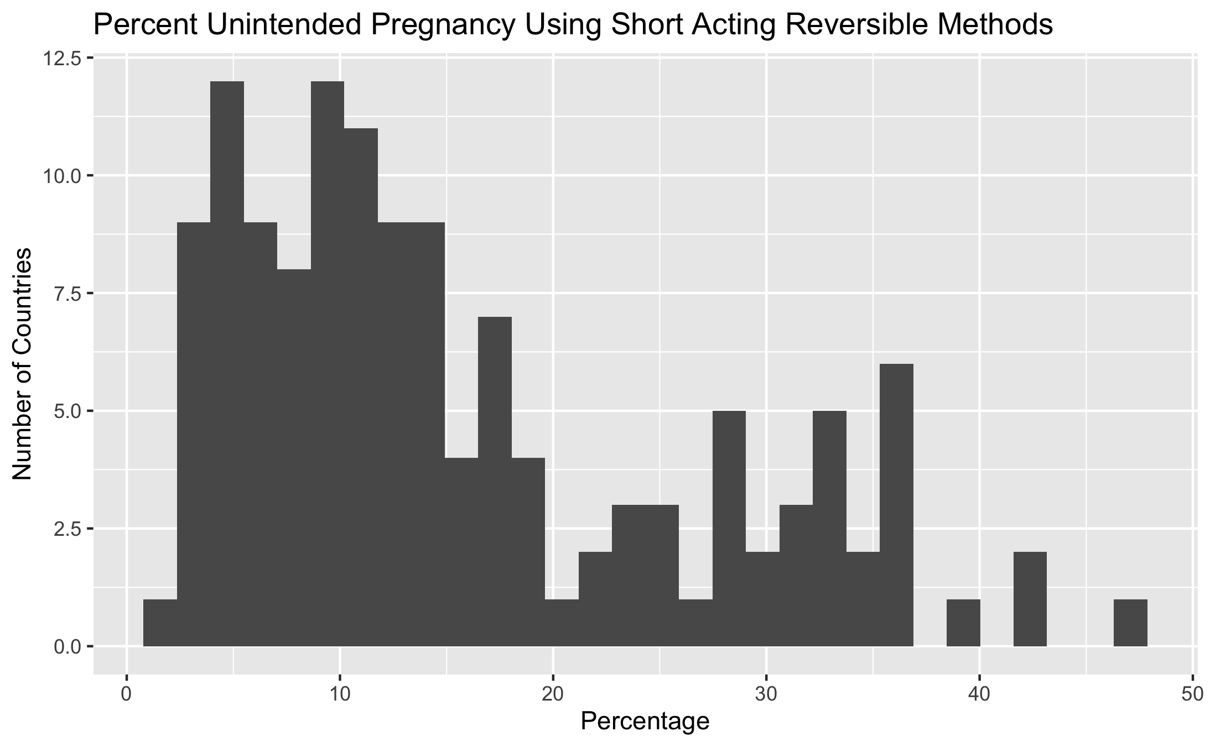

Histograms of Percentage of Unintended Pregnancy Use by Birth Control Method

The next set of variables we explored were the total counts of women using each birth control method. There were two large outliers that prevented the graphs from being useful. After exploring the outliers, we standardized using the population size of reproductive aged women (15-49 years). There is a positive association between the percentage of unintended pregnancies among short acting reversible method users and the total number of women using that method of birth control, which is to be expected. This association is displayed in (**exploratory-result2?**).

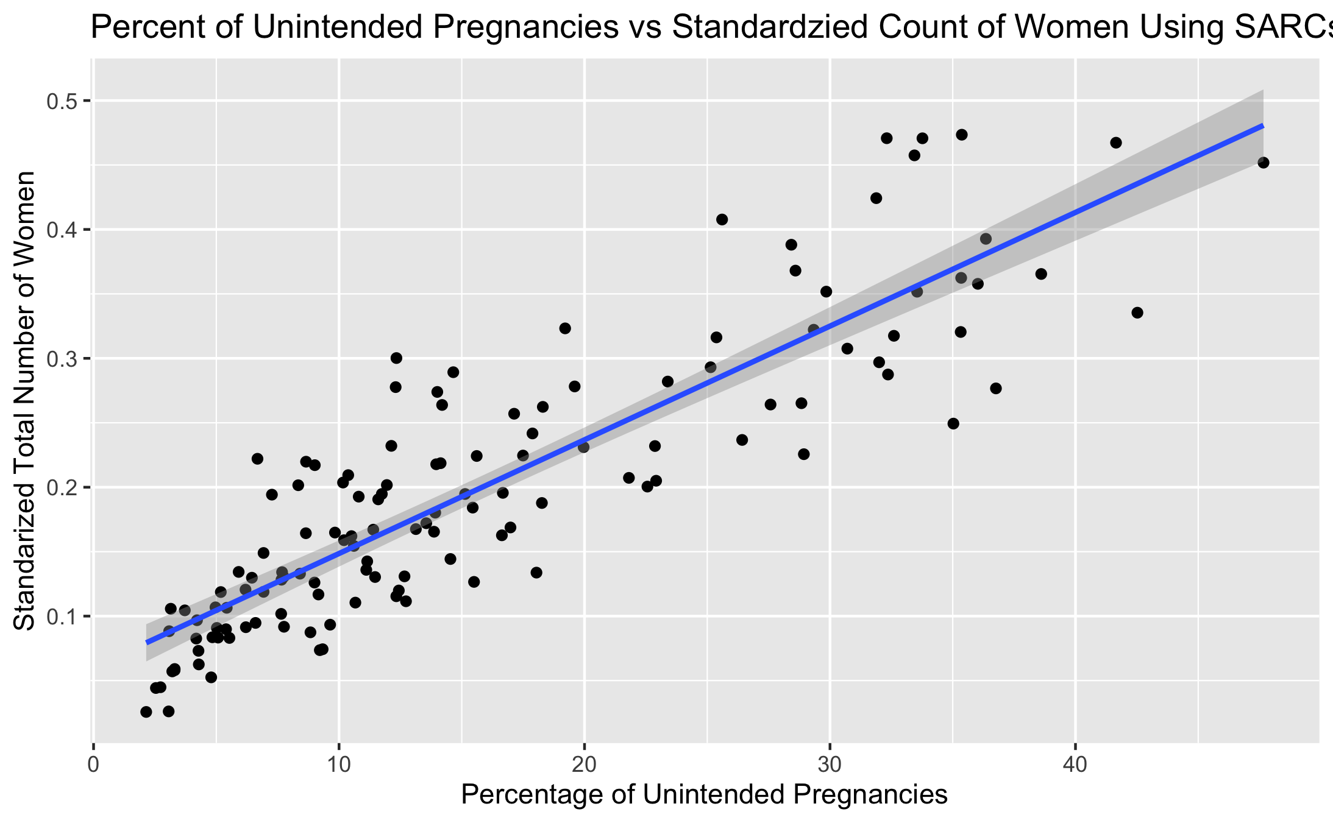

Relationship between Percentage of Unintended Pregnancies and Standardized Population Total

We stratified these four graphs by region to examine how the relationship differs across each of the t regions which is shown in (**exploratory-result3?**) . The graph for short acting reversible methods shows clearer differences between regions, and Latin America/the Caribbean leads in the percentage of unintended pregnancies in this category, but Africa shows the sharpest increase in percentage of unintended pregnancies as the total population increases.

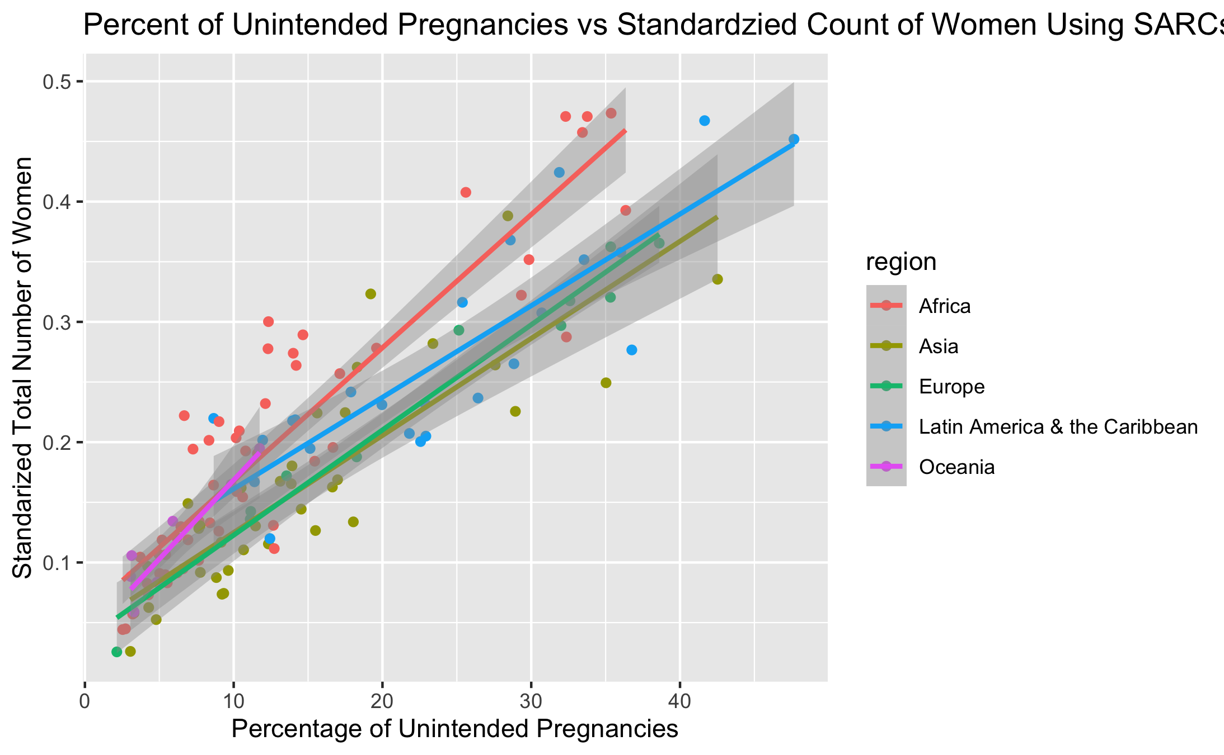

Percentage of Unintended Pregnancies Stratified by Region

We also created violin plots using the categorical usage variables for each birth control method as shown in (**exploratory-result4?**). It appears that the distribution of short acting reversible method usage is skewed towards lower percentages of unintended pregnancies across all usage levels, suggesting that more countries have lower percentage of unintended pregnancies among women using this method. The high usage countries appear to have a bottleneck in percentage of unintended pregnancies. The high and low usage countries appear to be skewed towards higher levels of unintended pregnancies, but the medium usage countries appear to have lower percentage of unintended pregnancies.

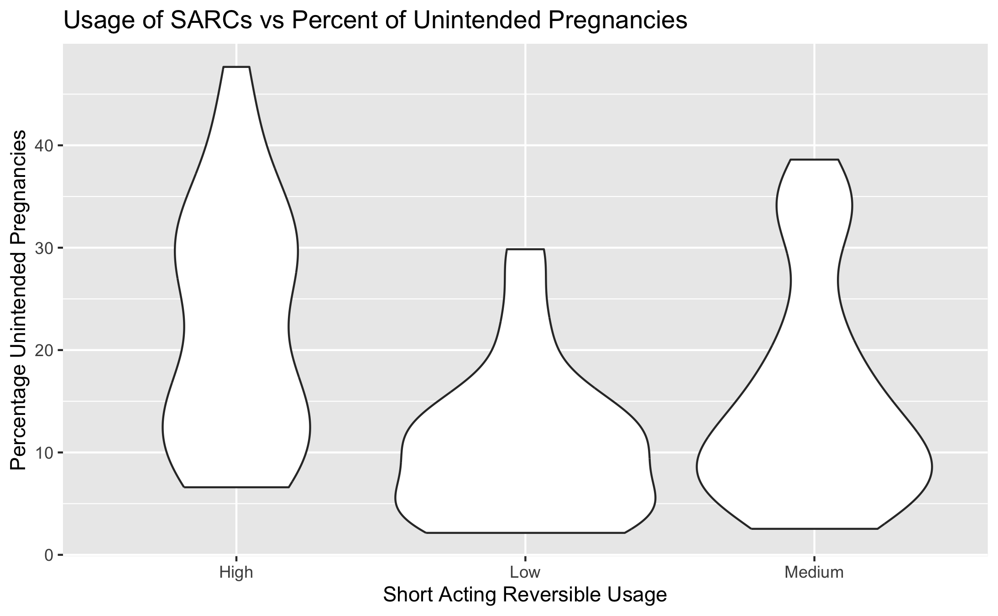

Violin Plots with Birth Control Usage Levels

Lastly, we explored the predictor variables that will be used in our models, and the graphs are shown in (**exploratory-result5?**). The Africa region accounts for most of the observations with about 53 countries, followed by Asia that includes. about 35 countries. Latin America/the Caribbean accounts for about 25 countries. Europe and Oceania account for the least number of observations. The distribution of women currently married is approximately normal with an average around 57% and no major outliers. The distribution of women never married is slightly skewed to the right with an average around 30%, but there are a few outliers greater than 60%. The distribution of the total maternal mortality rate is highly skewed to the right with a couple outliers. We would have expected the highest rates to belong to India and China because they have the most people, but it is Chad, Sierra Leone, and South Sudan that account for the highest rates of total maternal mortality. The distribution of the maternal mortality rate from unintended pregnancies is highly skewed to the right with a couple outliers, which is to be expected based on the trend shown in the previous histogram. Chad and South Sudan also account for the highest rates of maternal mortality in this category. The distribution of maternal mortality rate from abortions is also highly skewed to the right. The outliers are accounted for by Gambia and Mauritania in this predictor.

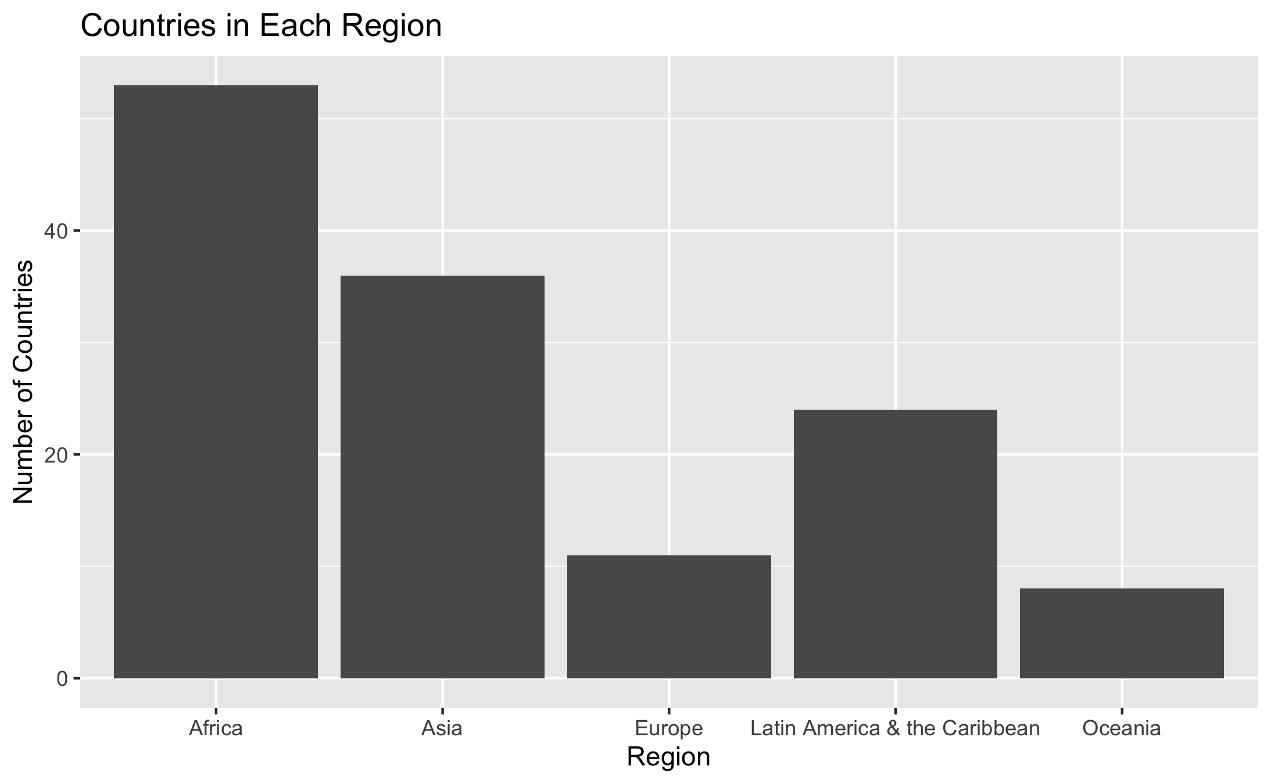

Predictor Variable Distributions

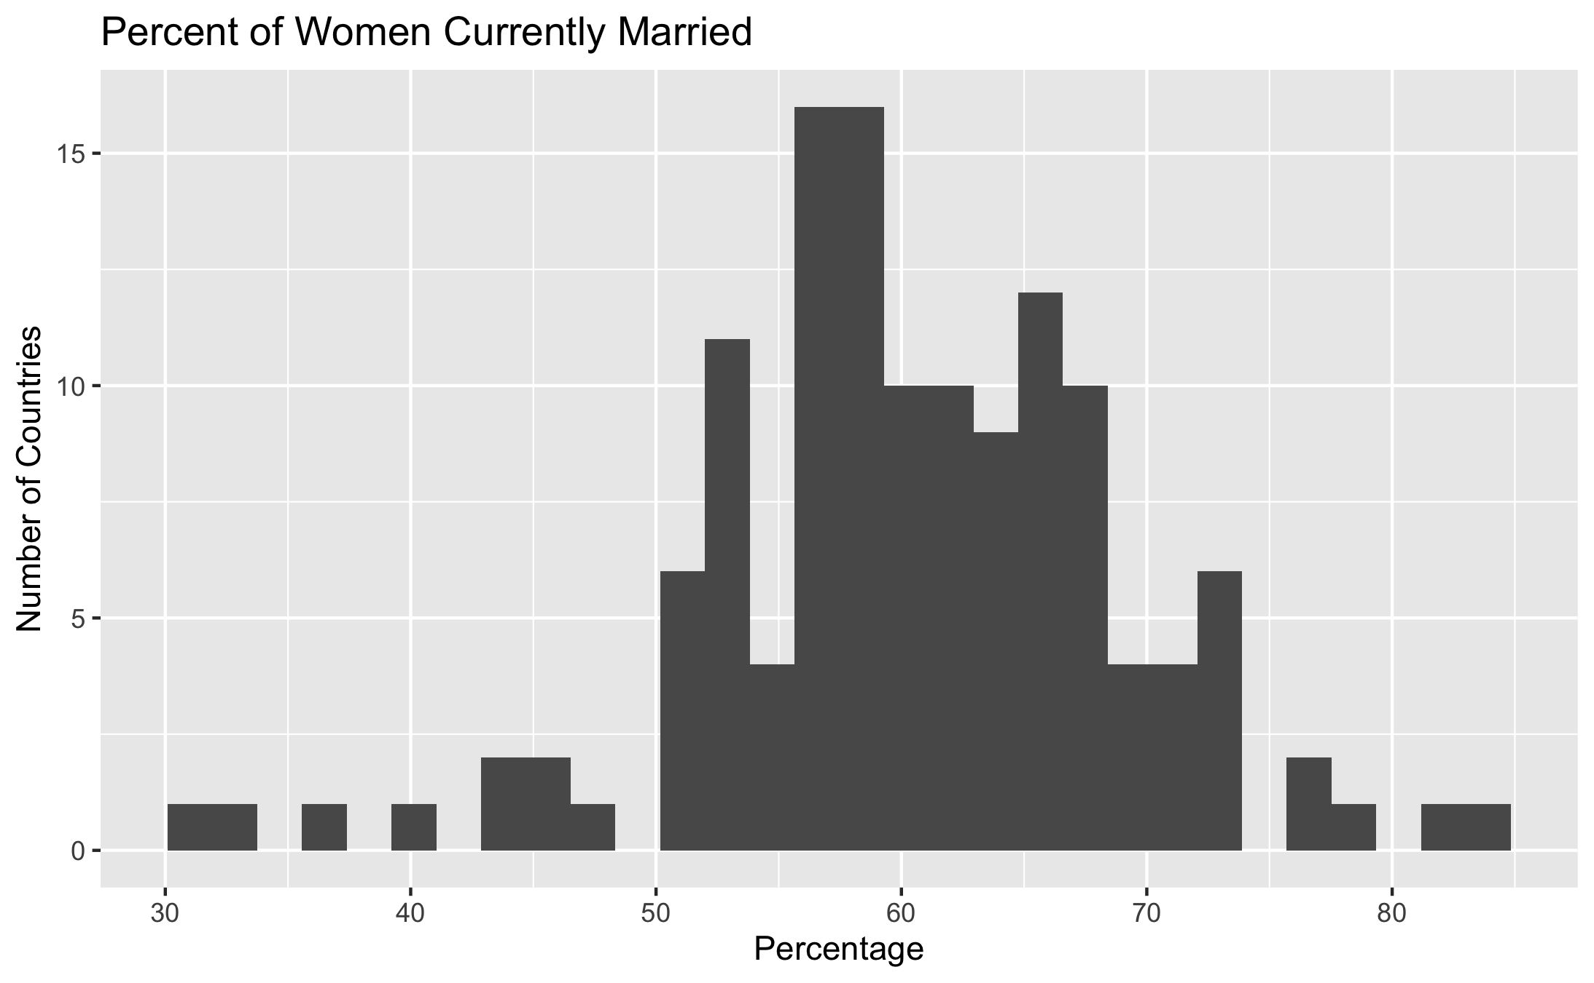

Predictor Variable Distributions

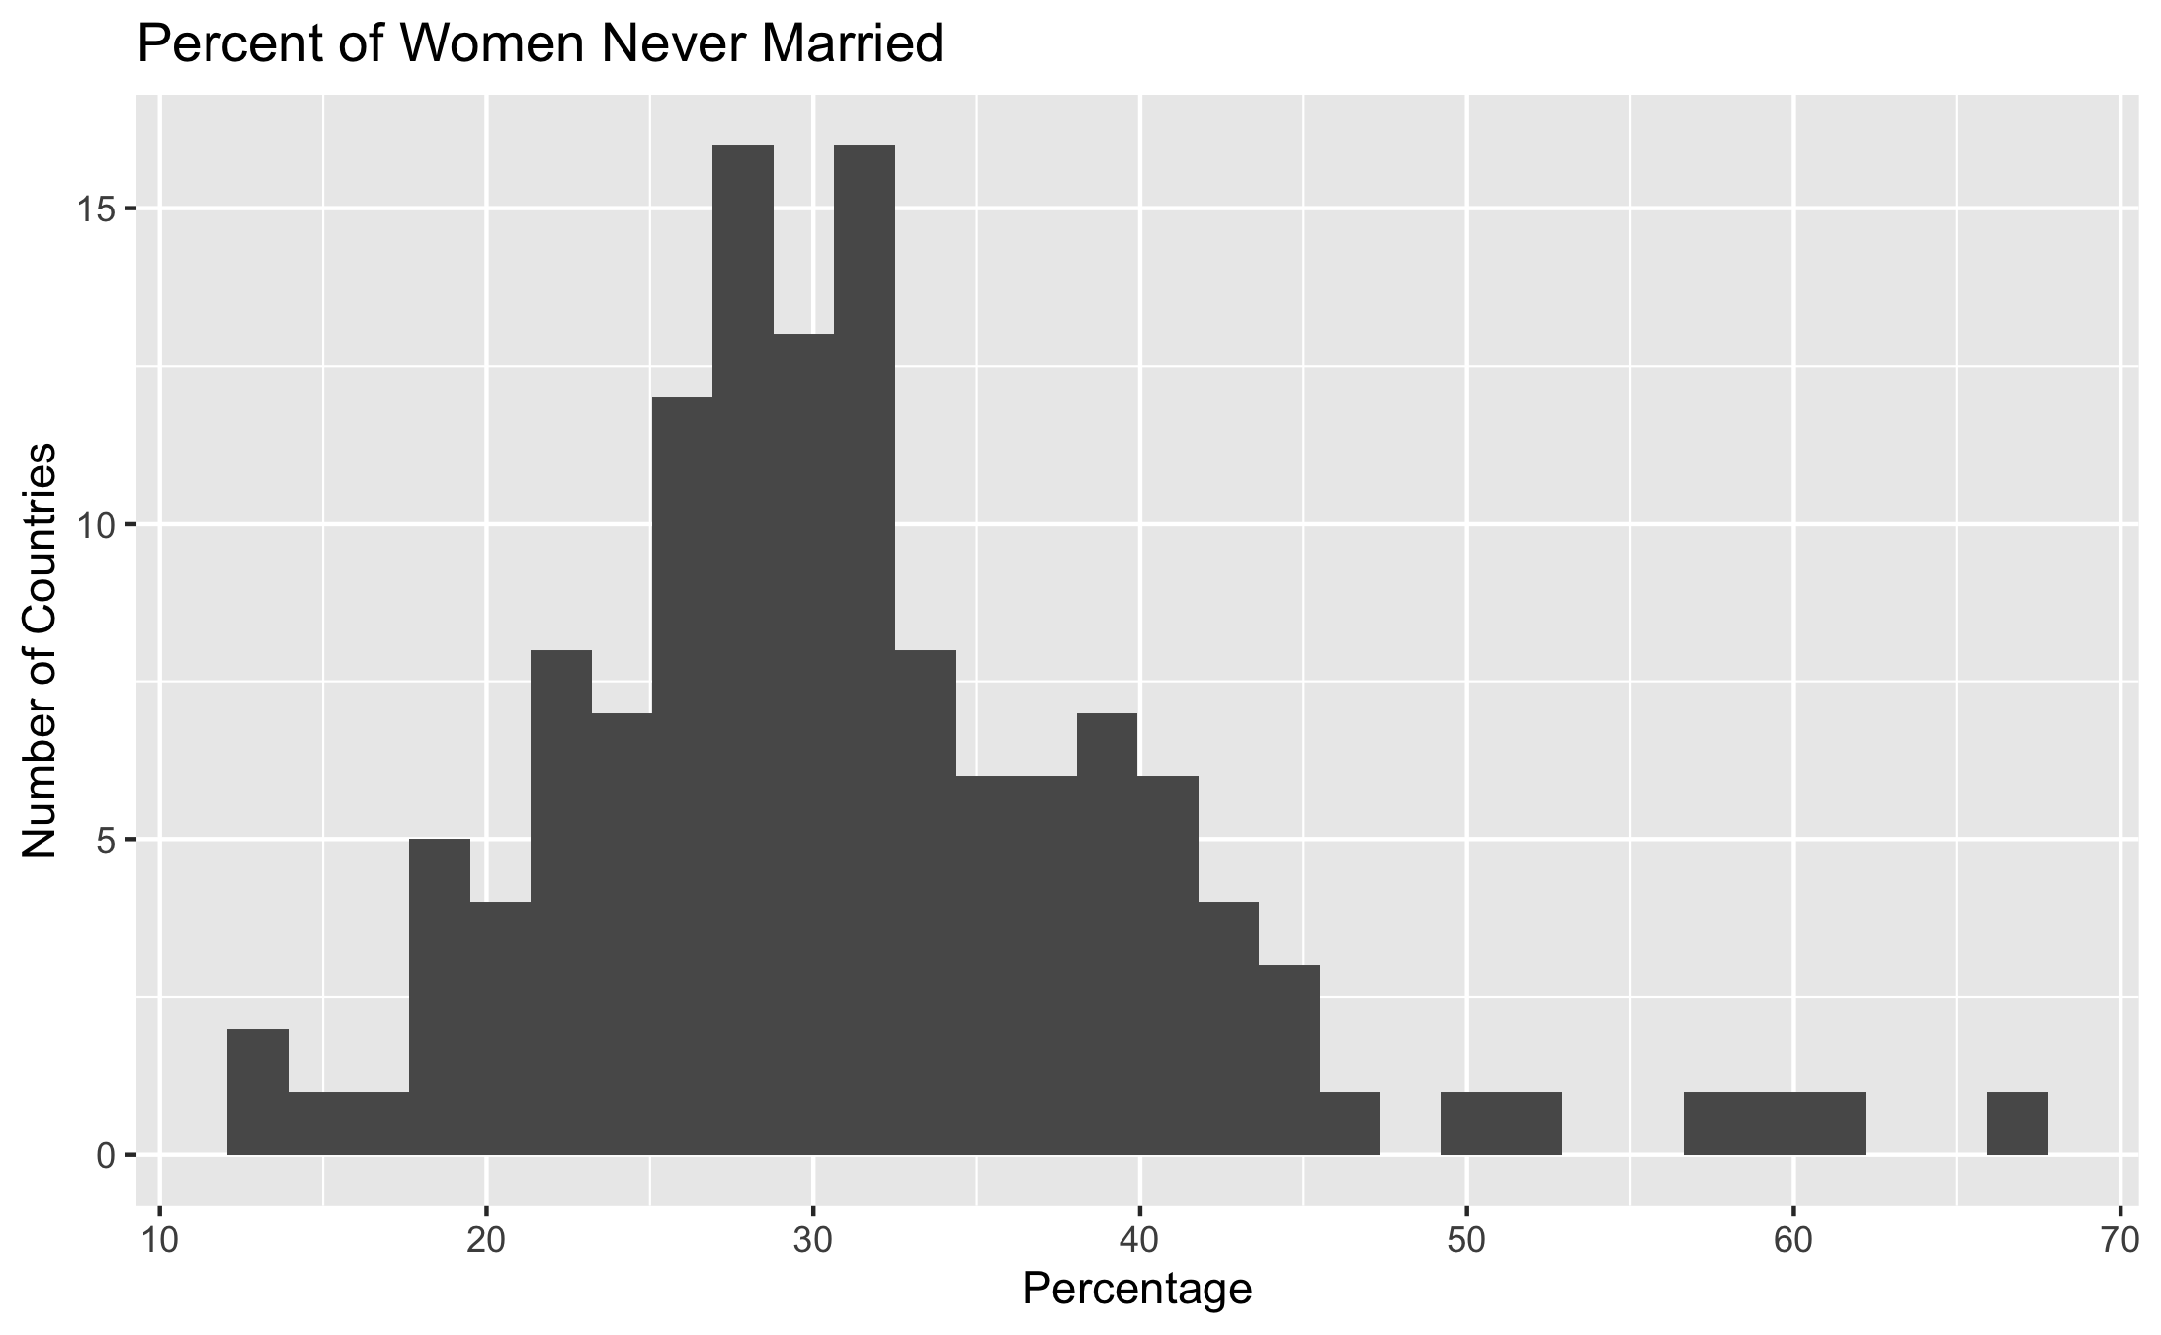

Predictor Variable Distributions

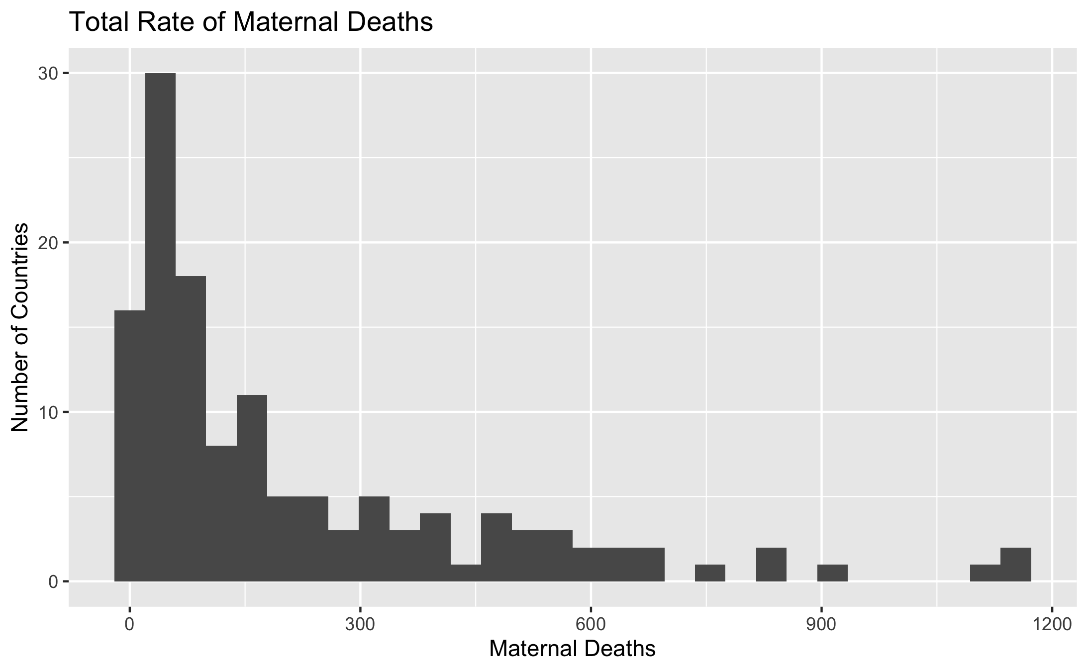

Predictor Variable Distributions

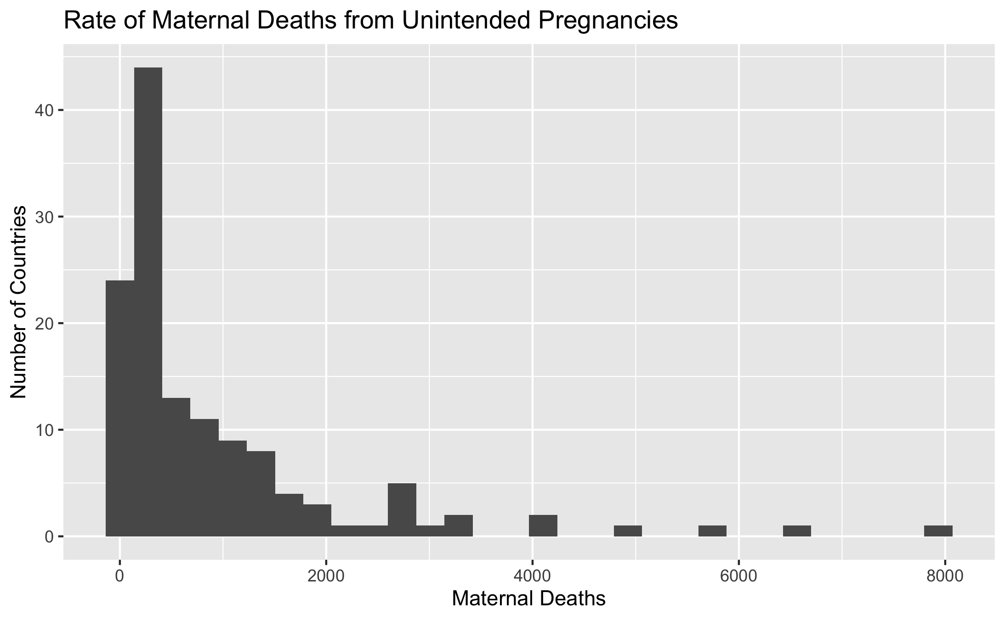

Predictor Variable Distributions

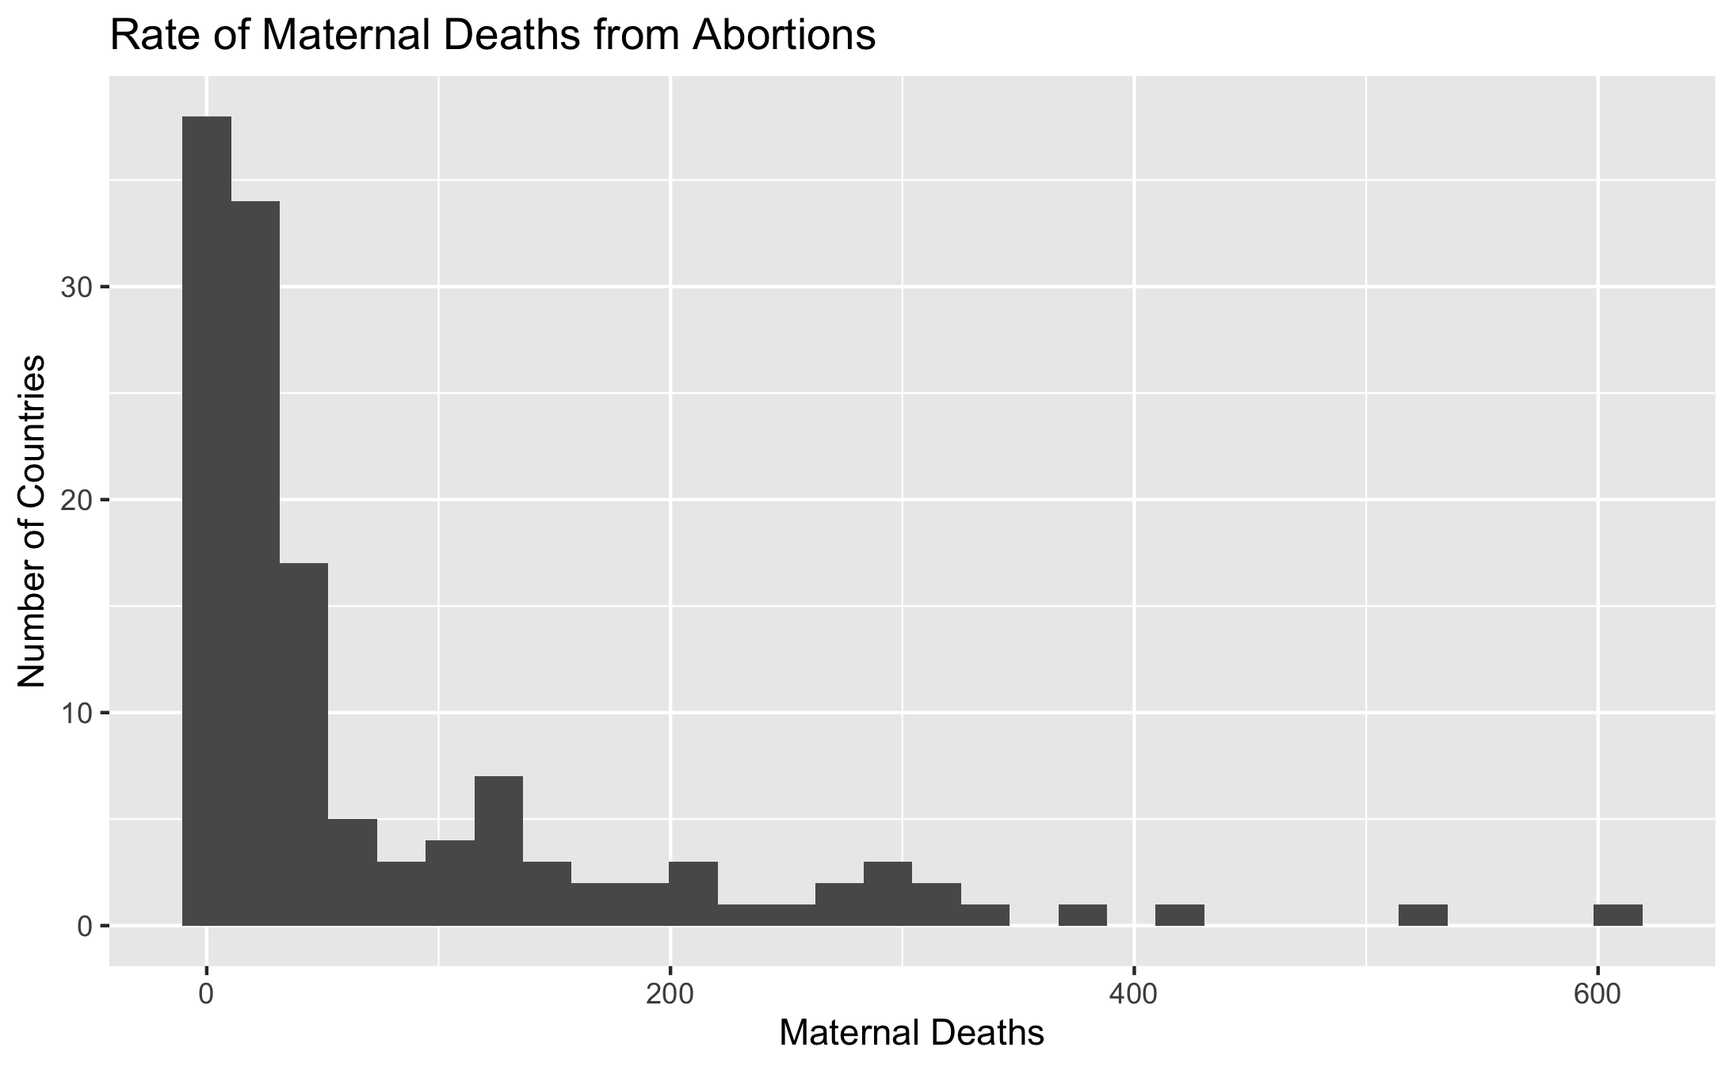

Predictor Variable Distributions

## 4.2 Basic statistical analysis

*To get some further insight into your data, if reasonable you could compute simple statistics (e.g. simple models with 1 predictor) to look for associations between your outcome(s) and each individual predictor variable. Though note that unless you pre-specified the outcome and main exposure, any “p<0.05 means statistical significance” interpretation is not valid.*

We completed a simple linear regression analysis with each of the 7 predictors shown in (**statistical-analysis1?**). The predictor with the strongest relationship with the outcome is total number of women using short acting reversible methods (sarc_standard).

# A tibble: 2 × 5  
 term estimate std.error statistic p.value  
 <chr> <dbl> <dbl> <dbl> <dbl>  
1 (Intercept) -1.70 0.947 -1.80 7.42e- 2  
2 sarc_standard 87.7 4.16 21.1 1.01e-43

The second model we created used the region predictor, which revealed that the Latin America/the Caribbean region had the strongest relationship with the outcome variable followed closely by the Asia region. The Oceania region does not appear to have a strong effect on the outcome variable with the Europe region only showing a slightly larger association. These associations can be seen in (**statistical-analysis2?**).

# A tibble: 5 × 5  
 term estimate std.error statistic p.value  
 <chr> <dbl> <dbl> <dbl> <dbl>  
1 (Intercept) 0.418 0.159 2.63 0.00960   
2 regionAsia 1.47 0.250 5.87 0.0000000350  
3 regionEurope 0.330 0.384 0.860 0.392   
4 regionLatin America & the Caribbean 1.62 0.285 5.69 0.0000000827  
5 regionOceania 0.251 0.439 0.572 0.568

We created one model with all 7 predictors using multiple linear regression. This model shows the strongest predictor is the number of women using short acting reversible contraception. The next strongest predictor is the European region followed by the Latin America/the Caribbean region and the Asia region, which is a shift from the model with the singular region predictor. The Oceania region now has a negative association with the outcome. Both of the marriage status predictors are associated with a decrease in the outcome. The coefficient estimates for the rate of maternal death due to unintended pregnancies and abortion both flipped from the single predictor models to show a positive association with the outcome.

# A tibble: 11 × 5  
 term estimate std.error statistic p.value  
 <chr> <dbl> <dbl> <dbl> <dbl>  
 1 (Intercept) 1.09 9.37 0.116 9.08e- 1  
 2 sarc_standard 85.6 4.33 19.8 9.44e-40  
 3 regionAsia 3.32 1.38 2.41 1.77e- 2  
 4 regionEurope 5.11 1.76 2.91 4.35e- 3  
 5 regionLatin America & the Caribbean 4.20 1.32 3.18 1.84e- 3  
 6 regionOceania -1.26 1.91 -0.660 5.10e- 1  
 7 pct_currentlymarried -0.0487 0.108 -0.451 6.53e- 1  
 8 pct_nevermarried -0.0174 0.0918 -0.190 8.50e- 1  
 9 rate_matdeaths -0.0156 0.00522 -2.98 3.45e- 3  
10 rate_matdeaths_upreg 0.00186 0.000787 2.36 2.00e- 2  
11 rate_matdeaths_abs 0.0101 0.00628 1.61 1.09e- 1

The full statistical analysis can be found in the statistical-analysis.qmd file in the code > analysis-code folder.

## 4.3 Full analysis

*Use one or several suitable statistical/machine learning methods to analyze your data and to produce meaningful figures, tables, etc. This might again be code that is best placed in one or several separate R scripts that need to be well documented. You want the code to produce figures and data ready for display as tables, and save those. Then you load them here.*

Example Table 2 shows a summary of a linear model fit.

|  |
| --- |
| Table 2: Linear model fit table. |

# 5. Discussion

## 5.1 Summary and Interpretation

*Summarize what you did, what you found and what it means.*

## 5.2 Strengths and Limitations

*Discuss what you perceive as strengths and limitations of your analysis.*

## 5.3 Conclusions

*What are the main take-home messages?*

*Include citations in your Rmd file using bibtex, the list of references will automatically be placed at the end*

This paper (Leek & Peng, 2015) discusses types of analyses.

These papers (McKay, Ebell, Billings, et al., 2020; McKay, Ebell, Dale, Shen, & Handel, 2020) are good examples of papers published using a fully reproducible setup similar to the one shown in this template.

Note that this cited reference will show up at the end of the document, the reference formatting is determined by the CSL file specified in the YAML header. Many more style files for almost any journal [are available](https://www.zotero.org/styles). You also specify the location of your bibtex reference file in the YAML. You can call your reference file anything you like, I just used the generic word references.bib but giving it a more descriptive name is probably better.

# 6. References

* https://pubmed.ncbi.nlm.nih.gov/32981858/
* https://www.sciencedirect.com/science/article/pii/S001078241730478X
* https://www.sciencedirect.com/science/article/abs/pii/S0020729211005406 #legal status article
* https://www.guttmacher.org/report/adding-it-up-investing-in-sexual-reproductive-health-2019-methodology (Guttmacher source)
* https://pubmed.ncbi.nlm.nih.gov/35332057/ (original source of data)

Leek, J. T., & Peng, R. D. (2015). Statistics. What is the question? *Science (New York, N.Y.)*, *347*(6228), 1314–1315. <https://doi.org/10.1126/science.aaa6146>

McKay, B., Ebell, M., Billings, W. Z., Dale, A. P., Shen, Y., & Handel, A. (2020). Associations Between Relative Viral Load at Diagnosis and Influenza A Symptoms and Recovery. *Open Forum Infectious Diseases*, *7*(11), ofaa494. <https://doi.org/10.1093/ofid/ofaa494>

McKay, B., Ebell, M., Dale, A. P., Shen, Y., & Handel, A. (2020). Virulence-mediated infectiousness and activity trade-offs and their impact on transmission potential of influenza patients. *Proceedings. Biological Sciences*, *287*(1927), 20200496. <https://doi.org/10.1098/rspb.2020.0496>