System and Software Architecture Description (SSAD)

**Discovery Tool**

**Team 3**

**Josh Bendig - IIV&V**

**Xizhao Deng - Project manager**

**Jingzhou Hong - Requirement Engineer**

**Guancheng Liu - Tester**

**Michael Russo - Prototyper**

**Shenghao Tang - Feasibility Analyst**

**Fan Zhan - Software Architect**

**Yiming Zhang - System Architect**

**11/28/18**

# Version History

|  |  |  |  |  |
| --- | --- | --- | --- | --- |
| Date | Author | Version | Changes made | Rationale |
| 10/20/18 | FZ | 1.0 | Initial draft | Initial draft for Discovery Tool SSAD |
| 10/21/18 | XD | 1.1 | Fixed formatting | Reviewed and small fixes for DC package |
| 10/21/18 | ST, JH | 1.2 | System Analysis (Content contributor dashboard page) | Need further work on remaining part |
| 10/22/18 | FZ | 1.3 | Update 4.1 | Documentation increments |
| 10/22/18 | GL | 1.4 | Increments to 2.1.3 | Documentation increments |
| 10/22/18 | FZ | 1.5 | Update 2.1.2, 4.1.2 | Documentation increments |
| 11/25/18 | XD | 2.0 | Updated section 2-5 | Revised per client meeting and CCD feedback |
| 11/28/18 | ST,JH | 2.1 | Updated figures 1,2,3,4,7,9,10,11,12,13,14,15,20,21,22,23,24,25,26 | Revised figures |

# Table of Contents

Version History 1

Table of Contents 2

1. Introduction 4

1.1 Purpose of the SSAD 4

1.2 Status of the SSAD 4

2. System Analysis 4

2.1 System Analysis Overview 4

2.1.1 System Context 5

2.1.2 Artifacts & Information 6

2.1.3 Behavior 7

2.1.3.1 Login page 13

2.1.3.2 Content contributor dashboard page 14

2.1.3.3 Content contributor draft board page 22

2.1.3.4 Content contributor global pitch board page 27

2.1.3.5 Content contributor setting page 29

2.1.3.6 Super admin dashboard board page 30

Global2.1.3.7 Super admin global pitch board page 37

2.1.3.8 Super admin weekly publishing calendar page 40

2.1.3.9 Super admin parking board page 44

2.1.3.10 Super admin team board page 47

2.1.3.11 Super admin goals board page 51

2.1.3.12 Super admin setting page 54

2.1.3.13 Admin dashboard page 55

2.1.3.14 Admin global pitch board page 62

2.1.3.15 Admin team board page 65

2.1.3.16 Admin setting page 69

2.1.4 Modes of Operation 70

2.2 System Analysis Rationale 70

3. Technology-Independent Model 71

3.1. Design Overview 71

3.1.1 System Structure 71

3.1.2 Design Classes 74

3.1.3 Process Realization 75

3.2 Design Rationale 78

4. Technology-Specific System Design 78

4.1 Design Overview 79

4.1.1 System Structure 79

4.1.2 Design Classes 81

4.1.3 Process Realization 83

4.2 Design Rationale 86

5. Architectural Styles, Patterns and Frameworks 86

# 1. Introduction

## 1.1 Purpose of the SSAD

SSAD provides a number of benefits for discovery-tool:

* It gives a basis for analysis of software system’s behavior before the system has been built. With this documentation, team will have better understanding of the project requirements.
* It provides a basis for re-use of elements and decisions. With this documentation, the team should have the sense of which component could be reused in the future so that we could build a more extensible framework. For example, what if we add more types of the content rather than only pitches?
* It supports early design decisions that impact a system's development, deployment, and maintenance.
* It facilitates communication with stakeholders, contributing to a system that better fulfills their needs. With this documentation, team will have better idea about how to build a system that every member could do contribution to it. For example, with better organization, each member could be one or several API’s owner in our Flask framework, and our backend system is consists of all of these APIs.
* It enables [cost reduction](https://en.wikipedia.org/wiki/Cost_reduction). Software architecture is a means to manage risk and costs in complex IT projects.

## 1.2 Status of the SSAD

System Analysis Overview, System Analysis Rationale, Design Overview and Design Rationale have been added. This is the version 2.0 release of SSAD for Fall 2018 DC package deliverables.

# 2. System Analysis

## 2.1 System Analysis Overview

Discovery Tool is a web app based idea management system. It serves as an internal tool to System1. It provides a solution to help System1 content contributors and admins to streamline, manage, accelerate their workflow. It gives the admins necessary tooling to quickly scale the team as well as content production. Overall, the system supports the team to work cross-functionally, leveraging resources to meet needs as efficiently as possible.

### 2.1.1 System Context

Figure 1: System Context Diagram

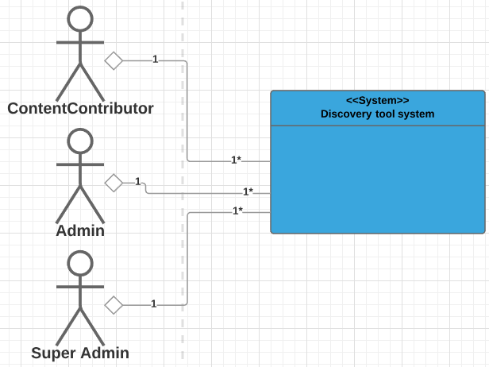

Table 1: Actors Summary

|  |  |  |
| --- | --- | --- |
| **Actor** | **Description** | **Responsibilities** |
| Content contributor | User who draft ideas and pitch ideas | * Draft pitches and submit for approval |
| Content Admin | User who review and approve pitches, and manage user accounts | * Manage user accounts * Manage pitches |
| Super Admin | User who review and approve pitches, manage user accounts, set weekly goals, and review publishing calendar | * Manage user accounts * Manage pitches * Set goals * Manage publishing calendar |

### 2.1.2 Artifacts & Information

Figure 2: Artifacts and Information Diagram

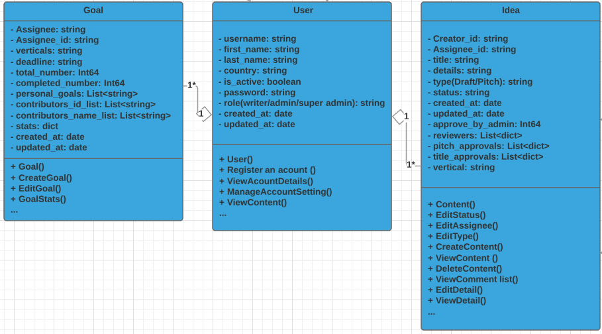

Table 2: Artifacts and Information Summary

|  |  |
| --- | --- |
| **Class** | **Purpose** |
| User | User is the object who is going to use the system. It is the fundamental artifacts of the system. |
| Idea | Idea is the object that is used by users. It is the fundamental artifacts of the system. |
| Goal | Goal is defined by the super admin to trace the progress weekly |

### 

### 

### 

### 

### 

### 2.1.3 Behavior

Figure 3: Process Diagram - admin and super admin

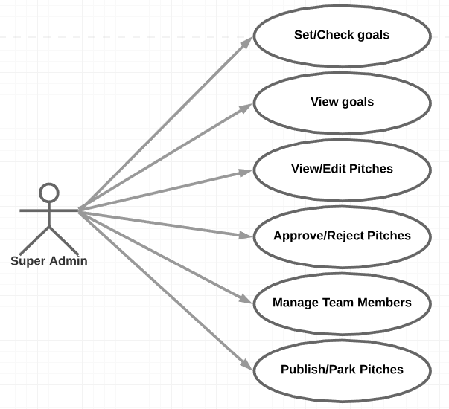

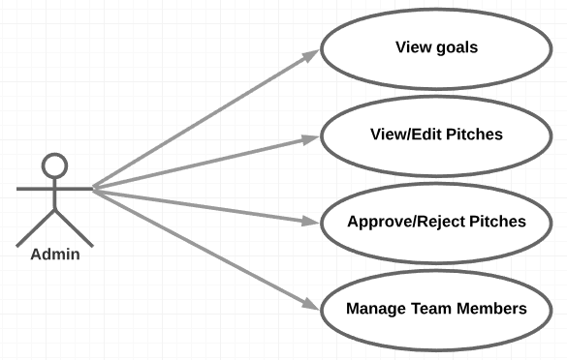

Figure 4: Process Diagram - content contributor

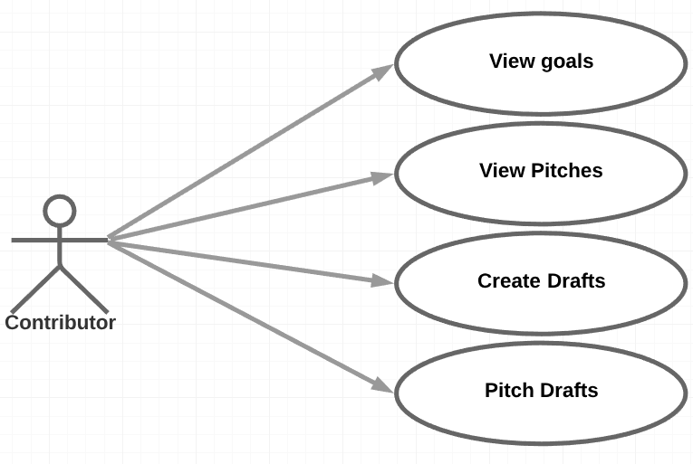

Table 3: Use Case List

|  |  |  |
| --- | --- | --- |
| **Use Case ID** | **Use Case Name** | **Description** |
| **Login page** | | |
| UC-1 | Login | User logs into the system with a username and password |
| **Content contributor dashboard page** | | |
| UC-2 | View current week goals and progress | Contributor can view overall project progress, current week goal, verticals in work. For each vertical, show number of draft, number of pitches submitted, number of pitches approved/ parked/ rejected. |
| UC-3 | View past week goals | Contributor can view goals made in past weeks |
| UC-4 | View future week goals | Contributor can view goals set for future weeks |
| UC-5 DEFERRED | Receive notifications | Contributor can receive notifications as a piece of content moves through the various stages of development (approved, rejected, parked) |
| UC-6 DEFERRED | Send message | Contributor can send a message to a specific user |
| UC-7 DEFERRED | Receive message | Contributor can receive message from other users |
| UC-8 DEFERRED | View content success rates by draft to approved pitch conversion ratio | Contributor can track his/her own success rate by the draft to approved pitch conversion ratio |
| UC-9 | Logout | Contributor logs out of the system and ends their current session |
| **Content contributor draft board page** | | |
| UC-10 | Create a draft | Contributor can create a new draft and add details |
| UC-11  DEFERRED | Edit a draft | Contributor can modify a draft |
| UC-12  DEFERRED | Delete a draft | Contributor can remove a draft |
| UC-13  DEFERRED | View a draft | Contributor can view a draft’s details: draft ID, title, vertical, creator ID, time created, last time modified, details(description, URL, buyside network), status(new, approved, rejected, parked), log(contributor X modified at 11:30pm 11-10-18) |
| UC-14 | Pitch a draft | When a contributor thinks this draft is ready, he/she can click the “pitch it” button to publish this draft to the global pitch list. This draft is then removed from this draft board. |
| **Content contributor global pitch board page** | | |
| UC-15  DEFERRED | View a pitch | Contributor can click on a pitch in the list to view its details: pitch ID, title, vertical, creator ID, time created, last time modified, details(description, URL, buyside network), status(new, approved, rejected, parked), log(contributor X modified at 11:30pm 11-10-18), admin reviews |
| UC-16 DEFERRED | Filter pitches by criteria | Contributor can filter pitches by criteria such as status, creator etc |
| **Content contributor setting page** | | |
| UC-17 | Edit a personal profile | Contributor can make changes to their own profile including address, contact etc |
| **Super admin dashboard page** | | |
| UC-20 | View current week goals and progress | Super admin can view overall project progress, goal verticals, number of pitch needed by each vertical, progress of each vertical (pitch approved / needed). Super admin does not edit goal in dashboard page, it must be done in goals board page |
| UC-21 | View past week goals | Super admin can view goals made in past weeks |
| UC-22 | View future weeks goals | Super admin can view goals set for future weeks |
| UC-23 DEFERRED | Receive notifications | Super admin can receive notifications as a piece of content moves through the various stages of development (approved, rejected, parked). Super admin will receive notification as a new pitch needs to be reviewed / when weekly deadline approves, weekly publishing calendar needs to be reviewed. |
| UC-24 DEFERRED | Send message | Super admin can send a message to a specific user |
| UC-25 DEFERRED | Receive message | Super admin contributor can receive message from other users |
| UC-26 | Logout | Super admin logs out of the system and ends their current session |
| **Super admin global pitch board page** | | |
| UC-27 | View/Edit a pitch | Super admin can click on a pitch in the list to view its details: pitch ID, title, vertical, creator ID, time created, last time modified, details(description, URL, buyside network), status(new, approved, rejected, parked), log(contributor X modified at 11:30pm 11-10-18), admin reviews [1][0]. Super admin can edit the pitch in the global pitch board page |
| UC-28 | Approve/reject a pitch | Super admin can click on a pitch, change its status to approved or rejected. If a total number of 2 admin/super admin have different opinions, the status of the pitch is changed to “parked” which is then moved to the parking board, and removed from the pitch board. Rejected pitch is permanently removed from database |
| UC-29 DEFERRED | Filter pitches by criteria | Super admin can filter pitches by criteria such as status, creator etc |
| **Super admin weekly publishing calendar page** | | |
| UC-30 | View/Edit a pitch | Super admin can click on a pitch in the list to view its details: pitch ID, title, vertical, creator ID, time created, last time modified, details(description, URL, buyside network), status(new, approved, rejected, parked, which will always be approved), log(contributor X modified at 11:30pm 11-10-18), Super admin can edit the pitch in the Weekly publishing calendar page |
| UC-31 | Approve the publishing calendar | Super admin can make the decision to publish the pitches in the weekly publishing calendar (approved for publish) |
| UC-32 DEFERRED | Filter pitches by criteria | Super admin can filter pitches by criteria such as status, creator etc |
| UC-33 | Export weekly publishing calendar | Super admin can export the weekly publishing calendar into CSV file |
| **Super admin parking board page** | | |
| UC-34 | View/Edit a pitch | Super admin can click on a pitch in the list to view its details: pitch ID, title, vertical, creator ID, time created, last time modified, details(description, URL, buyside network), status(new, approved, rejected, parked, which will always be parked), log(contributor X modified at 11:30pm 11-10-18), Super admin can edit the pitch in the parking board |
| UC-35 | Pull in parked pitch | If there is not enough pitches in the weekly publishing calendar, the super admin can move some parked pitches into publishing calendar (change parked pitches’ status to approved, remove them from parking board, move into publishing calendar) |
| **Super admin team board page** | | |
| UC-36 | View a team member details | Super admin can click on a team member and view his/her information: member name, account type(contributor, admin, super admin), number of draft pitched, number of pitch approved, total weekly number of pitch needed, success rate, details (name, gender, email, phone, address, county, state, country) |
| UC-37 | Change a team member’s type | Super admin can change a team member’s type between admin and contributor |
| UC-38 | Create a new user | Super admin can create a new admin or contributor account |
| UC-39 | Delete an existing user | Super admin can delete an existing account |
| **Super admin goals board page** | | |
| UC-40 | Set goals for current week | Super admin can set a list of goals desired for current week, each goal has one desired vertical, and number of pitch needed for that vertical. Once the goal is set, it’s given to all contributors but the number of pitch is evenly distributed among the contributors. |
| UC-41 | Set goals for future weeks | Super admin can set a list of goals desired for future weeks |
| UC-42 | Check past weeks’ goals | Super admin can select a week in history and check its goals |
| **Super admin setting page** | | |
| UC-43 | Edit a personal profile | Super admin can make changes to their own profile including address, contact etc |
| **Admin dashboard page** | | |
| UC-44 | View current week goals and progress | Admin can view overall project progress, goal verticals, number of pitch needed by each vertical, progress of each vertical (pitch approved / needed). |
| UC-45 | View past week goals | Admin can view goals made in past weeks |
| UC-46 | View future weeks goals | Admin can view goals set for future weeks |
| UC-47 DEFERRED | Receive notifications | Admin can receive notifications as a piece of content moves through the various stages of development (approved, rejected, parked). Admin will receive notification as a new pitch needs to be reviewed |
| UC-48 DEFERRED | Send message | Admin can send a message to a specific user |
| UC-49 DEFERRED | Receive message | Admin contributor can receive message from other users |
| UC-50 | Logout | Admin logs out of the system and ends their current session |
| **Admin global pitch board page** | | |
| UC-51 | View/Edit a pitch | Admin can click on a pitch in the list to view its details: pitch ID, title, vertical, creator ID, time created, last time modified, details(description, URL, buyside network), status(new, approved, rejected, parked), log(contributor X modified at 11:30pm 11-10-18), admin reviews [1][0]. Admin can edit the pitch in the global pitch board page |
| UC-52 | Approve/reject a pitch | Admin can click on a pitch, change its status to approved or rejected. If a total number of 2 admin/super admin have different opinions, the status of the pitch is changed to “parked” which is then moved to the parking board, and removed from the pitch board. Rejected pitch is permanently removed from database |
| UC-53 DEFERRED | Filter pitches by criteria | Admin can filter pitches by criteria such as status, creator etc |
| **Admin team board page** | | |
| UC-54 | View a team member details | Admin can click on a team member and view his/her information: member name, account type(contributor, admin, super admin), number of draft pitched, number of pitch approved, total weekly number of pitch needed, success rate, details (name, gender, email, phone, address, county, state, country) |
| UC-55 | Change a team member’s type | Admin can change a team member’s type between admin and contributor |
| UC-56 | Create a new user | Admin can create a new admin or contributor account |
| UC-57 | Delete an existing user | Admin can delete an existing account |
| **Admin setting page** | | |
| UC-58 | Edit a personal profile | Admin can make changes to their own profile including address, contact etc |

#### 2.1.3.1 Login page

Table 3: Process Description - UC-1

|  |  |
| --- | --- |
| **Identifier** | UC-1 |
| **Purpose** | Log into the user’s session |
| **Requirements** | A valid account has been set up |
| **Development Risks** | None |
| **Pre-conditions** | Account registration |
| **Post-conditions** | None |

Table 4: Typical Course of Action - UC-1 success

|  |  |  |
| --- | --- | --- |
| **Seq#** | **Actor’s Action** | **System’s Response** |
| **1** | Fill in username and password, click “login” |  |
| **2** |  | Check user credentials |
| **3** |  | Redirect to user dashboard page |

Table 5: Typical Course of Action - UC-1 failure

|  |  |  |
| --- | --- | --- |
| **Seq#** | **Actor’s Action** | **System’s Response** |
| **1** | Fill in incorrect username and password, click “login” |  |
| **2** |  | Check user credentials |
| **3** |  | Display error message |

#### 2.1.3.2 Content contributor dashboard page

Table 6: Process Description - UC-2

|  |  |
| --- | --- |
| **Identifier** | UC-2 |
| **Purpose** | Contributor can view overall project progress, current week goal, verticals in work. For each vertical, show number of draft, number of pitches submitted, number of pitches approved/ parked/ rejected. |
| **Requirements** | A valid account, user type as “contributor”. |
| **Development Risks** | None |
| **Pre-conditions** | Account logged in |
| **Post-conditions** | None |

Table 7: Typical Course of Action - UC-2 success

|  |  |  |
| --- | --- | --- |
| **Seq#** | **Actor’s Action** | **System’s Response** |
| **1** | Users go to contributor dashboard page |  |
| **2** |  | Check and show the contributor dashboard page |
| **3** | Click on a submitted pitch |  |
| **4** |  | Display detail of the pitch |

Table 8: Typical Course of Action - UC-2 failure

|  |  |  |
| --- | --- | --- |
| **Seq#** | **Actor’s Action** | **System’s Response** |
| **1** | Users go to the pitch board |  |
| **2** |  | Check the user dashboard page |
| **3** |  | Display error message |

Table 9: Process Description - UC-3

|  |  |
| --- | --- |
| **Identifier** | UC-3 |
| **Purpose** | Contributor can view goals made in past week |
| **Requirements** | A valid account, user type as “contributor” |
| **Development Risks** | None |
| **Pre-conditions** | Account login, user in contributor dashboard page |
| **Post-conditions** | None |

Table 10: Typical Course of Action - UC-3 success

|  |  |  |
| --- | --- | --- |
| **Seq#** | **Actor’s Action** | **System’s Response** |
| **1** | Users be on the dashboard |  |
| **2** |  | Show that week’s goal |

Table 11: Typical Course of Action - UC-3 failure

|  |  |  |
| --- | --- | --- |
| **Seq#** | **Actor’s Action** | **System’s Response** |
| **1** | Users be on the dashboard |  |
| **2** |  | No goals were presented for the desired week |

##### 

Table 12: Process Description - UC-4

|  |  |
| --- | --- |
| **Identifier** | UC-4 |
| **Purpose** | Contributor can view goals set for future weeks |
| **Requirements** | Valid contributor account |
| **Development Risks** | None |
| **Pre-conditions** | Account login, user in contributor dashboard page |
| **Post-conditions** | View goal detail of the chosen week |

Table 13: Typical Course of Action - UC-4 success

|  |  |  |
| --- | --- | --- |
| **Seq#** | **Actor’s Action** | **System’s Response** |
| **1** | Users be on the dashboard |  |
| **2** |  | Show that week’s goal |
| **3** |  | Display goal verticals and pitch quota |

Table 14: Typical Course of Action - UC-4 failure

|  |  |  |
| --- | --- | --- |
| **Seq#** | **Actor’s Action** | **System’s Response** |
| **1** | Users be on the dashboard |  |
| **2** |  | No goals were presented for the desired week |

##### 

Table 15: Process Description - UC-5

|  |  |
| --- | --- |
| **Identifier** | UC-5 DEFERRED |
| **Purpose** | Contributor can receive notifications as a piece of content moves through the various stages of development (approved, rejected, parked) |
| **Requirements** | Valid contributor account |
| **Development Risks** | None |
| **Pre-conditions** | Account login, user in contributor dashboard page |
| **Post-conditions** | None |

Table 16: Typical Course of Action - UC-5 success

|  |  |  |
| --- | --- | --- |
| **Seq#** | **Actor’s Action** | **System’s Response** |
| **1** | User see notification icon with numbers aside of it |  |
| **2** | User clicks the notification icon |  |
| **3** |  | Redirect user to notification page |

Table 17: Typical Course of Action - UC-5 failure

|  |  |  |
| --- | --- | --- |
| **Seq#** | **Actor’s Action** | **System’s Response** |
| **1** | User see notification icon with numbers aside of it |  |
| **2** | User clicks the notification icon |  |
| **3** |  | Fail to redirect user to notification page |

##### 

Table 18: Process Description - UC-6

|  |  |
| --- | --- |
| **Identifier** | UC-6 DEFERRED |
| **Purpose** | Contributor can send a message to a specific user |
| **Requirements** | Valid contributor account |
| **Development Risks** | May lack skill set for integrate messaging functionality |
| **Pre-conditions** | Account login, user in contributor dashboard page |
| **Post-conditions** | Message sent |

Table 19: Typical Course of Action - UC-6 success

|  |  |  |
| --- | --- | --- |
| **Seq#** | **Actor’s Action** | **System’s Response** |
| **1** | User choose a user |  |
| **2** | User type a message and send |  |
| **3** |  | Forward the message to the chosen user |
| **4** |  | Display message on the chosen user’s notification area |

Table 20: Typical Course of Action - UC-6 failure

|  |  |  |
| --- | --- | --- |
| **Seq#** | **Actor’s Action** | **System’s Response** |
| **1** | User choose a user |  |
| **2** | User type a message and send |  |
| **3** |  | Forwarding message failed |
| **4** |  | Display error message |

Table 21: Process Description - UC-7

|  |  |
| --- | --- |
| **Identifier** | UC-7 DEFERRED |
| **Purpose** | Contributor can receive message from other users |
| **Requirements** | Valid account, user type as “contributor” |
| **Development Risks** | None |
| **Pre-conditions** | Account login, user in contributor dashboard page |
| **Post-conditions** | Message received |

Table 22: Typical Course of Action - UC-7 success

|  |  |  |
| --- | --- | --- |
| **Seq#** | **Actor’s Action** | **System’s Response** |
| **1** | Users move to contributor dashboard page |  |
| **2** |  | Show the contributor dashboard page |
| **3** | Click on “message box” |  |
| **4** |  | Show the list of message received |
| **5** | Click on one message to read |  |
| **6** |  | Show the message |

Table 23: Typical Course of Action - UC-7 failure

|  |  |  |
| --- | --- | --- |
| **Seq#** | **Actor’s Action** | **System’s Response** |
| **1** | Users move to contributor dashboard page |  |
| **2** |  | Show the contributor dashboard page |
| **3** | Click on “message box” |  |
| **4** |  | Show error info that why message box is unavailable |

##### 

Table 24: Process Description - UC-8

|  |  |
| --- | --- |
| **Identifier** | UC-8 DEFERRED |
| **Purpose** | Contributor can track his/her own success rate by the draft to approved pitch conversion ratio |
| **Requirements** | Valid account, user type as “contributor” |
| **Development Risks** | None |
| **Pre-conditions** | Account login, user in contributor dashboard page |
| **Post-conditions** | None |

Table 25: Typical Course of Action - UC-8 success

|  |  |  |
| --- | --- | --- |
| **Seq#** | **Actor’s Action** | **System’s Response** |
| **1** | User on dashboard page |  |
| **2** |  | Show ratio |

Table 26: Typical Course of Action - UC-8 failure

|  |  |  |
| --- | --- | --- |
| **Seq#** | **Actor’s Action** | **System’s Response** |
| **1** | User on dashboard page |  |
| **2** |  | Incorrect ratio shown |

Table 27: Process Description - UC-9

|  |  |
| --- | --- |
| **Identifier** | UC-9 |
| **Purpose** | Contributor logs out of the system and ends their current session |
| **Requirements** | Valid account, user type as “contributor” |
| **Development Risks** | None |
| **Pre-conditions** | Account login, user in contributor dashboard page |
| **Post-conditions** | Account logged out |

Table 28: Typical Course of Action - UC-9 success

|  |  |  |
| --- | --- | --- |
| **Seq#** | **Actor’s Action** | **System’s Response** |
| **1** | User click account icon |  |
| **2** |  | Show log out option |
| **3** | User click on log out button |  |
| **4** |  | Log the account out |

Table 29: Typical Course of Action - UC-9 failure

|  |  |  |
| --- | --- | --- |
| **Seq#** | **Actor’s Action** | **System’s Response** |
| **1** | User click account icon |  |
| **2** |  | Show log out option |
| **3** | User click on log out button |  |
| **4** |  | Fail to log out, show error message |

#### 2.1.3.3 Content contributor draft board page

Table 30: Process Description - UC-10

|  |  |
| --- | --- |
| **Identifier** | UC-10 |
| **Purpose** | Contributor can create a new draft and add details |
| **Requirements** | Valid account, user type as “contributor” |
| **Development Risks** | None |
| **Pre-conditions** | Account login, user in contributor dashboard page |
| **Post-conditions** | None |

Table 31: Typical Course of Action - UC-10 success

|  |  |  |
| --- | --- | --- |
| **Seq#** | **Actor’s Action** | **System’s Response** |
| **1** | Users click on draft board on the sidebar |  |
| **2** |  | Visit contributor draft board |
| **3** | Enter details of the idea, click “Pitch it” |  |
| **4** |  | Save the new draft in the draft board and database |

Table 32: Typical Course of Action - UC-10 failure

|  |  |  |
| --- | --- | --- |
| **Seq#** | **Actor’s Action** | **System’s Response** |
| **1** | Users click on draft board on the sidebar |  |
| **2** |  | Visit contributor draft board |
| **3** | Enter details of the idea without title or vertical, click “Pitch it” |  |
| **4** |  | Fail to save the new draft in the draft board and database |
| **5** |  | Pop error message |

##### 

Table 33: Process Description - UC-11

|  |  |
| --- | --- |
| **Identifier** | UC-11 DEFERRED |
| **Purpose** | Contributor can modify a draft |
| **Requirements** | Valid account |
| **Development Risks** | None |
| **Pre-conditions** | Account login |
| **Post-conditions** | None |

Table 34: Typical Course of Action - UC-11 success

|  |  |  |
| --- | --- | --- |
| **Seq#** | **Actor’s Action** | **System’s Response** |
| **1** | User click on the edit button |  |
| **2** |  | Bring up the portal for editing this idea |
| **3** | User make changes and click “save” |  |
| **4** |  | Save changes to database |

Table 35: Typical Course of Action - UC-11 failure

|  |  |  |
| --- | --- | --- |
| **Seq#** | **Actor’s Action** | **System’s Response** |
| **1** | User click on setting menu and then click on log out button |  |
| **2** |  | Log out of the system |
| **3** |  | Display error message |

Table 36: Process Description - UC-12

|  |  |
| --- | --- |
| **Identifier** | UC-12 DEFERRED |
| **Purpose** | Contributor can remove a draft |
| **Requirements** | Valid account |
| **Development Risks** | None |
| **Pre-conditions** | Account login |
| **Post-conditions** | None |

Table 37: Typical Course of Action - UC-12 success

|  |  |  |
| --- | --- | --- |
| **Seq#** | **Actor’s Action** | **System’s Response** |
| **1** | User click on “remove” next to the pitch |  |
| **2** |  | Remove the pitch from UI and database |

Table 38: Typical Course of Action - UC-12 failure

|  |  |  |
| --- | --- | --- |
| **Seq#** | **Actor’s Action** | **System’s Response** |
| **1** | User click on “remove” next to the pitch |  |
| **2** |  | Fail to remove the pitch from UI and database |
| **3** |  | Pop error message |

##### 

Table 39: Process Description - UC-13

|  |  |
| --- | --- |
| **Identifier** | UC-13 DEFERRED |
| **Purpose** | Contributor can view a draft’s details: draft ID, title, vertical, creator ID, time created, last time modified, details, status, log |
| **Requirements** | Valid account |
| **Development Risks** | None |
| **Pre-conditions** | Account login |
| **Post-conditions** | None |

Table 40: Typical Course of Action - UC-13 success

|  |  |  |
| --- | --- | --- |
| **Seq#** | **Actor’s Action** | **System’s Response** |
| **1** | User click on “detail” button of a pitch in the draft board |  |
| **2** |  | Show the draft details portal |

Table 41: Typical Course of Action - UC-13 failure

|  |  |  |
| --- | --- | --- |
| **Seq#** | **Actor’s Action** | **System’s Response** |
| **1** | User click on “detail” button of a pitch in the draft board |  |
| **2** |  | Fail to show the draft details portal or shows incorrect details |

##### 

Table 42: Process Description - UC-14

|  |  |
| --- | --- |
| **Identifier** | UC-14 |
| **Purpose** | When a contributor thinks this draft is ready, he/she can click the “pitch it” button to publish this draft to the global pitch list. This draft is then removed from this draft board. |
| **Requirements** | Valid account |
| **Development Risks** | None |
| **Pre-conditions** | Account login |
| **Post-conditions** | None |

Table 43: Typical Course of Action - UC-14 success

|  |  |  |
| --- | --- | --- |
| **Seq#** | **Actor’s Action** | **System’s Response** |
| **1** | After populate the entries of a new pitch, click on “pitch it” |  |
| **2** |  | Change the status of the pitch to “new”, remove it from contributor’s draft board, move it into the global pitch board |

Table 44: Typical Course of Action - UC-14 failure

|  |  |  |
| --- | --- | --- |
| **Seq#** | **Actor’s Action** | **System’s Response** |
| **1** | After populate the entries of a new pitch, click on “pitch it” |  |
| **2** |  | Fail to change the status of the pitch |

#### 2.1.3.4 Content contributor global pitch board page

Table 45: Process Description - UC-15

|  |  |
| --- | --- |
| **Identifier** | UC-15 |
| **Purpose** | Contributor can click on a pitch in the list to view its details: pitch ID, title, vertical, creator ID, time created, last time modified, details, status, log, admin reviews |
| **Requirements** | Valid account |
| **Development Risks** | None |
| **Pre-conditions** | Account login |
| **Post-conditions** | None |

Table 46: Typical Course of Action - UC-15 success

|  |  |  |
| --- | --- | --- |
| **Seq#** | **Actor’s Action** | **System’s Response** |
| **1** | User click on the “details” button of a pitch in the global pitch board |  |
| **2** |  | Bring up the detail portal and show the details of that pitch |

Table 47: Typical Course of Action - UC-15 failure

|  |  |  |
| --- | --- | --- |
| **Seq#** | **Actor’s Action** | **System’s Response** |
| **1** | User click on the “details” button of a pitch in the global pitch board |  |
| **2** |  | Fail to show the detail portal or shows incorrect pitch details |

Table 48: Process Description - UC-16

|  |  |
| --- | --- |
| **Identifier** | UC-16 DEFERRED |
| **Purpose** | Contributor can filter pitches by criteria such as status, creator etc |
| **Requirements** | Valid account |
| **Development Risks** | None |
| **Pre-conditions** | Account login |
| **Post-conditions** | None |

Table 49: Typical Course of Action - UC-16 success

|  |  |  |
| --- | --- | --- |
| **Seq#** | **Actor’s Action** | **System’s Response** |
| **1** | In the global pitch board, user enter the desired keyword on a column to show matching pitches |  |
| **2** |  | Query database and show the filtered pitch list |

Table 50: Typical Course of Action - UC-16 failure

|  |  |  |
| --- | --- | --- |
| **Seq#** | **Actor’s Action** | **System’s Response** |
| **1** | In the global pitch board, user enter the desired keyword on a column to show matching pitches |  |
| **2** |  | Fail to query the correct pitches |

#### 2.1.3.5 Content contributor setting page

Table 51: Process Description - UC-17

|  |  |
| --- | --- |
| **Identifier** | UC-17 |
| **Purpose** | Contributor can make changes to their own profile including address, contact etc |
| **Requirements** | Valid account |
| **Development Risks** | None |
| **Pre-conditions** | Account login |
| **Post-conditions** | None |

Table 52: Typical Course of Action - UC-17 success

|  |  |  |
| --- | --- | --- |
| **Seq#** | **Actor’s Action** | **System’s Response** |
| **1** | User click on “settings” on the side bar |  |
| **2** |  | Visit setting page, show existing user profile |
| **3** | User change desired entries, click “update profile” |  |
| **4** |  | Save the new profiles in database |

Table 53: Typical Course of Action - UC-17 failure

|  |  |  |
| --- | --- | --- |
| **Seq#** | **Actor’s Action** | **System’s Response** |
| **1** | User click on “settings” on the side bar |  |
| **2** |  | Visit setting page, show existing user profile |
| **3** | User change desired entries, click “update profile” |  |
| **4** |  | New profile does not save to database properly |

#### 2.1.3.6 Super admin dashboard board page

Table 60: Process Description - UC-20

|  |  |
| --- | --- |
| **Identifier** | UC-20 |
| **Purpose** | Super admin can view overall project progress, goal verticals, number of pitch needed by each vertical, progress of each vertical (pitch approved / needed). Super admin does not edit goal in dashboard page, it must be done in goals board page |
| **Requirements** | Valid account |
| **Development Risks** | None |
| **Pre-conditions** | Account login |
| **Post-conditions** | None |

Table 61: Typical Course of Action - UC-20 success

|  |  |  |
| --- | --- | --- |
| **Seq#** | **Actor’s Action** | **System’s Response** |
| **1** | In the dashboard, the weekly goal KPI and work progress is presented to the user |  |
| **2** | User choose a specific member in the dropdown list of the work progress section, show that person’s progress over a selected month |  |
| **3** |  | Query selected person’s progress data |

Table 62: Typical Course of Action - UC-20 failure

|  |  |  |
| --- | --- | --- |
| **Seq#** | **Actor’s Action** | **System’s Response** |
| **1** | In the dashboard, the weekly goal KPI and work progress is presented to the user |  |
| **2** | User choose a specific member in the dropdown list of the work progress section, show that person’s progress over a selected month |  |
| **3** |  | Fail to query selected person’s progress data |

Table 63: Process Description - UC-21

|  |  |
| --- | --- |
| **Identifier** | UC-21 |
| **Purpose** | Super admin can view goals made in past weeks |
| **Requirements** | Valid account |
| **Development Risks** | None |
| **Pre-conditions** | Account login |
| **Post-conditions** | None |

Table 64: Typical Course of Action - UC-21 success

|  |  |  |
| --- | --- | --- |
| **Seq#** | **Actor’s Action** | **System’s Response** |
| **1** | In the dashboard, user select a desired week in the calendar in the weekly goal KPI section |  |
| **2** |  | Query goal info from that week and the week before it and generate the KPI graph |

Table 65: Typical Course of Action - UC-21 failure

|  |  |  |
| --- | --- | --- |
| **Seq#** | **Actor’s Action** | **System’s Response** |
| **1** | In the dashboard, user select a desired week in the calendar in the weekly goal KPI section |  |
| **2** |  | Fail to query goal info from that week and the week before it and generate the KPI graph |

Table 66: Process Description - UC-22

|  |  |
| --- | --- |
| **Identifier** | UC-22 |
| **Purpose** | Super admin can view goals set for future weeks |
| **Requirements** | Valid account |
| **Development Risks** | None |
| **Pre-conditions** | Account login |
| **Post-conditions** | None |

Table 67: Typical Course of Action - UC-22 success

|  |  |  |
| --- | --- | --- |
| **Seq#** | **Actor’s Action** | **System’s Response** |
| **1** | In the dashboard, user select a desired week in the calendar in the weekly goal KPI section |  |
| **2** |  | Query goal info from that week and the week before it and generate the KPI graph |

Table 68: Typical Course of Action - UC-22 failure

|  |  |  |
| --- | --- | --- |
| **Seq#** | **Actor’s Action** | **System’s Response** |
| **1** | In the dashboard, user select a desired week in the calendar in the weekly goal KPI section |  |
| **2** |  | Fail to query the correct goal info from that week and the week before it and generate the KPI graph |

Table 69: Process Description - UC-23

|  |  |
| --- | --- |
| **Identifier** | UC-23 DEFERRED |
| **Purpose** | Super admin can receive notifications as a piece of content moves through the various stages of development (approved, rejected, parked). Super admin will receive notification as a new pitch needs to be reviewed / when weekly deadline approves, weekly publishing calendar needs to be reviewed |
| **Requirements** | Valid account |
| **Development Risks** | None |
| **Pre-conditions** | Account login |
| **Post-conditions** | None |

Table 70: Typical Course of Action - UC-23 success

|  |  |  |
| --- | --- | --- |
| **Seq#** | **Actor’s Action** | **System’s Response** |
| **1** | User see notification icon with numbers aside of it |  |
| **2** | User clicks the notification icon |  |
| **3** |  | Redirect user to notification page |

Table 71: Typical Course of Action - UC-23 failure

|  |  |  |
| --- | --- | --- |
| **Seq#** | **Actor’s Action** | **System’s Response** |
| **1** | User see notification icon with numbers aside of it |  |
| **2** | User clicks the notification icon |  |
| **3** |  | Fail to redirect user to notification page |

Table 72: Process Description - UC-24

|  |  |
| --- | --- |
| **Identifier** | UC-24 DEFERRED |
| **Purpose** | Super admin can send a message to a specific user |
| **Requirements** | Valid account |
| **Development Risks** | None |
| **Pre-conditions** | Account login |
| **Post-conditions** | None |

Table 73: Typical Course of Action - UC-24 success

|  |  |  |
| --- | --- | --- |
| **Seq#** | **Actor’s Action** | **System’s Response** |
| **1** | User choose a user |  |
| **2** | User type a message and send |  |
| **3** |  | Forward the message to the chosen user |
| **4** |  | Display message on the chosen user’s notification area |

Table 74: Typical Course of Action - UC-24 failure

|  |  |  |
| --- | --- | --- |
| **Seq#** | **Actor’s Action** | **System’s Response** |
| **1** | User choose a user |  |
| **2** | User type a message and send |  |
| **3** |  | Forwarding message failed |
| **4** |  | Display error message |

Table 75: Process Description - UC-25

|  |  |
| --- | --- |
| **Identifier** | UC-25 DEFERRED |
| **Purpose** | Super admin contributor can receive message from other users |
| **Requirements** | Valid account |
| **Development Risks** | None |
| **Pre-conditions** | Account login |
| **Post-conditions** | None |

Table 76: Typical Course of Action - UC-25 success

|  |  |  |
| --- | --- | --- |
| **Seq#** | **Actor’s Action** | **System’s Response** |
| **1** | Users move to contributor dashboard page |  |
| **2** |  | Show the contributor dashboard page |
| **3** | Click on “message box” |  |
| **4** |  | Show the list of message received |
| **5** | Click on one message to read |  |
| **6** |  | Show the message |

Table 77: Typical Course of Action - UC-25 failure

|  |  |  |
| --- | --- | --- |
| **Seq#** | **Actor’s Action** | **System’s Response** |
| **1** | Users move to contributor dashboard page |  |
| **2** |  | Show the contributor dashboard page |
| **3** | Click on “message box” |  |
| **4** |  | Show error info that why message box is unavailable |

#### 

Table 78: Process Description - UC-26

|  |  |
| --- | --- |
| **Identifier** | UC-26 |
| **Purpose** | Super admin logs out of the system and ends their current session |
| **Requirements** | Valid account |
| **Development Risks** | None |
| **Pre-conditions** | Account login |
| **Post-conditions** | None |

Table 79: Typical Course of Action - UC-26 success

|  |  |  |
| --- | --- | --- |
| **Seq#** | **Actor’s Action** | **System’s Response** |
| **1** | User click account icon |  |
| **2** |  | Show log out option |
| **3** | User click on log out button |  |
| **4** |  | Log the account out |

Table 80: Typical Course of Action - UC-26 failure

|  |  |  |
| --- | --- | --- |
| **Seq#** | **Actor’s Action** | **System’s Response** |
| **1** | User click account icon |  |
| **2** |  | Show log out option |
| **3** | User click on log out button |  |
| **4** |  | Fail to log out, show error message |

#### Global2.1.3.7 Super admin global pitch board page

Table 81: Process Description - UC-27

|  |  |
| --- | --- |
| **Identifier** | UC-27 |
| **Purpose** | Super admin can click on a pitch in the list to view its details: pitch ID, title, vertical, creator ID, time created, last time modified, details(description, URL, buyside network), status(new, approved, rejected, parked), log(contributor X modified at 11:30pm 11-10-18), admin reviews [1][0]. Super admin can edit the pitch in the global pitch board page |
| **Requirements** | Valid account |
| **Development Risks** | None |
| **Pre-conditions** | Account login |
| **Post-conditions** | None |

Table 82: Typical Course of Action - UC-27 success

|  |  |  |
| --- | --- | --- |
| **Seq#** | **Actor’s Action** | **System’s Response** |
| **1** | User click on the “details” button of a pitch in the global pitch board |  |
| **2** |  | Bring up the detail portal and show the details of that pitch |
| **3** | User click on the “action” button to edit the details of the pitch, then click “submit” |  |
| **4** |  | Save the updated details to database |

Table 83: Typical Course of Action - UC-27 failure

|  |  |  |
| --- | --- | --- |
| **Seq#** | **Actor’s Action** | **System’s Response** |
| **1** | User click on the “details” button of a pitch in the global pitch board |  |
| **2** |  | Fail to show the detail portal or shows incorrect pitch details |
| **3** | User click on the “action” button to edit the details of the pitch, then click “submit” |  |
| **4** |  | Fail to save the updated details to database |

Table 84: Process Description - UC-28

|  |  |
| --- | --- |
| **Identifier** | UC-28 |
| **Purpose** | Super admin can click on a pitch, change its status to approved or rejected. If a total number of 2 admin/super admin have different opinions, the status of the pitch is changed to “parked” which is then moved to the parking board, and removed from the pitch board. Rejected pitch is permanently removed from database |
| **Requirements** | Valid account |
| **Development Risks** | None |
| **Pre-conditions** | Account login |
| **Post-conditions** | None |

Table 85: Typical Course of Action - UC-28 success

|  |  |  |
| --- | --- | --- |
| **Seq#** | **Actor’s Action** | **System’s Response** |
| **1** | User click on the “Action” button of a pitch |  |
| **2** | Approve, reject, or park the pitch |  |
| **3** |  | Pitch status gets updated to approved, rejected, or parked based on decision user made, and move to the respective board |

Table 86: Typical Course of Action - UC-28 failure

|  |  |  |
| --- | --- | --- |
| **Seq#** | **Actor’s Action** | **System’s Response** |
| **1** | User click on the “Action” button of a pitch |  |
| **2** | Approve, reject, or park the pitch |  |
| **3** |  | Pitch status gets updated to approved, rejected, or parked based on decision user made, but fail to move to the respective board |

Table 87: Process Description - UC-29

|  |  |
| --- | --- |
| **Identifier** | UC-29 |
| **Purpose** | Super admin can filter pitches by criteria such as status, creator etc |
| **Requirements** | Valid account |
| **Development Risks** | None |
| **Pre-conditions** | Account login |
| **Post-conditions** | None |

Table 88: Typical Course of Action - UC-29 success

|  |  |  |
| --- | --- | --- |
| **Seq#** | **Actor’s Action** | **System’s Response** |
| **1** | In the global pitch board, user enter the desired keyword on a column to show matching pitches |  |
| **2** |  | Query database and show the filtered pitch list |

Table 89: Typical Course of Action - UC-29 failure

|  |  |  |
| --- | --- | --- |
| **Seq#** | **Actor’s Action** | **System’s Response** |
| **1** | In the global pitch board, user enter the desired keyword on a column to show matching pitches |  |
| **2** |  | Fail to query the correct pitches |

#### 2.1.3.8 Super admin weekly publishing calendar page

Table 90: Process Description - UC-30

|  |  |
| --- | --- |
| **Identifier** | UC-30 |
| **Purpose** | Super admin can click on a pitch in the list to view its details: pitch ID, title, vertical, creator ID, time created, last time modified, details(description, URL, buyside network), status(new, approved, rejected, parked, which will always be approved), log(contributor X modified at 11:30pm 11-10-18), Super admin can edit the pitch in the Weekly publishing calendar page |
| **Requirements** | Valid account, user type as “contributor” |
| **Development Risks** | None |
| **Pre-conditions** | Account login |
| **Post-conditions** | None |

Table 91: Typical Course of Action - UC-30 success

|  |  |  |
| --- | --- | --- |
| **Seq#** | **Actor’s Action** | **System’s Response** |
| **1** | User click on the “details” button of a pitch in the weekly publishing board |  |
| **2** |  | Bring up the detail portal and show the details of that pitch |
| **3** | User click on the “action” button to edit the details of the pitch, then click “submit” |  |
| **4** |  | Save the updated details to database |

Table 92: Typical Course of Action - UC-30 failure

|  |  |  |
| --- | --- | --- |
| **Seq#** | **Actor’s Action** | **System’s Response** |
| **1** | User click on the “details” button of a pitch in the global pitch board |  |
| **2** |  | Fail to show the detail portal or shows incorrect pitch details |
| **3** | User click on the “action” button to edit the details of the pitch, then click “submit” |  |
| **4** |  | Fail to save the updated details to database |

Table 93: Process Description - UC-31

|  |  |
| --- | --- |
| **Identifier** | UC-31 DEFERRED |
| **Purpose** | Super admin can make the decision to publish the pitches in the weekly publishing calendar |
| **Requirements** | Valid account, user type as “super admin” |
| **Development Risks** | None |
| **Pre-conditions** | Account login |
| **Post-conditions** | None |

Table 94: Typical Course of Action - UC-31 success

|  |  |  |
| --- | --- | --- |
| **Seq#** | **Actor’s Action** | **System’s Response** |
| **1** | Users click “publish” to send the pitch list in calendar board to the next phase of content creation |  |
| **2** |  | Send the CSV file to a targeted user |

Table 95: Typical Course of Action - UC-31 failure

|  |  |  |
| --- | --- | --- |
| **Seq#** | **Actor’s Action** | **System’s Response** |
| **1** | Users click “publish” to send the pitch list in calendar board to the next phase of content creation |  |
| **2** |  | Fail to send the CSV file to a targeted user |

Table 96: Process Description - UC-32

|  |  |
| --- | --- |
| **Identifier** | UC-32 |
| **Purpose** | Super admin can filter pitches by criteria such as status, creator etc |
| **Requirements** | Valid account |
| **Development Risks** | None |
| **Pre-conditions** | Account login |
| **Post-conditions** | None |

Table 97: Typical Course of Action - UC-32 success

|  |  |  |
| --- | --- | --- |
| **Seq#** | **Actor’s Action** | **System’s Response** |
| **1** | User enter the desired keyword on a column to show matching pitches |  |
| **2** |  | Query database and show the filtered pitch list |

Table 98: Typical Course of Action - UC-32 failure

|  |  |  |
| --- | --- | --- |
| **Seq#** | **Actor’s Action** | **System’s Response** |
| **1** | User enter the desired keyword on a column to show matching pitches |  |
| **2** |  | Fail to query the correct pitches |

Table 99: Process Description - UC-33

|  |  |
| --- | --- |
| **Identifier** | UC-33 |
| **Purpose** | Super admin can export the weekly publishing calendar into CSV file |
| **Requirements** | Valid account |
| **Development Risks** | None |
| **Pre-conditions** | Account login |
| **Post-conditions** | None |

Table 100: Typical Course of Action - UC-33 success

|  |  |  |
| --- | --- | --- |
| **Seq#** | **Actor’s Action** | **System’s Response** |
| **1** | User click on “Download” |  |
| **2** |  | Export the calendar board as a CSV file |

Table 101: Typical Course of Action - UC-33 failure

|  |  |  |
| --- | --- | --- |
| **Seq#** | **Actor’s Action** | **System’s Response** |
| **1** | User click on “Download” |  |
| **2** |  | Fail to export the calendar board as a CSV file |

#### 2.1.3.9 Super admin parking board page

Table 102: Process Description - UC-34

|  |  |
| --- | --- |
| **Identifier** | UC-34 |
| **Purpose** | Super admin can click on a pitch in the list to view its details: pitch ID, title, vertical, creator ID, time created, last time modified, details(description, URL, buyside network), status(new, approved, rejected, parked, which will always be parked), log(contributor X modified at 11:30pm 11-10-18), Super admin can edit the pitch in the parking board |
| **Requirements** | Valid account |
| **Development Risks** | None |
| **Pre-conditions** | Account login |
| **Post-conditions** | None |

Table 103: Typical Course of Action - UC-34 success

|  |  |  |
| --- | --- | --- |
| **Seq#** | **Actor’s Action** | **System’s Response** |
| **1** | User click on the “details” button of a pitch in the weekly publishing board |  |
| **2** |  | Bring up the detail portal and show the details of that pitch |
| **3** | User click on the “action” button to edit the details of the pitch, then click “submit” |  |
| **4** |  | Save the updated details to database |

Table 104: Typical Course of Action - UC-34 failure

|  |  |  |
| --- | --- | --- |
| **Seq#** | **Actor’s Action** | **System’s Response** |
| **1** | User click on the “details” button of a pitch in the global pitch board |  |
| **2** |  | Fail to show the detail portal or shows incorrect pitch details |
| **3** | User click on the “action” button to edit the details of the pitch, then click “submit” |  |
| **4** |  | Fail to save the updated details to database |

Table 105: Process Description - UC-35

|  |  |
| --- | --- |
| **Identifier** | UC-35 |
| **Purpose** | If there is not enough pitches in the weekly publishing calendar, the super admin can move some parked pitches into publishing calendar (change parked pitches’ status to approved, remove them from parking board, move into publishing calendar) |
| **Requirements** | Valid account |
| **Development Risks** | None |
| **Pre-conditions** | Account login |
| **Post-conditions** | None |

Table 106: Typical Course of Action - UC-35 success

|  |  |  |
| --- | --- | --- |
| **Seq#** | **Actor’s Action** | **System’s Response** |
| **1** | User click on the “action” button to change the status to be “approve”, then click “submit” |  |
| **2** |  | Update pitch status to approved and move it to the publish calendar |

Table 107: Typical Course of Action - UC-35 failure

|  |  |  |
| --- | --- | --- |
| **Seq#** | **Actor’s Action** | **System’s Response** |
| **1** | User click on the “action” button to change the status to be “approve”, then click “submit” |  |
| **2** |  | Fail to update pitch status to approved and move it to the publish calendar |

#### 2.1.3.10 Super admin team board page

Table 108: Process Description - UC-36

|  |  |
| --- | --- |
| **Identifier** | UC-36 |
| **Purpose** | Super admin can click on a team member and view his/her information: member name, account type(contributor, admin, super admin), number of draft pitched, number of pitch approved, total weekly number of pitch needed, success rate, details (name, gender, email, phone, address, county, state, country) |
| **Requirements** | Valid account |
| **Development Risks** | None |
| **Pre-conditions** | Account login |
| **Post-conditions** | None |

Table 109: Typical Course of Action - UC-36 success

|  |  |  |
| --- | --- | --- |
| **Seq#** | **Actor’s Action** | **System’s Response** |
| **1** | User is presented with a list of members and their information |  |
| **2** |  | Show the most up to date member list |

Table 110: Typical Course of Action - UC-36 failure

|  |  |  |
| --- | --- | --- |
| **Seq#** | **Actor’s Action** | **System’s Response** |
| **1** | User should be presented with a list of members and their information |  |
| **2** |  | Fail to show the most up to date member list |

Table 111: Process Description - UC-37

|  |  |
| --- | --- |
| **Identifier** | UC-37 |
| **Purpose** | Super admin can change a team member’s type between admin and contributor |
| **Requirements** | Valid account |
| **Development Risks** | None |
| **Pre-conditions** | Account login |
| **Post-conditions** | None |

Table 112: Typical Course of Action - UC-37 success

|  |  |  |
| --- | --- | --- |
| **Seq#** | **Actor’s Action** | **System’s Response** |
| **1** | User click “action”, change a member’s type to either admin or contributor |  |
| **2** |  | Update the member’s type |

Table 113: Typical Course of Action - UC-37 failure

|  |  |  |
| --- | --- | --- |
| **Seq#** | **Actor’s Action** | **System’s Response** |
| **1** | User click “action”, change a member’s type to either admin or contributor |  |
| **2** |  | Fail to update the member’s type |

#### 

Table 114: Process Description - UC-38

|  |  |
| --- | --- |
| **Identifier** | UC-38 |
| **Purpose** | Super admin can create a new admin or contributor account |
| **Requirements** | Valid account |
| **Development Risks** | None |
| **Pre-conditions** | Account login |
| **Post-conditions** | None |

Table 115: Typical Course of Action - UC-38 success

|  |  |  |
| --- | --- | --- |
| **Seq#** | **Actor’s Action** | **System’s Response** |
| **1** | User click on “+” |  |
| **2** |  | Bring up portal for creating new user |
| **3** | Enter user information and account type, click “submit” |  |
| **4** |  | Save the new user into database |

Table 116: Typical Course of Action - UC-38 failure

|  |  |  |
| --- | --- | --- |
| **Seq#** | **Actor’s Action** | **System’s Response** |
| **1** | User click on “+” |  |
| **2** |  | Bring up portal for creating new user |
| **3** | Enter user information and account type, click “submit” |  |
| **4** |  | Fail to save the new user into database |

Table 117: Process Description - UC-39

|  |  |
| --- | --- |
| **Identifier** | UC-39 |
| **Purpose** | Super admin can delete an existing account |
| **Requirements** | Valid account |
| **Development Risks** | None |
| **Pre-conditions** | Account login |
| **Post-conditions** | None |

Table 118: Typical Course of Action - UC-39 success

|  |  |  |
| --- | --- | --- |
| **Seq#** | **Actor’s Action** | **System’s Response** |
| **1** | User click on “delete” to remove a member account |  |
| **2** |  | Delete the member account from database |

Table 119: Typical Course of Action - UC-39 failure

|  |  |  |
| --- | --- | --- |
| **Seq#** | **Actor’s Action** | **System’s Response** |
| **1** | User click on “delete” to remove a member account |  |
| **2** |  | Fail to delete the member account from database |

#### 2.1.3.11 Super admin goals board page

Table 120: Process Description - UC-40

|  |  |
| --- | --- |
| **Identifier** | UC-40 |
| **Purpose** | Super admin can set a list of goals desired for current week, each goal has one desired vertical, and number of pitch needed for that vertical. Once the goal is set, it’s given to all contributors but the number of pitch is evenly distributed among the contributors. |
| **Requirements** | Valid account |
| **Development Risks** | None |
| **Pre-conditions** | Account login |
| **Post-conditions** | None |

Table 121: Typical Course of Action - UC-40 success

|  |  |  |
| --- | --- | --- |
| **Seq#** | **Actor’s Action** | **System’s Response** |
| **1** | User click on “Edit”, then click on “+” |  |
| **2** | User enter the desired vertical and pitch quota |  |
| **3** |  | Save the goal into database, then distribute to all contributors as their individual goals |

Table 122: Typical Course of Action - UC-40 failure

|  |  |  |
| --- | --- | --- |
| **Seq#** | **Actor’s Action** | **System’s Response** |
| **1** | User click on “Edit”, then click on “+” |  |
| **2** | User enter the desired vertical and pitch quota |  |
| **3** |  | Fail to save the goal into database, then distribute to all contributors as their individual goals |

Table 123: Process Description - UC-41

|  |  |
| --- | --- |
| **Identifier** | UC-41 |
| **Purpose** | Super admin can set a list of goals desired for future weeks |
| **Requirements** | Valid account |
| **Development Risks** | None |
| **Pre-conditions** | Account login |
| **Post-conditions** | None |

Table 124: Typical Course of Action - UC-41 success

|  |  |  |
| --- | --- | --- |
| **Seq#** | **Actor’s Action** | **System’s Response** |
| **1** | Select a week from the calendar |  |
| **2** | User click on “Edit”, then click on “+” |  |
| **3** | User enter the desired vertical and pitch quota |  |
| **4** |  | Save the goal into database, then distribute to all contributors as their individual goals |

Table 125: Typical Course of Action - UC-41 failure

|  |  |  |
| --- | --- | --- |
| **Seq#** | **Actor’s Action** | **System’s Response** |
| **1** | Select a week from the calendar |  |
| **2** | User click on “Edit”, then click on “+” |  |
| **3** | User enter the desired vertical and pitch quota |  |
| **4** |  | Fail to save the goal into database, then distribute to all contributors as their individual goals |

Table 126: Process Description - UC-42

|  |  |
| --- | --- |
| **Identifier** | UC-42 |
| **Purpose** | Super admin can select a week in history and check its goals |
| **Requirements** | Valid account |
| **Development Risks** | None |
| **Pre-conditions** | Account login |
| **Post-conditions** | None |

Table 127: Typical Course of Action - UC-42 success

|  |  |  |
| --- | --- | --- |
| **Seq#** | **Actor’s Action** | **System’s Response** |
| **1** | User select a week in the calendar |  |
| **2** |  | Query the goal list for that week |

Table 128: Typical Course of Action - UC-42 failure

|  |  |  |
| --- | --- | --- |
| **Seq#** | **Actor’s Action** | **System’s Response** |
| **1** | User select a week in the calendar |  |
| **2** |  | Fail to query the goal list for that week |

#### 2.1.3.12 Super admin setting page

Table 129: Process Description - UC-43

|  |  |
| --- | --- |
| **Identifier** | UC-43 |
| **Purpose** | Super admin can make changes to their own profile including address, contact etc |
| **Requirements** | Valid account |
| **Development Risks** | None |
| **Pre-conditions** | Account login |
| **Post-conditions** | None |

Table 130: Typical Course of Action - UC-43 success

|  |  |  |
| --- | --- | --- |
| **Seq#** | **Actor’s Action** | **System’s Response** |
| **1** | User click on “settings” on the side bar |  |
| **2** |  | Visit setting page, show existing user profile |
| **3** | User change desired entries, click “update profile” |  |
| **4** |  | Save the new profiles in database |

Table 131: Typical Course of Action - UC-43 failure

|  |  |  |
| --- | --- | --- |
| **Seq#** | **Actor’s Action** | **System’s Response** |
| **1** | User click on “settings” on the side bar |  |
| **2** |  | Visit setting page, show existing user profile |
| **3** | User change desired entries, click “update profile” |  |
| **4** |  | New profile does not save to database properly |

#### 2.1.3.13 Admin dashboard page

Table 132: Process Description - UC-44

|  |  |
| --- | --- |
| **Identifier** | UC-44 |
| **Purpose** | Admin can view overall project progress, goal verticals, number of pitch needed by each vertical, progress of each vertical (pitch approved / needed). |
| **Requirements** | Valid account |
| **Development Risks** | None |
| **Pre-conditions** | Account login |
| **Post-conditions** | None |

Table 133: Typical Course of Action - UC-44 success

|  |  |  |
| --- | --- | --- |
| **Seq#** | **Actor’s Action** | **System’s Response** |
| **1** | In the dashboard, the weekly goal KPI and work progress is presented to the user |  |
| **2** | User choose a specific member in the dropdown list of the work progress section, show that person’s progress over a selected month |  |
| **3** |  | Query selected person’s progress data |

Table 134: Typical Course of Action - UC-44 failure

|  |  |  |
| --- | --- | --- |
| **Seq#** | **Actor’s Action** | **System’s Response** |
| **1** | In the dashboard, the weekly goal KPI and work progress is presented to the user |  |
| **2** | User choose a specific member in the dropdown list of the work progress section, show that person’s progress over a selected month |  |
|  |  | Fail to query selected person’s progress data |

Table 135: Process Description - UC-45

|  |  |
| --- | --- |
| **Identifier** | UC-45 |
| **Purpose** | Admin can view goals made in past weeks |
| **Requirements** | Valid account |
| **Development Risks** | None |
| **Pre-conditions** | Account login |
| **Post-conditions** | None |

Table 136: Typical Course of Action - UC-45 success

|  |  |  |
| --- | --- | --- |
| **Seq#** | **Actor’s Action** | **System’s Response** |
| **1** | In the dashboard, user select a desired week in the calendar in the weekly goal KPI section |  |
| **2** |  | Query goal info from that week and the week before it and generate the KPI graph |

Table 137: Typical Course of Action - UC-45 failure

|  |  |  |
| --- | --- | --- |
| **Seq#** | **Actor’s Action** | **System’s Response** |
| **1** | In the dashboard, user select a desired week in the calendar in the weekly goal KPI section |  |
| **2** |  | Fail to query goal info from that week and the week before it and generate the KPI graph |

Table 138: Process Description - UC-46

|  |  |
| --- | --- |
| **Identifier** | UC-46 |
| **Purpose** | Admin can view goals set for future weeks |
| **Requirements** | Valid account |
| **Development Risks** | None |
| **Pre-conditions** | Account login |
| **Post-conditions** | None |

Table 139: Typical Course of Action - UC-46 success

|  |  |  |
| --- | --- | --- |
| **Seq#** | **Actor’s Action** | **System’s Response** |
| **1** | In the dashboard, user select a desired week in the calendar in the weekly goal KPI section |  |
| **2** |  | Query goal info from that week and the week before it and generate the KPI graph |

Table 140: Typical Course of Action - UC-46 failure

|  |  |  |
| --- | --- | --- |
| **Seq#** | **Actor’s Action** | **System’s Response** |
| **1** | In the dashboard, user select a desired week in the calendar in the weekly goal KPI section |  |
| **2** |  | Fail to query the correct goal info from that week and the week before it and generate the KPI graph |

Table 141: Process Description - UC-47

|  |  |
| --- | --- |
| **Identifier** | UC-47 DEFERRED |
| **Purpose** | Admin can receive notifications as a piece of content moves through the various stages of development (approved, rejected, parked). Admin will receive notification as a new pitch needs to be reviewed |
| **Requirements** | Valid account |
| **Development Risks** | None |
| **Pre-conditions** | Account login |
| **Post-conditions** | None |

Table 142: Typical Course of Action - UC-47 success

|  |  |  |
| --- | --- | --- |
| **Seq#** | **Actor’s Action** | **System’s Response** |
| **1** | User see notification icon with numbers aside of it |  |
| **2** | User clicks the notification icon |  |
| **3** |  | Redirect user to notification page |

Table 143: Typical Course of Action - UC-47 failure

|  |  |  |
| --- | --- | --- |
| **Seq#** | **Actor’s Action** | **System’s Response** |
| **1** | User see notification icon with numbers aside of it |  |
| **2** | User clicks the notification icon |  |
| **3** |  | Fail to redirect user to notification page |

Table 144: Process Description - UC-48

|  |  |
| --- | --- |
| **Identifier** | UC-48 DEFERRED |
| **Purpose** | Admin can send a message to a specific user |
| **Requirements** | Valid account |
| **Development Risks** | None |
| **Pre-conditions** | Account login |
| **Post-conditions** | None |

Table 145: Typical Course of Action - UC-48 success

|  |  |  |
| --- | --- | --- |
| **Seq#** | **Actor’s Action** | **System’s Response** |
| **1** | User choose a user |  |
| **2** | User type a message and send |  |
| **3** |  | Forward the message to the chosen user |
| **4** |  | Display message on the chosen user’s notification area |

Table 146: Typical Course of Action - UC-48 failure

|  |  |  |
| --- | --- | --- |
| **Seq#** | **Actor’s Action** | **System’s Response** |
| **1** | User choose a user |  |
| **2** | User type a message and send |  |
| **3** |  | Forwarding message failed |
| **4** |  | Display error message |

Table 147: Process Description - UC-49

|  |  |
| --- | --- |
| **Identifier** | UC-49 DEFERRED |
| **Purpose** | Admin contributor can receive message from other users |
| **Requirements** | Valid account |
| **Development Risks** | None |
| **Pre-conditions** | Account login |
| **Post-conditions** | None |

Table 148: Typical Course of Action - UC-49 success

|  |  |  |
| --- | --- | --- |
| **Seq#** | **Actor’s Action** | **System’s Response** |
| **1** | Users move to contributor dashboard page |  |
| **2** |  | Show the contributor dashboard page |
| **3** | Click on “message box” |  |
| **4** |  | Show the list of message received |
| **5** | Click on one message to read |  |
| **6** |  | Show the message |

Table 149: Typical Course of Action - UC-49 failure

|  |  |  |
| --- | --- | --- |
| **Seq#** | **Actor’s Action** | **System’s Response** |
| **1** | Users move to contributor dashboard page |  |
| **2** |  | Show the contributor dashboard page |
| **3** | Click on “message box” |  |
| **4** |  | Show error info that why message box is unavailable |

#### 

Table 150: Process Description - UC-50

|  |  |
| --- | --- |
| **Identifier** | UC-50 |
| **Purpose** | Admin logs out of the system and ends their current session |
| **Requirements** | Valid account |
| **Development Risks** | None |
| **Pre-conditions** | Account login |
| **Post-conditions** | None |

Table 151: Typical Course of Action - UC-50 success

|  |  |  |
| --- | --- | --- |
| **Seq#** | **Actor’s Action** | **System’s Response** |
| **1** | User click account icon |  |
| **2** |  | Show log out option |
| **3** | User click on log out button |  |
| **4** |  | Log the account out |

Table 152: Typical Course of Action - UC-50 failure

|  |  |  |
| --- | --- | --- |
| **Seq#** | **Actor’s Action** | **System’s Response** |
| **1** | User click account icon |  |
| **2** |  | Show log out option |
| **3** | User click on log out button |  |
| **4** |  | Fail to log out, show error message |

#### 2.1.3.14 Admin global pitch board page

Table 153: Process Description - UC-51

|  |  |
| --- | --- |
| **Identifier** | UC-51 |
| **Purpose** | Admin can click on a pitch in the list to view its details: pitch ID, title, vertical, creator ID, time created, last time modified, details(description, URL, buyside network), status(new, approved, rejected, parked), log(contributor X modified at 11:30pm 11-10-18), admin reviews [1][0]. Admin can edit the pitch in the global pitch board page |
| **Requirements** | Valid account |
| **Development Risks** | None |
| **Pre-conditions** | Account login |
| **Post-conditions** | None |

Table 154: Typical Course of Action - UC-50 success

|  |  |  |
| --- | --- | --- |
| **Seq#** | **Actor’s Action** | **System’s Response** |
| **1** | User click on the “details” button of a pitch in the global pitch board |  |
| **2** |  | Bring up the detail portal and show the details of that pitch |
| **3** | User click on the “action” button to edit the details of the pitch, then click “submit” |  |
| **4** |  | Save the updated details to database |

Table 155: Typical Course of Action - UC-51 failure

|  |  |  |
| --- | --- | --- |
| **Seq#** | **Actor’s Action** | **System’s Response** |
| **1** | User click on the “details” button of a pitch in the global pitch board |  |
| **2** |  | Fail to show the detail portal or shows incorrect pitch details |
| **3** | User click on the “action” button to edit the details of the pitch, then click “submit” |  |
| **4** |  | Fail to save the updated details to database |

Table 156: Process Description - UC-52

|  |  |
| --- | --- |
| **Identifier** | UC-52 |
| **Purpose** | Admin can click on a pitch, change its status to approved or rejected. If a total number of 2 admin/super admin have different opinions, the status of the pitch is changed to “parked” which is then moved to the parking board, and removed from the pitch board. Rejected pitch is permanently removed from database |
| **Requirements** | Valid account |
| **Development Risks** | None |
| **Pre-conditions** | Account login |
| **Post-conditions** | None |

Table 157: Typical Course of Action - UC-52 success

|  |  |  |
| --- | --- | --- |
| **Seq#** | **Actor’s Action** | **System’s Response** |
| **1** | User click on the “Action” button of a pitch |  |
| **2** | Approve, or reject the pitch |  |
| **3** |  | Pitch status gets updated to approved, rejected, or parked based on decision two admin users made, and move to the respective board |

Table 158: Typical Course of Action - UC-52 failure

|  |  |  |
| --- | --- | --- |
| **Seq#** | **Actor’s Action** | **System’s Response** |
| **1** | User click on the “Action” button of a pitch |  |
| **2** | Approve, or reject the pitch |  |
| **3** |  | Pitch status gets updated to approved, rejected, or parked based on decision two admin users made, but fail to move to the respective board |

Table 159: Process Description - UC-53

|  |  |
| --- | --- |
| **Identifier** | UC-53 |
| **Purpose** | Admin can filter pitches by criteria such as status, creator etc |
| **Requirements** | Valid account |
| **Development Risks** | None |
| **Pre-conditions** | Account login |
| **Post-conditions** | None |

Table 160: Typical Course of Action - UC-53 success

|  |  |  |
| --- | --- | --- |
| **Seq#** | **Actor’s Action** | **System’s Response** |
| **1** | In the global pitch board, user enter the desired keyword on a column to show matching pitches |  |
| **2** |  | Query database and show the filtered pitch list |

Table 161: Typical Course of Action - UC-53 failure

|  |  |  |
| --- | --- | --- |
| **Seq#** | **Actor’s Action** | **System’s Response** |
| **1** | In the global pitch board, user enter the desired keyword on a column to show matching pitches |  |
| **2** |  | Fail to query the correct pitches |

#### 

#### 2.1.3.15 Admin team board page

Table 162: Process Description - UC-54

|  |  |
| --- | --- |
| **Identifier** | UC-54 |
| **Purpose** | Admin can click on a team member and view his/her information: member name, account type(contributor, admin, super admin), number of draft pitched, number of pitch approved, total weekly number of pitch needed, success rate, details (name, gender, email, phone, address, county, state, country) |
| **Requirements** | Valid account |
| **Development Risks** | None |
| **Pre-conditions** | Account login |
| **Post-conditions** | None |

Table 163: Typical Course of Action - UC-54 success

|  |  |  |
| --- | --- | --- |
| **Seq#** | **Actor’s Action** | **System’s Response** |
| **1** | User is presented with a list of members and their information |  |
| **2** |  | Show the most up to date member list |

Table 164: Typical Course of Action - UC-54 failure

|  |  |  |
| --- | --- | --- |
| **Seq#** | **Actor’s Action** | **System’s Response** |
| **1** | User should be presented with a list of members and their information |  |
| **2** |  | Fail to show the most up to date member list |

Table 165: Process Description - UC-55

|  |  |
| --- | --- |
| **Identifier** | UC-55 |
| **Purpose** | Admin can change a team member’s type between admin and contributor |
| **Requirements** | Valid account |
| **Development Risks** | None |
| **Pre-conditions** | Account login |
| **Post-conditions** | None |

Table 166: Typical Course of Action - UC-55 success

|  |  |  |
| --- | --- | --- |
| **Seq#** | **Actor’s Action** | **System’s Response** |
| **1** | User click “action”, change a member’s type to either admin or contributor |  |
| **2** |  | Update the member’s type |

Table 167: Typical Course of Action - UC-55 failure

|  |  |  |
| --- | --- | --- |
| **Seq#** | **Actor’s Action** | **System’s Response** |
| **1** | User click “action”, change a member’s type to either admin or contributor |  |
| **2** |  | Fail to update the member’s type |

Table 168: Process Description - UC-56

|  |  |
| --- | --- |
| **Identifier** | UC-56 |
| **Purpose** | Admin can create a new admin or contributor account |
| **Requirements** | Valid account |
| **Development Risks** | None |
| **Pre-conditions** | Account login |
| **Post-conditions** | None |

Table 169: Typical Course of Action - UC-56 success

|  |  |  |
| --- | --- | --- |
| **Seq#** | **Actor’s Action** | **System’s Response** |
| **1** | User click on “+” |  |
| **2** |  | Bring up portal for creating new user |
| **3** | Enter user information and account type, click “submit” |  |
| **4** |  | Save the new user into database |

Table 170: Typical Course of Action - UC-56 failure

|  |  |  |
| --- | --- | --- |
| **Seq#** | **Actor’s Action** | **System’s Response** |
| **1** | User click on “+” |  |
| **2** |  | Bring up portal for creating new user |
| **3** | Enter user information and account type, click “submit” |  |
| **4** |  | Fail to save the new user into database |

Table 171: Process Description - UC-57

|  |  |
| --- | --- |
| **Identifier** | UC-57 |
| **Purpose** | Admin can delete an existing account |
| **Requirements** | Valid account |
| **Development Risks** | None |
| **Pre-conditions** | Account login |
| **Post-conditions** | None |

Table 172: Typical Course of Action - UC-57 success

|  |  |  |
| --- | --- | --- |
| **Seq#** | **Actor’s Action** | **System’s Response** |
| **1** | User click on “delete” to remove a member account |  |
| **2** |  | Delete the member account from database |

Table 173: Typical Course of Action - UC-57 failure

|  |  |  |
| --- | --- | --- |
| **Seq#** | **Actor’s Action** | **System’s Response** |
| **1** | User click on “delete” to remove a member account |  |
| **2** |  | Fail to delete the member account from database |

#### 2.1.3.16 Admin setting page

Table 174: Process Description - UC-58

|  |  |
| --- | --- |
| **Identifier** | UC-58 |
| **Purpose** | Admin can make changes to their own profile including address, contact etc |
| **Requirements** | Valid account |
| **Development Risks** | None |
| **Pre-conditions** | Account login |
| **Post-conditions** | None |

Table 175: Typical Course of Action - UC-58 success

|  |  |  |
| --- | --- | --- |
| **Seq#** | **Actor’s Action** | **System’s Response** |
| **1** | User click on “settings” on the side bar |  |
| **2** |  | Visit setting page, show existing user profile |
| **3** | User change desired entries, click “update profile” |  |
| **4** |  | Save the new profiles in database |

Table 176: Typical Course of Action - UC-58 failure

|  |  |  |
| --- | --- | --- |
| **Seq#** | **Actor’s Action** | **System’s Response** |
| **1** | User click on “settings” on the side bar |  |
| **2** |  | Visit setting page, show existing user profile |
| **3** | User change desired entries, click “update profile” |  |
| **4** |  | New profile does not save to database properly |

#### 

### 2.1.4 Modes of Operation

* Content contributor mode: log in, log out, draft idea, pitch draft
* Content admin mode: log in, log out, edit pitch, review/approve/reject pitch, manage user accounts
* Super admin mode: log in, log out, edit pitch, review/approve/reject pitch, manage user accounts, review publishing calendar, set goals, overwrite parked pitch status

## 2.2 System Analysis Rationale

Super admin registration is not included explicitly as it would be created manually by the dev team or maintainer. Number of admins should be limited and should not be shown in the UI. The scope does not include optimization for mobile platform, thus the web app is preferred to be used in a laptop/desktop browser environment.

# 

# 3. Technology-Independent Model

Note: This section is exactly the same as section 4. Due to time constraints that team 3 has and the fact that we already know what technology we’ll use, we used the content of section 4 for section 3.

## 3.1. Design Overview

### 3.1.1 System Structure

Figure 5: Conceptual Domain Model

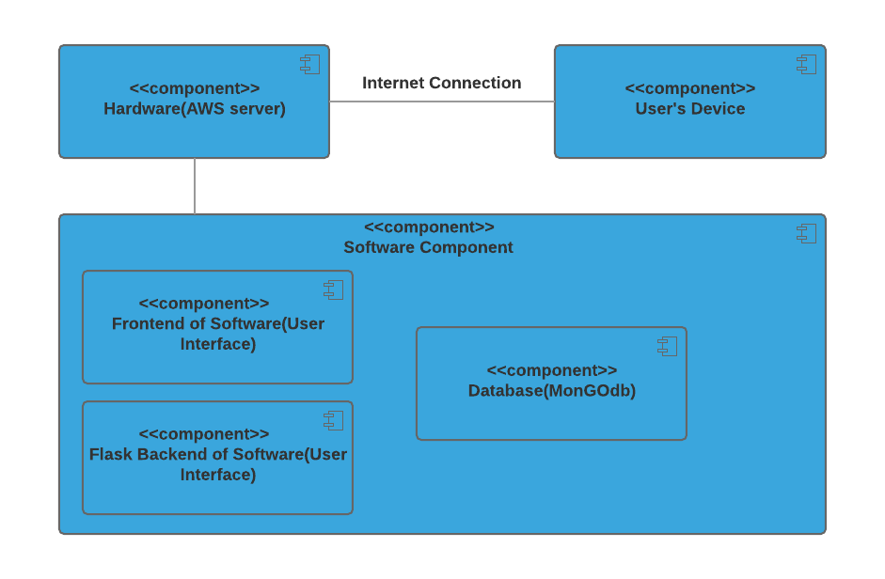

Figure 6: Hardware Component Class Diagram 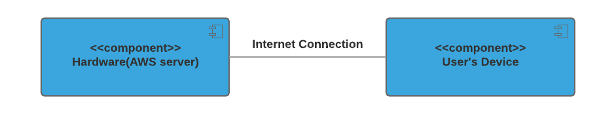

Table 142 a: Hardware Component Description

|  |  |
| --- | --- |
| **Hardware Component** | **Description** |
| AWS | For system hosting in production. |
| User’s device | Work computers, for browser access |

Figure 7: Software Component Class Diagram

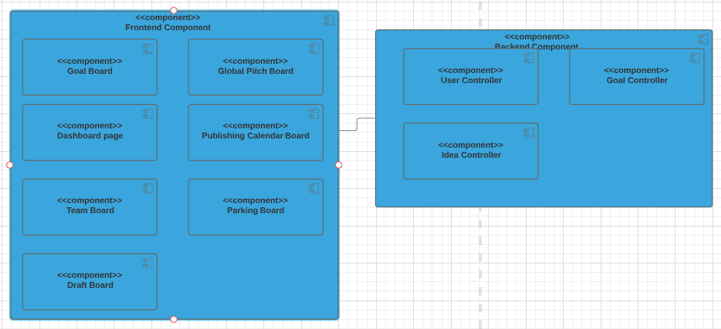

Table 142 b: Software Component Description

|  |  |
| --- | --- |
| **Software Component** | **Description** |
| **Goal Board** | Super admin can set goal vertical and amount of pitch desired by each vertical for current or future weeks |
| **Dashboard Page** | Super admin, content admins, and contributor can view overall project progress, individual vertical progress, and goals of the past, current, or future weeks |
| **Team Board** | Super admin and content admins can manage user accounts |
| **Draft Board** | Contributor can draft an idea then pitch it for approval |
| **Global Pitch Board** | Super admin and content admins can review, edit, and approve submitted pitches, whereas contributor can only view the submitted pitches |
| **Publishing Calendar Board** | Super admin can review and edit approved pitches meant for publish in the current week |
| **Parking Board** | Super admin can review and edit parked pitches or overwrite their status to be approved and move to publishing calendar board |
| **User Controller** | Implement the logic for user behaviors and store the user data model |
| **Idea Controller** | Implement the logic for pitch behaviors and store the user data model |
| **Goal Controller** | Implement the logic for goal behaviors and store the user data model |

Figure 8: Deployment Diagram

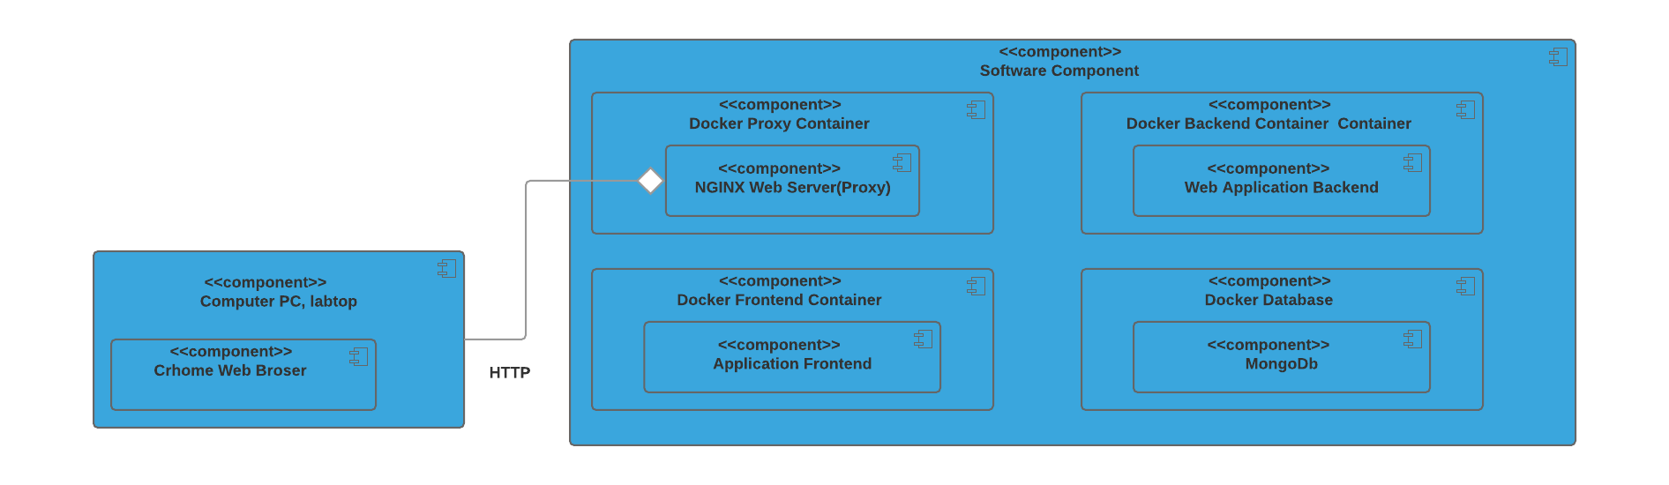

### 

### 

### 

### 3.1.2 Design Classes

Figure 9: Design Class Diagram

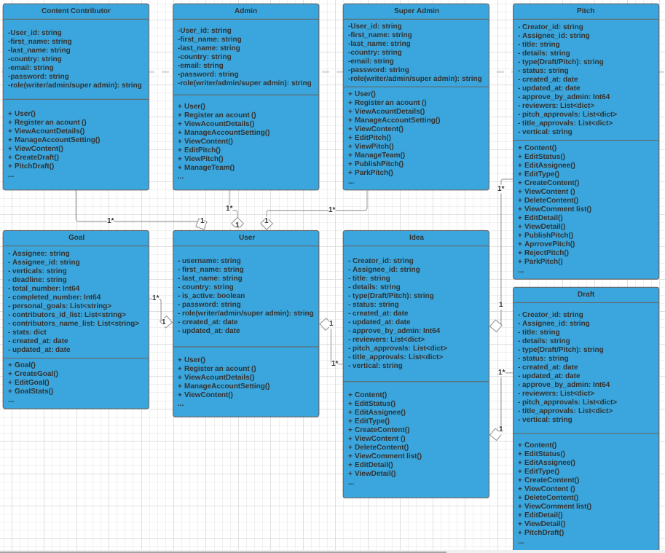

Table 144: Design Class Description

|  |  |  |
| --- | --- | --- |
| **Class** | **Type** | **Description** |
| User | Entity | Describe user information and model, include user attributes and methods |
| Idea | Entity | Describe a draft, pitch, include idea attributes and methods |
| Goal | Entity | Describe weekly goal of the team, include goal attributes and methods |
| Pitch | Entity | This class extends idea class. |
| draft | Entity | This class extends idea class. |
| Admin | Entity | This class extends user class |
| Super admin | Entity | This class extends user class |
| Content contributor | Entity | This class extends user class |

### 3.1.3 Process Realization

Figure 10: Robustness Diagram - draft a new pitch

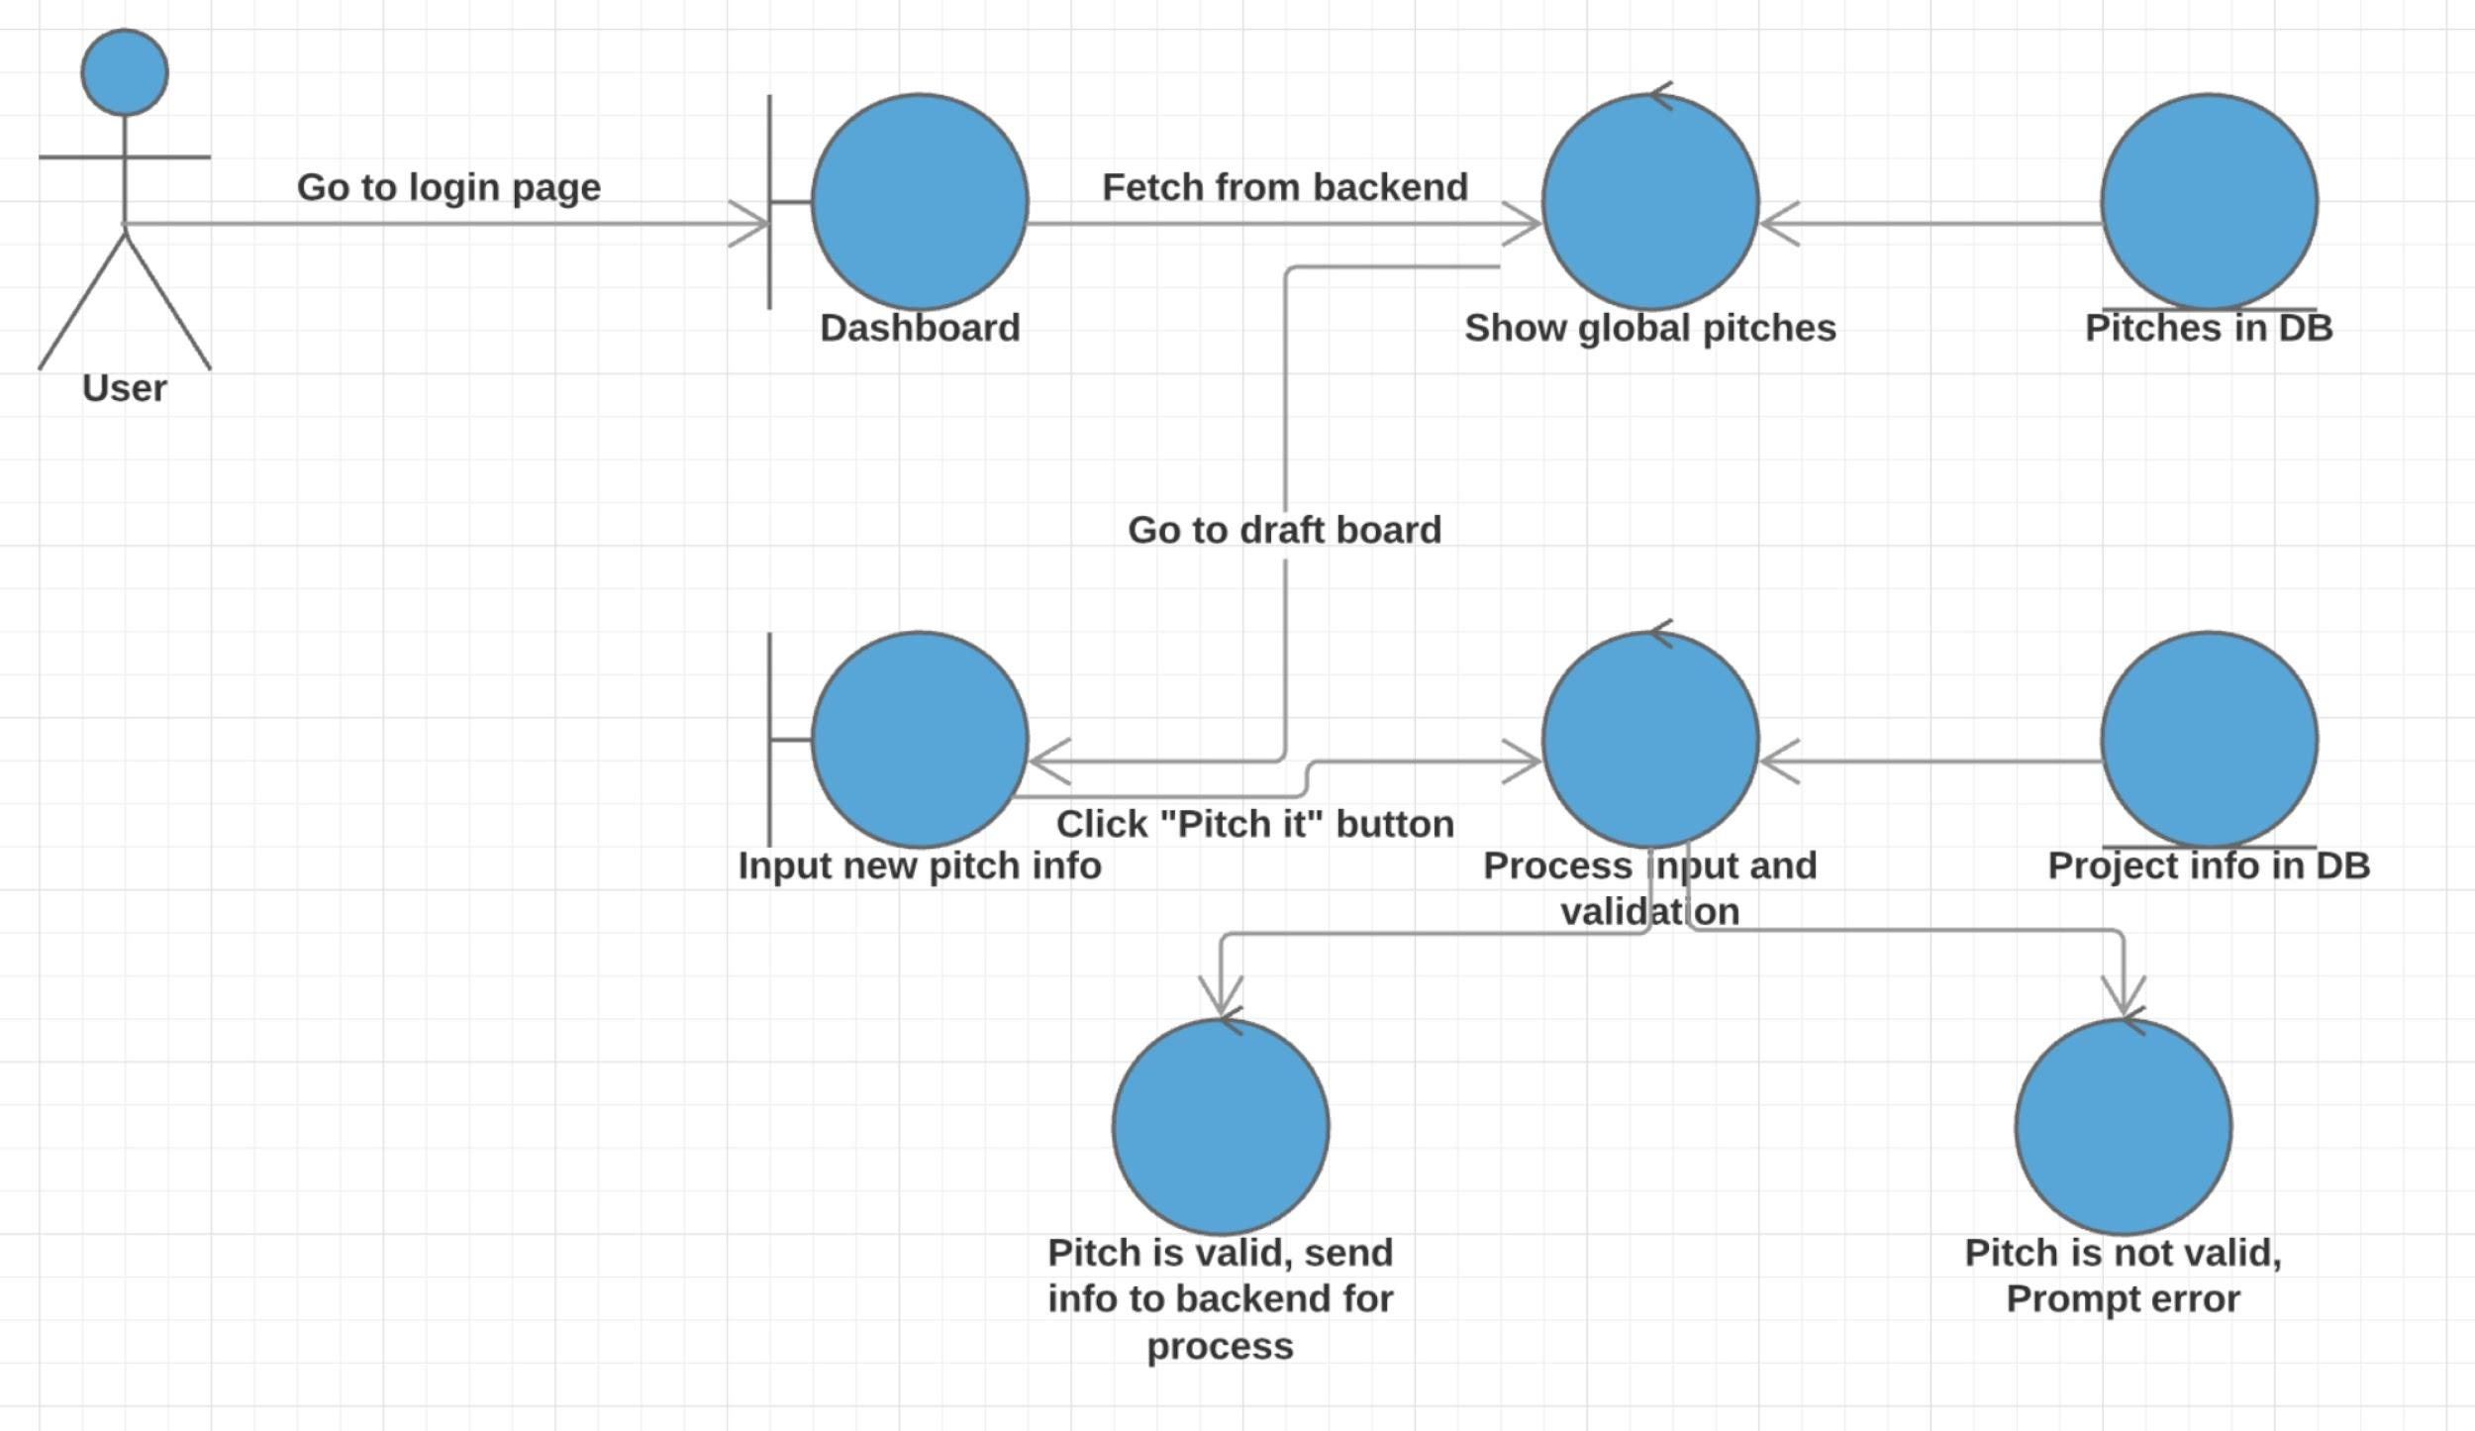

Figure 11: Process Realization Diagram - draft a new pitch

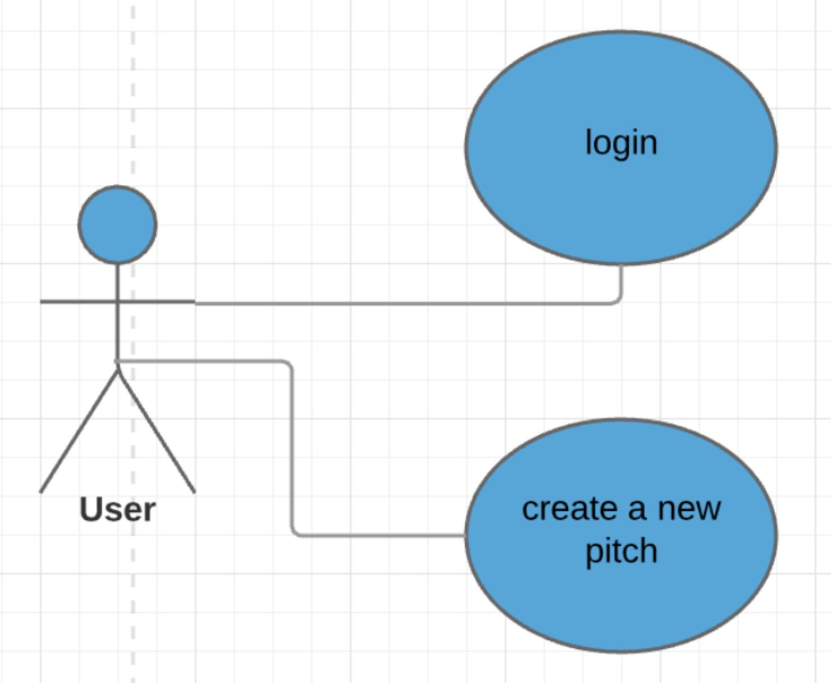

Figure 12: Sequence Diagram - draft a new pitch

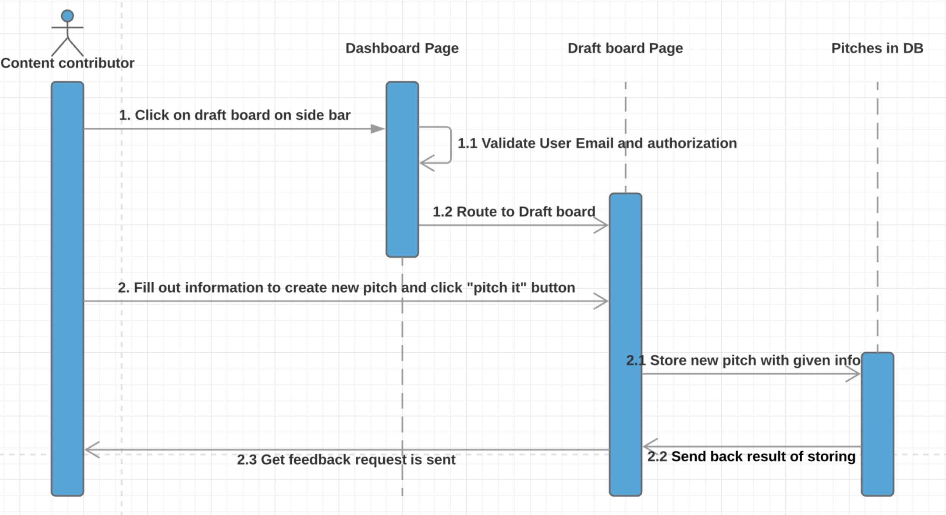

Figure 13: Robustness Diagram - change the status of the a new pitch

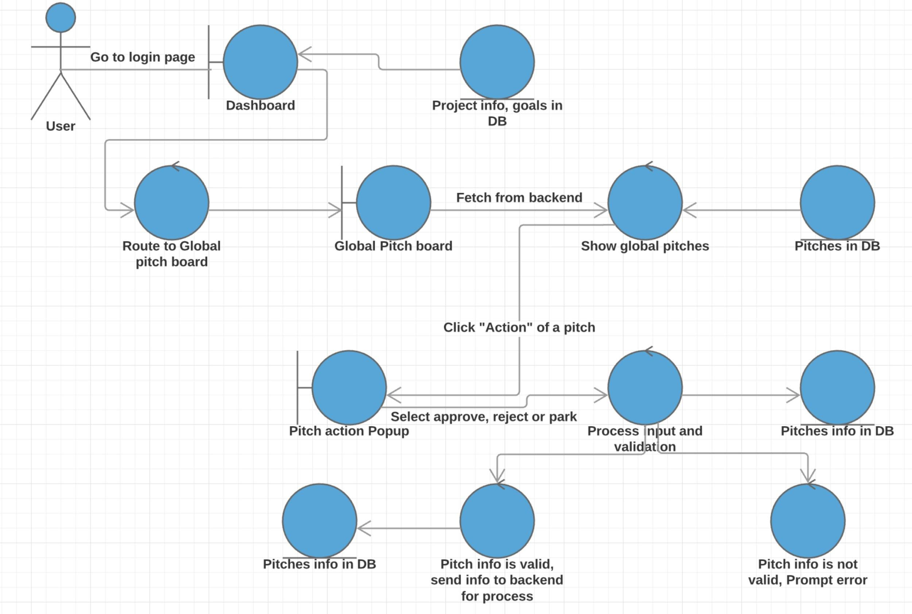

Figure 14: Process Realization Diagram - change the status of the a new pitch

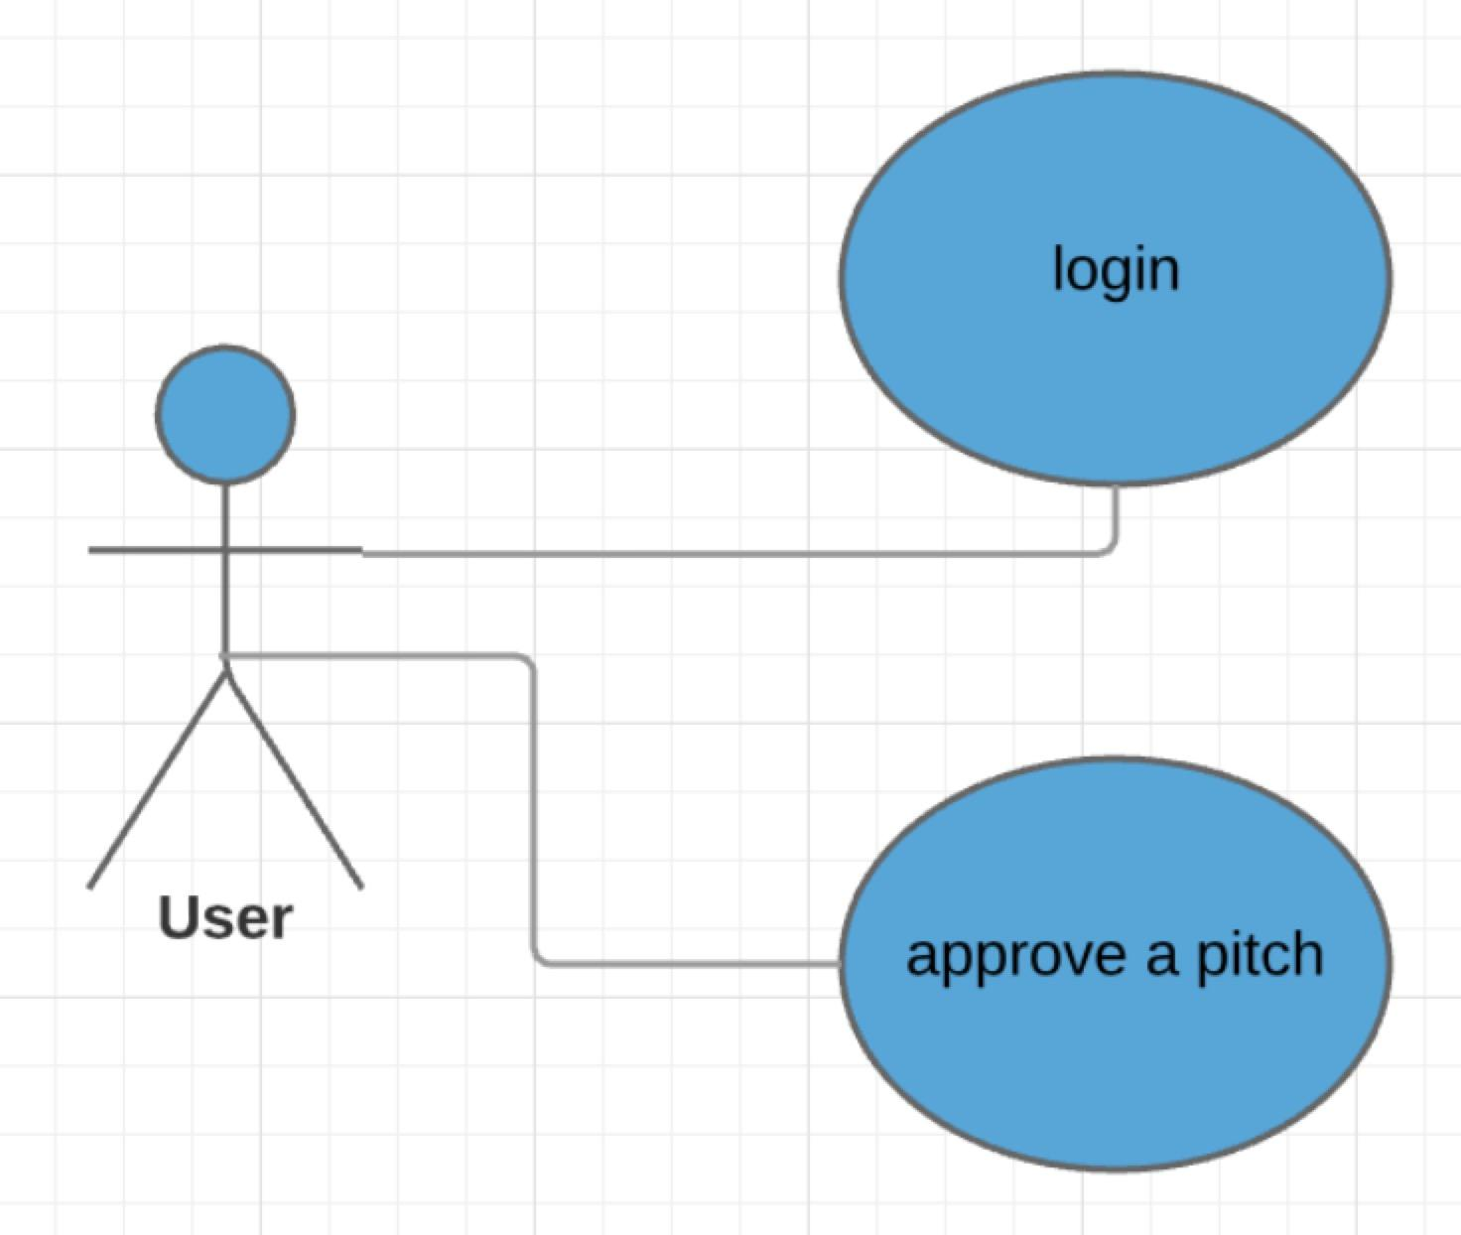

Figure 15: Process Realization Diagram - change the status of a new pitch

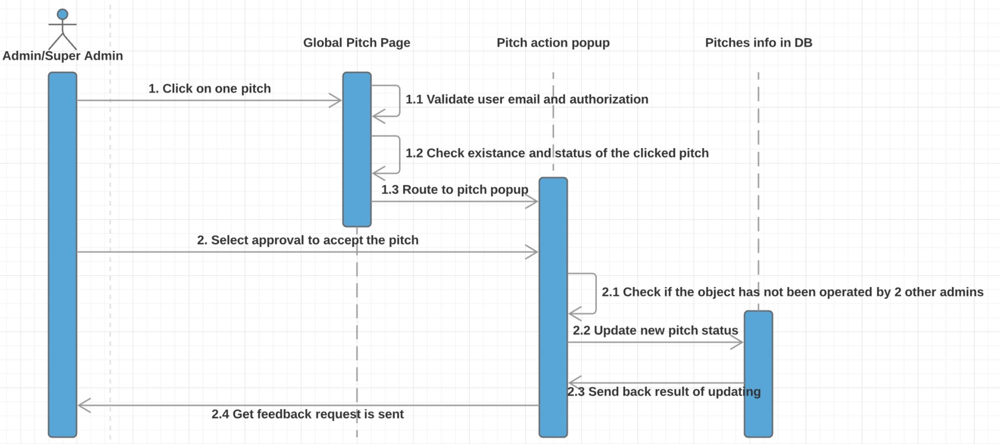

## 3.2 Design Rationale

The design is solely following the principle to mimic and streamline System1’s current workflow on idea formulation using most recent and mainstream technologies, including the utilization of modern database hosting, cloud service, web app hosting, mainstream frameworks etc. Meanwhile, the design aims to be maintainer friendly, meaning that it’s modular and has clear boundary between subparts.

# 4. Technology-Specific System Design

## 4.1 Design Overview

### 4.1.1 System Structure

Figure 16: Conceptual Domain Model



Figure 17: Hardware Component Class Diagram



Table 145: Hardware Component Description

|  |  |
| --- | --- |
| **Hardware Component** | **Description** |
| AWS | For system hosting in production. |
| User’s device | Work computers, for browser access |

Figure 18: Software Component Class Diagram

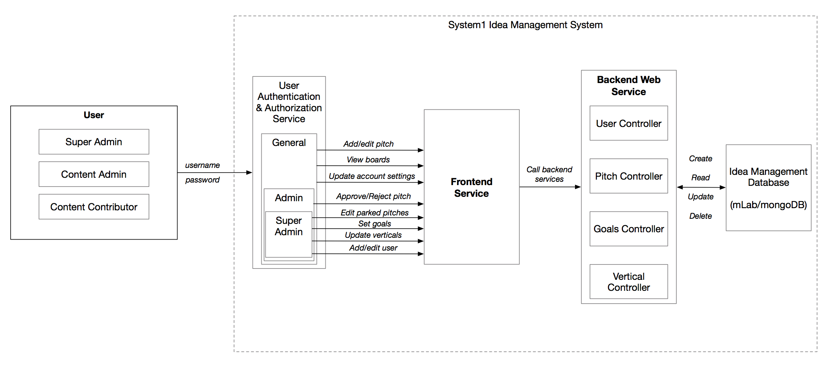

Table 146: Software Component Description

|  |  |
| --- | --- |
| **Software Component** | **Description** |
| **Goal Board** | Super admin can set goal vertical and amount of pitch desired by each vertical for current or future weeks |
| **Dashboard Page** | Super admin, content admins, and contributor can view overall project progress, individual vertical progress, and goals of the past, current, or future weeks |
| **Team Board** | Super admin and content admins can manage user accounts |
| **Draft Board** | Contributor can draft an idea then pitch it for approval |
| **Global Pitch Board** | Super admin and content admins can review, edit, and approve submitted pitches, whereas contributor can only view the submitted pitches |
| **Publishing Calendar Board** | Super admin can review and edit approved pitches meant for publish in the current week |
| **Parking Board** | Super admin can review and edit parked pitches or overwrite their status to be approved and move to publishing calendar board |
| **User Controller** | Implement the logic for user behaviors and store the user data model |
| **Idea Controller** | Implement the logic for pitch behaviors and store the user data model |
| **Goal Controller** | Implement the logic for goal behaviors and store the user data model |

Figure 19: Deployment Diagram 

### 4.1.2 Design Classes

Figure 20: Design Class Diagram



Table 147: Design Class Description

|  |  |  |
| --- | --- | --- |
| **Class** | **Type** | **Description** |
| User | Entity | Describe user information and model, include user attributes and methods |
| Idea | Entity | Describe a draft, pitch, include idea attributes and methods |
| Goal | Entity | Describe weekly goal of the team, include goal attributes and methods |
| Pitch | Entity | This class extends idea class. |
| draft | Entity | This class extends idea class. |
| Admin | Entity | This class extends user class |
| Super admin | Entity | This class extends user class |
| Content contributor | Entity | This class extends user class |

### 4.1.3 Process Realization

Figure 21: Robustness Diagram - draft a new pitch



Figure 22: Process Realization Diagram - draft a new pitch



Figure 23: Sequence Diagram - draft a new pitch



Figure 24: Robustness Diagram - change the status of the a new pitch



Figure 25: Process Realization Diagram - change the status of the a new pitch



Figure 26: Process Realization Diagram - change the status of the a new pitch



## 

## 4.2 Design Rationale

The design is solely following the principle to mimic and streamline System1’s current workflow on idea formulation using most recent and mainstream technologies, including the utilization of modern database hosting, cloud service, web app hosting, mainstream frameworks etc. Meanwhile, the design aims to be maintainer friendly, meaning that it’s modular and has clear boundary between subparts

# 5. Architectural Styles, Patterns and Frameworks

Table 148: Architectural Styles, Patterns, and Frameworks

|  |  |  |
| --- | --- | --- |
| **Name** | **Description** | **Benefits, Costs, and Limitations** |
| Three-Tier | Having 3 major parts:   * User Interface Tier(ReactJS): * Logic Tier (Server, or Backend with Flask * Data Tier (MongoDB) | * Changes in any part is independent from the other parts, no impact on other Tiers. * This architecture has no cost, for using explicitly this architecture, we do not pay for other 3rd party system (JavaScript,Flask library and frameworks are open-source, likewise for the MongoDB) |
| Client Server | Having this style in 2 parts:   * Sending Request from computer browser to the application server * Docker Tool communicating with Containers | * Modifiability, maintenance, evolvability, are the most important benefits to our project. (Client Pooyan even can later use our backend for mobile or another platform development) |
| ReactJS | React JS Software Pattern: A JS Library for building fast, simple, and scalable to create Web App | * With this structure, react code is more predictable, easier to debug. * Easier to learn compared with other framework like Angularjs * ReactJS is one of the most popular framework so that there are lots of templates could be used, which decrease the development and maintenance cost. |
| Flask | Backend service framework | * Better choice compared with Spring(Java) and thrift or grpc(Golang) since the client requires to use python. * Since our application is not complex, so compared to Django, a lightweight framework like flask is easy to implement, which decreases the development and maintenance cost. |