System1: Content Management System

User Manual

# 

# 

# 

# 

# 

# 

# 

Written by Discovery Tool Team 3:

Josh Bendig

Xizhao (Kerry) Deng

Jingzhou Hong

Guancheng Liu

Michael Russo

Shenghao Teng

Fan Zhang

Yiming Zhang

Version History

|  |  |  |  |  |
| --- | --- | --- | --- | --- |
| Date | Author | Version | Changes made | Rationale |
| 11/19/18 | JB | 1.0 | Document skeleton | First cut at user manual outline |
| 12/01/18 | ST,JH | 1.1 | Documentation increments | Added more content |
| 12/03/18 | XD,JB | 1.2 | Documentation increments | Added workflow screenshots, and filled out some information for each section |

**Introduction**3

**Using the Tool: Content Contributor**3

Dashboard and Overview 3

Drafting and Submitting a Pitch 4

**Using the Tool: Content Admin**5

Dashboard and Overview 5

Creating, Deleting, and Changing Active Status for Users 5

Approving/Rejecting a Pitch 6

**Using the Tool: Super Admin**7

Dashboard and Overview 7

Updating the Team 8

Creating, Deleting, and Changing Active Status for Users 8

Managing Pitches 9

Updating the Global Pitch Board 9

Updating the Parking Board 9

Setting Goals 10

**Developer Notes**11

**Appendix A: High Level Business Workflow**12

# Introduction

This tool was developed by Team 3 of USC’s CSCI 577a Fall 2018 course for System1. The purpose of this internal tool is to provide a web-based idea management system that streamlines the idea generation and management process. This document aims to identify the tool’s core capabilities and provide instruction on how to use the tool for all potential users. Using the Tool: Content Contributor describes features that are associated with content creation, and are available to all users of the tool. Using the Tool: Content Admin describes aspects of the tool that are limited to administrators, such as approving pitches. Using the Tool: Super Admin describes features with the highest access limitations such as overriding content and creating administrator accounts. Developer Notes highlights aspects of the tool that are of importance to a maintainer of the software system.

# Using the Tool: Content Contributor

## **Dashboard and Overview**

The dashboard is intended to be a quick stop to view your weekly assigned goals. The goals will be broken down by verticals and track your progress based on the number of submitted pitches that have been approved.

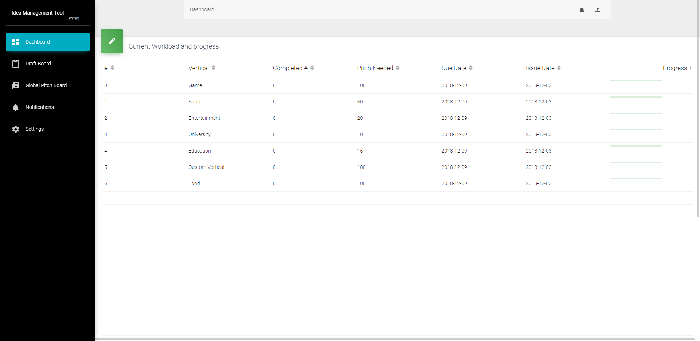

## **Drafting and Submitting a Pitch**

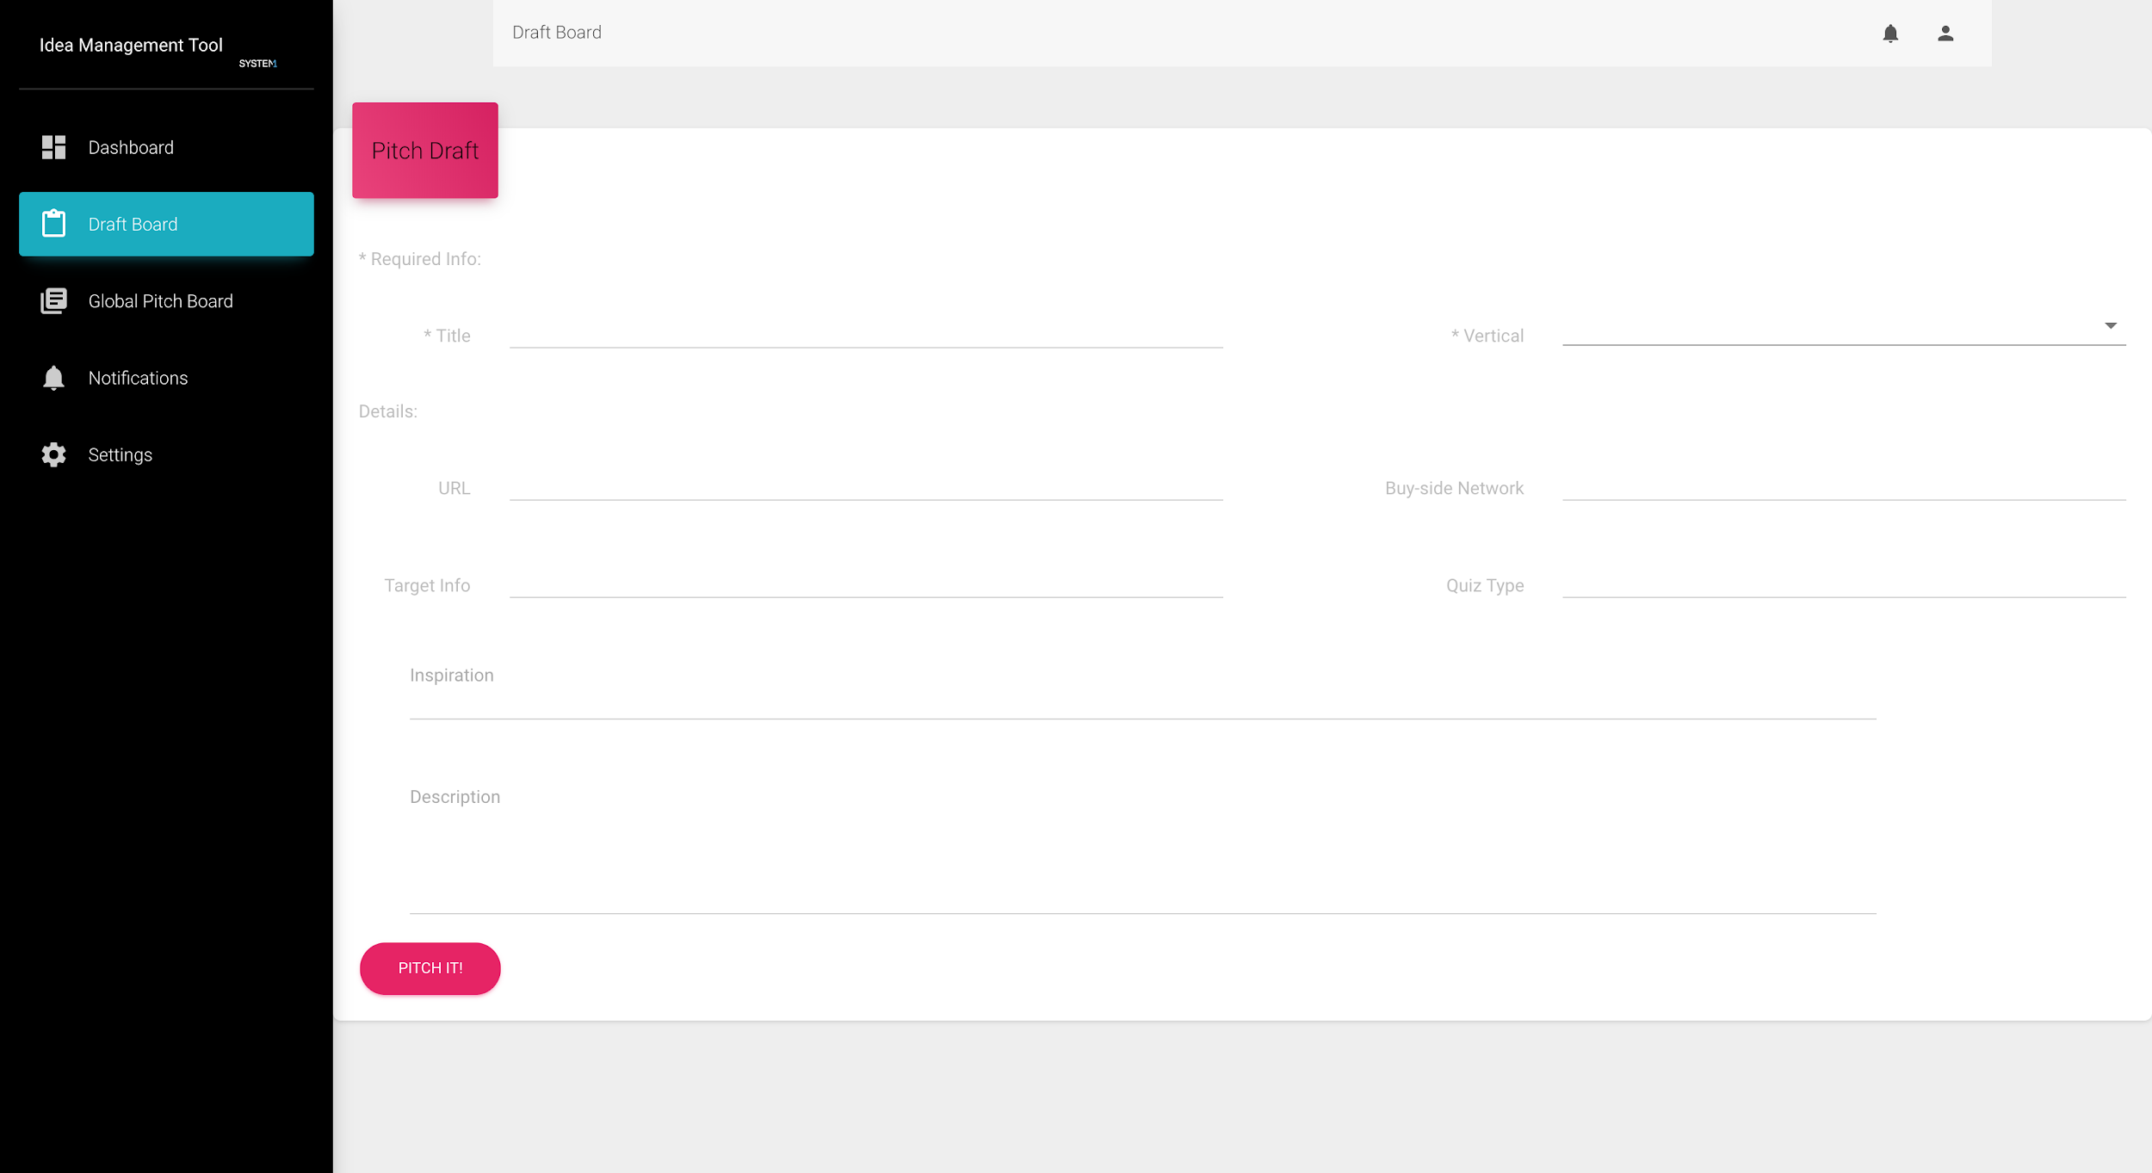

In order to pitch an idea, navigate to the ‘Draft Board’. From there, enter the fields of your pitch. Note that only the Title and Vertical are required. Lastly, simply press ‘Pitch It!’. From there, the pitch will be moved into the ‘Global Pitch Board’ to be reviewed by administrators.

# Using the Tool: Content Admin

## **Dashboard and Overview**

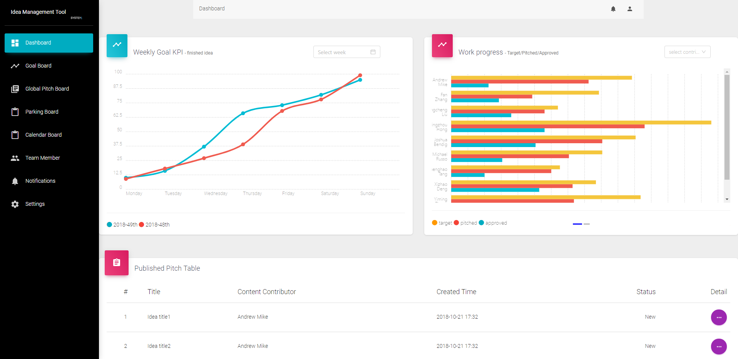

As a content admin, the dashboard provides views of searchable weekly metrics for how many pitches have been approved for a given week and its prior. Also, the dashboard provides views of the content contributor’s target, approved, and pitched submissions.

## Creating, Deleting, and Changing Active Status for Users

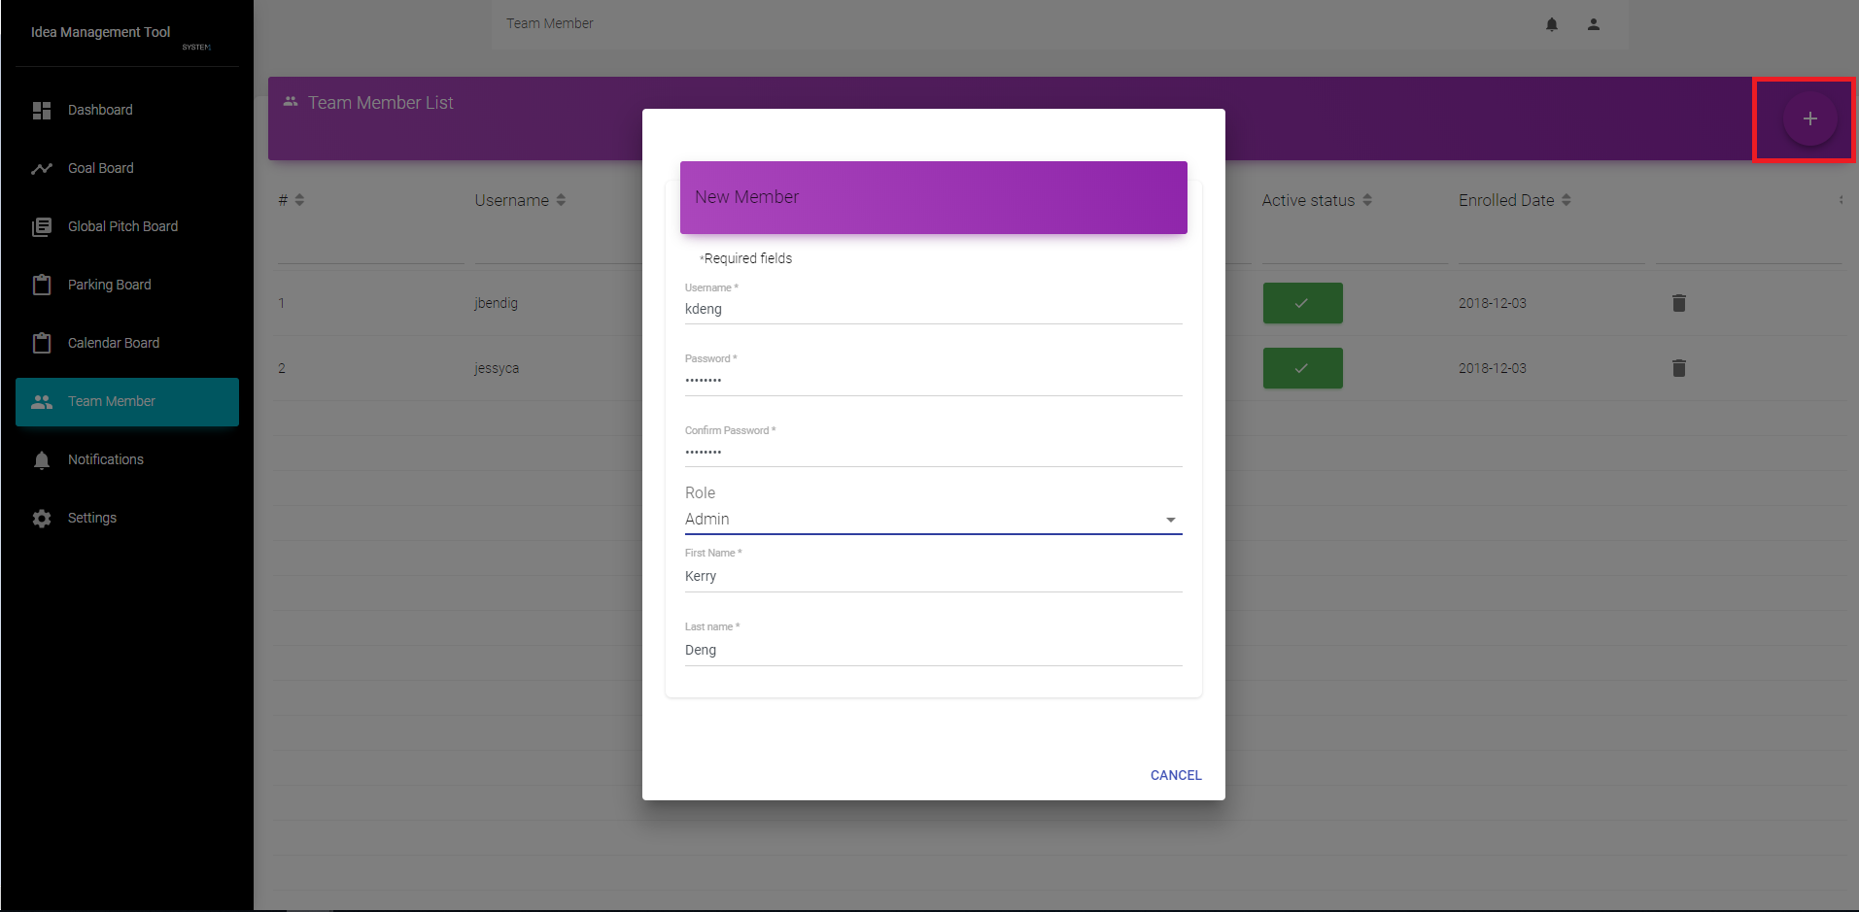

As an admin, in the ‘Team Member’ board, by clicking the ‘+’ button in the top right, a new user can be created that may either be an ‘Admin’ or ‘Writer’. To toggle a user’s activity, under ‘Active status’ simply press the box associated with the target user. Additionally, to remove a user, simply press the trash icon on the right of the screen.

## **Approving/Rejecting a Pitch**

When navigating to the ‘Global Pitch Board’, each pitch will be listed that is new and pending approval. As an admin, the ‘Action’ buttons will be available, and you can select the blue check to approve the pitch, and the red ‘X’ to reject it. Note that once a review option is selected, the action button will be greyed out, as shown below.

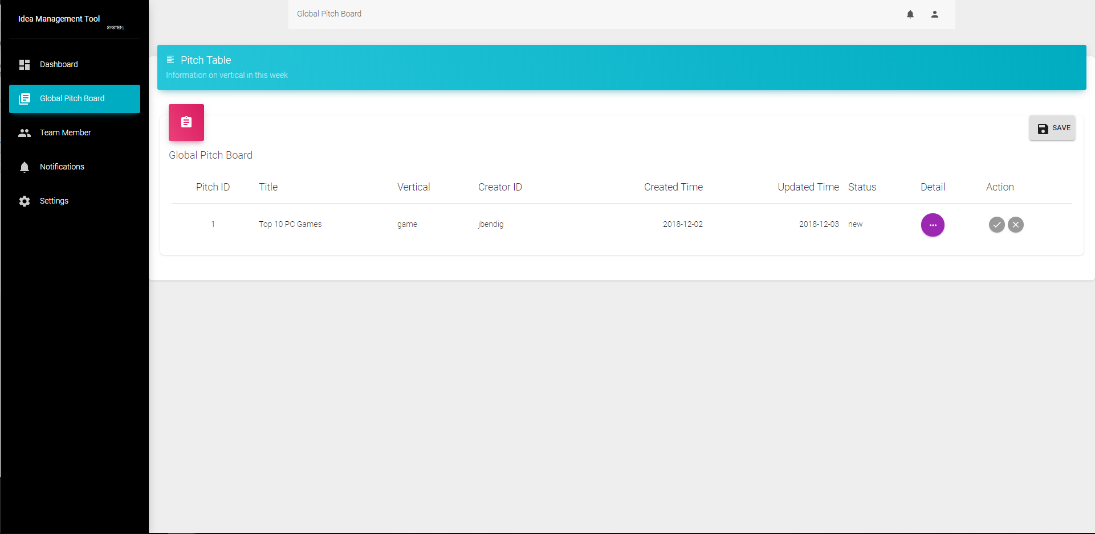

# Using the Tool: Super Admin

## **Dashboard and Overview**



As a admin, the dashboard provides views of searchable weekly metrics for how many pitches have been approved for a given week and its prior. Also, the dashboard provides views of the content contributor’s target, approved, and pitched submissions.

## **Updating the Team**

### Creating, Deleting, and Changing Active Status for Users



As an admin, in the ‘Team Member’ board, by clicking the ‘+’ button in the top right, a new user can be created that may either be an ‘Admin’ or ‘Writer’. To toggle a user’s activity, under ‘Active status’ simply press the box associated with the target user. Additionally, to remove a user, simply press the trash icon on the right of the screen.

## **Managing Pitches**

### Updating the Global Pitch Board

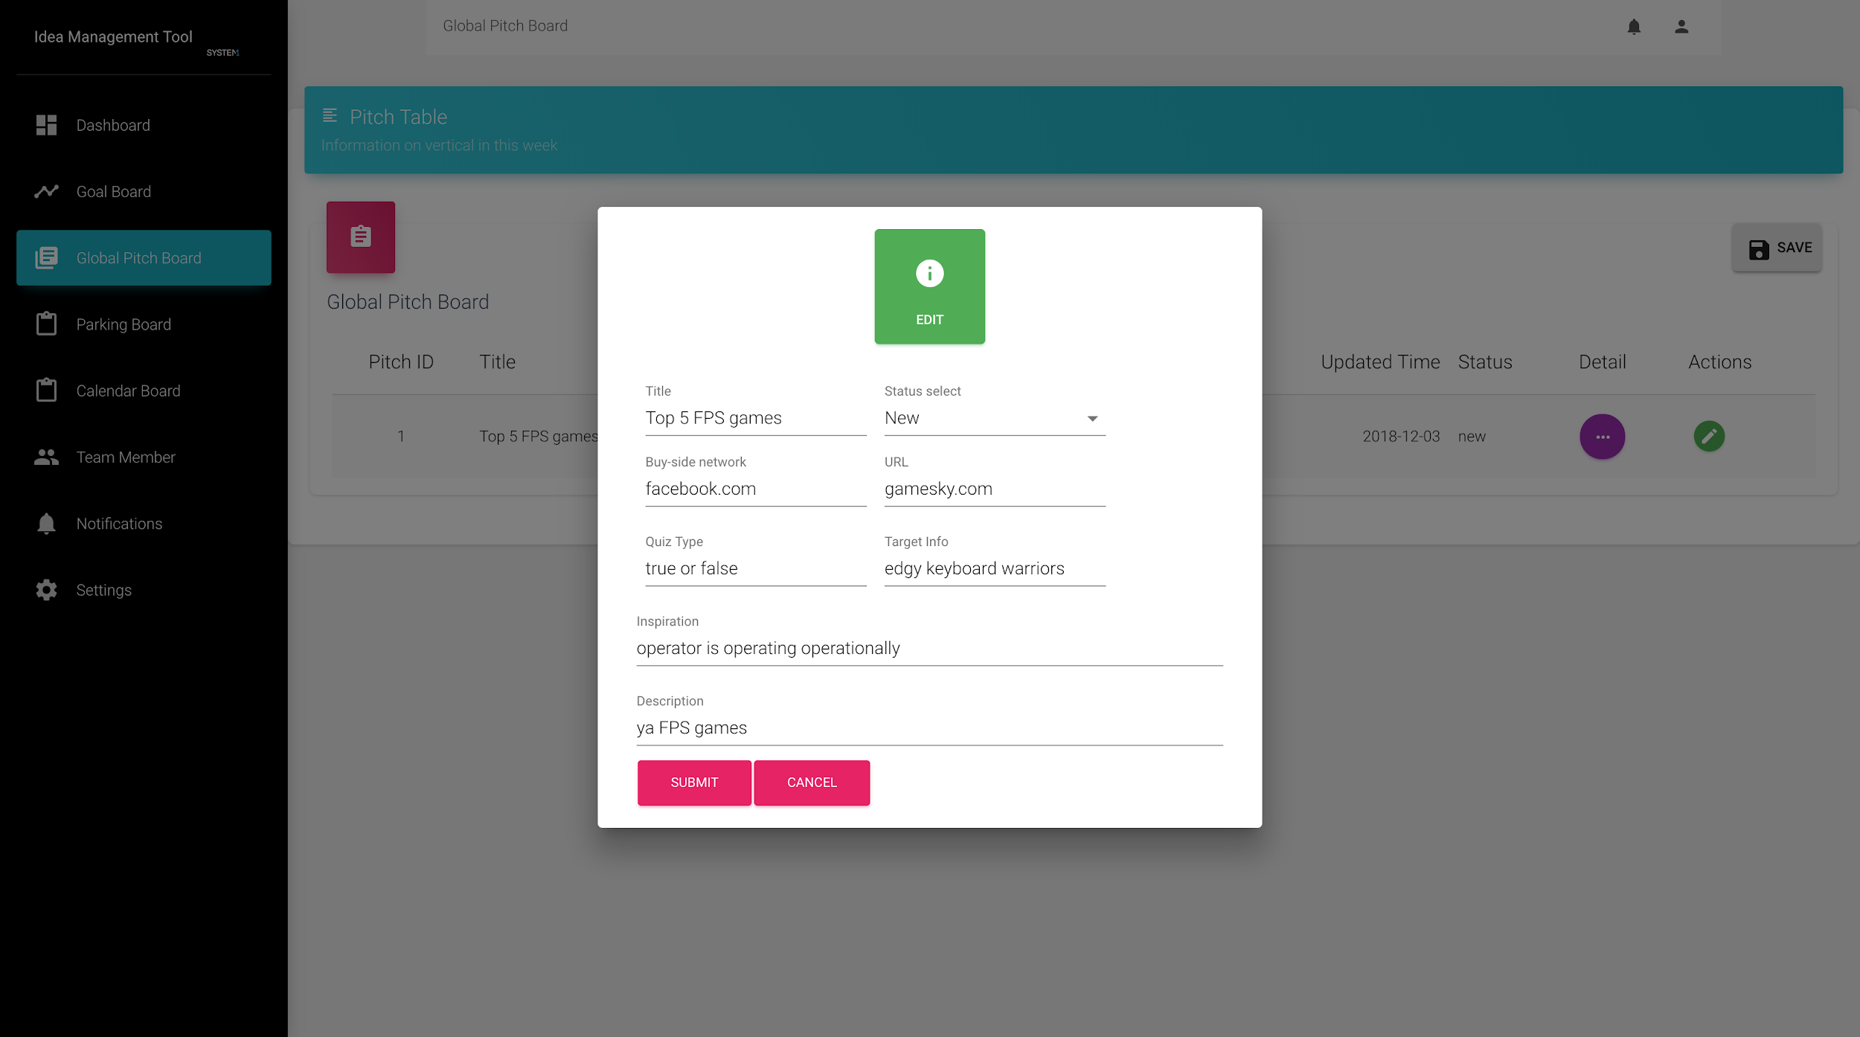A super admin has full control over pitches. In the detailed information under ‘Actions’, a super admin can change any of the information within a pitch, as well as overriding approval. A super admin can select to move the pitch ‘Approved’, ‘Rejected’, or ‘Parked’.

### Updating the Parking Board

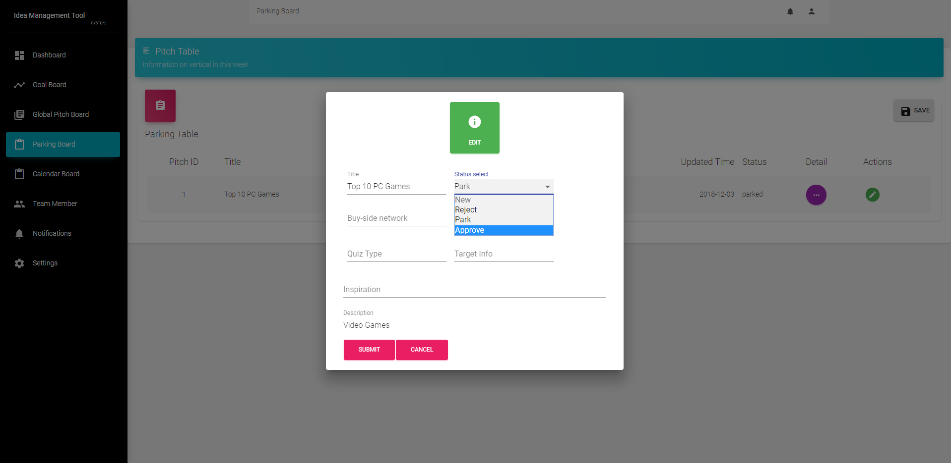In the parking board, similar to the functionality allocated to the super admin in the ‘Global Pitch Board’, a super admin can edit all of the fields of a pitch, including moving it to ‘Approved’ to add it to the publishing calendar.

### Setting Goals

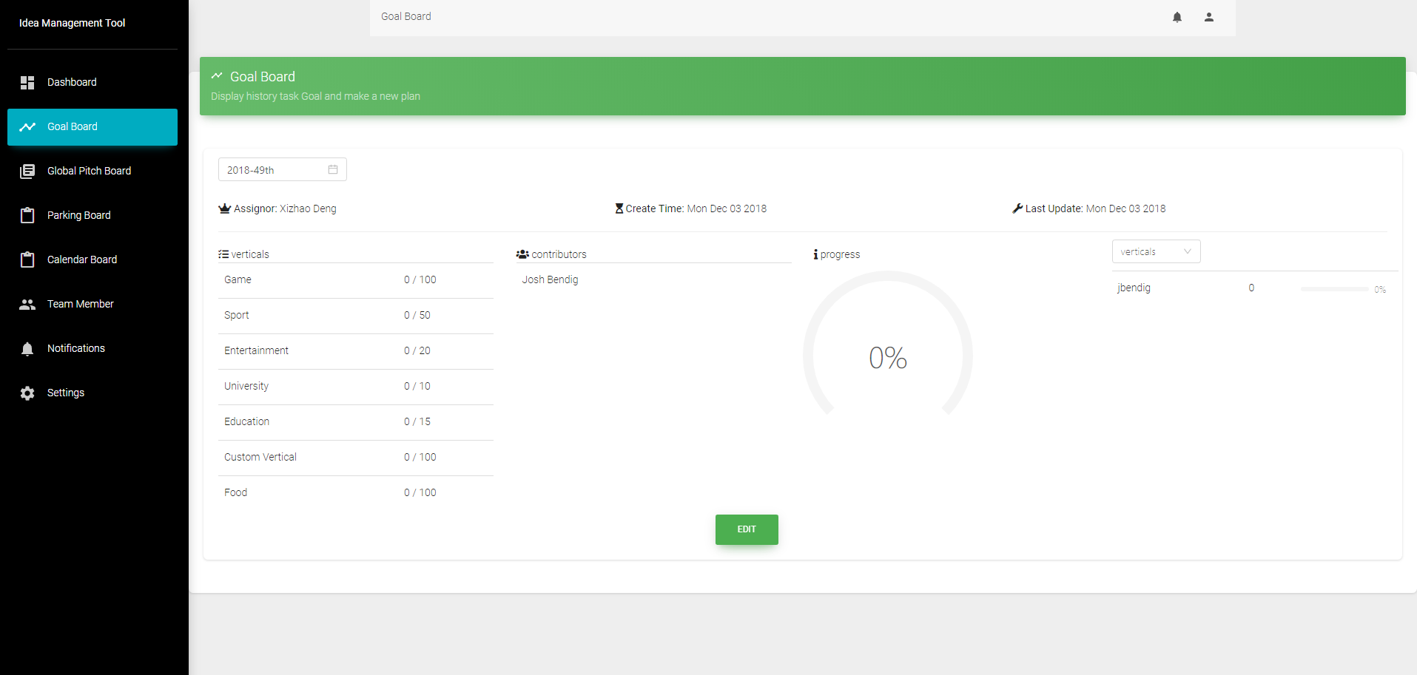When viewing the goals board, the super admin is shown a view of the latest week’s goals as well as the current progress. The super admin can edit these goals, and add custom verticals as desired (shown below). When updating the goal for a selected vertical, the system will automatically distribute the goals to active content creators for the week.

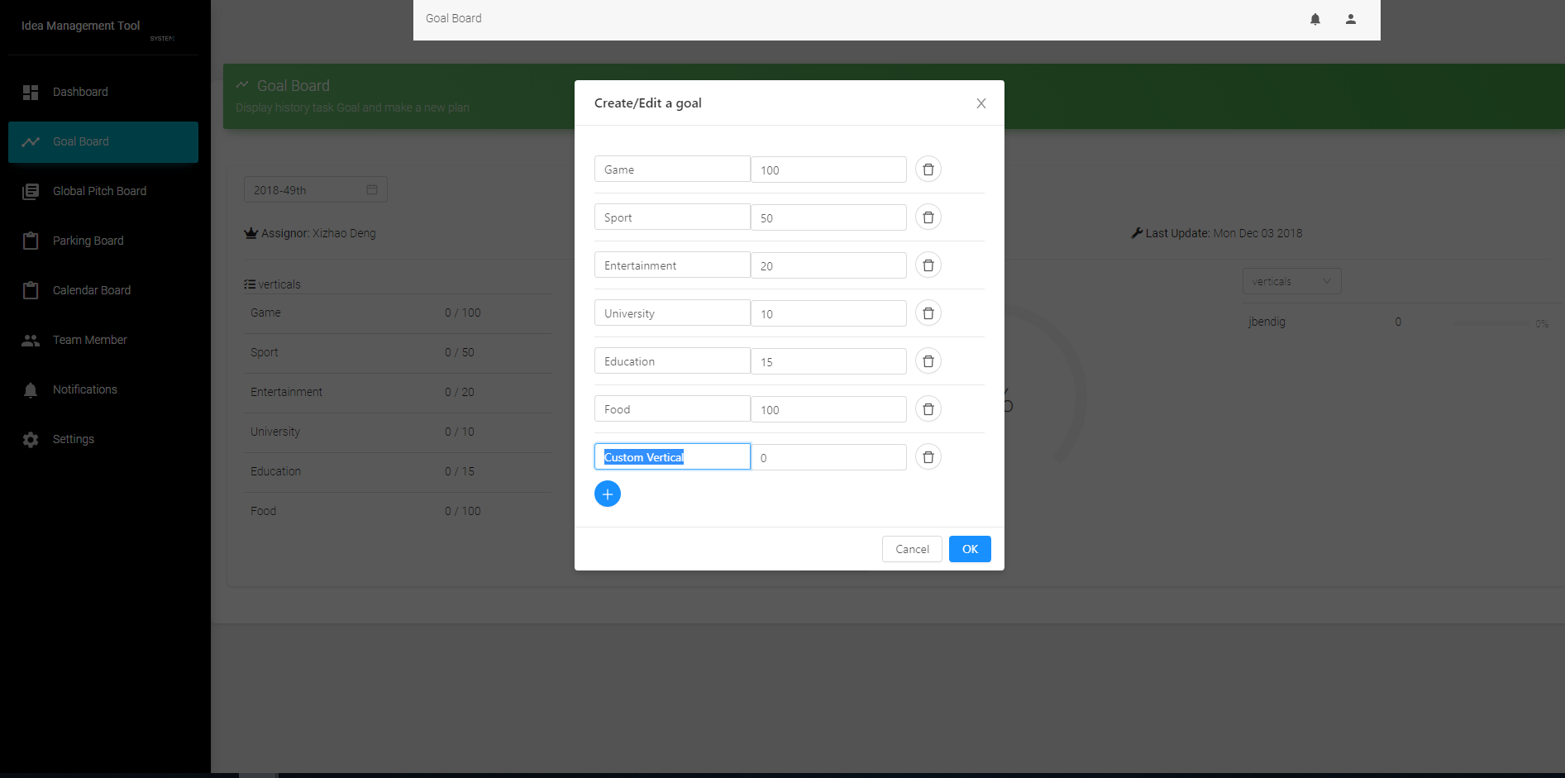

# Developer Notes

The latest iteration of the system’s software can be found at <https://github.com/russomp/t3-discovery-tool>. Additional information about the conceptual and software design can be found at <https://greenbay.usc.edu/csci577/fall2018/projects/team03/>.

# Appendix A: High Level Business Workflow

