Operational Concept Description (OCD)

**Discovery Tool**

**Team 3**

**Josh Bendig - IIV&V**

**Xizhao Deng - Project manager**

**Jingzhou Hong - Requirement Engineer**

**Guancheng Liu - Tester**

**Michael Russo - Prototyper**

**Shenghao Tang - Feasibility Analyst**

**Fan Zhan - Software Architect**

**Yiming Zhang - System Architect**

**10/16/18**

# Version History

|  |  |  |  |  |
| --- | --- | --- | --- | --- |
| Date | Author | Version | Changes made | Rationale |
| 10/15/18 | XD | 1.0 | Section 1,2,3 | Initial draft for Discovery Tool OCD of DC package |
| 10/16/18 | JB | 1.1 | figures 1-5 | Added figures 1-5 |

# 

# 

# 

# 

# 

# 

# 

# 

# Table of Contents

**Version History** **1**

**Table of Contents** **2**

**Table of Tables** **3**

**Table of Figures** **3**

**1. Introduction** **4**

1.1 Purpose of the OCD 4

1.2 Status of the OCD 4

**2. Shared Vision** **4**

2.1 Benefits Chain 5

2.2 System Capability Description 6

2.3 System Boundary and Environment 6

**3. System Transformation** **7**

3.1 Information on Current System 7

3.1.1 Infrastructure 7

3.1.2 Artifacts 7

3.1.3 Current Business Workflow 7

3.2 System Objectives, Constraints and Priorities 8

3.2.1 Capability Goals 8

3.2.2 Level of Service Goals 9

3.2.3 Organizational Goals 9

3.2.4 Constraints 9

3.2.5 Relation to Current System 10

3.3 Proposed New Operational Concept 11

3.3.1 Element Relationship Diagram 11

3.3.2 Business Workflows 12

3.4 Organizational and Operational Implications 12

3.4.1 Organizational Transformations 12

3.4.2 Operational Transformations 12

# Table of Tables

Table 1: The Program Model ………………………………………………………...…………..………. 5

Table 2: Level of Capability Goals …………………………………………………………..………..…. 8

Table 3: Level of Service Goals ………………………………………………………...……………..…. 9

Table 4: Relation to Current System ………………………………………………...……………….…. 10

# Table of Figures

Figure 1: Benefits Chain Diagram ……………………………………………………….……...…………5

Figure 2: System Boundary and Environment Diagram ………………………...……….……...…………6

Figure 3: Current Workflow Diagram ……………………………………...…………….……...…………7

Figure 4: Element Relationship Diagram ………………………………………………...……...…..……10

Figure 5: Business Workflow Diagram ……………………………………………….….……...…..……11

# 

# 

# 

# 

# 

# 

# 

# 

# 1. Introduction

## 1.1 Purpose of the OCD

This document has the following objectives:

1. Describe, in detail, the shared vision and goals of the stakeholders of the idea management system for System1.
2. It will be used to obtain consensus between the client and dev team.

The success-critical stakeholders of the projects are:

1. System1 Content Writer, who would use this tool to streamline their existing procedure and speed up content production.
2. System1 Content Admin, who would use this tool to serve similar purpose as the content writer, plus scaling the project and team with more confidence.
3. Developers: Students of CSCI577A F18 Team 3, who would be building this system.
4. Maintainers: Potential technical personnels from System1, who would maintain and continue the development and integration after the project is handed over.

## 1.2 Status of the OCD

The status of the OCD is currently at the initial draft stage of version 1.0. There are no previous versions to this project. The scope of the discovery tool project, which started as a trend identifier system, has been re-evaluated and pivoted to idea management system. The change of direction was proposed by the client and has gained consensus from all the stakeholders.

# 2. Shared Vision

|  |  |  |  |
| --- | --- | --- | --- |
| **Assumptions**   * System1 content writers and admins are willing to migrate to a new idea management tool * The new idea management tool will be able to adequately support System1’s formulation process end-to-end to effectively migrate the system * Client will have maintainers on staff to take over the project upon handoff * Development team will have access to sufficient resources to host the tool and store its data * System1 access to the internet to connect to the tool | | | |
| **Stakeholders** | **Initiatives** | **Value Propositions** | **Beneficiaries** |
| -System1 Content Writer(User)  -System1 Content admin(User)  -System1 Maintainer  -Developers | -Content writer and admin correctly use the app  -Maintainers maintain the whole system after handoff occured  -Admin and content writer are responsive to the different stages of content production  -Developers implement system to mimic and streamline existing process | -Increased publication speed  -Modernized frontend and backend technology  -Streamlined process with real-time feedback  -Ease of scaling the project and team size  -Monitoring team progress and performance with confidence | -System1 Content writer  -System1 Content admin |
| **Cost** | | | |
| * Development costs * Database hosting service costs * Maintenance costs | | | |

Table 1: The Program Model

## 2.1 Benefits Chain

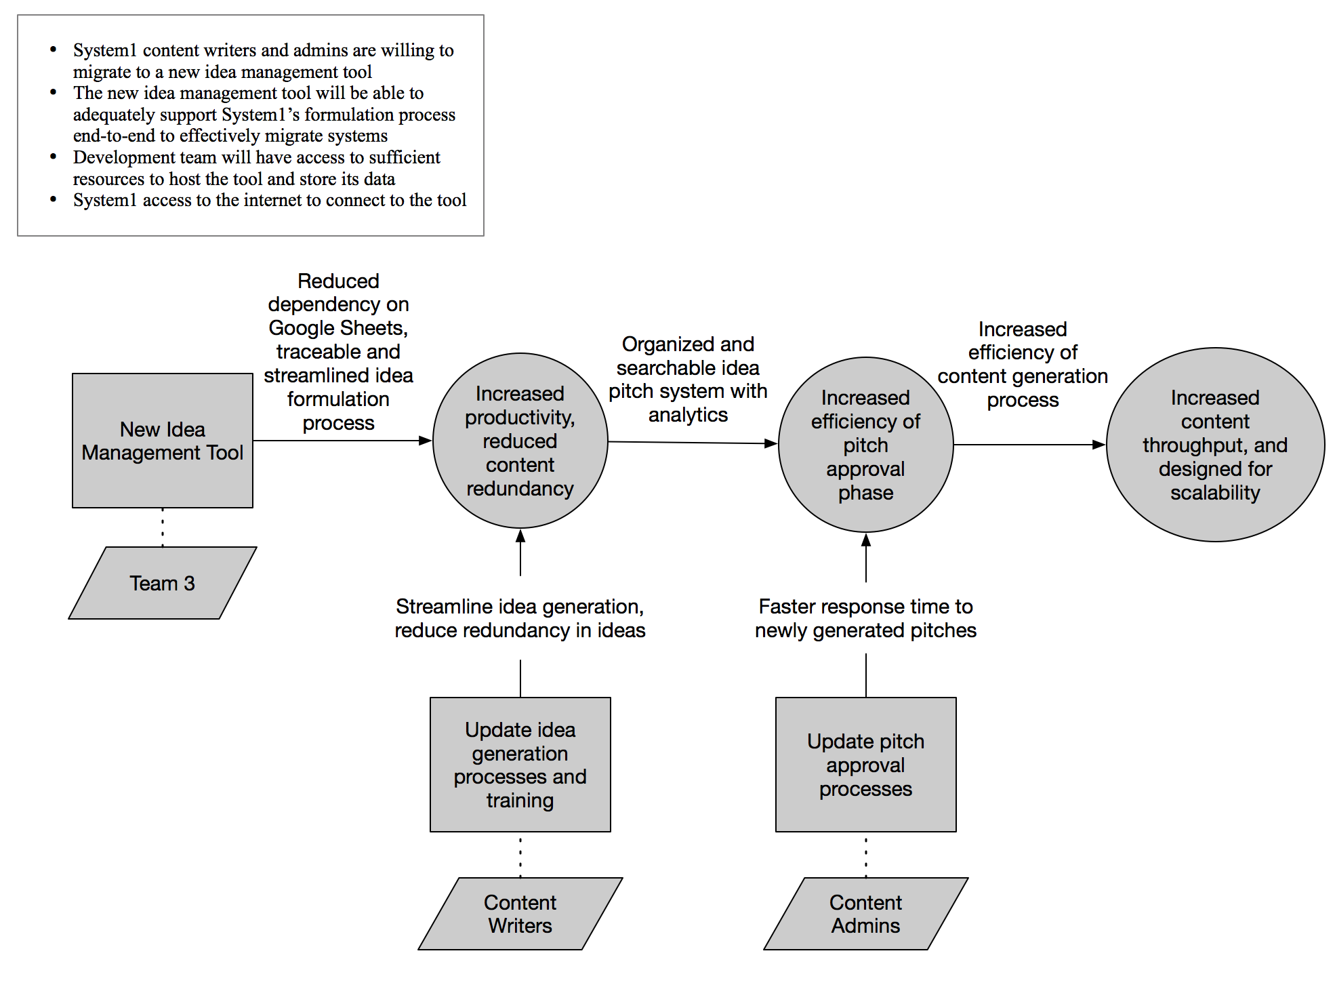

Figure 1: Benefits Chain Diagram

## 2.2 System Capability Description

Discovery Tool is an web app based idea management system. It serves as an internal tool to System1. It provides a solution to help System1 content writers and admins to streamline, manage, accelerate their workflow. It gives the admins necessary tooling to quickly scale the team as well as content production. Overall, the system supports the team to work cross-functionally, leveraging resources to meet needs as efficiently as possible. Currently there’s no competitor identified so far.

## 2.3 System Boundary and Environment

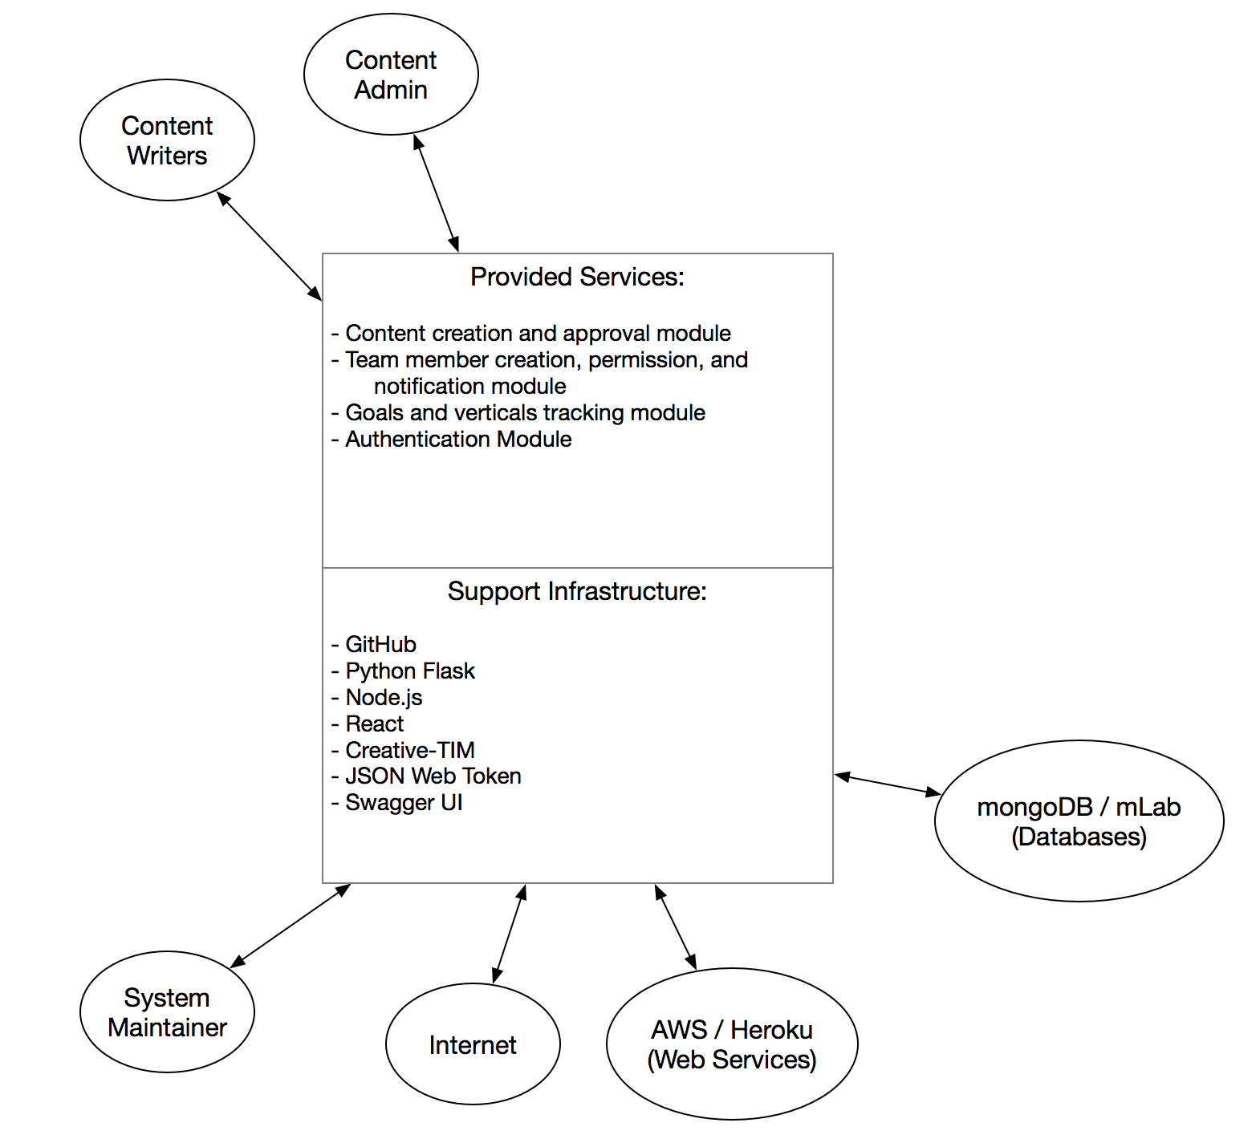

Figure 2: System Boundary and Environment Diagram

# 3. System Transformation

## 3.1 Information on Current System

### 3.1.1 Infrastructure

Currently, there is no existing idea management system in place at System1. This is the first initiative. The client performs the idea management task by manually managing several spreadsheets used across the whole team.

### 3.1.2 Artifacts

Currently, the spreadsheets are maintained on client’s cloud server. Our idea management web app will be hosted on AWS EC2 in production.

### 3.1.3 Current Business Workflow

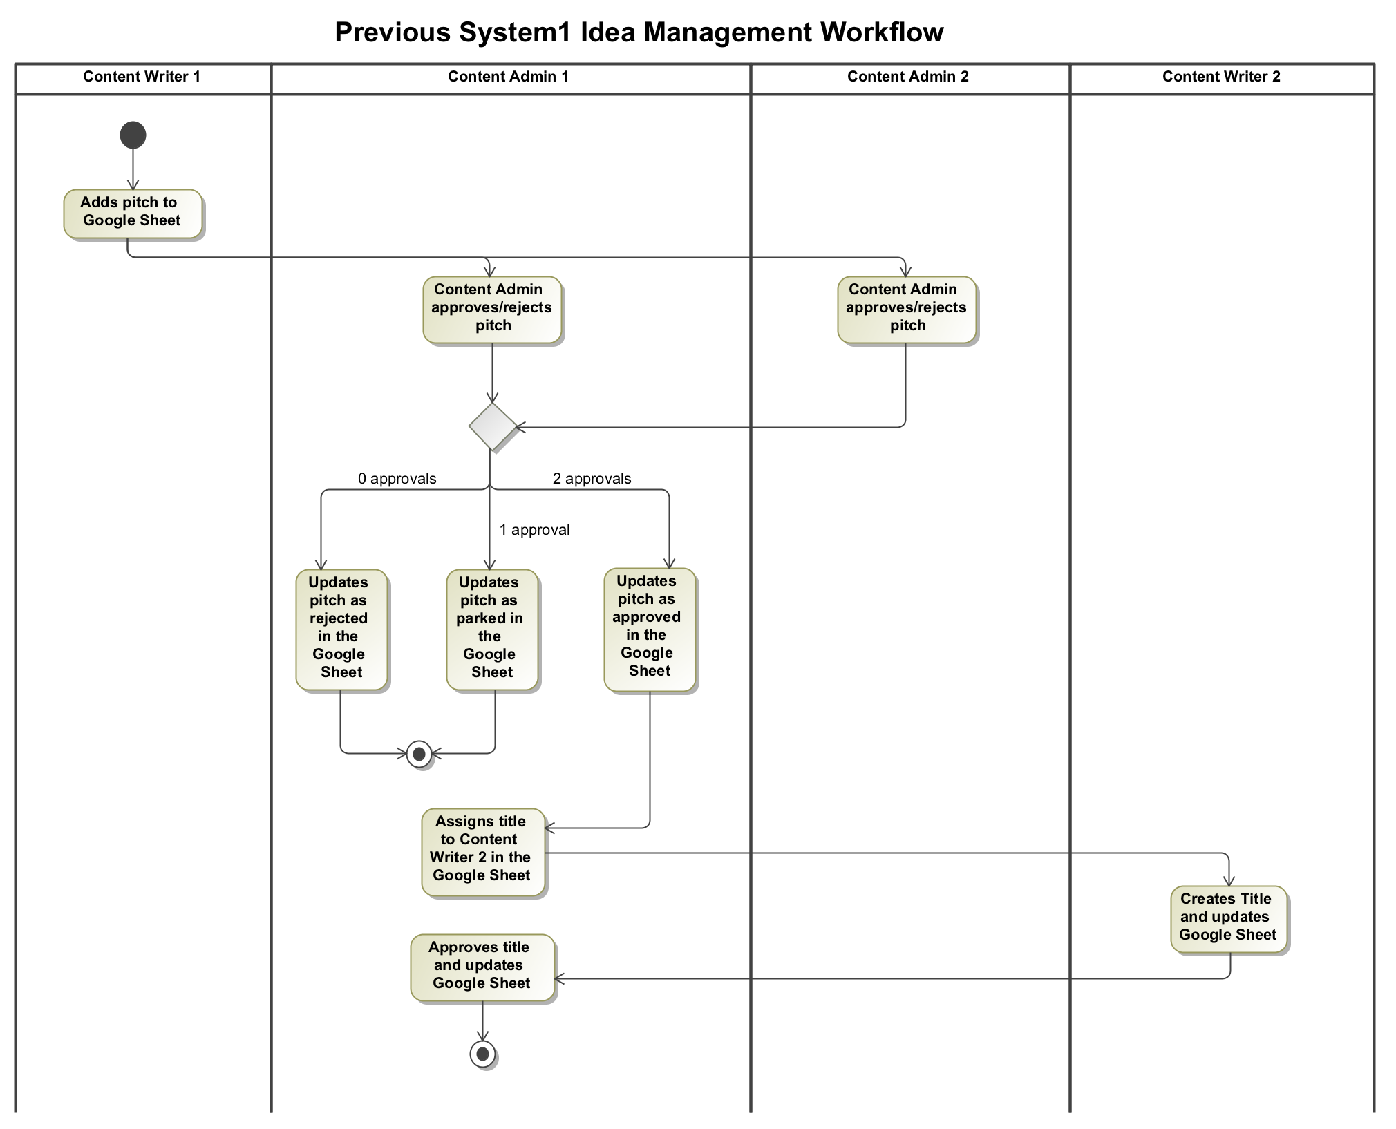

Figure 3: Current Workflow Diagram

## 3.2 System Objectives, Constraints and Priorities

### 3.2.1 Capability Goals

|  |  |
| --- | --- |
| **Capability Goals** | **Priority Level** |
| OC-1 Login page: users can log into the session with their credentials | High |
| OC-2 Content writer home page: writer can view overall project progress, individual vertical progress, and targets of the past, current, or future months | High |
| OC-3 Content writer draft board: writer can draft an idea then pitch it for approval | High |
| OC-4 Content writer global pitch board: writer can view pitch details, and upvote pitches with high content creation value | High |
| OC-5 Content writer local title board: Shows all titles assigned to current writer. Writer can create title for a content piece | High |
| OC-6 Admin home page: admin can view overall project progress, individual vertical progress, and targets of the past, current, or future months | High |
| OC-7 Admin global pitch board: shows all pitched ideas from writers. Admin can review and approve / reject pitches | High |
| OC-8 Admin global title board: admin can view title details and assign title to writers | High |
| OC-9 Team Board: admin can view team member’s performance and progress and change member’s account type | High |
| OC-10 Admin goals board: admin can set target vertical and amount of titles desired for current or future months, and also assign content writers to verticals | High |

Table 2: Level of Capability Goals

### 

### 

### 3.2.2 Level of Service Goals

|  |  |  |
| --- | --- | --- |
| **Level of Service Goals** | **Priority Level** | **Referred WinWin Agreements** |
| LOS1: System shall mimic and streamline the entire idea formulation workflow currently practiced by the client | Must have | WC_4947, WC_4955, WC_4964, WC_4969, WC_4970, WC_4977 |
| LOS2: System shall be easy and pleasant to use by a typical team size of 50 content writers and 5 content admins and with the ability to scale up or down | Nice to have | WC_4978 |
| LOS3: System should be designed in a way such that the handoff to client will be smooth | Nice to have | WC_4832 |

Table 3: Level of Service Goals

### 3.2.3 Organizational Goals

OG-1: Manage the team more easily by content admins through implementing privilege control

OG-2: Speed up content creation for content writers and content admins by streamlining current workflow

OG-3: Scale content production and traffic acquisition via modern database hosting and management

### 3.2.4 Constraints

CO-1: Cloud based web application - the system shall be deployed on AWS for production. Note that Heroku will be used for prototype purpose

CO-2: Limited Access: The system shall only be available to our client System1 with their employee credentials and the authentication module will be implemented based on JWT

CO-3: Preferred backend technology: Backend shall be implemented using python flask and documented by Swagger UI. Database will be hosted on mongoDB mLab

CO-4: Preferred frontend technology: Frontend shall be implemented using React JS, Node JS, Creative TIM, material, and webpack

### 

### 3.2.5 Relation to Current System

|  |  |  |
| --- | --- | --- |
| **Capabilities** | **Current System** | **New System** |
| Roles and Responsibilities | * Content writer identify, draft, and pitch a trending subject * Admin approves the pitch for title creation * Content writer creates eye-catching title * Admin approves the title for content production | Mimic and streamline the entire existing workflow |
| User Interactions | Edit shared spreadsheet | Create a new content piece entry and follow it along its lifespan from draft to content production |
| Infrastructure | Cloud based spreadsheet | Cloud based database hosting and web app |
| Stakeholder Essentials and Amenities | N/A | * Monitor and manage team activity and performance * Follow content lifespan with live notification |
| Future Capabilities | N/A | Potentially integration with content production and trend identification functionalities |

Table 4: Relation to Current System

## 

## 

## 

## 

## 

## 3.3 Proposed New Operational Concept

### 3.3.1 Element Relationship Diagram

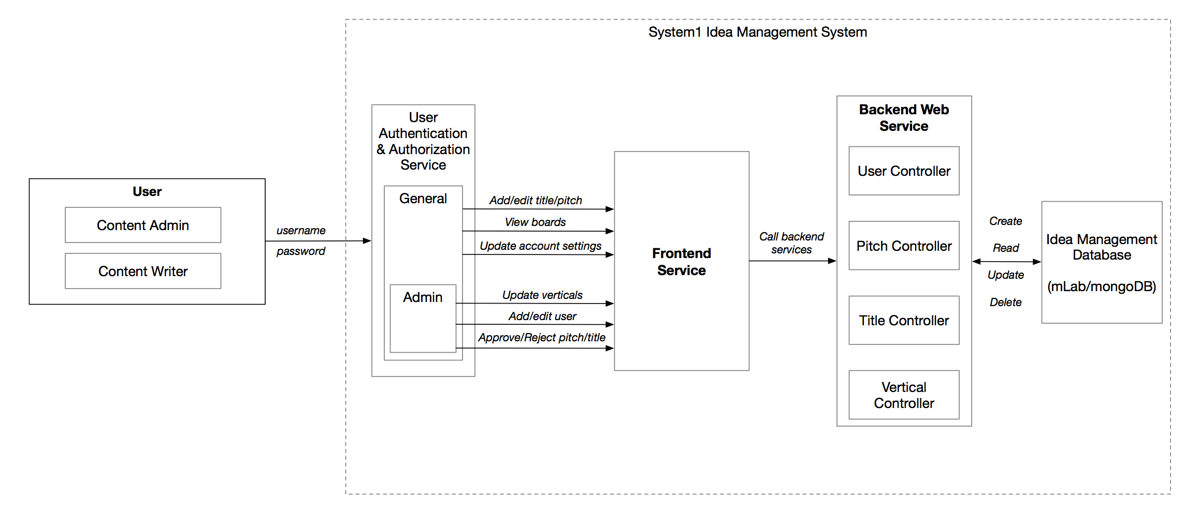

Figure 4: Element Relationship Diagram

### 

### 

### 

### 

### 

### 

### 

### 

### 

### 

### 

### 3.3.2 Business Workflows

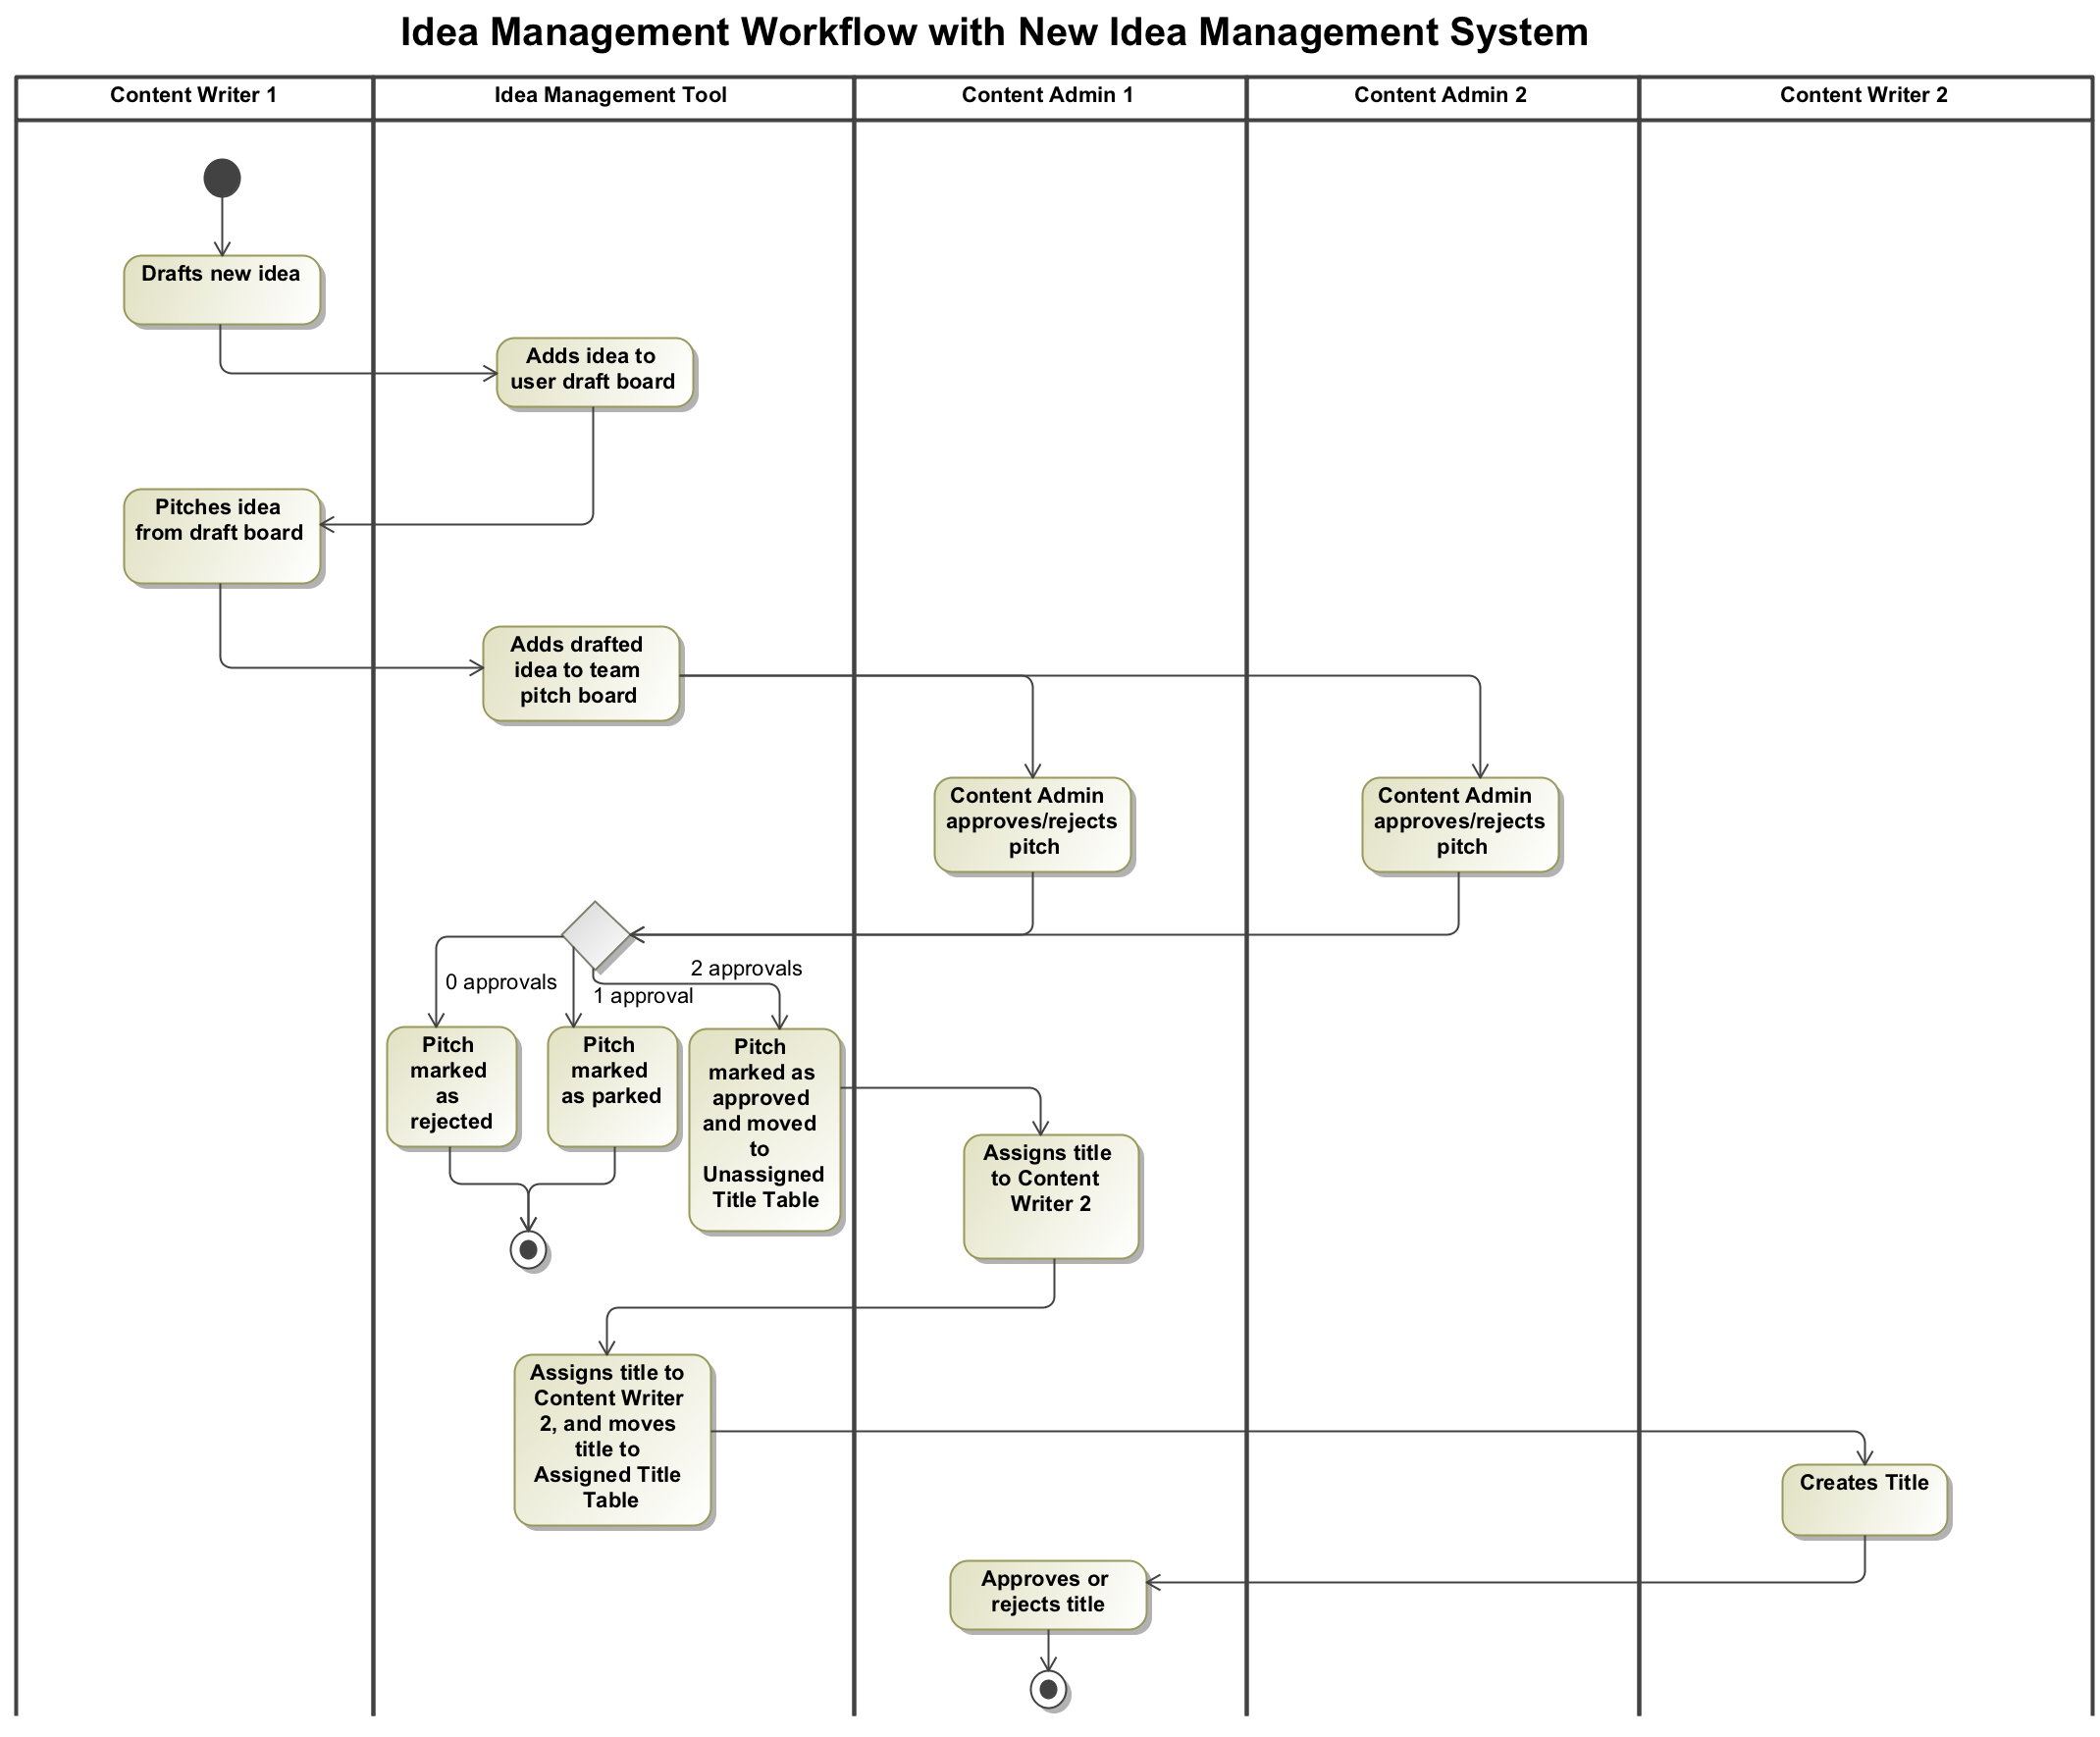

Figure 5: Business Workflows Diagram

## 3.4 Organizational and Operational Implications

### 3.4.1 Organizational Transformations

The following organizational transformation will result from transitioning to the new system:

* The need of dedicated staff to maintain the system, both backend hosting and frontend website

### 3.4.2 Operational Transformations

The following operational transformation will result from transitioning to the new system:

* Content writer and admin will receive immediate notifications of the content piece over the different stages of content creation
* Admin will be able to manage team member access privilege
* Content writers and admins will need to log in or log out of the web app session
* The option to export data into spreadsheet