System and Software Architecture Description (SSAD)

**Discovery Tool**

**Team 3**

**Josh Bendig - IIV&V**

**Xizhao Deng - Project manager**

**Jingzhou Hong - Requirement Engineer**

**Guancheng Liu - Tester**

**Michael Russo - Prototyper**

**Shenghao Tang - Feasibility Analyst**

**Fan Zhan - Software Architect**

**Yiming Zhang - System Architect**

**10/22/18**

# Version History

|  |  |  |  |  |
| --- | --- | --- | --- | --- |
| Date | Author | Version | Changes made | Rationale |
| 10/20/18 | FZ | 1.0 | Initial draft | Initial draft for Discovery Tool SSAD |
| 10/21/18 | XD | 1.1 | Fixed formatting | Reviewed and small fixes for DC package |
| 10/21/18 | ST, JH | 1.2 | System Analysis (Content writer home page) | Need further work on remaining part |
| 10/22/18 | FZ | 1.3 | Update 4.1 | Documentation increments |
| 10/22/18 | GL | 1.4 | Increments to 2.1.3 | Documentation increments |
| 10/22/18 | FZ | 1.5 | Update 2.1.2, 4.1.2 | Documentation increments |

# 

# 

# 

# 

# Table of Contents

**Version History** **1**

**Table of Contents** **2**

**1. Introduction** **4**

1.1 Purpose of the SSAD 4

1.2 Status of the SSAD 4

**2. System Analysis** **4**

2.1 System Analysis Overview 4

2.1.1 System Context 5

2.1.2 Artifacts & Information 6

2.1.3 Behavior 7

2.1.3.1 Login page 11

2.1.3.1.1 Register for account 11

2.1.3.1.2 Login 12

2.1.3.2 Content writer home page 13

2.1.3.2.1 View current month target and progress 13

2.1.3.2.2 View approved titles created by writer 14

2.1.3.2.3 Content writers view targets made in past months 15

2.1.3.2.4 Content writers view targets made in future months 16

2.1.3.2.5 Content writers receive notifications 17

2.1.3.2.6 Content writers send a message 18

2.1.3.2.7 Content writers receive a message 19

2.1.3.2.8 Content writers track performance 20

2.1.3.2.9 Content writers log out 21

2.1.3.3 Content writer draft board 22

2.1.3.3.1 Content writers create draft 22

2.1.3.3.2 Content writers modify a draft 23

2.1.3.3.3 Content writers remove a draft 24

2.1.3.3.4 Content writers view draft details 25

2.1.3.4 Content writer global pitch board 26

2.1.3.5 Content writer local title board 31

2.1.3.6 Admin home board 35

2.1.3.7 Admin global pitch board 42

2.1.3.8 Admin global title board 47

2.1.3.9 Admin team board 52

2.1.3.10 Admin goal board 53

2.1.4 Modes of Operation 57

2.2 System Analysis Rationale 57

**3. Technology-Independent Model** **57**

3.1. Design Overview 57

3.1.1. System Structure 57

3.1.2. Design Classes 61

3.1.3. Process Realization 62

3.2 Design Rationale 65

**4. Technology-Specific System Design** **65**

4.1 Design Overview 65

4.1.1 System Structure 66

4.1.2 Design Classes 69

4.1.3 Process Realization 70

4.2 Design Rationale 73

**5. Architectural Styles, Patterns and Frameworks** **73**

# 1. Introduction

## 1.1 Purpose of the SSAD

SSAD provides a number of benefits for discovery-tool:

* It gives a basis for analysis of software system’s behavior before the system has been built. With this documentation, team will have better understanding of the project requirements.
* It provides a basis for re-use of elements and decisions. With this documentation, the team should have the sense of which component could be reused in the future so that we could build a more extensible framework. For example, what if we add more types of the content rather than only pitches, title?
* It supports early design decisions that impact a system's development, deployment, and maintenance.
* It facilitates communication with stakeholders, contributing to a system that better fulfills their needs. With this documentation, team will have better idea about how to build a system that every member could do contribution to it. For example, with better organization, each member could be one or several API’s owner in our Flask framework, and our backend system is consists of all of these APIs.
* It enables [cost reduction](https://en.wikipedia.org/wiki/Cost_reduction). Software architecture is a means to manage risk and costs in complex IT projects.

## 1.2 Status of the SSAD

System Analysis Overview, System Analysis Rationale, Design Overview and Design Rationale have been added. This is the an early release of SSAD for Fall 2018 DC package deliverables.

# 2. System Analysis

## 2.1 System Analysis Overview

Discovery Tool is a web app based idea management system. It serves as an internal tool to System1. It provides a solution to help System1 content writers and admins to streamline, manage, accelerate their workflow. It gives the admins necessary tooling to quickly scale the team as well as content production. Overall, the system supports the team to work cross-functionally, leveraging resources to meet needs as efficiently as possible.

### 

### 

### 

### 2.1.1 System Context

Figure 1: System Context Diagram

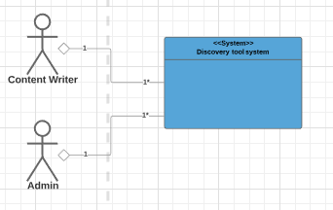

Table 1: Actors Summary

|  |  |  |
| --- | --- | --- |
| **Actor** | **Description** | **Responsibilities** |
| Content Writer (aka content creator) | Writer who draft ideas, pitch ideas, and write titles for approved pitches | * Draft ideas in vertical responsible for Pitch ideas * Upvote pitched ideas * Write title to approved ideas assigned |
| Content Admin | Administrators who manage the writers and review ideas at different stages of the content creation | * Control content writer access privilege * Manage pitches and titles * Assign tasks * Set targets |

### 

### 

### 

### 

### 

### 

### 2.1.2 Artifacts & Information

Figure 2: Artifacts and Information Diagram

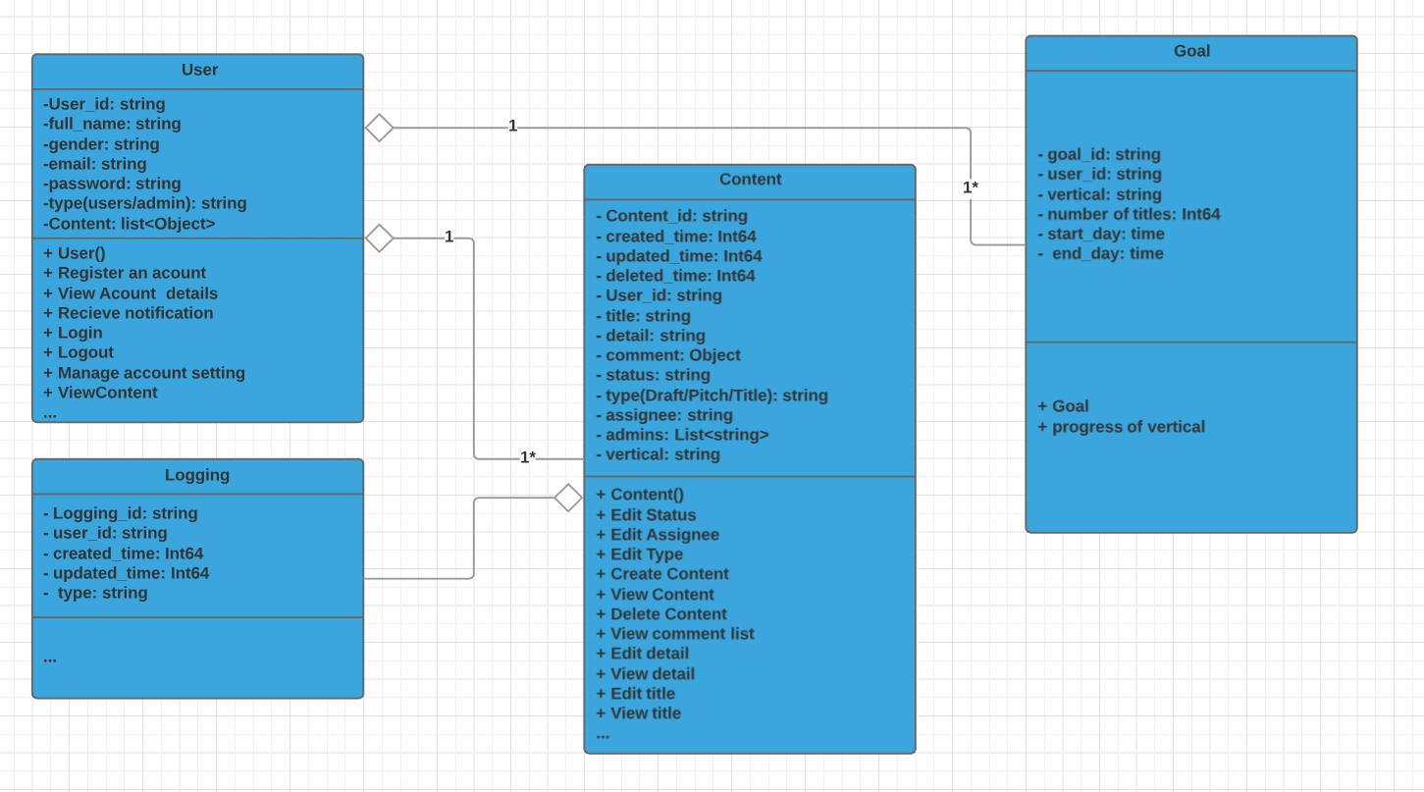

Table 2: Artifacts and Information Summary

|  |  |
| --- | --- |
| **Class** | **Purpose** |
| User | User is the object who is going to use the system. It is the fundamental artifacts of the system. |
| Content | Content is the object that is used by users. It is the fundamental artifacts of the system. |
| Goal | Goal is defined by the admin to trace the plan and progress monthly |
| Logging | Logging traces the history change of the content status. |

### 

### 

### 

### 

### 

### 2.1.3 Behavior

Figure 3: Process Diagram - content admin

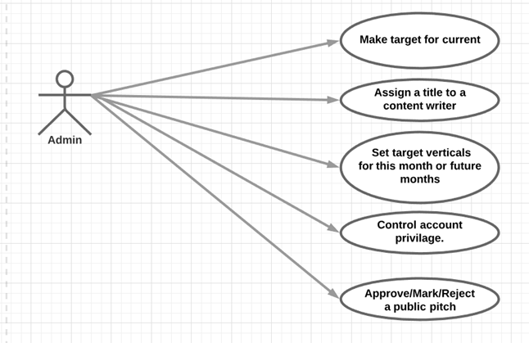

Figure 4: Process Diagram - content writer

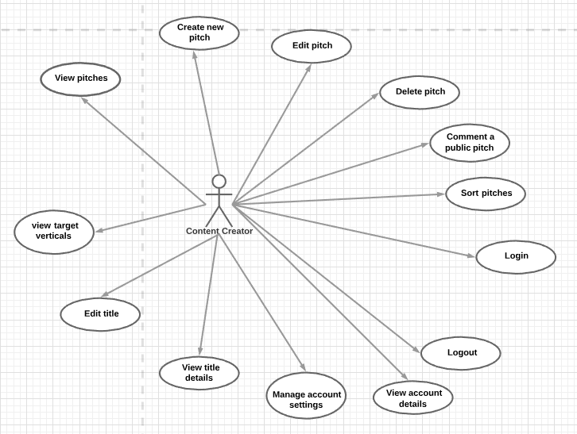

Table 3: Use Case List

|  |  |  |
| --- | --- | --- |
| **Use Case ID** | **Use Case Name** | **Description** |
| **Login page** | | |
| UC-1 | Register for account | User can create a new account profile |
| UC-2 | Login | User logs into the system with a username and password |
| **Content writer home page** | | |
| UC-3 | View current month target and progress | Content writer can view the total number of titles needed for this month. The desired verticals and number of titles needed by each vertical, titles approved so far. Assignee of each vertical. Vertical assigned to this writer. Titles assigned/worked/approved to this writer. |
| UC-4 | View approved titles | A content writer can view all the title created by him/her that were approved for content production |
| UC-5 | View past month targets | Content writer can view targets made in past months |
| UC-6 | View future month targets | Content writer can view targets set for future months |
| UC-7 | Receive notifications | A content writer can receive notifications as a piece of content moves through the various stages of development (approved, rejected, parked, unassigned, assigned and untitled, titled, approved for publishing, parked for publishing) |
| UC-8 | Send message | A content writer can send a message to a specific user |
| UC-9 | Receive message | A content writer can receive message from other users |
| UC-10 | View content success rates by draft to title conversion ratio | A content writer can track his/her own success rate by the draft to approved title conversion ratio |
| UC-11 | Logout | Content writer logs out of the system and ends their current session |
| **Content writer draft board page** | | |
| UC-12 | Create a draft | content writer can create a new draft and add details, notes, and tags |
| UC-13 | Edit a draft | content writer can modify a draft |
| UC-14 | Delete a draft | content writer can remove a draft |
| UC-15 | View a draft | content writer can view a draft’s details: draft ID, creator, type, vertical, description, time created, last time modified, URL, buy-side network, tags |
| UC-16 | Pitch a draft | When a content writer thinks this draft is ready, he/she can click the “pitch it” button to publish this draft to the global pitch list. This draft is then removed from this draft board. |
| **Content writer global pitch board page** | | |
| UC-17 | View a pitch | Content writer can click on a pitch in the list to view its details: pitch ID, creator, type, vertical, description,time created,last time modified, URL, buy-side network, tags, status(new, approved, rejected, parked), upvote number |
| UC-18 | Upvote a pitch | Content writer can click on the upvote button to upvote a pitch they like |
| UC-19 | Filter pitches by criteria | A content writer can filter pitches by criteria such as status, creator etc |
| UC-20 | Sort pitches by upvote | A content writer can change the view of the board locally by sorting pitches in order of upvotes to identify promising pitches via crowdsourcing |
| UC-21 | Export global pitch board | A content writer can export the master pitch list into a spreadsheet |
| **Content writer local title board page** | | |
| UC-22 | Edit a title | Content writer can make an eye-catching title for this title instance, the status of the title will change from “assigned and untitled” to “titled” |
| UC-23 | View a title | Content writer can click on a title in the list to view its details: title ID, creator, assignee, type, vertical, description, time created, last time modified, URL, buy-side network, tags, status |
| UC-24 | Filter titles by criteria | A content writer can filter titles by criteria such as status, creator etc |
| UC-25 | Export local title board | A content writer can export the local title board list into a spreadsheet |
| **Admin home page** | | |
| UC-26 | View current month target and progress | Admin can view the target number of titles needed for this month and progress(number of approved / still needed). The desired verticals, number of titles needed by each vertical, assignee of each vertical, progress of each vertical (titles approved / needed) |
| UC-27 | View past month targets | Admin can view targets made in past months |
| UC-28 | View future month targets | Admin can view targets set for future months |
| UC-29 | Receive notifications | Admin can receive notifications as a piece of content moves through the various stages of development (approved, rejected, parked, unassigned, assigned and untitled, titled, approved for publishing, parked for publishing) |
| UC-30 | Send message | Admin can send a message to a specific user |
| UC-31 | Receive message | Admin writer can receive message from other users |
| UC-32 | Logout | Admin logs out of the system and ends their current session |
| **Admin global pitch board page** | | |
| UC-33 | View a pitch | Admin can click on a pitch in the list to view its details: pitch ID, creator, type, vertical, description,time created,last time modified, URL, buy-side network, tags, status(new, approved, rejected, parked), upvote number |
| UC-34 | Approve/reject a pitch | Admin can click on a pitch, change its status to approved or rejected. If two admin has different opinions, the status of the pitch is changed to “parked” |
| UC-35 | Filter pitches by criteria | Admin can filter pitches by criteria such as status, creator etc |
| UC-36 | Sort pitches by upvote | Admin can change the view of the board locally by sorting pitches in order of upvotes to identify promising pitches via crowdsourcing |
| UC-37 | Export global pitch board | Admin can export the master pitch list into a spreadsheet |
| **Admin global title board page** | | |
| UC-38 | View a title | Admin can click on a title in the list to view its details: title ID, creator, assignee, type, vertical, description, time created, last time modified, URL, buy-side network, tags, status |
| UC-39 | Assign a title to content writer | Admin can change the assignee of a title to a specific content writer. By default, the assignee is blank and status of the title is “unassigned and untitled”. Once assigned a writer, the status changes to “assigned” |
| UC-40 | Approve a title | One admin needs to approve a title for production. Status changes from “titled” to “approved”. If a title is reviewed but not approved, the status changes to “parked” |
| UC-41 | Filter titles by criteria | Admin can filter titles by criteria such as status, creator etc |
| UC-42 | Export global title list | Admin can export the global title board list into a spreadsheet |
| **Admin team board page** | | |
| UC-43 | View a team member details | Admin can click on a team member and view his/her information: member name, account type(writer, admin), number of draft pitched, number of titles assigned, number of titles approved, assigned vertical, number of title needed by that vertical, success rate, contact info |
| UC-44 | Change a team member’s type | Admin can change a team member’s type between admin and writer |
| **Admin goals board page** | | |
| UC-45 | Set target verticals for current month | Admin can set a list of verticals desired for current month |
| UC-46 | Set target verticals for future months | Admin can set a list of verticals desired for future months |
| UC-47 | Set target number of titles needed for each vertical | Admin can set the number of titles needed for each vertical, then the numbers will be summed up to be the total number of titles needed by that month |
| UC-48 | Assign vertical to content writers | Admin can assign a content writer to a vertical |

#### 2.1.3.1 Login page

##### 2.1.3.1.1 Register for account

Table 3: Process Description - UC-1

|  |  |
| --- | --- |
| **Identifier** | UC-1 |
| **Purpose** | User creates a new account profile |
| **Requirements** | Must be able to set up account profile |
| **Development Risks** | None |
| **Pre-conditions** | None |
| **Post-conditions** | None |

Table 4: Typical Course of Action - UC-1 success

|  |  |  |
| --- | --- | --- |
| **Seq#** | **Actor’s Action** | **System’s Response** |
| **1** | Click on “create” |  |
| **2** |  | Redirect to sign up page |
| **3** | Fill in required fields with unique and correctly formatted information, click “create” |  |
| **4** |  | Check for uniqueness, correct format, and completion |
| **5** |  | Update database |
| **6** |  | Display success message |

Table 5: Typical Course of Action - UC-1 failure

|  |  |  |
| --- | --- | --- |
| **Seq#** | **Actor’s Action** | **System’s Response** |
| **1** | Click on “create” |  |
| **2** |  | Redirect to sign up page |
| **3** | Fill in required fields with incorrect information, click “create” |  |
| **4** |  | Check for uniqueness, correct format, and completion |
| **5** |  | Display error message |

##### 2.1.3.1.2 Login

Table 6: Process Description - UC-2

|  |  |
| --- | --- |
| **Identifier** | UC-2 |
| **Purpose** | Log into the user’s session |
| **Requirements** | A valid account has been set up |
| **Development Risks** | None |
| **Pre-conditions** | Account registration |
| **Post-conditions** | None |

Table 7: Typical Course of Action - UC-2 success

|  |  |  |
| --- | --- | --- |
| **Seq#** | **Actor’s Action** | **System’s Response** |
| **1** | Fill in username and password, click “login” |  |
| **2** |  | Check user credentials |
| **3** |  | Redirect to user home page |

Table 8: Typical Course of Action - UC-2 failure

|  |  |  |
| --- | --- | --- |
| **Seq#** | **Actor’s Action** | **System’s Response** |
| **1** | Fill in incorrect username and password, click “login” |  |
| **2** |  | Check user credentials |
| **3** |  | Display error message |

#### 2.1.3.2 Content writer home page

##### 2.1.3.2.1 View current month target and progress

Table 9: Process Description - UC-3

|  |  |
| --- | --- |
| **Identifier** | UC-3 |
| **Purpose** | Content writer can view total number of titles for this month, desired verticals, number of titles for each verticals, titles approved, assignee of each vertical, vertical assigned to which writer |
| **Requirements** | A valid account, user class as “writer”. |
| **Development Risks** | None |
| **Pre-conditions** | Account login |
| **Post-conditions** | View titles and verticals details |

Table 10: Typical Course of Action - UC-3 success

|  |  |  |
| --- | --- | --- |
| **Seq#** | **Actor’s Action** | **System’s Response** |
| **1** | Users go to writer home page |  |
| **2** |  | Check and show the user home page, containing target or this month |
| **3** | Click one vertical |  |
| **4** |  | Check and display detail of the vertical |
| **5** | Click one title |  |
|  |  | Check and display detail of the title |

Table 11: Typical Course of Action - UC-3 failure

|  |  |  |
| --- | --- | --- |
| **Seq#** | **Actor’s Action** | **System’s Response** |
| **1** | Users go to the pitch board |  |
| **2** |  | Check the user home page |
| **3** |  | Display error message |

##### 2.1.3.2.2 View approved titles created by writer

Table 12: Process Description - UC-4

|  |  |
| --- | --- |
| **Identifier** | UC-4 |
| **Purpose** | View approved titles created by him/her |
| **Requirements** | A valid account, user class as “writer”. |
| **Development Risks** | None |
| **Pre-conditions** | Account login, user in writer home page |
| **Post-conditions** | View approved title details |

Table 13: Typical Course of Action - UC-4 success

|  |  |  |
| --- | --- | --- |
| **Seq#** | **Actor’s Action** | **System’s Response** |
| **1** | Users click on “Approved titles” button |  |
| **2** |  | Check on all approved titles belonged to this writer |
| **3** |  | Redirect to Approved titles page |

Table 14: Typical Course of Action - UC-4 failure

|  |  |  |
| --- | --- | --- |
| **Seq#** | **Actor’s Action** | **System’s Response** |
| **1** | Users click on “Approved titles” button |  |
| **2** |  | Check on all approved titles belonged to this writer |
| **3** |  | Display error message |

##### 2.1.3.2.3 Content writers view targets made in past months

Table 15: Process Description - UC-5

|  |  |
| --- | --- |
| **Identifier** | UC-5 |
| **Purpose** | Content writer can view targets made in past months |
| **Requirements** | Valid account |
| **Development Risks** | None |
| **Pre-conditions** | Account login, user in writer home page |
| **Post-conditions** | View target detail of last month |

Table 16: Typical Course of Action - UC-5 success

|  |  |  |
| --- | --- | --- |
| **Seq#** | **Actor’s Action** | **System’s Response** |
| **1** | Users click on “Select Date” drop down menu and set date |  |
| **2** | User click on search button |  |
| **3** |  | Check on all targets and their titles during that search date |
| **4** |  | Display target and title list |

Table 17: Typical Course of Action - UC-5 failure

|  |  |  |
| --- | --- | --- |
| **Seq#** | **Actor’s Action** | **System’s Response** |
| **1** | Users click on “Select Date” drop down menu and set date |  |
| **2** | User click on search button |  |
| **3** |  | Check on all targets and their titles during that search date |
| **4** |  | Display error message |

##### 2.1.3.2.4 Content writers view targets made in future months

Table 18: Process Description - UC-6

|  |  |
| --- | --- |
| **Identifier** | UC-6 |
| **Purpose** | Content writer can view targets made in future months |
| **Requirements** | Valid account |
| **Development Risks** | None |
| **Pre-conditions** | Account login, user in writer home page |
| **Post-conditions** | View target detail of future month |

Table 19: Typical Course of Action - UC-6 success

|  |  |  |
| --- | --- | --- |
| **Seq#** | **Actor’s Action** | **System’s Response** |
| **1** | Users click on “Select Date” drop down menu and set date |  |
| **2** | User click on search button |  |
| **3** |  | Check on all targets and requirement during that search date |
| **4** |  | Display target requirement list |

Table 20: Typical Course of Action - UC-6 failure

|  |  |  |
| --- | --- | --- |
| **Seq#** | **Actor’s Action** | **System’s Response** |
| **1** | Users click on “Select Date” drop down menu and set date |  |
| **2** | User click on search button |  |
| **3** |  | Check on all targets and requirement during that search date |
| **4** |  | Display error message |

##### 2.1.3.2.5 Content writers receive notifications

Table 21: Process Description - UC-7

|  |  |
| --- | --- |
| **Identifier** | UC-7 |
| **Purpose** | content writer can receive notifications as a piece of content moves through the various stages of development (approved, rejected, parked, unassigned, assigned, etc.) |
| **Requirements** | Valid account |
| **Development Risks** | None |
| **Pre-conditions** | Account login, user in writer home page |
| **Post-conditions** | None |

Table 22: Typical Course of Action - UC-7 success

|  |  |  |
| --- | --- | --- |
| **Seq#** | **Actor’s Action** | **System’s Response** |
| **1** |  | Notification pops on user’s screen as notification displaying the updated information about his/her piece of content |
| **2** |  | New notification updated in user’s notification page. |

Table 23: Typical Course of Action - UC-7 failure

|  |  |  |
| --- | --- | --- |
| **Seq#** | **Actor’s Action** | **System’s Response** |
| **1** |  | No response |

##### 2.1.3.2.6 Content writers send a message

Table 24: Process Description - UC-8

|  |  |
| --- | --- |
| **Identifier** | UC-8 |
| **Purpose** | A content writer can send a message to a specific user |
| **Requirements** | Valid account, user class as “writer” |
| **Development Risks** | None |
| **Pre-conditions** | Account login, user in writer home page |
| **Post-conditions** | Receive message |

Table 25: Typical Course of Action - UC-8 success

|  |  |  |
| --- | --- | --- |
| **Seq#** | **Actor’s Action** | **System’s Response** |
| **1** | Users move to writer home page |  |
| **2** |  | Show the writer home page |
| **3** | Click on “send message” |  |
| **4** |  | Show address field and text field |
| **5** | Choose the user who will receive the message |  |
| **6** | Write message |  |
| **7** | Click “send” |  |
| **8** |  | Try to transfer the message in backend |
| **9** |  | Show “message is sent successfully” |

Table 26: Typical Course of Action - UC-8 failure

|  |  |  |
| --- | --- | --- |
| **Seq#** | **Actor’s Action** | **System’s Response** |
| **1** | Users move to writer home page |  |
| **2** |  | Show the writer home page |
| **3** | Click on “send message” |  |
| **4** |  | Show address field and text field |
| **5** | Choose the user who will receive the message |  |
| **6** | Write message |  |
| **7** | Click “send” |  |
| **8** |  | Try to transfer the message in backend |
| **9** |  | Show failed information |

##### 2.1.3.2.7 Content writers receive a message

Table 27: Process Description - UC-9

|  |  |
| --- | --- |
| **Identifier** | UC-9 |
| **Purpose** | A content writer can receive message from other users |
| **Requirements** | Valid account, user class as “writer” |
| **Development Risks** | None |
| **Pre-conditions** | Account login, user in writer home page |
| **Post-conditions** | None |

Table 28: Typical Course of Action - UC-9 success

|  |  |  |
| --- | --- | --- |
| **Seq#** | **Actor’s Action** | **System’s Response** |
| **1** | Users move to writer home page |  |
| **2** |  | Show the writer home page |
| **3** | Click on “message box” |  |
| **4** |  | Show the list of message received |
| **5** | Click on one message to read |  |
| **6** |  | Show the message |

Table 29: Typical Course of Action - UC-9 failure

|  |  |  |
| --- | --- | --- |
| **Seq#** | **Actor’s Action** | **System’s Response** |
| **1** | Users move to writer home page |  |
| **2** |  | Show the writer home page |
| **3** | Click on “message box” |  |
| **4** |  | Show error info that why message box is unavailable |

##### 2.1.3.2.8 Content writers track performance

Table 30: Process Description - UC-10

|  |  |
| --- | --- |
| **Identifier** | UC-10 |
| **Purpose** | A content writer can track his/her own success rate by the draft to approved title conversion ratio |
| **Requirements** | Valid account, user class as “writer” |
| **Development Risks** | None |
| **Pre-conditions** | Account login, user in writer home page |
| **Post-conditions** | None |

Table 31: Typical Course of Action - UC-10 success

|  |  |  |
| --- | --- | --- |
| **Seq#** | **Actor’s Action** | **System’s Response** |
| **1** | Users move to writer home page |  |
| **2** |  | Show the writer home page |
| **3** | Click on “check success rate” |  |
| **4** |  | Show the data of successful conversion ratio |

Table 32: Typical Course of Action - UC-10 failure

|  |  |  |
| --- | --- | --- |
| **Seq#** | **Actor’s Action** | **System’s Response** |
| **1** | Users move to writer home page |  |
| **2** |  | Show the writer home page |
| **3** | Click on “check success rate” |  |
| **4** |  | Show error info that why conversion ratio is unavailable |

##### 2.1.3.2.9 Content writers log out

Table 33: Process Description - UC-11

|  |  |
| --- | --- |
| **Identifier** | UC-11 |
| **Purpose** | Content writer logs out of the system and ends their current session |
| **Requirements** | Valid account |
| **Development Risks** | None |
| **Pre-conditions** | Account login |
| **Post-conditions** | None |

Table 34: Typical Course of Action - UC-11 success

|  |  |  |
| --- | --- | --- |
| **Seq#** | **Actor’s Action** | **System’s Response** |
| **1** | User click on setting menu and then click on log out button |  |
| **2** |  | Log out of the system |
| **3** |  | Redirect to login page |

Table 35: Typical Course of Action - UC-11 failure

|  |  |  |
| --- | --- | --- |
| **Seq#** | **Actor’s Action** | **System’s Response** |
| **1** | User click on setting menu and then click on log out button |  |
| **2** |  | Log out of the system |
|  |  | Display error message |

#### 2.1.3.3 Content writer draft board

##### 2.1.3.3.1 Content writers create draft

Table 36: Process Description - UC-12

|  |  |
| --- | --- |
| **Identifier** | UC-12 |
| **Purpose** | Content writer can create a new draft and add details, notes, and tags |
| **Requirements** | Valid account |
| **Development Risks** | None |
| **Pre-conditions** | Account login |
| **Post-conditions** | None |

Table 37: Typical Course of Action - UC-12 success

|  |  |  |
| --- | --- | --- |
| **Seq#** | **Actor’s Action** | **System’s Response** |
| **1** | User click on create a draft button |  |
| **2** |  | Show the draft information page |
| **3** | User add details, notes, and tags |  |
| **4** |  | Show the success of creating a draft |

Table 38: Typical Course of Action - UC-12 failure

|  |  |  |
| --- | --- | --- |
| **Seq#** | **Actor’s Action** | **System’s Response** |
| **1** | User click on create a draft button |  |
| **2** |  | Show the draft information page |
| **3** | User add details, notes, and tags |  |
| **4** |  | Show the failure of creating a draft |

##### 2.1.3.3.2 Content writers modify a draft

Table 39: Process Description - UC-13

|  |  |
| --- | --- |
| **Identifier** | UC-13 |
| **Purpose** | Content writer can modify a draft |
| **Requirements** | Valid account |
| **Development Risks** | None |
| **Pre-conditions** | Account login |
| **Post-conditions** | None |

Table 40: Typical Course of Action - UC-13 success

|  |  |  |
| --- | --- | --- |
| **Seq#** | **Actor’s Action** | **System’s Response** |
| **1** | User click on edit a draft button |  |
| **2** |  | Show the draft information page |
| **3** | User edit details, notes, and tags |  |
| **4** |  | Show the success of creating a draft |

Table 41: Typical Course of Action - UC-13 failure

|  |  |  |
| --- | --- | --- |
| **Seq#** | **Actor’s Action** | **System’s Response** |
| **1** | User click on edit a draft button |  |
| **2** |  | Show the draft information page |
| **3** | User edit details, notes, and tags |  |
| **4** |  | Show the failure of creating a draft |

##### 2.1.3.3.3 Content writers remove a draft

Table 42: Process Description - UC-14

|  |  |
| --- | --- |
| **Identifier** | UC-14 |
| **Purpose** | Content writer can remove a draft |
| **Requirements** | Valid account |
| **Development Risks** | None |
| **Pre-conditions** | Account login |
| **Post-conditions** | None |

Table 43: Typical Course of Action - UC-14 success

|  |  |  |
| --- | --- | --- |
| **Seq#** | **Actor’s Action** | **System’s Response** |
| **1** | User click on delete a draft button |  |
| **2** |  | Show the deleted draft information page |
| **3** | User confirm the delete button |  |
| **4** |  | Show the success of delete a draft |

Table 44: Typical Course of Action - UC-14 failure

|  |  |  |
| --- | --- | --- |
| **Seq#** | **Actor’s Action** | **System’s Response** |
| **1** | User click on delete a draft button |  |
| **2** |  | Show the deleted draft information page |
| **3** | User confirm the delete button |  |
| **4** |  | Show the failure of delete a draft |

##### 2.1.3.3.4 Content writers view draft details

Table 45: Process Description - UC-15

|  |  |
| --- | --- |
| **Identifier** | UC-15 |
| **Purpose** | Content writer can view a draft’s details: draft ID, creator, type, vertical, description, time created, last time modified, URL, buy-side network, tags |
| **Requirements** | Valid account |
| **Development Risks** | None |
| **Pre-conditions** | Account login |
| **Post-conditions** | None |

Table 46: Typical Course of Action - UC-15 success

|  |  |  |
| --- | --- | --- |
| **Seq#** | **Actor’s Action** | **System’s Response** |
| **1** | User click on view a draft button |  |
| **2** |  | Show the success draft information page |

Table 47: Typical Course of Action - UC-15 failure

|  |  |  |
| --- | --- | --- |
| **Seq#** | **Actor’s Action** | **System’s Response** |
| **1** | User click on view a draft button |  |
| **2** |  | Show the failure draft information page |

#### 2.1.3.4 Content writer global pitch board

Table 48: Process Description - UC-16

|  |  |
| --- | --- |
| **Identifier** | UC-16 |
| **Purpose** | When a content writer thinks this draft is ready, he/she can click the “pitch it” button to publish this draft to the global pitch list. This draft is then removed from this draft board |
| **Requirements** | Valid account |
| **Development Risks** | None |
| **Pre-conditions** | Account login |
| **Post-conditions** | None |

Table 49: Typical Course of Action - UC-16 success

|  |  |  |
| --- | --- | --- |
| **Seq#** | **Actor’s Action** | **System’s Response** |
| **1** | User click on pitch a draft button |  |
| **2** |  | Show the draft information page |
| **3** | User confirm the pitch button |  |
| **4** |  | Show the success of pitch a draft |

Table 50: Typical Course of Action - UC-16 failure

|  |  |  |
| --- | --- | --- |
| **Seq#** | **Actor’s Action** | **System’s Response** |
| **1** | User click on pitch a draft button |  |
| **2** |  | Show the draft information page |
| **3** | User confirm the pitch button |  |
| **4** |  | Show the failure of pitch a draft |

Table 51: Process Description - UC-17

|  |  |
| --- | --- |
| **Identifier** | UC-17 |
| **Purpose** | Content writer can click on a pitch in the list to view its details |
| **Requirements** | Valid account |
| **Development Risks** | None |
| **Pre-conditions** | Account login |
| **Post-conditions** | None |

Table 52: Typical Course of Action - UC-17 success

|  |  |  |
| --- | --- | --- |
| **Seq#** | **Actor’s Action** | **System’s Response** |
| **1** | User click on view a pitch button |  |
| **2** |  | Show the success pitch information page |

Table 53: Typical Course of Action - UC-17 failure

|  |  |  |
| --- | --- | --- |
| **Seq#** | **Actor’s Action** | **System’s Response** |
| **1** | User click on view a pitch button |  |
| **2** |  | Show the failure pitch information page |

Table 54: Process Description - UC-18

|  |  |
| --- | --- |
| **Identifier** | UC-18 |
| **Purpose** | Content writer can click on the upvote button to upvote a pitch they like |
| **Requirements** | Valid account |
| **Development Risks** | None |
| **Pre-conditions** | Account login |
| **Post-conditions** | None |

Table 55: Typical Course of Action - UC-18 success

|  |  |  |
| --- | --- | --- |
| **Seq#** | **Actor’s Action** | **System’s Response** |
| **1** | User click on upvote a pitch button |  |
| **2** |  | Show the pitch information page |
| **3** | User confirm the upvote button |  |
| **4** |  | Show the success of upvoting pitch |

Table 56: Typical Course of Action - UC-19 failure

|  |  |  |
| --- | --- | --- |
| **Seq#** | **Actor’s Action** | **System’s Response** |
| **1** | User click on upvote a pitch button |  |
| **2** |  | Show the pitch information page |
| **3** | User confirm the upvote button |  |
| **4** |  | Show the failure of upvoting pitch |

Table 57: Process Description - UC-19

|  |  |
| --- | --- |
| **Identifier** | UC-19 |
| **Purpose** | Content writer can filter pitches by criteria such as status, creator etc |
| **Requirements** | Valid account |
| **Development Risks** | None |
| **Pre-conditions** | Account login |
| **Post-conditions** | None |

Table 58: Typical Course of Action - UC-19 success

|  |  |  |
| --- | --- | --- |
| **Seq#** | **Actor’s Action** | **System’s Response** |
| **1** | User select criteria such as status, creator etc |  |
| **2** |  | Show the selected criteria information page |
| **3** | User confirm the filter button |  |
| **4** |  | Show the success of filter pitches |

Table 59: Typical Course of Action - UC-19 failure

|  |  |  |
| --- | --- | --- |
| **Seq#** | **Actor’s Action** | **System’s Response** |
| **1** | User select criteria such as status, creator etc |  |
| **2** |  | Show the selected criteria information page |
| **3** | User confirm the filter button |  |
| **4** |  | Show the failure of filter pitches |

Table 60: Process Description - UC-20

|  |  |
| --- | --- |
| **Identifier** | UC-20 |
| **Purpose** | A content writer can change the view of the board locally by sorting pitches in order of upvotes to identify promising pitches via crowdsourcing |
| **Requirements** | Valid account |
| **Development Risks** | None |
| **Pre-conditions** | Account login |
| **Post-conditions** | None |

Table 61: Typical Course of Action - UC-20 success

|  |  |  |
| --- | --- | --- |
| **Seq#** | **Actor’s Action** | **System’s Response** |
| **1** | User select sort button |  |
| **2** |  | Show success of the sorted pictures |

Table 62: Typical Course of Action - UC-20 failure

|  |  |  |
| --- | --- | --- |
| **Seq#** | **Actor’s Action** | **System’s Response** |
| **1** | User select sort button |  |
| **2** |  | Show failure of the sorted pictures |

Table 63: Process Description - UC-21

|  |  |
| --- | --- |
| **Identifier** | UC-21 |
| **Purpose** | A content writer can export the master pitch list into a spreadsheet |
| **Requirements** | Valid account |
| **Development Risks** | None |
| **Pre-conditions** | Account login |
| **Post-conditions** | None |

Table 64: Typical Course of Action - UC-21 success

|  |  |  |
| --- | --- | --- |
| **Seq#** | **Actor’s Action** | **System’s Response** |
| **1** | User click on the export global pitch board |  |
| **2** |  | Show the pitch information page |
| **3** | User confirm the export button |  |
| **4** |  | Show the success of export pitch |

Table 65: Typical Course of Action - UC-21 failure

|  |  |  |
| --- | --- | --- |
| **Seq#** | **Actor’s Action** | **System’s Response** |
| **1** | User click on the export global pitch board |  |
| **2** |  | Show the pitch information page |
| **3** | User confirm the export button |  |
| **4** |  | Show the failure of export pitch |

#### 2.1.3.5 Content writer local title board

Table 66: Process Description - UC-22

|  |  |
| --- | --- |
| **Identifier** | UC-22 |
| **Purpose** | Content writer can make an eye-catching title for this title instance, the status of the title will change from “assigned and untitled” to “titled” |
| **Requirements** | Valid account |
| **Development Risks** | None |
| **Pre-conditions** | Account login |
| **Post-conditions** | None |

Table 67: Typical Course of Action - UC-22 success

|  |  |  |
| --- | --- | --- |
| **Seq#** | **Actor’s Action** | **System’s Response** |
| **1** | User click on editing a title |  |
| **2** |  | Show the title information page |
| **3** | User click the status of the title from “assigned and untitled” to “titled”  button |  |
| **4** |  | Show the success of editing a title |

Table 68: Typical Course of Action - UC-22 failure

|  |  |  |
| --- | --- | --- |
| **Seq#** | **Actor’s Action** | **System’s Response** |
| **1** | User click on editing a title |  |
| **2** |  | Show the title information page |
| **3** | User click the status of the title from “assigned and untitled” to “titled”  button |  |
| **4** |  | Show the failure of editing a title |

Table 69: Process Description - UC-23

|  |  |
| --- | --- |
| **Identifier** | UC-23 |
| **Purpose** | Content writer can click on a title in the list to view its details: title ID, creator, assignee, type, vertical, description, time created, last time modified, URL, buy-side network, tags, status |
| **Requirements** | Valid account |
| **Development Risks** | None |
| **Pre-conditions** | Account login |
| **Post-conditions** | None |

Table 70: Typical Course of Action - UC-23 success

|  |  |  |
| --- | --- | --- |
| **Seq#** | **Actor’s Action** | **System’s Response** |
| **1** | User click on view a title |  |
| **2** |  | Show success of the title information page |

Table 71: Typical Course of Action - UC-23 failure

|  |  |  |
| --- | --- | --- |
| **Seq#** | **Actor’s Action** | **System’s Response** |
| **1** | User click on view a title |  |
| **2** |  | Show failure of the title information page |

Table 72: Process Description - UC-24

|  |  |
| --- | --- |
| **Identifier** | UC-24 |
| **Purpose** | A content writer can filter titles by criteria such as status, creator etc |
| **Requirements** | Valid account |
| **Development Risks** | None |
| **Pre-conditions** | Account login |
| **Post-conditions** | None |

Table 73: Typical Course of Action - UC-24 success

|  |  |  |
| --- | --- | --- |
| **Seq#** | **Actor’s Action** | **System’s Response** |
| **1** | User select criteria such as status, creator etc |  |
| **2** |  | Show the selected criteria information page |
| **3** | User confirm the filter button |  |
| **4** |  | Show the success of filter titles |

Table 74: Typical Course of Action - UC-24 failure

|  |  |  |
| --- | --- | --- |
| **Seq#** | **Actor’s Action** | **System’s Response** |
| **1** | User select criteria such as status, creator etc |  |
| **2** |  | Show the selected criteria information page |
| **3** | User confirm the filter button |  |
| **4** |  | Show the failure of filter titles |

Table 75: Process Description - UC-25

|  |  |
| --- | --- |
| **Identifier** | UC-25 |
| **Purpose** | Content writer can export the local title board list into a spreadsheet |
| **Requirements** | Valid account |
| **Development Risks** | None |
| **Pre-conditions** | Account login |
| **Post-conditions** | None |

Table 76: Typical Course of Action - UC-25 success

|  |  |  |
| --- | --- | --- |
| **Seq#** | **Actor’s Action** | **System’s Response** |
| **1** | User click on the export local pitch board |  |
| **2** |  | Show the title information page |
| **3** | User confirm the export button |  |
| **4** |  | Show the success of export title |

Table 77: Typical Course of Action - UC-25 failure

|  |  |  |
| --- | --- | --- |
| **Seq#** | **Actor’s Action** | **System’s Response** |
| **1** | User click on the export local pitch board |  |
| **2** |  | Show the title information page |
| **3** | User confirm the export button |  |
| **4** |  | Show the failure of export title |

#### 2.1.3.6 Admin home board

Table 78: Process Description - UC-26

|  |  |
| --- | --- |
| **Identifier** | UC-26 |
| **Purpose** | Admin can view the target number of titles needed for this month and progress(number of approved / still needed). The desired verticals, number of titles needed by each vertical, assignee of each vertical, progress of each vertical (titles approved / needed) |
| **Requirements** | Valid account |
| **Development Risks** | None |
| **Pre-conditions** | Account login |
| **Post-conditions** | None |

Table 79: Typical Course of Action - UC-26 success

|  |  |  |
| --- | --- | --- |
| **Seq#** | **Actor’s Action** | **System’s Response** |
| **1** | User click on the view current month target and progress |  |
| **2** |  | Show the success of the current month target and progress information page |

Table 80: Typical Course of Action - UC-26 failure

|  |  |  |
| --- | --- | --- |
| **Seq#** | **Actor’s Action** | **System’s Response** |
| **1** | User click on the view current month target and progress |  |
| **2** |  | Show the failure of the current month target and progress information page |

Table 81: Process Description - UC-27

|  |  |
| --- | --- |
| **Identifier** | UC-27 |
| **Purpose** | Admin can view targets made in past months |
| **Requirements** | Valid account |
| **Development Risks** | None |
| **Pre-conditions** | Account login |
| **Post-conditions** | None |

Table 82: Typical Course of Action - UC-27 success

|  |  |  |
| --- | --- | --- |
| **Seq#** | **Actor’s Action** | **System’s Response** |
| **1** | User click on the view past month target and progress |  |
| **2** |  | Show the success of the past month target and progress information page |

Table 83: Typical Course of Action - UC-27 failure

|  |  |  |
| --- | --- | --- |
| **Seq#** | **Actor’s Action** | **System’s Response** |
| **1** | User click on the view past month target and progress |  |
| **2** |  | Show the failure of the past month target and progress information page |

Table 84: Process Description - UC-28

|  |  |
| --- | --- |
| **Identifier** | UC-28 |
| **Purpose** | Admin can view targets set for future months |
| **Requirements** | Valid account |
| **Development Risks** | None |
| **Pre-conditions** | Account login |
| **Post-conditions** | None |

Table 85: Typical Course of Action - UC-27 success

|  |  |  |
| --- | --- | --- |
| **Seq#** | **Actor’s Action** | **System’s Response** |
| **1** | User click on the view future months target and progress |  |
| **2** |  | Show the success of the future months  target and progress information page |

Table 86: Typical Course of Action - UC-27 failure

|  |  |  |
| --- | --- | --- |
| **Seq#** | **Actor’s Action** | **System’s Response** |
| **1** | User click on the view future months target and progress |  |
| **2** |  | Show the failure of future months  target and progress information page |

Table 87: Process Description - UC-29

|  |  |
| --- | --- |
| **Identifier** | UC-29 |
| **Purpose** | Admin can receive notifications as a piece of content moves through the various stages of development |
| **Requirements** | Valid account |
| **Development Risks** | None |
| **Pre-conditions** | Account login |
| **Post-conditions** | None |

Table 88: Typical Course of Action - UC-29 success

|  |  |  |
| --- | --- | --- |
| **Seq#** | **Actor’s Action** | **System’s Response** |
| **1** | Users move to writer home page |  |
| **2** |  | Show the writer home page |
| **3** | Click on “message box” |  |
| **4** |  | Show the list of message received |
| **5** | Click on one message to read |  |
| **6** |  | Show the message |

Table 89: Typical Course of Action - UC-29 failure

|  |  |  |
| --- | --- | --- |
| **Seq#** | **Actor’s Action** | **System’s Response** |
| **1** | Users move to writer home page |  |
| **2** |  | Show the writer home page |
| **3** | Click on “message box” |  |
| **4** |  | Show error info that why message box is unavailable |

Table 90: Process Description - UC-30

|  |  |
| --- | --- |
| **Identifier** | UC-30 |
| **Purpose** | Admin can send a message to a specific user |
| **Requirements** | Valid account, user class as “writer” |
| **Development Risks** | None |
| **Pre-conditions** | Account login, user in writer home page |
| **Post-conditions** | Receive message |

Table 91: Typical Course of Action - UC-30 success

|  |  |  |
| --- | --- | --- |
| **Seq#** | **Actor’s Action** | **System’s Response** |
| **1** | Users move to writer home page |  |
| **2** |  | Show the writer home page |
| **3** | Click on “send message” |  |
| **4** |  | Show address field and text field |
| **5** | Choose the user who will receive the message |  |
| **6** | Write message |  |
| **7** | Click “send” |  |
| **8** |  | Try to transfer the message in backend |
| **9** |  | Show “message is sent successfully” |

Table 92: Typical Course of Action - UC-30 failure

|  |  |  |
| --- | --- | --- |
| **Seq#** | **Actor’s Action** | **System’s Response** |
| **1** | Users move to writer home page |  |
| **2** |  | Show the writer home page |
| **3** | Click on “send message” |  |
| **4** |  | Show address field and text field |
| **5** | Choose the user who will receive the message |  |
| **6** | Write message |  |
| **7** | Click “send” |  |
| **8** |  | Try to transfer the message in backend |
| **9** |  | Show failed information |

Table 93: Process Description - UC-31

|  |  |
| --- | --- |
| **Identifier** | UC-31 |
| **Purpose** | Admin can send a message to a specific user |
| **Requirements** | Valid account, user class as “writer” |
| **Development Risks** | None |
| **Pre-conditions** | Account login, user in writer home page |
| **Post-conditions** | Receive message |

Table 94: Typical Course of Action - UC-31 success

|  |  |  |
| --- | --- | --- |
| **Seq#** | **Actor’s Action** | **System’s Response** |
| **1** | Users move to writer home page |  |
| **2** |  | Show the writer home page |
| **3** | Click on “send message” |  |
| **4** |  | Show address field and text field |
| **5** | Choose the user who will receive the message |  |
| **6** | Write message |  |
| **7** | Click “send” |  |
| **8** |  | Try to transfer the message in backend |
| **9** |  | Show “message is sent successfully” |

Table 95: Typical Course of Action - UC-31 failure

|  |  |  |
| --- | --- | --- |
| **Seq#** | **Actor’s Action** | **System’s Response** |
| **1** | Users move to writer home page |  |
| **2** |  | Show the writer home page |
| **3** | Click on “send message” |  |
| **4** |  | Show address field and text field |
| **5** | Choose the user who will receive the message |  |
| **6** | Write message |  |
| **7** | Click “send” |  |
| **8** |  | Try to transfer the message in backend |
| **9** |  | Show failed information |

Table 96: Process Description - UC-32

|  |  |
| --- | --- |
| **Identifier** | UC-32 |
| **Purpose** | Admin logs out of the system and ends their current session |
| **Requirements** | Valid account |
| **Development Risks** | None |
| **Pre-conditions** | Account login |
| **Post-conditions** | None |

Table 97: Typical Course of Action - UC-32 success

|  |  |  |
| --- | --- | --- |
| **Seq#** | **Actor’s Action** | **System’s Response** |
| **1** | User click on setting menu and then click on log out button |  |
| **2** |  | Log out of the system |
| **3** |  | Redirect to login page |

Table 98: Typical Course of Action - UC-32 failure

|  |  |  |
| --- | --- | --- |
| **Seq#** | **Actor’s Action** | **System’s Response** |
| **1** | User click on setting menu and then click on log out button |  |
| **2** |  | Log out of the system |
|  |  | Display error message |

#### 2.1.3.7 Admin global pitch board

Table 99: Process Description - UC-33

|  |  |
| --- | --- |
| **Identifier** | UC-33 |
| **Purpose** | Admin can click on a pitch in the list to view its details: pitch ID, creator, type, vertical, description,time created,last time modified, URL, buy-side network, tags, status(new, approved, rejected, parked), upvote number |
| **Requirements** | Valid account |
| **Development Risks** | None |
| **Pre-conditions** | Account login |
| **Post-conditions** | None |

Table 100: Typical Course of Action - UC-33 success

|  |  |  |
| --- | --- | --- |
| **Seq#** | **Actor’s Action** | **System’s Response** |
| **1** | User click on view a pitch button |  |
| **2** |  | Show the success pitch information page |

Table 101: Typical Course of Action - UC-33 failure

|  |  |  |
| --- | --- | --- |
| **Seq#** | **Actor’s Action** | **System’s Response** |
| **1** | User click on view a pitch button |  |
| **2** |  | Show the failure pitch information page |

Table 102: Process Description - UC-34

|  |  |
| --- | --- |
| **Identifier** | UC-34 |
| **Purpose** | Admin can click on a pitch in the list to view its details: pitch ID, creator, type, vertical, description,time created,last time modified, URL, buy-side network, tags, status(new, approved, rejected, parked), upvote number |
| **Requirements** | Valid account |
| **Development Risks** | None |
| **Pre-conditions** | Account login |
| **Post-conditions** | None |

Table 103: Typical Course of Action - UC-34 success

|  |  |  |
| --- | --- | --- |
| **Seq#** | **Actor’s Action** | **System’s Response** |
| **1** | User click on Approve/reject a pitch button |  |
| **2** |  | Show the success pitch information page |

Table 104: Typical Course of Action - UC-34 failure

|  |  |  |
| --- | --- | --- |
| **Seq#** | **Actor’s Action** | **System’s Response** |
| **1** | User click on Approve/reject a pitch button |  |
| **2** |  | Show the failure pitch information page |

Table 105: Process Description - UC-35

|  |  |
| --- | --- |
| **Identifier** | UC-35 |
| **Purpose** | Admin can filter pitches by criteria such as status, creator etc |
| **Requirements** | Valid account |
| **Development Risks** | None |
| **Pre-conditions** | Account login |
| **Post-conditions** | None |

Table 106: Typical Course of Action - UC-35 success

|  |  |  |
| --- | --- | --- |
| **Seq#** | **Actor’s Action** | **System’s Response** |
| **1** | User select criteria such as status, creator etc |  |
| **2** |  | Show the selected criteria information page |
| **3** | User confirm the filter button |  |
| **4** |  | Show the success of filter titles |

Table 107: Typical Course of Action - UC-35 failure

|  |  |  |
| --- | --- | --- |
| **Seq#** | **Actor’s Action** | **System’s Response** |
| **1** | User select criteria such as status, creator etc |  |
| **2** |  | Show the selected criteria information page |
| **3** | User confirm the filter button |  |
| **4** |  | Show the failure of filter titles |

Table 108: Process Description - UC-36

|  |  |
| --- | --- |
| **Identifier** | UC-36 |
| **Purpose** | Admin can change the view of the board locally by sorting pitches in order of upvotes to identify promising pitches via crowdsourcing |
| **Requirements** | Valid account |
| **Development Risks** | None |
| **Pre-conditions** | Account login |
| **Post-conditions** | None |

Table 109: Typical Course of Action - UC-36 success

|  |  |  |
| --- | --- | --- |
| **Seq#** | **Actor’s Action** | **System’s Response** |
| **1** | User select sort button |  |
| **2** |  | Show success of the sorted pictures |

Table 110: Typical Course of Action - UC-36 failure

|  |  |  |
| --- | --- | --- |
| **Seq#** | **Actor’s Action** | **System’s Response** |
| **1** | User select sort button |  |
| **2** |  | Show failure of the sorted pictures |

Table 111: Process Description - UC-37

|  |  |
| --- | --- |
| **Identifier** | UC-37 |
| **Purpose** | A admin can export the master pitch list into a spreadsheet |
| **Requirements** | Valid account |
| **Development Risks** | None |
| **Pre-conditions** | Account login |
| **Post-conditions** | None |

Table 112: Typical Course of Action - UC-37 success

|  |  |  |
| --- | --- | --- |
| **Seq#** | **Actor’s Action** | **System’s Response** |
| **1** | User click on the export global pitch board |  |
| **2** |  | Show the pitch information page |
| **3** | User confirm the export button |  |
| **4** |  | Show the success of export pitch |

Table 113: Typical Course of Action - UC-37 failure

|  |  |  |
| --- | --- | --- |
| **Seq#** | **Actor’s Action** | **System’s Response** |
| **1** | User click on the export global pitch board |  |
| **2** |  | Show the pitch information page |
| **3** | User confirm the export button |  |
| **4** |  | Show the failure of export pitch |

#### 2.1.3.8 Admin global title board

Table 114: Process Description - UC-38

|  |  |
| --- | --- |
| **Identifier** | UC-38 |
| **Purpose** | admin can click on a title in the list to view its details: title ID, creator, assignee, type, vertical, description, time created, last time modified, URL, buy-side network, tags, status |
| **Requirements** | Valid account |
| **Development Risks** | None |
| **Pre-conditions** | Account login |
| **Post-conditions** | None |

Table 115: Typical Course of Action - UC-38 success

|  |  |  |
| --- | --- | --- |
| **Seq#** | **Actor’s Action** | **System’s Response** |
| **1** | User click on view a title |  |
| **2** |  | Show success of the title information page |

Table 116: Typical Course of Action - UC-38 failure

|  |  |  |
| --- | --- | --- |
| **Seq#** | **Actor’s Action** | **System’s Response** |
| **1** | User click on view a title |  |
| **2** |  | Show failure of the title information page |

Table 117: Process Description - UC-39

|  |  |
| --- | --- |
| **Identifier** | UC-39 |
| **Purpose** | Admin can change the assignee of a title to a specific content writer. By default, the assignee is blank and status of the title is “unassigned and untitled”. Once assigned a writer, the status changes to “assigned” |
| **Requirements** | Valid account |
| **Development Risks** | None |
| **Pre-conditions** | Account login |
| **Post-conditions** | None |

Table 118: Typical Course of Action - UC-39 success

|  |  |  |
| --- | --- | --- |
| **Seq#** | **Actor’s Action** | **System’s Response** |
| **1** | User click on assign a title to content write button |  |
| **2** |  | Show the content writer list page |
| **3** | User select content writer |  |
| **4** |  | Show the success of assigning a title to content write button |

Table 119: Typical Course of Action - UC-39 failure

|  |  |  |
| --- | --- | --- |
| **Seq#** | **Actor’s Action** | **System’s Response** |
| **1** | User click on assign a title to content write button |  |
| **2** |  | Show the content writer list page |
| **3** | User select content writer |  |
| **4** |  | Show the failure of assigning a title to content write button |

Table 120: Process Description - UC-40

|  |  |
| --- | --- |
| **Identifier** | UC-40 |
| **Purpose** | One admin needs to approve a title for production. Status changes from “titled” to “approved”. If a title is reviewed but not approved, the status changes to “parked” |
| **Requirements** | Valid account |
| **Development Risks** | None |
| **Pre-conditions** | Account login |
| **Post-conditions** | None |

Table 121: Typical Course of Action - UC-40 success

|  |  |  |
| --- | --- | --- |
| **Seq#** | **Actor’s Action** | **System’s Response** |
| **1** | User click on showing title list button |  |
| **2** |  | Show the title list page |
| **3** | User select approve a title button |  |
| **4** |  | Show the success of approving a title |

Table 122: Typical Course of Action - UC40 failure

|  |  |  |
| --- | --- | --- |
| **Seq#** | **Actor’s Action** | **System’s Response** |
| **1** | User click on showing title list button |  |
| **2** |  | Show the title list page |
| **3** | User select approve a title button |  |
| **4** |  | Show the failure of approving a title |

Table 123: Process Description - UC-41

|  |  |
| --- | --- |
| **Identifier** | UC-41 |
| **Purpose** | Admin can filter titles by criteria such as status, creator etc |
| **Requirements** | Valid account |
| **Development Risks** | None |
| **Pre-conditions** | Account login |
| **Post-conditions** | None |

Table 124: Typical Course of Action - UC-41 success

|  |  |  |
| --- | --- | --- |
| **Seq#** | **Actor’s Action** | **System’s Response** |
| **1** | User select criteria such as status, creator etc |  |
| **2** |  | Show the selected criteria information page |
| **3** | User confirm the filter button |  |
| **4** |  | Show the success of filter titles |

Table 125: Typical Course of Action - UC-41 failure

|  |  |  |
| --- | --- | --- |
| **Seq#** | **Actor’s Action** | **System’s Response** |
| **1** | User select criteria such as status, creator etc |  |
| **2** |  | Show the selected criteria information page |
| **3** | User confirm the filter button |  |
| **4** |  | Show the failure of filter titles |

Table 126: Process Description - UC-42

|  |  |
| --- | --- |
| **Identifier** | UC-42 |
| **Purpose** | Admin can export the local title board list into a spreadsheet |
| **Requirements** | Valid account |
| **Development Risks** | None |
| **Pre-conditions** | Account login |
| **Post-conditions** | None |

Table 127: Typical Course of Action - UC-42 success

|  |  |  |
| --- | --- | --- |
| **Seq#** | **Actor’s Action** | **System’s Response** |
| **1** | User click on the export local pitch board |  |
| **2** |  | Show the title information page |
| **3** | User confirm the export button |  |
| **4** |  | Show the success of export title |

Table 128: Typical Course of Action - UC-42 failure

|  |  |  |
| --- | --- | --- |
| **Seq#** | **Actor’s Action** | **System’s Response** |
| **1** | User click on the export local pitch board |  |
| **2** |  | Show the title information page |
| **3** | User confirm the export button |  |
| **4** |  | Show the failure of export title |

#### 2.1.3.9 Admin team board

Table 129: Process Description - UC-43

|  |  |
| --- | --- |
| **Identifier** | UC-43 |
| **Purpose** | Admin can click on a team member and view his/her information: member name, account type(writer, admin), number of draft pitched, number of titles assigned, number of titles approved, assigned vertical, number of title needed by that vertical, success rate, contact info |
| **Requirements** | Valid account |
| **Development Risks** | None |
| **Pre-conditions** | Account login |
| **Post-conditions** | None |

Table 130: Typical Course of Action - UC-43 success

|  |  |  |
| --- | --- | --- |
| **Seq#** | **Actor’s Action** | **System’s Response** |
| **1** | User click on the View a team member details button |  |
| **2** |  | Show success of the team member details information page |

Table 131: Typical Course of Action - UC-43 failure

|  |  |  |
| --- | --- | --- |
| **Seq#** | **Actor’s Action** | **System’s Response** |
| **1** | User click on the View a team member details button |  |
| **2** |  | Show failure of the team member details information page |

Table 132: Process Description - UC-44

|  |  |
| --- | --- |
| **Identifier** | UC-44 |
| **Purpose** | Admin can change a team member’s type between admin and writer |
| **Requirements** | Valid account |
| **Development Risks** | None |
| **Pre-conditions** | Account login |
| **Post-conditions** | None |

Table 133: Typical Course of Action - UC-44 success

|  |  |  |
| --- | --- | --- |
| **Seq#** | **Actor’s Action** | **System’s Response** |
| **1** | User click on Change a team member’s types button |  |
| **2** |  | Show success of the team member details changed information page |

Table 134: Typical Course of Action - UC-44 failure

|  |  |  |
| --- | --- | --- |
| **Seq#** | **Actor’s Action** | **System’s Response** |
| **1** | User click on the Change a team member’s type button |  |
| **2** |  | Show failure of the team member details changed information page |

#### 2.1.3.10 Admin goal board

Table 135: Process Description - UC-45

|  |  |
| --- | --- |
| **Identifier** | UC-45 |
| **Purpose** | Admin can set a list of verticals desired for current month |
| **Requirements** | Valid account |
| **Development Risks** | None |
| **Pre-conditions** | Account login |
| **Post-conditions** | None |

Table 136: Typical Course of Action - UC-45 success

|  |  |  |
| --- | --- | --- |
| **Seq#** | **Actor’s Action** | **System’s Response** |
| **1** | User click on set target verticals for current month button |  |
| **2** |  | Show success of target verticals for current month information page |

Table 137: Typical Course of Action - UC-45 failure

|  |  |  |
| --- | --- | --- |
| **Seq#** | **Actor’s Action** | **System’s Response** |
| **1** | User click on set target verticals for current month button |  |
| **2** |  | Show failure of target verticals for current month information page |

Table 138: Process Description - UC-46

|  |  |
| --- | --- |
| **Identifier** | UC-46 |
| **Purpose** | Admin can set a list of verticals desired for future months |
| **Requirements** | Valid account |
| **Development Risks** | None |
| **Pre-conditions** | Account login |
| **Post-conditions** | None |

Table 139: Typical Course of Action - UC-46 success

|  |  |  |
| --- | --- | --- |
| **Seq#** | **Actor’s Action** | **System’s Response** |
| **1** | User click on set target verticals for future months button |  |
| **2** |  | Show success of target verticals for future months information page |

Table 140: Typical Course of Action - UC-46 failure

|  |  |  |
| --- | --- | --- |
| **Seq#** | **Actor’s Action** | **System’s Response** |
| **1** | User click on set target verticals for future months button |  |
| **2** |  | Show failure of target verticals for future months information page |

Table 141: Process Description - UC-47

|  |  |
| --- | --- |
| **Identifier** | UC-47 |
| **Purpose** | Admin can set the number of titles needed for each vertical, then the numbers will be summed up to be the total number of titles needed by that month |
| **Requirements** | Valid account |
| **Development Risks** | None |
| **Pre-conditions** | Account login |
| **Post-conditions** | None |

Table 142: Typical Course of Action - UC-47 success

|  |  |  |
| --- | --- | --- |
| **Seq#** | **Actor’s Action** | **System’s Response** |
| **1** | User click on Set target number of titles button |  |
| **2** |  | Show success of target number of titles information page |

Table 143: Typical Course of Action - UC-47 failure

|  |  |  |
| --- | --- | --- |
| **Seq#** | **Actor’s Action** | **System’s Response** |
| **1** | User click on Set target number of titles button |  |
| **2** |  | Show failure of target number of titles information page |

Table 144: Process Description - UC-48

|  |  |
| --- | --- |
| **Identifier** | UC-48 |
| **Purpose** | Admin can assign a content writer to a vertical |
| **Requirements** | Valid account |
| **Development Risks** | None |
| **Pre-conditions** | Account login |
| **Post-conditions** | None |

Table 145: Typical Course of Action - UC-48 success

|  |  |  |
| --- | --- | --- |
| **Seq#** | **Actor’s Action** | **System’s Response** |
| **1** | User click on Assign vertical to content writers button |  |
| **2** |  | Show success of vertical information page |

Table 141: Typical Course of Action - UC-48 failure

|  |  |  |
| --- | --- | --- |
| **Seq#** | **Actor’s Action** | **System’s Response** |
| **1** | User click on Assign vertical to content writers button |  |
| **2** |  | Show failure of vertical information page |

### 2.1.4 Modes of Operation

* Content Writer mode: log in, log out, draft idea, pitch draft, upvote pitch, write title, make comment
* Content Admin mode: Approve pitch, control writer privilege, set targets, assign vertical to writers, assign title to writers, review and approve pitched idea or titles

## 2.2 System Analysis Rationale

Content admin registration is not included explicitly as it would be created manually for each admin by the dev team or maintainer. Number of admins should be limited and should not be shown in the UI. Only existing admins should be able to add new admins. The scope does not include optimization for mobile platform, thus the web app is preferred to be used in a laptop/desktop browser environment.

# 3. Technology-Independent Model

Note: This section is exactly the same as section 4. Due to time constraints that team 3 has and the fact that we already know what technology we’ll use, we used the content of section 4 for section 3.

## 3.1. Design Overview

### 3.1.1. System Structure

Figure 5: Conceptual Domain Model

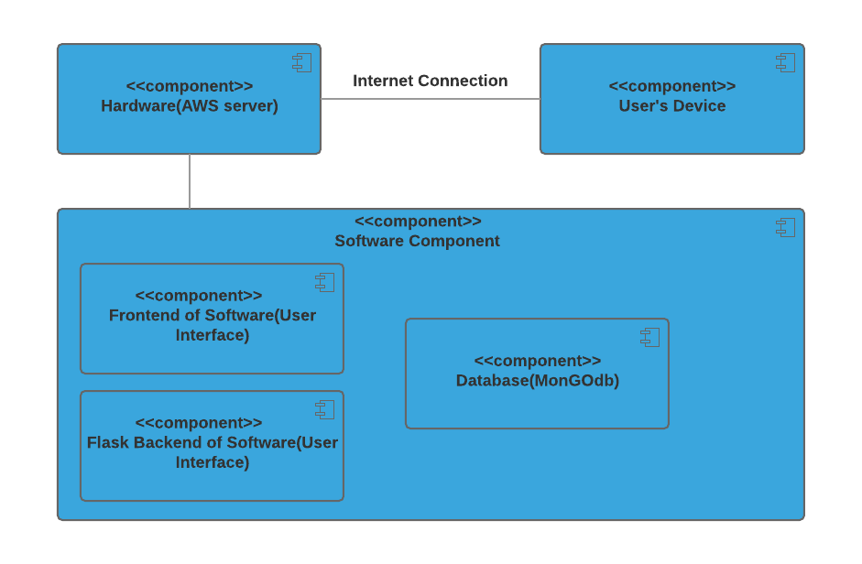

Figure 6: Hardware Component Class Diagram

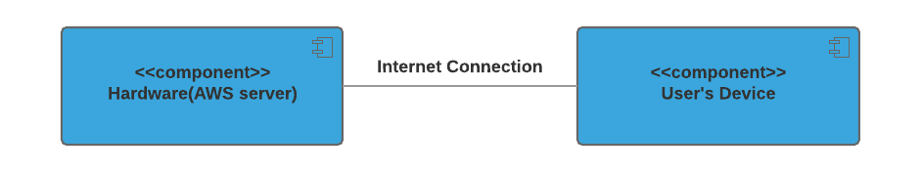

Table 142 a: Hardware Component Description

|  |  |
| --- | --- |
| **Hardware Component** | **Description** |
| AWS | For system hosting in production. |
| User’s device | Work computers, for browser access |

Figure 7: Software Component Class Diagram

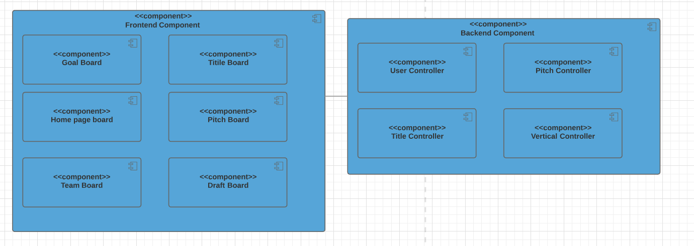

Table 142 b: Software Component Description

|  |  |
| --- | --- |
| **Software Component** | **Description** |
| **Goal Board** | admin can set target vertical and amount of titles desired for current or future months, and also assign content writers to verticals |
| **Home Page** | admin and writer can view overall project progress, individual vertical progress, and targets of the past, current, or future months |
| **Team Board** | admin can view team member’s performance and progress and change member’s account type |
| **Draft Board** | writer can draft an idea then pitch it for approval |
| **Pitch Board** | admin and writer can view pitch details, and then admin can approve pitch to move into the next stage of content creation |
| **Title Board** | admin can view title details, and approve titles to move into the next stage of content creation. Writer can create title for a content piece |
| **User Controller** | Implement the logic for user behaviors and store the user data model. |
| **Pitch Controller** | Implement the logic for pitch behaviors and store the user data model. |
| **Title Controller** | Implement the logic for title behaviors and store the user data model. |
| **Vertical Controller** | Implement the logic for vertical behaviors and store the user data model. |

Figure 8: Deployment Diagram

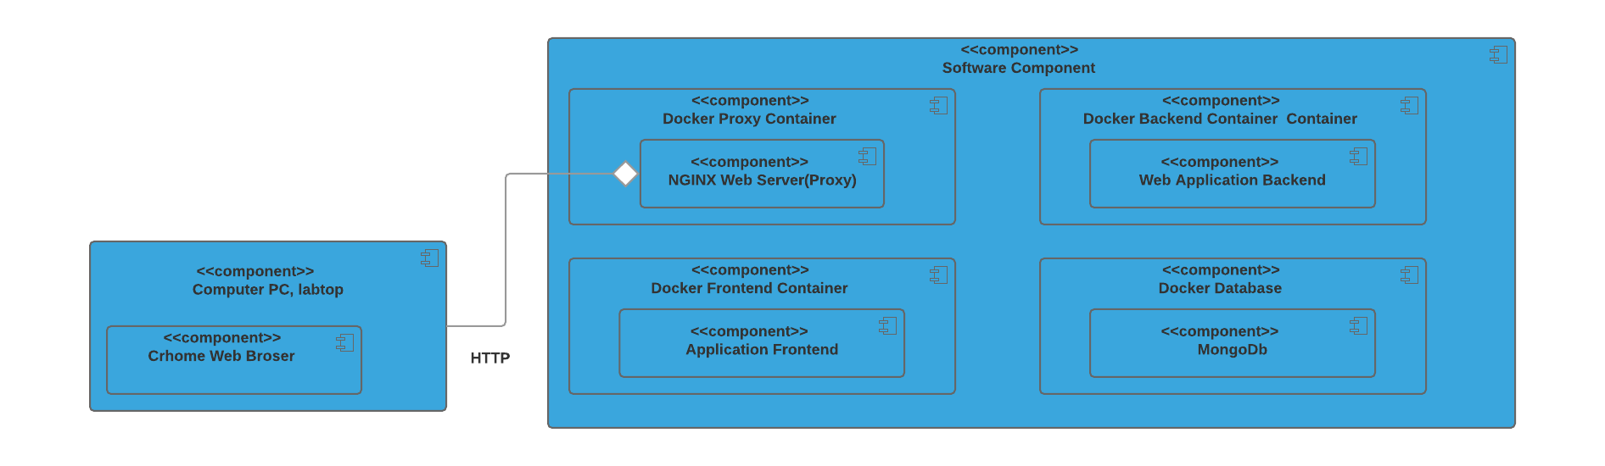

### 

### 

### 

### 

### 

### 

### 

### 

### 

### 

### 3.1.2. Design Classes

Figure 9: Design Class Diagram

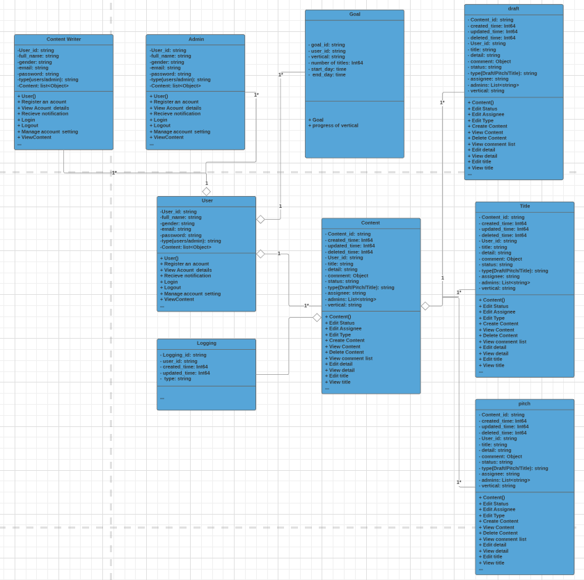

Table 144: Design Class Description

|  |  |  |
| --- | --- | --- |
| **Class** | **Type** | **Description** |
| User | Entity | Describe user information and model, include user attributes and methods |
| Content | Entity | Describe a draft, pitch, and title data models, include content attributes and methods |
| Goal | Entity | Describe monthly goal of the team, include goal attributes and methods |
| Logging | Entity | Describe logging of the users’ operations and system status, include logging attributes and methods |
| Pitch | Entity | This class extends content class. |
| draft | Entity | This class extends content class. |
| title | Entity | This class extends content class. |
| Admin | Entity | This class extends user class |
| Content writer | Entity | This class extends user class |

### 3.1.3. Process Realization

Figure 10: Robustness Diagram - draft a new pitch

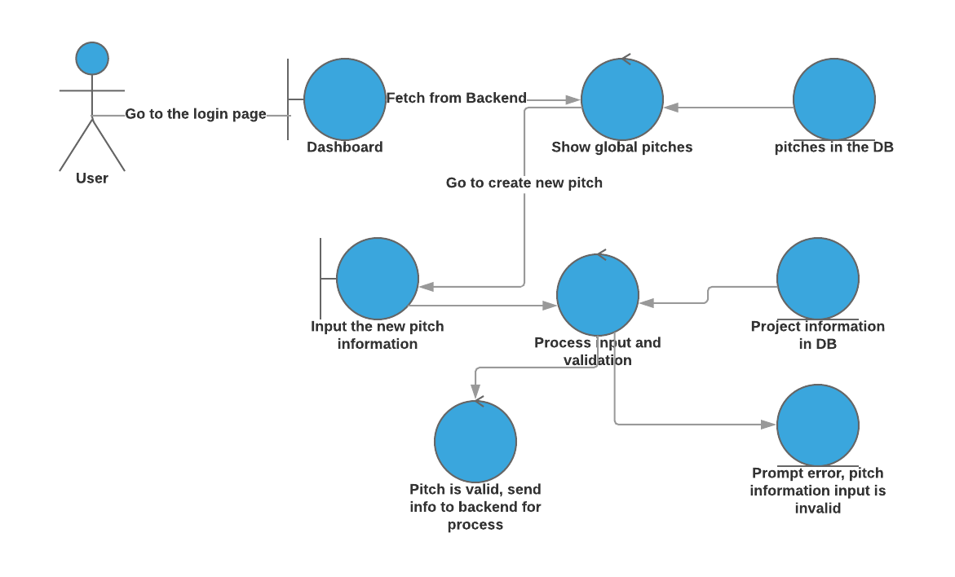

Figure 11: Process Realization Diagram - draft a new pitch

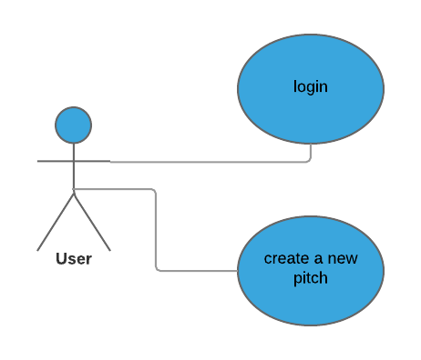

Figure 12: Sequence Diagram - draft a new pitch

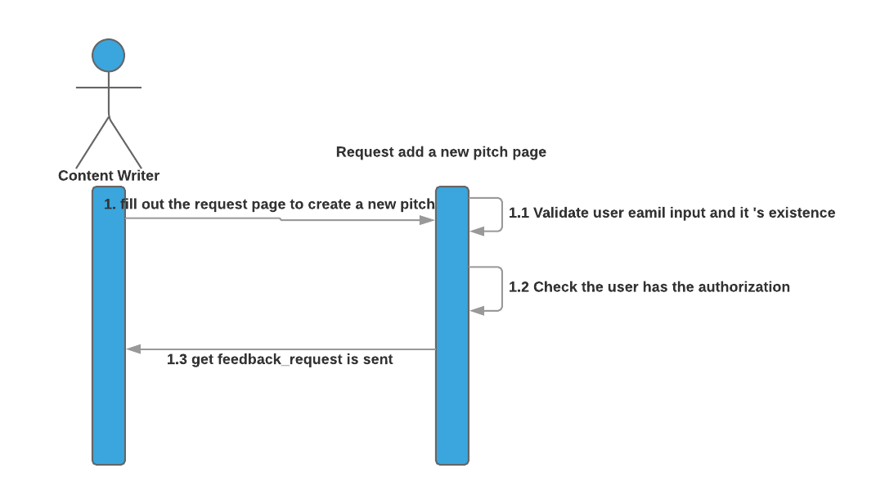

Figure 13: Robustness Diagram - change the status of the a new pitch 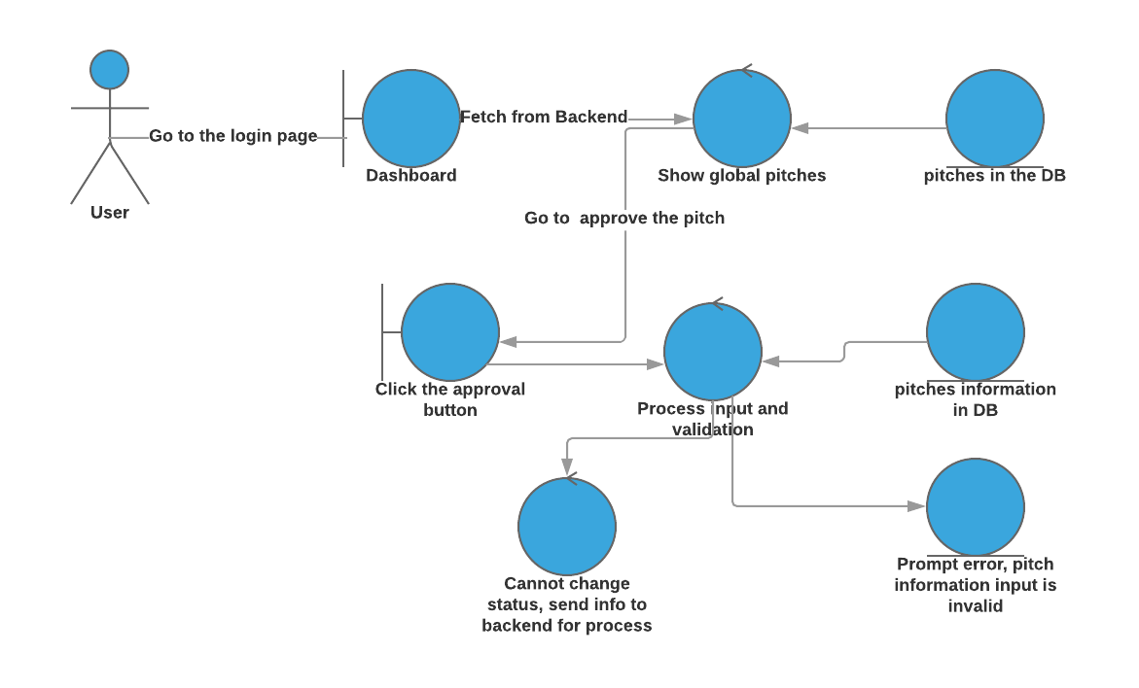

Figure 14: Process Realization Diagram - change the status of the a new pitch

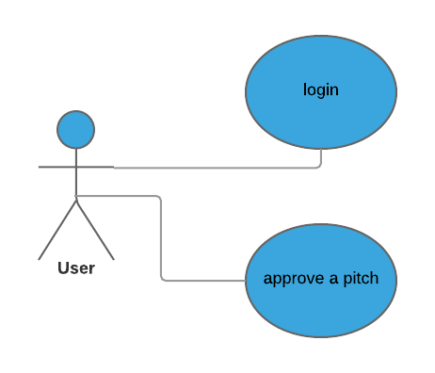

Figure 15: Process Realization Diagram - change the status of the a new pitch

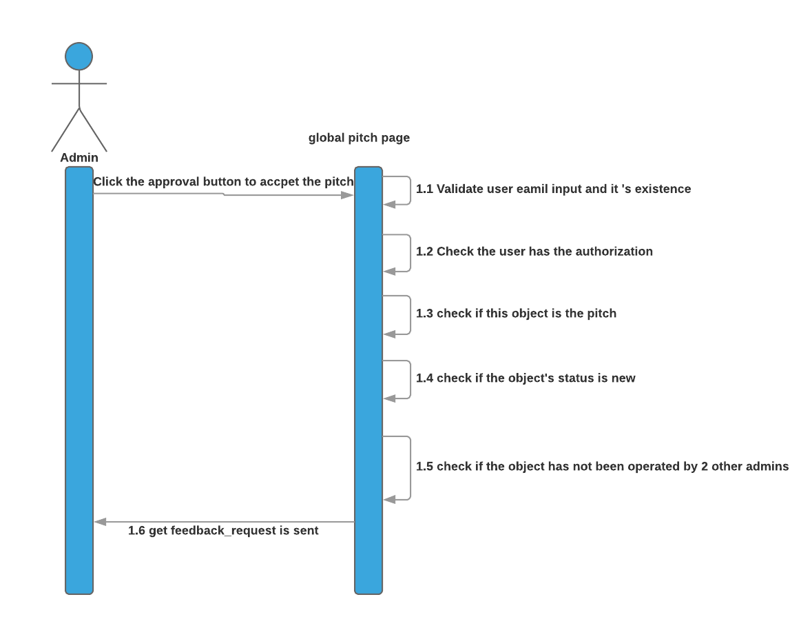

## 3.2 Design Rationale

The design is solely following the principle to mimic and streamline System1’s current workflow on idea formulation using most recent and mainstream technologies, including the utilization of modern database hosting, cloud service, web app hosting, mainstream frameworks etc. Meanwhile, the design aims to be maintainer friendly, meaning that it’s modular and has clear boundary between subparts.

# 4. Technology-Specific System Design

## 4.1 Design Overview

### 

### 

### 4.1.1 System Structure

Figure 16: Conceptual Domain Model



Figure 17: Hardware Component Class Diagram



Table 145: Hardware Component Description

|  |  |
| --- | --- |
| **Hardware Component** | **Description** |
| AWS | For system hosting in production. |
| User’s device | Work computers, for browser access |

Figure 18: Software Component Class Diagram

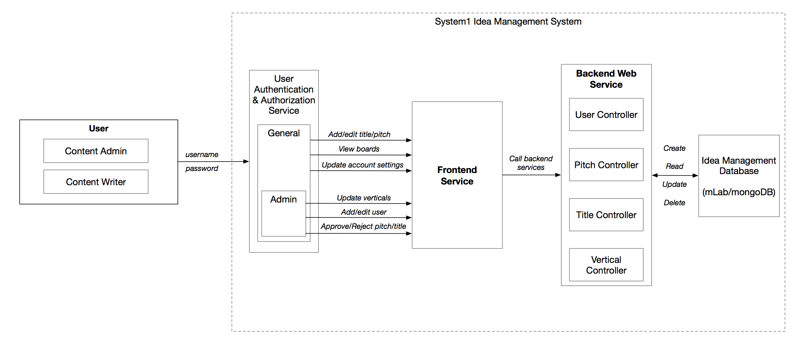

Table 146: Software Component Description

|  |  |
| --- | --- |
| **Software Component** | **Description** |
| **Goal Board** | admin can set target vertical and amount of titles desired for current or future months, and also assign content writers to verticals |
| **Home Page** | admin and writer can view overall project progress, individual vertical progress, and targets of the past, current, or future months |
| **Team Board** | admin can view team member’s performance and progress and change member’s account type |
| **Draft Board** | writer can draft an idea then pitch it for approval |
| **Pitch Board** | admin and writer can view pitch details, and then admin can approve pitch to move into the next stage of content creation |
| **Title Board** | admin can view title details, and approve titles to move into the next stage of content creation. Writer can create title for a content piece |
| **User Controller** | Implement the logic for user behaviors and store the user data model. |
| **Pitch Controller** | Implement the logic for pitch behaviors and store the user data model. |
| **Title Controller** | Implement the logic for title behaviors and store the user data model. |
| **Vertical Controller** | Implement the logic for vertical behaviors and store the user data model. |

Figure 19: Deployment Diagram 

### 

### 

### 

### 

### 

### 

### 4.1.2 Design Classes

Figure 20: Design Class Diagram



Table 147: Design Class Description

|  |  |  |
| --- | --- | --- |
| **Class** | **Type** | **Description** |
| User | Entity | Describe user information and model, include user attributes and methods |
| Content | Entity | Describe a draft, pitch, and title data models, include content attributes and methods |
| Goal | Entity | Describe monthly goal of the team, include goal attributes and methods |
| Logging | Entity | Describe logging of the users’ operations and system status, include logging attributes and methods |

### 

### 

### 

### 

### 4.1.3 Process Realization

Figure 21: Robustness Diagram - draft a new pitch



Figure 22: Process Realization Diagram - draft a new pitch



Figure 23: Sequence Diagram - draft a new pitch



Figure 24: Robustness Diagram - change the status of the a new pitch



Figure 25: Process Realization Diagram - change the status of the a new pitch



Figure 26: Process Realization Diagram - change the status of the a new pitch



## 

## 4.2 Design Rationale

The design is solely following the principle to mimic and streamline System1’s current workflow on idea formulation using most recent and mainstream technologies, including the utilization of modern database hosting, cloud service, web app hosting, mainstream frameworks etc. Meanwhile, the design aims to be maintainer friendly, meaning that it’s modular and has clear boundary between subparts

# 5. Architectural Styles, Patterns and Frameworks

Table 148: Architectural Styles, Patterns, and Frameworks

|  |  |  |
| --- | --- | --- |
| **Name** | **Description** | **Benefits, Costs, and Limitations** |
| Three-Tier | Having 3 major parts:   * User Interface Tier(ReactJS): * Logic Tier (Server, or Backend with Flask * Data Tier (MongoDB) | * Changes in any part is independent from the other parts, no impact on other Tiers. * This architecture has no cost, for using explicitly this architecture, we do not pay for other 3rd party system (JavaScript,Flask library and frameworks are open-source, likewise for the MongoDB) |
| Client Server | Having this style in 2 parts:   * Sending Request from computer browser to the application server * Docker Tool communicating with Containers | * Modifiability, maintenance, evolvability, are the most important benefits to our project. (Client Pooyan even can later use our backend for mobile or another platform development) |
| ReactJS | React JS Software Pattern: A JS Library for building fast, simple, and scalable to create Web App | * With this structure, react code is more predictable, easier to debug. * Easier to learn compared with other framework like Angularjs * ReactJS is one of the most popular framework so that there are lots of templates could be used, which decrease the development and maintenance cost. |
| Flask | Backend service framework | * Better choice compared with Spring(Java) and thrift or grpc(Golang) since the client requires to use python. * Since our application is not complex, so compared to Django, a lightweight framework like flask is easy to implement, which decreases the development and maintenance cost. |