Dodona Learning Path: Pedagogical & Technical Overview

# Table of Contents

1. Overview of Learning Goals and Student Needs

2. Bloom's Taxonomy Alignment

3. Learning Design Strategies

4. Example Question Elements

5. Annotated Screenshots

# 1. Overview of Learning Goals and Student Needs

## Criminology Student Profile

Criminology students typically come from a social science orientation with limited mathematical background. They approach statistics not as abstract mathematical concepts but as practical tools for understanding crime data and social phenomena. These students are often more interested in the application and interpretation of statistical methods within their field rather than theoretical mathematical foundations. Additionally, many criminology students experience statistics anxiety, which can create barriers to learning and decrease confidence in their analytical abilities. This anxiety often stems from previous negative experiences with mathematics or perceived lack of quantitative skills.

## Purpose of the Learning Path

The primary purpose of this learning path is to support the development of statistical reasoning skills using crime-relevant examples and contexts. By embedding statistical concepts within criminological scenarios, the learning path aims to:

* Make abstract statistical concepts more concrete and relevant
* Demonstrate the practical utility of statistics in criminological research and practice
* Build confidence in statistical reasoning through familiar contexts
* Develop critical analytical skills needed for evidence-based criminology

# 2. Bloom's Taxonomy Alignment

## Cognitive Levels

Bloom's Taxonomy provides a hierarchical model of cognitive skills that progresses from lower-order to higher-order thinking skills:

1. Remember: Recall facts and basic concepts

2. Understand: Explain ideas or concepts

3. Apply: Use information in new situations

4. Analyze: Draw connections among ideas

5. Evaluate: Justify a stand or decision

6. Create: Produce new or original work

## Application to Learning Process

The integration of Bloom's Taxonomy into our questions strategically supports criminology students' learning process by:

* **Cognitive Progression**: Building from recall to complex applications, boosting confidence and competence
* **Transfer of Knowledge**: Requiring practical application of concepts in criminological contexts
* **Metacognitive Development**: Encouraging reflection on thinking processes at higher levels
* **Comprehensive Understanding**: Ensuring engagement across all cognitive levels for a holistic grasp

## Question-Bloom Level Mapping

|  |  |  |  |
| --- | --- | --- | --- |
| Question Title | Bloom Level | Cognitive Skill | Learning Intention |
| Gemiddelde vs. Mediaan | Understand | Concept comparison | Identify sensitivity to outliers in crime rate data |
| Doel van Beschrijvende Statistiek | Remember | Recall | Differentiate descriptive from inferential statistics |
| Berekenen van Modus | Apply | Calculation | Calculate mode from crime type frequencies |
| Chi-kwadraat Interpretatie | Analyze | Interpretation | Interpret chi-square results in demographic contexts |
| Uitschieters Identificeren | Apply | Data analysis | Identify outliers in crime rate datasets |
| Standaarddeviatie Vergelijking | Understand | Concept application | Compare variability in crime metrics |
| Correlatie vs. Causaliteit | Evaluate | Critical thinking | Evaluate claims of variable relationships |
| Regressieanalyse Interpretatie | Analyze | Interpretation | Interpret regression coefficients in context |
| Steekproef Representativiteit | Evaluate | Assessment | Assess sampling biases |
| Betrouwbaarheidsintervallen | Apply | Calculation | Calculate and interpret confidence intervals |
| p-Waarde Interpretatie | Understand | Concept application | Explain p-values in hypothesis testing |
| Scheve Verdeling Herkennen | Analyze | Pattern recognition | Identify skewed distributions |
| Type I en Type II Fouten | Evaluate | Critical assessment | Evaluate consequences of statistical errors |
| Effectgrootte Berekening | Apply | Calculation | Calculate effect sizes |
| Grafische Weergave Kiezen | Create | Decision making | Choose appropriate data visualizations |

# 3. Learning Design Strategies

## Instructional Design Strategy

The learning path is structured using Bloom's Taxonomy as a cognitive scaffold, progressing from basic understanding to higher-order skills like evaluation and creation.

This layered design includes:

* **Concept Reinforcement**: e.g., mean vs. median
* **Calculation Tasks**: e.g., chi-square, regression
* **Diagnostic Reasoning**: e.g., outlier influence, correlation vs. causality
* **Design/Decision-making**: e.g., choosing visuals, constructing surveys

## Scaffolding Techniques

* **Conceptual Prompts**: Short reminders of key ideas without revealing the answer
* **Strategic Questions**: Sub-questions that guide thinking
* **Relevant Examples**: Analogous situations to model thinking
* **Progressive Disclosure**: Stepwise reveal of complexity

## Anxiety Reduction Through Structured Design

The exercise design incorporates several features specifically aimed at reducing statistics anxiety:

* **Incremental Difficulty**: Questions gradually increase in complexity, allowing students to build confidence with early successes before tackling harder concepts
* **Contextualization**: Crime-related scenarios make abstract statistical concepts more concrete and relevant to students' career interests
* **Immediate Feedback**: Detailed, non-judgmental feedback helps students understand errors and reinforces correct thinking patterns
* **Multiple Attempts**: Most exercises allow multiple attempts, reducing the pressure of getting it right the first time
* **Clear Expectations**: Learning objectives are explicitly stated, removing uncertainty about what students are expected to know
* **Visual Supports**: Graphs, tables, and visual elements help students with different learning styles understand complex ideas
* **Consistent Structure**: Predictable exercise formats reduce cognitive load, allowing students to focus on content rather than navigating unfamiliar interfaces

These design elements collectively create a more supportive learning environment that acknowledges and addresses the statistical anxiety many criminology students experience.

## Feedback and Support Elements

### Example Tips (Dutch)

* "Het gemiddelde is gevoelig voor uitschieters..."
* "Let op: bij een chi-kwadraattoets..."
* "Denk aan de formule voor variantie..."
* "Een correlatie van 0,7 betekent..."

### Targeted Feedback

* **Correct Answers**: Confirm logic, extend concepts, connect to real-world application
* **Incorrect Answers**: Clarify misconceptions, explain concepts, and encourage reflection

### Metacognitive Reflection Examples

* "Fout – dit is inferentiële of voorspellende statistiek..."
* "Je hebt het gemiddelde goed berekend, maar..."
* "Let op: je hebt de nulhypothese verworpen, maar..."

### External Resources

Links to textbook chapters, videos, or slides are added to help students review concepts and fill gaps.

# 4. Example Question Elements

## Sample Question

* **Title**: Invloed van Uitschieters op Centrummaten
* **Context**: Inbraakcijfers in 10 wijken: [5, 7, 6, 8, 5, 9, 6, 7, 40, 7]
* **Question**: Welke uitspraak is correct?
* A) De mediaan geeft een beter beeld...
* B) Het gemiddelde geeft een beter beeld...
* C) Beide zijn even representatief
* D) Geen van beide is geschikt

## Feedback Logic

* **Correct (A)**: De mediaan wordt minder beïnvloed...
* **Incorrect (B)**: Het gemiddelde wordt sterk beïnvloed...
* **Incorrect (C)**: Bij uitschieters zijn ze niet gelijkwaardig...
* **Incorrect (D)**: De mediaan blijft bruikbaar ondanks uitschieters

## Hints and Visual Aids

* **Hint 1**: "Bereken zowel het gemiddelde als de mediaan"
* **Hint 2**: "Visualiseer de data met een boxplot"
* **Visual**: Boxplot with outlier marked at 40

# 5. Annotated Screenshots

This visual overview provides selected exercises from the Dodona learning path for criminology students. Each section includes the screenshot, its content description, and relevant pedagogical context.

## Course Structure

### 1. Series Overview – Part 1

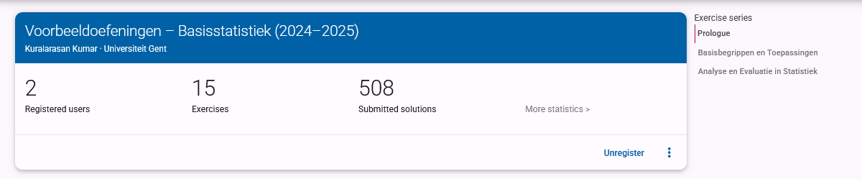

*dodona-series-overview-1*

**Description:** Shows the top portion of the full exercise series within the 'Basisstatistiek' course on Dodona.

**Purpose:** Highlights the structure and entry point of the course, where students see the learning objectives and can track their progress.

__________________________________________________

### 2. Series Overview – Part 2

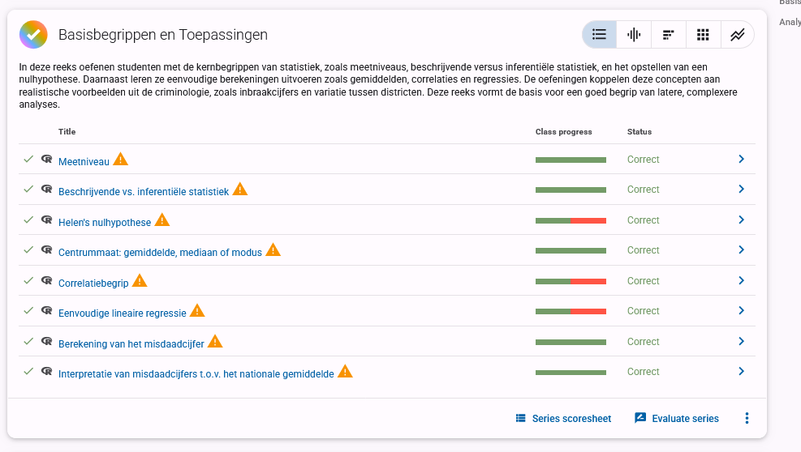

*dodona-series-overview-2*

**Description:** Displays the middle section of the course, including the first part: *Basisbegrippen en Toepassingen*.

**Purpose:** Demonstrates the progressive introduction of fundamental statistical concepts (e.g., measurement levels, crime rate, correlation). Most exercises here are aligned with Bloom's levels: Remember, Understand, and Apply.

__________________________________________________

### 3. Series Overview – Part 3

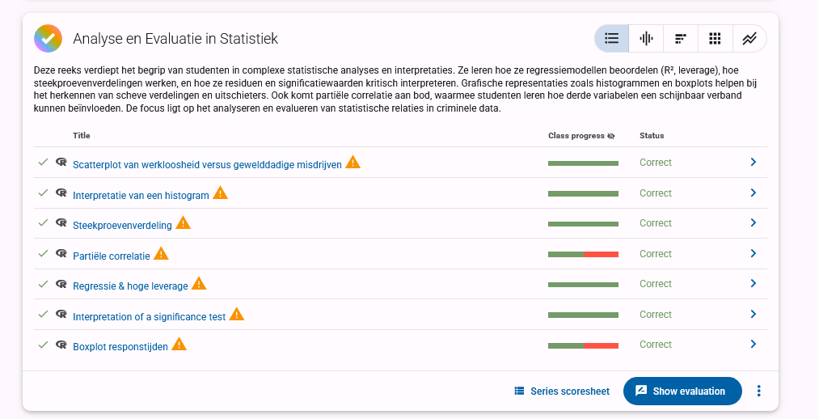

*dodona-series-overview-3*

**Description:** Covers the final section *Analyse en Evaluatie in Statistiek*, including advanced interpretation tasks (e.g., boxplots, leverage, spurious correlation).

**Purpose:** This section supports higher-order thinking with questions that target Bloom's levels: Analyze and Evaluate. It encourages students to interpret patterns, detect outliers, and assess methodological choices using realistic data.

## Performance Monitoring

### 4. Score Summary (Total Overview)

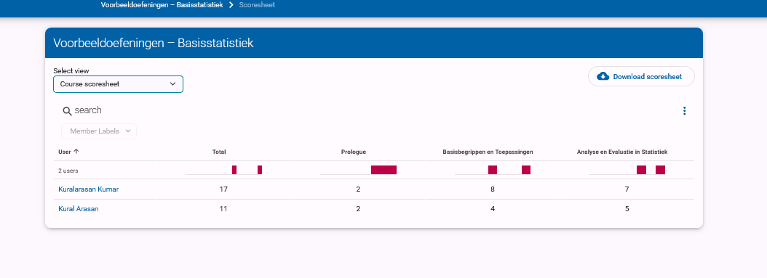

*Score Summary (Total Overview)*

**Description:** This shows the overall completion status for each user across the three sections.

**Purpose:** Allows monitoring of student progress and identifies where further scaffolding or support may be needed.

__________________________________________________

### 5. Score Summary – Basic Concepts

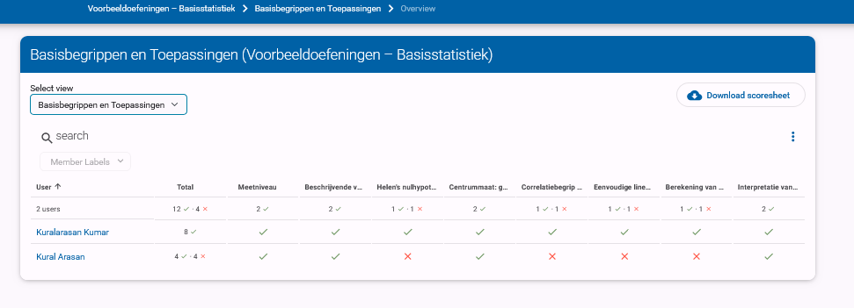

*Score Summary – Basic Concepts*

**Description:** This view provides insight into user performance on foundational concepts like measurement levels and descriptive statistics.

**Purpose:** Helps identify specific strengths and weaknesses in early-stage comprehension.

__________________________________________________

### 6. Score Summary – Analysis and Evaluation

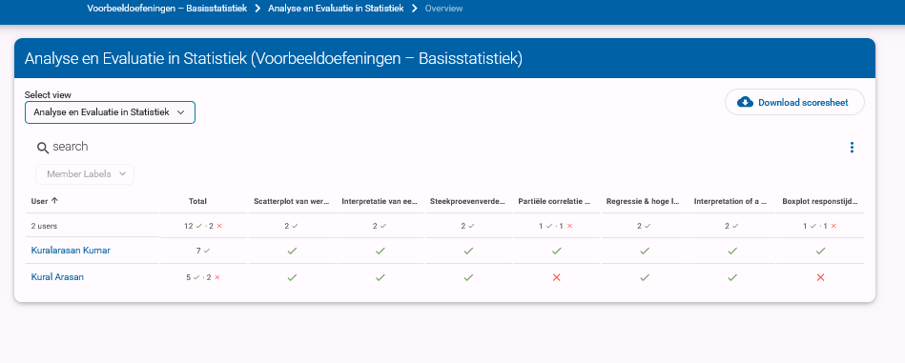

*Score Summary – Analysis and Evaluation*

**Description:** This section reflects progress on more complex tasks such as regression, outliers, and statistical inference.

**Purpose:** Highlights students' abilities to apply and evaluate statistical models using criminological data.

## Example Exercises

### 7. Crime Rate Calculation Exercise

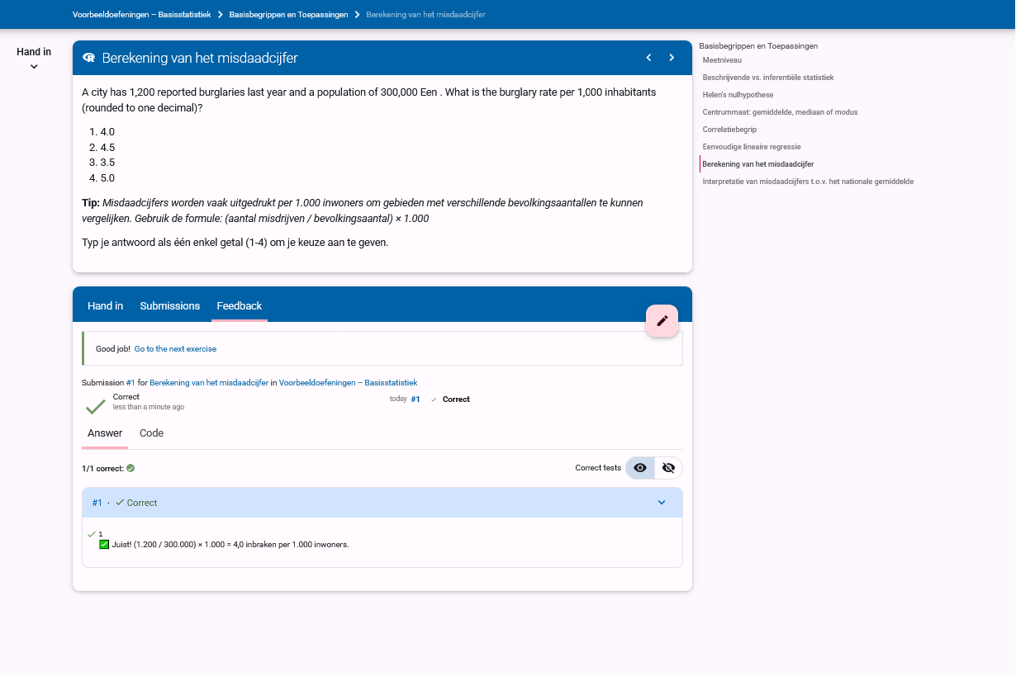

*Crime Rate Calculation Exercise*

**Description:** A simple question asking students to calculate crime rate per 1,000 inhabitants.

**Purpose:** Trains students in basic rate calculation using real-world population and crime data.

__________________________________________________

### 8. Descriptive vs Inferential Statistics

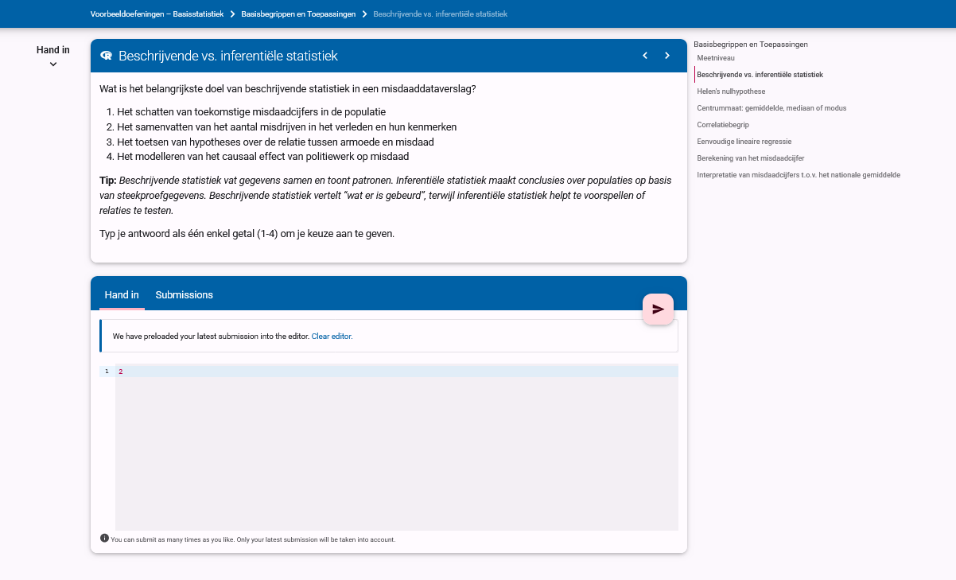

*Descriptive vs Inferential Statistics*

**Description:** This question checks understanding of the distinction between summarizing data and making predictions.

**Purpose:** Reinforces conceptual clarity on the purpose of statistical approaches.

__________________________________________________

### 9. Hypothesis Testing Exercise

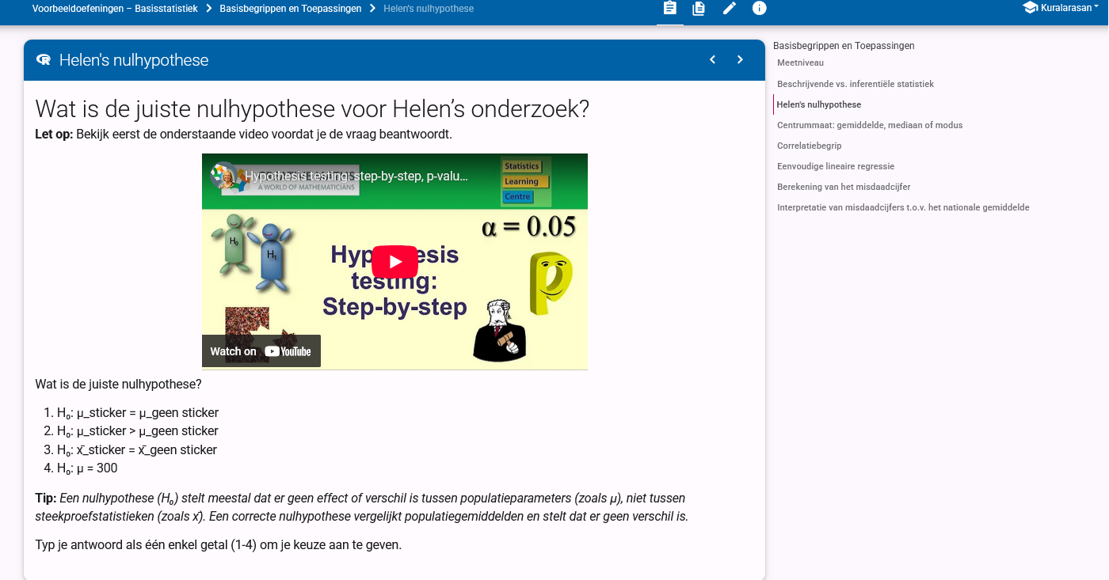

*Hypothesis Testing Exercise*

**Description:** A multimedia-supported question prompting students to define the correct null hypothesis.

**Purpose:** Introduces inferential statistics with visual support, helping explain abstract ideas.

__________________________________________________

### 10. Histogram Interpretation

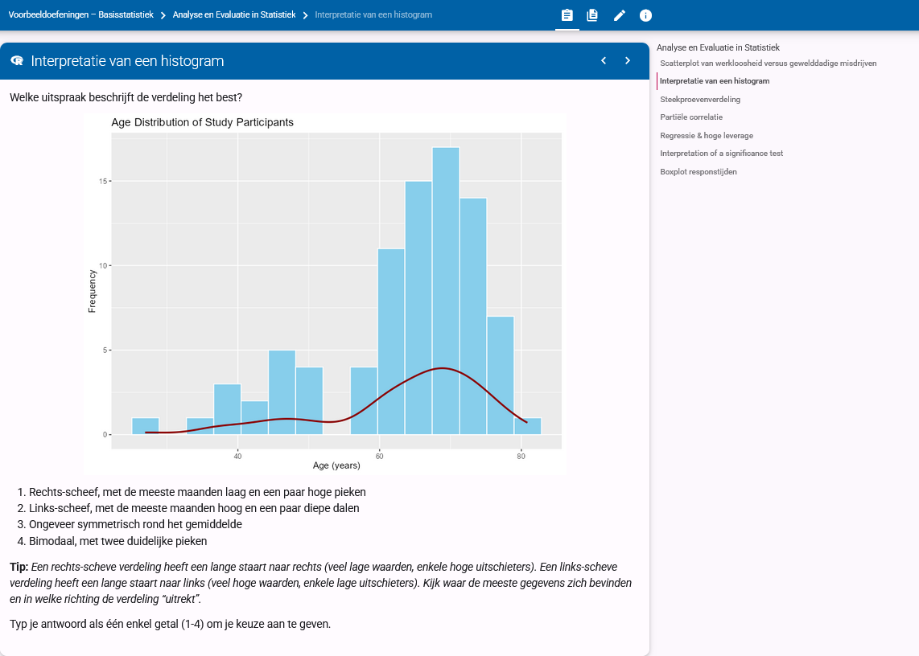

*Histogram Interpretation*

**Description:** Asks students to interpret the shape and distribution from a histogram of participant ages.

**Purpose:** Promotes data literacy and visual interpretation skills.

## Feedback Examples

### 11. Outlier Identification (Correct Answer)

[Image: Outlier Identification (Correct Answer) - Correct Answer]  
File not found

**Description:** Demonstrates how feedback is presented when students correctly identify a statistical outlier.

**Purpose:** Confirms correct reasoning with step-by-step solution and statistical justification (Z-score logic).

__________________________________________________

### 12. Outlier Identification (Incorrect Answer)

[Image: Outlier Identification (Incorrect Answer) - Incorrect Answer]  
File not found

**Description:** Illustrates how detailed feedback is used to correct misunderstandings.

**Purpose:** Leverages feedback as a learning opportunity by explaining why an answer is incorrect.