Appendix 2: Street segment classification (N = 2392)

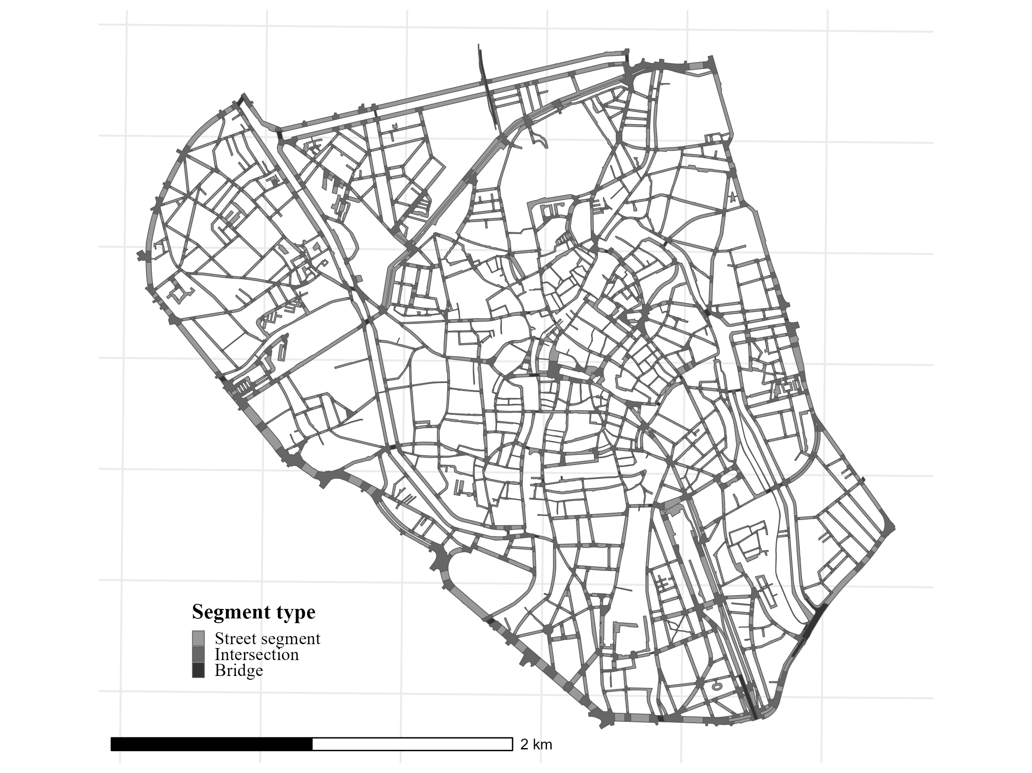

This map shows the street-segment units used in the study area. It separates standard street segments, intersections, and bridges.

