Appendix 3: Overview of Graffiti Observation (Street-segment network N = 2392; observed segments N = 2201)

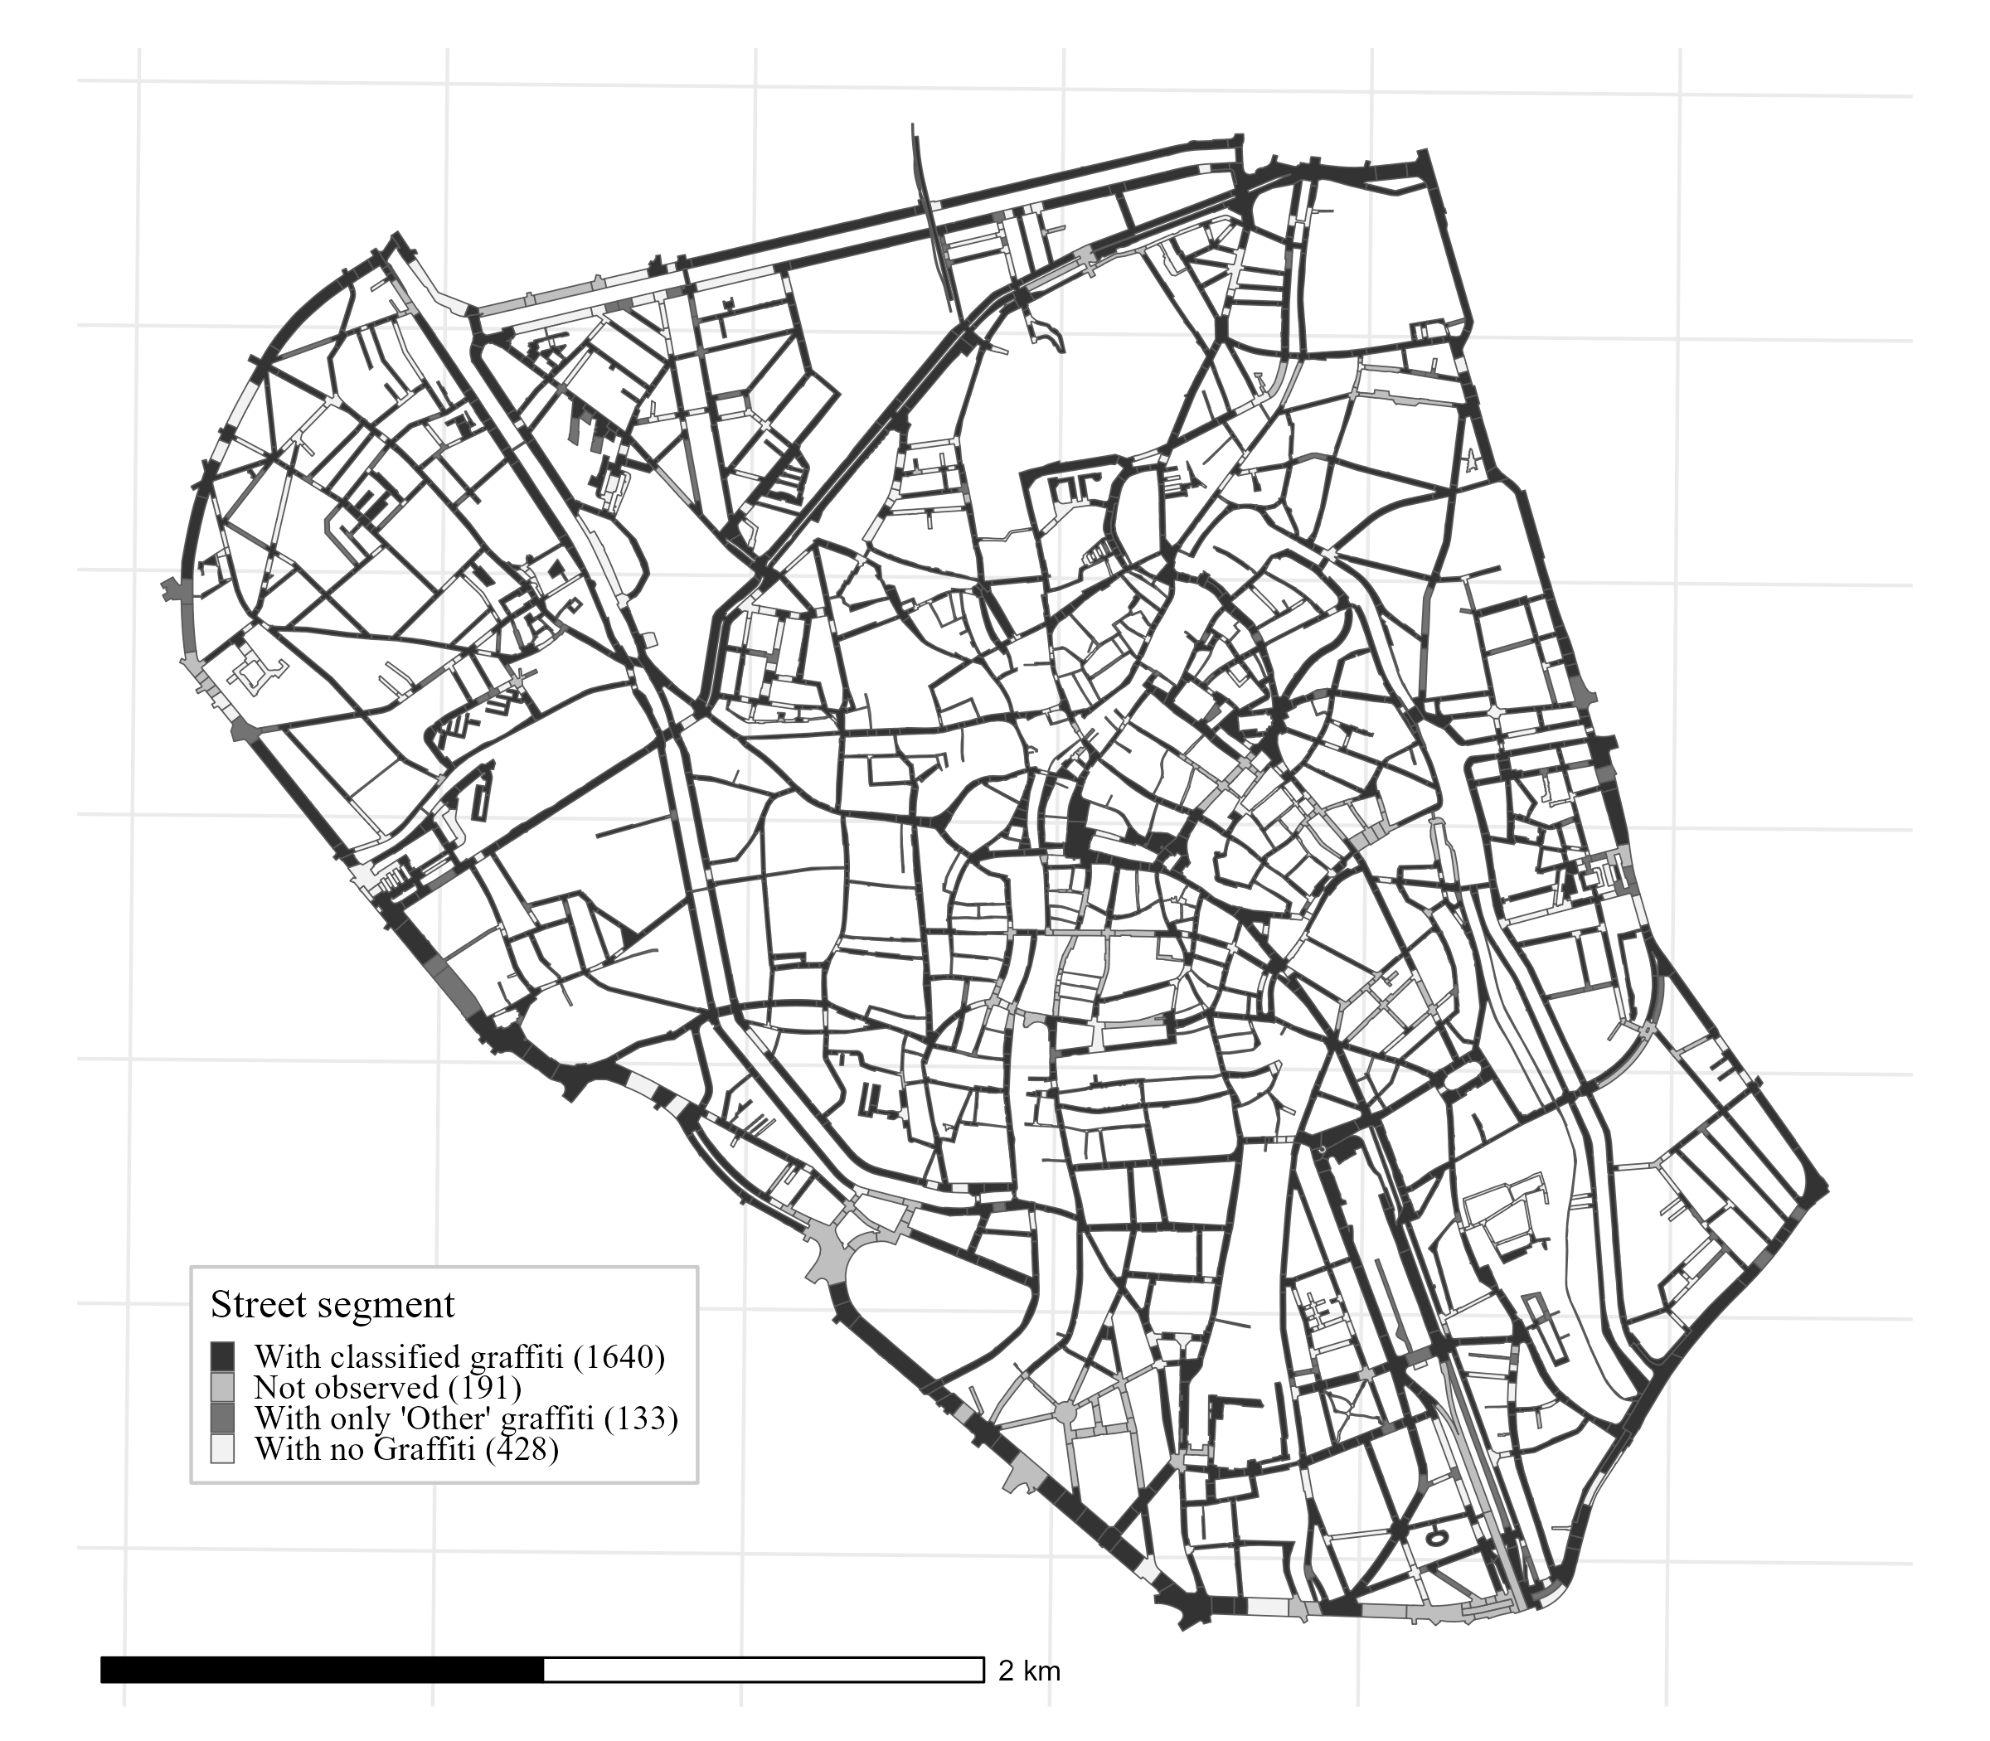

This map shows which street segments were observed, which were not observed, and which were excluded before the main analysis.

