Appendix 3: Street segment classification (N = 2392)

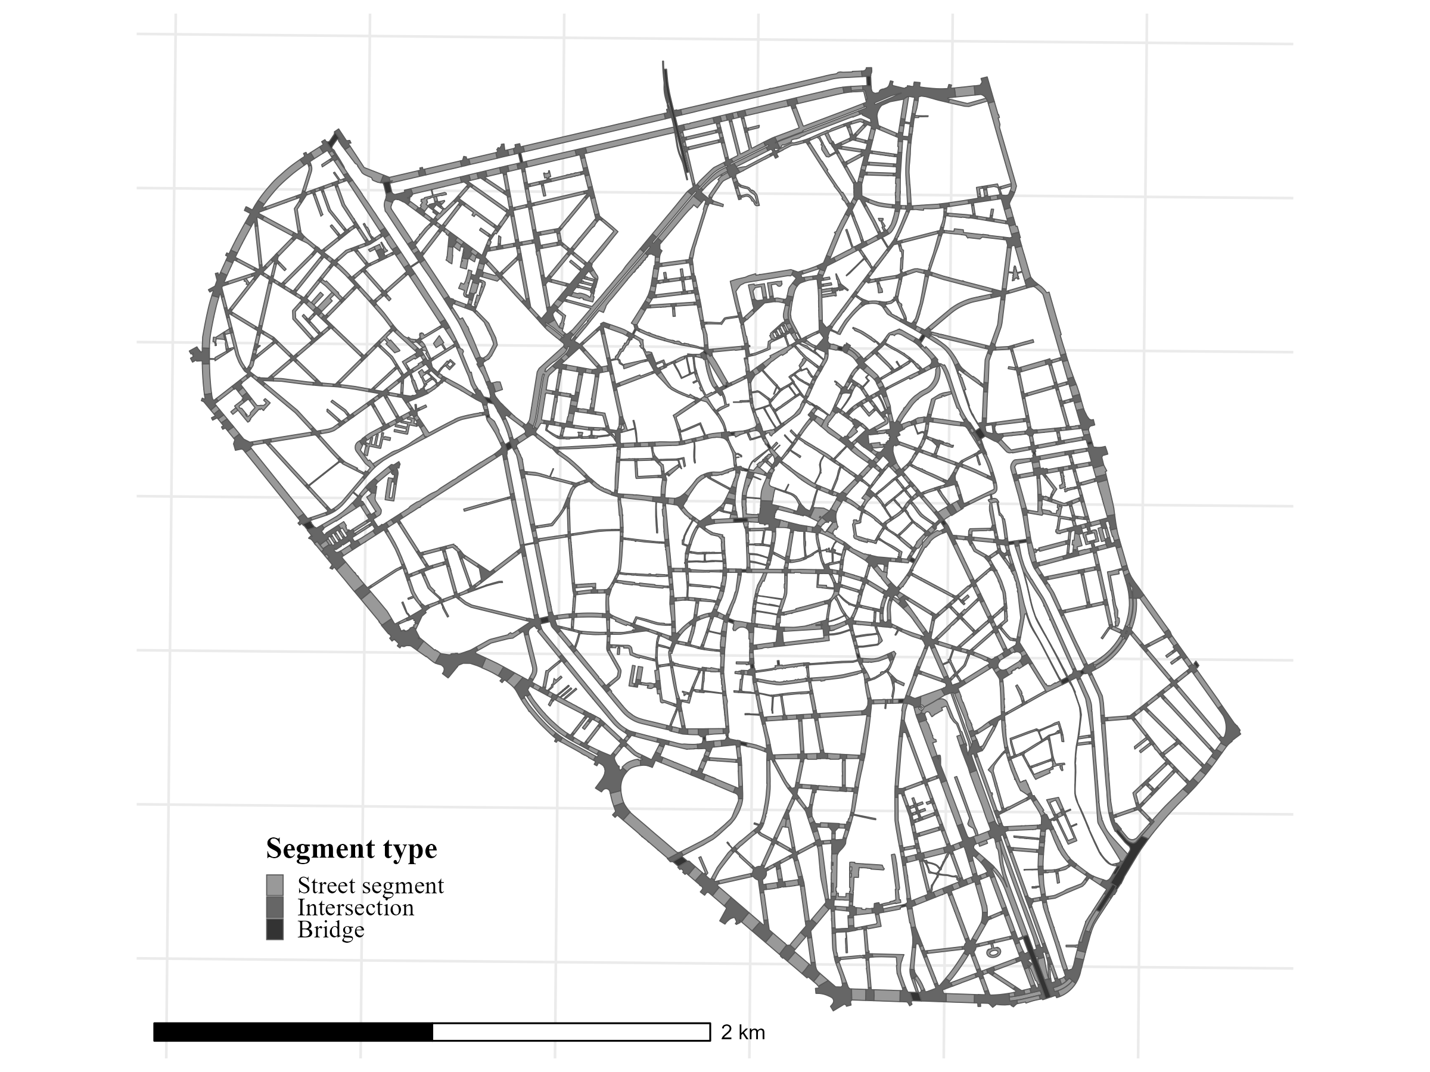

This map shows the street-segment units used in the study area.

