Appendix 4: Graffiti observation status (N segments = 2392)

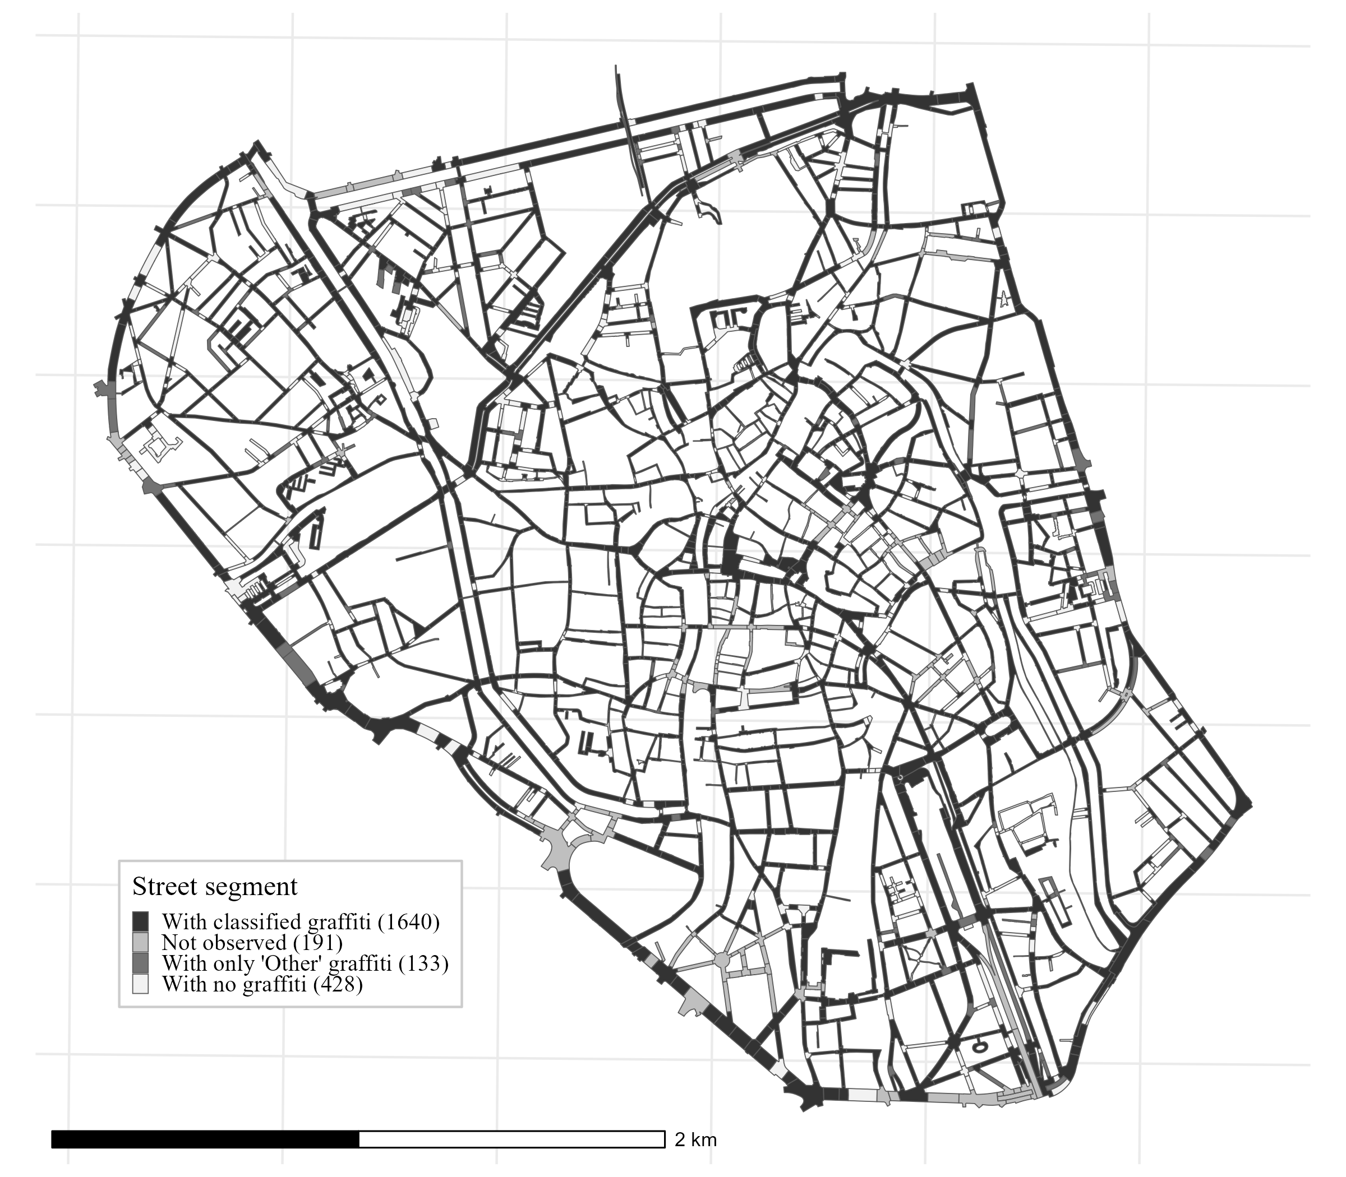

This map shows which street segments were observed, excluded, or not observed.

