

Analysis and Design of Algorithms (ADA)

Lab Assignment – 4

Task :

Understanding Algorithm Efficiency through Analysis, Recurrences, and Sorting

Submitted by : Md. Anas khan
Submitted to : Dr. Aarti
Course : B.Tech – CSE (Data Science)
Roll no. : 2401420035

Algorithm and Design Analysis - Lab Experiment 4

Topic: Backtracking, Branch and Bound, and String Matching

Problem Context

Many real-world problems need systematic search with pruning, such as scheduling, routing, and pattern matching.
This notebook shows how backtracking explores all valid choices, how branch and bound prunes bad choices early, and how string matching algorithms compare on time and comparisons.

Backtracking Algorithm

We assign flights to crew members so that:
a crew member does not get overlapping flights a small rest gap is maintained between flights
In [1]:
flights=[('F1',9,11),('F2',10,12),('F3',12,14),('F4',13,15),('F5',15,17)]
crew_members=['C1','C2','C3'] rest_gap=1

def can_assign(schedule,crew,flight):
_,s,e=flight
for f,c in schedule: if c==crew:
_,fs,fe=f
if not (e+rest_gap<=fs or s>=fe+rest_gap): return False
return True

calls=0
def backtrack_schedule(i=0,schedule=[]): global calls
calls+=1
if i==len(flights): return schedule
for crew in crew_members:
if can_assign(schedule,crew,flights[i]): ans=backtrack_schedule(i+1,schedule+[(flights[i],crew)]) if ans is not None:
return ans
return None
Out [1]:
Backtracking Solution: F1 C1
F2 C2
F3 C1 F4 C2 F5 C1
Recursive calls: 6

calls=0 solution=backtrack_schedule() print("Backtracking Solution:") for f,c in solution:
print(f[0],c) print("Recursive calls:",calls)
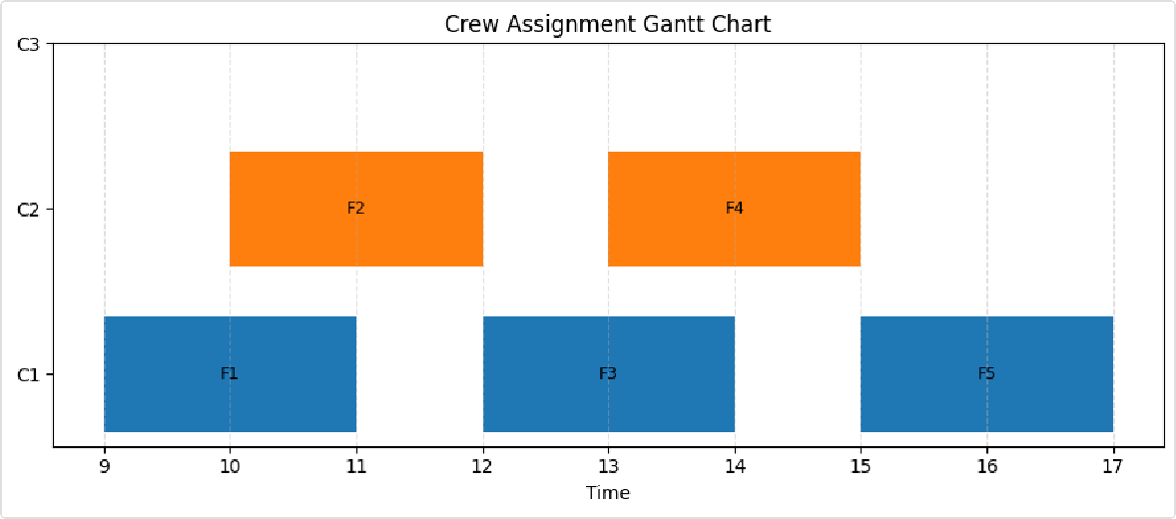
Out [2]:
In [2]:
import matplotlib.pyplot as plt

crew_colors={'C1':'tab:blue','C2':'tab:orange','C3':'tab:green'} fig,ax=plt.subplots(figsize=(9,4))
ypos={c:i for i,c in enumerate(crew_members)} for f,c in solution:
s,e=f[1],f[2]
ax.broken_barh([(s,e-s)],(ypos[c]-0.35,0.7),facecolors=crew_colors[c]) ax.text((s+e)/2,ypos[c],f[0],ha='center',va='center',fontsize=9)
ax.set_yticks(range(len(crew_members))) ax.set_yticklabels(crew_members) ax.set_xlabel("Time")
ax.set_title("Crew Assignment Gantt Chart") ax.grid(True,axis='x',linestyle='--',alpha=0.4) plt.tight_layout()
plt.show()

Backtracking Experiment
We increase the number of flights and track recursive calls. This shows how quickly the search space grows.
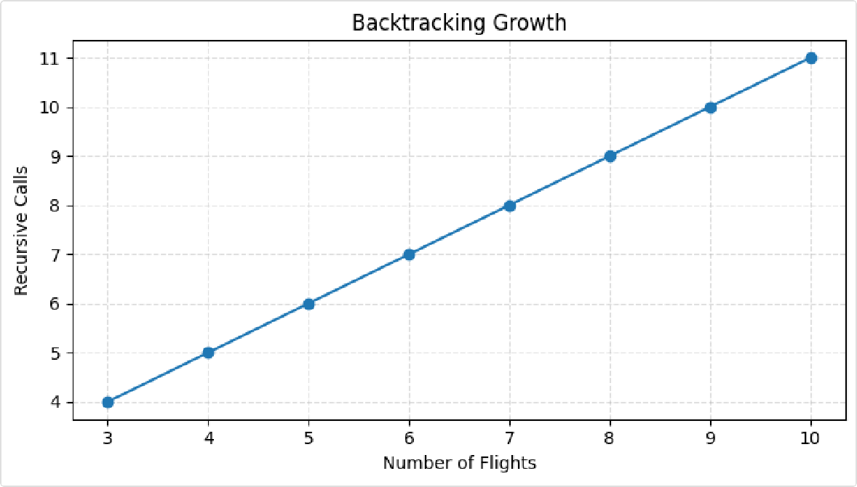
In [3]:
def gen_flights(n): out=[]
start=8
for i in range(n): out.append((f'F{i+1}',start,start+2)) start+=1
return out

def solve_bt(fls,crews): rest=1
cnt=0
def ok(sched,crew,flight):
_,s,e=flight
for f,c in sched: if c==crew:
_,fs,fe=f
if not (e+rest<=fs or s>=fe+rest): return False
return True
def bt(i=0,sched=[]): nonlocal cnt cnt+=1
if i==len(fls): return sched
for crew in crews:
if ok(sched,crew,fls[i]): ans=bt(i+1,sched+[(fls[i],crew)]) if ans is not None:
return ans
return None
bt()
return cnt

sizes=list(range(3,11)) calls_list=[solve_bt(gen_flights(n),crew_members) for n in sizes]

fig,ax=plt.subplots(figsize=(7,4)) ax.plot(sizes,calls_list,marker='o') ax.set_xlabel("Number of Flights") ax.set_ylabel("Recursive Calls") ax.set_title("Backtracking Growth") ax.grid(True,linestyle='--',alpha=0.4) plt.tight_layout()
plt.show()

Out [3]:

Branch and Bound Algorithm

Here we use a 0/1 knapsack-style branch and bound example.
Each node represents choosing or skipping an item, and the upper bound helps prune weak branches.

In [4]:
items=[('A',2,10),('B',3,14),('C',4,16),('D',5,30),('E',7,40),('F',1,7)]
capacity=10
items=sorted(items,key=lambda x:x[2]/x[1],reverse=True)

best_value=0 best_set=[] nodes=0

def bound(level,w,v): if w>=capacity:
return 0
b=v tw=w i=level
while i<len(items) and tw+items[i][1]<=capacity: tw+=items[i][1]
b+=items[i][2] i+=1
if i<len(items):
b+=(capacity-tw)*items[i][2]/items[i][1] return b

def bb(level=0,w=0,v=0,chosen=[]): global best_value,best_set,nodes nodes+=1
if w<=capacity and v>best_value: best_value=v best_set=chosen[:]
if level==len(items): return
if bound(level,w,v)<=best_value:
return name,wt,val=items[level] if w+wt<=capacity:
bb(level+1,w+wt,v+val,chosen+[name]) bb(level+1,w,v,chosen)

nodes=0 best_value=0 best_set=[] bb()
print("Best value:",best_value) print("Chosen items:",best_set) print("Visited nodes:",nodes)

Out [4]:
Best value: 57
Chosen items: ['F', 'E', 'A'] Visited nodes: 22

In [5]:
def brute_force_knapsack(itms,cap): best=0
nodes=0
from itertools import combinations for r in range(len(itms)+1):
for comb in combinations(itms,r):
nodes+=1
w=sum(x[1] for x in comb) v=sum(x[2] for x in comb) if w<=cap and v>best:
best=v
return best,nodes

def solve_bb_for_cap(itms,cap): best_value=0
best_set=[] nodes=0
def bound2(level,w,v): if w>=cap:
return 0
b=v tw=w i=level
while i<len(itms) and tw+itms[i][1]<=cap: tw+=itms[i][1]
b+=itms[i][2] i+=1
if i<len(itms):
b+=(cap-tw)*itms[i][2]/itms[i][1] return b
def bb2(level=0,w=0,v=0,chosen=[]): nonlocal best_value,best_set,nodes nodes+=1
if w<=cap and v>best_value: best_value=v best_set=chosen[:]
if level==len(itms):
return
if bound2(level,w,v)<=best_value: return
name,wt,val=itms[level] if w+wt<=cap:
bb2(level+1,w+wt,v+val,chosen+[name]) bb2(level+1,w,v,chosen)
bb2()
return best_value,best_set,nodes

cap_list=list(range(5,16)) bb_nodes=[]
bf_nodes=[]
for cap in cap_list:
_,_,n1=solve_bb_for_cap(items,cap)
_,n2=brute_force_knapsack(items,cap) bb_nodes.append(n1) bf_nodes.append(n2)

fig,ax=plt.subplots(figsize=(7,4)) ax.plot(cap_list,bf_nodes,marker='o',label='Brute Force') ax.plot(cap_list,bb_nodes,marker='o',label='Branch and Bound') ax.set_xlabel("Capacity")
ax.set_ylabel("Nodes / States") ax.set_title("Search Space Reduction") ax.grid(True,linestyle='--',alpha=0.4) ax.legend()
plt.tight_layout()
plt.show()

Out [5]:

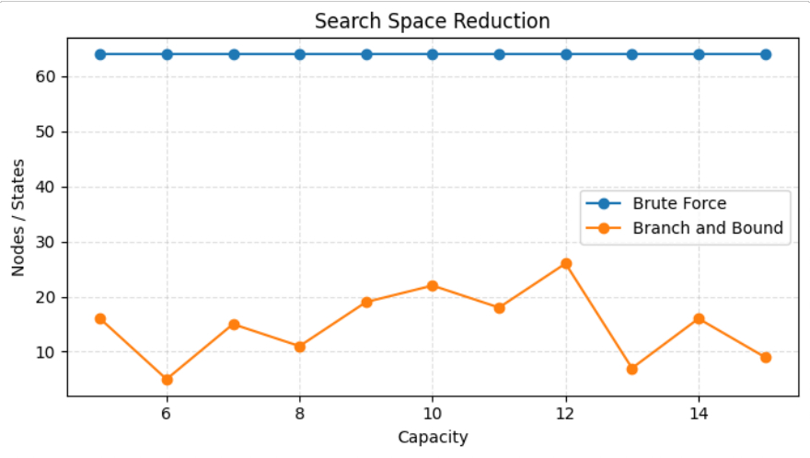

String Matching Algorithms

We compare:
Naive Search KMP
Rabin-Karp
We count character comparisons and measure execution time.
In [6]:
def naive_search(text,pat): n,m=len(text),len(pat) pos=[]
comp=0
for i in range(n-m+1): j=0
while j<m:
comp+=1
if text[i+j]!=pat[j]: break
j+=1
if j==m:
pos.append(i) return pos,comp

def kmp_lps(pat): lps=[0]*len(pat) j=0
i=1
while i<len(pat):
if pat[i]==pat[j]: j+=1
lps[i]=j i+=1
elif j!=0:
j=lps[j-1] else:
i+=1
return lps

def kmp_search(text,pat): n,m=len(text),len(pat)

lps=kmp_lps(pat) pos=[]
comp=0 i=j=0 while i<n:
comp+=1
if text[i]==pat[j]: i+=1
j+=1
if j==m:
pos.append(i-j) j=lps[j-1]
elif j!=0:
j=lps[j-1] else:
i+=1
return pos,comp

def rabin_karp_search(text,pat): n,m=len(text),len(pat) d,q=256,101
h=pow(d,m-1,q)
p=t=0 pos=[] comp=0
for i in range(m): p=(d*p+ord(pat[i]))%q t=(d*t+ord(text[i]))%q
for s in range(n-m+1): if p==t:
j=0
while j<m and text[s+j]==pat[j]: comp+=1
j+=1
if j==m:
pos.append(s) elif j<m:
comp+=1 if s<n-m:
t=(d*(t-ord(text[s])*h)+ord(text[s+m]))%q
t%=q return pos,comp

text="ABABDABACDABABCABAB" pat="ABAB"
print("Naive:",naive_search(text,pat)) print("KMP:",kmp_search(text,pat))
print("Rabin-Karp:",rabin_karp_search(text,pat))

Out [6]:
Naive: ([0, 10, 15], 33)
KMP: ([0, 10, 15], 23)
Rabin-Karp: ([0, 10, 15], 12)

String Matching Comparison
In [7]:
import string,random,time random.seed(7)
def make_text(n): base="A"
txt=[random.choice("ABCD") for _ in range(n)] pat="ABCDAB"
txt[n//2:n//2+len(pat)]=list(pat) return "".join(txt),pat

sizes=[200,500,1000,2000,4000]
naive_time=[] kmp_time=[]
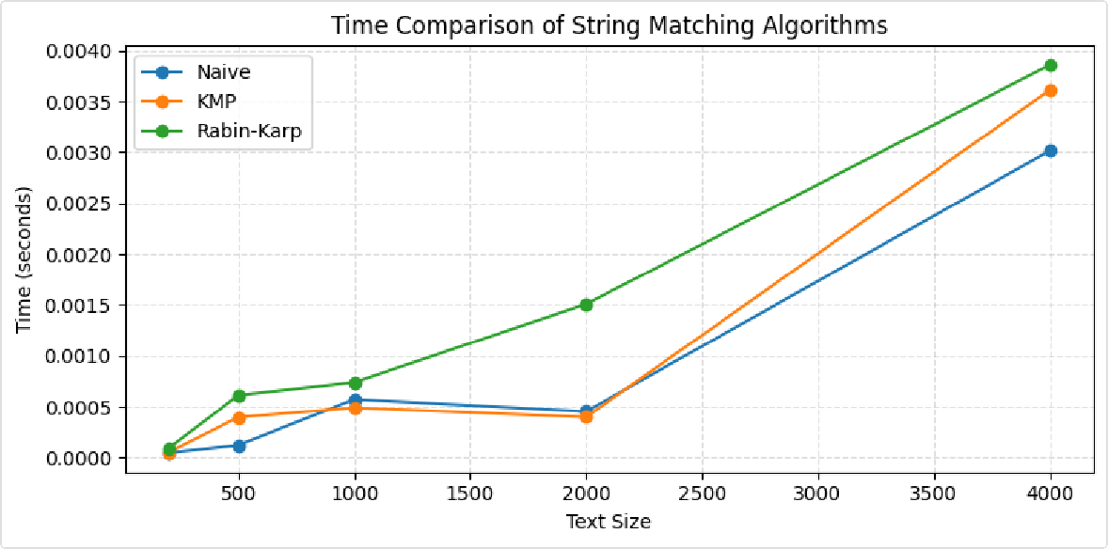
rk_time=[] naive_comp=[] kmp_comp=[] rk_comp=[]

for n in sizes: txt,pat=make_text(n) st=time.perf_counter()
_,c1=naive_search(txt,pat) naive_time.append(time.perf_counter()-st) naive_comp.append(c1)

st=time.perf_counter()
_,c2=kmp_search(txt,pat) kmp_time.append(time.perf_counter()-st) kmp_comp.append(c2)

st=time.perf_counter()
_,c3=rabin_karp_search(txt,pat) rk_time.append(time.perf_counter()-st) rk_comp.append(c3)

fig,ax=plt.subplots(figsize=(8,4)) ax.plot(sizes,naive_time,marker='o',label='Naive') ax.plot(sizes,kmp_time,marker='o',label='KMP') ax.plot(sizes,rk_time,marker='o',label='Rabin-Karp') ax.set_xlabel("Text Size")
ax.set_ylabel("Time (seconds)")
ax.set_title("Time Comparison of String Matching Algorithms") ax.grid(True,linestyle='--',alpha=0.4)
ax.legend()
plt.tight_layout() plt.show()

Out [7]:

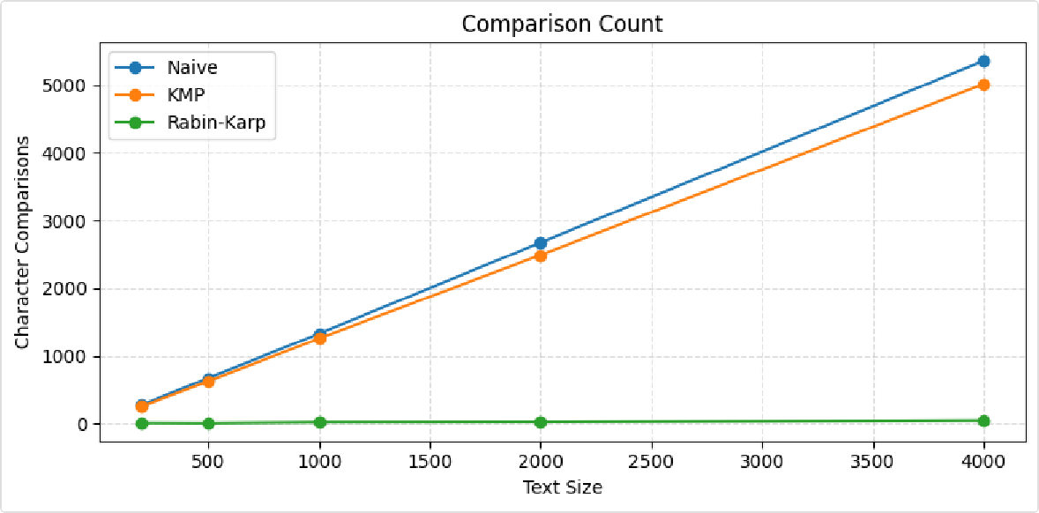
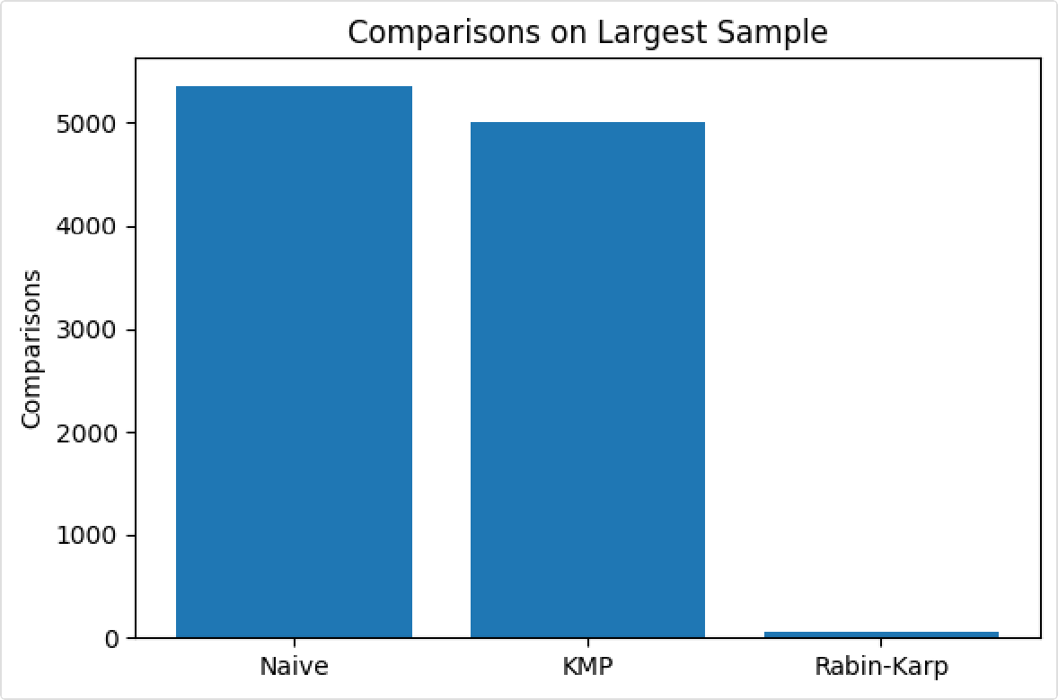

Out [9]:

In [8]:
fig,ax=plt.subplots(figsize=(8,4)) ax.plot(sizes,naive_comp,marker='o',label='Naive') ax.plot(sizes,kmp_comp,marker='o',label='KMP') ax.plot(sizes,rk_comp,marker='o',label='Rabin-Karp') ax.set_xlabel("Text Size")
ax.set_ylabel("Character Comparisons")
ax.set_title("Comparison Count") ax.grid(True,linestyle='--',alpha=0.4) ax.legend()
plt.tight_layout()
plt.show()

In [9]:
labels=["Naive","KMP","Rabin-Karp"] vals=[naive_comp[-1],kmp_comp[-1],rk_comp[-1]] fig,ax=plt.subplots(figsize=(6,4)) ax.bar(labels,vals) ax.set_ylabel("Comparisons") ax.set_title("Comparisons on Largest Sample") plt.tight_layout()
plt.show()

4. Observations
Backtracking is easy to implement but grows fast as the number of choices increases.
Branch and Bound reduces the search space using a bound, so it explores fewer states than brute force. KMP is usually better than naive search when the text becomes large.
Rabin-Karp uses hashing, so it is useful when many patterns or long texts are involved.

Conclusion
This experiment shows how algorithm choice changes performance: backtracking is correct but expensive,
branch and bound improves efficiency with pruning,
string matching algorithms differ in time and comparison count. The plots help verify both correctness and scalability.

