**BANKING MANAGEMENT SYSTEM (VSA)**

**Team members :-**

* Vamshi Krishna – 19CS01037
* Santosh Yakkala – 19CS01042
* Ashwin K. L – 19CS01041

**Professor :-** Dr . Padmalochan Bera

**README :-**

* Run the XAMPP Control panel in the host system. Turn on the Apache & MySQL modules.

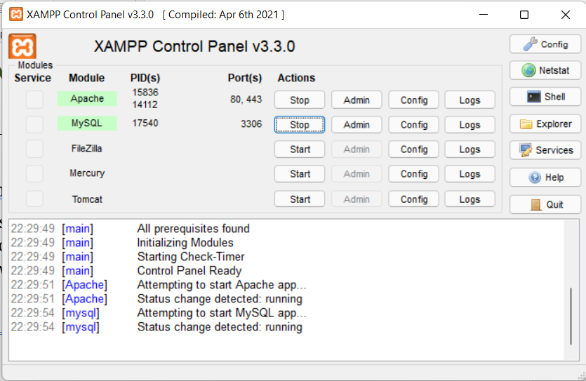

* Click the link <http://localhost/phpmyadmin/> to access the database of the project in phpMyAdmin.
* Then in the banking_management database you can see the data which has been stored under this project.

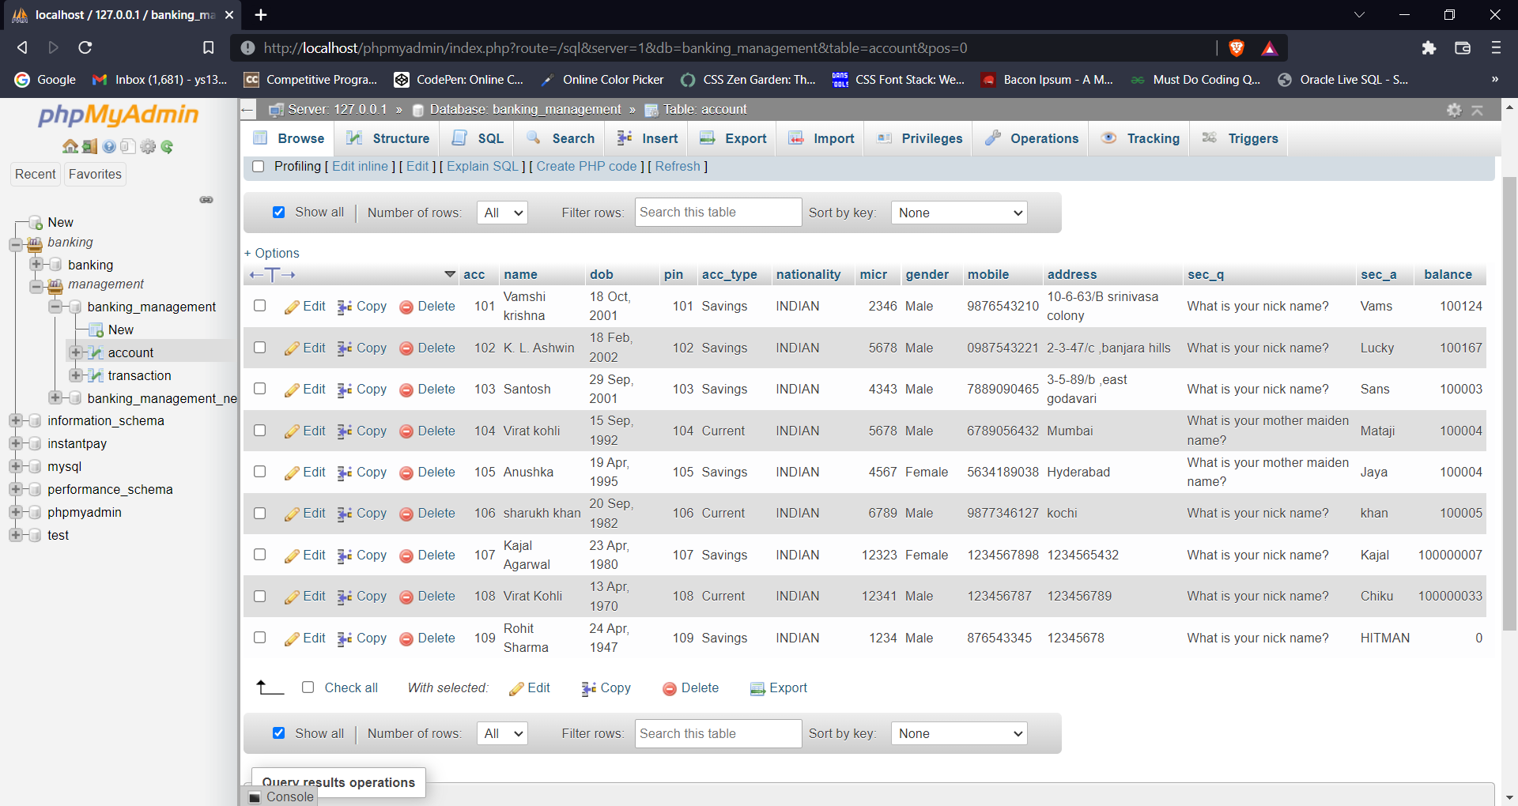

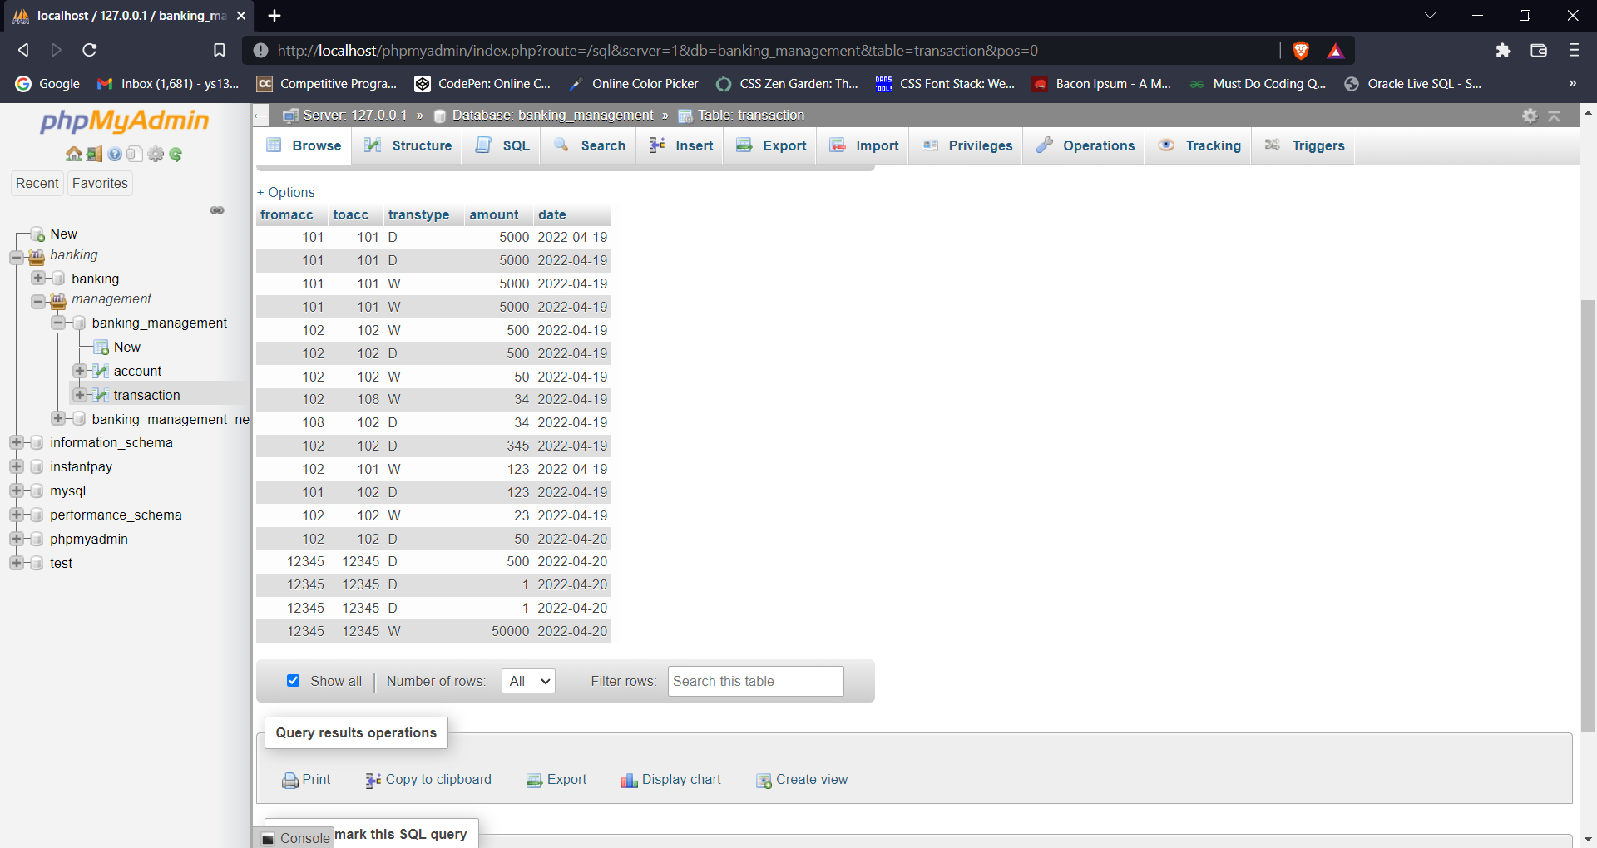

* Open the project in NetBeans 8.2 ide and run the project. It will pop up a login window as shown in the below figure. You can click the register button and create a new account.

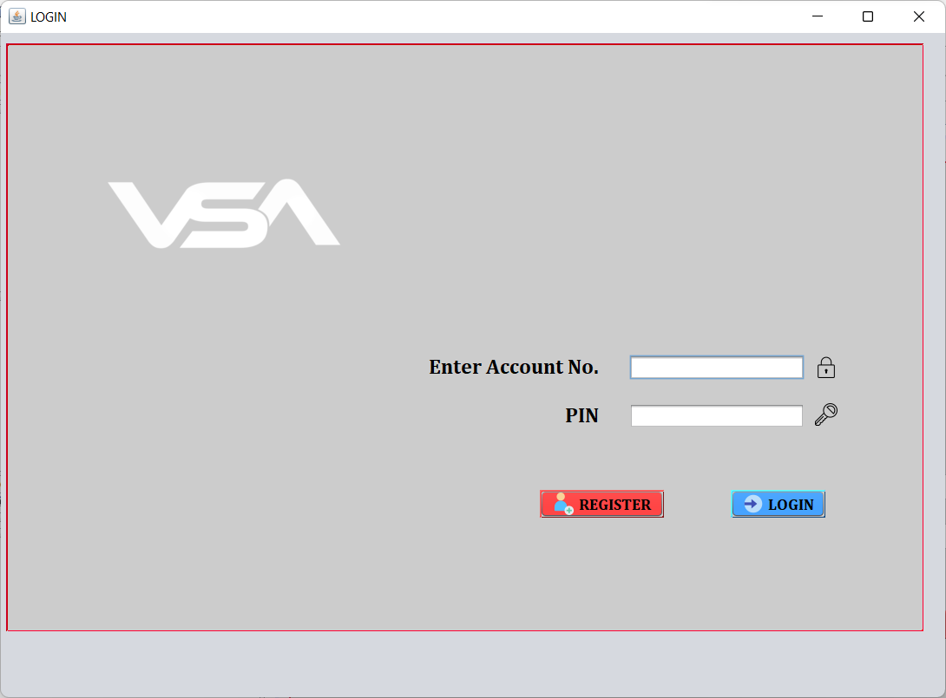

* Enter the credentials in the given fields.

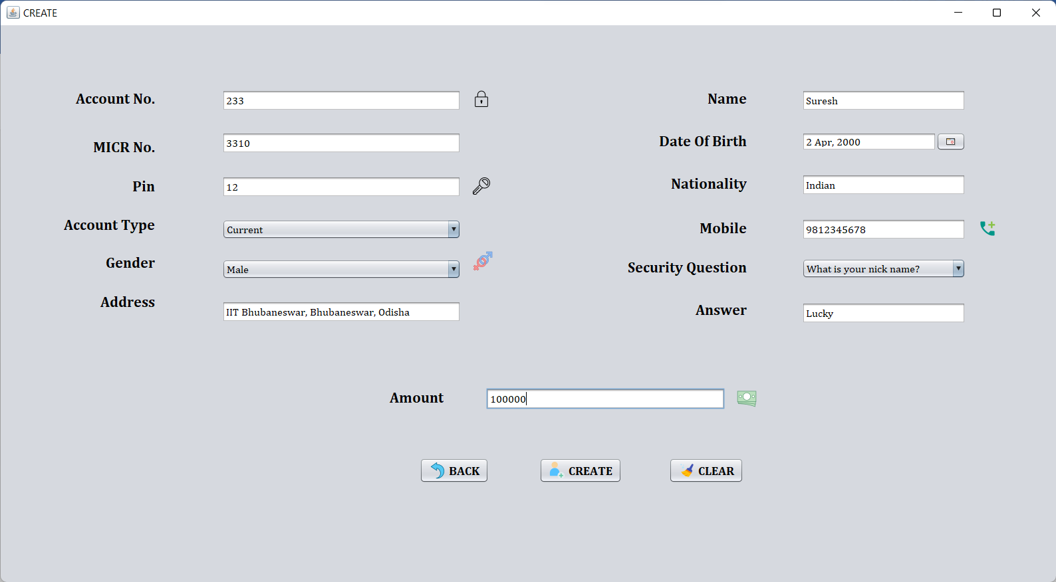

* After entering the data click on the **CREATE** button.

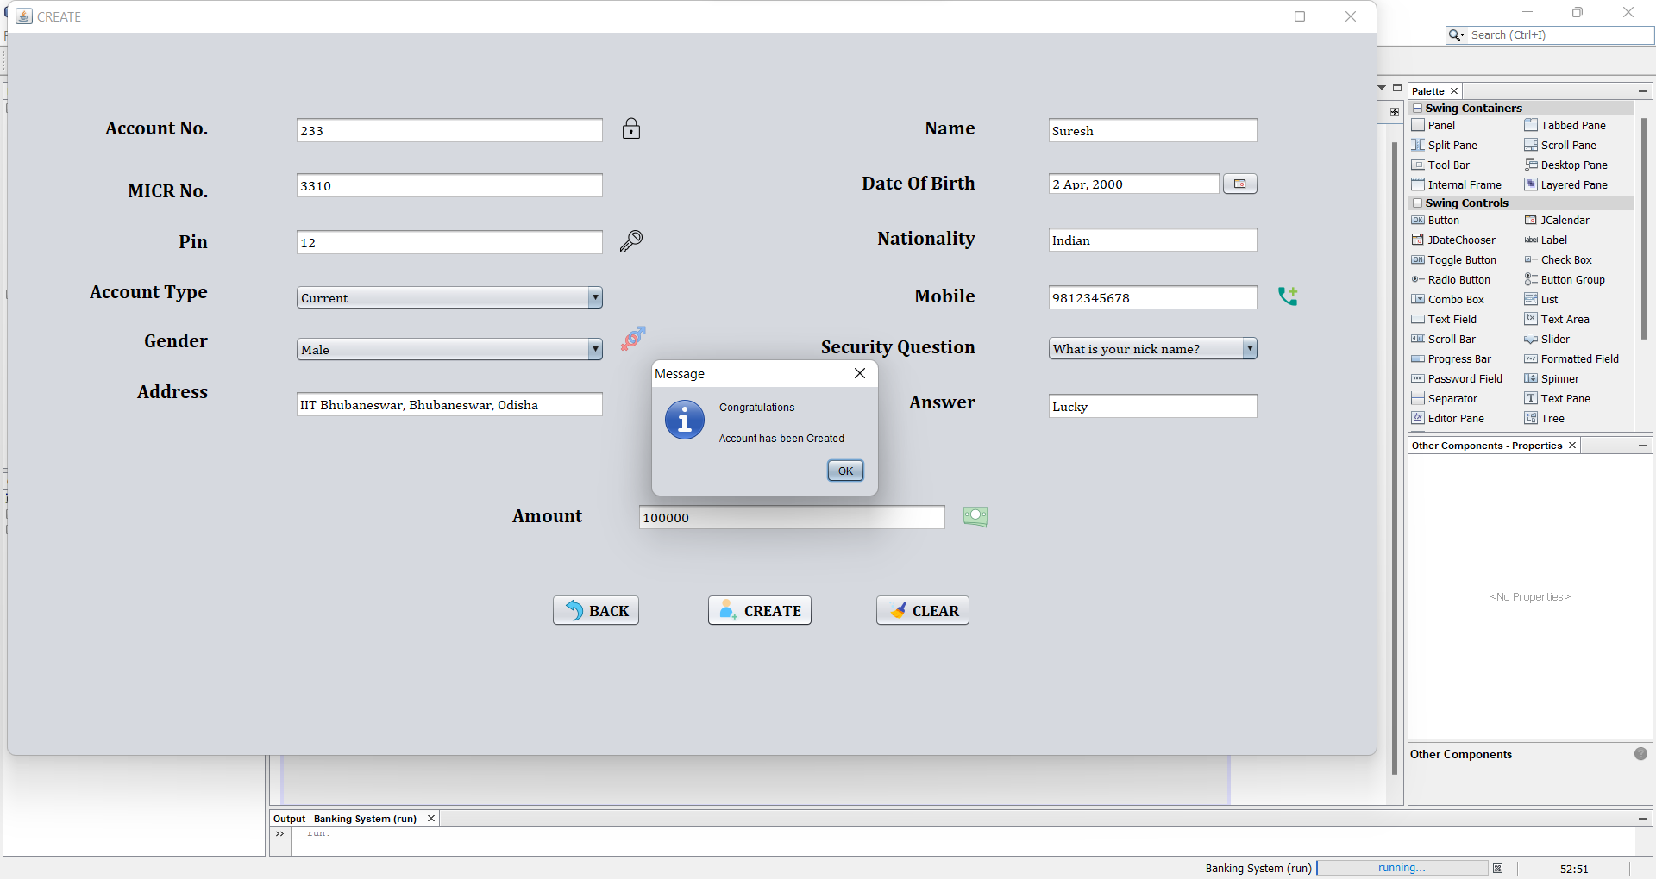

* And a window appears showing that your account has been successfully created.
* Login with the credentials.

