K L UNIVERSITY
ELECTRONICES AND COMMUNICATION (HTE) DEPARTMENT
ReportOn
OPEN-SOUCE ENGINEERING
SUBMITTED BY:

ID NUMBER | NAME
2400040217 | PASUPULETI VEDAVYASA

UNDER THE GUIDANCE OF
DR B . Arunekumar Balasubramanian
Assistant Professor



KL UNIVERSITY
Green fields, Vaddeswaram – 522 502 Guntur Dt., AP, India.

DEPARTMENT OF BASIC ENGINEERING SCIENCES



CERTIFICATE

This is to certify that the project based laboratory repor is submitted by PASULULETI VEDAVYASA 2400040217 Department of ELECTRONIC AND COMMUNICATION ENGINEERING
(HTE) , KL University in partial fulfillment of the requirements for the completion of a report in Open source Engenering ( 24CS02EF)” course in B Tech III Semester, is a Bonafede record of the work carried out by him/her under my supervision during the academic year 2025 – 2026.

PROJECT SUPERVISOR HEAD OF THE DEPARTMENT

N B Arunekumar Balasubramanian Dr Aswin

ACKNOWLEDGEMENTS

It is great pleasure for me to express my gratitude to our honorable President. Sri. Koneru Satyanarayana, for giving the opportunity and platform with facilities in accomplishing the project-based laboratory report.
I express sincere gratitude to our Coordinator and HOD-HTE Dr. Aswin for his leadership and constant motivation provided for the successful completion of our academic semester. I record it as my privilege to deeply thank you for providing us with the efficient faculty and facilities to make our ideas into reality.
I express my sincere thanks to our project supisor N B Arunekumar Balasubramanian encouragement, appreciation, and intellectual zeal which motivated us to venture this project successfully.
Finally, we are pleased to acknowledge our indebtedness to all those who devoted themselves directly orindirectly to making this project a success.

PASUPULETI VEDAVYASA-2400040217
6.2 Installation Steps
6.1 About the Server
6 Self-Hosted Server
  - Project Screenshot
  - Licensing Terms

Contents

3
1.4 Installation Steps
  - System Requirements
1.2 Why You Chose It
  - Name and Version
1 Linux Distribution Used
. 3
. 3
. 3
. 4

5
. 5
. 6
. 6
. 7

8
3 Sending Encrypted Email
2.4 Import/Export Keys
2.3 Generating Keys
2.2 What is GPG?
2.1 What is Encryption?
2 Encryption and GPG
. 8
3.1 Tools Used
. 8
4.2 2. Signal
3.2 Steps

10
. 10
4 Privacy Tools from prism-break.org
. 10
4.5 5. ProtonMail
4.4 4. DuckDuckGo
4.3 3. KeePassXC
4.1 1. TOR Browser
. 11
. 11
. 11

11
. 12
. 12
  - Why I Chose the MIT License
5 Open Source License Used
. 13

13
. 13
. 14
6.3 Localized Document / Poster
. 15

. 16
7.1 PR #1: Contribution no.1
7 Open Source Contributions
6.4 How You Used It

16
. 16
7.2 PR #2: Contributed a Java Program
. 17
. 18

19
8 LinkedIn Posts
7.3 PR #3: Code Optimization

Linux Distribution Used

Name and Version
For this project, I used Ubuntu 22.04 LTS (Jammy Jellyfish). Ubuntu is a Debian-based Linux distribution developed by Canonical and is widely known for its stability, security, and long-term support.

Why You Chose It
I selected Ubuntu 22.04 LTS due to the following reasons:

- Long-Term Support (LTS): Receives security and maintenance up- dates for 5 years.
- Beginner-Friendly Interface: GNOME desktop environment makes it easy to use.
- Strong Community Support: Large documentation, forums, and tutorials.
- Wide Software Availability: Supports development tools, privacy tools, and open-source applications.
- Enhanced Security: Includes UFW firewall, AppArmor, frequent security patches.

System Requirements
The minimum and recommended system requirements for Ubuntu 22.04 LTS are shown in Table 1.

Specification | Minimum Require-  ment | Recommended
RAM | 4 GB | 8 GB
Processor | 2 GHz Dual-Core | 2+ GHz Multi-Core
Storage | 25 GB | 50+ GB SSD
Graphics | 1024x768 resolution  support | GPU with 3D Acceler-  ation
Table 1: System Requirements for Ubuntu 22.04 LTS

Installation Steps
The installation process of Ubuntu 22.04 LTS involved the following steps:

- Downloaded the Ubuntu ISO from the official website.
- Created a bootable USB using tools like Rufus or Balena Etcher.
- Booted the system from the USB drive via BIOS/Boot Menu.
- Selected “Try or Install Ubuntu” and clicked “Install Ubuntu”.
- Chose keyboard layout and installation type (Normal Installation).
- Selected the installation drive and created a user account.
- Waited for installation to complete and restarted the system.
- Performed initial updates using:

sudo apt update && sudo apt upgrade

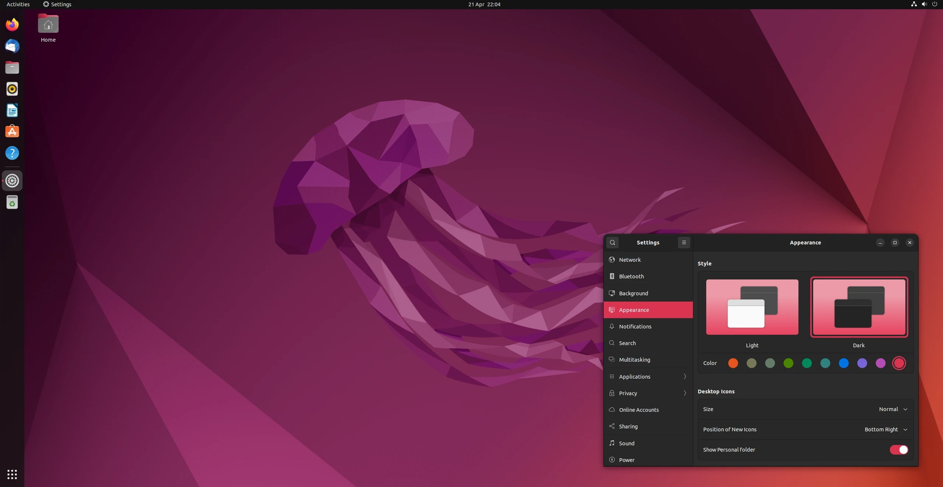

Figure 1: Installation Screenshot

Encryption and GPG

What is Encryption?
Encryption is the process of converting readable data (plaintext ) into an unreadable form (ciphertext ) to protect it from unauthorized access. Only someone with the correct key can decrypt and read the data.
There are two major types of encryption:

Symmetric Encryption:
  - Uses a single key for both encryption and decryption.
  - Fast and suitable for encrypting large files.
  - Example algorithms: AES, DES.
  - Limitation: Key must be securely shared between parties.

Asymmetric Encryption:
  - Uses two keys: a public key (for encryption) and a private key
(for decryption).
  - Public key can be shared openly, private key must be kept secret.
  - More secure for communication because keys are not shared.

  - Example algorithms: RSA, ECC.

What is GPG?
GNU Privacy Guard (GPG) is an open-source tool that implements asym- metric encryption for secure communication and data protection.
- Based on the OpenPGP standard.
- Allows users to encrypt files, emails, and messages.
- Uses public-private key pairs.
- Supports digital signatures to verify identity and data integrity.
- Works on Linux, including Ubuntu natively.

Generating Keys
To use GPG for encryption, a key pair must be created.

Steps:
- Open the terminal.
- Run the command to generate a new key:

gpg --full-generate-key

- Select key type (default RSA and RSA).
- Choose key size (recommended: 4096 bits).
- Set expiry time.
- Enter name, email, and password when prompted.
After completion, the public and private keys are stored securely in the GPG keyring.

Import/Export Keys
GPG allows sharing your public key with others and importing their keys for secure communication.

Exporting Public Key
- List keys:

gpg --list-keys

- Export public key:

gpg --export -a "Your Name" > publickey.asc

- Share publickey.asc with others.

Importing Someone’s Public Key
- Download their public key file.
- Import it using:

gpg --import publickey.asc

- Verify the key fingerprint for authenticity.

Exporting Private Key (Optional)
For backup purposes only:
gpg --export-secret-keys -a "Your Name" > privatekey.asc
Note: The private key must never be shared.

Sending Encrypted Email

Tools Used
To send encrypted emails using GPG, the following tools were used:

- Mozilla Thunderbird: An open-source email client that supports encryption.
- Thunderbird OpenPGP Built-in Support: Allows encryption, de- cryption, and digital signatures without external plugins.
- GPG (GNU Privacy Guard): Used for generating and managing public/private key pairs.
- Email Account (e.g., Gmail): Used for sending and receiving en- crypted mail through Thunderbird.
These tools together ensure secure communication using asymmetric en- cryption.

Steps
The process of sending an encrypted email involves three main stages: key exchange, encryption, and sending.

Configure Thunderbird
  - Install and open Mozilla Thunderbird.
  - Add your email account (e.g., Gmail) by signing in.
  - Open Account Settings and enable OpenPGP encryption.

Import Your GPG Keys
  - Thunderbird automatically detects your existing GPG key pair.
  - If needed, import the key manually:

gpg --export -a "Your Name" > publickey.asc

  - Load the key into Thunderbird.

Exchange Public Keys
  - Share your public key with the recipient.
  - Import their public key into Thunderbird or GPG:
gpg --import recipientkey.asc

  - This ensures both parties can encrypt messages for each other.

Compose an Encrypted Email
  - Click “Write” in Thunderbird.
  - Enter the recipient’s email address.
  - Enable encryption by clicking the Encrypt icon (lock symbol).
  - Optionally enable a Digital Signature for authenticity.

Send the Email
  - Click “Send”.
  - The message is encrypted automatically using the recipient’s pub- lic key.
  - Only the recipient’s private key can decrypt and read the email.

Recipient Decrypts the Email
  - The recipient receives ciphertext.
  - Their private key decrypts it automatically inside Thunderbird.

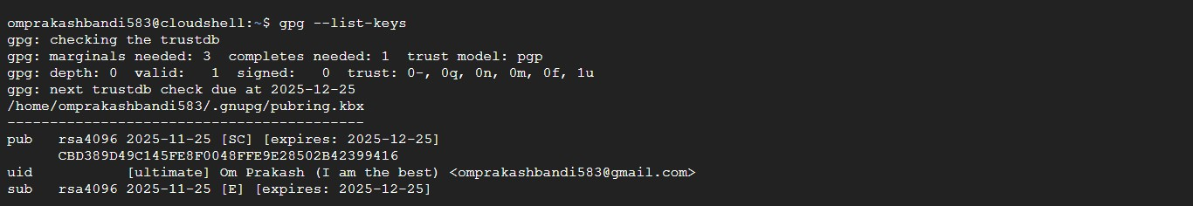

Figure 2: Encrypting an Email in Thunderbird

Privacy Tools from prism-break.org
For improving online privacy, security, and data protection, the following five tools were selected from prism-break.org. Each tool focuses on reducing tracking, surveillance, and unauthorized data access.

TOR Browser
TOR Browser is a privacy-focused web browser that routes internet traffic through the Tor network, making it difficult for websites, ISPs, or govern- ments to trace the user’s identity or location. It hides the user’s IP address and prevents fingerprinting to a large extent. TOR also blocks trackers and cookies by default, ensuring anonymous browsing. It is especially useful for accessing restricted content and avoiding surveillance. However, due to mul- tiple relays, browsing speed may be slower than normal browsers.

Signal
Signal is an open-source messaging application that provides end-to-end en- cryption for text messages, voice calls, video calls, and media sharing. Mes- sages are encrypted in such a way that even Signal’s servers cannot access their content. The app does not store user data, metadata, or contacts on its servers, ensuring strong privacy. Signal uses the Signal Protocol, one of the most secure encryption standards. It is free, cross-platform, and recom- mended by security experts like Edward Snowden.

KeePassXC
KeePassXC is an open-source password manager that securely stores pass- words in an encrypted offline database. Instead of remembering multiple passwords, users can manage all credentials with a single master password. The database uses strong AES-256 encryption, making unauthorized access extremely difficult. KeePassXC supports password generation, autofill, and multi-device syncing through secure storage options. Since data is stored locally, there is no risk of cloud-based breaches.

DuckDuckGo
DuckDuckGo is a privacy-focused search engine that does not track users, store search history, or profile individuals for targeted ads. Unlike traditional search engines, it does not collect personal data or link queries to specific identities. It blocks trackers and ensures encrypted connections whenever possible through its browser extensions. DuckDuckGo provides unbiased search results without personalization filters. It is a strong alternative for users looking to minimize online surveillance.

ProtonMail
ProtonMail is an encrypted email service based in Switzerland, a country with strong privacy laws. It provides end-to-end encryption, meaning only the sender and recipient can read the email content. ProtonMail does not log IP addresses or store readable messages on its servers. It offers self- destructing emails, secure key management, and zero-access architecture. The service is open-source and accessible via web and mobile apps, making secure communication simple and user-friendly.

Open Source License Used
For this project, I selected the MIT License, which is one of the most widely used and permissive open-source licenses. It allows developers to freely use, modify, distribute, and integrate the software with minimal restrictions.

Why I Chose the MIT License
The decision to use the MIT License was based on the following reasons:

  - Simplicity: The license is short, easy to understand, and legally clear.
  - Flexibility: Allows anyone to reuse or modify the project for personal or commercial purposes.
  - Low Restrictions: Only requires attribution to the original author, with no obligations to open-source modified versions.
  - Industry Standard: Popular among developers and used by major projects like React, Node.js, and jQuery.
  - Encourages Collaboration: Makes it easier for others to contribute without legal barriers.

Licensing Terms
The core terms of the MIT License include:

  - Permission to use, copy, modify, merge, publish, distribute, and subli- cense the software.
  - Users must include the original copyright notice and license text in any copies or derivative works.
  - The software is provided “as is” without any warranty or liability.
  - The author is not responsible for damages, claims, or losses arising from the software’s use.
These terms ensure that the software remains open and usable while protecting the developer from legal risks.

Project Screenshot
A screenshot of the project repository displaying the MIT License file is shown below.
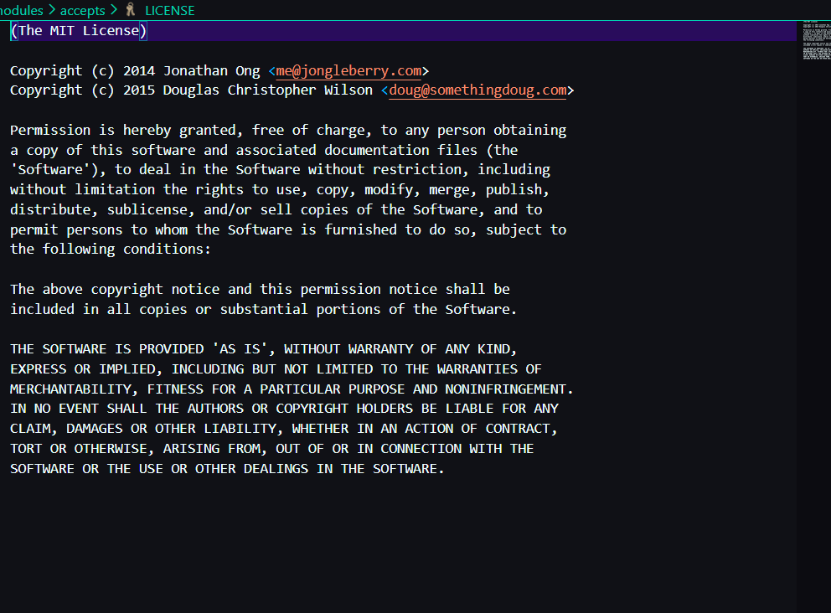

Figure 3: Project Repository Showing MIT License

Self-Hosted Server
About the Server
For this project, I self-hosted the Vikunja Task Management Server locally on my own machine. A self-hosted server means the service runs on a personal system instead of using a third-party cloud provider. This provides more privacy, full control, and ownership over the data.
Vikunja is an open-source task management tool that allows creating task lists, todo boards, project structures, deadlines, and collaborative workflows. By running it locally, I could access the full features of Vikunja securely without exposing anything to the public internet.
Self-hosting Vikunja helped me understand networking, Docker containers, hosting concepts, configuration files, YAML, port mappings, and general server management. It also gave me a clear idea of how real-world web applications run behind the scenes.
.

The following steps were used to install and run the Vikunja self-hosted server on Ubuntu using Docker and Docker Compose:
1. Updated System Packages
sudo apt update && sudo apt upgrade
2. Installed Docker and Docker Compose
sudo apt install docker.io docker-compose -y
3. Created a Project Directory
mkdir vikunja-server
cd vikunja-server
4. Created the docker-compose.yml File
version: '3'

services:
api:
image: vikunja/api
environment:
VIKUNJA_SERVICE_PUBLICURL: http://localhost:3456/
ports:
- "3456:3456"
volumes:
- ./files:/app/vikunja/files
- ./db:/app/vikunja/db

frontend:
image: vikunja/frontend
ports:
- "8080:80"
depends_on:
- api
5. Started the Vikunja Server
docker-compose up -d
6. Accessed the Server Locally
Opened the browser and navigated to:
http://localhost:8080

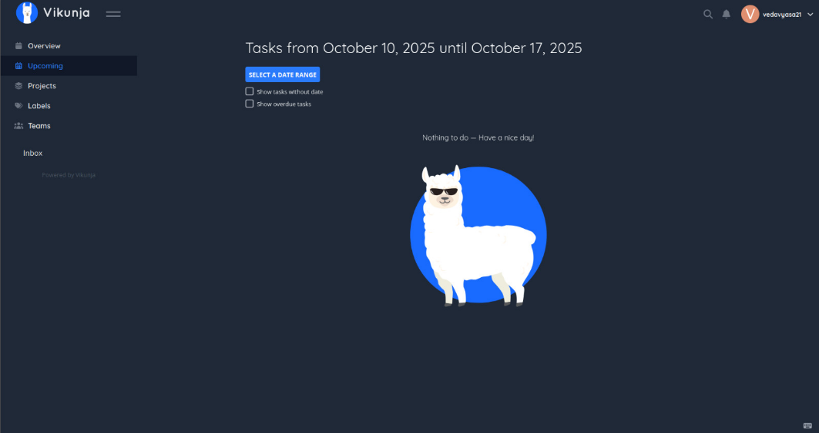
Figure 4: Local Host

  - Localized Document / Poster
  - A localized poster/document was created to clearly explain the Vikunja self-hosting setup in a simple manner. The poster includes:
  - What Vikunja is
  - What self-hosting means
  - Why hosting locally improves privacy and control
  - Steps to install and run Vikunja
  - Screenshots of Vikunja running on localhost
  - How to access and use the interface
  - This visual document helps anyone quickly understand the server usage and purpose

How I Used It:
- After successfully self-hosting the Vikunja server locally, I used it for the following purposes:
- Task & Project Management: Created task lists, deadlines, and kanban boards to test the platform.
- Testing the Server Environment: Verified that frontend and API ran correctly through Docker containers.
- Accessing Services Locally: Used the Vikunja interface from my browser to create and manage tasks.
- Learning Docker: Understood how containers, images, ports, and volumes work together.
- Server Management: Practiced starting, stopping, and monitoring services using Docker commands.
- Privacy & Security: Since the server was local, no external network could access my data.
- Experimentation: Modified environment variables and YAML configs and observed the real-time behavior.
- This hands-on experience helped me understand container-based hosting and how self-hosted applications work on personal hardware.
.

Open Source Contributions
During this project, I contributed to open-source development by identifying issues, fixing bugs, and submitting Pull Requests (PRs) to public repositories. These contributions helped me understand real-world collaboration, version control, and code review processes.

PR #1: Contribution no.1
  - Changes Done: [first contribution].
  - PR Link: https://github.com/firstcontributions/first-contributions/
pull/106319

  - Status: Merged

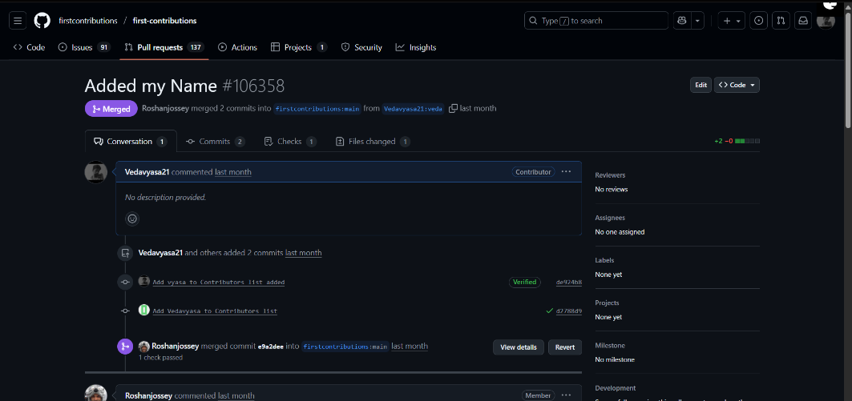

Figure 5: Pull Request #1

PR #2: Contribution to OMRChecker
- Issue Summary: Fixed an issue related to the OMR Checker functionality.
- What I Solved: I contributed by improving/fixing the code responsible for scanning the OMR image and giving the correct output.
- PR Link: https://github.com/DhanushNehru/OMRChecker
- Status: Merged

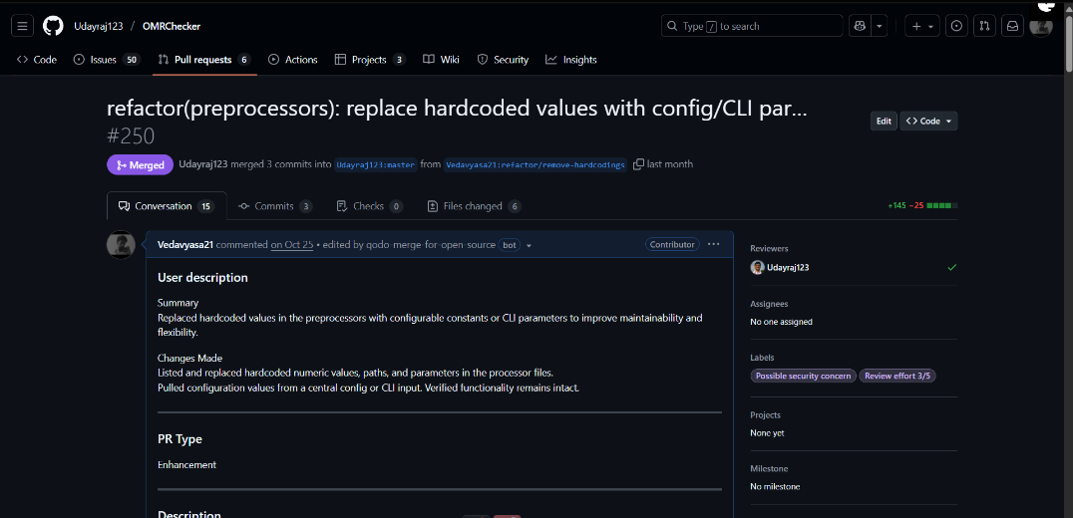
Figure 6: Enter Caption

Figure 7: Pull Request #2

PR #3: Code Optimization
  - Issue Summary:Add question on undefined behavior with string lit- erals
  - What I Solved: added a new quiz which help the repo owner
  - PR Link: https://github.com/Ebazhanov/linkedin-skill-assessments-quizzes/
pull/7229
  - Status: Merged

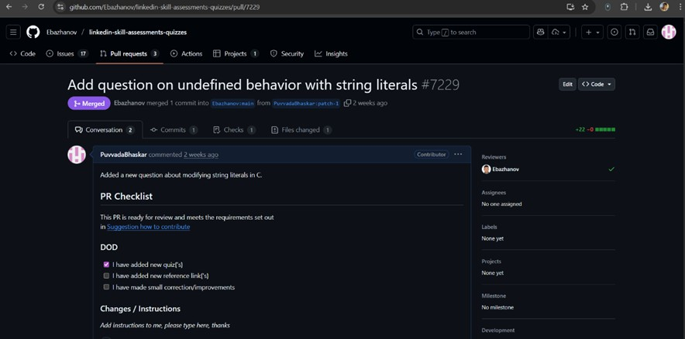

Figure 9: Pull Request #3

LinkedIn Posts
Add 3 links:
1. https://www.linkedin.com/posts/vedavyasa_i-have-successfully-completed-my-self-hosting-activity-7390948737105383424-r_Or?utm_source=social_share_send&utm_medium=member_desktop_web&rcm=ACoAAFhEqJYByffRVQR3__1p9jWZS2vz-Ko0t0o
2. https://www.linkedin.com/posts/vedavyasa_today-im-happy-to-share-that-my-contribution-activity-7398729648446267392-ze9L?utm_source=social_share_send&utm_medium=member_desktop_web&rcm=ACoAAFhEqJYByffRVQR3__1p9jWZS2vz-Ko0t0o
3. https://www.linkedin.com/posts/vedavyasa_this-is-my-journey-through-open-source-engineering-activity-7399124720324857856-TnEH?utm_source=social_share_send&utm_medium=member_desktop_web&rcm=ACoAAFhEqJYByffRVQR3__1p9jWZS2vz-Ko0t0o

