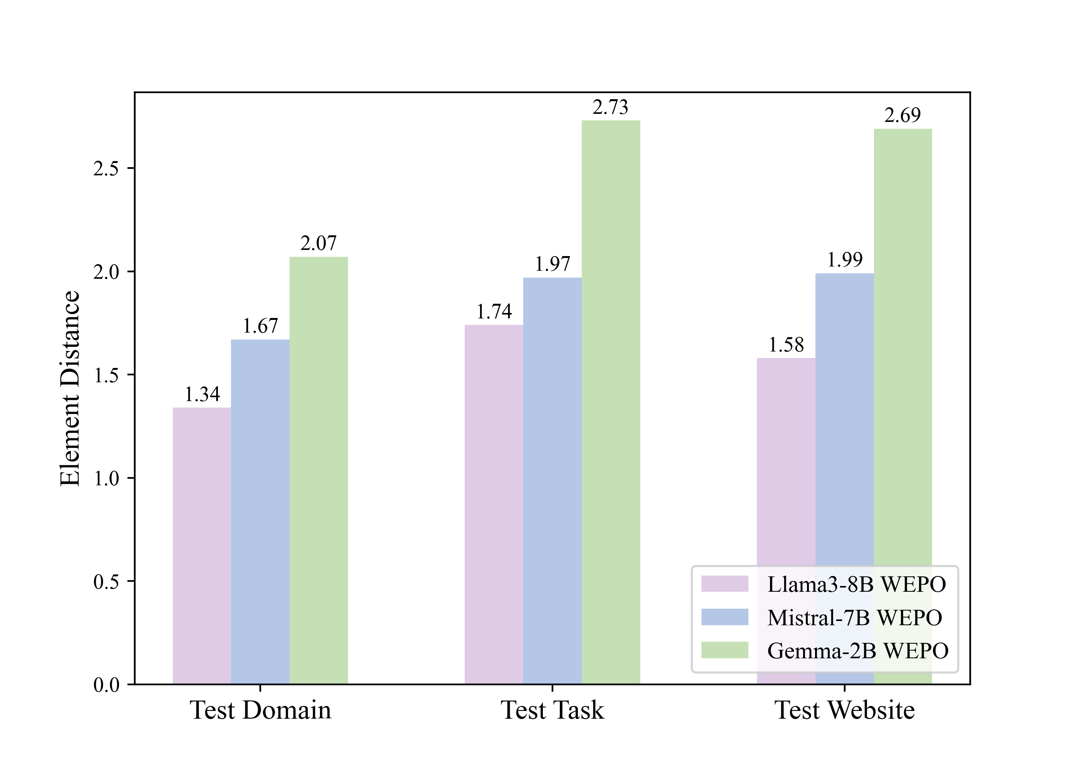  Figure 1: Statistical distribution of Element Distance for different models (Llama3-8B, Mistral-7B and Gemma-2B) on the test dataset. As the model size increases, the relative deviation in element distances decreases. | 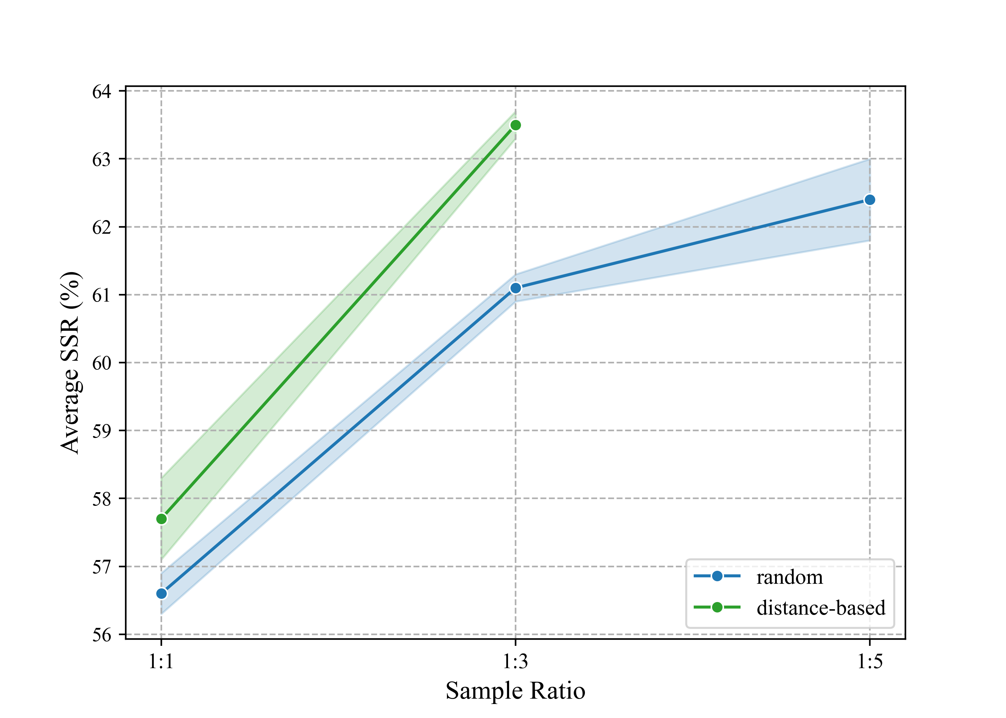  Figure 2: Ablation studies on the negative ratio. We experimented with the Llama3-8B-WEPO model at n = 1, 3, 5 and calculated the average SSR (%) on three cross-test sets, which were 57.7%, 63.5% for distance-based sampling and 56.6%, 61.1%, and 62.4% for random sampling, respectively. An elbow point was observed at n = 3 for random sampling, where the increase in SSR sharply levels off. Furthermore, the performance of distance-based sampling at a 1:3 ratio has already surpassed that of random sampling at a 1:5 ratio by 1.1%.

