Question3: Municipal Waste Collection Optimizer3
a) Data Types:W
rite a Java program to store anddisplay the following details of a waste collection vehicle: V
ehicle number – integer Wa
ste collected in kilograms – decimal value Num
ber of collection points – integer Vehi
cle status – characterUse ap
propriate Java data types foreach value and display all the details.3b) If-
Else Condition:Write a Java program to c
heck thewaste collecti
on status based on the amount of waste collected. Read the wastecollected in kilograms. If the waste collected is 100 kg or more, di
splay "Collection Target Achieved". Otherwise, display "More Waste Collection
Required".Use an if-else statement.3c) Methods:Write
a Java program to calcula
te thetotal waste collected from two col
lection poin
ts using a method.Create the following method:calculateTotalWaste(doublepoint1Waste, double point2Wast
e)The method should return t
he totalwaste collected. Read the waste collected at the tw
o collection points from theuser, call the method, and display the total waste collected.

3a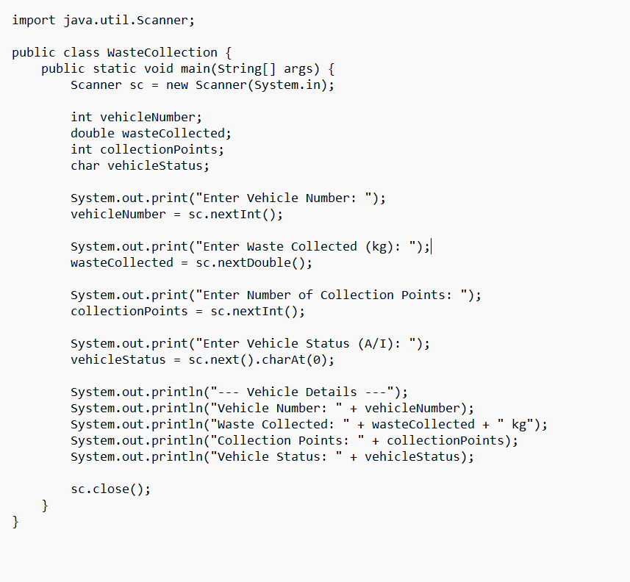
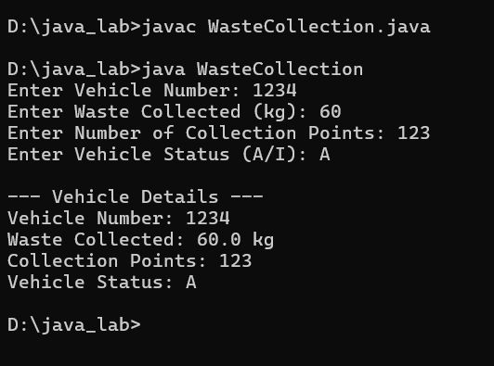
3b
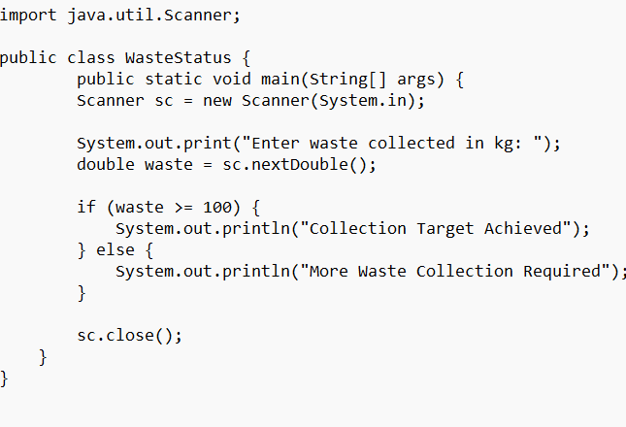
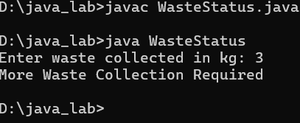
3c
