Skill Week-11
- To Connect Modules, Validate Interfaces, Test End-to-End Execution, Handle Errors, Improve Reliability, Refactor Components
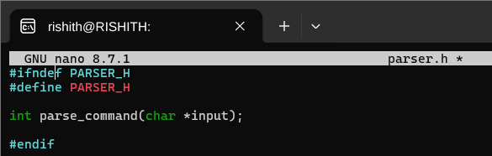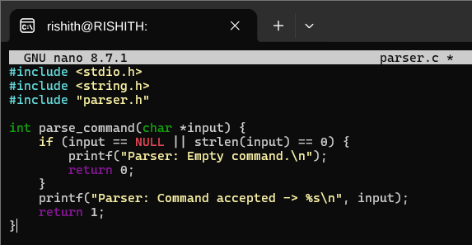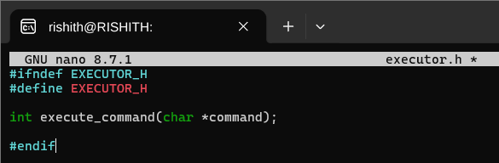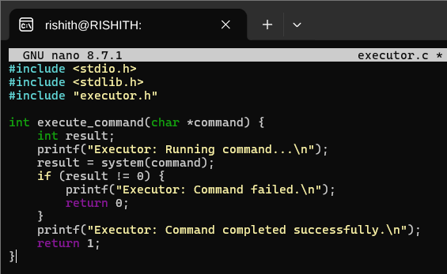

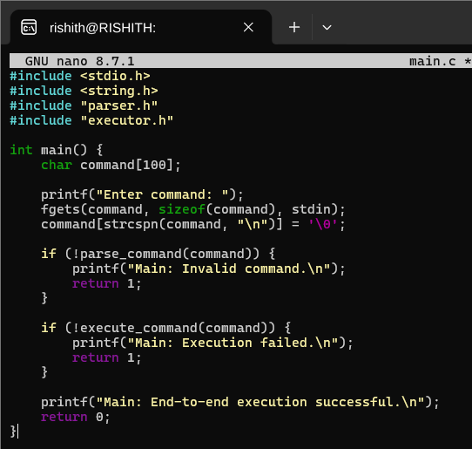

Output:

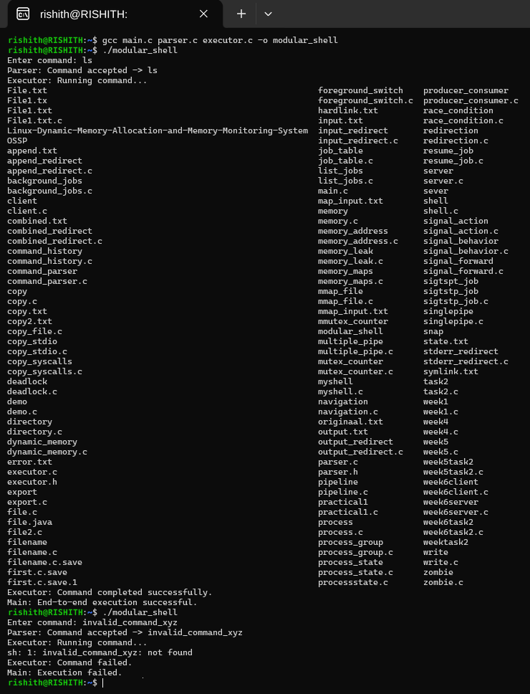

- To Detect Runtime Errors, Generate Messages, Log Failures, Handle Invalid Syntax, Recover Gracefully, Test Error Scenarios
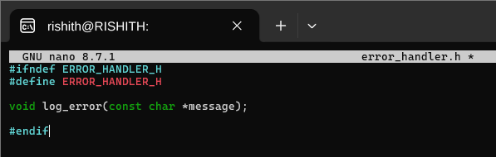
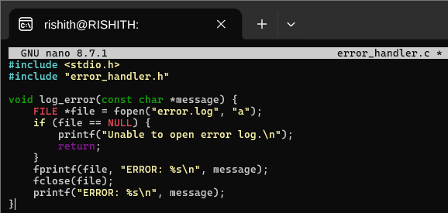
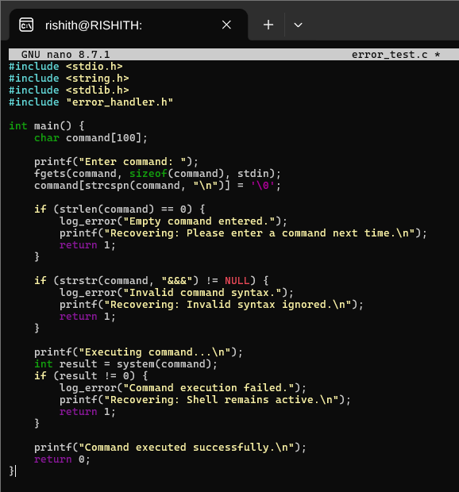

Output:
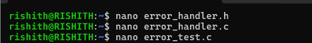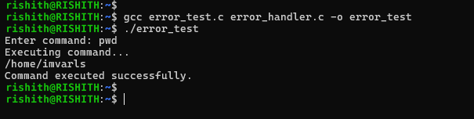

- To Run Valgrind, Identify Leaks, Fix Memory Errors, Release Resources, Verify Cleanup, Document Findings
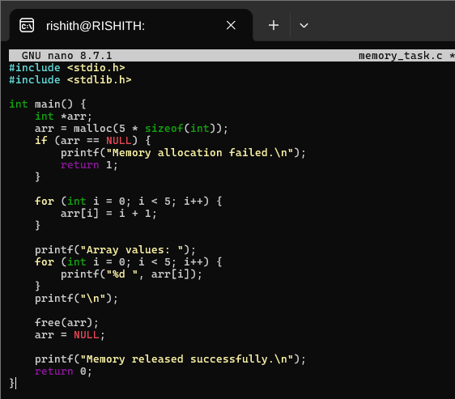
Output:
