Name: P. MOHIT KARTHIK ID number: 2520080059
Week 3
SESSION-5
Task 1: To Apply Single Quotes, Preserve Literal Content, Ignore Variable Expansion, Store Quoted Strings, Validate Parsing Results, Test Edge Cases.

CODE:
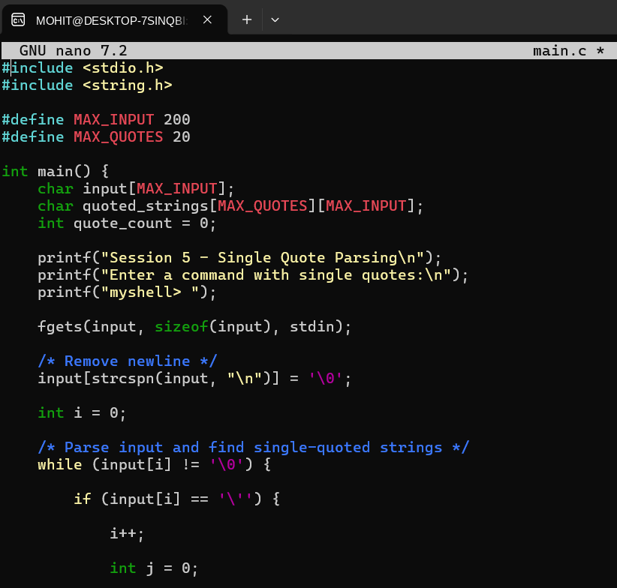
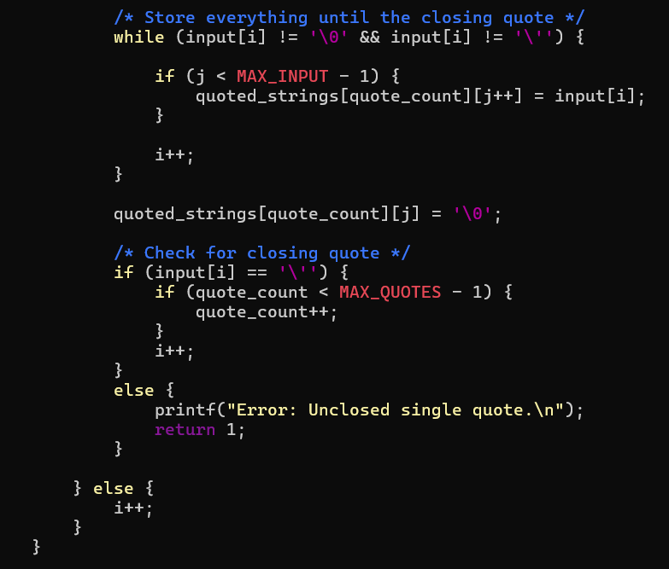
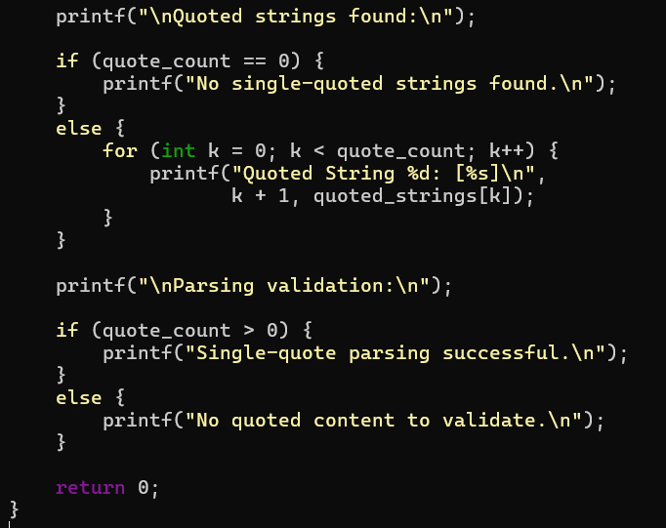

OUTPUT:
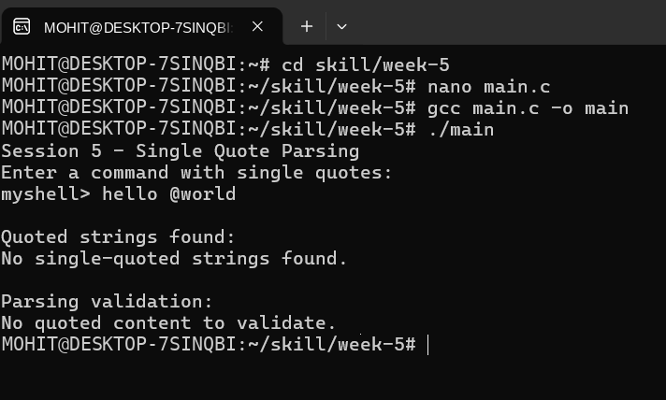

Task 2: To Apply Double Quotes, Preserve Spaces, Allow Variable Expansion, Parse Nested Tokens, Validate Outputs, Test Quoted Commands.
CODE:
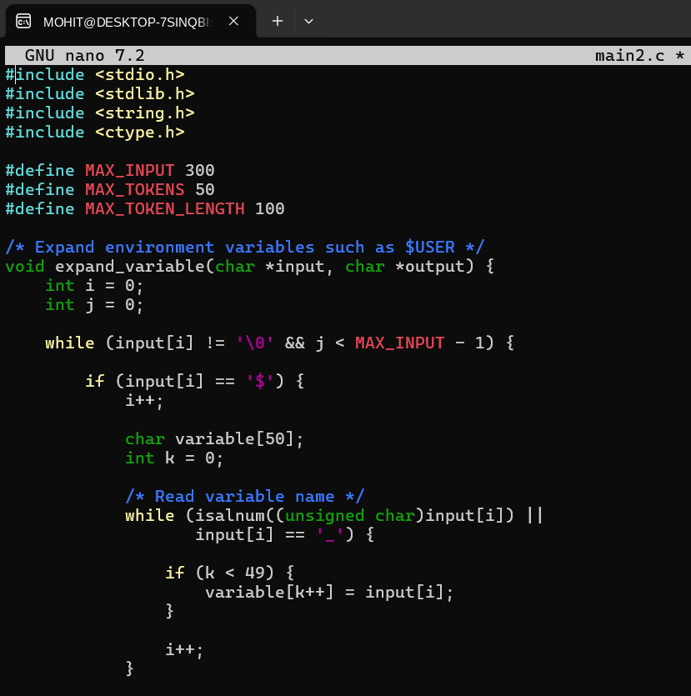
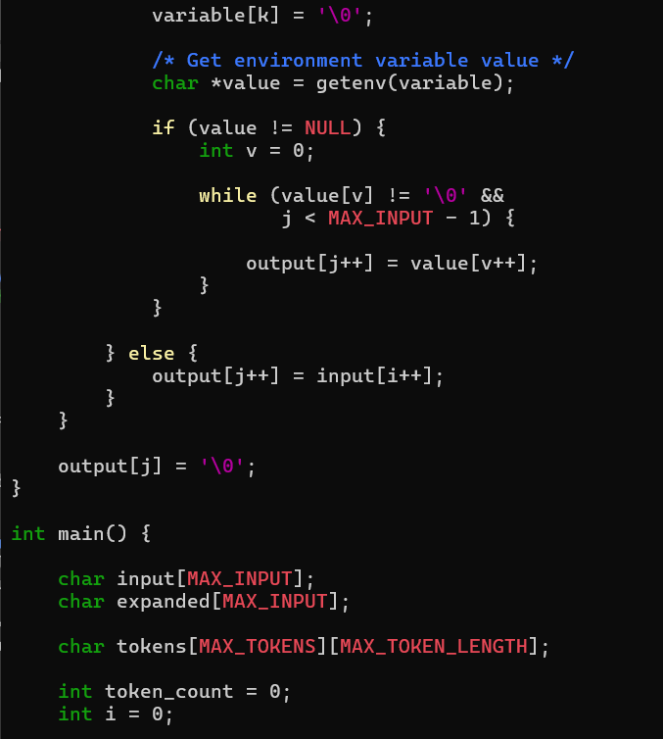
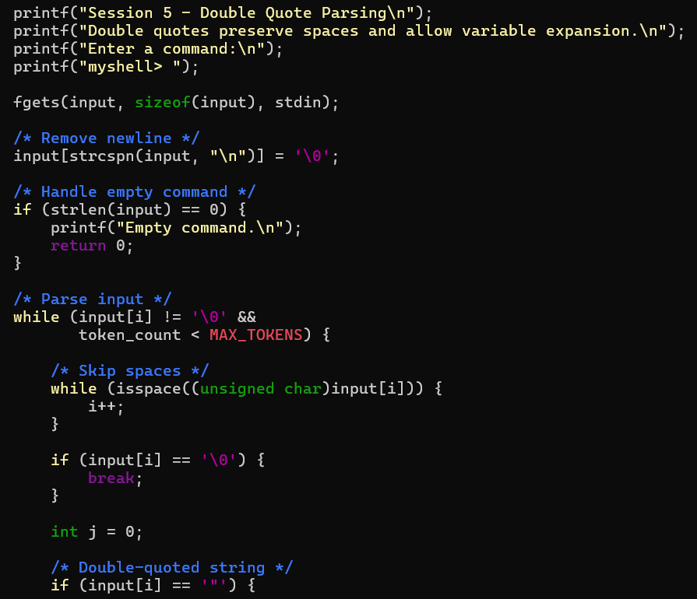
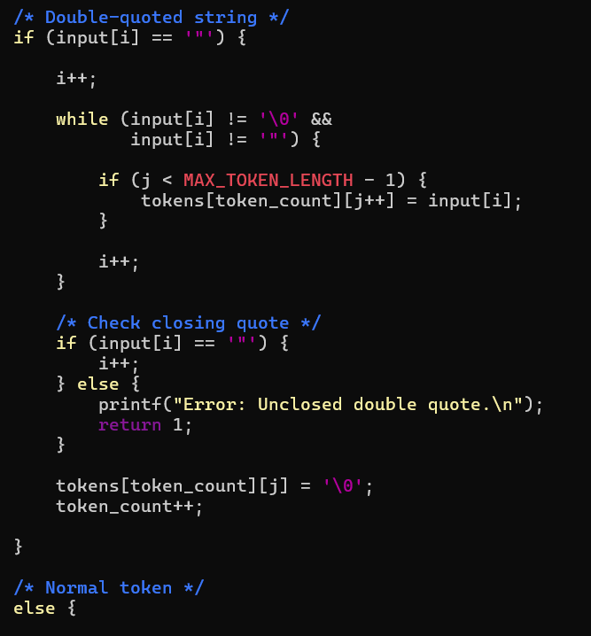
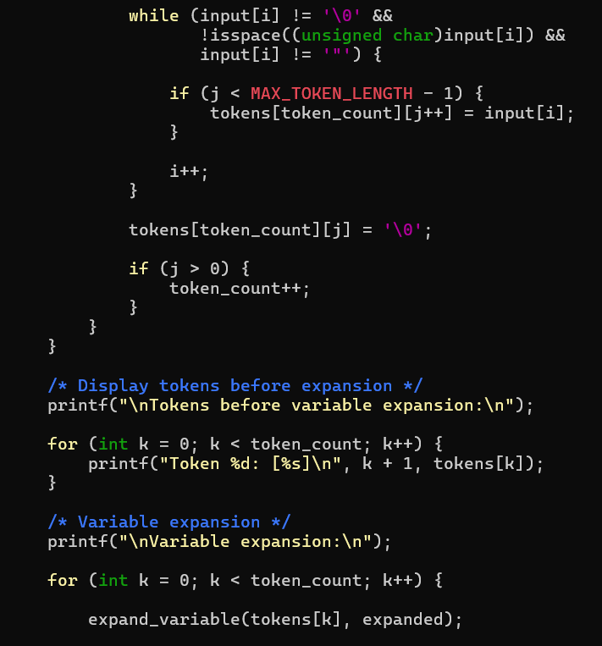
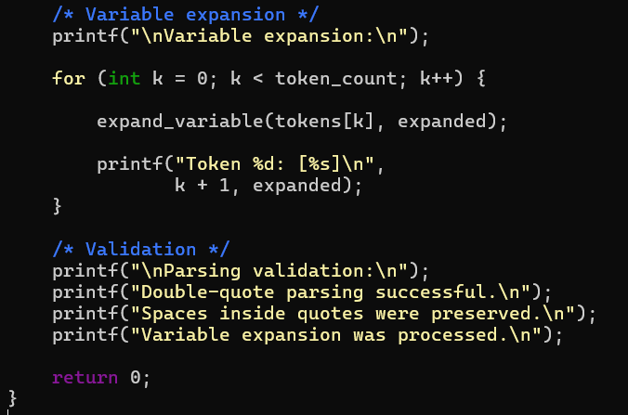

OUTPUT:
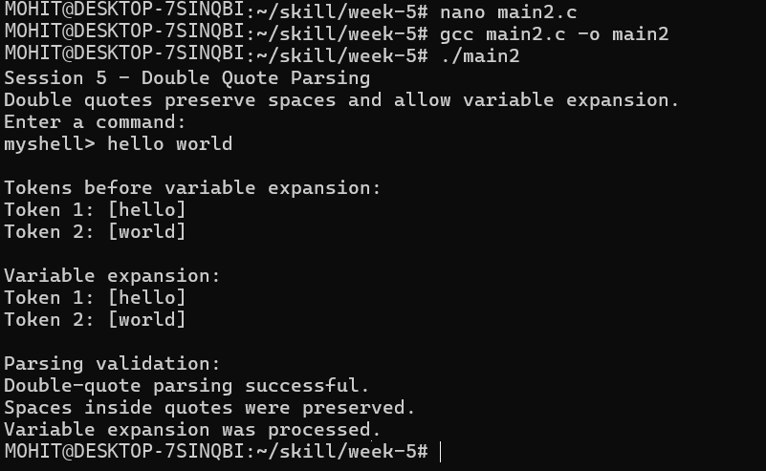

SESSION-6
Task 1: To Create Process Escape Sequences, Handle Escaped Spaces, Escape Special Symbols, Preserve Characters, Validate Parser Output, Test Complex Inputs.

CODE:
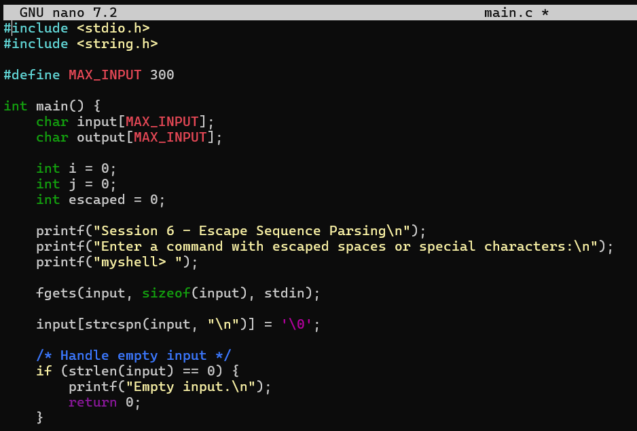
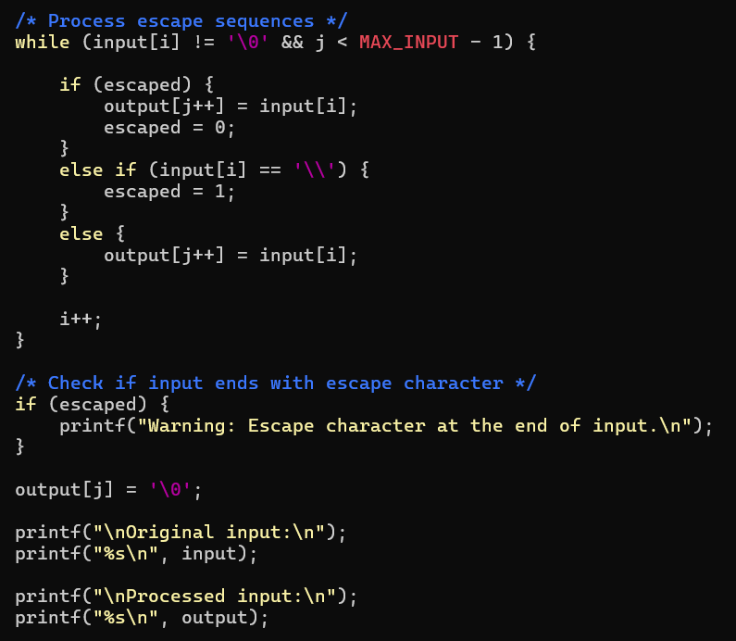

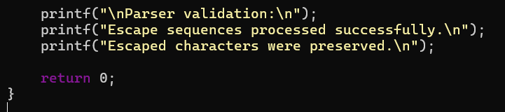

OUTPUT:
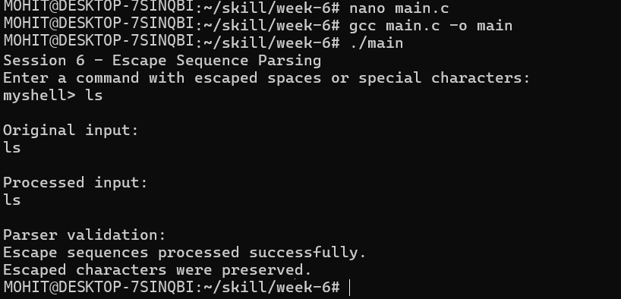

Task 2: To Create Child Processes, Execute Programs, Handle Execution Errors, Pass Arguments, Manage Parent Process, Test Command Launching
CODE:
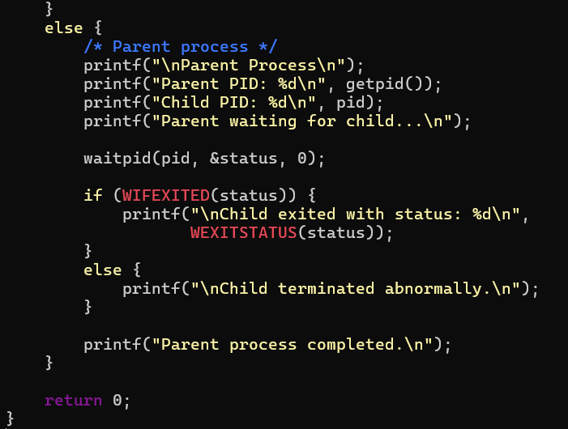
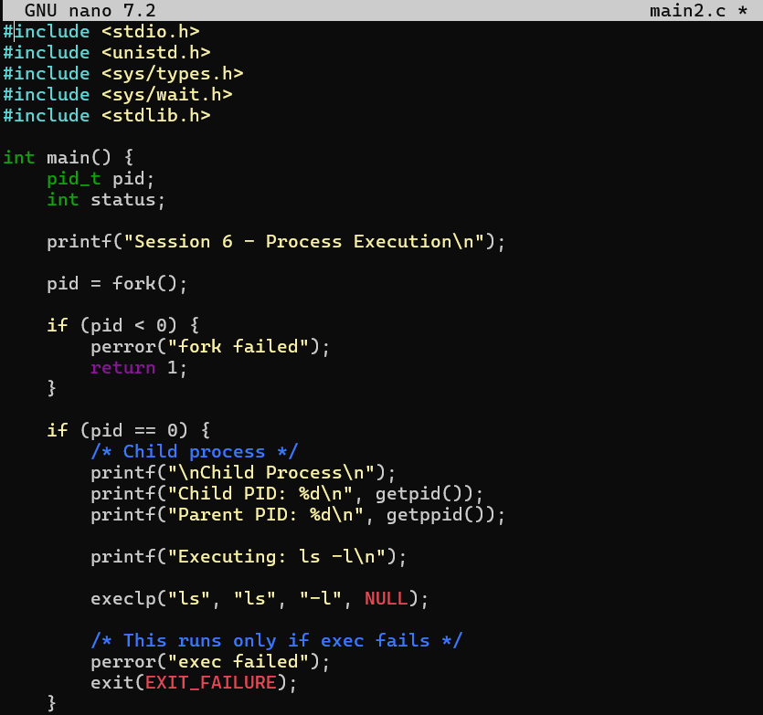

OUTPUT:
