Name: D. Bala Charan ID number: 2520090087
Week 2
SESSION-3
Task 1: To Install Linux VM, Configure GCC, Setup Git Repository, Create Project Structure, Understand Shell Architecture, Build Initial Make file.

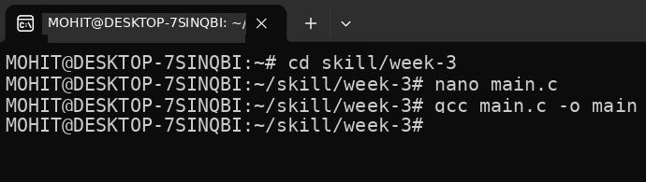
CODE:
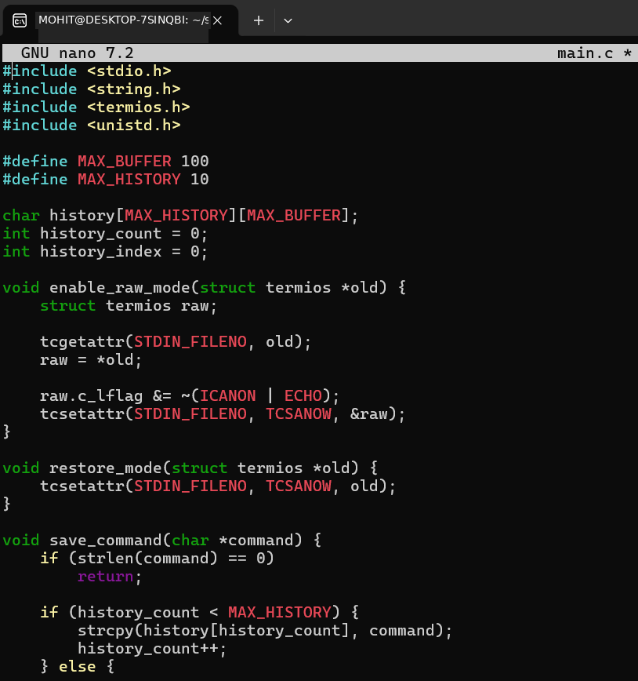

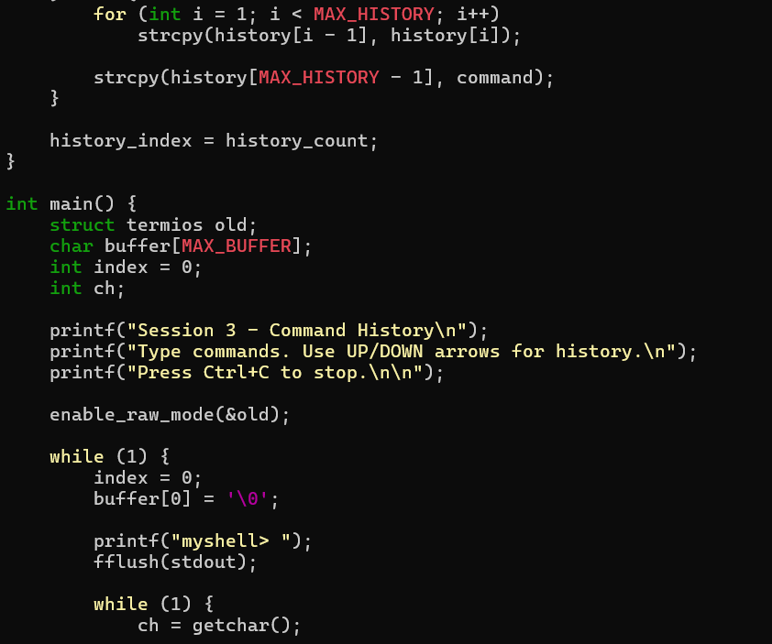
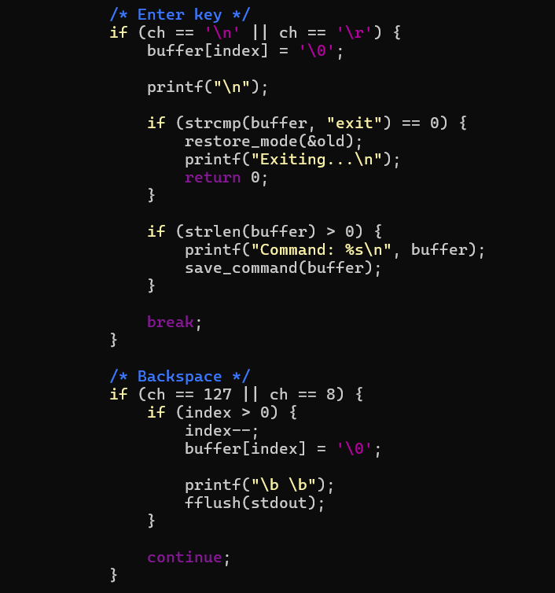

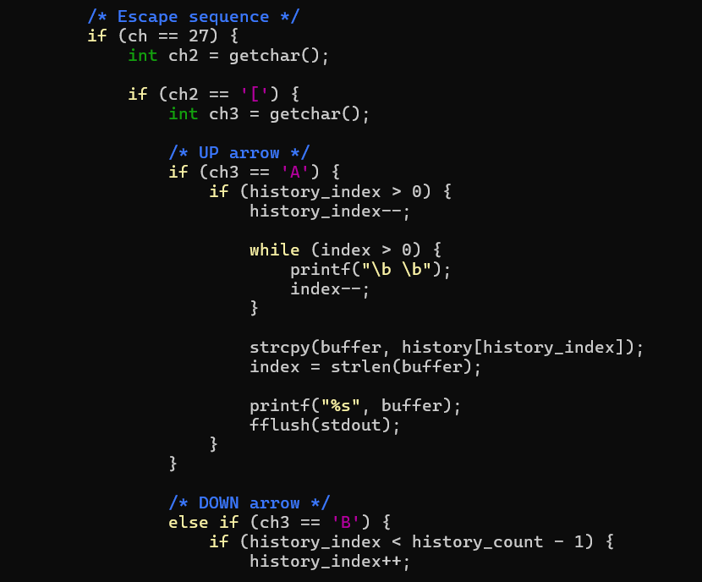

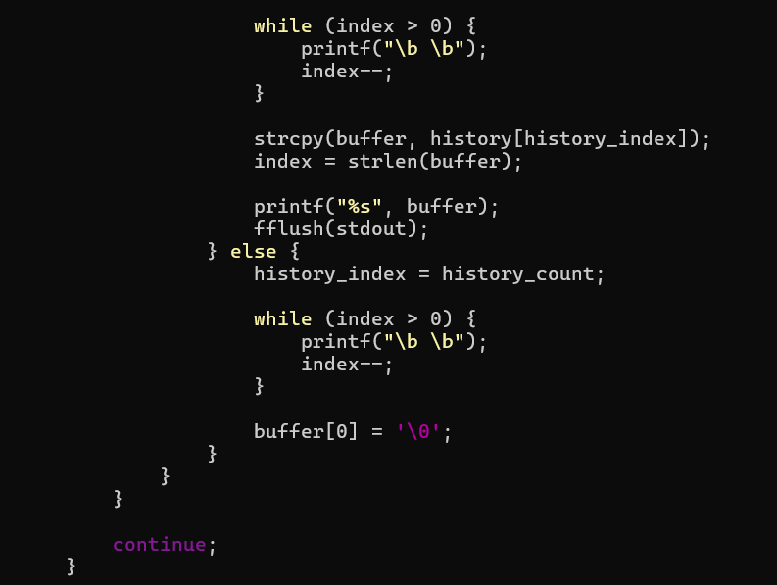

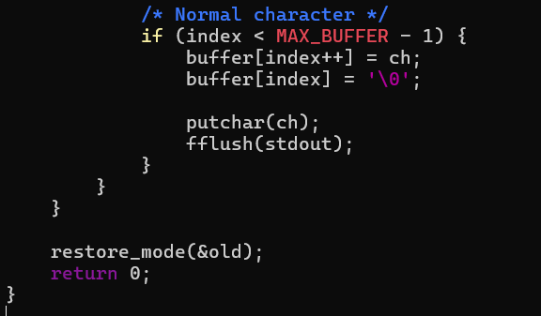
OUTPUT:
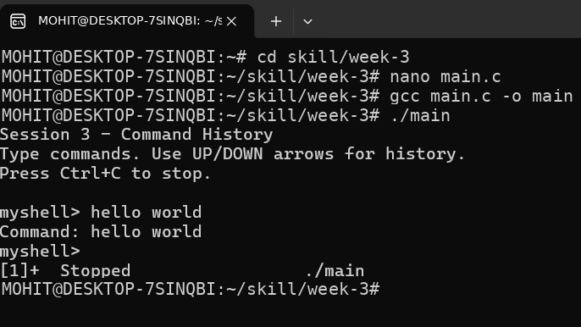
Task 2: To Split Input into Tokens, Identify Delimiters, Handle Whitespace, Create Token Structures, Validate Token Streams, Debug Parsing Output.
CODE:
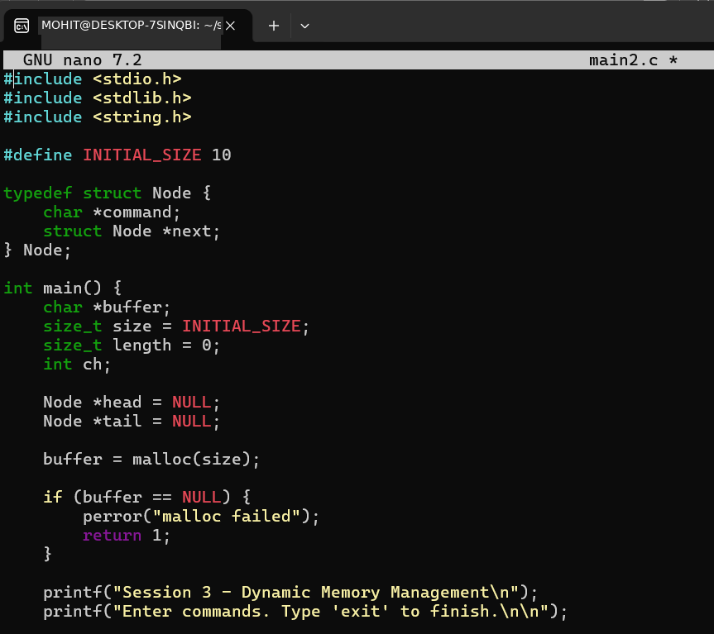
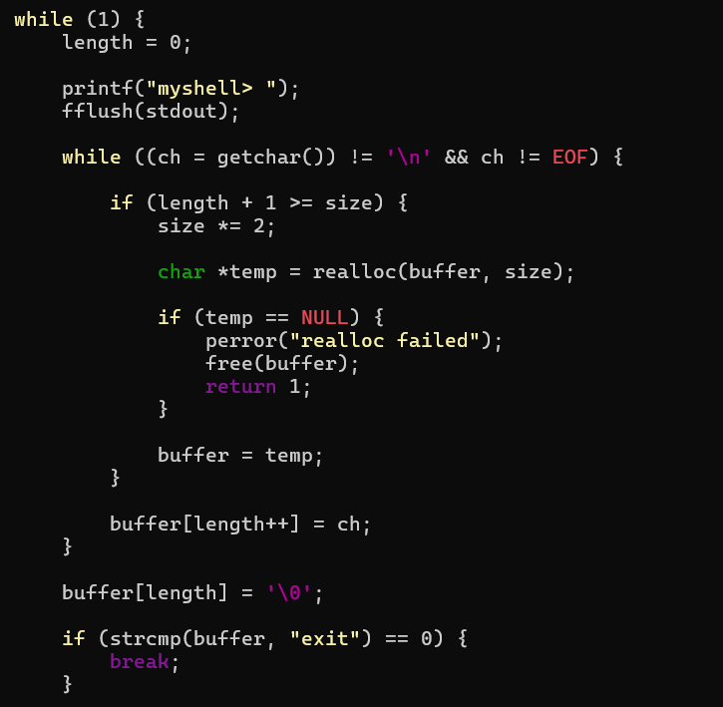
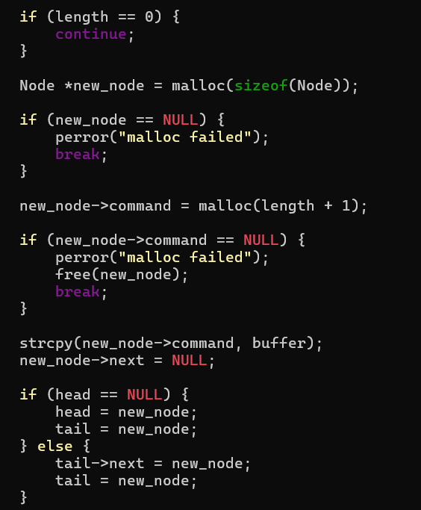
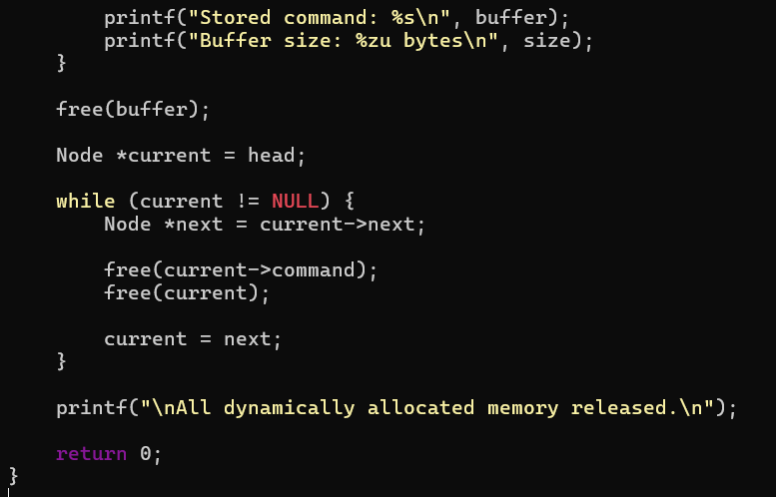
OUTPUT:
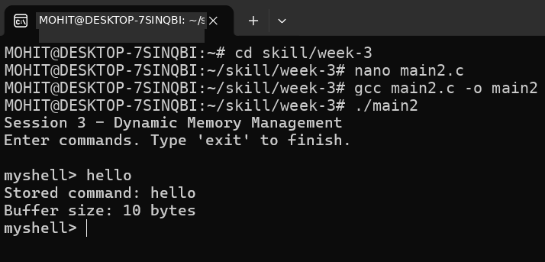

SESSION-4
Task 1: To Split Input into Tokens, Identify Delimiters, Handle Whitespace, Create Token Structures, Validate Token Streams, Debug Parsing Output.
CODE:
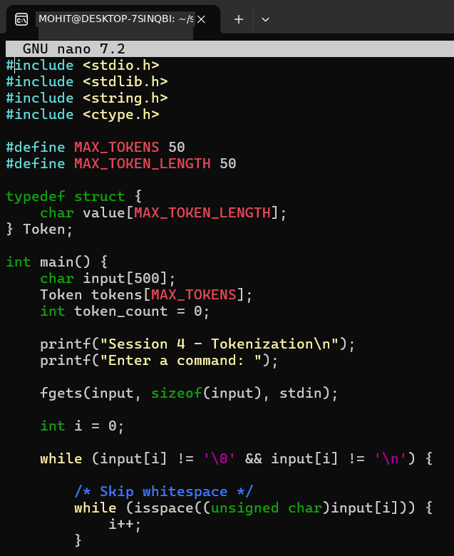
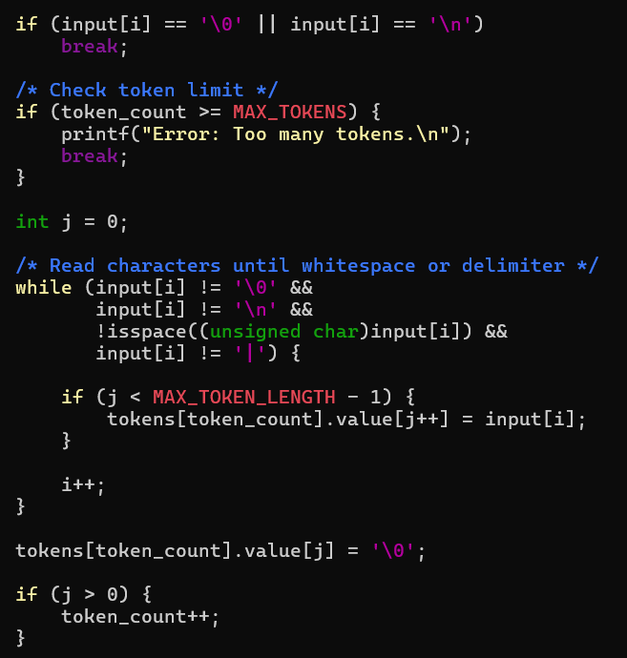
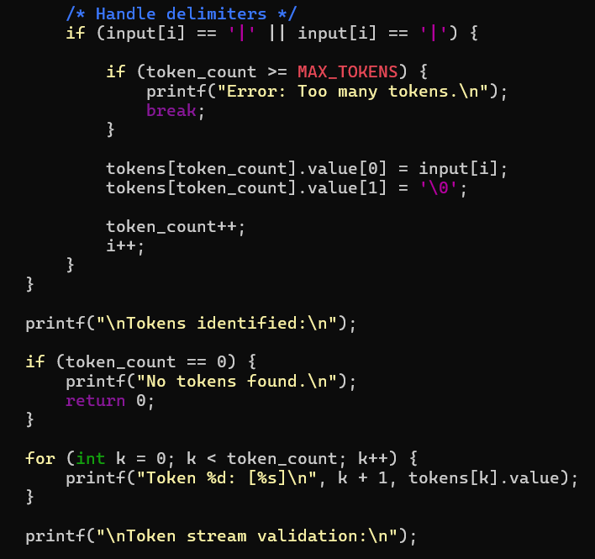
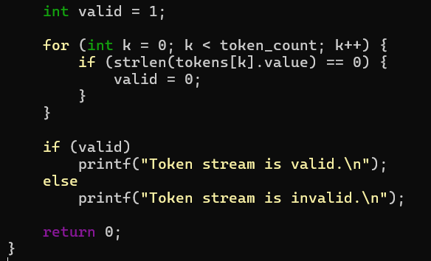

OUTPUT:
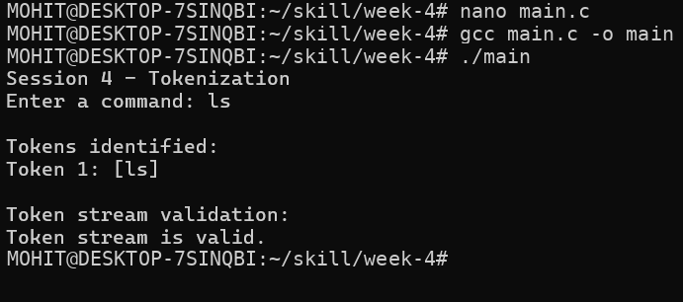
Task 2: To Design Parser Logic, Generate Parse Trees, Validate Syntax, Detect Errors, Handle Empty Commands, Produce Execution Structures.
CODE:
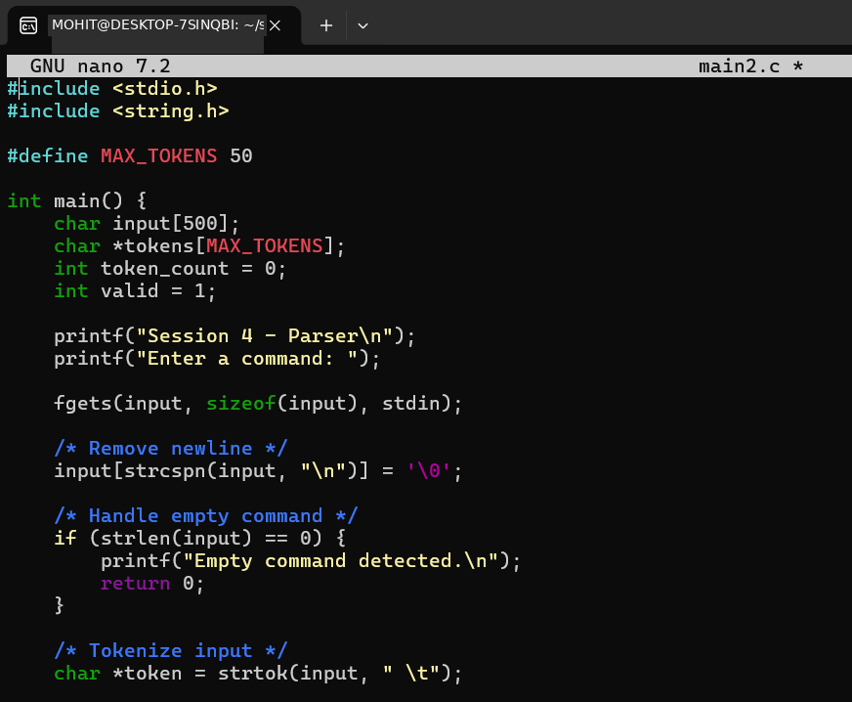
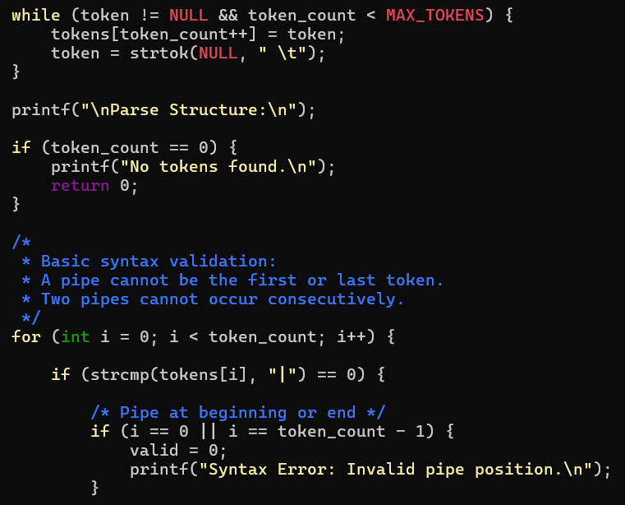
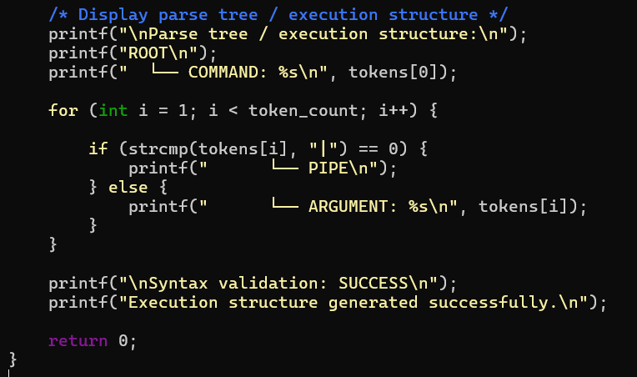
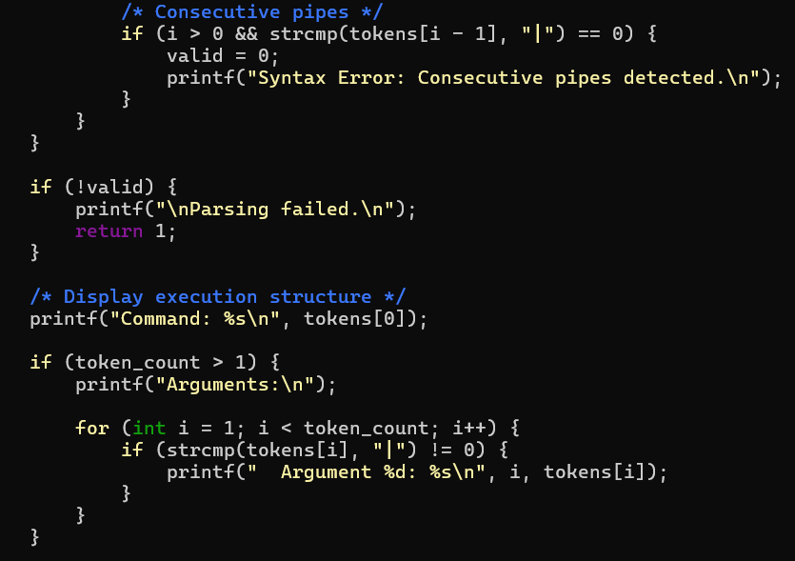

OUTPUT:
