Buono, Angelo http://maamodt.asp.radford.edu/Buono, Angelo.htm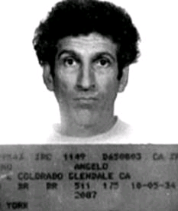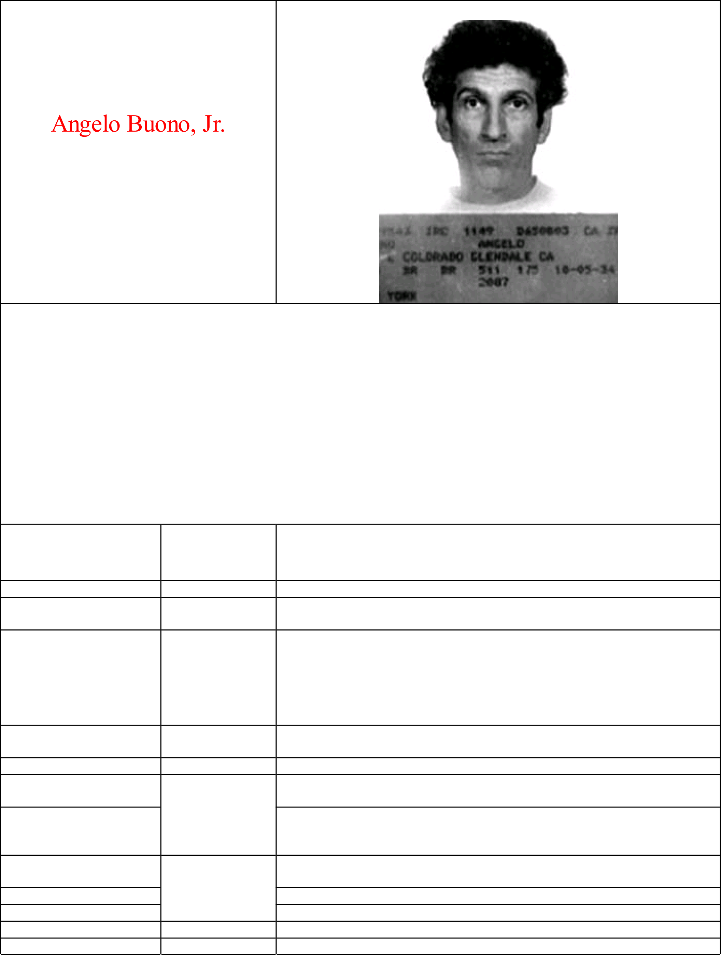

With Kenneth Bianchi, known as   
the*“Hillside Stranglers”*

Information summarized by   
*Jennifer Cable, Travis Hall, Brittney Hawks Meredith Hornsby, Amanda Howe*

Serial killer researched by   
*Kathy Futrell, Sean Reardon, Lauren Sade, Aaron Shank, Brandon Torrence*

Department of Psychology   
Radford University   
Radford, V A 24142-6946

|  |  |  |  |
| --- | --- | --- | --- |
| 1 of 9 | **Date** | **Age** | **Life Event** |
| October 5, 1934 | 0 | Angelo Buono is born in Rochester, New York. |
| 1939 | 5 | After his parents divorce, Angelo moves to Glendale, California with his mother Jenny, and his sister Cecilia. |
| 1948 | 14 | Angelo boasts to his friends about sodomizing and raping girls.  He idolizes Caryl Chessman, a notorious rapist known as the “red light bandit”. He considers Chessman to be his hero even though he thinks that Chessman should have killed his victims, instead of just sexually assaulting them. He begins calling his mother demeaning names like “whore” and“cunt”. |
| 1950 | 16 | Angelo drops out of school and is arrested several times for larceny. He is sent to reform school but escapes. |
| 1951 | 17 | Angelo is recaptured by the California Youth Authority |
| 1955 | 21 | Angelo impregnates Geraldine Vinal, a 17 year-old girl from his high school. He marries Geraldine only to leave her less than a week later. |
| January 10, 1956 | Michael Lee Buono, Angelo’s first child, is born.  He divorces Geraldine and refuses to pay child support. He also refuses to let Michael call him “father.” |
| Late 1956 | 22 | Angelo’s second son, Angelo Anthony Buono III, is born. The child’s mother is Angelo’s current girlfriend, Mary Catherine Castillo. |
| April 5, 1957 | Angelo marries Mary Castillo. |
| 1957 | 24 | Mary gives birth to their second child Peter (Angelo’s third child). |
| 1958 | Mary gives birth to their third child Danny (Angelo’s fourth child). |
| 1960 | 26 | Mary gives birth to their fourth son Louis (Angelo’s fifth child). |
| 9/16/2012 3:29 PM |

|  |  |
| --- | --- |
| Buono, Angelo | http://maamodt.asp.radford.edu/Buono, Angelo.htm |

|  |  |  |
| --- | --- | --- |
| 1962 | 28 | Mary gives birth to their fifth child, and first daughter, Grace (Angelo’s sixth child). |
| Angelo is jailed for five days |
| 1964 | 30 | Angelo is jailed again, this time for petty theft. |
| Angelo is believed to have raped his two year-old daughter, Grace.  *(Not enough supporting information was found to elaborate on this event)* |
| Mary files for divorce because of Angelo’s perverse sexual desires and his violence. He shows no concern of the fact that his children had witnessed all of the abuse he inflicted on their mother. |
| May 1964 | 29 | Mary tries to reconcile with Angelo. He handcuffs her and threatens to kill her after shoving a gun into her stomach. She does not try reconciling with Angelo again. |
| 1965 | 31 | Angelo moves in with Nanette Campina, a 25 year-old single mother of two children. He treats Nanette the same way he had treated Mary. Nanette doesn’t leave him for fear that he will kill her if she does. |
| 1967 | 33 | Angelo is arrested for stealing cars and sentenced to one year in prison. However, because of his large family, the sentence is suspended so that he may work.  *(There are conflicting dates as to when this arrest actually occurred. Some*  *sources report it as being 1967 while others report it as 1968)* |
| Nanette gives birth to her and Angelo’s first child together (Angelo’s 7th child), Tony. |
| 1969 | 35 | Nanette gives birth to their second child together (Angelo’s 8th child), Sam. |
| 1971 | 37 | Angelo begins to abuse Nanette’s 14 year-old daughter and claims that “she needs breaking in.” Angelo brags to his friends about raping the girl and claims that he then turned her over to his sons for their pleasure.  Nanette decides to risk everything to get away from Angelo. She takes the children and leaves the state. |
| 1972 | 38 | Angelo marries Deborah Taylor. The two never live together, and never bother to get a divorce. |
| 1972-1975 | 38-41 | Angelo’s roommate witnesses him masturbating as he watches school children with binoculars from their apartment window. Angelo admits to his roommate that he had forced his sons to rape his daughter and that he had sodomized one of his sons.  *(There are conflicting dates as to when Angelo’s confession to his roommate*  *actually occurred. Therefore a precise date is not available).* |
| 1975 | 41 | Angelo moves into his own place and opens up an upholstering shop in the back.  He frequently forces women to perform oral sex on him and often has sex with his sons’ girlfriends.  He has the reputation for being a “stud” and refers to himself as “The Italian Stallion.” Many young girls are attracted to Angelo and he begins dating a teenager and gets her pregnant twice. The girl aborts the first child and suffers a miscarriage during the second pregnancy. She stays loyal to Angelo, but he is promiscuous and keeps several other girlfriends at the same time. |
| Angelo’s adoptive cousin, Kenneth Bianchi, moves to L.A. to love with him. |
| September 1977 | 42 | Angelo and Kenneth discuss the idea of getting young girls to work for them as prostitutes. It is Angelo’s idea as a way for them to get money (as they are short on cash). They purchase a list of names of men who frequent prostitutes from Deborah Noble. Unbeknownst to Angelo and Kenneth, Deborah delivers a “trick list” and deceives them. |
| October 1977 | 43 | Deborah Noble and her friend Yolanda Washington deliver the list of men to Angelo. Yolanda is 19 years-old, a part-time waitress and a prostitute. Yolanda tells Angelo that she usually works a particular stretch on Sunset Boulevard.  Angelo and Kenneth soon find out that the list is a fake and seek out to get revenge for the money they paid. |
| October 17, 1977 | Angelo and Kenneth begin their rampage. They seek out Yolanda Washington, rape and strangle her in the back seat of Kenneth’s car. |

2 of 9 9/16/2012 3:29 PM

|  |  |
| --- | --- |
| Buono, Angelo | http://maamodt.asp.radford.edu/Buono, Angelo.htm |

|  |  |  |
| --- | --- | --- |
| October 18, 1977 |  | Washington’s boy is found near Universal City in a cemetery. She still has the fabric around her neck that was used to strangle her. |
| October 31, 1977 | Victim Two-Judith Miller, a 15 years-old runaway and prostitute. |
| November 1, 1977 | Miller’s body is found with ligature marks on her ankles, wrists, and neck. She has also been raped. |
| November 5, 1977 | Victim Three-Elissa Kastin, a 21 years-old waitress. |
| November 6, 1977 | Kastin’s nude body is found on a highway embankment. She is found with ligature marks similar to those found on Judith Miller. She has also been raped and sodomized. |
| November 9, 1977 | Victim Four-Jane King, a 28 year–old aspiring actress. |
| November 13, 1977 | Victims Five and Six- Sonja Johnson age 14 and Dolly Cepeda age 12. |
| November 20, 1977 | A nine year-old boy finds the bodies of Sonja Johnson and Dolly Cepeda in Highland Park. They too are found nude with ligature marks and had been raped.  Victim Seven- Kristina Weckler, a 20 year-old college student. She is found the same day with ligature marks on the inner arm and on her neck. |
| November 23, 1977 | Jane King’s body is found near Los Feliz off-ramp on the Golden State Freeway. She has been sodomized and strangled.  *(sources on the condition of King’s body coincide. Some say she had been raped, while others report that the body was so badly deteriorated that rape could not be definitively determined)* |
| November 28, 1977 | Victim Eight-Lauren Wagner, an 18 year-old student. |
| November 29, 1977 | Lauren Wagner’s body is found nude, strangled, and with electrical burns on her palms. She also has ligature marks on her body and had been raped. |
| December 13, 1977 | Victim Nine - Kimberly Martin, an 18 year-old call girl who went by the name of Donna*. Her body is found the same day in a vacant lot on a hillside. *\*(some sources report Martin’s name as Kimberly Diane Martin, while*  *others say she went by “Donna”)* |
| January 1978 | Angelo’s mother dies. |
| February 17, 1978 | Victim Ten-Cindy Hudspeth, a 20 year-old college student. Her body is found in the trunk of her car which had been pushed over a cliff. She is also found nude, raped, and with ligature marks on her body.  This is the last murder that Angelo and Kenneth participate in together, and Angelo’s final murder before being arrested and ultimately sent to prison. |
| October 22, 1979 | 45 | Angelo Buono is arrested after Kenneth Bianchi tells police of his and Angelo’s involvement in the murders. |
| July 6, 1981 | 46 | At the preliminary hearing Kenneth Bianchi testifies in court that he does not know if he was telling the truth or not when he told police of Angelo’s involvement in the murders. Due to this unexpected testimony by Bianchi, Roger Kelly, Buono’s attorney, moves to dismiss all 10 counts of murder against Angelo and to drop prosecution against him as a Hillside Strangler. |
| July 21, 1981 | Judge Ronald M. George, who had been appointed to hear the Buono case, denies Kelly’s motion to dismiss the charges against Angelo explaining that a dismissal would not be “in the furtherance of justice.” |
| 1981 | The District Attorney’s office withdraws from Angelo’s case and Attorney General George Deukmejian brings in two new attorneys for the prosecution, Michael Nash and Michael Boren. A special investigator, Paul Tulleners, is assigned to assist the new prosecutors in evaluating the evidence. After deciding that the evidence against Angelo is sufficient enough to prosecute him, it is decided that George Deukmejian will prosecute the case in court. |
| November 1981 | 47 | Angelo’s case finally goes to trial, but is disrupted by continuances which the defense appeals all the way to the California Supreme Court. |
| 1982 | Jury selection in the trial begins which lasts for three and a half months |
| Spring 1982 | Angelo’s trial finally begins and eventually becomes the longest trial in United States at the time. |
| 1982 – 1983 | 47-49 | Angelo’s trial continues for over a year.  Some of the witnesses in the trial include some of the girls that Angelo had abused and tormented, Becky Spears and Sabra Hannan.  Judge George and members of the jury were taken to the actual hillsides where |

3 of 9 9/16/2012 3:29 PM

|  |  |
| --- | --- |
| Buono, Angelo | http://maamodt.asp.radford.edu/Buono, Angelo.htm |

|  |  |  |
| --- | --- | --- |
|  |  | the victims were found and were given a presentation by the key detective at each site.  The prosecution finally produces a key witness, a young girl whom Angelo had a run-in with the night he and Kenneth killed Kimberly Martin. The girl testifies that Angelo had harassed and terrorized her in the Hollywood Library.  She was able to testify that Angelo had used a payphone in the library to call Kimberly Martin and lure her to him and Kenneth. These payphone calls had been part of the clues in Kimberly Martin’s death, but detectives could never prove who had made the calls.  The defense efforts of Angelo’s trial are short due to his non-cooperation with his attorneys. |
| October 21, 1983 | 49 | The jury in Angelo’s trial begins deliberations. |
| October 31, 1983 | The jury comes to the agreement that Angelo is guilty in the murder of Lauren Wagner. |
| November 3, 1983 | The jury finds Anglo not guilty in the murder of Yolanda Washington. |
| November 1983 | The jury finds Angelo guilty of the murder of Judy Miller, Dolores Cepeda, Sonja Johnson, Kimberly Martin, Kristina Weckler, Lisa Kastin, Jane King and Cindy Hudspeth.  After this decision Angelo is considered a “multiple-murderer” under California law, and will face either life in prison or capital punishment. |
| 1983 | Angelo takes the stand after jury deliberations end and claims “My morals and constitutional rights has been broken.” After the jury deliberates for an hour, they recommend life in prison without the possibility of parole for Angelo and spare him of the death penalty. The judge upholds the sentence.  Angelo is initially sent to Folsom Prison. Here he refuses to come out of his cell for fear of injury by other inmates. |
| 1983-1986 | 49-62 | Angelo is transferred from Folsom Prison to Calipatria State Prison in California.  *(exact date unknown)* |
| 1986 | 62 | Angelo marries Christine Kizuka while in prison. She is a supervisor at the Los Angeles office of the state employment development department and a mother to three children. She had met Angelo in prison when she came to visit her husband whose cell was next to Angelo’s. Kizuka had divorced her husband in 1983 and continued to visit Angelo in prison. Prison officials agreed to never allow conjugal visits between Angelo and Christine due to the nature of Angelo’s crimes and his history of violence against women. |
| September 21, 2002 | 67 | Angelo Buono dies at Calipatria State Prison from a heart condition. He is alone in his cell at the time of his death and officials rule out the possibility of any foul play. |
| **General Information** | | |
| Sex | | Male |
| Race | | White |
| Number of victims | | 10 |
| Country where killing occurred | | United States |
| States where killing occurred | | California |
| **Childhood Information** | | |
| Date of birth | | October 5, 1934 |
| Location | | New York State |
| Birth order | | 1st of ?  *(some sources report that Angelo had 2 sisters, while others say he had only one)* |
| Number of siblings | | 1 or 2  *(see comment above)* |
| XYY? | | Unknown |
| Raised by | | Mother – Jenny |
| Birth category | | Unknown  *(some sources report Angelo as being the oldest while others say his sister was 4 years older than him*) |

4 of 9 9/16/2012 3:29 PM

|  |  |
| --- | --- |
| Buono, Angelo | http://maamodt.asp.radford.edu/Buono, Angelo.htm |

|  |  |
| --- | --- |
| Parent’s marital status | Divorced |
| Family event | Parents divorce, and moves from New York to California with his mother and sister |
| Age of family event | 5 |
| Problems in school? | Yes –disruptive, demonstrates perverse sexual obsessions from a young age |
| Teased while in school? | Unknown |
| Physically attractive? | Yes |
| Physical defect? | No |
| Speech defect? | No |
| Head injury? | Unknown |
| Physically abused? | Unknown |
| Psychologically abused? | Unknown |
| Sexually abused? | Unknown, although his early interest in odd forms of sexual thrills may indicate some type of sexual abuse as a child. |
| Father’s occupation | Unknown, very little is known about Angelo’s father |
| Age of first sexual experience | Unknown |
| Age when first had intercourse | Unknown |
| Mother’s occupation | Unknown |
| Father abused drugs/alcohol | Unknown |
| Mother abused drugs/alcohol | Unknown |
| **Cognitive Ability** | |
| Highest grade in school | 9th, dropped out of school in 10th grade |
| Highest degree | None |
| Grades in school | Poor |
| IQ | Unknown |
| **Work History** | |
| Served in the military? | No |
| Branch | N/A |
| Type of discharge | N/A |
| Saw combat duty | N/A |
| Killed enemy during service? | N/A |
| Applied for job as a cop? | No |
| Worked in law enforcement? | No |
| Fired from jobs? | No |
| Types of jobs worked | Specialty trades (ex. – reupholstering) |
| Employment status during series | Angelo had been running his own re-upholstering shop in Los Angeles |
| **Relationships** |  |
| Sexual preference | Heterosexual |
| Marital status | Married a total of 4 times (including once while in prison); unmarried at time of murders |
| Number of children | 8 |
| Lives with his children | Does not live with children after he divorces their mothers |
| Living with | Kenneth Bianchi at the time of the murders |
| **Triad** | |
| Animal torture | Unknown |
| Fire setting | Unknown |
| Bed wetting | Unknown |
| **Killer Psychological Information** | |
| Abused drugs? | No |
| Abused alcohol? | No |
| Been to a psychologist? | Unknown |
| Time in forensic hospital? | No |
| Diagnosis | Sexual sadism, pedophile, anti-social personality disorder |
| **Killer Criminal History** | |
| Committed previous crimes? | Yes |
| Spend time in jail? | Yes |

5 of 9 9/16/2012 3:29 PM

|  |  |
| --- | --- |
| Buono, Angelo | http://maamodt.asp.radford.edu/Buono, Angelo.htm |

|  |  |
| --- | --- |
| Spend time in prison? | Yes |
| Killed prior to series? Age? | No |
| **Serial Killing 10-17-77 thru 2-16-78** | |
| Number of victims | 10 |
| Victim type | Vulnerable young women (prostitutes, low-income, students, low scale models and actresses) |
| Killer age at start of series | 43 |
| Gender of victims | Female |
| Race of victims | White, African-American |
| Age of victims | 12 - 28 |
| Method of killing | Strangulation, rape, various types of torture |
| Type of serial killer | Organized lust |
| How close did killer live? | Drove to crime |
| Killing occurred in home of victim? | No |
| Killing occurred in home of killer? | No |
| Weapon | No weapons, as most of the murders were ruled as death by strangulation. However, various items were used to tie and bound the victims. |
| Behavior During Crimes | |
| Rape? | Yes |
| Tortured victims? | Yes, as the murders progressed the detectives investigating saw the Hillside Stranglers experimenting more and more with methods of torture. |
| Stalked victims? | No |
| Overkill? | Yes |
| Quick & efficient? | No, torture was evident |
| Used blindfold? | No |
| Bound the victims? | Yes, ligature marks on the victims hands and feet were the “calling card” of the Hillside Stranglers. |
| After Death Behavior | |
| Sex with the body? | No |
| Mutilated body? | No |
| Ate part of the body? | No |
| Drank victim’s blood? | No |
| Posed the body? | Yes |
| Took totem – body part | No |
| Took totem – personal item | Yes |
| Robbed victim or location | No |
| Disposal of Body | |
| Left at scene, no attempt to hide | No |
| Left at scene, hidden | No |
| Left at scene, buried | No |
| Moved, no attempt to hide | Yes – once murdered, the bodies were moved to remote locations near hillsides |
| Moved, buried | No |
| Cut-up and disposed of | No |
| Moved, to home | No |
| Sentencing |  |
| Date killer arrested | October 22, 1979 |
| Date convicted | November 18, 1983 |
| Sentence | Life in prison |
| Killer executed? | No |
| Name and state of prison | Calipatria State Prison - California |
| Killer committed suicide? | No |
| Killer killed in prison? | No |
| Date of death | September 21, 2002 |
| **References** | |

6 of 9 9/16/2012 3:29 PM

|  |  |
| --- | --- |
| Buono, Angelo | http://maamodt.asp.radford.edu/Buono, Angelo.htm |

|  |
| --- |
| **Multimedia:**  The Hillside Stranglers (videotape) (1998). Arts and Entertainment Television. Mind of a killer. (1995). Chatsworth, CA: Kozel Multimedia.  **Articles:**  Candida, F. (1981, July 7). Hillside Strangler Case: The 2 faces of Bianchi. *Los*  *Angeles Times.*  Farr, B. (1981, July 26). Prosecution memos list holes in strangler case. *The*  *Los Angeles Times.*  They’ll be back. (1997). *Newsweek, 129 (11),* 12-13.  Wilson, W. (1981, May 13). Stranglers’ power of psychological manipulation. *Sacramento Bee.*  Wilson, W. (1981, May 12). The Bianchi case: finding a labyrinth of personalities. *Sacramento Bee.*  Wilson, W. (1981, May 10). Tragedy’s evidence ignored too long. *Sacramento*  *Bee.*  Wilson, W. (1981, May 14). Was Buono just Bianchi’s dupe in Hillside Stranglings? *Sacramento Bee.*  **Books:**  Newton, Michael (1990). Hunting Humans: An Encyclopedia of Modern Serial Killers. Loompanics Unlimited: Port Townsend, Washington.  O’Brien, Darcy. (1985). *Two of a Kind: The Hillside Stranglers.* New York: New American Library.  Schwarz, Ted. (2001). *The Hillside Strangler*. NY: Vivisphere Publishing **Websites:**  http://carpenoctem.tv/killers/hillside.html*  http://llr.lls.edu/volumes/v33-issue2/boren.pdf*  http://www.angelfire.com/oh/yodaspage5/hillside.htm**  http://www.angelfire.com/oh/yodaspage5/report2.htm**  http://www.crimelibrary.com/serial_killers/predators/straglers/rampage_1.html* http://www.crimeweb.homestead.com/Hillside-ns4.html**  http://www.hillside-strangler.com*  http://www.macalester.edu/~whathap/UBNRP/serialkillers/ken_bianchi.html** |

7 of 9 9/16/2012 3:29 PM

|  |  |
| --- | --- |
| Buono, Angelo | http://maamodt.asp.radford.edu/Buono, Angelo.htm |

|  |
| --- |
| http://www.pbs.org/wgbh/pages/frontline/progrms/transcripts/207.html* **\* - New websites used for information summary**  **\*\* - Websites originally used for** |
| **REFERENCES**  **Multimedia:**  The Hillside Stranglers (videotape) (1998). Arts and Entertainment Television. Mind of a killer. (1995). Chatsworth, CA: Kozel Multimedia.  **Articles:**  Candida, F. (1981, July 7). Hillside Strangler Case: The 2 faces of Bianchi. *Los*  *Angeles Times.*  Farr, B. (1981, July 26). Prosecution memos list holes in strangler case. *The*  *Los Angeles Times.*  They’ll be back. (1997). *Newsweek, 129 (11),* 12-13.  Wilson, W. (1981, May 13). Stranglers’ power of psychological manipulation. *Sacramento Bee.*  Wilson, W. (1981, May 12). The Bianchi case: finding a labyrinth of personalities. *Sacramento Bee.*  Wilson, W. (1981, May 10). Tragedy’s evidence ignored too long. *Sacramento*  *Bee.*  Wilson, W. (1981, May 14). Was Buono just Bianchi’s dupe in Hillside Stranglings? *Sacramento Bee.*  **Books:**  Newton, Michael (1990). Hunting Humans: An Encyclopedia of Modern Serial Killers. Loompanics Unlimited: Port Townsend, Washington.  O’Brien, Darcy. (1985). *Two of a Kind: The Hillside Stranglers.* New York: New American Library.  Schwarz, Ted. (2001). *The Hillside Strangler*. NY: Vivisphere Publishing **Websites:**  http://carpenoctem.tv/killers/hillside.html*  http://llr.lls.edu/volumes/v33-issue2/boren.pdf*  http://www.angelfire.com/oh/yodaspage5/hillside.htm**  http://www.angelfire.com/oh/yodaspage5/report2.htm** |

8 of 9 9/16/2012 3:29 PM

|  |  |
| --- | --- |
| Buono, Angelo | http://maamodt.asp.radford.edu/Buono, Angelo.htm |

|  |
| --- |
| http://www.crimelibrary.com/serial_killers/predators/straglers/rampage_1.html* http://www.crimeweb.homestead.com/Hillside-ns4.html**  http://www.hillside-strangler.com*  http://www.macalester.edu/~whathap/UBNRP/serialkillers/ken_bianchi.html** http://www.pbs.org/wgbh/pages/frontline/progrms/transcripts/207.html*  **\* - New websites used for information summary**  **\*\* - Websites originally used for research but are no longer active** |

|  |  |
| --- | --- |
| 9 of 9 | 9/16/2012 3:29 PM |