HOME PAGE :
Book Free Consultation – ( Get Enquiry): Here Same Details as “ APPLY NOW” page.
It will have to go direct contact us Page.
APPLY NOW :
Name :
Mob No: Start with +91
Mil ID : Mail id Should be correct entry.
Apply for: Display All services
TALK TO EXPERT:
While clicking on this Directly it connected to Mob no.
CHAT ON WHATS APP:
It will directly connected into whats app chat.
GET INSTANT CHECK ELIGIBILITY:
Display Loan Calc.
Name :
Income Type : Busyness or SAL
Age : ( Sal – Max Age 60 / for Business people Max age 70 Years)
Net Sal : If they select Business then It should be Display Avg Monthly Income.
Any Obligations:
check eligibility.

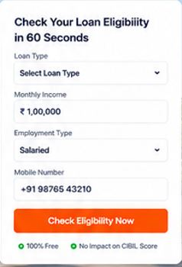
Backend Develop:
Net sal * 60% - Obligations = Net Income / Per lac EMI.
Here Age factor should be consider based on profile.

OUR SERVICES :
While clicking on this services that main page should be open.

EMI CALCULATER :
Home Loans :
Loan amount : Put Max Loan 20 cr.
Interest rate : Put starting 5 to 30 %
Loan Tenure : Max 30 years .
write Your Valuable Feed Back Here:
Name :
Profession : Salaried or Business.
Mon No : Start with + 91
Mial Id :
Photo : Your Identity safe Here.
Feed Back Box : ( Max 300 letters).
Rating : *****
Submit
Note : All Feedbacks will be display after checking backend. Need option this

- OUR BANKING PARTNESR SHILD BE DISPLAY SAME AS HOME PAGE DISPLAY .
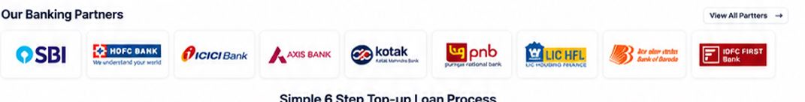
- DIPLAY ALL FAQ IN BOTTOM PAGE : Hide Answers , after click that question then only the answer will be open which is Related to that Page.
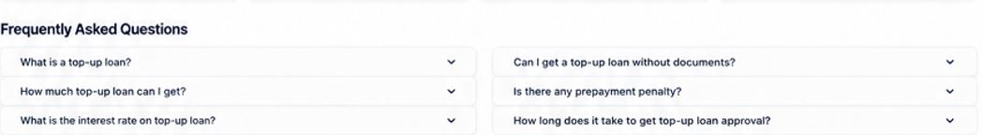

ABOUT US PAGE :
Book Free Consultation – ( Get Enquiry): Here Same Details as “ APPLY NOW” page.
It will have to go direct contact us Page.

APPLY NOW :
Name :
Mob No: Start with +91
Mil ID : Mail id Should be correct entry.
Apply for: Display All services
After click “ know more about Us”
KLL Financial & Marketing Services, established in 2015, is a trusted financial services company providing Home Loans, Mortgage Loans, Professional Loans, Business Loans, Personal Loans, Insurance Services, Income Tax Filing, and Property Services.
To become a trusted one-stop financial and property services partner, helping individuals and businesses achieve their financial goals through simple, transparent, and reliable solutions.
With access to 40+ Banks & NBFCs and a customer-first approach, we provide personalized solutions, transparent guidance, and end-to-end assistance—from eligibility and documentation to approval and completion.
Since 2015, we have been committed to making financial decisions simpler, smarter, and more accessible.

TALK TO AN EXPERT AND CHAT ON WHATS SAME AS HOME PAGE
- OUR BANKING PARTNESR SHILD BE DISPLAY SAME AS HOME PAGE DISPLAY .

- DIPLAY ALL FAQ IN BOTTOM PAGE : Hide Answers , after click that question then only the answer will be open which is Related to that Page.

