Karnataka Law Society’s

**GOGTE INSTITUTE OF TECHNOLOGY**

UDYAMBAG, BELAGAVI – 590010

(An Autonomous Institution under Visvesvaraya Technological University, Belagavi)

**Approved by AICTE, New Delhi**

Department of Computer Science and Engineering



**A Project Report on**

***“BookMyBus”***

**Submitted By:**

**Sanjana D. Kamakar 2GI19CS419**

**Laxmi Suresh Naik 2GI19CS411**

**Owais Shaikh 2GI19CS414**

**Pranali Prakash Hake 2GI19CS409**

**GUIDE: Prof. Gajendra Deshpande HOD: Dr. Vijay S. R.**

**2020 – 2021**

**CERTIFICATE**



*This is to certify that the project entitled “BookMyBus”**is a bonafide record of the Project work done by* ***Sanjana D. Kamakar*** *(2GI19CS419),* ***Laxmi Suresh Naik*** *(2GI19CS411),* ***Owais Shaikh*** *(2GI19CS414)* and ***Pranali Prakash Hake*** *(2GI19CS409)*,*under my supervision and guidance, in partial fulfillment of the requirements for the Outcome Based Education paradigm in Computer Science & Engineering from the Gogte Institute of Technology, Belgaum for the academic year 2020-21.*

**Prof. Gajendra Deshpande *Dr.Vijay S. R.***

###### *Asst. Professor Professor & Head*

*Dept. of Computer Science and Engg.*

Place: KLS Gogte Institute of Technology, Belgaum.

Date: – 12 – 2020

**ACKNOWLEDGEMENT**

This group feels indebted to the Computer Science & Engineering Department, for the giving us the oppurtunity to undertake the *“BookMyBus”* project. This project includes thoughts and contributions of many individuals. And we would like to express our appreciation and gratitude to them.

First and foremost we want to extend our gratitude to our lecturer, *Prof. Gajendra Deshpande,*for sharing his knowledge and profound wisdom with us. We appreciate all his comments and suggestions, which are incorporated into this project.

We would also like to express our gratitude towards our group members. Without their help, support, and encouragement, this project would have never been completed.

In our respect, this project is an outcome of the learning experiences we have shared with our fellow students. We dedicate this project to all our fellow friends, acquaintances and engineering students.

***Sanjana D. Kamakar,***

***Laxmi Suresh Naik,***

***Owais Shaikh and***

***Pranali Prakash Hake***

**Course Project Report and Presentation Content**

1. Title

2. Problem statement for that the project

3. Objectives of defined problem statement

4. Design / Algorithm / Flowchart / Methodology

5. Implementation details / Function / Procedures / Classes and Objects (Language / Tools)

6. Working model of the final solution

7. Report and oral presentation skill

**Marks allocation:**

|  |  |  |  |  |  |  |
| --- | --- | --- | --- | --- | --- | --- |
|  | Batch No. : | | | | | |
| 1. | Project Title: | Marks Range | USN | | | |
| 2GI19CS419 | 2GI19CS411 | 2GI19CS414 | 2GI19CS409 |
| 2. | Problem statement (PO2) | 0-1 |  |  |  |  |
| 3. | Objectives of defined problem statement (PO1, PO2) | 0-2 |  |  |  |  |
| 4. | Design/algorithm/flowchart/methodology (PO3) | 0-3 |  |  |  |  |
| 5. | Implementation details  /Function/Procedures/ Classes and Objects (Language/Tools) (PO1, PO3, PO4, PO5) | 0-4 |  |  |  |  |
| 6. | Working model of the final solution (PO3, PO12) | 0-5 |  |  |  |  |
| 7. | Report and Oral presentation skill (PO9, PO10) | 0-5 |  |  |  |  |
|  | Total | 20 |  |  |  |  |

**\* 20 marks is converted to 10 marks for CGPA calculation**

**1. Engineering Knowledge:** Apply the knowledge of mathematics, science, engineering fundamentals and an engineering specialization to the solution of complex engineering problems.

**2. Problem Analysis:** Identify, formulate, review research literature, and analyze complex engineering problems reaching substantiated conclusions using first principles of mathematics, natural sciences and Engineering sciences.

**3. Design/Development of solutions:** Design solutions for complex engineering problems and design system components or processes that meet the specified needs with appropriate consideration for the public health and safety, and the cultural, societal, and environmental considerations.

**4. Conduct investigations of complex problems:** Use research-based knowledge and research methods including design of experiments, analysis and interpretation of data, and synthesis of the information to provide valid conclusions.

**5. Modern tool usage:** Create, select, and apply appropriate techniques, resources, and modern engineering and IT tools including prediction and modeling to complex engineering activities with an understanding of the limitations.

**6. The engineer and society:** Apply reasoning informed by the contextual knowledge to assess societal, health, safety, legal and cultural issues and the consequent responsibilities relevant to the professional engineering practice.

**7. Environment and sustainability:** Understand the impact of the professional engineering solutions in societal and environmental contexts, and demonstrate the knowledge of, and need

for sustainable development.

**8. Ethics:** Apply ethical principles and commit to professional ethics and responsibilities and norms of the engineering practice.

**9. Individual and team work:** Function effectively as an individual and as a member or leader in diverse teams, and in multidisciplinary settings.

**10. Communication:** Communicate effectively on complex engineering activities with the engineering community and with society at large, such as, being able to comprehend and write effective reports and design documentation, make effective presentations, and give and receive clear instructions.

**11. Project management and finance:** Demonstrate knowledge and understanding of the engineering management principles and apply these to one's own work, as a member and leader in a team, to manage projects and in multidisciplinary environments.

**12. Life-long learning:** Recognize the need for and have the preparation and ability to engage in independent and lifelong learning in the broadest context of technological change.

**TABLE OF CONTENTS**

**1.** Introduction

1.1 Full Stack Development and AMP … 1

1.2 Apache Server … 1

1.3 MySQL and MariaDB … 1

1.4 PHP and phpMyAdmin … 1

**2.**  Proposed System … 2

**3.** Objectives … 2

**4.** Requirements Specification

4.1 Functional Requirements … 3

4.2 Non-functional Requirements … 3

4.3 Hardware Requirements … 3

4.4 Software Requirements … 4

**5.** Project Artifacts

5.1 Entity-Relationship Diagram (ERD) … 4

5.2 Class Diagram … 4

5.3 Use Case Diagram … 5

5.4 Sequence Diagram … 6

5.5 Activity Diagrams … 6

**6.** Demo and Testing

6.1 Screenshots … 7

6.2 Test Cases … 7

**7.** Conclusion … 10

References … 11

***BookMyBus***

**Chapter 1. Introduction**

1.1 **Full Stack Development and AMP**

A full stack web developer is a person who can develop both client and server software. In addition to mastering HTML and CSS, he/she also knows how to: program a browser (like using JavaScript), a server (like PHP), and a database (like SQL).

In this project, we’ve elected to use the LAMP stack. LAMP is the combination of the most frequently used software packages to build dynamic websites. LAMP is an abbreviation that uses the first letter of each of the packages included in it: Linux, Apache, MariaDB, and PHP.

1.2 **Apache**

Apache is the most widely used web server software. Developed and maintained by Apache Software Foundation, Apache is an open source software available for free. It runs on 67% of all webservers in the world. It is fast, reliable, and secure. It can be highly customized to meet the needs of many different environments by using extensions and modules. Most WordPress hosting providers use Apache as their web server software. However, WordPress can run on other web server software as well.

1.3 **MySQL and MariaDB**

MySQL is a database management system that allows you to manage relational databases. It is open source software backed by Oracle. If you want, you can change its source code to suit your needs. Even though MySQL is open source software, you can buy a commercial license version from Oracle to get premium support services. MySQL is easy to master in comparison with other database software like Oracle Database, or Microsoft SQL Server. MySQL can run on various platforms UNIX, Linux, Windows, etc. You can install it on a server or even in a desktop. Besides, MySQL is reliable, scalable, and fast.

1.4 **PHP and phpMyAdmin**

The PHP Hypertext Preprocessor (PHP) is a programming language that allows web developers to create dynamic content that interacts with databases. PHP is basically used for developing web based software applications. This tutorial helps you to build your base with PHP. PHP started out as a small open source project that evolved as more and more people found out how useful it was. Rasmus Lerdorf unleashed the first version of PHP way back in 1994. phpMyAdmin is a free and open source administration tool for MySQL and MariaDB. As a portable web application written primarily in PHP, it has become one of the most popular MySQL administration tools, especially for web hosting services.

1

**Chapter 2. Proposed System**

Clients need a comprehensive online bus booking system where their customers can do the booking online easily and save their time of joining a long queue to buy ticket. They also want to include advanced features such as, hotel room booking during the stay at destination, Seat booking at their shop floor by their counter operators, agent login for seat booking are few major necessities. They asked for options to collect the cash online using the payment gateway method as well as direct cash. The customers must be able to take the print out of their e-tickets. At the back end, the administrator of the web application should be able to manage the trips, ticket rates, coach seating, discounts and also can generate trip sheet with passenger details. The passenger details must possess passport details, age eligibility, etc. Thus, BookMyBus was made.

**Chapter 3. Objectives**

BookMyBus currently aims to maintain the transport company’s process manually which is a very time consuming process. It deals with booking and transport maintenance, so it becomes a very tedious job for the ticket booking transporter to look after these particulars to complete the task at right time. The system not only deals with transporters owned vehicles but also takes into consideration about the other types project of system transport vehicles available with other transporters.

* This system will lead to increase in the ticket booking efficiency of the project Staff and members of booking agencieswith little throughput.
* This system is made as user friendly as possible so that any one can use it with little knowledge of system computers.
* BookMyBus provides up-to-date information that is very slow manually.
* The objective of our project is to make easy the ticket booking project system of Ticket Booking Agency simple, reliable, user friendly, and corrective. Moreover less time consuming as compared to manual work.

2

**Chapter 4. Requirements Specification**

4.1 **Functional Requirements**

**Passenger Domain**

* The passengers book tickets.
* Passengers can cancel tickets.
* Passengers can view status

**Staff Domain**

* Staff has database control
* Staff can view fleet, drivers and passengers
* Staff can cancel tickets

4.2 **Non-Functional Requirements**

Non-functional requirements are requirements that are not compulsory, but add a nice feature to the application, such as UI Design, notifications, animations etc.

* Easy-to-use user interface design.
* Use of lightweight and fast-loading components like CSS headers.
* Minimalist user interface.
* Notifying users of errors in an obvious manner.

4.3 **Hardware Requirements**

***Server***

* Any Intel Core / ARM-based / Apple Silicon 32-bit device @ 768MHz or more
* Minimum 512MB of RAM
* Minimum 1GB of Internal Storage
* Connectivity to a network

***Client***

* Any Intel Core / ARM-based / Apple Silicon 32-bit device @ 768MHz or more
* Minimum 512MB of RAM
* Minimum 10MB of Internal Storage
* Connectivity to the Internet via WiFi / Cellular Data / Ethernet
* Android devices with 64-bit ARMv7 architecture (32-bit and Intel x86 unsupported)

3

4.4 **Software Requirements**

***Server***

* An Apache server
* PHP 5 or newer and phpMyAdmin
* A MySQL / MariaDB Database

***Client***

* Mozilla Firefox / Google Chrome / Microsoft Edge or any modern browser

**Chapter 5. Project Artifacts**

5.1 **Entity-Relationship Diagram (ERD)**

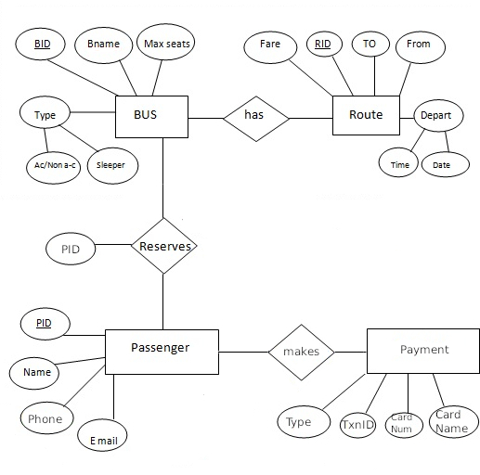

4

5.2 **Class Diagram**

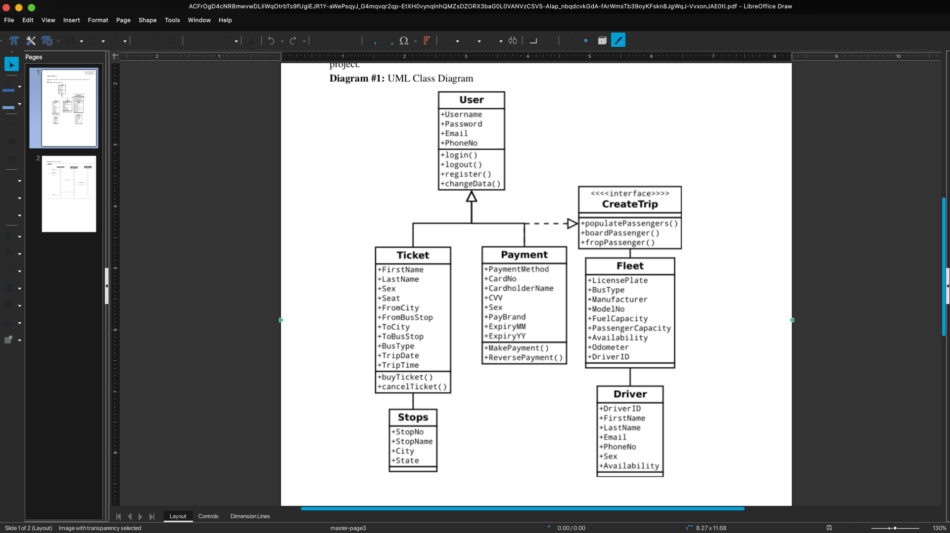

5.3 **Use Case Diagram**

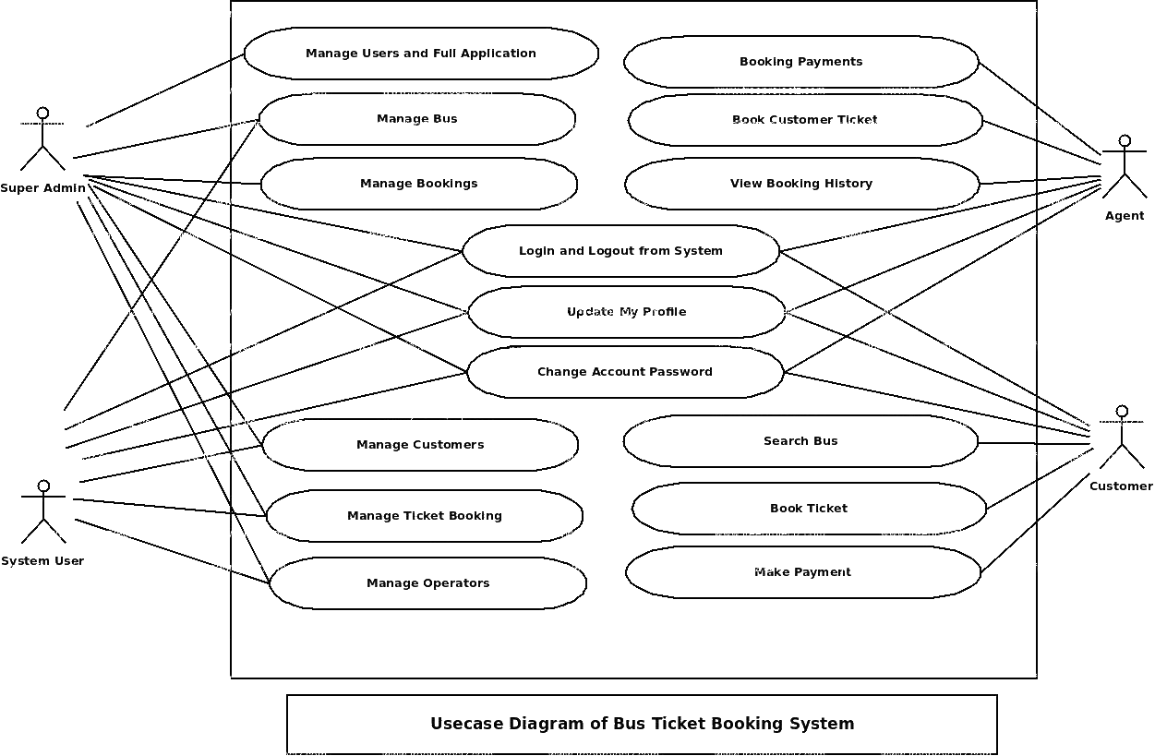

5

5.4 **Sequence Diagram**

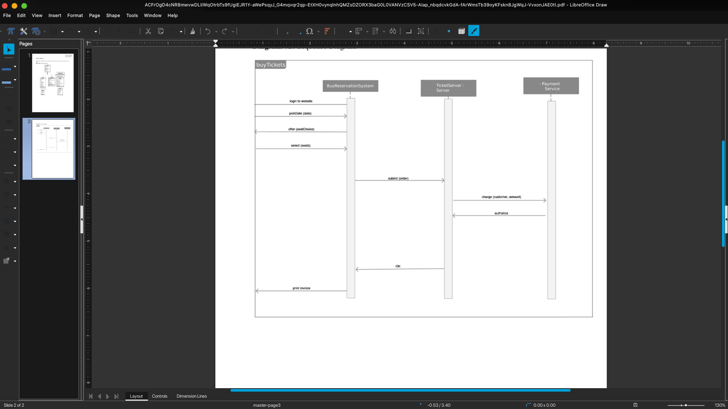

5.5 **Activity Diagram**

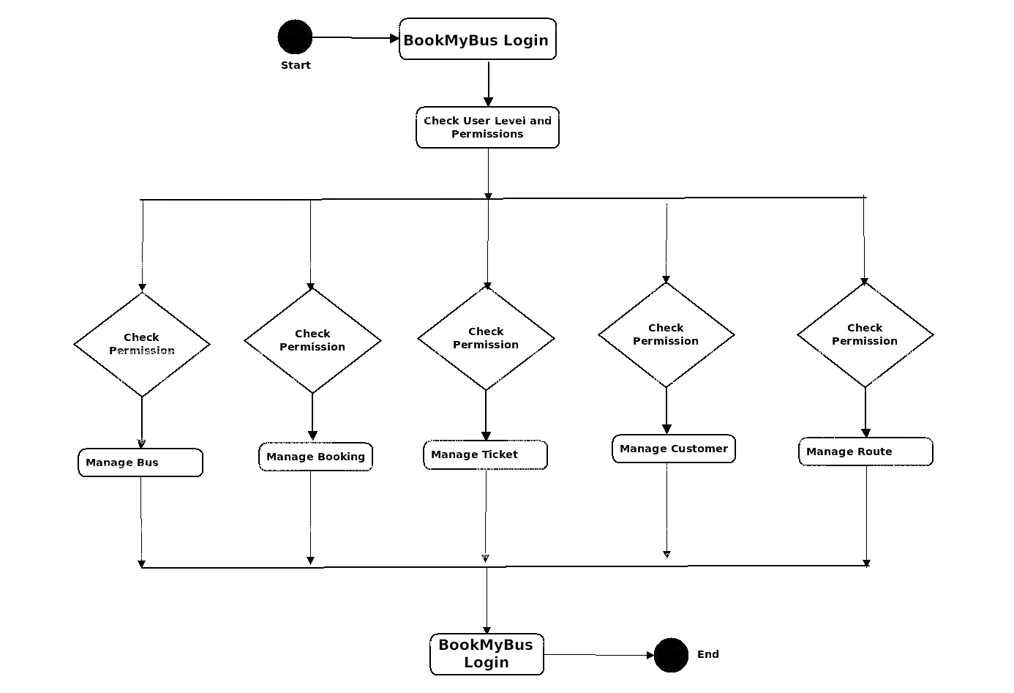

6

**Chapter 6. Demo and Testing**

6.1 **Test Cases**

|  |  |  |  |  |
| --- | --- | --- | --- | --- |
| **TEST CASE** | **TEST DATA** | **EXPECTED RESULT** | **ACTUAL RESULT** | **STATUS** |
| Booking tickets and seats with all valid inputs | Valid Text Inputs  Valid Button Inputs  Valid dropdowns  Click “NEXT >” | Payments page opens | Payments page opens | Pass |
| Entering valid payment information | Valid Credit Card  Valid CVV  Valid dropdowns  Click “NEXT >” | Receipt page opens | Receipt page opens | Pass |
| Entering invalid payment information | Invalid Credit Card  Valid CVV  Invalid dropdowns  Click “NEXT >” | Error page displays | Error page displays | Fail |
| Cancelling tickets | Valid Transaction ID  Click “NEXT >” | Cancellation success page displays | Cancellation success page displays | Pass |

6.2 **Screenshots**

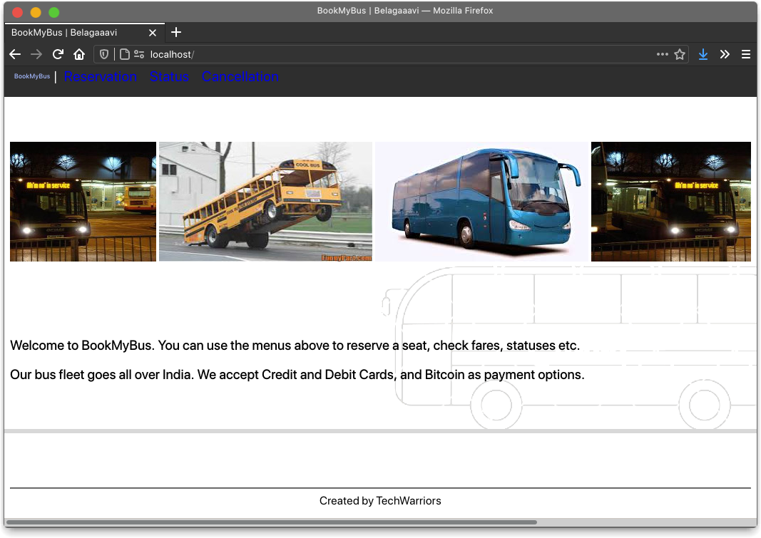

7

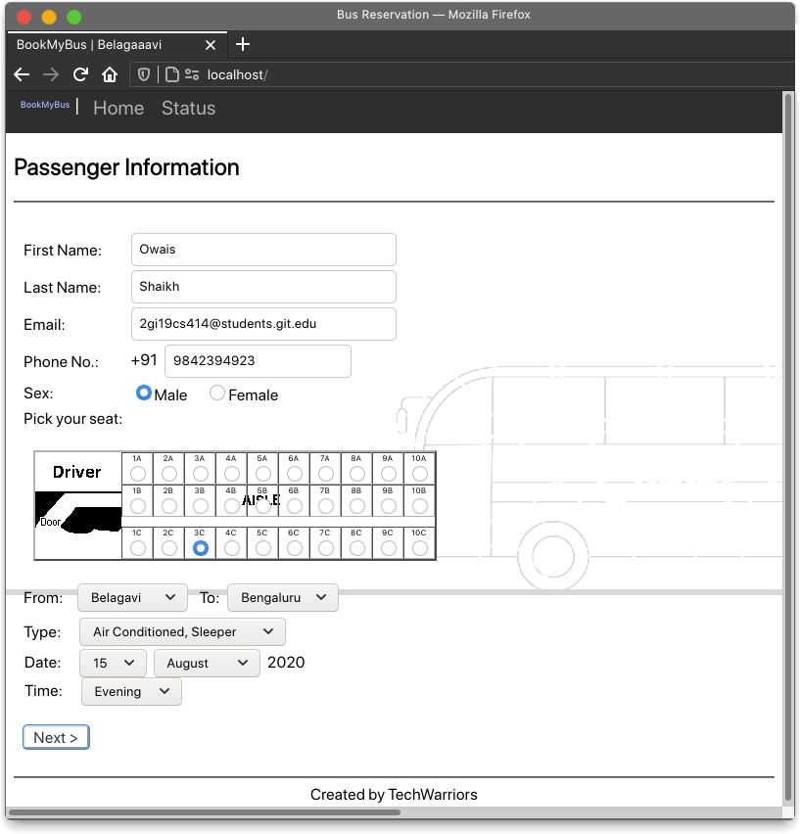

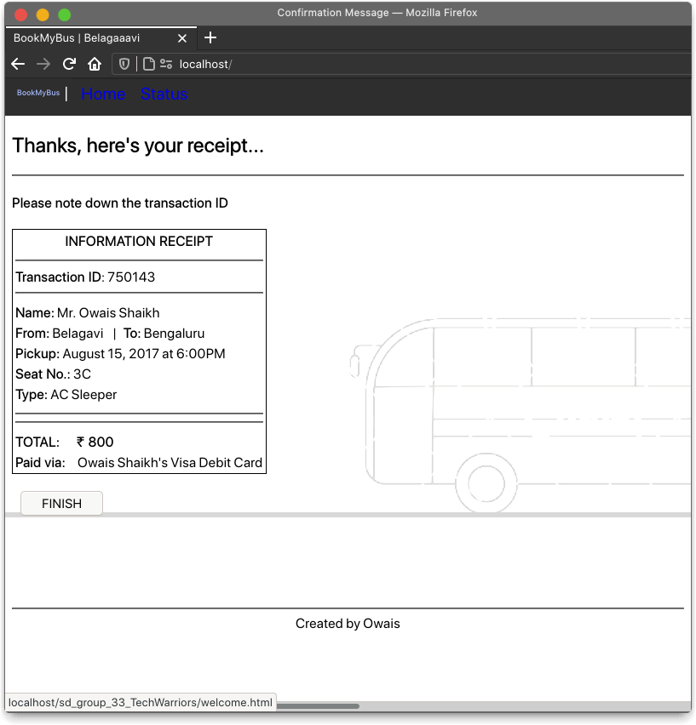

8



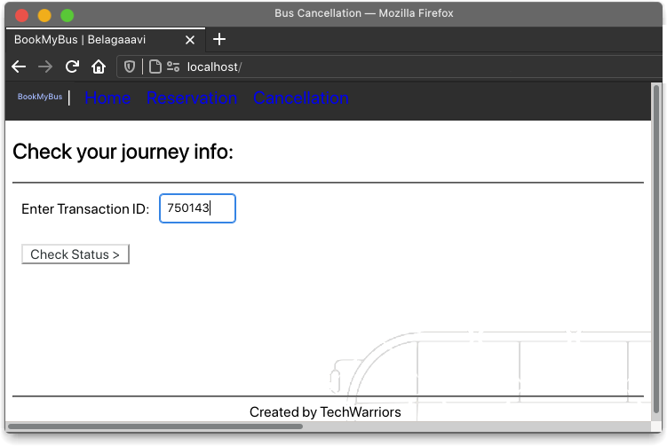

9

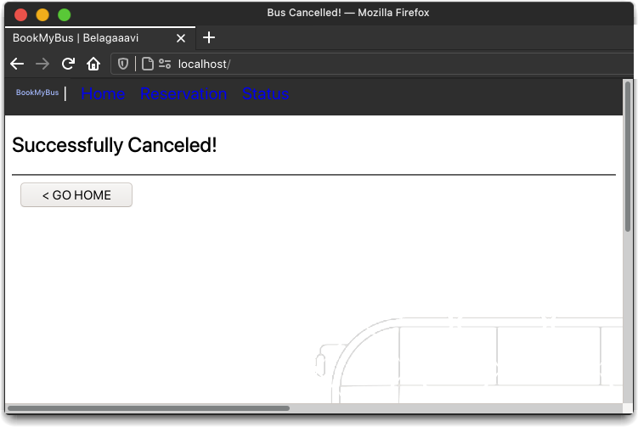

**Chapter 6. Conclusion**

With the BookMyBus site, the client can reach the vast number of customers. Tourists can book the tickets from their home even out of country. They can save time spent by standing in queue for purchase of your tickets, cancel the reserved tickets at any whenever required from online, postpone travel, pay online using online payment facility, take ticket printouts.

We also learned about LAMP, and how LAMP can be used to meet the needs of many different environments by using extensions and modules, and why it is the most frequently used software to build dynamic websites. We did a detailed study of the client’s requirement and designed a very comprehensive online bus booking system that would save both time and money. The system had all requested features for e- ticket booking, booking cancel, postponement, advance booking with expected dates etc.

10

**References**

**[ 1 ] Programming the World Wide Web –** *Robert Sebesta*, 5th Edition, ISBN-13: 978- 0133775983

**[ 2 ] Software Engineering Virtual Labs –**  *http://vlabs.iitkgp.ernet.in/se/*

**[ 3 ] Apache –**  *https://www.apache.org/*

**[ 4 ] MySQL –** [*https://www.mysql.com/*](https://www.mysql.com/)

**[ 5 ] MariaDB –** *https://mariadb.org/*

**[ 6 ] PHP –**[*https://www.php.net/*](https://www.php.net/)

**[ 7 ] phpMyAdmin –**[*https://www.phpmyadmin.net/*](https://www.phpmyadmin.net/)

**[ 8 ] W3Schools –***https://www.w3schools.com/*

*This project can be found at https://github.com/KLS-Gogte-Institute-of-Technology-bgm/sd-lab-project-group_5thsem_techwarriors*

11