



INTELLI-GATE: AN IOT-BASED SMART GATE SYSTEM WITH TEMPERATURE SCREENING, HEADCOUNT MONITORING, AND METAL DETECTION

SCHOOL OF ENGINEERING, COMPUTER STUDIES AND ARCHITECTURE
BACHELOR OF SCIENCE IN INFORMATION TECHNOLOGY

CAYAO, JOHN LIAN T.
TACDORO, DIETHER J.
PONCE, JAPHETH IVAN P.

December 2026
Table of Contents

- Introduction
  - Background of the Study 1
  - Statement of the Problem 3
  - Objectives of the Study 4
  - Significance of the Study 5
  - Scope and Limitations 5
- Review of Related Literature
  - Related works 7
  - Theoretical Framework 11
    - Type of System (Decision Support System) 11
  - Conceptual Framework 20
- Methodology
  - Research Design 22
3.2 Materials 22
    - Hardware 22
    - Software 22
3.3 Methods 22
    - SDLC – (Models example: Agile, Waterfall, Spiral, etc.) 23
    - Data Flow Diagram 23
    - Use Case Diagram 23
    - Data Dictionary 23
    - Entity Relationship Diagram 23
3.4 Project Timeline 22
3.5 Risk Analysis 22
3.6 Estimated Cost 22
- Preliminary Works
  - Prototypes 32
- Work Plan 35
  - Gantt Chart 32
References

Chapter 1
Introduction
  - Background of the Study
Campus entrances serve as important checkpoints where security, health screening, and crowd monitoring take place. However, many schools still rely on manual and disconnected procedures to manage these functions. Headcounts may be estimated visually or recorded by hand, which can result in errors during peak hours. Temperature screening often uses handheld devices that may slow down entry, while metal detection is commonly performed using standalone equipment.
Despite this, most campuses still depend on traditional methods. Headcounts are often estimated visually or logged by hand, prone to error during peak hours. Temperature screening relies on handheld scanners that slow foot traffic, while metal detection uses standalone detectors disconnected from any headcount or temperature system, three related functions carried out separately.
Internet of Things (IoT) sensing has progressed on each function individually, but the literature treats them separately. Non-contact infrared systems can capture temperature while tallying entries through one sensor pathway [1]. Passive Infrared (PIR) sensors are widely used for entrance headcounting because they are inexpensive and privacy-preserving., though placement affects its accuracy [2]. Campus-scale Internet of Things (IoT) architectures can reliably transmit sensor data for centralized monitoring [3]. Coil-based metal detection sensors can detect the presence of metallic objects by sensing changes in an electromagnetic field, providing a practical approach for integrating metal detection into an automated entrance system [4]. Zone-based metal detection remains the standard for localizing concealed objects [5], with ISO/IEC 25010 offering recognized benchmarks for evaluation [6]. What the literature lacks is a single low-cost platform unifying all three functions for a school gate comparable options remain costly, out of reach for budget-limited institutions.
Intelli-gate addresses this gap by unifying temperature screening, headcount monitoring, and metal detection into a single Internet of Things (IoT)-based smart gate, using coil-based metal detection sensors together with other sensing components and a Raspberry Pi to process and transmit sensor readings to a locally monitored LCD display.
  - Statement of the Problem

Statement of the Problem
Educational institutions generally rely on manual and disconnected methods for monitoring entrances. Headcounts are typically estimated through visual observation, a method well documented as tedious and prone to error compared to automated counting approaches [6]. Temperature screening still depends heavily on handheld infrared thermometers, whose accuracy is known to vary with the operator and the distance at which they are held, creating both delays and inconsistent readings at the point of entry [7]. Detection of prohibited or metallic objects is largely limited to manual bag searches and hand-wanding, processes documented as slow, one-at-a-time, and prone to human error [8]. Because these processes are never consolidated into a single monitoring platform, the resulting data stays scattered across separate devices instead of being unified for prompt review by school administrators and security personnel. This fragmented approach limits how quickly entrance-related concerns can be addressed.
To address these challenges, this study proposes Intelli-gate: An IoT-Based Smart Gate System with Temperature Screening, Headcount Monitoring, and Metal Detection, which integrates these functions using a Raspberry Pi, an LCD display, and Local area network (LAN) based communication to support centralized campus entrance monitoring.
Specifically, this study seeks to answer the following questions:
- How can Intelli-gate detect and classify metallic objects into six predefined zones, display detection alerts on an LCD, and measure body temperature for preliminary health screening?
- How can Intelli-gate automate campus headcount monitoring and integrate metal detection, temperature screening, and monitoring through a Raspberry Pi and LAN-based communication for centralized processing and real-time security alerts?
- How can the functionality, accuracy, reliability, and usability of Intelli-gate be evaluated under simulated campus entrance conditions using selected ISO/IEC 25010 characteristics?
  - Objective of the Study
General Objectives
This study aims to develop, implement, and evaluate Intelli-gate, an IoT-based smart gate system that integrates temperature screening, headcount monitoring, and metal detection into a local monitoring system using an LCD display and LAN-based communication for campus entrance security.

Specific Objectives
1. Develop a system that detects and classifies metallic objects into six zones, displays alerts on an Liquid Crystal Display (LCD), and measures body temperature for preliminary health screening.
2. Automate campus headcount and integrate metal detection, temperature screening, and monitoring through Raspberry Pi and Local area network (LAN) for centralized processing and real-time security alerts.
3. Evaluate the system’s functionality, accuracy, reliability, and usability under simulated campus entrance conditions using selected ISO/IEC 25010 characteristics.
  - Significance of the Study
The development of Intelli-gate aims to enhance campus entrance monitoring by integrating metal detection, temperature screening, and headcount monitoring into a centralized system. Through real-time data monitoring and alerts, the system is intended to support campus security, improve entrance monitoring efficiency, and provide relevant information for security management. The findings and implementation of this study are expected to benefit the following stakeholders.
School Administration
The system provides consolidated entrance monitoring data that can assist administrators in evaluating campus security measures, monitoring foot traffic, and making informed decisions regarding entrance management.

Security Personnel and Guards
The system assists security personnel by providing metal-detection alerts, temperature readings, and headcount records, helping them identify situations that may require further inspection or attention.
Students and Faculty
The system supports a more organized entrance screening process by helping monitor metallic objects, body temperature, and the number of individuals entering the campus.
Parents and Guardians
The system supports the institution’s security efforts through technology-assisted entrance monitoring, providing additional assurance that measures are in place to help maintain a safer campus environment.
Future Researchers and Developers
The study provides a technical and methodological reference for developing and evaluating integrated IoT based systems that combine multiple monitoring functions for campus security applications.
  - Scope and Limitations
Scope
This study covers the development, implementation, and evaluation of Intelli-gate as an Internet of Things (IoT) based smart gate system for a school or campus environment. Specifically, the system performs temperature screening at designated entry points, monitors the number of individuals entering the campus, and detects metallic objects across six designated zones: upper body, middle body, lower body. These sensing components are interconnected through Internet of Things (IoT) technology and integrated into a local monitoring system, enabling the collection and transmission of entrance-related data in real time. The system also provides a local LCD dashboard that presents headcount information, temperature readings, and metal detection alerts, while generating basic notifications for elevated temperature readings and detected metal objects. For metal detection, the system provides a single audible beep for general metal detection and repeated beeps for objects classified as potentially critical or dangerous based on predefined detection criteria. Finally, the study evaluates the overall quality and performance of Intelli-gate using relevant characteristics of the ISO/IEC 25010 software quality model.
Limitations
This study is limited to a selected school or campus entrance and does not extend to other institutional settings. Temperature screening is intended for monitoring purposes only and is not a substitute for medical diagnosis, as infrared temperature readings may be affected by sensor positioning, measurement distance, environmental conditions, and individual movement.
Headcount accuracy may be affected by simultaneous entry, reversed movement, and missed sensor detections, which can produce ambiguous passage records. Similarly, metal detection identifies the presence of metallic objects but cannot determine their specific type, size, or exact location. The proposed detection design also presents inconsistencies between six logical zones, three vertical sensing sections on each side, and a six-zone configuration. Therefore, a final zone architecture must be established and validated before evaluating detection accuracy. Additionally, multiple sensing coils may experience electromagnetic interference, requiring appropriate signal isolation, shielding, or sequential sampling to ensure reliable zone identification.
System performance depends on the availability and condition of sensors, power supply, network connectivity, and other hardware components. Network interruptions may affect real-time dashboard updates, making local alert operation, offline data storage, and recovery procedures necessary considerations. Furthermore, the system must address data privacy and security by limiting unnecessary personal information, restricting dashboard access, and implementing appropriate data retention and deletion procedures in accordance with institutional policies and applicable Philippine data privacy requirements.
Physical safety is another consideration, particularly regarding structural stability, electrical enclosures, exposed edges, tripping hazards, and emergency access. Any automated gate mechanism must not obstruct evacuation routes. Overall, Intelli-gate is designed to assist rather than replace authorized security personnel, who remain responsible for verifying flagged objects and responding to alerts. Consequently, the system's accuracy, reliability, and effectiveness may vary depending on the testing environment, hardware configuration, and operating conditions.
1.6 Definition of Terms
- LCD Monitoring Display – Refers to the LCD screen used to display temperature readings, headcount information, metal-detection alerts, and detected zones in real time.
- Headcount Monitoring – Refers to the process of automatically recording and tracking the number of individuals entering and exiting the campus through the designated entrance.
- Intelli-gate – Refers to the proposed Internet of Things (IoT)-based smart gate system that integrates temperature screening, headcount monitoring, and zone-based metal detection for campus entrance monitoring and security.
- Internet of Things (IoT) – Refers to the network of interconnected sensors, devices, and computing components that collect, transmit, and exchange data through a network to support real-time monitoring and system communication.
- ISO/IEC 25010 – Refers to the international software quality model used as a guide for evaluating the quality of the Intelli-gate system based on applicable characteristics such as functional suitability, performance efficiency, reliability, usability, and other relevant quality attributes.
- Metal Detection – Refers to the process of detecting the presence of metallic objects carried by individuals as they pass through the designated entrance area.
- Metal Detection Zone – Refers to the predefined body or carrying areas used by Intelli-gate to classify where a metallic object is detected, namely the upper body, middle body, lower body, and bag zones.
- Monitoring System – Refers to the integrated hardware and software components responsible for collecting, processing, transmitting, and displaying data generated by Intelli-gate.
- Raspberry Pi – Refers to the compact single-board computer used as the central processing and communication unit of Intelli-gate, connecting the sensors and transmitting collected data to the local LCD dashboard.
- Real-Time Monitoring – Refers to the capability of Intelli-gate to receive, process, and display sensor information with minimal delay as events occur at the campus entrance.
- Temperature Screening – Refers to the process of measuring an individual's body temperature as they pass through the campus entrance using a temperature-sensing device.
- Temperature Sensor – Refers to the electronic component used by Intelli-gate to detect and obtain the body temperature reading of an individual during entrance screening.
- Zone-Based Detection – Refers to the method of identifying the general area where a metallic object is detected and categorizing it into one of four predefined zones: upper body, middle body, lower body, or bag.
- Authorized Personnel – Refers to designated school personnel who are permitted to access and monitor the information presented on the Intelli-gate local LCD dashboard.

Chapter 2
Review of Related Literature
2.1 Related Works
This chapter presents the review of literature, related studies, and existing systems that provide relevant concepts, technologies, and findings supporting the development of Intelli-gate: An IoT-Based Smart Gate System with Temperature Screening, Headcount Monitoring, and Metal Detection. The reviewed literature focuses on technologies related to IoT-enabled monitoring, temperature screening, automated people counting, metal detection, and centralized security monitoring systems.
Foreign Studies
An IoT-based automated gate control system was developed and validated using an Arduino Uno and ESP8266 Wi-Fi module paired with an RC522 RFID reader, a relay, and a DC motor, with every access event logged to a local Apache–MySQL web server. Across fifty controlled trials, the prototype achieved 100 percent RFID reading accuracy and an average tag-to-motor response time of 1.42 seconds, with zero packet loss during wireless transmission, demonstrating that low-cost microcontrollers can reliably drive both the authentication and the physical actuation sides of a smart gate [9].
This is particularly useful for your coil sensor foundation. The study implemented an induction-coil sensor with a PIC16F887 microcontroller and VLF technology. It also examined how coil shape, size, and configuration affect metal-detection capability [10].
Closer to IntelliGate's screening function, an IoT-based visitor monitoring system was designed that paired non-contact temperature sensing with automatic visitor counting, displaying both readings on an LCD and restricting entry once a set occupancy or temperature threshold was reached [11].

Local Studies
Developed an IoT-based laboratory security and attendance monitoring system utilizing RFID technology and NodeMCU microcontrollers. The primary objective was to secure university computer laboratories while automating student attendance logging and access authentication. The methodology involved deploying passive RFID card readers interfaced with an Arduino/ESP microprocessing unit linked via Wi-Fi to a central MySQL database and PHP web application. The major findings showed that automated RFID validation significantly minimized unauthorized access incidents and reduced physical roll-call processing times by over 80% [12].
An automated contactless body temperature screening and contact tracing gateway for educational institutions in the Philippines. The researchers aimed to mitigate virus transmission risks during post-pandemic campus re-entries by automating non-contact thermal checks and digital entry logging. The system utilized an MLX90614 infrared temperature sensor, an ultrasonic distance sensor for positioning, an ESP32-CAM for visual documentation, and a servo-actuated physical gate barrier, all connected to a cloud server via IoT protocols. Major findings revealed that the infrared thermometry module achieved a high accuracy within compared to medical-grade contact thermometers, while drastically reducing queue delays at gate checkpoints [13].
IoT-based entrance screening and contact-tracing system that automates temperature measurement and digital logging of individuals entering an establishment, addressing the manual and high-risk processes prevalent during the pandemic . The methodology centered on a Raspberry Pi 4B as the main controller, integrated with an MLX90614 non-contact infrared thermometer for thermal screening and a Raspberry Pi Camera Module for QR code validation, all connected to a web server and database that supported a web application for monitoring and contact tracing . Major findings showed that the system could reliably perform contactless temperature checks, validate QR-coded identities, and log entries into a centralized database accessible via a web interface, thereby reducing physical contact and improving data accuracy for contact tracing [14].
2.2 Related System
Foreign Systems
Developed an IoT-enabled smart entrance gate utilizing thermal array sensors and deep learning algorithms for human segmentation, temperature screening, and spatial occupancy estimation in smart building environments. Designed in Italy, the project aimed to provide unobtrusive, non-contact thermal monitoring and real-time crowd counting without compromising personal privacy through visual camera feeds. The system deployed grid-based infrared thermal array sensors interfaced with an edge computing gateway running a convolutional encoder-decoder neural network to count passing individuals and evaluate individual thermal signatures. The research demonstrated a 92% accuracy rate in occupant counting and successfully identified thermal anomalies under varying ambient lighting conditions [15].
Developed an IoT-aware smart gate framework utilizing passive RFID technology and Machine Learning (Random Forest combined with Isolation Forest outlier detection) to monitor tag movements, direction, and spatial passing in real-time. Developed in South Korea, the objective was to solve the directional ambiguity of standard RFID gates by accurately classifying whether individuals or tagged items were entering, exiting, or passing by the gate area. The implementation combined passive UHF RFID readers with secondary infrared beam sensors, streaming real-time timestamped data via MQTT protocols to a centralized cloud analytics server. The system achieved a classification accuracy of 94.25% in tracking directional movement and updating live inventory and personnel counts [16].
Presented the design and physical implementation of an automated vehicle and pedestrian portal utilizing Ultra-High Frequency (UHF) RFID identification, non-contact body temperature screening, and automated logging in Indonesia. The system was engineered to combine long-range physical access control with health screening protocols. Utilizing an Arduino Uno microcontroller, a GY-906 MLX90614 non-contact infrared sensor, a UHF RFID module, a BTS7960 motor driver for physical gate actuation, and an ESP32-CAM for visual verification, the system captures credential data, thermal readings, and timestamps, storing them locally on a microSD logger and transmitting alerts to an administrative terminal. Experimental results confirmed that the portal successfully restricted entry whenever an individual presented a body temperature exceeding or an unregistered credential, achieving an entry validation speed of under 1.5 seconds per user [17].

Local Systems
Designed an IoT-enabled automated campus access gate integrating RFID credential authentication and non-contact infrared temperature screening connected to a centralized web portal. Implemented to secure university campus perimeter points, the system deployed an ESP32 microcontroller, an RC522 RFID reader, an MLX90614 infrared temperature sensor module, an LCD status screen, and a servo motor barrier connected via Wi-Fi to a Firebase real-time database. The portal validated student credentials, logged individual body temperatures upon entry, and denied entry to individuals exhibiting elevated body temperatures. Their field results demonstrated stable performance with a processing delay under 2 seconds per individual and real-time data sync across the campus management dashboard [18].
An IoT-based bidirectional headcount monitoring and automated room power management system at a Philippine educational institute. The system aimed to prevent room overcrowding and conserve energy by continuously maintaining an accurate tally of occupants within an enclosed space. The methodology involved installing two time-aligned infrared (IR) beam-break sensor pairs at the doorway connected to an Arduino Mega controller, which processed entry and exit sequences to increment or decrement an occupancy counter displayed on an OLED screen and a local web application. The system achieved a 98% accuracy rate in headcount tracking under single-file passage conditions and triggered visual warning indicators when predefined capacity thresholds were exceeded [19].
An automated walkthrough metal detector gate integrated with an IoT security management dashboard for commercial building access. The system objective was to replace traditional standalone metal detection walkthrough gates with a network-connected unit capable of real-time logging and remote alert generation. The hardware setup featured high-sensitivity inductive coil sensor panels mounted on a wooden gate frame, an Arduino Uno microcontroller for digital signal processing, an audible alarm buzzer, and an ESP8266 Wi-Fi module transmitting detection events to a web portal monitored by security staff. System testing confirmed consistent detection of ferrous and non-ferrous metals larger than a standard handgun, sending event logs to the web portal within 500 milliseconds [20].
  - Theoretical Frameworks
The study entitled " Intelli-gate: An IoT-Based Smart Gate System with Temperature Screening, Headcount Monitoring, and Metal Detection" is anchored on five complementary theoretical and standards-based foundations: the Internet of Things (IoT) Paradigm, the Technology Acceptance Model (TAM), the DeLone and McLean Information Systems Success Model, Diffusion of Innovations (DOI) Theory, and the ISO/IEC 25010 Software Product Quality Model.
The first foundation, the IoT Paradigm, draws on Atzori, Iera, and Morabito's widely cited survey, which frames IoT as an environment where physical objects rely on integrated sensing, communication, and computing technologies to identify, track, and exchange information with one another [21]. This paradigm underlies Intelli-gate directly: its temperature-screening, headcount, and metal-detection components gather entrance-related data at the point of sensing and route that data through a Raspberry Pi for processing before it reaches a centralized monitoring dashboard. The IoT paradigm therefore supplies the technological rationale for treating sensors, a processing unit, network communication, and a real-time display as parts of one coherent entrance-monitoring system rather than as disconnected hardware.
The second foundation is Davis's Technology Acceptance Model, which proposes that a user's willingness to adopt an information technology is driven chiefly by two beliefs: how useful they judge the system to be and how easy they find it to operate [22]. TAM matters to Intelli-gate because the system's real-world value depends on more than sensor accuracy it depends on whether campus personnel actually find the dashboard worth consulting and simple to read. Perceived usefulness, in this context, concerns whether staff regard the temperature, headcount, and metal-detection data as genuinely helpful for entrance monitoring, while perceived ease of use concerns how intuitively that same information can be interpreted from the dashboard interface.
Building on the Technology Acceptance Model (TAM), the third foundation is the DeLone and McLean Information Systems Success Model. The original 1992 model proposed system quality, information quality, use, user satisfaction, and individual and organizational impact as the core dimensions of a successful information system [23]. A decade later, the model was revised into an updated framework organized around system quality, information quality, service quality, use, user satisfaction, and net benefits [24]. Applied to Intelli-gate, system quality can be read through the reliability and responsiveness of the sensors and dashboard, while information quality concerns the accuracy, timeliness, and relevance of the temperature, headcount, and detection data personnel actually see.
The fourth foundation, Rogers's Diffusion of Innovations Theory, explains how an innovation gains or fails to gain acceptance within a social system based on five characteristics: relative advantage, compatibility, complexity, trialability, and observability [25]. Digital Object Identifier (DOI) is relevant here because Intelli-gate is not simply a working prototype but a proposed replacement for existing, largely manual entrance-monitoring routines. Its relative advantage may be demonstrated through automated, centralized monitoring; its compatibility through alignment with current school procedures; its complexity through how readily personnel can learn to operate it; and its reliability and observability through controlled testing that makes the system's benefits visible before wider adoption is considered.
The fifth foundation, ISO/IEC 25010, supplies the evaluative standard against which the finished system is measured. Rather than describing why people adopt technology, this international standard defines what counts as a quality software product in the first place, organizing that judgment into characteristics such as functional suitability, performance efficiency, reliability, usability, and maintainability [26]. Where the first four theories explain the conceptual reasoning behind Intelli-gate's design and its expected acceptance, ISO/IEC 25010 grounds the study's actual evaluation instrument, giving the functionality, accuracy, reliability, and usability assessments a standardized, non-subjective basis rather than an ad hoc checklist.
Taken together, these five foundations give Intelli-gate both a design rationale and an evaluation framework. The IoT Paradigm accounts for the integration of sensors, processing, communication, and the dashboard; TAM addresses user acceptance through perceived usefulness and ease of use, the DeLone and McLean Model evaluates system and information quality alongside user satisfaction and benefits, DOI Theory considers the system's prospects for adoption as an innovation, and ISO/IEC 25010 anchors the study's formal quality assessment. Collectively, they support the premise that an effective smart gate system must not only detect and process entrance related conditions accurately, but also deliver that information through an interface personnel find useful and easy to use, meet recognized software quality benchmarks, and stand a realistic chance of adoption within existing school procedures.
  - Conceptual Frameworks
The Input Process Output (IPO) diagram illustrates how Intelli-gate processes sensor data and system inputs to generate real-time monitoring information for campus entrance security. The system consists of three main components input, process, and output. These components work together to integrate temperature screening, headcount monitoring, and metal detection through a Raspberry Pi-based system.
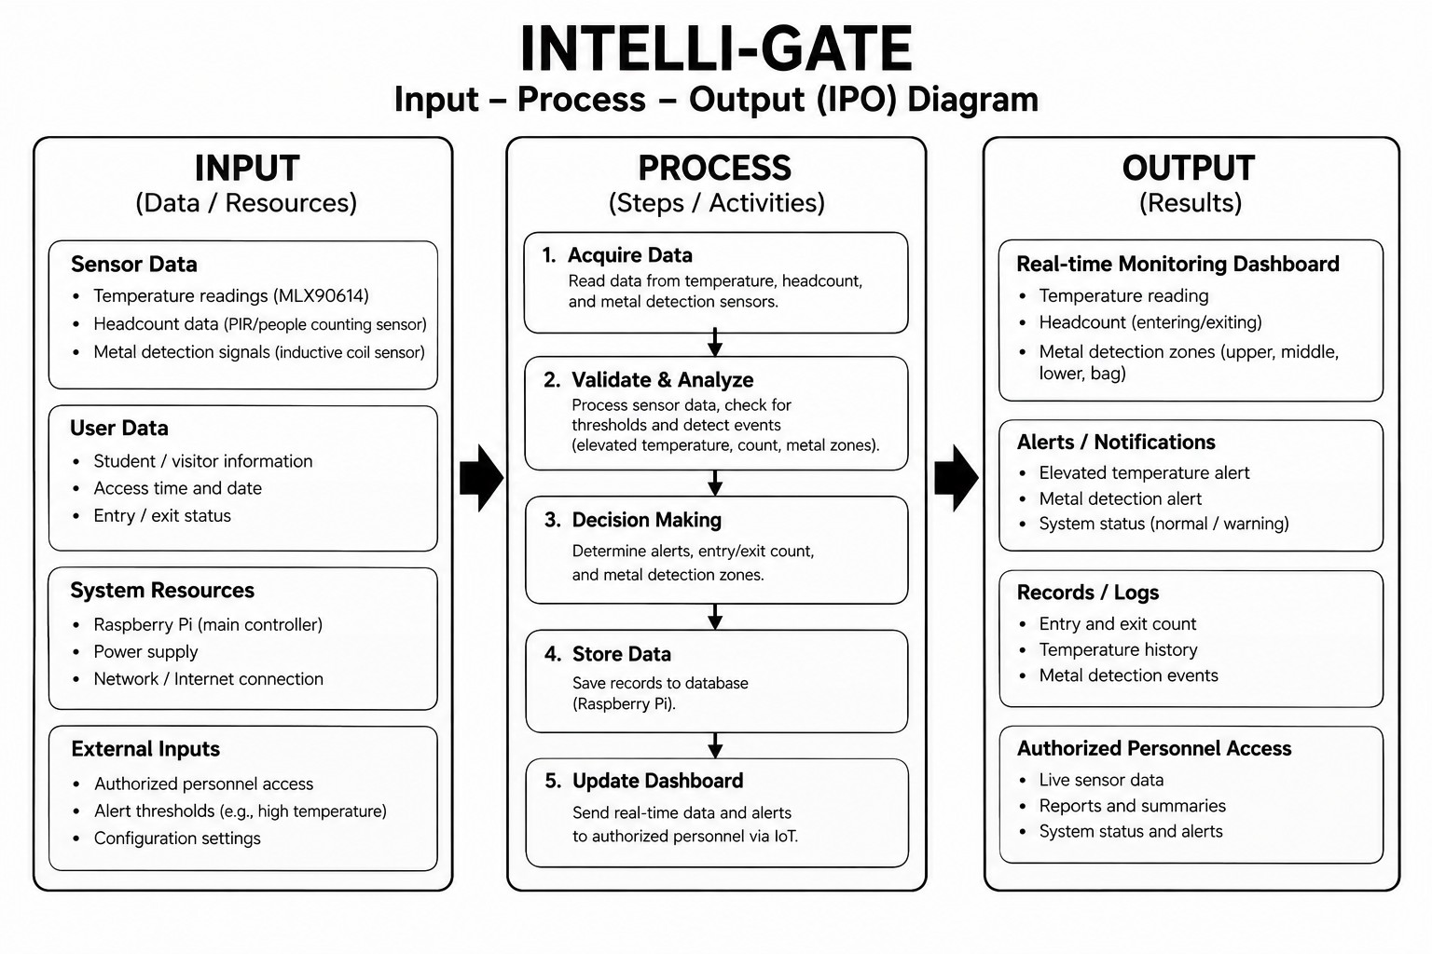

Figure 2.1: (IPO) Input Process Output of Intelli-gate.
Input
The input component consists of the data and resources required for system operation. Temperature data are obtained from the infrared temperature sensor, while headcount data represent the number of individuals entering and exiting the campus. Metal-detection data are collected from the detection coils and categorized according to the system’s predefined zones: upper body, middle body, and lower body. User and entry data include entry status and the date and time of monitoring. The system also requires a Raspberry Pi as its main controller, a power supply, and a local area network (LAN) connection. System settings include alert thresholds, sensor configurations, and authorized personnel access.
Process
The Raspberry Pi receives and processes the sensor data. First, the system collects the temperature, headcount, and metal detection data. It then validates and analyzes the readings based on the system's configured conditions. The system determines whether an alert is needed, records the entry count, and identifies the detected metal zone. The processed information is then stored and sent to the IoT monitoring dashboard for real-time viewing.
Output
The output is the information presented to authorized personnel through the monitoring dashboard. This includes temperature readings, entering headcount, and metal detection zones. The system can also provide alerts or notifications for detected metal or elevated temperature, together with records of system events. These outputs help authorized personnel monitor the campus entrance and respond appropriately to detected conditions.

Chapter 3
Research Methodology
This chapter presents the methodology employed in the development and evaluation of Intelli-gate: An IoT-Based Smart Gate System with Temperature Screening, Headcount Monitoring, and Metal Detection. It discusses the research design, setting and participants, system development methodology, research instruments, data-gathering procedure, system evaluation, data analysis, and ethical considerations.
3.1 Research Design
This study will employ a developmental research design with a mixed-methods approach. The developmental design is appropriate because the study involves the systematic implementation, development, testing, and evaluation of an IoT-based prototype. The mixed-methods approach allows the integration of quantitative and qualitative data to provide a comprehensive assessment of the system.
Quantitative data will be obtained through controlled testing of the system's temperature screening, headcount monitoring, metal detection, response time, and reliability. Qualitative data will be gathered through observations and structured feedback from authorized personnel concerning the system's functionality, usability, and applicability to campus entrance monitoring.
The system will be evaluated using the ISO/IEC 25010 software quality model, specifically the characteristics of functional suitability, reliability, and usability.

Research Setting and Participants
The study will be conducted at a designated campus entrance, where testing conditions will approximate actual entrance monitoring operations while observing appropriate safety and operational controls.
Participants will be selected through purposive sampling, specifically from the Southland College Crisis Management Committee (SC-CMC) and Security personnel. The committee members will serve as the primary research respondents because of their roles and responsibilities in campus safety, emergency preparedness, security, and crisis management. Their knowledge and experience will provide relevant assessments of Intelli-gate in terms of functionality, reliability, usability, and suitability for campus entrance monitoring.

System Development Methodology
The development of Intelli-gate will follow the Iterative Process Model. This model supports incremental development, stage level testing, and the incorporation of refinements in successive iterations. The process comprises the following phases:

Planning
This phase establishes the objectives, scope, requirements, resources, and schedule of the project. The primary functions of the system are identified as non contact temperature screening, entry and exit headcount monitoring, zone based metal detection, audible and visual alerts, and centralized monitoring through an IoT enabled dashboard. The technical and material requirements for prototype development are also determined.

Analysis
This phase determines the operational and functional requirements of the system. Existing campus entrance monitoring procedures will be examined through observation, consultation, and a review of related literature and studies. Requirements will be specified for temperature screening, entry monitoring, metal detection, alert generation, real-time monitoring, record keeping, and data privacy and authorized access. The results will serve as the basis for the system specifications.

Design
This phase translates the specified requirements into the system architecture and prototype structure. The hardware configuration, software architecture, database structure, dashboard interface, and physical gate layout will be prepared. The proposed system integrates temperature sensors, people counting sensors, inductive metal detection coils, a Raspberry Pi controller, local indicators, and an IoT enabled monitoring dashboard. Metal detection is organized into zones corresponding to the upper, middle, and lower body, with a detection zone where applicable to the final prototype configuration.

Development
In this phase, the hardware components will be assembled and the supporting software implemented. The sensors will be interfaced with the Raspberry Pi, and the dashboard will be configured to receive, process, and display the collected data. The principal functions to be implemented are:

- Temperature data acquisition.
- Entry counting.
- Zone-based metal detection.
- Alert generation.
- Data recording.
- Real-time monitoring.
Testing
This phase determines whether the system conforms to its specified functional and operational requirements. Testing will be conducted at both the component and integrated system levels through the following procedures.
Table 3.1: Testing Procedures for Intelli-gate.
Test | Description
Unit Testing | Evaluates the operation of individual hardware and software components.
Integration Testing | Verifies communication among the sensors, controller, alert mechanisms, and dashboard.
Functional Testing | Determines whether the system performs its specified functions correctly.
Accuracy Testing | Measures the correctness of temperature readings, headcounts, and metal detection results.
Reliability Testing | Assesses the consistency of performance across repeated trials.
Response-Time Testing | Measures the interval between sensor detection and system response.

Deployment and Maintenance
Upon successful testing, the prototype will be deployed in the designated testing environment, where its operation will be observed under controlled conditions and feedback from authorized personnel will be gathered. Revisions will be made based on testing and evaluation results. Maintenance activities include correcting errors, improving system performance, and modifying components as necessary.
Research Instruments
The following instruments will be used to collect the data required for system development and evaluation.
Table 3.2: Research Instruments for Intelli-gate.
Instrument | Purpose
Observation Checklist | Documents the operational behavior of the prototype and whether each function meets the established requirements.
System Testing Form | Records the results of controlled trials on temperature screening, headcount monitoring, metal detection, alert generation, and response time.
Evaluation Questionnaire | Obtains participant ratings based on ISO/IEC 25010 characteristics of functionality, reliability, and usability, using a five-point rating scale (1 to 5).
Interview Guide | Gathers semi-structured, qualitative feedback on perceived usefulness, operational suitability, limitations, and recommended improvements.

The evaluation questionnaire will use the following five-point scale.
Table 3.3: Five-Point Ratings Scale for Intelli-gate.
Rating | Descriptive Interpretation
5 | Strongly Agree
4 | Agree
3 | Neutral
2 | Disagree
1 | Strongly Disagree

Data-Gathering Procedure
The data-gathering procedure will proceed as follows:
- The researchers will secure approval from the appropriate institutional authorities.
- Existing entrance-monitoring procedures will be assessed through observation and consultation with relevant personnel.
- The prototype will be developed based on the identified requirements.
- Controlled testing will be conducted, with multiple trials for each major function, and results will be recorded using the testing instruments.
- Selected participants will evaluate the prototype by rating each questionnaire item on the five-point scale and by participating in an interview.
- The collected data will be consolidated, analyzed, and interpreted to determine the overall performance and acceptability of the system.
System Evaluation
The system will be evaluated on its ability to perform its intended functions under controlled testing conditions, as summarized below.
Table 3.4: System Evaluation Matrix for Intelli-gate.
Evaluation Area | Basis of Evaluation | Instrument
Temperature Screening | Accuracy and consistency of readings | System Testing Form
Headcount Monitoring | Accuracy of entry and exit counts | System Testing Form
Metal Detection | Detection capability and zone identification | System Testing Form
Functionality | Successful execution of required functions | Observation Checklist; Questionnaire
Reliability | Consistency across repeated trials | System Testing Form; Questionnaire
Response Time | Interval between detection and system response | System Testing Form
Usability | Ease of operation and monitoring | Questionnaire; Interview

Data Privacy and Ethical Considerations
The researchers will observe established ethical standards and data privacy principles throughout the study:
- Informed participation. Respondents will be informed of the purpose, procedures, and intended use of the data prior to participation, and participation will be voluntary.
- Data minimization. Only information necessary for the development and evaluation of the system will be collected, and personal information will not be unnecessarily disclosed or shared.
- Restricted access. Access to system records and the monitoring dashboard will be limited to authorized personnel.
- Secure handling. Collected data will be handled securely and used solely for academic and system-evaluation purposes.
- Scope of temperature screening. The temperature-screening component will serve only as a general monitoring mechanism and will not be used for medical diagnosis.
3.2 Materials
3.2.1 Hardware
This section presents the hardware and software materials required for the development, assembly, testing, operation, and maintenance of Intelli-gate. The materials are classified into hardware components, which constitute the physical and sensing infrastructure of the system, and software components, which govern data processing, communication, and system administration through a centralized IoT monitoring dashboard.

3.2.1.1 Development Hardware
Table 3.5: Development Hardware for Intelli-gate.
COMPONENT | SPECIFICATION | PURPOSE
Computer/Laptop | • Intel Core i5 or AMD Ryzen 5 equivalent  • 8 GB RAM minimum  • 256 GB SSD or higher  • Windows 10/11 or Linux | Software development, programming, configuration, debugging, and system testing
Development Board/Programmer | •Raspberry Pi-compatible development environment  • USB connectivity | System programming, configuration, and testing
Testing Equipment | • Digital multimeter  • Breadboard  • Jumper  Regulated power supply | Circuit testing, voltage measurement, wiring, and hardware validation
Network Equipment | • Wi-Fi router• 2.4 GHz/5 GHz support• Ethernet connectivity | Testing communication between the Raspberry Pi and monitoring dashboard

3.2.1.2 Core System Hardware
Table 3.6: Core System Hardware Components Intelli-gate.
COMPONENT & MODEL | SPECIFICATIONS | PURPOSE
Central processing unit Raspberry Pi 4 Model B | • Quad-core ARM Cortex-A72 64-bit processor  • 1.5 GHz clock speed  • 4 GB RAM recommended  • 32 GB microSD card minimum  • 2.4/5 GHz Wi-Fi  • Gigabit Ethernet• 40-pin GPIO | Main processing unit responsible for collecting sensor data, processing system logic, controlling peripherals, and communicating with the centralized dashboard
Temperature screening sensor MLX90614 | • Non-contact infrared temperature sensor  • I²C digital interface  • Approximately ±0.5°C accuracy  • Non-contact measurement | Performs non-contact temperature screening of individuals passing through the gate
Metal detection sensor Coil-Based/Inductive Sensor Module | • Inductive/coil-based detection  • Adjustable sensitivity  • Digital output compatible with Raspberry Pi GPIO  • Detection range dependent on coil configuration | Detects the presence of metallic objects within the designated detection zones
Upper-body metal detection coil | • Coil-based inductive sensing  • GPIO-compatible output | Detects metallic objects within the upper-body detection zone
Middle-body metal detection coil | • Coil-based inductive sensing  • GPIO-compatible output | Detects metallic objects within the middle-body detection zone
Lower-body metal detection coil | • Coil-based inductive sensing  • GPIO-compatible output | Detects metallic objects within the lower-body detection zone
Bag metal detection coil | • Coil-based inductive sensing  • GPIO-compatible output | Detects metallic objects within the bag detection zone
People-counting sensor Break-Beam Sensor Pair | • Infrared emitter and receiver  • Digital output  • GPIO-compatible | Detects individuals entering and exiting the gate for headcount monitoring
Buzzer/alarm module | • Active piezoelectric buzzer  • 5V DC operation• GPIO-controlled | Provides an audible warning when an abnormal temperature or metallic object is detected
LCD display module 16×2 or 20×4 I²C LCD | • I²C interface  • 5V DC operation  • Character-based display | Displays temperature readings, headcount information, and detection alerts at the gate
Gate motor/Servo gate | • 4.8–6V DC  • Torque dependent on gate design | Controls the opening and closing of the prototype gate
Breadboard/Prototype PCB | • 830-point breadboard or prototyping PCB | Provides a platform for connecting and testing electronic components
Jumper wires and connectors | • Male-to-male  • Male-to-female  • Female-to-female | Establishes electrical connections among the Raspberry Pi, sensors, and peripherals
Enclosure/Gate Frame | • PVC, acrylic, or other suitable non-conductive material  • Sized according to prototype design | Supports and protects the controller, sensors, wiring, and other electronic components

3.2.1.3 Power Management and Supporting Components
Table 3.7: Power Management and Supporting Components for Intelli-gate.
COMPONENT | SPECIFICATIONS | PURPOSE
Power Supply Unit | • Regulated 5V DC  • Minimum 3A output  • Compatible with Raspberry Pi | Provides stable power to the Raspberry Pi and connected peripherals
Auxiliary Power Supply | • Appropriate voltage/current based on motor and peripheral requirements | Provides additional power for components requiring higher current
Voltage Regulator/Converter | • Output voltage appropriate for connected sensors and modules | Regulates voltage to ensure safe operation of electronic components
Power and Signal Cables | • Appropriate gauge and connectors | Provides power and signal connections between components
3.2.1.4 Command Centre Requirements
For centralized monitoring, the following equipment is required to allow authorized personnel to view and manage information collected by the INTELLIGATE system.
Table 3.8: Command Centre Requirements for Intelli-gate.
COMPONENT | SPECIFICATIONS | PURPOSE
Computer System | • Intel Core i3 or equivalent  • 8 GB RAM  • 256 GB SSD• Windows 10/11 or equivalent | Monitoring system data and accessing the centralized dashboard
Network Equipment | • Wi-Fi router  • 2.4 GHz/5 GHz support  • Internet/LAN connectivity | Provides communication between the INTELLIGATE system and command centre
Display/Monitor | • Minimum 19-inch display  • 1080p resolution | Provides real-time visualization of temperature readings, headcount, metal detection, and system alerts
Keyboard and Mouse | • Standard USB or wireless keyboard and mouse | Used to interact with and manage the monitoring dashboard

3.2.1 Software
For the software side of the project, particularly the IoT-based monitoring application and the centralized web-based dashboard, the following software development tools and technologies are used in the development of Intelli-gate:

Raspberry Pi OS - the operating system installed on the Raspberry Pi and provides the environment required to run the system's programs, sensor interfaces, database, and web server.

Python - is the primary programming language used to develop the Intelli-gate system. It is used for sensor interfacing, data processing, system logic, GPIO control, and communication between the Raspberry Pi and the centralized monitoring dashboard.

Flask - is a lightweight Python web framework used to develop the backend of the Intelli-gate web-based monitoring system. It handles system requests, processes sensor data, and provides information to the centralized dashboard.

HTML5 - used to structure the content and components of the Intelli-gate centralized monitoring dashboard, including temperature readings, headcount information, metal-detection status, and system alerts.

CSS3 - to design and format the visual appearance of the centralized monitoring dashboard. It provides the layout, typography, spacing, and responsive presentation of the interface.

JavaScript - provide interactive and dynamic functions within the dashboard. It allows information such as temperature readings, headcount, and metal-detection alerts to be updated without requiring continuous manual page refreshes.

SQLite - used as the database management system for storing Intelli-gate monitoring records, including temperature readings, entry and exit counts, metal-detection events, and other relevant system logs.

Visual Studio Code - primary source-code editor used to write, organize, modify, and debug the Python, HTML, CSS, and JavaScript files used in the Intelli-gate system.

GPIO Libraries - are used to establish communication between the Raspberry Pi and the connected sensors and actuators. These libraries allow the system to receive sensor inputs and control devices such as the buzzer and gate mechanism.

Smbus2 - The smbus2 Python library is used to facilitate I²C communication between the Raspberry Pi and compatible devices, particularly the MLX90614 temperature sensor and I²C LCD display.

Flask-SocketIO - Flask-SocketIO is used to support real-time communication between the Raspberry Pi backend and the centralized monitoring dashboard. It allows sensor readings, headcount information, and alerts to be transmitted to the dashboard in real time.

Web Browser - A modern web browser such as Google Chrome, Microsoft Edge, or Mozilla Firefox is used to access and test the Intelli-gate centralized monitoring dashboard.

Software Requirements

Table 3.9: The Software Requirements for Intelli-gate.
NAME | RECOMMENDED REQUIREMENT
Operating System | Raspberry Pi OS 64-bit, Bullseye or later
Programming Language | Python 3.9 or later
Web Framework | Flask 2.x or later
Database | SQLite 3.x
Web Technologies | HTML5, CSS3, and JavaScript
Real-Time Communication | Flask-SocketIO / WebSocket
GPIO Library | RPi.GPIO or gpiozero
I²C Communication Library | smbus2
Code Editor | Visual Studio Code, latest stable version
Web Browser | Latest stable version of Google Chrome, Microsoft Edge, or Mozilla Firefox
Network Connectivity | Wi-Fi or Ethernet local area network

3.3 Methods
3.3.1 Software Life Cycle Model – Iterative Process Model
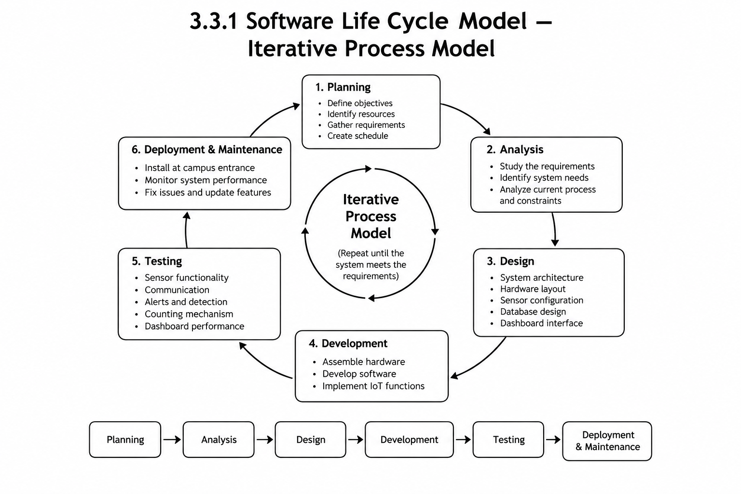
This section presents the systematic approach adopted by the researchers in developing, testing, and implementing Intelli-gate. It describes the software development life cycle (SDLC) model applied to the project and explains how each phase of the model is carried out in the context of building an IoT-based smart gate system that integrates temperature screening, headcount monitoring, and coil-based/inductive metal detection.

Figure 3.2: Iterative Process model Intelli-gate
The researchers adopted the Iterative Process Model as the software development life cycle model for Intelli-gate. The Iterative Process Model is an SDLC approach in which a system is developed through repeated cycles, or iterations, rather than through a single, strictly linear sequence of phases . Each cycle centers on a modest, well-understood slice of the system, with each successive version progressively gaining complexity and additional features as earlier work is refined. The results and feedback obtained from one iteration are carried forward to inform and improve the succeeding iteration, so that the system moves toward greater refinement and reliability with each pass [37]. Rather than attempting to finalize the entire system in one pass, the model allows the researchers to progressively build, test, and enhance the system's components until the desired level of functionality, accuracy, and reliability is achieved.
The Iterative Process Model is considered appropriate for Intelli-gate because the project integrates multiple hardware sensors and software components that must work together reliably. This iterative approach to development is particularly suited to projects of this nature because it improves stakeholder engagement, encourages prompt feedback, and increases the likelihood of arriving at a refined, well integrated final product [38]. Sensor performance and accuracy require repeated testing before they can be considered dependable for real world use. The temperature screening module, for instance, may require calibration and refinement across several trials to achieve consistent readings. Similarly, the headcount monitoring mechanism requires repeated testing to improve counting accuracy, particularly under varying conditions of movement and traffic at the gate. The coil-based/inductive metal detection system likewise requires iterative testing and sensitivity adjustment, and because Intelli-gate incorporates four distinct metal-detection zones upper body, middle body, lower body each zone must be individually validated to confirm that it detects metallic objects accurately and independently of the others. Beyond the sensors themselves, the Raspberry Pi controller must be tested for proper communication with all connected peripherals, and the centralized IoT monitoring dashboard requires repeated interface and functionality testing to ensure that real-time data is displayed accurately. The iterative nature of the model allows feedback and test results at each stage to be used to identify problems and progressively improve the system before final deployment.
The researchers applied the following phases of the Iterative Process Model to the development of Intelli-gate:
Planning - In this phase, the researchers identify the objectives of the project, the required hardware and software components, the overall project scope, the resources and schedule needed for development, and the expected outputs of the system. This phase establishes the foundation for the subsequent iterations by defining what Intelli-gate is intended to accomplish and the constraints within which it will be developed.
Analysis - The researchers analyze the existing entrance-monitoring process to identify its limitations and determine the security and monitoring requirements that Intelli-gate must address. This includes determining the specific functions required of each sensor such as temperature screening, headcount detection, and metal detection and identifying the functional and technical requirements of the system as a whole.
Design - The researchers design the overall system architecture, including the physical arrangement of hardware components, the placement of sensors at the gate, the configuration of the four metal detection zones, the wiring and communication connections to the Raspberry Pi, the structure of the database used to store monitoring records, the layout of the centralized dashboard interface, and the communication scheme linking the gate system to the dashboard.
Development - The researchers assemble and program the physical components of Intelli-gate, including the Raspberry Pi controller, the temperature sensor, the people-counting sensors, the four coil-based/inductive metal-detection sensors, the buzzer, the LCD display, and the gate mechanism. In parallel, the researchers develop the backend logic, the database, the centralized dashboard, and the IoT communication functions that allow data to be transmitted from the gate hardware to the monitoring interface.
Testing - Each developed iteration undergoes testing to verify that the system performs as intended. Testing activities include evaluating temperature screening accuracy, entry headcount detection, metal detection performance, the individual reliability of the four detection zones, alert and buzzer functionality, LCD and dashboard display accuracy, communication between the Raspberry Pi and its connected sensors, database recording, real-time dashboard updates, and the overall functionality and reliability of the integrated system. Errors, inaccurate readings, or integration problems identified during testing are documented, corrected, and retested in the succeeding iteration.
Deployment - Once a version of the prototype has been sufficiently tested and refined, it is installed or demonstrated in the intended school/campus entrance environment under controlled conditions. During this phase, the system is configured for actual operation and connected to the centralized monitoring dashboard so that its performance can be observed in a setting that approximates real-world use.
Maintenance - Following deployment, the researchers monitor the system's performance and conduct the necessary troubleshooting, software updates, sensor recalibration, and hardware adjustments. Improvements are made based on issues observed during operation or feedback gathered from users, consistent with the continuous-improvement principle underlying the Iterative Process Model.

3.3.2 Data Flow Diagram
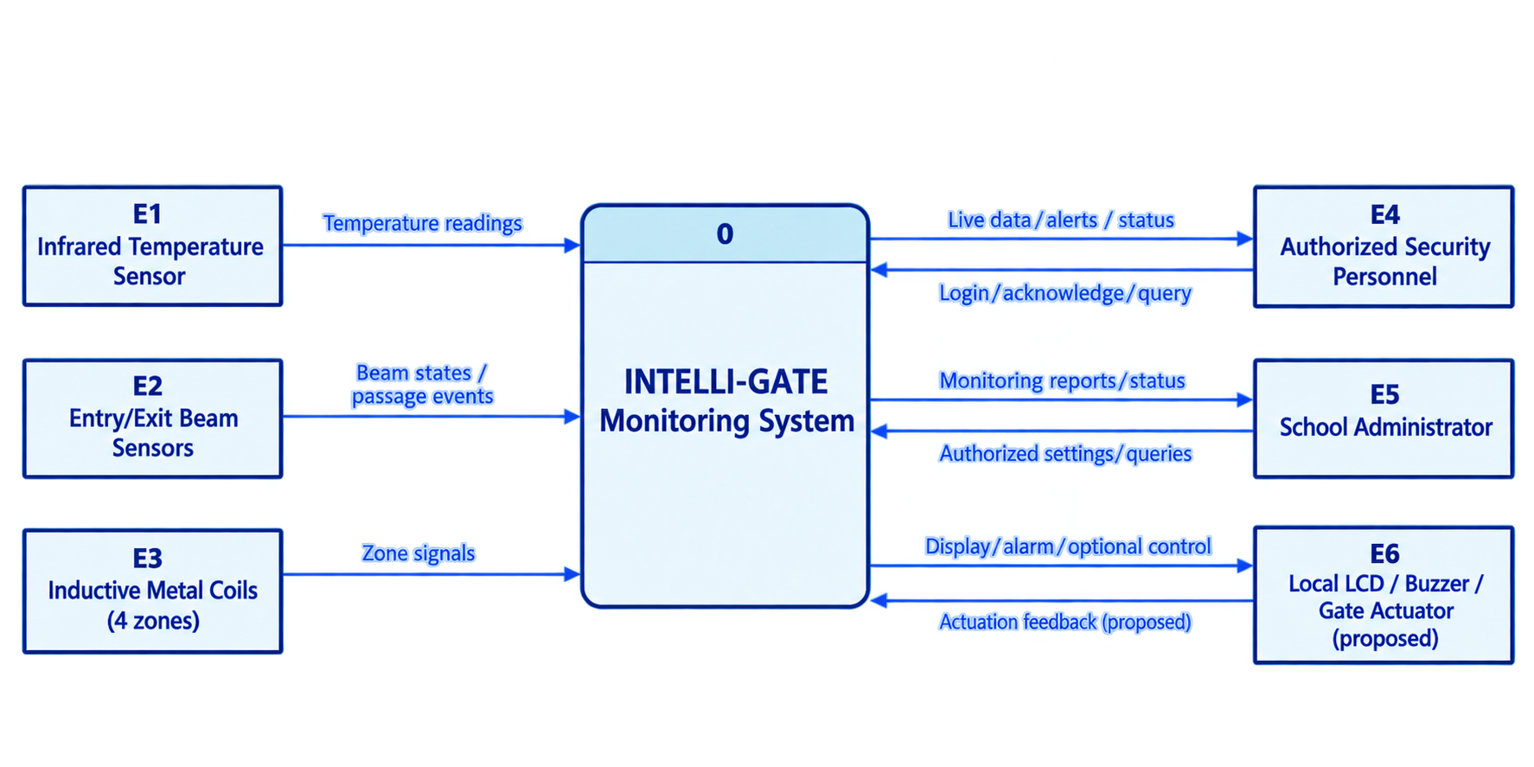
A Data Flow Diagram (DFD) illustrates how data moves throughout the Intelli-gate system. The Level 0 and Level 1 DFDs present the overall data flow and the detailed processes involved in the system.
Figure 3.3: Level 0 Data Flow Diagram of Intelli-gate
The DFD Level 0 illustrates the flow of data between Intelli-gate and its external entities. The system receives temperature readings, entry and exit signals, and metal-detection data, which are processed to generate alerts, monitoring reports, and status updates. Security personnel and administrators can monitor activities and manage settings, while the LCD and buzzer provide local notifications to support campus entrance security.

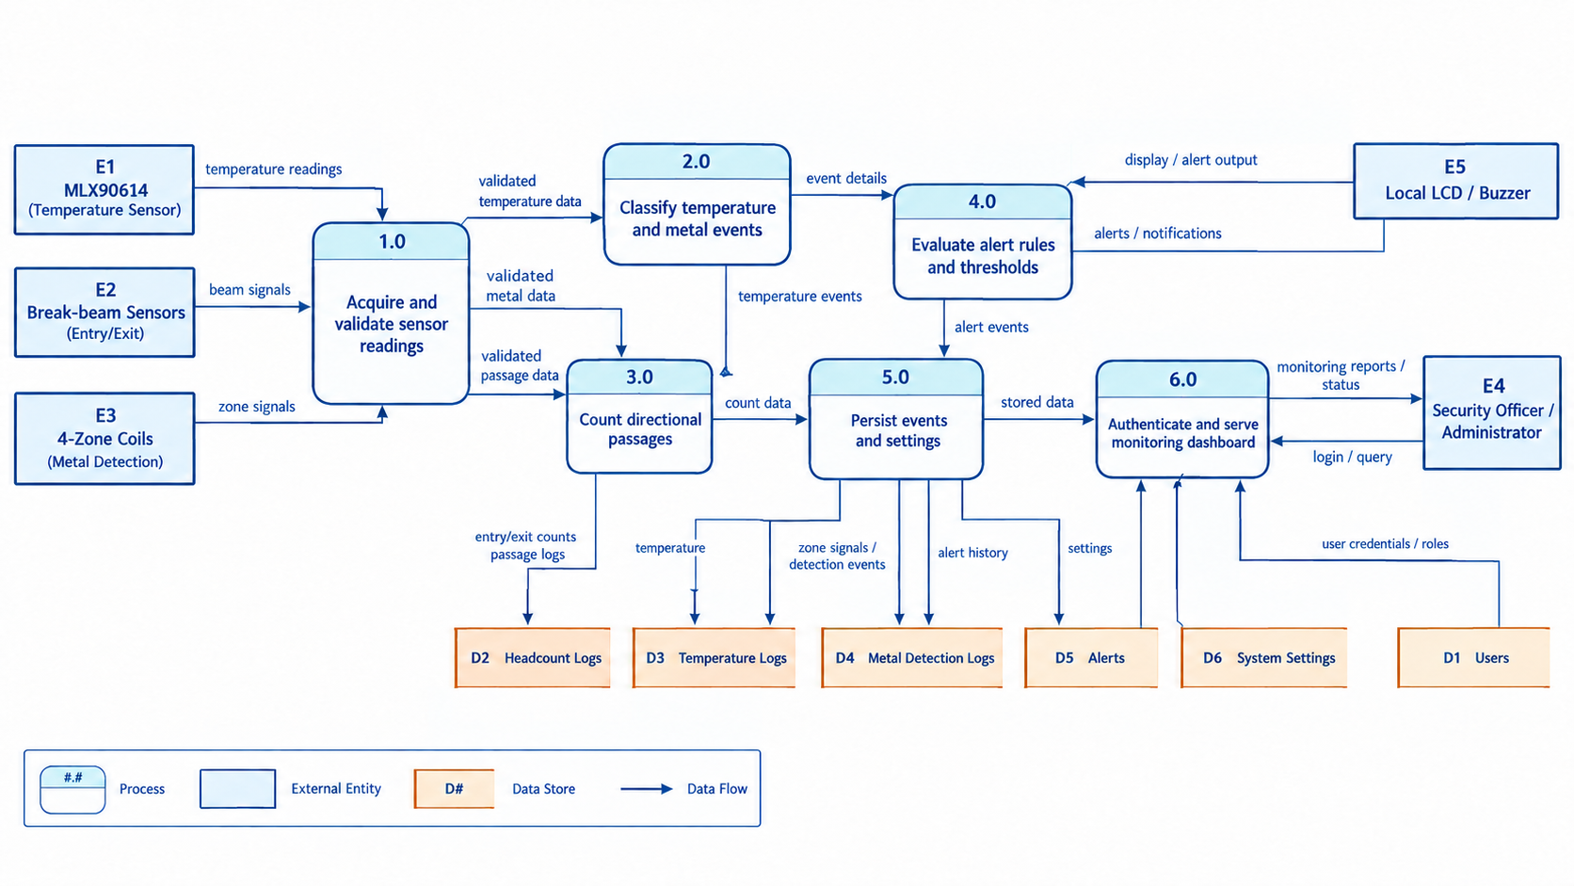Figure 3.4: Level 1 Data Flow Diagram of Intelli-gate
The Level 1 DFD provides a more detailed view of Intelli-gate by breaking the main system into its major processes, including temperature screening, headcount monitoring, metal detection, data processing, and dashboard monitoring. It shows how data flows between sensors, the Raspberry Pi, database, and authorized users.
3.3.3 Use Case Diagram
In this part, present a Use Case Diagram that illustrates the main functions of the Intelli-gate system and the actors who interact with it. The diagram should show how Authorized Personnel interact with the system to monitor temperature screening, headcount monitoring, and zone-based metal detection. It should also illustrate the system’s automated functions, including recording entries, detecting metallic objects, displaying temperature readings, generating alerts, and transmitting data to the centralized monitoring dashboard. This diagram provides a clear representation of the system’s functionality from the users’ point of view.
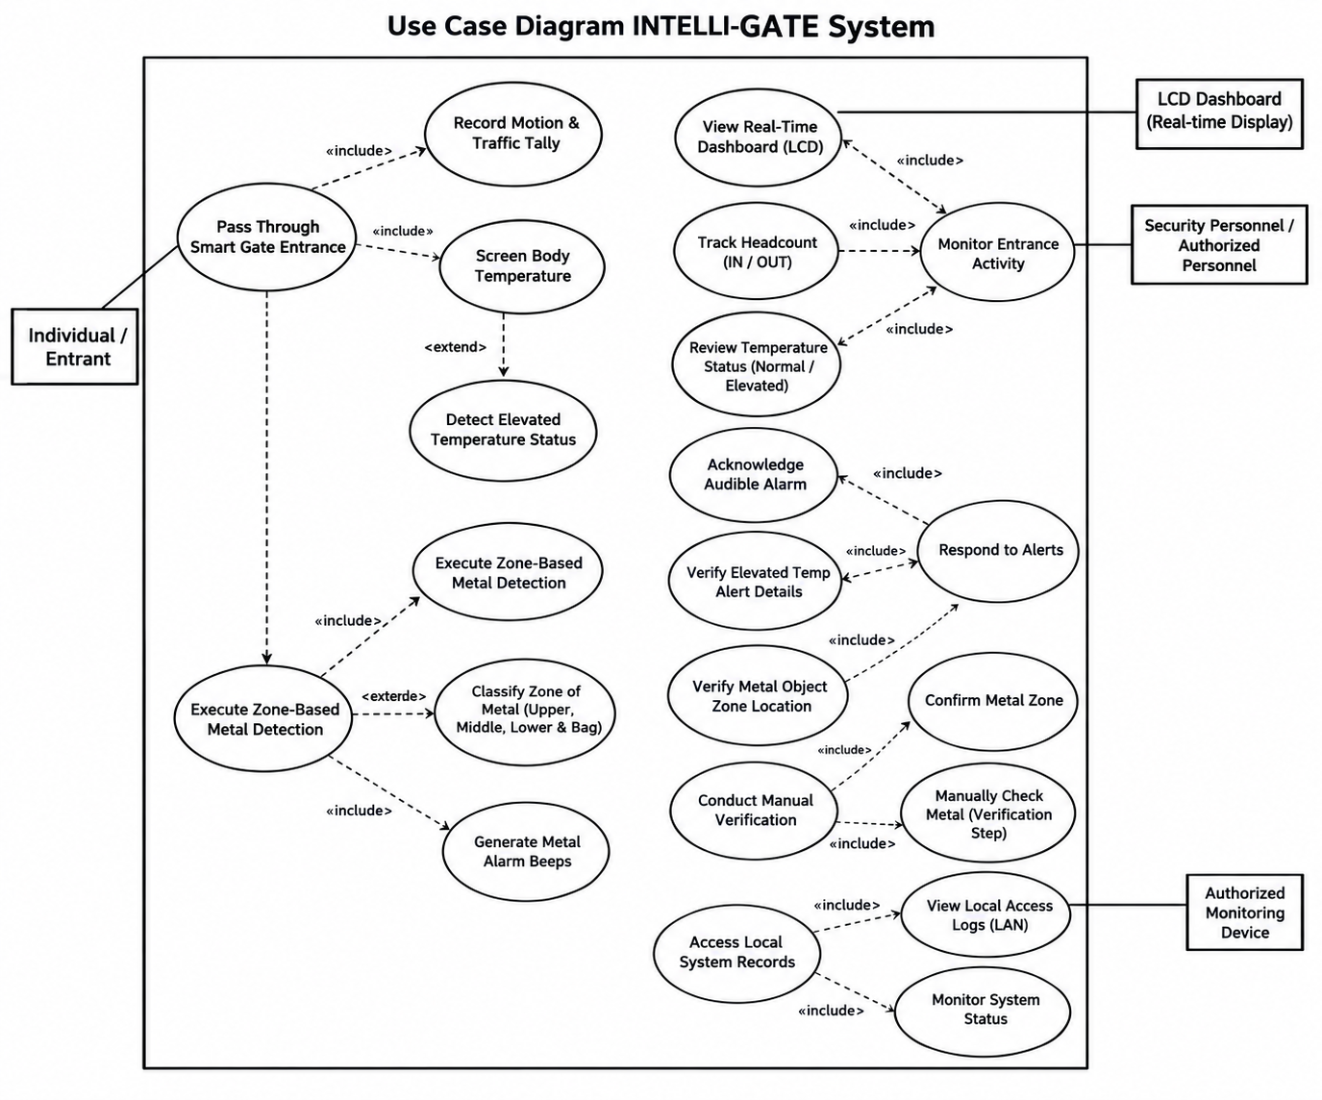
Figure 3.5: Use Case Diagram of Intelli-gate
The Use Case Diagram illustrates the interactions between users and the Intelli-gate system. It shows how individuals pass through the smart gate for temperature screening, headcount monitoring, and zone-based metal detection. Security personnel can monitor real-time activities, review alerts, verify detected objects, and access system records through the local network. The diagram highlights how Intelli-gate supports automated entrance monitoring and assists security personnel in maintaining campus safety.

3.3.4 Data Dictionary
This data dictionary defines the data elements used by Intelli-gate for temperature screening, headcount monitoring, zone-based metal detection, alert generation, and authorized access. This table stores the accounts of authorized personnel who are permitted to access the monitoring dashboard and system records. It supports restricted access by tying every login and system action to a registered user. Passwords are stored only in hashed form to protect account credentials.
Table 3.10: Headcount Logs
Field Name | Data Type | Length/Size | Key | Description
count_id | BIGINT UNSIGNED | — | PK, AI | Unique identifier of the passage record
event_uuid | CHAR | (36) | UQ | Unique identifier preventing duplicate passage events
gate_id | BIGINT UNSIGNED | — | FK → gates.gate_id | Gate where the event occurred
sensor_id | BIGINT UNSIGNED | — | FK → devices.device_id | Break-beam sensor device
direction | ENUM | — | — | Detected passage direction
ambiguous_passage | BOOLEAN | — | — | Indicates an uncertain passage sequence
event_time | DATETIME | (3) | — | Date and time of the detected passage
Table name: Headcount_tbl
The headcount_logs table records the entry and exit of individuals passing through Intelli-gate. It stores passage direction, sensor information, event time, and updated occupancy to monitor the number of people inside the premises.
Table 3.11: Temperature Logs
Field Name | Data Type | Length/Size | Key | Description
temp_id | BIGINT UNSIGNED | — | PK, AI | Unique identifier of the temperature record
device_id | BIGINT UNSIGNED | — | FK → devices.device_id | Sensor that generated the reading
event_uuid | CHAR | (36) | UQ | Unique event reference preventing duplicate recording
value_c | DECIMAL | (5,2) | NULL | Recorded temperature in Celsius
threshold_c | DECIMAL | (5,2) | — | Temperature threshold applied during screening
Table Name: Temperature_tbl
The temperature_logs table stores temperature readings captured by the MLX90614 infrared sensor. It records measured temperatures, configured thresholds, screening results, and timestamps to support temperature monitoring and identify elevated readings.

Table 3.12: Metal Detections Logs
Field Name | Data Type | Length/Size | Key | Description
detection_id | BIGINT UNSIGNED | — | PK, AI | Unique identifier of the detection record
event_uuid | CHAR | (36) | UQ | Unique detection-event identifier
zone_id | BIGINT UNSIGNED | — | FK → metal_zones.zone_id | Zone where the signal was detected
signal_value | DECIMAL | (12,4) | — | Recorded metal-detection signal
signal_unit | VARCHAR | (25) | — | Unit or representation of the signal

Table Name: Metal Detection_tbl
The metal_detection_logs table records metal-detection events from the system's sensing zones. It stores signal readings, detection results, and timestamps to identify and monitor possible metallic objects.

Table 3.13: Metal Zones
Field Name | Data Type | Length/Size | Key | Description | Example
zone_id | BIGINT UNSIGNED | — | PK, AI | Unique identifier of a detection zone | 1
device_id | BIGINT UNSIGNED | — | FK → devices.device_id | Device assigned to the zone | 2
zone_code | ENUM | — | Composite UQ with device_id | Assigned detection zone code | Z1
zone_label | VARCHAR | (80) | — | Descriptive name of the zone | Upper Body
body_position | ENUM | — | — | Body area or inspection location | UPPER
is_active | BOOLEAN | — | — | Indicates whether the zone is enabled | TRUE
Table Name: Metal Zones_tbl
The metal_zones table stores information about the designated metal-detection zones of Intelli-gate. It identifies each zone's code, location, and operational status to determine where a metal-detection event occurs.

Table 3.14: Alerts
Field Name | Data Type | Key | Description | Example
Field Name | Data Type | Length/Size | Key | Description
alert_id | BIGINT UNSIGNED | — | PK, AI | Unique identifier of the alert
gate_id | BIGINT UNSIGNED | — | FK → gates.gate_id | Gate associated with the alert
screening_id | BIGINT UNSIGNED | — | FK → screening_events.screening_id, NULL | Related screening event
temp_id | BIGINT UNSIGNED | — | FK → temperature_logs.temp_id, NULL | Related temperature record
count_id | BIGINT UNSIGNED | — | FK → headcount_logs.count_id, NULL | Related passage record
detection_id | BIGINT UNSIGNED | — | FK → metal_detection_logs.detection_id, NULL | Related metal-detection record
Table Name: Alerts_tbl
The alerts table stores notifications generated when the system detects conditions requiring attention. It records alert types, messages, severity levels, timestamps, and acknowledgment status to support security monitoring and incident management.
3.3.5 Entity Relationship Diagram
The Entity Relationship Diagram (ERD) illustrates the logical structure of the Intelli-gate database. It presents the main entities or tables, their corresponding attributes or fields, and the relationships between them. The ERD provides a clear representation of how system data, such as temperature records, headcount records, metal detection events, users, and system logs, are organized and related within the database. This serves as a guide for designing an organized and consistent database for the Intelli-gate system.
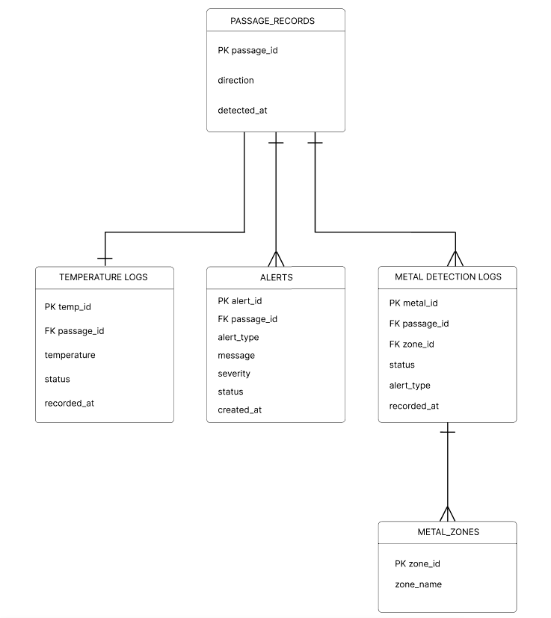
Figure 3.6: Entity Relationship Diagram for Intelli-gate

System Operation and Data Flow

1. Passage Monitoring
When an individual passes through the gate, the system determines whether the person is entering or exiting the campus. It then creates a passage record containing the direction of movement and the time of detection. This record serves as the reference for all other monitoring activities performed during the same passage.

2. Temperature Screening
The temperature logs table stores the readings obtained from the temperature sensor. Each record is linked to a specific passage through the passage_id and contains the following data:
- Temperature reading.
- Temperature status.
- Date and time of recording.
The temperature status indicates whether the reading is within the configured normal range or requires an alert. The temperature screening function is intended for general monitoring only and is not used for medical diagnosis.

3. Metal Detection
As the individual passes through the gate, the metal-detection coils monitor the designated detection areas. When metal is detected, the event is recorded in the METAL DETECTION LOGS table, which contains the following data:
- Metal detection ID.
- Related passage ID.
- Detected zone.
- Detection status.
- Alert type.
- Date and time of detection.
The zone_id links each detection record to the metal zone table, which identifies the corresponding detection area. This allows the system to determine whether the detection occurred in the upper, middle, lower, depending on the implemented configuration.

4. Alert Generation
The ALERTS table records the significant events generated by the system. An alert is produced when an elevated temperature reading or a metal detection requires attention. Each alert contains the following data:
- Alert type.
- Alert message.
- Severity.
- Alert status.
- Date and time created.

3.4 Project Timeline
The project timeline for Intelli-gate is structured according to the Iterative Process Model, allowing the researchers to develop, integrate, test, and refine the system through successive iterations.
Requirements Gathering and Planning
Identify the security and monitoring needs of the school entrance, gather functional requirements for temperature screening, headcount monitoring, metal detection, alerts, and dashboard monitoring; define system scope, hardware requirements, budget, and project schedule.
System Design
Design the overall Intelli-gate architecture, develop hardware schematics for the Raspberry Pi, temperature sensor, counting sensors, and zone-based metal-detection coils; design the database, system processes, and centralized monitoring dashboard; prepare the system prototype and interface layout.
Implementation and Integration
Assemble and configure the hardware components; program the Raspberry Pi for temperature screening, entry counting, and six zone metal detection (upper body, middle body, lower body) develop the monitoring dashboard and database, integrate all components for real-time data transmission and alerts.

Testing and Validation
Conduct controlled tests for temperature measurement, headcount accuracy, metal detection performance, sensor response, data transmission, and dashboard functionality; identify and correct system errors, repeat testing after modifications to improve reliability and accuracy.
Deployment and Initial Evaluation
Install and operate the prototype in a controlled school-entrance environment, demonstrate real-time temperature, headcount, and metal-detection monitoring, conduct user evaluation with authorized personnel and collect feedback regarding system functionality and usability.
Maintenance and Final Evaluation
Apply necessary hardware and software improvements based on test results and user feedback, evaluate the system using relevant ISO/IEC 25010 software quality characteristics, document the final results, limitations, and recommendations for future improvement and possible school l; wide implementation.

3.5 Risk Analysis
Risk analysis identifies potential threats that may affect the successful development, testing, and implementation of Intelli-gate: An IoT-Based Smart Gate System with Temperature Screening, Headcount Monitoring, and Metal Detection. Risks are categorized according to their likelihood of occurrence and potential impact on the project. The likelihood is classified as Low, Medium, or High, while the impact is categorized as Low: minor delays, Medium: moderate rework, and High: major project delays or system failure. Each identified risk includes its potential consequences and mitigation strategy. The researchers will prioritize risks based on their potential effect on system functionality, development schedule, and project cost.

Technical Risks
Temperature Sensor Inaccuracy (Likelihood: Medium, Impact: Medium): The MLX90614 temperature sensor may produce inconsistent readings due to improper distance, environmental temperature, or incorrect sensor positioning. Consequences: Inaccurate temperature readings may result in incorrect alerts and require additional calibration. Mitigation: Maintain a consistent sensor-to-person distance, calibrate the sensor before testing, conduct repeated measurements, and properly position the sensor at the entrance.
Coil-Based Metal Detection False Readings (Likelihood: Medium, Impact: High): The inductive/coil-based metal detection sensors may produce false detections or fail to detect metallic objects because of sensitivity settings, sensor positioning, or environmental interference. Consequences: Unnecessary alerts or missed metal detections may reduce the reliability of the security function. Mitigation: Adjust and calibrate sensor sensitivity, properly position the four detection coils, conduct repeated controlled tests, and refine the detection thresholds during each development iteration.
Headcount Monitoring Errors (Likelihood: Medium, Impact: High): People-counting sensors may incorrectly count individuals when multiple people enter or exit simultaneously or when a person is not properly detected. Consequences: The displayed headcount may become inaccurate, affecting the reliability of occupancy monitoring. Mitigation: Properly position the entry and exit sensors, establish appropriate detection zones, conduct repeated counting tests, and improve the counting logic during system iterations.
Software Bugs and Data Processing Errors (Likelihood: Medium, Impact: Medium): Errors in the software may affect sensor readings, headcount processing, database records, alerts, or dashboard displays. Consequences: Incorrect information may be displayed and system functions may not operate as intended. Mitigation: Conduct iterative development, perform debugging and functional testing, review source code, maintain backups, and test individual modules before full system integration.

Operational Risks
Delays in Prototyping (Likelihood: Medium, Impact: Medium): Delays in acquiring electronic components or assembling the prototype may affect the development schedule. Consequences: Hardware integration and system testing may be postponed. Mitigation: Identify required components early, purchase essential materials in advance, consider alternative compatible components, and follow the project timeline.
Hardware Failure During Testing (Likelihood: Medium, Impact: High): Electronic components such as sensors, the Raspberry Pi, power supply, or wiring may malfunction during development or testing. Consequences: Testing may be interrupted and additional expenses may be required for replacement components. Mitigation: Inspect components before use, use appropriate power supplies, secure wiring connections, maintain backup components when possible, and perform testing in stages.
Improper Sensor Placement (Likelihood: Medium, Impact: Medium): Incorrect placement of the temperature, counting, or metal detection sensors may affect system performance. Consequences: Detection accuracy may decrease and additional physical adjustments may be required. Mitigation: Conduct preliminary positioning tests, document suitable sensor locations, and adjust the hardware layout based on test results.
Team Resource Shortages (Likelihood: Medium, Impact: Medium): Limited availability of team members may slow hardware assembly, programming, testing, or documentation. Consequences: Development activities may take longer than scheduled. Mitigation: Assign specific responsibilities to team members, maintain a shared development schedule, and cross-train members in essential hardware and software tasks.

Financial Risks
Budget Overruns (Likelihood: Medium, Impact: Medium): Additional expenses may occur because of component replacement, wiring, testing materials, transportation, or unexpected hardware requirements. Consequences: The available project budget may become insufficient. Mitigation: Monitor expenses throughout development, prioritize essential components, compare suppliers, and maintain a contingency allowance for unexpected expenses.

External Risks
Network Connectivity Issues (Likelihood: Medium, Impact: Medium): Unstable Wi-Fi or local network connectivity may interrupt communication between the Raspberry Pi and the centralized monitoring dashboard. Consequences: Real-time monitoring may be temporarily interrupted or dashboard data may be delayed. Mitigation: Use a stable local network, test connectivity before deployment, and ensure that important sensor processing can continue locally on the Raspberry Pi.
Power Interruption (Likelihood: Medium, Impact: High): Unexpected power interruptions may stop the Raspberry Pi, sensors, and other system components from operating. Consequences: Monitoring and data recording may be temporarily unavailable. Mitigation: Use a regulated power supply, properly manage power connections, safely shut down the Raspberry Pi when necessary, and consider an appropriate backup power source if available.
Environmental Interference (Likelihood: Medium, Impact: Medium): Changes in lighting, temperature, electromagnetic interference, or physical conditions at the entrance may affect sensor performance. Consequences: Sensors may require recalibration or repositioning. Mitigation: Conduct testing under controlled entrance conditions, identify environmental factors affecting the sensors, and adjust sensor placement and sensitivity accordingly.
Overall, the researchers will continuously monitor these risks throughout the development process. The Iterative Process Model allows identified problems to be addressed through repeated testing, adjustment, and improvement before proceeding to the next development cycle.
3.6 Estimated Cost
The total estimated cost for the Intelli-gate project is approximately ₱39,387.00, based on the development of a small-scale academic prototype. The estimate assumes local sourcing of electronic components in the Philippines and the use of free or open-source software whenever possible. Actual costs may vary depending on supplier prices, component availability, and design modifications during development.
Table 3.15: Estimated Cost of Intelli-gate
Category | Description | Estimated Cost (₱)
Hardware Components | ESP32 controller, metal detection coils, sensors, power supply, display, and other electronic components | 20,430.00
Temperature Screening Module | Non-contact infrared temperature sensor and accessories | 2,500.00
Headcount Monitoring Module | People-counting sensors and accessories | 2,000.00
Gate Mechanism and Integration | Gate structure, wiring, and system integration materials | 3,000.00
Software and Dashboard | Dashboard development and system configuration | 0.00
Transportation | Travel for purchasing materials and project testing | 1,000.00
Testing and Calibration | Sensor testing, calibration, and troubleshooting | 1,000.00
Documentation and Printing | Research paper, printing, and documentation expenses | 1,000.00
Miscellaneous Expenses | Additional materials and unexpected expenses | 2,457.00
Other Fees | Assembly assistance, fabrication, and other project-related fees | 6,000.00
Total Estimated Cost |  | ₱39,387.00

The total estimated cost for the Intelli-gate project is ₱39,387.00, covering the hardware components, temperature screening and headcount monitoring modules, gate mechanism, system integration, and other necessary project expenses. The budget also includes transportation, testing and calibration, documentation and printing, assembly assistance, fabrication, and miscellaneous fees. Software and dashboard development will utilize free or open-source tools whenever possible to minimize expenses. The estimated amount is intended to support the development, testing, and evaluation of the Intelli-gate prototype. Actual costs may vary depending on supplier prices, component availability, and additional project requirements.

Chapter 4
Preliminary Works
4.1 Prototypes / Screenshots
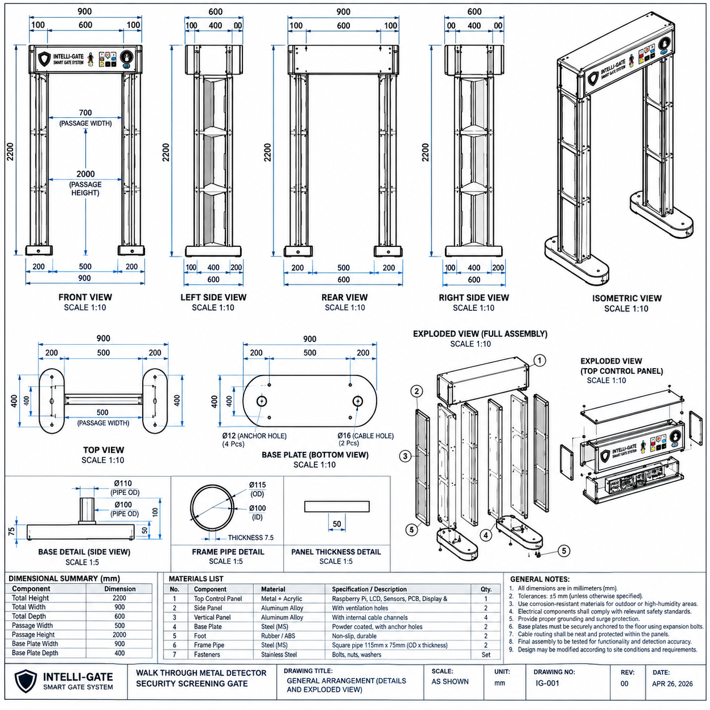
This section presents the proposed hardware architecture and interface connections of Intelli-gate An IoT-Based Smart Gate System with Temperature Screening, Headcount Monitoring, and Metal Detection. The two figures illustrate the physical arrangement of the smart gate, its embedded processing components, sensor interfaces, power distribution, and communication pathways.

Figure 4.7:. Submitted walk-through gate engineering concept: elevations, views, exploded assembly and component arrangement (source: user-provided preliminary drawing).

Presents the proposed structural design and dimensions of the Intelli-gate walk-through screening gate. It includes front, rear, side, top, isometric, and exploded views, along with dimensional specifications and a materials list.

Detailed Component Explanation
The proposed gate measures 2,200 mm in height, 900 mm in overall width, and 600 mm in depth. The dimensional summary specifies a passage width of 500 mm and a passage height of 2,000 mm. Its main components include the top control panel, side panels, vertical supports, frame pipes, base plates, and fasteners. The top control panel is designed to house the display, indicators, and electronic controls, while the vertical structure supports the screening components. The base plates provide structural support and attachment points for floor anchoring.

System Operation and Structural Arrangement
The gate is designed to allow individuals to pass through the screening area while sensors positioned within the structure collect monitoring information. The top control panel accommodates the electronic interface, while the side panels provide mounting space for the proposed detection components. The exploded views illustrate how the panels, frame, base plates, and fastening materials are intended to be assembled.

Relevance to Intelli-gate
The figure provides a technical reference for prototype fabrication, component placement, structural assembly, and material selection. It supports the physical implementation of the proposed temperature screening, headcount monitoring, and metal-detection system.

Limitations or Design Considerations
The structural dimensions, material strength, stability, and sensor placement require validation before fabrication. The drawing contains inconsistent passage-width annotations: the front view indicates 700 mm, while the dimensional summary specifies 500 mm. These measurements must be reconciled. Floor anchoring, electrical protection, and accessibility should also be considered during prototype construction.
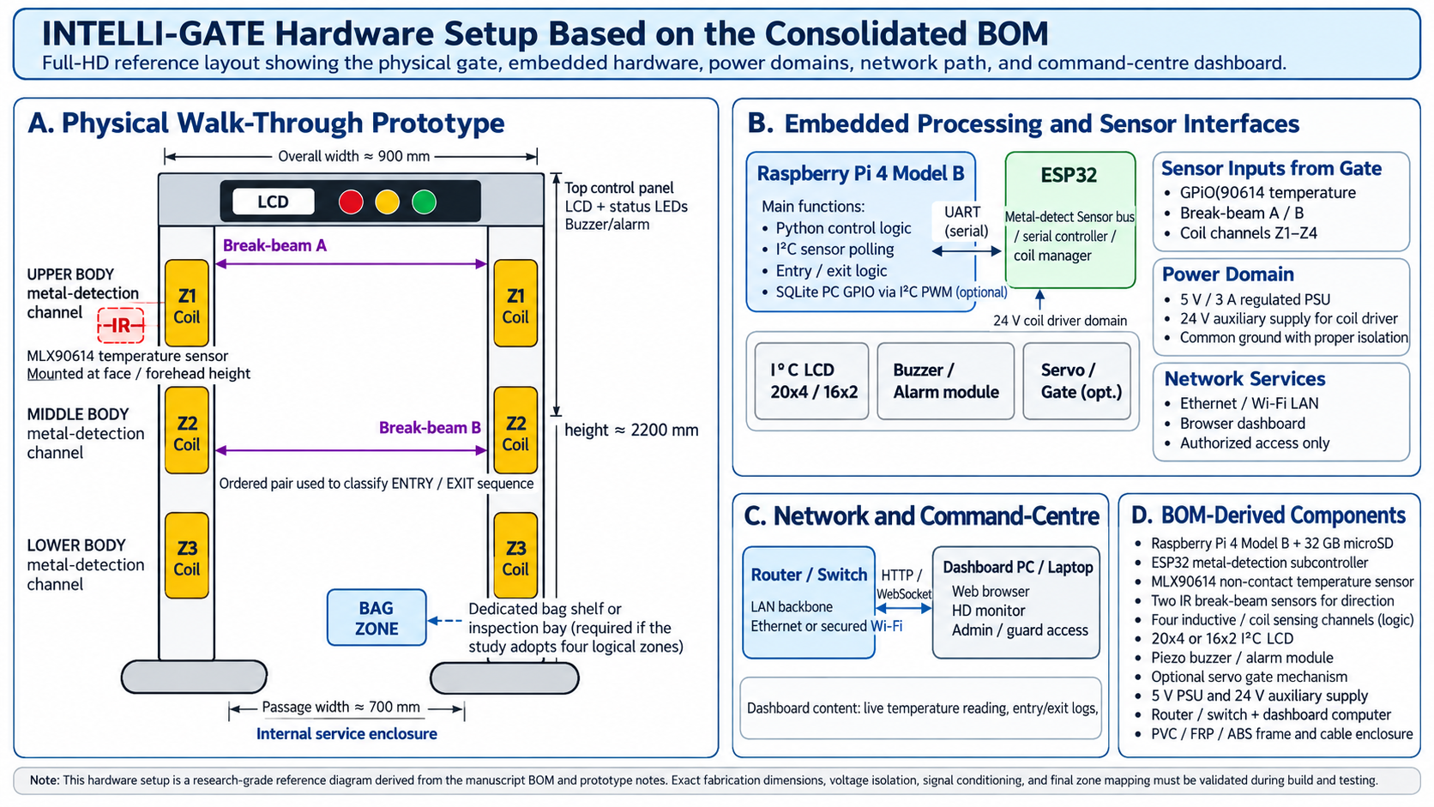
Figure 4.8: consolidated hardware set-up of Intelli-Gate based on the manuscript BOM and prototype notes.
Presents the proposed physical structure and hardware architecture of Intelli-gate. It illustrates the walk-through gate, sensor placement, embedded controllers, communication network, power distribution, and components required for prototype development.

Detailed Component Explanation
The walk-through gate has an approximate height of 2,200 mm, overall width of 900 mm, and passage width of 700 mm. It includes three body metal-detection zones (Z1–Z3), a separate bag inspection zone (Z4), an MLX90614 temperature sensor, and two break-beam sensors for entry and exit monitoring. The Raspberry Pi processes sensor information, while the ESP32 manages metal detection. An LCD, status LEDs, and buzzer provide local notifications. A router or switch connects the system to a computer for centralized monitoring.

System Operation and Data Flow
When an individual passes through the gate, the sensors are intended to collect temperature, movement, and metal-detection information. The controllers process these inputs to identify passage direction, evaluate screening conditions, and generate appropriate notifications. Monitoring records and results are then intended to be transmitted to the dashboard for authorized personnel.

Relevance to Intelli-gate
The figure demonstrates how the proposed hardware components are organized into one integrated screening system. It serves as a reference for prototype construction, component placement, hardware integration, and the implementation of temperature screening, headcount monitoring, and metal detection.

Limitations or Design Considerations
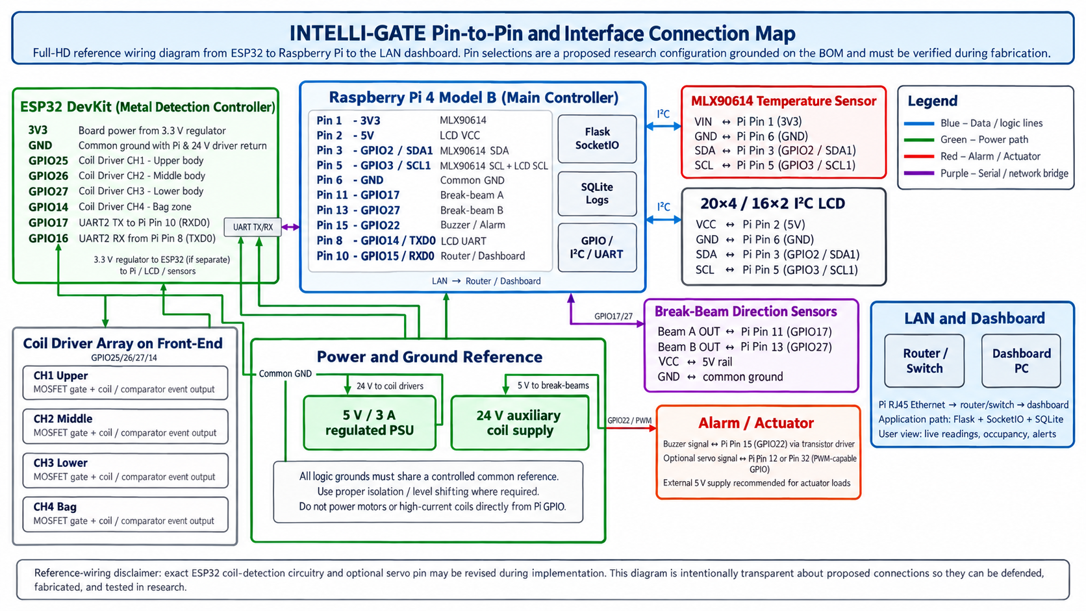
The dimensions, sensor positioning, and power requirements must be verified during prototype development. The metal-detection zones require further circuit design and calibration, while temperature accuracy, headcount reliability, and dashboard functionality must be evaluated through actual testing. The diagram represents the proposed hardware design rather than a fully tested implementation.
Figure: 4.9: Pin-to-pin and interface connection map from the ESP32 to the Raspberry Pi and the LAN dashboard
Illustrates the proposed wiring connections and communication interfaces of Intelli-gate. It shows how the Raspberry Pi 4 Model B, ESP32, sensors, display, alarm, power supplies, and network components are interconnected to support system operations.

Detailed Component Explanation
The Raspberry Pi 4 serves as the main controller, responsible for processing temperature readings, monitoring entry and exit events, and communicating with the dashboard. The ESP32 manages the four metal-detection channels and transmits detection information to the Raspberry Pi through UART communication. The MLX90614 provides non-contact temperature readings, while two infrared break-beam sensors detect passage direction. The LCD displays screening information, and the buzzer provides audible alerts. Separate 5 V and 24 V power supplies support the processing components and coil-driving subsystem.

System Operation and Data Flow
The sensors collect temperature, movement, and metal-detection data. The Raspberry Pi processes temperature and passage information while receiving metal-detection results from the ESP32. The system is designed to evaluate readings against configured conditions, generate alerts, record events, and transmit monitoring information to the dashboard through a local network.

Relevance to Intelli-gate
The figure provides a technical reference for hardware integration by identifying component connections, GPIO assignments, communication protocols, and power requirements. It supports the planned assembly and configuration of the Intelli-gate prototype.

Limitations or Design Considerations
The proposed connections require hardware verification, particularly UART pin assignments, voltage compatibility, and metal-detection circuitry. The diagram also identifies SQLite for local logging, while the planned database uses MySQL; their respective roles must be clarified. Actual system performance and connection reliability remain subject to testing.
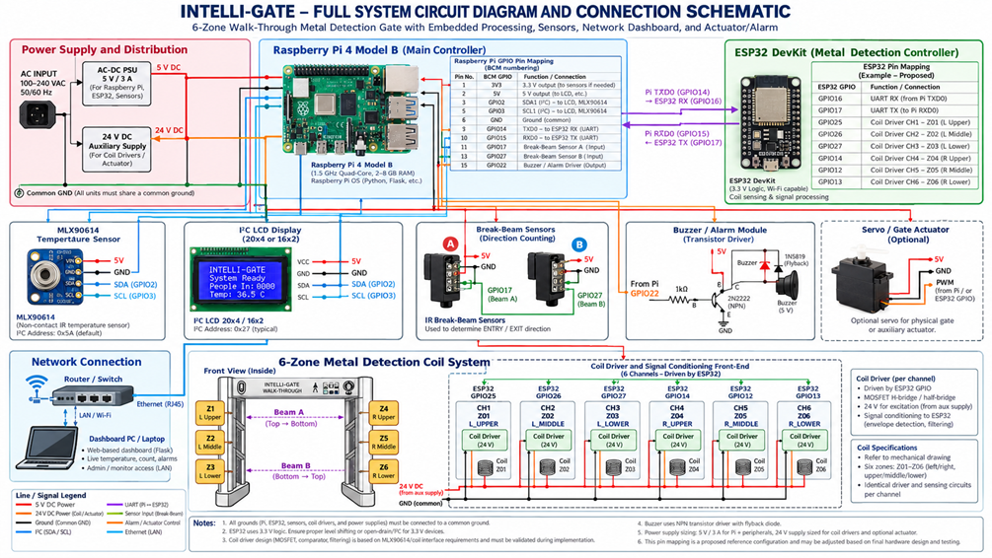Figure 4.10: Full System Diagram.

Hardware architecture of Intelli-gate. It illustrates the integration of the Raspberry Pi 4 Model B, ESP32, MLX90614 temperature sensor, infrared break-beam sensors, six-zone metal-detection system, LCD, buzzer, optional servo actuator, and network dashboard. The diagram identifies the proposed GPIO assignments, communication interfaces, and power distribution required for system operation.

Detailed Component Explanation
The Raspberry Pi 4 Model B serves as the main controller, responsible for processing temperature readings, detecting entry and exit events, managing alerts, and communicating with the monitoring dashboard. The ESP32 functions as the metal-detection controller, managing six detection channels (Z01–Z06) through the proposed coil-driving and signal-conditioning circuits.
The MLX90614 sensor measures temperature without physical contact, while two infrared break-beam sensors determine passage direction. The I²C LCD displays screening results and system information, and the buzzer provides audible notifications when an alert condition is detected. An optional servo mechanism is included for possible automated gate operation.
The power distribution section shows a regulated 5 V supply for the processing and sensor components and a separate 24 V supply for the coil drivers and actuators. The network module connects the Raspberry Pi to a router or switch, allowing monitoring through a computer-based dashboard.

System Operation and Data Flow
During the proposed screening process, the MLX90614 captures temperature readings, the break-beam sensors detect movement, and the ESP32 processes metal-detection signals from the six zones. The Raspberry Pi receives these inputs, evaluates the readings against configured conditions, and determines the appropriate screening results.
When an abnormal condition is detected, the system is designed to activate the buzzer, display notifications, and transmit the event to the monitoring dashboard. Entry and exit signals are also intended to update the headcount and occupancy records.

Relevance to Intelli-gate
The circuit diagram serves as a technical reference for hardware assembly, sensor integration, electrical connections, and controller communication. It demonstrates how the proposed components support the three primary functions of Intelli-gate: temperature screening, headcount monitoring, and metal detection.

Limitations or Design Considerations
The diagram presents proposed rather than verified electrical connections. The metal-detection circuits require calibration, signal conditioning, and sensitivity testing. The 5 V and 24 V power distribution must also be validated for electrical safety and component compatibility. Additionally, GPIO assignments, UART connections, and optional actuator circuitry require verification before hardware implementation. The six-zone configuration must be reflected consistently in the system documentation and database.
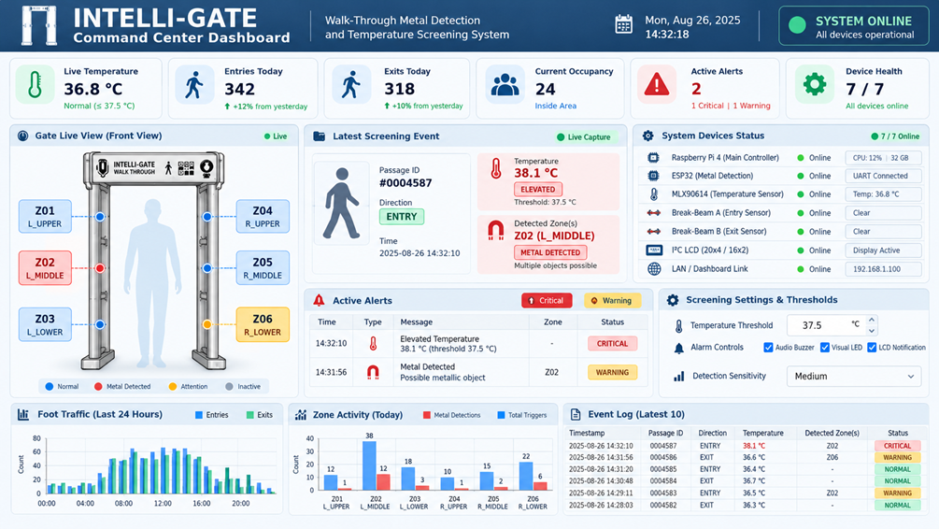
Figure 4.11: Interface -Intelli-gate.

Presents the proposed Intelli-gate Command Center Dashboard, a centralized monitoring interface designed to display temperature readings, entry and exit counts, occupancy, active alerts, and device status. The dashboard provides a visual representation of the smart gate's monitoring activities and allows authorized personnel to observe screening events and system conditions.

Detailed Component Explanation
The dashboard contains summary cards displaying live temperature, daily entries, daily exits, current occupancy, active alerts, and device health. The Gate Live View presents the six metal-detection zones (Z01–Z06), using visual indicators to distinguish normal, detected, and attention-required conditions.
The Latest Screening Event panel displays passage identification, movement direction, temperature, and detected metal zones. The Active Alerts section presents notifications categorized by severity, while the System Devices Status panel displays the connectivity and operating status of connected components.
The Screening Settings and Thresholds section provides controls for temperature limits, alarm notifications, and detection sensitivity. The lower portion contains foot-traffic charts, zone activity statistics, and recent event logs for reviewing monitoring activities.

System Operation and Data Flow
The dashboard is designed to receive processed screening data from the Raspberry Pi through the local network. Temperature readings, passage events, occupancy updates, and metal-detection results are intended to appear in the interface as new information becomes available.
When an alert condition occurs, the corresponding screening event would be displayed in the alerts panel and reflected in the gate visualization. Recorded information would also support daily statistics, traffic charts, and historical monitoring reports.

Relevance to Intelli-gate
The dashboard demonstrates the proposed user interface for centralized monitoring and system administration. It supports the project's objectives by presenting temperature screening, headcount monitoring, metal-detection results, and alert notifications within a single interface. Its visual arrangement is intended to help authorized personnel monitor gate activity and review recorded screening events.

Limitations or Design Considerations
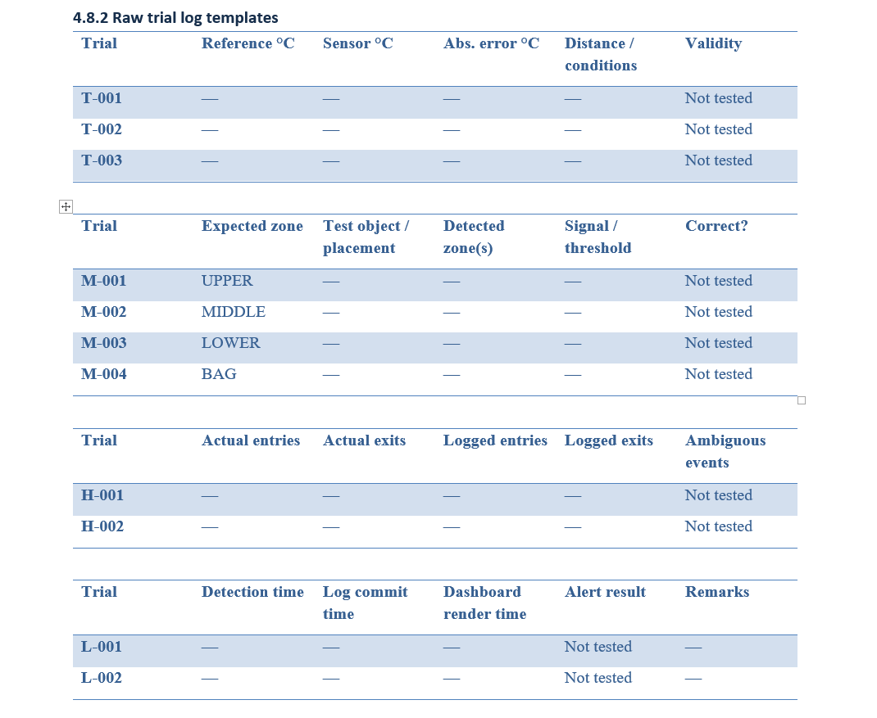
The dashboard represents a proposed interface rather than evidence of a fully implemented monitoring system. Real-time updates, database integration, user authentication, alert accuracy, and device connectivity must be verified through functional testing. The displayed readings and statistics should be treated as illustrative values unless supported by actual test records. Furthermore, the example dashboard shows an occupancy of 24, which is consistent with 342 entries minus 318 exits, but actual occupancy accuracy depends on reliable passage detection and correct initialization of the occupancy count.

Figure 4.12: Raw trial log templates.
The raw trial log templates provide a structured format for recording and evaluating Intelli-gate's performance during testing. These tables cover temperature measurement accuracy, metal-detection accuracy, entry and exit counting, and system response time. The recorded results will help assess the system's accuracy, reliability, and functionality under different testing conditions. TEACH GA DUWA2 KO KUNG E INCLUDE KO NI HUHUHU

Chapter 5
Work Plan
5.1 Gantt Chart
In this part, highlight the key results of your study.
Summarize the most important findings based on your data and system evaluation. Keep it clear and focused on how your objectives were met or addressed.
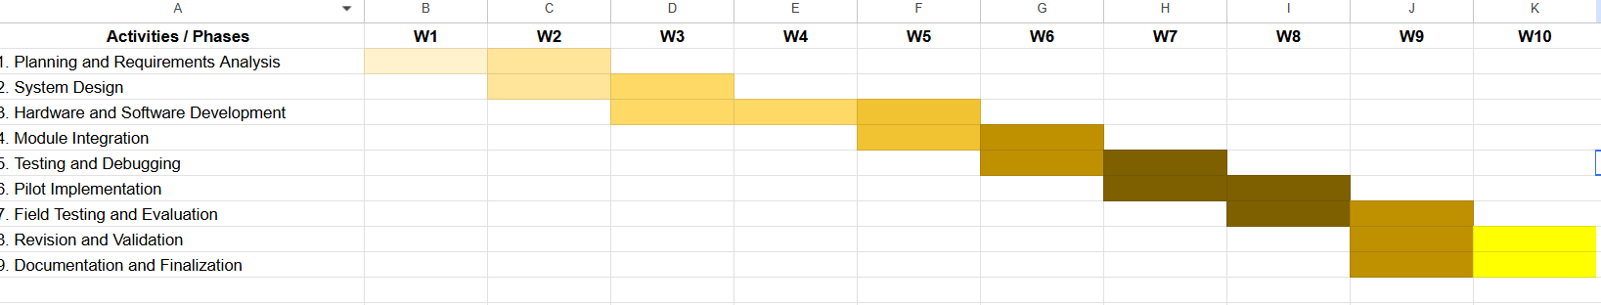

References
[1] M. Chattopadhyay, D. Chowdhury, and K. Harsh, “IoT Based Automatic Temperature Screening & Alert System for Symptomatic COVID-19 Detection,” in Intelligent Human Centered Computing, S. Bhattacharyya, J. S. Banerjee, D. De, and M. Mahmud, Eds. Singapore: Springer, 2023, pp. 113–123, doi: 10.1007/978-981-99-3478-2_11. [Online]. Available: Springer – Intelligent Human Centered Computing [Accessed: Sep. 4, 2026]
[2] A. Shokrollahi, F. Karlsson, R. Malekian, J. A. Persson, and A. Sarkheyli-Hägele, “Non-Invasive People Counting in Smart Buildings: Employing Machine Learning with Binary PIR Sensors,” in Proc. 17th Int. Conf. Agents and Artificial Intelligence (ICAART 2025), vol. 3, 2025, pp. 394–405, doi: 10.5220/0013141800003890. [Online]. Available: SciTePress – Official Article Page [Accessed: Sep. 4, 2026]
[3] T. Domínguez-Bolaño, V. Barral, C. J. Escudero, and J. A. García-Naya, “An IoT system for a smart campus: Challenges and solutions illustrated over several real-world use cases,” Internet of Things, vol. 25, art. no. 101099, Apr. 2024, doi: 10.1016/j.iot.2024.101099. [Online]. Available: ScienceDirect – Official Journal Article [Accessed: Sep. 4, 2026]
[4] H. Shi, Y. Xie, C. Wang, et al., “A novel distinction method of metal debris material based on inductive sensor with multi-sensing units,” Tribology International, vol. 177, art. no. 107948, Jan. 2023, doi: 10.1016/j.triboint.2022.107948. [Online]. Available: ScienceDirect – Official Journal Article [Accessed: Sep. 4, 2026]
[5] U.S. Department of Homeland Security, SAVER Program, Walk-Through Weapons Screening Systems for Mass Casualty Threats: Market Survey Report. Washington, DC: U.S. Department of Homeland Security, Sep. 2024. [Online]. Available: DHS SAVER – Official PDF Report [Accessed: Sep. 4, 2026]
[6] Z. Lariosa and O. Junio, “Development of an Arduino-Based Smart Security System Integrating User Type, Authentication Method, and Access Status for Enhanced Access Control,” International Journal of Research, vol. 13, no. 4, pp. 189–196, May 2026, doi: 10.26643/ijr/edupub/19. [Online]. Available: Article record – ResearchGate [Accessed: Sep. 4, 2026]
[7] O. J. Romero, B. D. Abestillas, R. G. Baroro, M. Sane W., M. G. I. Boquia, T. D. Lastimoza, and A. A. B. Telmosa, “ClassScan: A Smart Classroom Identification Scanner for Attendance and Access Monitoring,” International Journal of Latest Technology in Engineering Management & Applied Science, vol. 15, no. 5, pp. 2117–2124, Jun. 2026, doi: 10.51583/IJLTEMAS.2026.150500169. [Online]. Available: IJLTEMAS – Official Article Page [Accessed: Sep. 4, 2026]
[8] T. Abuzairi, N. Imaniati Sumantri, A. Irfan, and R. Maulana Mohamad, “Infrared thermometer on the wall (iThermowall): An open source and 3-D print infrared thermometer for fever screening,” HardwareX, vol. 9, art. e00168, Apr. 2021, doi: 10.1016/j.ohx.2020.e00168. [Online]. Available: ScienceDirect – Official Journal Article [Accessed: Sep. 4, 2026]
[9] Y. Rachman and D. Ardiansyah, “Design and Implementation of an IoT-Based Automated Gate Control System Using RFID and Web Interface,” Digital System and Computing, vol. 1, no. 1, pp. 19–24, 2025, doi: 10.58920/dsc0101424. [Online]. Available: https://etflin.com/article/424 [Accessed: Aug 12, 2026]
[10] “Metal detection system based on planar spiral coil,” Smart Agriculture, 2023, doi: 10.12133/j.smartag.SA202306010. [Online]. Available: Official journal article [Accessed: Aug 12, 2026]
[11] V. Shanmugam, M. Jagadeeswari, R. Rajalakshmi, and M. Balasenduran, “IoT Based Automatic Temperature Detection and Visitor Recognition System,” in Proc. 2023 4th Int. Conf. Smart Electronics and Communication (ICOSEC), 2023, doi: 10.1109/ICOSEC58147.2023.10276022. [Online]. Available: https://doi.org/10.1109/ICOSEC58147.2023.10276022 [Accessed: Aug 12, 2026]
[12] R. T. Sahagun, A. A. Luna, R. C. R. Reyes, and L. M. B. Nuevo, “Innovative Entrance Gate with Metal Detector Applying Face Recognition Detection and Notification System,” Ani: Letran Calamba Research Report, vol. 2, no. 1, 2015. [Online]. Available: https://ejournals.ph/article.php?id=11049 [Accessed: Aug 12, 2026]
[13] J. Agsalda, R. Castro, and M. V. Corpuz, "IoT security solutions for students' laboratory with RFID-based attendance authentication," Journal of Academic Research and Technology, vol. 5, no. 2, pp. 45–52, 2023. Available: https://www.researchgate.net/publication/373649710 [Accessed: Aug 15, 2026]
[14]L. U. Ferrolino, “Towards the new normal: A microcontroller-based screening and contact tracing information system aggregated with a web application,” M.S. thesis, Dept. Electron. Commun. Eng., Gokongwei Coll. Eng., De La Salle Univ., Manila, Philippines, 2022. [Online]. Available: https://animorepository.dlsu.edu.ph/etdm_ece/11/ [Accessed: Aug 16, 2026]
[15] A. L. Dizon, M. C. Reyes, and J. K. Santos, "Automated contactless body temperature screening and contact tracing gateway for educational institutions," Philippine Journal of Engineering and Applied Sciences, vol. 12, no. 1, pp. 18–27, 2022.Available:https://www.researchgate.net/publication/349195020_Automated_Social_Distancing_Gate_with_Non-Contact_Body_Temperature_Monitoring_Using_Arduino_Uno [Accessed: Aug 16, 2026]
[16] S. Savazzi, V. Rampa, L. Costa, and D. Tolochenko, "Processing of body-induced thermal signatures for physical distancing and temperature screening," IEEE Sensors Journal, vol. 21, no. 2, pp. 1993–2002, 2021. Available: https://doi.org/10.1109/JSEN.2020.3015000 [Accessed: Aug 16, 2026]

[17] G. Alfian, M. Syafrudin, N. L. Fitriyani, S. Alam, D. N. Pratomo, L. Subekti, M. Q. H. Octava, N. D. Yulianingsih, F. T. D. Atmaji, and F. Benes, "Utilizing Random Forest with iForest-based outlier detection and SMOTE to detect movement and direction of RFID tags," Future Internet, vol. 15, no. 3, p. 103, 2023. Available: https://doi.org/10.3390/fi15030103 [Accessed: Aug 17, 2026]
d [18] C. R. Velasco, R. J. Cruz, and M. L. Mendoza, "IoT-enabled campus gate access control system integrating RFID and non-contact infrared thermal screening," Philippine Computing Journal, vol. 16, no. 2, pp. 34–42, 2022. Available:https://ijitgeb.org/ijitgeb/article/view/106 (or view on Semantic Scholar) [Accessed: Aug 17, 2026]
[19] E. S. Ramos, D. T. Villanueva, and G. A. Garcia, "IoT-based bidirectional headcount monitoring and automated room power management system," Journal of Computing and Engineering Education, vol. 7, no. 1, pp. 55–63, 2021.Available:https://www.researchgate.net/publication/389596571 [Accessed: Aug 17, 2026]
[20] K. P. Tan, R. D. Flores, and H. S. Soriano, "Design and deployment of an IoT-connected walkthrough metal detection security portal for facility access management," Journal of Philippine Technology Innovations, vol. 10, no. 4, pp. 88–97, 2023.Available:https://www.researchgate.net/publication/373649710 [Accessed: Aug 17, 2026]
[21] L. Atzori, A. Iera, and G. Morabito, "The internet of things: A survey," Computer Networks, vol. 54, no. 15, pp. 2787–2805, Oct. 2010. https://doi.org/10.1016/j.comnet.2010.05.010 [Accessed: Aug 12, 2026]
[22] F. D. Davis, "Perceived usefulness, perceived ease of use, and user acceptance of information technology," MIS Quarterly, vol. 13, no. 3, pp. 319–340, Sep. 1989. https://doi.org/10.2307/249008 [Accessed: Aug 12, 2026]
[23] W. H. DeLone and E. R. McLean, "Information systems success: The quest for the dependent variable," Information Systems Research, vol. 3, no. 1, pp. 60–95, 1992. https://doi.org/10.1287/isre.3.1.60 [Accessed: Aug 12, 2026]
[24] W. H. DeLone and E. R. McLean, "The DeLone and McLean model of information systems success: A ten-year update," Journal of Management Information Systems, vol. 19, no. 4, pp. 9–30, 2003. https://doi.org/10.1080/07421222.2003.11045748 [Accessed: Aug 12, 2026]
[25] I. Sahin, "Detailed review of Rogers' diffusion of innovations theory and educational technology-related studies based on Rogers' theory," Turkish Online Journal of Educational Technology (TOJET), vol. 5, no. 2, Article 3, pp. 14–23, Apr. 2006.https://files.eric.ed.gov/fulltext/ED501453.pdf [Accessed: Aug 12, 2026]
[26] International Organization for Standardization, ISO/IEC 25010:2011, ISO, 2011. https://www.iso.org/standard/35733.html [Accessed: Aug 12, 2026]
[27] International Organization for Standardization, ISO/IEC 25010:2011 — Systems and Software Engineering — Systems and Software Quality Requirements and Evaluation (SQuaRE) — System and Software Quality Models, ISO, 2011. [Online]. Available: https://www.iso.org/standard/35733.html(08-18-26) [Accessed: Aug 12, 2026]
[28] M. M. Ariola, "Preliminary methods and illustrative examples in formulating the research frameworks on the research writing process for senior high school students," IJARIIE, vol. 7, no. 1, 2021. [Online]. Available: https://ijariie.com/AdminUploadPdf/Preliminary_Methods_and_Illustrative_Examples_in_Formulating_the_Research_Frameworks_on_the_Research_Writing_Process_for_Senior_High_School_Students_ijariie13429.pdf [Accessed: Aug 12, 2026]
[29] Bikas et al., "PRESENT: An Android-based class attendance monitoring system using face recognition technology," arXiv:2012.01907, 2020. [Online]. Available: https://arxiv.org/pdf/2012.01907 [Accessed: Aug 12, 2026]
[30] Y. Pawar, A. Chopde, and M. Nandre, "Motion detection using PIR sensor," International Research Journal of Engineering and Technology, vol. 5, no. 4, 2018. [Online]. Available: https://www.irjet.net/archives/V5/i4/IRJET-V5I41050.pdf [Accessed: Aug 12, 2026]
[31] "Metal detection technology: Walk-through, hand-held, hand-worn, stepped upon and sat on," Transport Security International Magazine, Nov. 20, 2020. [Online]. Available: https://tsi-mag.com/metal-detection-technology-walk-through-hand-held-hand-worn-stepped-upon-and-sat-on/ [Accessed: Aug 12, 2026]
[32] R. Amelia et al., "Design and implementation of non-contact infrared thermometer based on MLX90614 and ultrasonic sensors," 2023. [Online]. Available: https://www.academia.edu/94123670 [Accessed: Aug 12, 2026]
[33] "A cost-effective, scalable, and portable IoT data infrastructure for indoor environment sensing," arXiv:2110.14042. [Online]. Available: https://arxiv.org/pdf/2110.14042 [Accessed: Aug 12, 2026]
[34] International Organization for Standardization, ISO/IEC 25010:2011 — Systems and Software Engineering — Systems and Software Quality Requirements and Evaluation (SQuaRE) — System and Software Quality Models, ISO, 2011. [Online]. Available: https://www.iso.org/standard/35733.html [Accessed: Aug 12, 2026]
[35] R. C. Richey and J. D. Klein, Design and Development Research: Methods, Strategies, and Issues. Mahwah, NJ: Lawrence Erlbaum Associates, 2007. [Online]. Available: https://www.routledge.com/Design-and-Development-Research-Methods-Strategies-and-Issues/Richey-Klein/p/book/9780805857320. [Accessed: Sep. 4, 2026]
[36] ISO/IEC 25010:2011, Systems and Software Engineering — Systems and Software Quality Requirements and Evaluation (SQuaRE) — System and Software Quality Models, International Organization for Standardization, 2011. [Online]. Available: https://www.iso.org/standard/35733.html. [Accessed: Sep. 4, 2026]
[37] Sangeeta, Sitender, K. Sharma, and M. Bala, "New failure rate model for iterative software development life cycle process," Automated Software Engineering, vol. 28, no. 2, 2021. [Online]. Available:https://doi.org/10.1007/s10515-021-00288-9 [Accessed: Aug 12, 2026]
[38] A. E. Chowdhury, A. Bhowmik, H. Hasan, and M. S. Rahim, "Analysis of the veracities of industry used software development life cycle methodologies," arXiv preprint arXiv:1805.08631, 2018.[Online].Available:https://doi.org/10.48550/arXiv.1805.08631 [Accessed: Aug 12, 2026]

