ASSIGNMENT-1

1.
Report view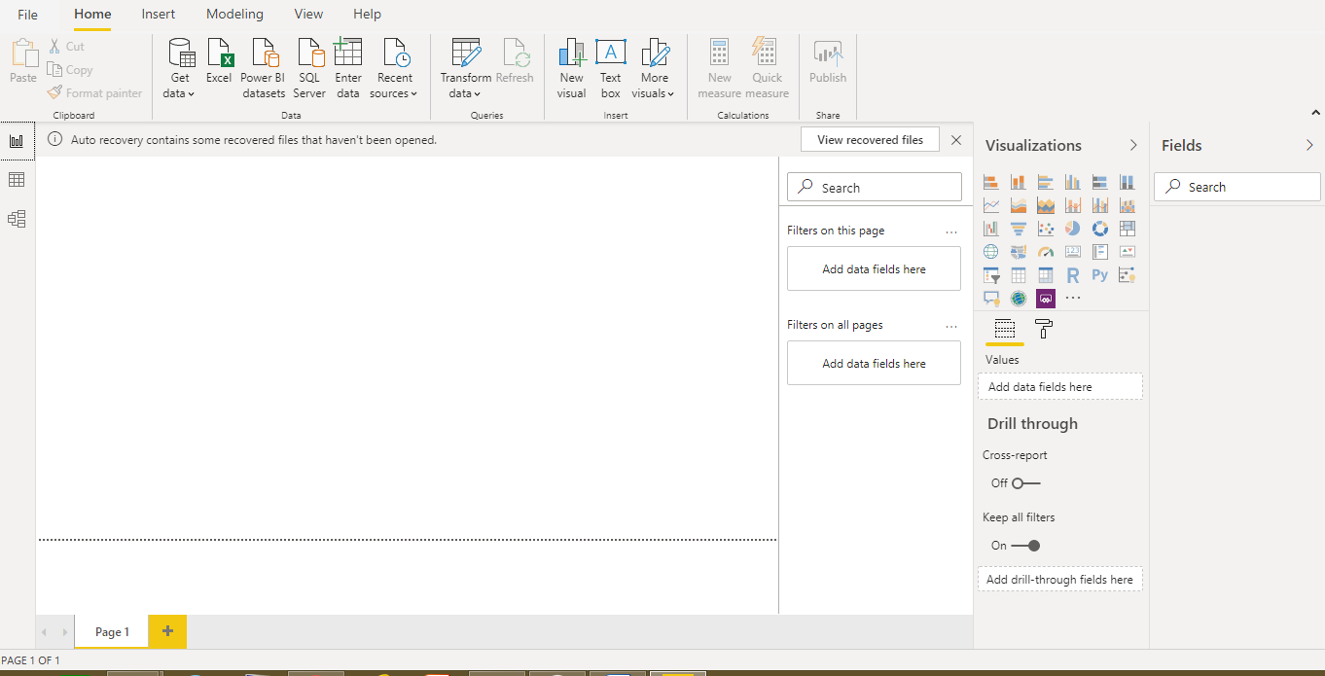

2.
Report View: used to visualize the data through different types like bar chart, line chart….

Data View: used to view the data in the table format with rows and columns
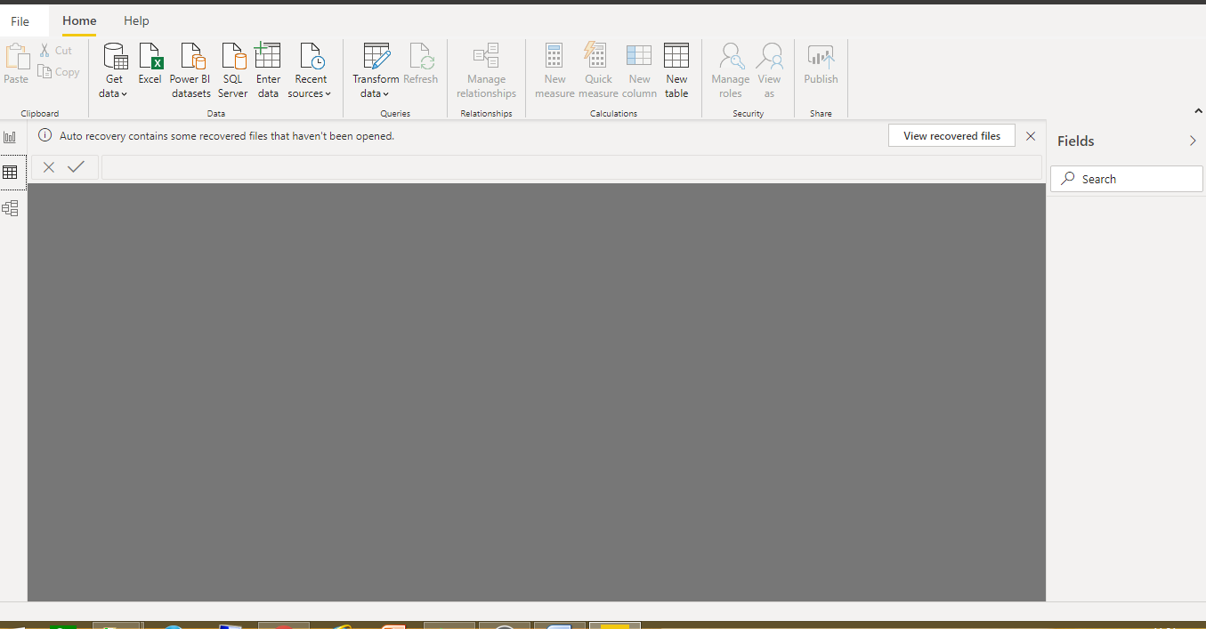

Model View: used to provide the relationships from one table to the other table
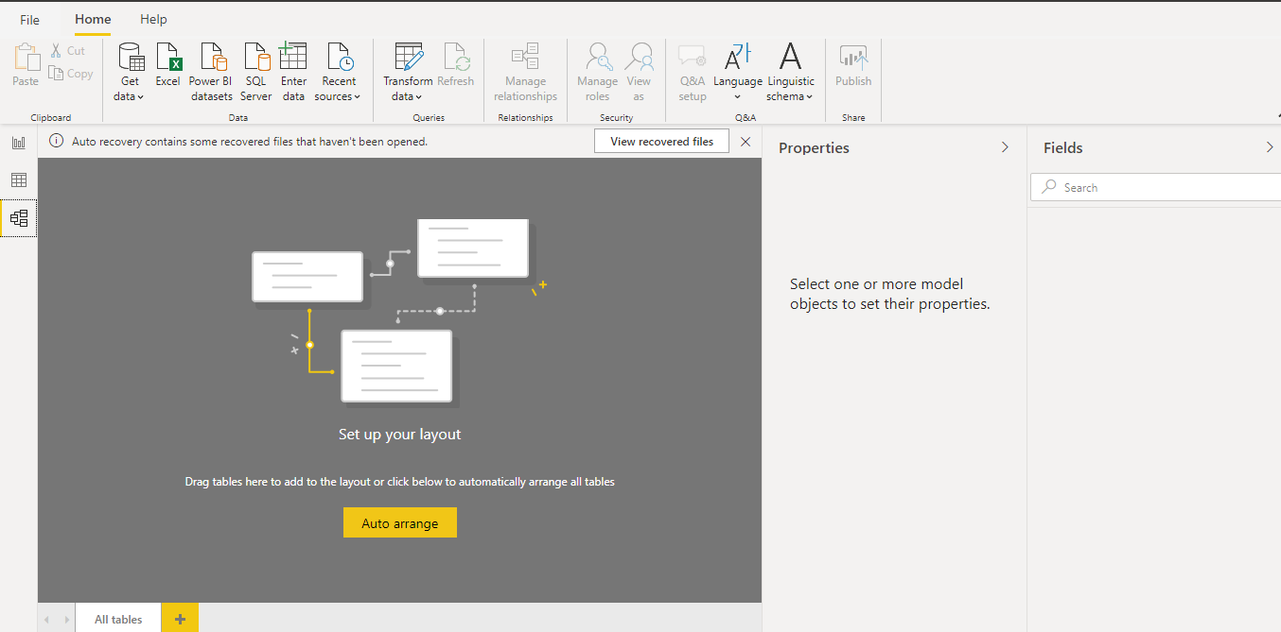

Power Query Editor: used to edit and make the changes in the table data
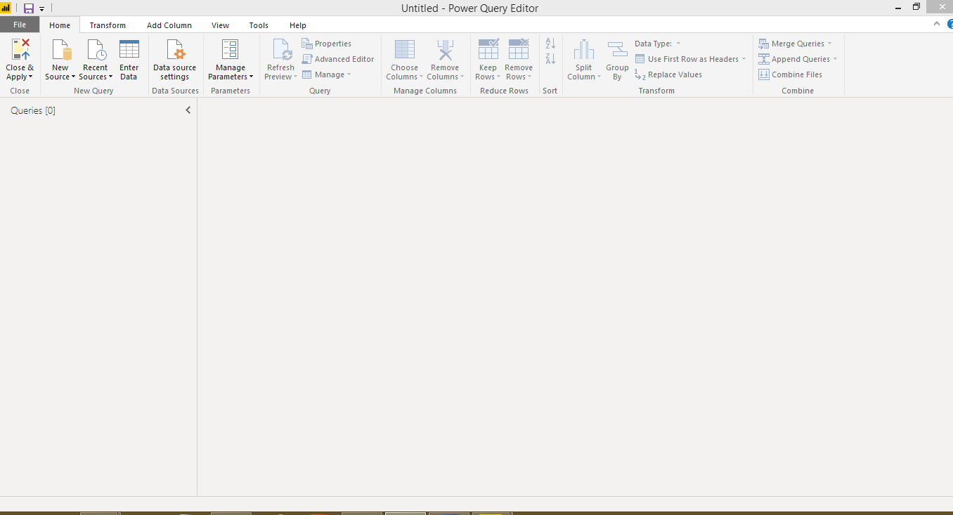

Advance Editor: provides advance editing options in the query editor
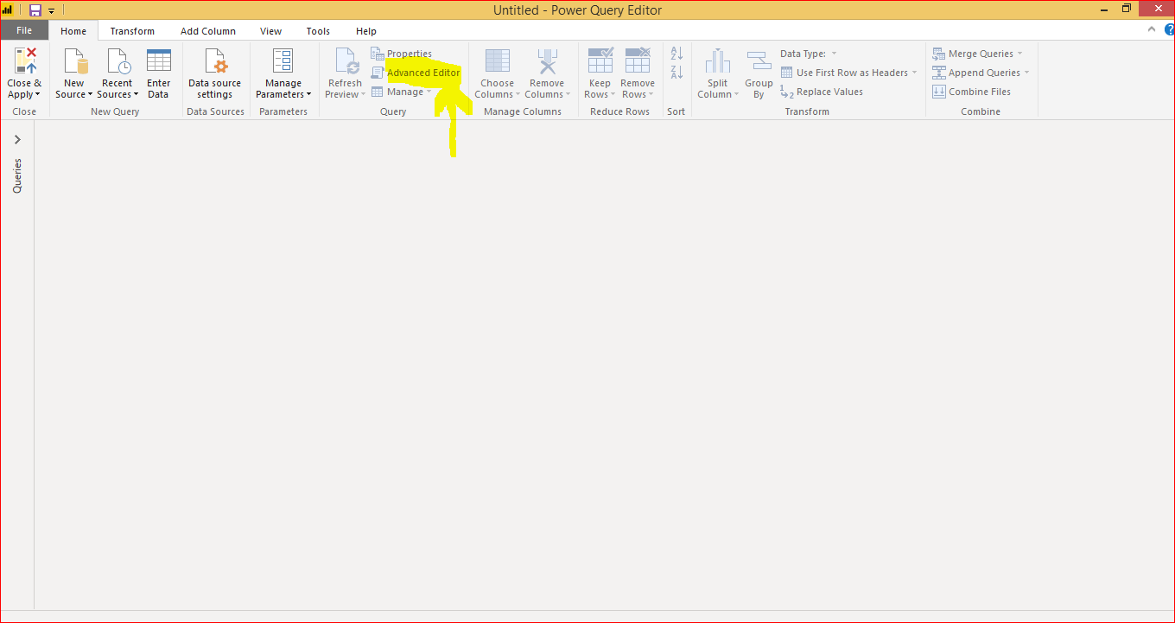

3.
Power BI Desktop: Power BI Desktop is the free version of Power BI that you can install on your local computer.
some feature limitations with the free Power BI Desktop
- Can’t share created reports with non-Power BI Pro users
- No App Workspaces
Cost: Free of Cost
Power BI Pro: Power BI Pro is licensed by individual user. Power BI Pro is the full version of Power BI, provides ability to use Power BI for both building dashboards and reports and unlimited viewing, sharing and consumption of your created reports.
It will be useful for a limited group of people in organization for example like 20-30 people.
Cost: $9.99/user/month
Power BI Premium: Power BI Premium is different from the other two. It has all advanced features. And it is mostly used by the large group of organizations. It can be purchased as a group of people not as a single individual.
Cost: $4,995 a month

